Great Outdoors Taskforce Recommendations Report
ISBN 978-1-76176-382-3 (Print)
ISBN 978-1-76176-383-0 (pdf/online/MS word)
Table of Contents
1. Taskforce’s foreword 3
2. Executive Summary 5
2.1. Summary of recommendations 8
3. Introduction 12
3.1. About Victoria’s state forests 12
3.2. About the Great Outdoors Taskforce 16
3.3. Traditional Owners Partnership Approach 23
4. Stakeholders and Community 24
4.1. How we engaged 24
4.2. What we heard 26
4.3. Evidence and information considered by the Taskforce 32
5. Healthy forests bring people and nature together 33
6. Elements of Healthy Forest Plans 39
6.1. Collaborative management, planning and governance 39
6.2. Managing for multiple values 44
6.3. Traditional Owner healing and caring for Country 48
6.4. Stewardship of our forests 59
6.5. Thriving tourism and economies 61
6.6. Biodiversity conservation 72
7. Sharing our healthy forests 76
Appendix 1: What we heard from stakeholders and the community 78
Summary of Key Themes 78
Data based on local government areas 84
Stakeholders we heard from: 91
Appendix 2: Nature-based and recreation projects for further investigation 95
Projects with high strategic alignment to recreation opportunities identified for Victoria 95
Projects in Gippsland 99
Projects in the North East 102
Appendix 3: Pilots proposed by Gunaikurnai, Taungurung and Yorta Yorta Traditional Owner groups on their Country 109
Gunaikurnai Land and Waters Aboriginal Corporation 109
Pilot for Tambo District Forest Management Area 109
Yorta Yorta Nation Aboriginal Corporation Pilot for Barambogie State Forest Pilot 115
Taungurung Land and Waters Council 122
Pilot for Reedy Lake: Collaborative Management at Place 122
Publication information 129
Acknowledgements 129
Copyright 129
Creative Commons 129
Disclaimer 129
Accessibility 129

Taskforce’s foreword
Victoria is home to some of the most impressive forests in the world. They are a much-loved backyard for Victorians and visitors to explore, and the rich biodiversity found in our forests provides habitat for unique animals and plants that is not found anywhere else.
The end of native timber harvesting in Victoria presents a landmark opportunity for Victorians to reimagine the future use of our state forests and how they can be managed.
It presents a chance for government, Traditional Owner groups, local agencies, forest users and the community to think differently, act differently, and work together to develop longer-term objectives, partnership approaches and plans for the shared use and care of our forests.
The Great Outdoors Taskforce was established in April 2024 to provide recommendations to the Victorian Government on the management of state forests in Gippsland and North East Victoria. This study area covers 1.5 million hectares of native forests that were formerly subject to native timber harvesting, and approximately 590,000 hectares of relevant adjacent state forests.
These areas include the lands of Gunaikurnai, Taungurung and Yorta Yorta Traditional Owners. The Taskforce has worked closely with these Traditional Owners, who are members of the Taskforce, to enable self-determination and support healing and caring for Country.
We want people to continue to do the activities they love, while at the same time ensuring enduring and sustainable environmental management practices.
Accessing our forests for recreation and tourism and improving our biodiversity and conservation efforts can go hand in hand, and planning for these shared objectives will usher in a new era of state forest management.
By improving management of our forests, we will help more people access our forests, improve and enhance experiences of nature, whilst ensuring our forests are healthy and resilient in the face of climate change, population growth, and increasing emergency events.
The Taskforce is making recommendations to the Victorian Government to ensure shared benefits for all Victorians – focusing on building regional economies, maximising tourism and recreation opportunities, while also ensuring forest values are protected for future generations.
We all have a role to play in creating a future where our forests are healthy and are enjoyed by all Victorians.
Hon Lisa Neville, Chairperson

Executive Summary
Victorians live in an incredible part of the world.
Victoria’s North East and Gippsland regions have unique characteristics that make these areas truly memorable destinations for visitors. We should be proud that these forests are right in our backyard, and they are already so well-loved and enjoyed.
Large-scale commercial native timber harvesting has ceased on public land in Victoria. This ended the threat commercial timber harvesting once posed to our biodiversity and forest ecosystems.
We can now come together to think about how we enjoy and share our forests into the future, enable more people to connect with nature, and work together to care for the precious ecosystems that support them.
We can enable access to our forests, plan for and manage our forests for multiple values, and improve how we share our forests with visitors.
Significant threats including climate change, bushfire and pest plants and animals remain and these need to be tackled across all land tenures.
We need to improve forest management regardless of land tenure. Commercial native timber harvesting has ended and there is no need to make large-scale changes to land tenure or create new national parks.
A great outdoors is one where people can:
- Gather to enjoy
- Recreation in our wonderful
- Environment through improving its health and providing
- Access in collaboration with
- Traditional Owners and community working together.
We heard that people care deeply about state forests in Victoria, whether they visit on weekends or consider them part of their backyard. They feel a strong connection to the unique nature in Victorian forests and want to continue to enjoy the vast array of experiences and activities our forests provide.
We also heard from Victorians who wanted to share their thoughts about bushfire management, firewood access and supply. While we recognise their interest in these areas, it is outside the scope of the Taskforce to make recommendations on bushfire management or firewood access and supply.
It is clear that many Victorians are passionate about our forests, and, understandably, they want to be part of the planning and decisions for management of forests that affect them and their communities.
To achieve this, we must fundamentally change the way we manage our forests.
Collaboration with Traditional Owners and local communities will be key.
The Taskforce recommends that this is achieved by developing Healthy Forest Plans across state forests. These should be place-based forest management plans developed and implemented in collaboration with local communities, Traditional Owners, and user groups.
Healthy Forest Plans are about bringing management of multiple uses and values together and taking collective ownership for the health of our forests. They should use genuine collaboration to ensure the best outcomes are achieved.
This new approach is a significant change to the way the Victorian Government currently manages state forests.
But it’s the right time for change.
We will make our forests better together.
We are at the start of a journey, and change will take time.
And we know when communities have a fair say and work together, we get better outcomes for nature and people.
The government must shift away from past approaches focused largely on managing the impacts of commercial native timber harvesting and move towards an active and adaptive approach that manages forests for multiple values. It must collaboratively govern, plan and manage our forests with Traditional Owners and community working together.
The Taskforce has heard the message loud and clear that people want to be part of the solution and are excited to embark on a change in approach.
True collaboration is easy in theory and hard in practice. We need to try different ways to make this a reality for Healthy Forest Plans. The Taskforce is recommending ways to test and learn from different approaches, particularly in partnership with Traditional Owners.
For change to succeed, it must also be properly resourced. There needs to be better investment in basic infrastructure and on-ground forest management. On-ground field staff are critical to ensure people follow the rules that keep forests accessible for everyone.
Many Victorians are already embracing tourism and recreation in our state forests and doing it in a way that respects these places and their future value. With targeted investment, we have an opportunity to ensure more Victorians and visitors enjoy and experience our unique forests.

Summary of recommendations
Table 1: Summary of recommendations
No. | Recommendation | Elements of Healthy  Forest Plans | Timeframe
1 | Develop Healthy Forest Plans across all state forests in the North East and Gippsland regions (Taskforce study area). Healthy Forest Plans should be place-based forest management plans that are developed and implemented in collaboration with local communities, Traditional Owners, and user groups to manage forests for multiple values. | Healthy Forest Plans | Short,  medium,  long
2 | The Departme nt of Energy, Environment and Climate Action (DEECA) should continue to have ultimate responsibility for the management and planning of state forests. | Collaborative management, planning and governance | Immediate
3 | Develop collaborative management guidelines for public participation and decision-making on forest management that is place-based and in partnership with local communities, Traditional Owners, and user groups. |  | Short
4 | State forests should be managed for multiple outcomes and values, including conservation, economic, social, biocultural, and recreational values. | Managing for  multiple values | Medium
5 | Change relevant legislation and regulations to prevent the return of large-scale commercial native timber harvesting in state forests. This should not limit Traditional Owner or the government’s forest and fire management activities. | Managing for  multiple values | Medium
6 | Invest in the collection of meaningful data and develop a holistic data system to accurately monitor and evaluate forests across all values. The data system should include indicators from conservation science, forests science, citizen science and Traditional Owner land management measures. |  | Medium
7 | Update Victoria’s public land management framework to enable Traditional Owner collaborative management, planning and governance across public forests. Collaborative management models should be developed and pilots resourced to demonstrate concepts and projects on Country at a local scale. | Traditional Owner management | Short
8 | Develop a Great Outdoors marketing campaign to encourage people to visit and value Victoria’s forests, and work with forest users to educate and promote positive behaviours when using forests. | Stewardship of our forests | Short
9 | Increase numbers of on-ground field staff to work with communities, collaborate locally, educate to address negative behaviours, enable better maintenance of amenities and infrastructure and provide more visible staff presence. |  | Medium
10 | Develop place-based forest tourism plans for priority destination nodes to drive investment in nature-based tourism and recreation in and adjacent to state forests. These plans should determine priorities and develop a holistic visitor experience based on the unique local attractions and amenities of each area. | Thriving recreation, tourism and economies | Medium
11 | Establish a dedicated fund for works that restore, maintain or improve existing visitor amenities and infrastructure in forests such as campgrounds, toilet blocks, picnic areas, and tracks and trails. Priorities for investment should be determined in consultation with the local communities, Traditional Owners, and user groups. |  | Short
12 | Establish an investment coordination panel to develop a nature-based Tourism Product Development and Licensing Strategy and investigate a ‘commercial user pays’ funding model that applies to commercial tourism uses of state forests. |  | Short
13 | Conduct further assessment of the feasibility, need and benefit of the listed nature-based and recreation projects in Appendix 2 of this report. |  | Short
14 | DEECA undertake restoration of state forests that have been previously subject to recent timber harvesting, in consultation with local communities, Traditional Owners and user groups. | Biodiversity Conservation | Short
15 | Implement ongoing programs that manage invasive pests and weeds across land tenures as part of Healthy Forest Plans. | Biodiversity Conservation | Short

Introduction

About Victoria’s state forests
State forests are important places for many Victorians. They provide unique, affordable, and accessible opportunities for families and friends to enjoy recreation and tourism, and to be immersed in our unique natural world.
The state forests in the North East and Gippsland regions are on lands that have been home to Traditional Owners, including the Gunaikurnai, Taungurung and Yorta Yorta peoples, for tens of thousands of years. They have lived on, cared for, and healed the land for generations, providing a rich biocultural and spiritual heritage.
Victoria’s forests provide homes for our unique biodiversity, store carbon, and support climate resilience. They support the health of our waterways by filtering water, reducing erosion and providing shade that maintains water temperatures. They are also important to our regional and local economies, supporting a range of activities, from tourism to bee-keeping.

Visitors and users of our forests
As our population grows, more and more Victorians are embracing nature-based tourism and recreation and visiting our great outdoors for hiking, camping, four-wheel driving, fishing, and hunting. There are over 16 million unique visits to state forests each year. More than sixty per cent are to state forests in the North East and Gippsland regions, and this number is growing every year.
Victorians from all walks of life visit our forests to immerse in our unique natural landscapes. Between Spring 2023 and Winter 2024, forty per cent of Victorians visited a state forest. This includes culturally diverse visitors, people with a disability, and people with long-term health conditions. Our forest experiences must be inclusive and accessible for all Victorians.
We visit state forests to relax, improve our health and wellbeing, seek adrenaline and adventure, disconnect from technology, we reconnect with nature. We want to experience Traditional Owner cultural tourism, and seek sustainable, low-impact tourism options.
Visitors to the region spend over $800 million per year going bushwalking, hiking, cycling, birdwatching, camping, fishing, four-wheel driving, on water activities, and sightseeing.
By getting the basics right, including maintaining visitor amenities and infrastructure (such as campgrounds, toilet blocks, picnic areas, and access roads, tracks and trails), we can support the continued benefits that tourism and recreation brings to our regions. A get-the-basics-right approach ensures these much-loved places remain accessible, safe, and enjoyable for everyone.

Current forest management in Victoria
Our forests are facing threats to their health. A changing climate, more intense and frequent bushfires, and pest plants and animals are becoming increasingly difficult to manage. This is a problem across land tenures.
Commercial native timber harvesting in state forests has ended and the Taskforce does not believe large scale tenure change is required to enhance protections in Victoria’s forests. It will not be making any recommendation for large-scale changes to land tenure, including not creating any new national parks. At the same time, the Taskforce believes there is a need to protect and enhance forest values by improving forest management regardless of land tenure.
The Department of Energy, Environment and Climate Action (DEECA) is the Victorian Government’s manager of state forests. DEECA is responsible for forest health and resilience, heritage protection, biodiversity conservation, and bushfire prevention and resource management. During decades of commercial native timber harvesting, DEECA and its predecessor departments had responsibility for regulating timber industry compliance, managing forests, and protecting communities and assets from bushfires.
While there are examples of positive outcomes for forests and communities, the current approach to governing, managing and protecting forests is outdated, and the system is no longer working effectively to address contemporary threats to the health of forests.
The current approach does not adequately support Traditional Owner self-determination, rights and interests, and barriers exist to Traditional Owner collaboration in land management to heal and care for Country. It also does not meet the needs of our communities, our regional economies and our rapidly changing climate.
This needs to change.

The opportunity to reimagine forest management
We have a landmark opportunity to reimagine the future use and management of our state forests.
This is a chance for government, Traditional Owner groups, local agencies, forest users and the community to think differently, act differently, and work together to develop longer-term objectives, partnership approaches and plans for the shared use and care of our forests.
Victoria needs a holistic approach that:
- manages state forests for multiple values and uses in collaboration with communities
- forms genuine partnerships with Traditional Owners to empower their self-determination and biocultural practices on Country
- addresses the escalating impacts of climate change and more frequent fires
- regenerates land previously subject to timber harvesting to recreate habitats for biodiversity
- adapts to changing and increasing social expectations and recreational demands for high quality nature-based tourism and visitor experiences
- adopts technology in the monitoring of forest health and to provide visitor services and experiences
establishes a long-term, cohesive strategic direction and investment to combat biodiversity loss and ensure the enduring health of state forests across generations.
We have heard from many Victorians that recreation and tourism in our forests can go hand in hand with improving and protecting biodiversity and conservation. People can continue to do the activities they love, and we can share the benefits of our forests – while protecting forest values for future generations.
The health of our forests and our continued enjoyment of recreational activities in them is our shared responsibility.

About the Great Outdoors Taskforce
The Great Outdoors Taskforce was established in April 2024 to provide recommendations to the Victorian Government on the management of state forests in Gippsland and North East Victoria.
This study area covers 1.5 million hectares of native forests that were formerly subject to native timber harvesting, and approximately 590,000 hectares of relevant adjacent state forests.
The members of the Great Outdoors Taskforce are:
- Lisa Neville, Chairperson
- Karen Cain, Chair of the Eminent Panel for Community Engagement in the Central Highlands, the Strathbogie Ranges and Mirboo North
- Mellissa Wood, Chair of the Victorian Environmental Assessment Council and member of the Eminent Panel for Community Engagement
- Graeme Dear, Board Chair of the Victorian Fisheries Authority and previously interim CEO of Parks Victoria
- Terry Robinson, Chief Executive Officer of Destination Gippsland
- Daniel Miller, nominee of Gunaikurnai Land and Waters Aboriginal Corporation
- Mike Nurse, nominee of Taungurung Land and Waters Council Aboriginal Corporation; and
- Jay Whittaker, nominee of Yorta Yorta Nation Aboriginal Corporation.
The Taskforce is separate to the Eminent Panel for Community Engagement (Panel), which assessed forest management in the Central Highlands, the Strathbogie Ranges and Mirboo North. The Panel undertook an extensive engagement process with communities in these locations.

Terms of reference
The Taskforce’s terms of reference require it to produce a written report for government consideration with advice and recommendations that identifies:
- priority areas for reservation change where there are clear outcomes and areas where further in-depth, place-based engagement is required to determine outcomes
- opportunities for Traditional Owner management
- areas important for the protection of biodiversity and threatened species
- opportunities to enhance outdoor recreation experiences, and
- opportunities to support enhanced tourism experiences and regional development.
It is outside the scope of the Taskforce’s terms of reference to make recommendations on bushfire management or on firewood access and supply.

Study area
The study area within the scope of the Taskforce encompasses approximately 1.5 million hectares of land previously managed for timber harvesting and about 590,000 hectares of adjacent state forests. It stretches across 11 Local Government Areas: Alpine, Baw Baw, Benalla, East Gippsland, Indigo, Latrobe, Mansfield, South Gippsland, Towong, Wangaratta, and Wellington. The Taskforce’s study area does not include the Central Highlands, the Strathbogie Ranges and Mirboo North.
The study area includes:
- 1.5 million hectares of state forest formerly subject to the timber harvest Allocation Order (the Allocation Order has now been abolished in legislation)
relevant adjacent state forest areas where assessment is required to support a Cultural Landscapes approach and/or management continuity, as determined by the Taskforce.
The Taskforce’s scope and study area is specific to state forests. State forests are part of a landscape that includes national parks, public land reserves, waterways, and private land.
Figure 1: The Great Outdoors Taskforce. From the left to right: Mike Nurse, Mellissa Wood, Terry Robinson, Lisa Neville, Graeme Dear, Karen Cain, Daniel Miller (top right) and Jay Whittaker (bottom right).
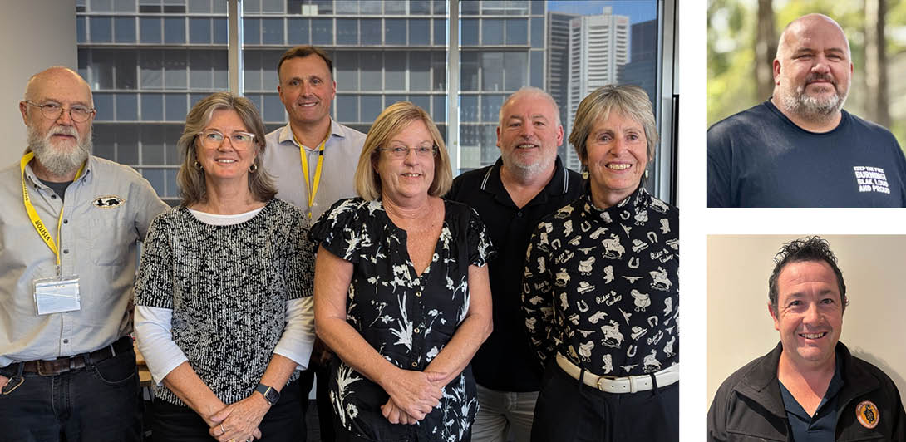

Unique regions in the study area
The study area spans across the Gippsland and North East regions, and contains a diverse blend of Victoria’s stunning nature, increasing recreation and a growing visitor economy, rich history and culture. Each region has its own unique characteristics making for truly memorable destinations.
Figure 2: Map of eastern Victoria showing the Taskforce’s study area.
Not all state forests are represented on the map.
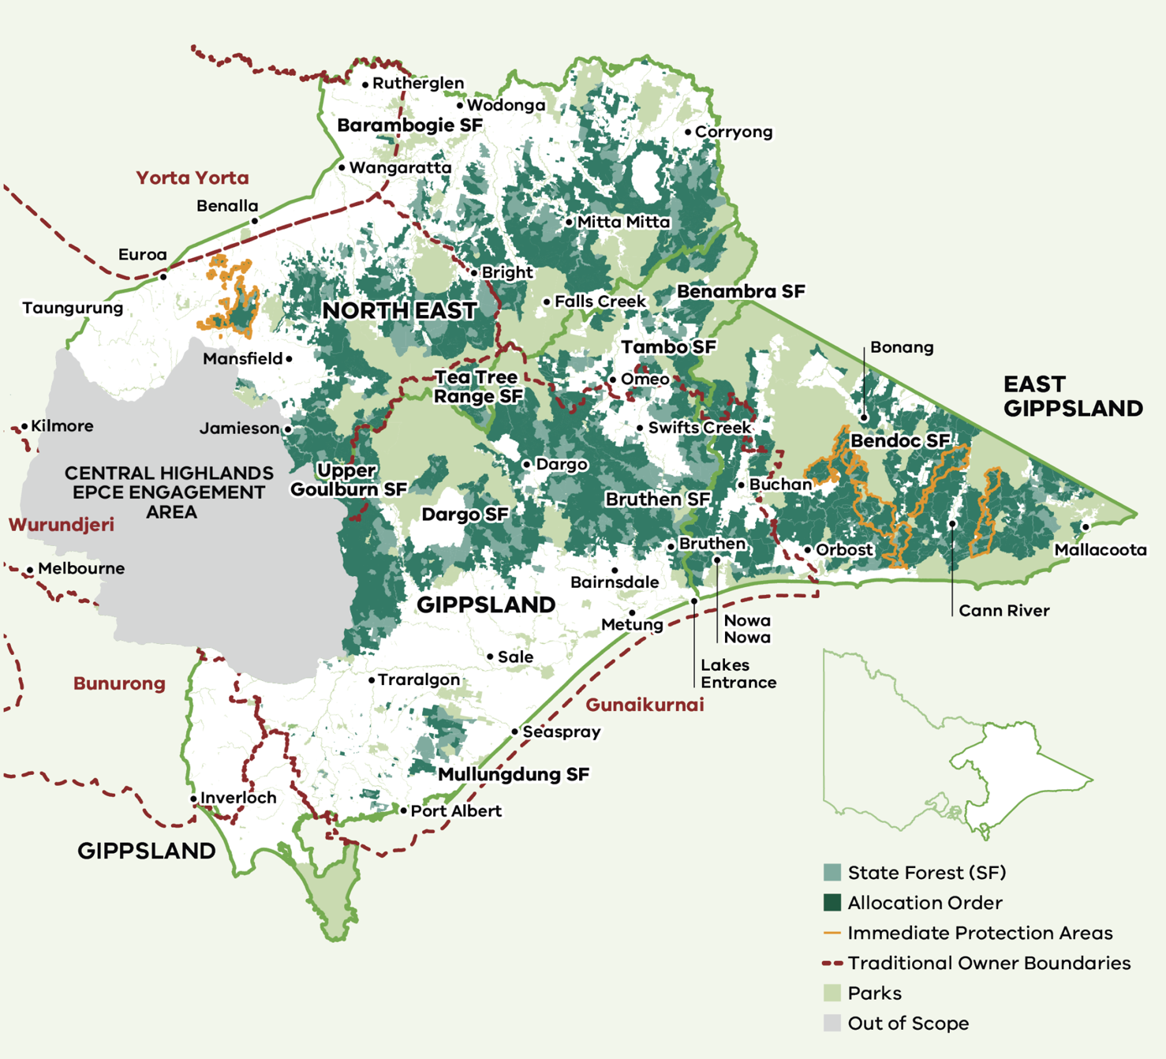

North East
Victoria’s North East region includes the well-known High Country, celebrated for its outstanding regional food and wine, alpine exploration, music festivals, arts and culture and a wide array of outdoor adventures.
The North East is home to Victoria’s highest mountains and serves as a premier destination for skiing and snowboarding during the winter months. The mountainous terrain offers further recreational opportunities year-round including hiking, mountain biking, and scenic drives along the Great Alpine Road – one of Australia’s most scenic routes. National parks, rivers, lakes and mountain ranges provide opportunities for bushwalking, fishing, boating and wildlife observation. The state forests in the North East region is home to 10 forest-dependent threatened species.
Cycling routes like the Murray to Mountains Rail Trail meander through scenic landscapes and connecting towns. Visitors and locals alike can enjoy exceptional wineries and culinary experiences. The region boasts diverse wine regions. The family-run wineries along the King Valley Prosecco Road offer warm Italian hospitality and picturesque vineyard views. The region's culinary scene complements its wine offerings, featuring local produce and artisanal goods. Beechworth, for instance, is known for its gourmet eateries and historic charm, while Bright offers a range of dining options set against alpine backdrops.
Throughout the region, seasonal events, such as the Mansfield High Country Festival in spring and Bright’s Autumn Festival, and its rich tapestry of arts and cultural experiences reflect its diverse heritage, vibrant communities, and creative spirit.

Gippsland
Gippsland, in Victoria’s east from the coast to the New South Wales border, is made up of natural landscapes of outstanding beauty. From seaside villages, alpine towns and farming communities,
visitors and locals can visit unspoilt beaches, enjoy farm-fresh produce and get active on the region's lakes, rivers and mountain ranges. Gippsland offers a wide range of outdoor activities, including hiking, fishing, boating, four-wheel driving, mountain biking and wildlife watching.
Gippsland is a place where diverse ecosystems converge, from coastal wilderness, to lush temperate rainforests, to alpine high country where mountain peaks rise to 1870 metres.
The state forests in the Gippsland region is home to over 35 forest-dependent threatened species, and 21 of these species are only found in Gippsland.
The region also features the country’s largest lake system, the Gippsland Lakes, and is home to Wilsons Promontory, celebrated for its stunning bush and coastal scenery, abundant wildlife, and acclaimed walking trails.
Gippsland’s economy is strongly tied to natural resources used in energy production, agriculture and fishing. Many towns in Gippsland once had a strong presence of the forestry industry. Gippsland is also gourmet food country, dotted with wineries, cheesemakers, farmers' markets, and fruit and berry farms.
Gippsland is a stronghold of forest ecosystems that provide critical habitats for Victoria’s unique and threatened plants and animals. It is home to Southern Greater Gliders, Long-Footed Potoroos, Powerful owls, and Glossy Black Cockatoos. The state forests with highest habitat values (shaded in dark blue in Figure 3) are in three key locations in East Gippsland:
- around Errinundra Plateau and its southern fall – from Bendoc south beyond Club Terrace
- between Coopracambra and Croajingolong national parks west and northwest of Genoa
in the Colquhoun state forest area between Bruthen, Lakes Entrance and Nowa Nowa.
Figure 3: Areas in Victoria’s forests, with dark blue indicating the highest habitat values for forest-dependent threatened species and a significant concentration in East Gippsland as identified by the Victorian Environmental Assessment Council, 2025.
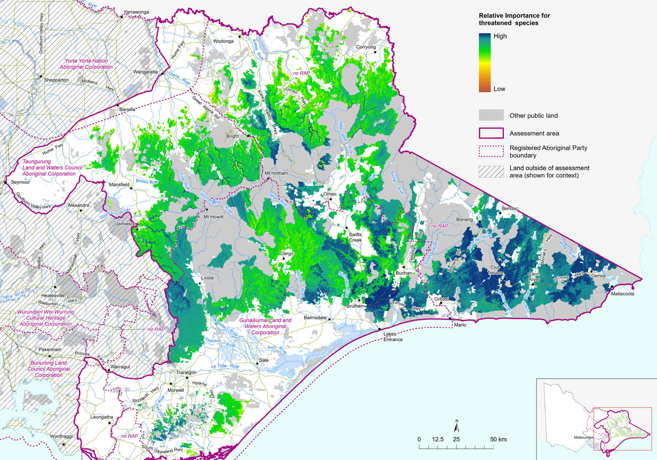

Traditional Owners Partnership Approach
The Great Outdoors Taskforce study area exists on the unceded Country of Traditional Owners and their Cultural Landscapes.
The Taskforce has partnered with the three Registered Aboriginal Parties on this land to support the development of advice and recommendations to the government for the future management of these areas of Country. The three Registered Aboriginal Parties are:
- Gunaikurnai Land and Waters Aboriginal Corporation
- Taungurung Land and Waters Council Aboriginal Corporation; and
Yorta Yorta Nation Aboriginal Corporation.
The Taskforce has worked with the Traditional Owners to determine their involvement in the Great Outdoors Taskforce, in ways that work for them. The Taskforce recognises First Nations priorities and rights, and that future arrangements and decisions about the management of forested Country needs to empower Traditional Owners’ self-determined objectives for land management.
The Taskforce process is just one part of the longer-term story of the partnership that is developing between First Nations groups and the Victorian Government. The Taskforce has built on the work undertaken in previous years through the Victorian Traditional Owner Cultural Landscapes Strategy, partnerships through the Eminent Panel for Community Engagement, and other policies and processes.
The work of the Taskforce also occurs in the broader context of the Victorian Treaty(ies) process, the Yoorrook Justice Truth Telling Commission, and consideration of land injustices through those processes. The Taskforce has committed that its work and its recommendations should not create barriers for future Treaty negotiations or outcomes.

Stakeholders and Community

How we engaged
The Taskforce conducted public engagement from June 2024 to January 2025. During this period, the Taskforce visited Gippsland and the North East region of Victoria to meet with stakeholders. It convened workshops with recreation, tourism, environmental, industry, and regional development organisations, and local governments. The Taskforce also met with and heard from the communities most affected by the state’s transition away from native timber harvesting, where locals are leading their own plans for economic transition and development through the Local Development Strategy program, supported by the Victorian Government.
The Taskforce conducted an eight-week Engage Victoria survey open to all Victorians. Workshop attendees and stakeholders who met with the Taskforce were encouraged to participate further by making detailed written submissions to the Taskforce.
This engagement provided the Taskforce with comprehensive information on the current challenges in state forest management, key economic and environmental data, and innovative ideas for a new era of forest management in Victoria.
185 unique stakeholder groups shared their knowledge with the Taskforce and 4,149 individuals provided survey submissions via the Engage Victoria consultation.
Across the engagement, there was almost equal representation from recreation, tourism and/or industry groups (35 per cent) and environment groups (32 per cent). Sixteen per cent of stakeholders were from government agencies, universities or Registered Aboriginal Parties.

Regional and one-on-one meetings
The Taskforce met with forty-nine stakeholders for one-on-one conversations on their regional visits, or through online meetings. The regional meetings helped the Taskforce understand local challenges early, using these learnings to refine their scope and inform further engagement. Meetings in Gippsland were held in Nowa Nowa, Orbost, Bairnsdale, Swifts Creek, Sale and Traralgon. Meetings in North East Victoria were held in Wodonga and Wangaratta.
Further online meetings were held with stakeholders to understand specific subject matter areas and stakeholder interests.

Workshops
Fifty-six stakeholder groups were represented across three full-day workshops focused on:
- recreation and tourism,
- industry and regional development, and
the environment.
Taskforce members had meaningful discussions with stakeholders to identify the most pressing issues in forest management, devise practical solutions, and discuss ways to balance multiple values and shared forest uses.
Maps were used to capture locations of importance for recreation, tourism and biodiversity.

Engage Victoria Survey
The eight-week whole-of-community consultation involved two elements:
- a detailed survey with a mix of closed and open-ended written questions designed to collect information on community views and suggestions for future forest management
a map survey where participants could place a pin on locations of interest and explain how they would like the specific area to be managed. Participants were able to respond to either the detailed survey or the map survey, or both.
2,944 people submitted a response to the detailed survey and 1,284 pins were placed on the map survey.
A detailed thematic analysis and accompanying location-based reports were produced to inform the Taskforce’s deliberations.

Written Submissions
One hundred and three detailed submissions were received by the Taskforce between June 2024 and January 2025. Fifty-six unique organisations and 30 individuals made submissions regarding their priorities and proposals for change.
Environmental groups (28), recreation groups (13), peak bodies and industry associations (6), local governments and agencies (9) were the main stakeholder groups that provided feedback to the Taskforce through this method. A detailed analysis of these submissions was undertaken to inform the recommendations.

What we heard
Consistent themes emerged across all the engagement activities with many common challenges and complementary priorities put forward.
There was strong public support across all interest groups for balancing conservation, recreation, and economic opportunities within Victoria’s state forests. A central theme was the desire for inclusive, community-driven forest management that allows for multiple, localised values to be considered, with an emphasis on integrating Traditional Owner knowledge alongside local knowledge and conservation science.
Broadly, the Taskforce heard that the reform to the management of Victoria’s state forests should include:
- new leadership and governance models
- local partnerships, place-based and multi-stakeholder decision-making
- a long-term vision and strategy to manage state forests for multiple uses and values and shared outcomes
- a cross-tenure approach to tackling pest plants and animals
- clear partnership roles and responsibilities for forest land managers and users
- an approach to healing country and managing forests that combines conservation science, forest science, local and Traditional Owner knowledge
- addressing infrastructure and investment gaps for recreation and tourism to build economic resilience
- education and behaviour change for forest users
- closing legislative ‘loopholes’ that could enable the return of native timber harvesting in Victoria
- adequate and long-term funding for all the above.

Engagement Highlights and Stakeholder Contributions
- 185 unique stakeholder groups engaged
- 50 one-on-one meetings with stakeholders and the Taskforce on regional visits
- 56 stakeholder groups represented across three full-day workshops
- 4,149 individuals who made survey and map submissions
- 103 detailed submissions received by the Taskforce

Major Themes

Important locations
- Ecologically significant and at-risk areas require specific types of management
- Places valued for specific tourism and recreation activities

Environmental and conservation outcomes
- Make biodiversity outcomes a core function of state forest management.
- Build forest resilience and heal Country through conservation and restoration
- Educate forests users to take care of our forests
- Tackle invasive species

Economic and social outcomes
- Make recreation and tourism a core function of state forest management.
- Maintain recreational
- infrastructure
- Invest in regional tourism and forest produce businesses
- Integrate bushfire risk
- management and firewood availability planning into forest management

Cross-cutting themes
- Managing forests for multiple uses
- Reform governance of forests and increase collaboration and partnership with land managers, regional communities and First Peoples
- Integrate conservation science, forest science and Indigenous management practices into forest management
Provide sustainable funding and workforce support

Diving deeper into key areas of interest

Conservation and biodiversity
Conservation and biodiversity emerged as the top priority across engagement, with climate change, invasive species (especially deer and blackberries), and old-growth forest degradation identified as urgent threats to be addressed. Stakeholders called for landscape-level conservation planning, wildlife corridors, and regeneration of previously harvested, or fire affected areas to protect ecosystems.

Recreation in Victorian forests
Recreation in Victorian forests was acknowledged as vital to our identity, lifestyles and health and well-being. Maintaining tracks, improving signage, expanding camping and toilet facilities, and building new walking trails were sought. Investing in recreational infrastructure, with fire and flood threats in mind, is required to build investment confidence with business and industry. Educating forest users to reduce environmental impacts, separating certain recreational activities, and increasing the numbers of on-the-ground park rangers were identified as ways to manage for multiple values and uses.

Economic opportunities
Economic opportunities raised included investment in destination nodes, four-wheel drive and trail bike track infrastructure, nature-based tourism, eco-tourism, and conservation-related employment in areas like pest management, reforestation, trail maintenance. Tourism infrastructure, such as accommodation and tour services, was also seen as a growth opportunity and boost for local jobs. Diversifying local economies through investment in other sustainable industries, including biochar production, hemp farming, and wild venison processing, were also expressed.

Traditional Owner partnerships
Traditional Owner partnerships were a consistent theme, by bringing Traditional Owner knowledge into forest management planning, enabling Traditional Owner-led forest management, and recruiting Traditional Owner rangers. Calls for co-management agreements, cultural tourism development, and economic empowerment through land tenure rights were prevalent.

Governance reform
Governance reform through leadership changes, stronger legal protections, and integration of place-based, collaborative governance models that empower local communities and Traditional Owners in decision-making were consistently called for across all stakeholder groups. Integrated, multi-tenure management at landscape scale was sought to break down silos between land management agencies and differences in management across tenures.

Important locations
Important locations were identified for conservation and recreation priorities, such as the protection of the Strzelecki Koala population in Mullungdung and Won Wron State Forests, and four-wheel driving in areas like Boola Boola and Upper Goulburn State Forests. Submitters emphasised creating biodiversity corridors to boost ecosystem resilience across the Alpine, Mitchell River, Snowy River, Errinundra, Coopracambra, Croajingolong, Lind and Alfred National Parks.

Funding
For holistic forest management to be effective and successful, people want secure, sustainable and long-term funding for forest management. The areas we heard are a priority for funding are:
- regeneration and restoration of damaged forest to their natural composition
- addressing and tackling invasive species
- improving, restoring and maintaining recreation and visitor facilities, infrastructure, roads and tracks, and
education to ensure responsible visitation of our forests
Stakeholders raised a need to identify and develop diversified funding streams for forest management.

Out of scope
Out of scope topics for the Taskforce’s assessment were raised and noted. Consideration of bushfire management by the Victorian Government (including planned burns and other mechanical bushfire risk reduction treatments) and firewood was out of the scope. However, the Taskforce recognises that stakeholders raised bushfire management and firewood access and supply in their submissions.

Firewood access and supply issues
The Taskforce heard the community express concern over domestic firewood collection areas. The Taskforce understands there are people in the community who rely on affordable firewood to heat their homes.
The Taskforce understands the Victorian Government is developing a domestic firewood strategy to improve its systems for managing firewood collection, and a framework for the government to consider the highest and best end use for incidental timber by-products. As these issues are beyond the scope of the Taskforce’s work, we will not make specific recommendations, other than acknowledge that access to affordable firewood is an important issue for many Victorians.

Evidence and information considered by the Taskforce
The Taskforce has considered inputs and evidence on the multiple values of forests, including conservation, economic, recreational and biocultural aspects.
The Taskforce has partnered with Traditional Owners and engaged with experts and the community to understand how we can support the forest recreation activities that underpin Victorians’ livelihoods and wellbeing, maintain forest biodiversity, and integrate community experience and input into forest management.
The Taskforce also considered inputs and evidence on the multiple values of forests through:
- engagement with the community, including from experts in environment, outdoor recreation, tourism, and regional development
- assessment of the values of state forests within eastern Victoria conducted by the Victorian Environmental Assessment Council
- assessment of tourism, recreation and economic development opportunities; and
- assessment of biocultural values led by Traditional Owner members of the Taskforce.

Healthy forests bring people and nature together

Recommendation 1
Develop Healthy Forest Plans across all state forests in the North East and Gippsland regions. Healthy Forest Plans should be place-based forest management plans developed and implemented in collaboration with local communities, Traditional Owners and user groups to manage forests for multiple values.
The health of our forests matter. Healthy forests bring people and nature together.
We want Victorians to enjoy our great outdoors while taking shared responsibility for its health. To do this, we need government working hand in hand with communities in determining the management and use of our forests.
Victorians love being in nature.
We love to immerse ourselves in the dynamic forest ecosystems, enjoy our favourite activities, pause to breathe and marvel at the spectacular world around us, often in the company of friends, family and loved ones.
But our forests are facing threats and challenges due to a changing climate, more intense and frequent bushfires, and increasing difficulty managing pest plants and animals. We also need to restore health to forests in areas that were previously harvested for timber.
Accessing our forests for recreation and tourism and improving our biodiversity and conservation efforts can go hand in hand, and planning for these shared objectives through Healthy Forest Plans can usher in a new era of state forest management.

Healthy Forest Plans: a new, holistic and balanced approach
The new era of state forest management must take a more holistic and balanced approach. This approach should enable more Victorians to reconnect with nature and ensure forest management for multiple priorities and values. How forests are managed needs to be determined in collaboration with community and Traditional Owners.
The Taskforce recommends the government develop Healthy Forest Plans across all state forests in the North East and Gippsland regions. Healthy Forest Plans should be place-based forest management plans developed and implemented in collaboration with local communities, Traditional Owners, and user groups to manage forests holistically for multiple values.
While forests will need to be managed for all values, priorities for forest management can differ from place to place. Different forest values also require diverse experiences, skills, and knowledge to manage and enhance these values holistically – a forest cannot be managed in isolation.
We must work together to improve our forests.
This is why the Taskforce recommends Healthy Forest Plans be developed, implemented and evaluated through a collaborative management approach. Collaborative management brings local communities, Traditional Owners and user groups together to:
- Identify, balance and prioritise the multiple values and uses for a particular place that should be managed, planned and governed for through Healthy Forest Plans
- identify high-value, at-risk habitats and/or threatened biodiversity and if specific actions for conservation values are required
- implement holistic solutions that enhance the health of our forests and address threats.
By working together, we can enhance the health of our forests and bring more people together in nature. Along the way we will build trust, improve our relationships as a community, harness our shared local knowledge, and bring greater benefits to our forests.
Healthy Forest Plans and collaborative management are significant changes to the way the Victorian Government has managed state forests in the past. In adopting Healthy Forest Plans, the government would be moving to active and adaptive management of forests for multiple values, and towards collaborative management, planning and governance of forests with Traditional Owners and community working together.
Collaboration is essential to ensure the plans reflect the unique biocultural, environmental, recreational and economic contexts of each place. These plans should replace any existing forest management plans.
There should be flexibility in how Healthy Forest Plans are developed and implemented locally. A Healthy Forest Plan could encompass one or more state forests and should consider a landscape approach. This may include state forests outside the Taskforce’s study area for consistent state forest management in Victoria. The plan may also include adjacent areas of a different land tenure.
The Taskforce recommends the progressive rollout of Healthy Forest Plans, prioritising areas of state forest most in need. While Healthy Forest Plans are being developed, it is expected that DEECA will continue to manage state forests for shared benefits.

Six elements of Healthy Forest Plans
Planning and managing our forests for good health cannot be done in isolation from the community, or by isolating or excluding any individual forest value. We need to manage forests for environment, social, recreational, economic, and biocultural priorities.
The Taskforce considers there are six elements essential to an effective Healthy Forest Plan.
These are:
- Collaborative management, planning and governance
- Managing for multiple values
- Traditional Owner healing and caring for Country
- Stewardship of our forests
- Thriving recreation, tourism and economies
- Biodiversity conservation
Healthy Forest Plans support Traditional Owner self-determination and can empower Traditional Owners as the custodians of Country by integrating their knowledge, practices and values into all aspects of forest management. This includes supporting landscape scale approaches, including Traditional Owner Cultural Landscapes and cross-tenure approaches where relevant.
When communities have a fair say, we get better outcomes for nature and people.
This is a new era for state forest management in Victoria, and we are at the start of a transition. It is a significant change and will take time.
The change will need to be implemented in stages so immediate actions can be taken to improve the amenity and health of priority areas, while we continue to test, learn and adapt Healthy Forest Plans and the way we work together. We will continue to evolve forest management practices as we continue this journey in collaborative management of our state forests.
Change of this magnitude requires government leadership, accountability, and transparency. The government will need to build and foster trust with local communities, Traditional Owners and user groups for collaboration to work effectively. It will need to empower them in decision-making processes so outcomes are based on local and Traditional Owner knowledge, conservation science and forest science.

Elements of Healthy Forest Plans

Collaborative management, planning and governance
Goal: Decision-making processes are grounded in inclusivity, respect and collaboration where diverse voices and local knowledge are valued and integrated into forest management and planning.
This is driven by leadership that fosters trust, innovation, and enabled by transparent and accountable governance processes.

Managing for multiple values
Goal: Forest management is holistic and balances multiple values—including conservation, economic, social, biocultural, and recreational values for both people and nature.

Traditional Owner healing and caring for Country
Goal: Traditional Owners are empowered as the custodians of Country and their knowledge, practices and values are integrated into all aspects of forest management.

Stewardship of our forests
Goal: Together, the community shares responsibility of our forests to ensure that our forests remain resilient, healthy, and vibrant.

Thriving recreation, tourism and economies
Goal: Our forests are places of thriving nature-based recreation and tourism that support sustainable livelihoods in balance with nature, promote biocultural and historical significance, and enhance local economies.

Biodiversity conservation
Goal: Our forests are dynamic and thriving ecosystems rich in biodiversity where threatened species are protected. They are resilient and can adapt to climate change, fire, invasive species, and other pressures.

Elements of Healthy Forest Plans

Collaborative management, planning and governance

Recommendation 2
DEECA should continue to have ultimate responsibility for the management and planning of state forests.

Recommendation 3
Develop collaborative management guidelines for public participation and decision-making on forest management that is place-based and in partnership with local communities, Traditional Owners and user groups.
Transitioning to a new collaborative approach for forest management is a significant change for the Victorian Government and will take time.
New Healthy Forest Plans will be developed to manage forests for multiple uses and values, and new approaches will be taken to collaborate effectively with local communities in decision-making.
The change will need to be implemented in stages. DEECA must continue to deliver immediate actions to improve the amenity and health of forests, while Healthy Forest Plans are developed and governance models tested with pilot communities before implementation throughout North East and Gippsland state forests.
The Taskforce recommends that DEECA continue to be the land manager for state forests, meaning it is the government body with ultimate responsibility for managing state forests for all values. As manager of state forests, DEECA will be required to develop collaborative management arrangements for state forests.
DEECA is best placed to lead this transition on behalf of the Victorian Government and take on additional responsibilities to manage state forests in a holistic and integrated manner. This is because DEECA has clear existing public accountability and governance frameworks and already manages state forests for some values. DEECA should be adequately resourced to perform its role as manager of state forests and to initiate collaborative management arrangements with key partners.

Working together through collaborative management
Giving people a greater voice in decisions that affect them and the forests we love and share will lead to many benefits for our forests and our relationships as a community.
We need to work together, have open and constructive dialogue, build trust, harness our shared local knowledge, and implement holistic solutions that address threats to our forests so we can all continue to experience our forests for generations to come.
Collaboration has not been a feature of Victorian forest management, which has resulted in a growing fatigue and distrust in current decision-making processes about our forests. We heard support from all stakeholder groups for a shift towards place-based decision-making process involving community, government, knowledge specialists, industry, and Traditional Owners and First Peoples.
The Taskforce recommends that DEECA, on behalf of the Victorian Government, develop collaborative management guidelines for public participation and decision-making on forest management that is place-based and happens in partnership with local users and communities. This collaborative management approach will be the process by which Healthy Forest Plans are developed, implemented, and evaluated.

Key components of the collaborative management guidelines

What is collaborative management?
Collaborative management is a participation and decision-making process involving a partnership among government agencies, local communities, resource users, non-governmental organisations, Traditional Owners and other stakeholders appropriate to each place or area. These stakeholders have a shared responsibility for managing the specific place or area. It is also referred to as co-management, or joint, participatory or multi-stakeholder management. Several Traditional Owner groups are leading the way on collaborative management and have begun piloting approaches to test what works in different places of Victoria.
Collaborative management will lead to more deliberation, and at times conflict, with different stakeholders who have different perspectives on the values and uses that should be managed in a particular place. The guidelines developed by DEECA must contain an approach to decision-making with clear accountabilities and with equity to diverse stakeholders. It must also contain clear conflict resolution processes that promote genuine dialogue, foster respect for diverse viewpoints, and enable timely decision-making.

Key components of the collaborative management guidelines for Victoria’s state forests
For a collaborative management approach to succeed, it should incorporate the following components:
Table 2: Components of the collaborative management guidelines and their meaning
Component | What that means
Leadership | Initiated by DEECA as the manager of state forests. May be led by key partners such as Traditional Owners of Country.  DEECA is responsible for developing the collaborative management guidelines, and establishing the processes for collaborative management, and standards for delivery.
Involve the right people | The approach includes diverse community members who live around, visit or use the forests in a specific place, such as:  - local communities and forest users  - Traditional Owners  - government agencies (federal, state, local, catchment management authorities)  - research institutions  - land managers and citizen scientists  - organisations and volunteer groups involved in the conservation, recreation, tourism and economic values of forests  - forest users and businesses involved in forest-based activities.
Equity in decision-making with clear accountability | Establish a group of decision-makers with clear accountabilities and decision-making criteria. The group should represent the various and diverse community members of the place with equitable decision-making powers.  An example of a current decision-making body is a committee of management used by the Victorian Government for its boards and governance. Any future committee of management or decision-making body for Healthy Forest Plans should be governed by a Terms of Reference and adhere to the collaborative management guidelines developed by DEECA.
Promote collective learning | The approach involves sharing knowledge, promoting collective learning and facilitating constructive decision-making. This helps to build the knowledge and practice of decision-makers and the community and supports effective decision-making.  Collective learning should be supported by a holistic data system that accurately monitors and evaluates forests across all values. When collective learning is done well, it can enable constructive deliberation and reduce conflicts.
Be appropriately resourced | Ensure DEECA is adequately resourced to initiate and lead collaborative management arrangements. This may involve resourcing of key partners in the collaborative management arrangement (e.g. Traditional Owner groups).
Take a place-based approach and establish a clear ‘place’ to be managed | Establish a ‘place’ to connect the surrounding forests and land based on shared and common community interests. It may include multiple tenure types or cut across different regions of Victoria.  The term ‘place’ commonly refers to a specific geographic area where people live, learn, work and recreate. ‘Place’ in the context of place-based approaches has no universal definition. The key is that the definition used by any initiative is meaningful and resonates with the local community.
Focus on inclusivity, respect, and collaboration | Public participation and decision-making processes should promote constructive dialogue, foster respect for diverse viewpoints, share knowledge, build capacity, and support equitable decision-making.
Have clear conflict resolution processes | More collaboration, especially among people who prioritise different values of forests, will come with challenges that need to be managed. Challenges include the potential for conflict and delays to making decisions.  The guidelines must outline clear conflict resolution processes that enable timely decision-making.

Managing for multiple values

Recommendation 4
State forests should be managed for multiple outcomes and values, including conservation, economic, social, biocultural, and recreational values.

Recommendation 5
Change relevant legislation and regulations to prevent the return of large-scale commercial native timber harvesting in state forests. This should not limit Traditional Owner or the government’s forest and fire management activities.

Recommendation 6
Invest in the collection of meaningful data and develop a holistic data system to accurately monitor and evaluate forests across all values. The data system should include indicators from conservation science, forests science, citizen science and Traditional Owner land management measures.
What defines a forest in good health will differ depending on where the forest is in Victoria, the animals and plants in the area, the community and their livelihoods, and available recreation and tourism experiences. Forests will need to be managed for all values, but priorities for forest management can differ from place to place.
Healthy Forest Plans should plan for the holistic management of state forests for multiple outcomes and all values, including conservation, economic, social, biocultural, and recreational values
The values and priorities for forest management in a particular place should be determined by the diverse community members who live around, visit or use the forests in a specific place, working together through collaborative management of the Healthy Forest Plans.

Legislative framework and regulations for state forests
The government must ensure the Victorian legislative framework for public land and state forests enables management of forests for multiple values, collaborative management, and Healthy Forest Plans, and that it reflects the government’s decisions. Good governance also requires an accountable and transparent approach to monitor and evaluate the effectiveness of forest management activities across all values.
Commercial native timber harvesting has ceased in Victoria and native timber harvesting is not an intended use or value that state forests should be managed for. Healthy Forest Plans must not include management of state forests for native timber harvesting.
The Victorian Government ended large-scale commercial native timber harvesting in January 2024. In mid-2024, the Victorian Government legislated the Sustainable Forests (Timber) Repeal Act 2024, removing the framework that enabled commercial native timber harvesting in state forests. The government also closed down VicForests, the state-owned business responsible for management and commercial sale of timber from Victoria’s state forests.
This is an important and significant first step to cease large-scale commercial native timber harvesting in Victoria. However, there is community concern that this is not clear across the Victorian legislative framework for public land and state forests. Government should make its decision to end commercial native timber harvesting in state forests clear through legislation and regulations.
The Taskforce recommends that the Victorian Government make appropriate and supplementary changes to other Victorian legislation and regulations managing forests and public land to prevent the return of commercial native timber harvesting in state forests.
Importantly, these legislative changes should not limit the ability of Traditional Owners to undertake forest and fire management activities on Country. The changes should not limit the government’s ability to continue activities that fulfil its ongoing forest and fire management obligations.
Healthy Forest Plans should plan for the holistic management of state forests for multiple outcomes and values, including conservation, economic, social, biocultural, recreational values.

Effective monitoring and evaluation
Decision-making through collaborative management must be underpinned by a robust evidence base. Stakeholders involved in governance and decision-making processes should be provided with access to information and evidence that enables them to make decisions with up-to-date and accurate information on forest values.
The Victorian Government should invest in the collection of meaningful data and develop a holistic data system to accurately monitor and evaluate forests across all values. The data system should include indicators from conservation science, forests science, citizen science and Traditional Owner land management measures.
The data system should be able to effectively collect and take into account knowledge held by local communities, conservation and forest scientists, citizen scientists, land managers and visitors of forests. This data then needs to be used to inform changes that may be required to the way the forests are managed as we continue to test, learn and adapt Healthy Forest Plans and the way we work together.
The government should explore greater use of technology, such as through mobile apps or platforms, and support local communities, forest users and visitors and citizen scientists to participate and contribute to a holistic data system.
The Taskforce has identified several gaps during its data and evidence collection process. There are various datasets on state forests and public land held by different government departments, agencies, research organisations, and nongovernmental organisations. These datasets are disconnected and disparate and make it challenging to have a clear holistic view of forests.
There are also gaps on tourism, recreation infrastructure and forest visitation data which limit understanding on the use and availability of infrastructure, satisfaction of the diverse experiences in forests, and market trends to support investment decisions.
The Victorian Government should also consider culturally sensitive and appropriate ways to integrate data on Traditional Owner land management measures and Cultural Landscapes to support landscape-scale healing and caring for Country.

Traditional Owner healing and caring for Country

Recommendation 7
Update Victoria’s public land management framework to enable Traditional Owner collaborative management, planning and governance across public forests. Collaborative management models should be developed and pilots resourced to demonstrate concepts and projects on Country at a local scale.
There is a significant opportunity to leverage a new approach to partnership, collaboration and forest management with Traditional Owners, land managers and communities – one that brings people together to improve the health of our forests and communities.
The Taskforce has worked with Gunaikurnai, Taungurung and Yorta Yorta Traditional Owner groups to identify opportunities to support Traditional Owner healing and caring for Country across the Taskforce’s assessment area.
Country is sick and more work needs to be done to return health to Country, including addressing the legacy of timber harvesting and mineral extraction, wrong fire for Country, damaging uses and pest plants and animals.
Each Traditional Owner group has its own pathway and interests on their Country but there are common themes across Forest Country.
The Taskforce’s work is part of a bigger story underway in Victoria to support Traditional Owner self-determination. This includes important work for truth telling, reconciliation and Treaty. The Victorian Traditional Owner Cultural Landscapes Strategy, as well as local Traditional Owner Country plans, include objectives and actions to enable self-determination in forest management.
We have heard strongly across all engagement activities that there is significant community support and willingness to work with Traditional Owners to improve the health of our forests and communities.

Enabling partnerships in the public management land framework
Traditional Owners need to be enabled to manage Country by activating their rights and interests in public land management. The Taskforce recommends that the government update Victoria’s public land management framework to enable Traditional Owner collaborative management, planning and governance across public forests. Collaborative management models should be developed and pilots resourced to demonstrate concepts and projects on Country at a local scale.
Traditional Owners want to heal and care for Country, continue culture, and restore the health of Country areas damaged by past practices. However, current public land management frameworks do not support Traditional Owner self-determination, rights and interests, and barriers exist to Traditional Owner collaboration in land management.
Shared authority for decision making with Traditional Owners that flows through the governance, planning and management of public forests is needed. Enabling this in existing and new management frameworks – such as the collaborative management guidelines recommended by the Taskforce – will be key to supporting Traditional Owners be key partners in the development of Healthy Forest Plans and collaborative management models.
Traditional Owner groups do not want to replace existing land managers. Rather, groups want to walk Country together to achieve the best outcomes for Country and community. Ultimately this is a process of decentralisation of land management governance, to a model that is more focused on local forests and local communities.

Cultural Landscapes planning
Healthy Forest Plans have been recommended primarily for state forests areas and can include areas from other land tenures. This is critical for the management of Traditional Owner biocultural values. Aboriginal place and landscapes, for example, are not bound by administrative boundaries.
Taking a Cultural Landscapes approach to governance, planning and management of forests presents an important lens through which landscapes and biocultural values can be planned for. While the Taskforce is not recommending land tenure change in this work, it acknowledges the importance of a cultural reserve land category as an important pathway for Traditional Owners to activate rights and interests for Country.
A cultural reserve public land category was identified in the Victorian Traditional Owner Cultural Landscape Strategy as a key pathway to supporting direct management of public lands, and cultural practice and management.
Application of this category and local piloting and testing will be critical to addressing many of the structural barriers that currently limit Traditional Owner self-determination in public land management.
For example, on Taungurung Country, this approach is being piloted at Corop cultural waterscape. This includes the coming together of land managers, community groups and private landholders to work with Taungurung to holistically plan for the management of waterways, forests and land.
While this work is being piloted locally, at present there are no provisions in Victoria’s public land management framework to support Cultural Landscapes planning.
It is recommended this approach be embedded in Victoria’s public land management framework and that pilots are supported and scaled up as a key mechanism to support holistic and collaborative land management planning.
An important foundation for this work includes supporting Traditional Owners to undertake reading Country through biocultural values assessments. This supports a contemporary understanding of Country and values that need to be planned for and managed.

Coming together to demonstrate success
The Taskforce’s recommendations for collaborative management of forests for all values is a new era for state forest management in Victoria, and we are at the start of this journey. Piloting and demonstrating concepts and projects at local scales are key to test ideas, learn what works, and establish practice for how we work together in managing forests now and in the future.
Pilots are critical to demonstrate what works in local collaborative models, effective forest management practices, and support Traditional Owner-led initiatives for forest management and cultural restoration in specific regions. The learnings from the pilots will inform future Healthy Forest Plans.
Pilots can support reorienting land management priorities and integrating Traditional Owner knowledge and practice with western conservation science to better manage forests. The juncture between Traditional Owner worldviews and western conservation science is not well understood and is often poorly navigated by governments and other stakeholders involved in forest management.
Four pilots are being proposed by the Gunaikurnai, Taungurung and Yorta Yorta Traditional Owner groups on their Country. The pilots are:
- Developing a Healthy Forest Plan for the Tambo District Forest Management Area through collaborative management led by Gunaikurnai Land and Waters Aboriginal Corporation
- Developing a Healthy Forest Plan for the management of Narraga iyoga – the rocky hills at Barambogie State Forest, with a local governance structure to drive forest planning and action over a 5-10 year timeframe led by Yorta Yorta Nation Aboriginal Corporation
- Piloting Collaborative Management on Country by activating collaborative models of management for the Stone Country Cultural Landscape, expanding on work already underway with local communities in this area led by Taungurung Land and Waters Council
- Developing a Healthy Forest Plan for Rushworth State Forest with collaborative management approaches for the Corop Cultural Waterscape led by Taungurung Land and Waters Council.
- Case studies of each pilot have been included on the next pages and a detailed description of pilots included in Appendix 3.

Resourcing
Traditional Owner groups need to be adequately resourced to partner effectively in forest management, especially in delivering pilots of collaborative management and Healthy Forest Planning. Traditional Owner groups should also be adequately resourced to deliver ranger programs, biocultural assessments, reading Country work and economic development opportunities.
There is currently a lack of ongoing secure funding for Traditional Owner groups, limiting capacity to undertake this work.
Adequate resourcing will lead to further opportunities to improve land management and First Peoples’ economic development through collaborative management that incorporates Traditional Ecological Knowledge, cultural tourism, and opportunities to reinvest economic benefits from forest management into local lands, Country and people.

Tambo Forest Partnership pilot by Gunaikurnai Land and Waters Aboriginal Corporation
Gunaikurnai propose a pilot forest management partnership program for the Tambo catchment in Gippsland.
This area has deep connection for Gunaikurnai. The Tambo, its forests, rivers, tracks and trails are recognised travelling routes that provided food, shelter and passage to and from the high country.
The pilot area stretches from Bruthen northward to Benambra and Omeo and includes a range of public land areas including state forest, parks and reserves. Work will commence in the Gunaikurnai Registered Aboriginal Party footprint and utilise relationships with other First Nations groups to extend the partnership over time.
Community and stakeholders in this area are highly engaged and recognise the importance of forests for the health and wellbeing of all.
The partnership will focus on identifying priorities and activities needed to manage public land for conservation, recreation, culture and safety. At its centre is forming a new collaborative governance model to build greater relationships between local community, Gunaikurnai and land management agencies to drive better outcomes for forests and communities.

Key actions include:
- Gunaikurnai to host the program and convene the pilot and work with land management agencies to develop a local governance structure, including appointment of a chairperson to oversee the pilot
- The governance group will work together to support the development of a Healthy Forest Plan for the area and drive the implementation of on ground forest management
- The group will engage with community to establish a communications pathway for shared use of the public estate
- The group will hold regular stakeholder and agency forums to plan and monitor the implementation of public works
Five years of funding is sought to for the pilot program, including to support the governance approach, improve community communications and engagement and support Gunaikurnai on-Country gathering and biocultural assessments.

Narraga iyoa – Rocky hills pilot by Yorta Yorta Nation Aboriginal Corporation at Barambogie State Forest
Yorta Yorta propose a pilot for the management of Narraga iyoga – the rocky hills.
The area includes Barambogie State Forest and surrounding Chilton Mount Pilot National Park. The rocky hills are places of ceremony and ritual and contain plants and animals not found in the other parts of Yorta Yorta Country. Much of the vegetation in rocky hills Country has been removed and areas that remain are of deep significance.
There is now a significant opportunity for increased presence of Yorta Yorta on Country and restoration of significant sites.
Yorta Yorta must be involved in decisions and activities on Country to sustain connection to and obligations to care for Country.
The proposed pilot program will be an important mechanism to progress collaborative management approaches and activate key actions of the Yorta Yorta Whole of Country Plan. This includes planning and on-ground works to protect and enhance values. The works would involve restoring vegetation links between hills, plains and waterways, undertaking cultural mapping, and re-affirming Yorta Yorta traditional ownership of Country through community events such as camp outs or seasonal gatherings including the public.
Key actions include:
- Yorta Yorta to host the pilot program and work with land management agencies to develop a local governance structure to drive forest planning and action over a 5-10 year timeframe. The approach will leverage learnings from similar work underway to support landscape planning in Barmah National Park
- Appointment of a Forest Partnership Chairperson to oversee the pilot and convene meetings with support of a Forest Partnership Administrator to provide secretariat support
- The governance group will oversee the development of a Healthy Forest Plan for this pilot area with a key focus on conservation, cultural and recreational values, to be developed within three years
- The group will work with local communities on improved pathways for greater collaboration, involvement and shared use of the public land estate
- Five years of funding is sought to deliver this work including to support the collaborative management approach, improve community communications and engagement and support Yorta Yorta on-Country gathering, broader community gatherings and biocultural assessments.

Activating Stone Country by Taungurung Land and Waters Council pilot
Taungurung seeks to activate collaborative models of management for the Stone Country Cultural Landscape, expanding on work already underway with local communities in this area.
The Stone Country Cultural Landscape extends from the Tallarook Ranges north along rocky outcrops and ridges through foothill forests to the Strathbogie Ranges. Several state forest areas, parks and reserves occur in the Cultural Landscape.
Recent biocultural values assessments undertaken by Taungurung have helped inform contemporary understanding of the Stone Country Cultural Landscape. This significant area is rich in expressions of culture, including archaeological material, culturally modified trees, pre-colonial quarries and grinding grooves. Taungurung has assessed the current biocultural health of Country as poor and that culturally informed land management is critical to re-establish biocultural relationships and strengthen biocultural values.
Work is underway with community groups in the north of the Cultural Landscape to develop a shared understanding of the Stone Country Cultural Landscape and its management. There is strong support for new models of collaborative management led by Traditional Owners and focus on enhancement of values in the area. This includes closer partnership with land managers including DEECA that provides important land management functions across forest roading, forest compliance and fire and emergency management.
Taungurung has identified the opportunity to pilot and test arrangements for a new cultural reserve public land category in Stone Country as a key mechanism to support cultural practice, management and collaboration. This work could commence immediately in targeted state forest areas. Priority areas identified by Taungurung include the Tallarook Ranges and Strathbogie Ranges (areas considered by the Eminent Panel for Community Engagement).
Key actions include:
- Appointment of Taungurung as a committee of management to lead and establish co-governance arrangements with land managers to pilot arrangements for a cultural reserve and guide governance, planning and management arrangements for key forest areas of the Cultural Landscape (e.g. Tallarook Ranges and Strathbogie Ranges state forests)
- The group will work with local community groups to identify pathways for improved collaboration and opportunities for involvement in land management
- The group will support the development of Healthy Forest Plans for the Stone Country Cultural Landscape and a Cultural Landscape overlay that guides planning and management across the Stone Country Cultural Landscape
- Taungurung to undertake Reading Country work that will underpin planning and management of Stone Country and inform a Country Speaks Statement
Three years of funding is sought to implement the pilot.

Collaborative management for Reedy Lake and the Corop Cultural Waterscape – by Taungurung Land and Waters Council pilot
Taungurung propose to build on work underway to develop collaborative management approaches for the Corop Cultural Waterscape. This includes Reedy Lake Wildlife Reserve and Rushworth State Forest.
Reedy Lake is a bioculturally important wetland system within the broader Corop Cultural Waterscape that extends across much of the Country between Rochester, Heathcote and Nagambie. Rushworth State Forest lies to the north of the lake.
The Corop Cultural Waterscape has a rich cultural heritage including Taungurung gathering places and travel routes, culturally modified trees, stone sources and artefacts that support the expression of important biocultural and ecological values. The area now also supports other diverse values including agricultural livelihoods dependent on grazing and cropping, and a wide range of recreational uses.
Taungurung is currently leading a collaborative program to achieve a coordinated and holistic approach to healing and managing Country for the Corop Cultural Waterscape. The program is founded on collective, Country-led, culturally informed leadership and action to heal Country by bringing Traditional Owners together with government agencies and the wider community.
Partners involved in this work include DEECA, Goulburn Broken Catchment Management Authority, Victorian Environmental Water Holder, Goulburn-Murray Water, Parks Victoria, and the local Corop community.
There is a significant opportunity to leverage the work underway at the Corop Cultural Waterscape and apply the learnings to new collaborative approaches for the management of Reedy Lake and Rushworth State Forest. The program requires funding to continue its work and implement the new planning methodologies being developed.
Key actions include:
- Commitment from government and land management agencies to support governance arrangements for the pilot for five years
- Taungurung to lead the governance group which will support the development of a Healthy Forest Plan for Rushworth State Forest
- Five years of funding is sought to deliver this work including to support the collaborative management approach, Taungurung on Country gatherings and biocultural assessments, broader community gatherings and on-ground management action.

Stewardship of our forests

Recommendation 8
Develop a Great Outdoors marketing campaign to encourage people to visit and value Victoria’s forests, and work with forest users to educate and promote positive behaviours when using forests.

Recommendation 9
Increase numbers of on-ground field staff to work together with communities, collaborate locally, educate to address negative behaviours, enable better maintenance of amenities and infrastructure, and provide a more visible staff presence.
Forest destinations provide unique experiences for visitors. As recreational activities and forest visitation increase, it becomes even more important to invest in visitor education to promote responsible behaviours.
We heard from communities that we are not just users of our forests – we are stewards of our forests for future generations. Healthy Forest Plans should consider what stewardship means in the context of the area, positive behaviours, and the field staff needed to work together with communities and collaborate locally.
Healthy forests rely on a collective effort to behave responsibly and minimise impacts on the environment and on other forest visitors. Positive behaviours, such as staying on trails, properly disposing of waste, and respecting wildlife, will ensure that forests remain healthy, vibrant, and enjoyable for years to come.
Promoting our shared responsibility
The Taskforce recommends the development of a Great Outdoors marketing campaign, encouraging forest visitation, appreciation and care for Victoria’s forests. The campaign should encourage:
- people to visit and value Victoria’s forests
- positive behaviours while visiting
investment in our forests.
In addition the campaign should describe what it means to be a steward of the forest and the benefits of caring for the forests we visit. It can showcase positive activities and behaviours and highlight local conservation efforts. The campaign should be designed and funded as a long-term strategy rather than a one-time push, and should be supported with effective monitoring and feedback mechanisms.
Forest user groups, clubs, recreational organisations and commercial operators have committed and active members who participate in many recreational activities. These organisations, which have direct relationships with their members, have an important role to promote responsible use, education and training opportunities. They are in a unique position to encourage a sense of responsibility through education, promotion of positive behaviours, ensure compliance with rules and law that keep forests accessible for everyone, and organisation of community activities that demonstrate these positive behaviours.

Increasing people on the ground
Encouraging positive behaviours requires people on the ground to provide immediate guidance and education to visitors. The Taskforce recommends that DEECA increase numbers of on-ground field staff to work together with communities, collaborate locally, educate to address negative behaviours, ensure compliance with rules and law that keep forests accessible for everyone, enable better maintenance of amenities and infrastructure, and provide a more visible staff presence. The government should also consider how DEECA is structured and resourced to ensure on-ground staff can support the delivery of Healthy Forest Plans, initiate and support collaborative management, maintain basic infrastructure, and provide education and guidance to visitors.

Thriving tourism and economies

Recommendation 10
Develop place-based forest tourism plans for priority destination nodes to drive investment in nature-based tourism and recreation in and adjacent to state forests. These plans should determine priorities and develop a holistic visitor experience based on the unique local attractions and amenities of each area.

Recommendation 11
Establish a dedicated fund for works that restore, maintain or improve existing visitor amenities and infrastructure in forests such as campgrounds, toilet blocks, picnic areas, and tracks and trails. Priorities for investment should be determined in consultation with local communities, Traditional Owners and user groups.

Recommendation 12
Establish an investment coordination panel to develop a nature-based Tourism Product Development and Licensing Strategy and investigate a ‘commercial user pays’ funding model that applies to commercial tourism uses of state forests.

Recommendation 13
Conduct further assessment of the feasibility, need and benefit of the listed nature-based and recreation projects in Appendix 2 of this report.
Victoria’s visitor economy is strong and diverse. It is the fastest growing visitor economy in Australia. Victoria’s compact geography and diverse landscape means that visitors to Melbourne can spend time in the lush rainforests of East Gippsland, in the mountains, by the coast and in the desert within a short time.
The North-East and Gippsland regions attract over 10 million visitors per year, and 40 per cent of Victorians visited a state forest in 2023–24. Visitors to the region, especially those that stayed overnight, spent over $800 million per year going bushwalking, hiking, cycling, birdwatching, camping, fishing, four-wheel driving, sightseeing, and participating in water activities.
The visitors who participate in recreation activities spend around $200 per night (excluding snow sport visitors, who spend more than double the average). The Alpine Resorts generate $2.1 billion in economic activity each year, with $1.33 billion directly from visitors. These figures are expected to grow as Victoria’s population grows and more people engage in nature-based tourism.
The North East and Gippsland support around 160,000 jobs across the regions, and employment in regional areas is transitioning to support jobs in a diversified recreation, tourism and nature-based economy. This means new jobs in industries that support great recreation and tourism experiences, like managing tourism and recreation activities, managing invasive species, maintaining trails and campsites, and monitoring activity on public land. Tourism and recreation are strategic economic opportunities for some towns transitioning away from the native timber industry.
The study area is a crucial resource for outdoor recreation tourism activity in Victoria with
many well-established tourism and recreation activities. The study area and its immediate surrounds supports:
- 19% of all bushwalking visitor activity in Victoria
- 30% of all cycling visitor activity in Victoria
- 50% of camping visitor activity in National Parks and Crown land in Victoria
- 31% of fishing visitor activity in Victoria
- 24% of water activity / water sport visitor activity in Victoria
- 18% of all birdwatching visitor activity in Victoria
- 95% of all snow sports visitor activity in Victoria.

Nature-based tourism and recreation
Nature-based tourism and recreation in state forests involves activities and experiences that preserve and showcase the ecological value of these environments and highlight natural landscapes.
Nature-based tourism and recreation are major economic development opportunities for many towns and communities impacted by the end of commercial native timber harvesting in Victoria.
For nature-based tourism to be successful into the future, it needs to balance economic growth with conservation goals and be part of a broader forest management planning framework that careful manages the health of our forests for people and nature.
Victoria’s compact geography and diverse landscape means that visitors to Melbourne can spend time in the lush rainforests of East Gippsland, in the mountains, by the coast and in the desert within a short time.
- 10 million visitors per year
- over $800 million spent per year... going bushwalking, hiking, cycling, birdwatching, camping, fishing, four-wheel driving, on water activities, and sightseeing
- 40% of Victorians visited a state forest in 2023–24
over $200 spent per night by visitors
Visitor activity supported by the study area and its immediate surrounds:
- 19% of all bushwalking
- 30% of all cycling
- 50% of camping in National Parks and Crown land in Victoria
- 31% of fishing
- 24% of water activity/water sport
- 18% of all birdwatching
95% of all snow sports
The activities most people are participating in are relatively simple, and only require basic amenities to thrive. Sustaining and growing these economic benefits can be achieved by getting these fundamentals right, through strategic investments in restoring, maintaining and improving basic recreation and visitor amenities and infrastructure in forests. These include campgrounds, toilet blocks and picnic areas, and access tracks and trails.

Immersing in our forests
Our forests are loved and regularly visited by many Victorians and visitors. Some of our favourite reasons for visiting state forests are to relax and unwind, escape the urban environment, improve our health, and participate in a diverse range of outdoor recreation activities.
Increased visitation and tourism, if not managed well, can negatively impact visitor experiences through congestion. Some forests are not able to accommodate adequate tourist infrastructure or connectivity to mobile reception without significant and expensive upgrades, which can sometimes affect the health and amenity of the sites themselves. Popular recreation and tourism areas often show signs of overuse, including trampling of vegetation, and waste disposal issues.
The Taskforce heard there were many people concerned about the current state of access roads, tracks, and other recreational infrastructure, including campgrounds and toilet blocks, raising issues such as:
- reduced safety
- closures leading to reduced visitor accessibility and tourism
- poorly maintained access roads and tracks preventing access to recreation and visitor sites, preventing enjoyment of motorised recreational activities, and indirectly encouraging visitors to find alternative off-trail routes and leading to increased disturbances in sensitive ecosystems
increasing pressure on already congested sites to accommodate more tourists.
Many of these issues can be addressed with targeted investment to maintain or upgrade existing infrastructure. The Taskforce recommends that the Victorian Government establish a dedicated fund for works that restore, maintain or improve existing visitor amenities and infrastructure in forests such as campgrounds, toilet blocks, picnic areas, and roads, tracks and trails. Priorities for investment should be determined in consultation with the local communities, Traditional Owners and user groups.

A strategic approach to growing tourism
Many Victorians are already embracing tourism and recreation in our state forests. There is an opportunity to ensure more visitors enjoy our backyard.
Expectations and demand for outdoor experiences are growing and we can capitalise on this momentum for growth with strategic and targeted investments in our regions. Managing our state forests should also leverage new economic opportunities in towns transitioning from timber harvesting.
The Taskforce recommends that the government develop place-based forest tourism plans for priority destination nodes to drive investment in nature-based tourism and recreation in and adjacent to state forests. These plans should determine priorities and develop a holistic visitor experience based on the unique local attractions and amenities of each area.
The Taskforce has identified eleven priority destination nodes (nine emerging nodes and two remote nodes) for the development of place-based forest tourism plans and for investment in forest activities and infrastructure.
Emerging nodes are areas with high growth potential and suited to investment as they have the following attributes:
- attractive, high-amenity township hubs that are suitable for tourist growth
- large areas of forest conducive to investment in high-quality landscapes
- accessible forest areas close to townships and geographic areas where visitors come from
- proximity from a regional centre, accessible within a 45-minute drive
- presence of some existing and complementary tourism and visitor amenities (e.g. accommodation)
- contain areas transitioning from the forestry industry
are highly reliant on forest tourism opportunities with limited other industries in the area.
Remote nodes – Buchan and Dargo – are popular for touring and form important stopover points or hubs within remote forest areas. They have high quality landscapes and scenery such as the honeycomb of limestone caves and rock formations at Buchan or the Dargo High Plains. Remote nodes have smaller populations and lower employment but have an important role in connecting emerging nodes and supporting forest visitation across the region. Investment in remote nodes should recognise their importance as stopover points or hubs for visitors.
Alpine areas with snow sports in Mansfield/Mt. Bulla and the Alpine Region are highly established destination nodes with existing public and private investments to drive tourism. Forest tourism plans do not need to be prioritised for these alpine areas.
Figure 4: Destination nodes, highlighting emerging, remote and established destination nodes in Gippsland and the North East.
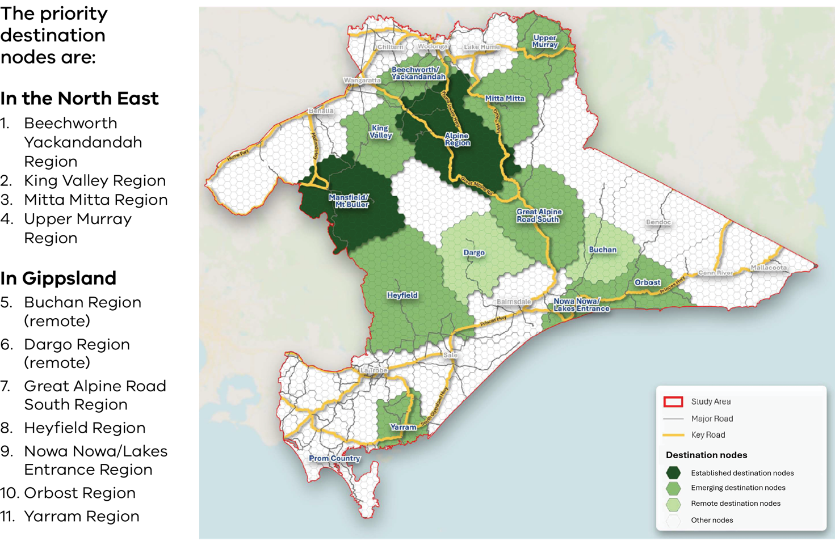
Healthy Forest Plans should draw on the forest tourism plans developed for priority destination nodes for information on recreation, economic and social values of the forests.
Destination nodes will bring a consistent and strategic approach to plan the growth of tourism and recreation in different parts of the North East and Gippsland regions, in a way that captures the diversity and uniqueness of each node. This strategic approach can also help address ongoing concerns from visitors and the community about poor management of increasing visitation to forests. The plans should also identify key areas for nature-based tourism, identify areas for future growth, and prioritise key areas for investment and resourcing.
These destination nodes can complement Traditional Owner priorities for management of forests by focussing effort on certain areas. These nodes should be planned in partnership with Traditional Owners to get the balance right between tourism opportunities and culturally sensitive management.

Commercial investments in tourism and recreation
We have an opportunity to promote high quality destinations and experiences in our backyard, and ensure commercial settings encourage investment on or near our state forests.
The Taskforce recommends that the Victorian Government establish an investment coordination panel to develop a nature-based Tourism Product Development and Licensing Strategy and investigate a ‘commercial user pays’ funding model that applies to commercial tourism uses of state forests.

Product Development and Licensing Strategy
The Product Development and Licensing Strategy will align with existing Destination Management Plans and provide strategic direction for tourism and recreation products in the Gippsland and North East. This strategy will inform future growth direction of nature-based tourism products, assets and infrastructure to support visitation to the region and attract investment. This strategy will consider visitor access, gaps and opportunities to improve or create new recreation and tourism experiences, and the market need for nature-based tourism assets and infrastructure to support visitation.
The Product Development and Licencing Strategy is different to place-based forest tourism plans which are specific to Destination Nodes. This strategy will encompass all eleven Destination Nodes and inform the development of place-based forest tourism plans for each Destination Node. This can be led by the Victorian Government in partnership with Tourism North East and Destination Gippsland.

Commercial user pays funding model
The investment coordination panel should also investigate a ‘commercial user pays’ funding model for commercial tourism uses of state forests. This may include undertaking a review of commercial licensing arrangements for tourism, recreation and event operators.
Victoria’s commercial tour operators and education and recreational activity providers are important partners in a thriving tourism and recreation sector. They create opportunities to connect people with nature, and provide safe, sustainable and high-quality experiences that contribute to our economy.
However, the lack of a robust commercial licensing system for some activities has meant that some people or businesses that make a profit from tourism in state forests, do not contribute their fair share to manage and maintain the forests. This has led to negative visitor experiences, further detracts from the tourism potential of an area, make monitoring and enforcement of their activities difficult, and has resulted in lost revenue to support forest management.
While the Victorian Government has completed a recent review of the commercial tour operator licensing system for public land, certain activities that have a high-risk of amenity and environmental impacts, such as one-off events, remain exempt. Future work should consider any gaps noted in the government’s review and consider how the government ensures commercial tourism operators contribute to protecting and maintaining the health of our forests.

Opportunities to enhance tourism, outdoor recreation experiences and develop regions
The Taskforce has identified several strategic recreation and tourism opportunities that can drive economic growth in state forests and destination nodes. The recreation and tourism opportunities are:
- Bushwalking and hiking trails, such as a mix of short, half-day, and signature multi-day walks suited to different market segments.
- Cycling experiences, such as mountain bike parks, signature road rides through forest landscapes.
- First Nations tourism experiences, such as guided educational tours, walks, interpretive signage and visitor hubs.
- Adventure infrastructure and adrenaline experiences, such as ziplining, high ropes courses, tree top-canopy walks, gliding (potential for tandem flights), rock climbing locations and cave tours.
- Water access infrastructure, including access to unique swimming, kayaking and canoeing experiences.
- Forest access and visitor infrastructure enhancements, which encourage general sightseeing, picnics, photography, wildlife and birdwatching experiences (e.g. improvements to road access, car parking, signage, lookout platforms and viewpoints, picnic tables and seating).
- Guided tours, such as walking/hiking tours, horse riding, cycling, and four-wheel driving.
- Accommodation infrastructure, including strategically located camp sites and opportunities for commercial accommodation located adjacent to state forests and in nearby local towns, including exploring potential for off-grid accommodation, hike lodges and group accommodation.
The Taskforce conducted a high-level analysis of tourism and recreation projects in the North East and Gippsland regions. This includes seeking project proposals from stakeholders during public consultation. Some projects align with the strategic recreation opportunities identified for Victoria.
The Taskforce recommends that the Victorian Government conduct further assessment of the feasibility, need and benefit of the listed nature-based and recreation projects in Appendix 2: Nature-based and recreation projects for further investigation.

Biodiversity conservation

Recommendation 14
DEECA undertake restoration of state forests that have been previously subject to recent timber harvesting, in consultation with local communities, Traditional Owners and user groups.

Recommendation 15
Implement ongoing programs that manage invasive pests and weeds across land tenures as part of Healthy Forest Plans.
State forests in the Taskforce’s study area, particularly in East Gippsland, have some of the most pristine, vast and unbroken stretches of forests in the world that provide critical habitats for numerous native plant and animal species. These areas contain significant high-value habitats, with species and ecological communities that are found nowhere else in the world. These values include:
- habitat for threatened species, including the Southern Greater Glider, Long-Footed Potoroo, Powerful owl, Glossy Black Cockatoos and threatened Galaxias fish
- threatened ecological communities such as the endangered Alpine Sphagnum Bogs and Associated Fens community
- areas of rainforest that cover just 0.14 per cent of the state of Victoria and are home to 30 per cent of Victoria’s rare or threatened plant species. These are particularly concentrated in East Gippsland.
- heritage rivers of significant biocultural and conservation value that provide habitat, clean drinking water and contribute to the Murray-Darling Basin water resource
critical carbon sequestration and storage functions.
Biodiversity across Victoria is declining. There are significant environmental disturbances contributing to this – some of which cannot be easily tackled. These include:
- Native timber harvesting in the past which has substantially altered the forest structure and species diversity in areas of state forest. Some previously felled areas have not been restored.
- More frequent and severe bushfires which have impacted almost all of the Taskforce’s study area in the last fifty years.
- Spread of invasive pest and weeds which has led to reductions in species diversity and abundance. This affects people’s enjoyment of forests, such as through the spread of blackberries.
- Climate change which is exacerbating the impact of bushfire and pest and weeds on native species, and causing more intense droughts, heatwaves and storms.
These multiple disturbances have caused a decline in old growth forest – the habitat which many species need to thrive and survive. Many remaining high-value habitat areas are at risk, and fragmented across the region.
Active and careful forest management is needed to restore habitat connections through the landscape and prevent further fragmentation.
State forests in the Taskforce’s study area, particularly in East Gippsland, have some of the most pristine, vast and unbroken stretches of forests in the world that provide critical habitats for numerous native plant and animal species.

Stopping biodiversity decline
The end of native timber harvesting in Victoria presents a significant opportunity to reimagine how we manage forests to stop biodiversity decline. Managing for multiple values through Healthy Forest Plans provides an opportunity to take a holistic approach to managing for biodiversity conservation, move away from existing piecemeal approaches to managing risks and threats to biodiversity values, and work to enhance these values.
The Taskforce understands there are approximately 1,200 hectares of state forest areas previously subject to native timber harvesting that requires regeneration following the closure of VicForests. DEECA should undertake restoration of state forests that have been previously subject to recent timber harvesting, in consultation with local communities, Traditional Owners and user groups.
The Taskforce also recommends that the government implement ongoing programs that manage invasive pests and weeds across land tenures as part of Healthy Forest Plans. Targeted pest and weed control strategies, including investing in researching new approaches, is critical. Collaboration with the community on control approaches and the priority areas for pest and weed control should occur as part of the Healthy Forest Plan collaborative management process.

Long term pest control for biodiversity outcomes – Southern Ark
An example of a successful, long term, pest control program that could be enabled as part of Healthy Forest Plans is the Southern Ark (East Gippsland) project. This project targets foxes across the entire eastern ‘wedge’ of Victoria, from the Snowy River valley to Cape Howe. It has assisted the recovery of multiple species across nearly one million hectares of state forest, national parks and private land.
The reduction in the predation pressure from foxes has led to the recovery of both rare and more common species. This has also led to the reinvigoration of ecosystem processes that many of these species are involved in, including soil aeration, the dispersal of critically important symbiotic hypogeal (underground) fungi, the breakdown in leaf litter and nutrient recycling, the reduction in fine fuels on the forest floor, and pollination and seed dispersal.
The project is delivered by DEECA in partnership with Parks Victoria, a wide range of local private landholders and Moogji Aboriginal Council.

Sharing our healthy forests
Victoria’s great outdoors and state forests are at the centre of many things that Victorians value. They are a much-loved backyard where all Victorians can find something they love to do, see or explore.
Our great outdoors is where people can:
Gather to enjoy
Recreation in our wonderful
Environment through improving its health and providing
Access in collaboration with
Traditional Owners and community working together.
These forests we love live on a tapestry of interwoven Cultural Landscapes – reflections of how Traditional Owners and First Peoples engage with Country.
Victorians are privileged to have access to more than three million hectares of state forest across the state. If we work together to manage them well, we can all share in the benefits they bring for generations to come.
It is clear to the Taskforce that there needs to be a significant transformation in the way Victoria’s forests are managed. The Victorian Government needs to collaborate with communities and Traditional Owners to determine the best ways to do this. Together, we can combine different types of knowledge to drive more holistic and effective forest management practices that reflect our unique biocultural, environmental and economic contexts.
This will be a major change to the government’s approach to state forest management, and it will take time. But it’s the right time to start.
The Taskforce heard that Victorians from all walks of life are excited to do things differently. We have met stewards of our forests everywhere we went, heard their stories and felt their enthusiasm for Victoria’s exemplary forests.
We are at the start of a journey, and we will make our forests better, together.
The Taskforce thanks everyone who contributed to this work. We hope this report and the recommendations and actions that follow will see you enjoying healthy forests into the future.

Appendix 1: What we heard from stakeholders and the community
The following appendix summarises insights gathered through the Taskforce’s public engagement between June 2024 and January 2025. The Taskforce heard from a wide range of voices through regional visits, stakeholder workshops, the Engage Victoria whole-of-community consultation and detailed submissions. Consistent themes emerged across all the engagement activities with many common challenges and complementary priorities put forward. There was strong public support across all interest groups for balancing conservation, recreation, and economic opportunities within Victoria’s state forests.
This appendix provides a more detailed summary of key themes, place-based information of what we heard in different local government areas, and a list of stakeholders the Taskforce heard from.

Summary of Key Themes

Forest Governance and Local Decision-Making
A major theme was the need to reform forest governance towards local, collaborative, and evidence-based decision-making. Stakeholders criticised existing centralised and siloed approaches, saying they limit responsiveness, erode trust, and leave communities feeling unheard. A common desire was for governance systems that bring together government, communities, Traditional Owners, user groups, scientists, and local organisations.
Proposed models included place-based management, regional forest committees, and co-designed zoning frameworks that reflect the unique character and needs of different areas. Stakeholders stressed the importance of dialogue, transparency, and clear communication from government. Many requested that land use be planned based on scientific and local knowledge, with an emphasis on long-term outcomes.
There were calls to formally recognise community rights to participate in forest decisions, and for improved accountability through independent monitoring. Collaboration was also seen as necessary to resolve tensions between competing uses, for example by mapping out usage zones and seasonal access together with stakeholders.

Recreation and Managing for Multiple Uses
Recreation was identified as a valued forest use, with a strong desire to continue passive and active recreation. Some concerns were raised about the damage caused by inappropriate behaviours while participating in activities like four-wheel driving, trail biking, and horse riding, particularly in sensitive areas or during wetter seasons. Some stakeholders advocated for zoning systems that separate high-impact activities from conservation and low-impact recreation areas to reduce conflicts and ecological stress.
There was consensus on the need for clearer guidelines, better signage, increased monitoring, and stronger enforcement mechanisms to ensure users understand what is appropriate. Ideas included seasonal closures, defined access routes, and user codes of conduct. Many highlighted that managing forest activities through collaboration with local user groups would help develop shared-use strategies, reduce tensions, and foster a sense of responsibility.
A strong cultural theme was the push for fostering “forest etiquette” through public education. Programs aimed at changing attitudes and behaviours—particularly of new visitors—were proposed, alongside community reporting tools and engagement apps. Long-term sustainable use was the goal, where recreation coexists with environmental protection and shared access.

Economic Opportunities and Transition
Participants saw the transition from commercial native timber harvesting as an opportunity to build a more sustainable, diversified forest economy. Ideas included employment in forest restoration, pest management, nature tourism, education, and local land-stewardship programs. The community stressed the need to retain and retrain workers from the forestry sector and support regional towns through tourism and conservation jobs.
Tourism was seen as a major growth area, especially eco- and cultural tourism. Suggestions included iconic routes for bushwalking, mountain biking hubs, regenerative tourism experiences, and visitor centres. The Emerald Link project was highlighted as a good model combining environmental education, economic development, and conservation.
Broader ideas included supporting local firewood cooperatives, forest produce programs for First Nations communities, and community-led forest product initiatives like seed collection, bush foods, and biochar production. There was a desire for integrated land-use models where environmental health and economic opportunity go hand in hand.

Embedding Traditional Owner Stewardship
There was resounding support across all sectors for greater inclusion of Traditional Owners in forest planning, management, and governance. Stakeholders advocated for co-management and Traditional Owner-led land stewardship grounded in Traditional Ecological Knowledge. They highlighted that this would enhance biodiversity outcomes, cultural revitalisation, and self-determination.
Practical opportunities included more Traditional Owner ranger programs, cultural tourism ventures, and funding for capacity-building within Traditional Owner organisations. Ideas such as Two-Eyed Seeing (integrating Traditional Owner and scientific perspectives), cultural burning, and biocultural assessments were widely supported.
Challenges included lack of insurance to conduct cultural burns, limited representation in governance processes, and historical exclusion from decision-making. Stakeholders urged for systemic change to ensure meaningful consultation, resourcing, and secure tenure models that recognise Traditional Owner self-determination, rights and interests. Many called for integration of Traditional Owner principles into legislative and land-use reforms.

Tourism and Visitation
Tourism offers vital regional economic benefits but also poses risks to forest health and visitor experiences when not managed well. Stakeholders acknowledged the value of increasing visitation but warned that without proper planning, infrastructure, and education, overuse could lead to degradation of trails, campsites, and ecosystems.
The strongest support was for low-impact, nature-based tourism that includes walking trails, wildlife observation, and interpretive experiences. These forms of tourism were seen as compatible with conservation goals and more likely to draw respectful visitors. Stakeholders proposed facilities like boardwalks, toilets, audio guides, and all-abilities access to improve the visitor experience.
Concerns about poorly maintained roads and tracks, lack of signage, and unregulated activities were common. Solutions included stronger coordination between land managers, improved mobile reception, and development of centralised digital platforms for tourism planning and education. The role of local enterprises in maintaining tracks and guiding visitors was also highlighted.

Conservation and Biodiversity
Community feedback demonstrated overwhelming concern for the protection and restoration of Victoria’s rich forest ecosystems. Forests were described as globally significant biodiversity hotspots that deserve strong, long-term protections. Stakeholders stressed the importance of preserving habitats and enhancing the resilience of forests in response to climate change, bushfires, and the spread of invasive species. The emphasis was on holistic, landscape-level planning that avoids piecemeal conservation.
Feedback included increasing efforts to control invasive plants and animals, such as blackberry and deer, and investing in ecological restoration of previously logged areas. Concerns were raised about mono-species regrowth and the degradation of understory biodiversity. There was strong support from some stakeholder groups to convert state forests into national parks or introducing new conservation-focused land tenures with legal protections from extractive industries.
Education, signage, and awareness programs were suggested to help the public understand the importance of conservation values, with a strong push for increased ranger presence to combine education with enforcement. The inclusion of community and Traditional Owners in conservation activities was widely supported, aiming to embed care for the land within local values and traditional knowledge systems.

Innovation and Best-Practice Management
Modernising forest management through technology and data was a recurring suggestion. Stakeholders saw potential in using artificial intelligence, drones, and remote sensing to monitor forest health, assess threats, and guide adaptive management. These tools were seen as critical to understanding and responding to pressures such as invasive species, bushfires, and climate impacts.
Citizen science and educational tools were also viewed as powerful. Apps, signage, visitor centres, and online platforms could help forest users learn about biodiversity and act as informed stewards. A single, integrated forest data system was proposed to coordinate efforts across government agencies, track forest values, and inform public reporting.
Innovative models such as a Forest Centre of Excellence or bioregional planning frameworks were proposed to bring together research, management, and community knowledge in one hub. Stakeholders advocated for stronger integration of scientific and cultural knowledge in all aspects of forest use and care.

Funding
Funding challenges were highlighted strongly by stakeholders. Stakeholders expressed frustration with the inadequacy and short-term nature of current funding, warning that without stable investment, goals for forest health, tourism, and community development would be unattainable.
Some stakeholders suggested committing a set percentage of the state budget to forest management, diversifying funding streams, and ensuring long-term financial security. Other ideas included modest access fees for heavy forest users, philanthropic and circular economy models, and reinvestment of tourism revenues into forest care. Some also proposed compensation mechanisms for Traditional Owners to lead land management programs.
Priorities for investment included restoration of damaged areas, pest control, track and facility maintenance, ranger programs, education, research, and local employment. Stakeholders called for funding models to be transparent, participatory, and accountable to forest users and communities.

Data based on local government areas
Table 3: Location-based findings from the Engage Victoria mapping tool
Local Government Areas | Top values selected for management of forests in order of importance | Summary of Key Themes
East  Gippsland  Shire | Top ranked: Conservation and biodiversity: (80% of pins in top 3).  Second: Education & learning about nature:  Significant: Regional economic benefits & Aboriginal heritage: | - Conservation & Protection: Focus on old-growth rainforests, endangered species, and new National Parks for long-term protection.  - Access & Sustainable Recreation: Calls for low-impact activities (walking, biking, canoeing) and linked economic benefits.  - Restoration: Emphasis on restoring ecosystems impacted by past disturbances.  - Community Engagement: Involving local groups and Traditional Owners for sustainable management.
Wellington  Shire | Top ranked: Conservation and biodiversity: (82% of pins in top 3).  Second: Enjoyment & recreation  Third: Education about nature (64%). | - Conservation of Endangered Species: Focus on protecting the Strzelecki Koala population.  - Access & Recreation: Advocacy for maintaining access for recreation (economic & social benefits).
Mansfield  Shire | Top ranked: Enjoyment & recreation  Second: Conservation and biodiversity  Significant: Regional economic benefits & access to natural resources. | - Recreational Infrastructure: Support for tracks, campgrounds, and facilities for four-wheel driving, camping, and dirt biking.  - Economic & Conservation Balance: Linking recreation with economic benefits while stressing the need for conservation to protect biodiversity and restore degraded areas.  - Fire & Weed Control: Comments on fire prevention and logging impact.
Alpine  Shire | Top ranked: Conservation and biodiversity  Second: Enjoyment & recreation  Significant: Protecting Aboriginal cultural heritage | - Balanced Approach: Conservation and recreation should coexist.  - Biodiversity Preservation: Focus on restoring habitats and improving wildlife connectivity, especially between Alpine and Mt Buffalo National Parks.  - Recreation: Support for safe, well-maintained tracks for hiking, mountain biking, and four-wheel driving.
Baw Baw  Shire | Top Ranked: Enjoyment & recreation  Second: Conservation and biodiversity  Third: Education & learning about nature | - Recreation & Conservation Mix: Calls for continued access for activities (four-wheel driving, hunting, firewood collection).  - National Parks: Support for converting areas into national parks.  - Safety & Maintenance: Emphasis on better signage, cleared tracks, and keeping campers away from hunting areas.
Towong  Shire | Top ranked: Conservation and biodiversity  Second: Enjoyment & recreation  Third: Regional economic benefits | - Conservation Focus: Emphasis on pest management, invasive species control, and converting areas to national parks.  - Recreational Use: Support for sustainable management of activities like four-wheel driving and deer hunting.  - Economic Impact: Recognising regional economic benefits alongside conservation.
Wangaratta/  Indigo (combined data) | Tie-top ranked: Enjoyment & recreation with conservation and biodiversity.  Second: Protecting & preserving Aboriginal cultural heritage | - Vegetation & Invasive Species: Concerns about vegetation decline and the spread of invasive species.  - National Park Conversion: Calls for converting areas to national parks.  - Recreation & Nature-Based Tourism: Advocating for responsible recreation, limiting damaging activities like illegal dirt bike riding and hunting.
Table 4: Location-based findings from stakeholder workshops
Local Government Areas | Challenges | New ideas
Alpine, Towong,  Indigo | - Biodiversity degradation, failed regeneration (e.g., Dargo High Plains), inadequate weed control.  - Bushfire corridor issues (e.g., Black Range), restrictive overlays.  - Lack of tailored land/forest strategies and poor monitoring.  - Over-centralised management, unclear recreation economics, lack of firewood access.  - High staff turnover in small Local Government Areas.  - Succession issues in farming (e.g., Strathbogie), economic losses from end of commercial native timber harvesting.  - Limited community involvement due to liability concerns. | - “Pay to use” tourism, QR-coded cultural signage.  - Keep revenue local with reinvestment plans.  - Geocaching app for weed monitoring.  - Repair access (e.g., Mt Pilot), firewood depots.  - Focus on high-traffic sites like Bright.  - Fee-for-service eco-tourism models.  - Tech tools for site maintenance, community pride, and accountability.
Wangaratta, Benalla, Mansfield | - Calls to reinstate camping fees and introduce environmental levies.  - Lack of private sector contribution to park maintenance.  - Poor invasive species control (pigs, deer, rabbits, weeds).  - Inadequate waste disposal facilities, including for human waste.  - Need for improved visitor education and citizen science. | - Promote bird watching, eco tours, walking trails.  - Eco-friendly mountain biking (no heavy machinery).  - Accessible boardwalks (e.g., Wirrawilla).  - Forest food enterprises using native plants.  - Carbon offset programs.  - Partner with Traditional Owners for cultural signage and eco-tourism.
Wellington  and La Trobe | - Legal issues around land tenure blocking forest-to-park conversion.  - Invasive species control underfunded in remote areas.  - Community resistance to new parks due to timber heritage.  - Conflict balancing fire mitigation with ecology.  - Difficulty uniting diverse community stakeholders. | - Push for World Heritage nomination.  - Co-management by Traditional Owners.  - Biodiversity corridors for ecological resilience.  - Sustainable eco-tourism balancing access and conservation.  - Climate-resilient restoration of fire-prone areas.  - Carbon credits and other innovative funding models.
East Gippsland | - Community division slows action; citizen science seen as a solution.  - Centralised “one-size-fits-all” policies fail to reflect local needs.  - Pests, feral animals, and invasive species are damaging ecosystems.  - Insufficient funding, staffing, and infrastructure.  - High wildfire risk; need for strategic and ecologically sensitive fire management. | - Traditional Owner-led, science-based restoration.  - Job creation via restoration projects.  - Restore fire-affected areas (e.g. Martins Creek).  - Shift from traditional forestry to ecological and cultural regeneration models.
Whole of Region / Victoria | - Funding and staff stretched thin, especially post-disaster.  - Centralised decision-making delays action and ignores local knowledge.  - Overregulation blocks community initiatives and eco-tourism efforts. | - Destination Gippsland model with Traditional Owner co-management.  - Forest stewardship hubs for knowledge-sharing.  - Restore logged areas to enhance ecosystems (e.g., bee habitat).  - Flexible policies that let locals shape site-based solutions.  - Regulated, sustainable eco-tourism partnerships.
Table 5: Summary of Recommendations for the Management of State Forests in Gippsland and North East Victoria
Locations where good management is taking place | Locations identified for recreation priorities | Locations identified for biodiversity and conservation of threatened species
Mount Buffalo for effective management and conservation efforts. Goughs Bay: Collaborative waste management. Invasive species (blackberries) efforts in Wellington/Latrobe. Biodiversity gains from co-op models in Strathbogie and Central Highlands. Eco-tourism integration in Cape Conran and Phillip Island. | Boola Boola, Upper Goulburn, and Boulung-Deera State Forest, Arte Forest Reserve, Gondwanic forests. | Alpine, Mitchell River, Snowy River, Errinundra, Coopracambra, Croajingolong, Lind, Alfred National Park, Mullungdung and Wron Wron State Forest areas.

Stakeholders we heard from:

- Alexandra & District Motorcycle Club
- Alpine Shire Council
- Australian Motorcycle Trail Riders Association
- Aus Cycling
- Australian Conservation Foundation
- Australian Deer Association
- Australian Land and Conservation Alliance
- Australian Trail Horse Riders Association
- Avan Club of Australia – Victorian Branch
- Bairnsdale & District Field
Naturalists Club
- Bairnsdale 4WD
- Baw Baw Shire Council
- Bendigo Orienteers
- Birdlife Australia
- Birdlife East Gippsland
- Building Industry Group Unions
- Bunarong Bushwalking Club
- Bushwalking Victoria
- Central Otways Landcare Network
- Community Advocacy Eastern Region
- Community Forest Alliance
- DEECA Bushfire and Forest Executive
- DEECA Forest Policy Branch
- DEECA Gippsland Region
- DEECA Hume Region
- Department of Jobs, Skills, Industry and Regions
- Destination Gippsland
- Diamond Valley Bushwalking Club
- East Gippsland Conservation Management Network
- East Gippsland Shire Council
- East Gippsland CMA
- Eastern Region Community Advocacy
- Emerald Link
- Environment East Gippsland
- Environment Victoria
- Environmental Justice Australia
- Errinundra 2 Snowy Community Representative Committee
- Fauna and Flora Research Collective
- Federation of Victorian Traditional Owner Corporations
- Field & Game Australia
- Field Naturalists Club
- Firewood Association of Australia
- Food and Fibre Gippsland
- Forestry Australia
- Four Wheel Drive Victoria
- Friends of Bats & Bushcare
- Friends of Bats and Habitat Gippsland
- Friends of Box Ironbark Forests
- Friends of Chiltern – Mt Pilot
National Park
- Friends of Gunyah Reserves
- Friends of Mallacoota
- Friends of Plenty Gorge
- Friends of Rokeby Crossover Bush
- Friends of Strzelecki Bush
- Friends of the Earth Melbourne
- Friends of the Earth North East Alps
- Friends of the Leadbeater’s Possum
- Friends of the Strzelecki Bush
- Friends of Tyers Park Inc.
- Future of Orbost and District Project
- Future of Orbost Leadership Group
- Geelong Gardens for Wildlife
- Gippsland Environment Group
- Gippsland Forest Dialogues
- Gippsland Mountain Bike Club
- Gippsland Mountain Bike Park
- Gippsland Regional Partnership
- Goongerah Environment Centre
- Goulburn Broken CMA
- Goulburn Valley Environment Group
- Great Dividing Trail Association
- Gunaikurnai Land and Waters Aboriginal Council
- Hancock Victorian Plantations
- Healthy Forests Foundation
- Heyfield Community Resource Centre
- Historic Rally Association
- Indigo Shire Council
- Institute of Foresters
- International Nature and Forest Therapy Alliance
- Kinglake Friends of the Forest
- Koala Alliance
- Labor Environment Action Network
- Landcare Australia
- Landcare Victoria
- Latrobe Shire Council
- Libertarian Party
- Lighter Footprints
- Mansfield Shire Council
- Melbourne Jeep Owners club
- Melbourne Women’s Bushwalking Club
- Mitta Valley Inc
- Monash University, School of Biological Sciences
- Mountain Cattlemen’s Association of Victoria
- Murrindindi Shire Council
- Nomads Bush Walking group
- North Eastern Apiarists’ Association
- North-East CMA
- Nowa Nowa Community Development Group
- One Gippsland
- Orbost & District Chamber of Commerce & Industry
- Orbost Community Transition and Recovery Committee
- Otway Tonewoods
- Outdoor Recreation and Tourism Workshop
- Outdoors Victoria
- Ovens Murray partnership
- Parklands Albury Wodonga Ltd
- Parks Victoria North East District
- Permaculture Yarra Valley Warburton Environment
- Preserve our Forests Mirboo North
- Prospectors and Miners Association of Victoria
- Regional Development Victoria
- Rubicon Forest Protection Group
- Rural City of Wangaratta
- Save Our Strathbogie Forest
- Save Our Strzelecki
- Save the Little Dargo
- School of Life and Environment, Deakin University
- Scouts Victoria
- Sheepwash Creek Landcare
- Sporting Shooters Association Australia
- Sporting Shooters Association Victoria)
- Strzelecki Bushwalking Club
- Swifts Creek LDS Community Reference Group
- Taungurung Land and Waters Council
- The Howitt Society INC
- The Nature Conservancy
- The West Gippsland Relic, Mining & Heritage Protection Inc
- The Wilderness Society
- Tourism North-East
- Trust for Nature
- Upper Murray Inc.
- Vic Catchments
- Vic High Country Huts Association
- Vic High Country Trips Facebook group
- Victoria Axemen’s Council
- Victorian Apiarists Association Inc
- Victorian Blackberry Taskforce
- Victorian Deer Association
- Victorian Environmental Assessment Council
- Victorian Forest Alliance
- Victorian Forest Products Association
- Victorian High Country Association
- Victorian Hound Hunters Inc
- Victorian Kangaroo Alliance
- Victorian Mountain Tramping Club
- Victorian National Parks Association
- Victorian Recreational Fishing Peak Body
- Victorians Against the Great National Park
- Wellington Shire Council
- West Gippsland CMA
- Wildlife of the Central Highlands
- Wombat Forest Care
- Wombat State Forest Riders Group
- Yorta Yorta Nation Aboriginal Corporation
- + 30 Written Submissions from Individuals

Appendix 2: Nature-based and recreation projects for further investigation
The Taskforce conducted a high-level analysis of tourism and recreation projects in the North East and Gippsland regions. This includes seeking project proposals from stakeholders during public consultation. This appendix contains the list of projects that align with the strategic recreation opportunities identified for Victoria. A preliminary review of the projects has been conducted with an assessment of the links to Destination Management Plans (DMP), Local Development Strategies (LDS) and Local Government Area (LGA) projects. The Taskforce recommends that the Victorian Government conduct further assessment of the feasibility, need and benefit of these projects.

Projects with high strategic alignment to recreation opportunities identified for Victoria
Table 6: Projects with high strategic alignment to recreation opportunities identified for Victoria
Project Name | Project Category | Relevant Region | Relevant LGA(s) | Recreational Activity | Project Status | Link to DMP | Link to LDS | Source
Mountain Bike Strategy for Gippsland and the North East | High alignment – Policy & Strategy Projects | Entire Study Area | Region-wide | Mountain bike riding | Funding needed | No | No | DEECA
Great Outdoors Marketing Campaign | High alignment – Policy & Strategy Projects | Entire  Study  Area | Region-wide | – | Funding needed | No | No | Stakeholder: Tourism North-East, Destination Gippsland
Design-Construct-Maintenance Company (DCMCo) to maintain Gippsland tracks and trails | High alignment – Policy & Strategy Projects | Gippsland | Region-wide | Cycling, Walking | Shovel ready / funding needed | Yes | No | Stakeholder: Destination Gippsland
Activating Gippsland and North-East Forest Tourism- Product Development Strategy and Licensing System | High alignment – Policy & Strategy Projects | Entire Study Area | Region-wide | – | Funding needed | No | No | Stakeholder: Tourism North-East, Destination Gippsland
Mount Elliot Adventure Park | High alignment – Regionally Significant Products & Experiences | North-East | Towong Shire Council | Horse riding; Mountain bike riding; Paragliding; Walking | Shovel ready (approval and funding needed) | Yes | Yes | Stakeholder: Towong Shire Council, LDS  High Country DMP
Mitta Valley Mountain Bike Park (Stage 2) | High alignment – Regionally Significant Products & Experiences | North-East | Towong Shire Council | Mountain bike riding | Shovel ready (approval and funding needed) | Yes | No | Stakeholder: Towong Shire Council  High Country DMP
Coastal Wilderness Walk (Stage 2) | High alignment – Regionally Significant Products & Experiences | North-East | East Gippsland Shire Council | Walking | Shovel ready (master plan and business case complete) | Yes | Yes | Gippsland DMP
Gippsland Odyssey Rail Trail | High alignment – Regionally Significant Products & Experiences | Gippsland | All of Gippsland | Cycling; Walking | Shovel ready (master plan and business case complete) | Yes | Yes | Gippsland DMP
Gippsland Lakes Aquatic Trail | High alignment – Regionally Significant Products & Experiences | Gippsland | East Gippsland Shire Council | Cycling; Walking | Shovel ready (business plan and testing complete) | Yes | No | Gippsland DMP
The King Valley Trail | High alignment – Regionally Significant Products & Experiences | North-East | Rural City of Wangaratta | Cycling; Walking | Shovel ready (design work and business case complete) | Yes | No | High Country DMP

Projects in Gippsland
Table 7: A list of Projects in Gippsland
Project Name | Relevant LGA(s) | Recreational Activity | Project Status | Link to DMP | Link to LDS | Source
Coastal Wilderness Walk (Stage 2) | East Gippsland Shire Council | Walking | Shovel ready (master plan and business case complete) | Yes | Yes | Gippsland DMP
Gippsland Odyssey Rail Trail | All of Gippsland | Cycling;  Walking | Shovel ready (master plan and business case complete) | Yes | Yes | Gippsland DMP
Lower Snowy Camping Precinct  (Stage 2: Wall Track Campground, Long Point Campground and Hectors Campground) | East Gippsland Shire Council | Camping | Shovel ready (master plan and business case complete) | No | Yes | DEECA, LDS
Gippsland Lakes Aquatic Trail | East Gippsland Shire Council | Cycling;  Walking | Shovel ready (business plan and testing complete) | Yes | No | Gippsland DMP
Buchan Caves  Masterplan | East Gippsland Shire Council | Caving | Master plan needed | Yes | No | Gippsland DMP
The Snowy River Drive | East Gippsland Shire Council | Four-wheel driving | Master plan and business case needed | Yes | Yes | Gippsland DMP
Mt Taylor New  Blue Flow Trail | East Gippsland Shire Council | Mountain bike riding | Shovel ready | No | No | DEECA
Nowa Nowa Trail Connection Project  (Stage 1) | East Gippsland Shire Council | Mountain bike riding | Shovel ready | No | Yes | Nowa Nowa LDS  DEECA
The Holding Paddock (Stage 2: Cheynes  Bridge Campground) | Wellington Shire Council | Camping; Four-wheel driving; Picnicking | Shovel ready | No | No | DEECA
Wilsons Promontory Circuit Walk | South Gippsland Shire Council | Walking | Master plan  needed | Yes | No | Gippsland DMP
Cultural Centre  at Tarra-Bulga  National Park | Wellington  Shire Council | Cultural | Feasibility study and business case needed | Yes | No | Gippsland DMP
Wild River Journey (Mitchell River Lodge/Glamping) | East Gippsland Shire Council | Accommodation | Feasibility study needed | Yes | Yes | LDS
Emerald Link  Sea to Summit | East Gippsland Shire Council | Mountain bike riding; Sightseeing; Walking | Concept (market research and feasibility studies complete) | Yes | Yes | LDS
Reopening of Errinundra Road | East Gippsland Shire Council | Four-wheel driving; Touring | Concept | No | Yes | LDS
Swifts Creek Jinkee Race Walk in the Cassilis Historic Area | East Gippsland Shire Council | Walking trail | Concept | No | Yes | LDS
The Davies Plains Drive | East Gippsland Shire Council; Towong Shire Council | Four-wheel driving | Masterplan and business case needed | Yes | No | Gippsland DMP

Projects in the North East
Table 8: A list of Projects in the North East
Project Name | Relevant LGA(s) | Recreational Activity | Project Status | Link to DMP | Link to LDS | Source
Mount Elliot Adventure Park | Towong Shire Council | Horse riding; Mountain bike riding; Paragliding; Walking | Shovel ready (approval and funding needed) | Yes | Yes | Stakeholder: Towong Shire Council, LDS  High Country DMP
Mitta Valley Mountain Bike Park (Stage 2) | Towong Shire Council | Mountain  bike riding | Shovel ready (approval and funding needed) | Yes | No | Stakeholder: Towong Shire Council  High Country DMP
Yackandandah Creek Shared Trail | Indigo Shire Council | Camping; Mountain bike riding; Walking | Shovel ready | No | No | DEECA
Shelly Wilderness  Trail in Upper Murray | Towong Shire Council | Mountain  bike riding | Shovel ready (approval and funding needed) | No | Yes | DEECA, Towong Shire Council
Mt Buller & Mt Stirling Mountain Bike Trail Expansions | Mt Buller Alpine Resort; Mt Stirling Alpine Resort | Mountain bike riding | Shovel ready (planning and design complete) | Yes | No | High Country DMP
The King Valley Trail | Rural City of Wangaratta | Cycling; Walking | Shovel ready (design work and business case complete) | Yes | No | High Country DMP
Bright to Mount Beauty ‘Epic Trail’ | Alpine Shire Council | Mountain bike riding | Shovel ready (approval and funding needed) | No | No | Stakeholder: Alpine Shire Council
Murray River Adventure Trail | Indigo Shire Council; Wodonga Shire Council | Gravel riding; Mountain bike riding | Business case complete, detailed design work needed | Yes | No | Stakeholder: Albury Wodonga Parklands
Buckland Valley Visitor Experience Area | Alpine Shire Council | Horse riding; Picnicking; Walking | Shovel ready | No | No | DEECA
Craigs Hut Visitor Experience Area (Circuit Road Lookouts and All Abilities Access) | Mansfield Shire Council | Four-wheel driving; Horse riding; Walking | Shovel ready | No | No | DEECA
Upper Murray Discovery Trail | Towong Shire Council | Cycling; Walking | Master plan  needed | No | No | DEECA
Falls Creek MTB Trail Network Expansions | Falls Creek Alpine Resort | Mountain bike riding | Unknown | Yes | No | High Country DMP
The Wonnangatta Drive | Mansfield Shire Council; Wellington Shire Council | Four-wheel driving | Master plan and business case needed | Yes | No | Gippsland DMP
Gravel Riding and Running Trails between Reform Hill and Gapsted | Alpine Shire Council | Gravel riding; Walking | Shovel ready (approval and funding needed) | No | No | Stakeholder: Alpine Shire Council
Delatite Arm Reserve Mountain Bike Track & Motorbike Unloading Area | Mansfield Shire Council | Mountain bike riding; Motor bike riding | Shovel ready | No | No | DEECA
Upper Jamieson Hut (Mt Macdonald Walking Track) | Mansfield Shire Council | Walking | Shovel ready | No | No | DEECA
Upper Murray section of the High Country Rail Trail | Towong Shire Council | Gravel riding; Mountain bike riding; Walking | Detailed master plan and business case needed | Yes | No | Stakeholder: Towong Shire Council
Mt Mittamatite Regional Park 54km Gravel Trail Circuit | Towong Shire Council | Gravel riding; Mountain bike riding; Walking | Concept only, business case needed | No | Yes | Stakeholder: Towong Shire Council, LDS
Mt Buller & Mt Stirling Huts Trail | Mansfield Shire Council; Mt Buller Mt Stirling Alpine Resort | Walking | Funding for detailed concept and feasibility needed | Yes | No | High Country DMP
Mt Stirling Horse Riding Adventures | Mansfield Shire Council; Mt Stirling Alpine Resort | Horse riding | Funding for detailed concept and feasibility needed | Yes | No | DEECA
Offroad Motorcycle Trailhead & Trail Network in the Buckland Valley | Alpine Shire Council | Motor bike riding | Concept (some community engagement complete) | No | No | Stakeholder: Alpine Shire Council
4WD & Side-by-Side Dedicated Trails across Buckland Valley | Alpine Shire Council | Four-wheel driving; Side-by-side | Concept only, master plan and business case needed | No | No | Stakeholder: Alpine Shire Council
Murray to Mountains Trail Connection | Alpine Shire Council | Cycling | Concept only, master plan and business case needed | Yes | No | Stakeholder: Alpine Shire Council
Delatite Trail | Mansfield Shire Council | Cycling; Walking | Concept only, master plan and business case needed | Yes | No | High Country DMP
Elevated Walkway (Hotham Heaven Walk) | Mt Hotham Alpine Resort | Walking | Funding for design work needed | Yes | No | High Country DMP
Mystic Mountain Enhancements | Alpine Shire Council | Hang gliding | Funding needed (for detailed concept and feasibility) | Yes | No | Stakeholder: Alpine Shire Council
Mt Buller Mega Ziplines | Mt Buller Alpine Resort | Adventure | Funding needed (for feasibility) | Yes | No | High Country DMP
Mt Buller Alpine Coaster | Mt Buller Alpine Resort | Adventure | Funding needed (for feasibility) | Yes | No | High Country DMP
Mt Porepunkah Hiking & Running Trail Network | Alpine Shire Council | Walking | Ready soon (requires final design, approval, and funding) | No | No | Stakeholder: Alpine Shire Council
All Seasons Walks Trail in Dinner Plain | Alpine Shire Council | Walking | Funding needed (for detailed concept and feasibility) | Yes | No | Stakeholder: Alpine Shire Council
Yackandandah to Baranduda MTB Trail Network | Towong Shire Council | Mountain bike riding | Concept only, master plan  needed | No | No | Stakeholder: Albury Wodonga Parklands
Harrietville MTB Trail Masterplan & Construction | Alpine Shire Council | Mountain bike riding | Ready soon (final project planning, approval and funding needed) | No | No | Stakeholder: Alpine Shire Council
Apex Hill Mountain Bike Trails | Alpine Shire Council | Mountain bike riding | Concept only, master plan and business case needed | No | No | Stakeholder: Alpine Shire Council

Appendix 3: Pilots proposed by Gunaikurnai, Taungurung and Yorta Yorta Traditional Owner groups on their Country

Gunaikurnai Land and Waters Aboriginal Corporation

Pilot for Tambo District Forest Management Area

Introduction:
The Gunaikurnai Land and Waters Aboriginal Corporation (GLaWAC) is pleased to be involved directly in the Great Outdoor Taskforce’s (GOT) review of state forest areas previously reserved for timber harvesting.
Each Traditional Owner will likely have differing suggestions for ways forward on their Country. Gunaikurnai have no intention of suggesting what is required in other parts within the scope of the GOT and respectfully leave those matters to their relevant Traditional Owners. Gunaikurnai see this as an advantage for Government, as it brings opportunity to pilot several ways or methodologies to bring communities together and monitor and learn from the outcomes achieved.
We propose a pilot Forest Management Partnership be implemented in the state forest, national parks and private land largely within the Tambo catchment areas between Bruthen to the South and Benambra and Omeo in the North.

Background and Current State (Why):
The accelerated closure of commercial native timber harvesting on public land has left communities and agencies unsure of how public land will be adequately and safely managed in the future. A new proposed direction to satisfy these heightened community concerns is important to Gunaikurnai people.
“Gunaikurnai people have occupied, used and cared for our Country for thousands of years. Our Country includes the people and the stories, the past and the future. All of it is connected, and all of it is important to us. Country heals us and connects us to our Ancestors, culture and history.” –Gunaikurnai Elder.
All people living in Gippsland are largely surrounded by the Crown estate. There is a natural co-dependency that comes from the management activity undertaken by neighbours within this area. For many years now there has been deep criticism of DEECA and Parks Victoria’s land management, which is severely affecting government’s reputation within communities.
Communities living near public land consider its condition and lack of shared management a significant threat to their own cultural and economic sustainability (particularly pest plants and animals) and their safety (particularly risks of landscape fire and safe ingress and egress).
Currently, there is little or no indication that these major agencies have any intention to involve stakeholders; or alter their current practices, despite deep concerns about a lack of accountability to the community.
The possibility of an ongoing trusting relationship between private and public land managers is severely under threat.
When things don’t go right, it creates a sense of shared helplessness and loss within the broader Gippsland community. Gunaikurnai people can associate closely with these feelings, as we have also lost connectedness to our Country for many years now.
“As Gunaikurnai, we see our land (Wurruk), waters (Yarnda), air (Watpootjan) and every living thing as one. All things come from Wurruk, Yarnda and Watpootjan and they are the spiritual life- giving resources, providing us with resources and forming the basis of our cultural practices. We have a cultural responsibility to ensure that all of it is looked after.” – Gunaikurnai Whole of Country Plan, 2015

Opportunity (What):
The Victorian Government has now sought to re-consider management of public land after the cessation of native timber harvesting. This gives a significant opportunity to address long-held community concerns and undertake pilots or trials of new approaches.
A large portion of land currently under review by the Eminent Panel for Community Engagement and the Great Outdoors Taskforce is within the footprint of Gunaikurnai Country.
It would not be feasible to attempt a pilot over such a vast area at one time. This would create an unrealistic expectation that cannot be resourced. We propose instead, an area where established relationships in communities and strong rationale for a changed approach already exists.
The pilot area proposed has deep connection to us. The Tambo, its forests, rivers, tracks and trails, contain recognised travelling routes that provided food, shelter and passage to and from the high country. The broader community of the area also recognises the importance of these areas for the health and wellbeing of all.
The upper areas within the Tambo District Forest Management Area (the district) are largely surrounded by the Crown estate and within Gunaikurnai Country. Populated localities that make up the district include Anglers Rest, Benambra, Bindi, Bingo Munjie, Brookville, Bundarra, Cassilis, Cobungra, Doctors Flat, Ensay, Ensay North, Glen Valley, Hinnomunjie, Livingstone Valley, Omeo, Omeo Valley, Reedy Flat, Shannonvale, Swifts Creek, Tambo Crossing and Tongio.
This community has worked collaboratively many times in the past in response to emergencies and economic downturns. They have proven capability to work collaboratively and have expressed willingness to work together on a new Tambo Forest Partnership (Forest Partnership).
The area is not entirely within Gunaikurnai Country, so it is proposed to begin the Forest Partnership within our footprint (South of Omeo/Benambra) and use GLaWAC’s relationship with other non-RAP TOs to extend the partnership further over time.
This approach will help government trial a partnership overlapping non-RAP areas as well as within RAP Country. Joint lessons for the future will be achieved through this approach.
GLaWAC has experience working this way on a current Sea Country project extending East of Gunaikurnai Country and can draw from this experience for the Forest Partnership pilot.
The Forest Partnership will pilot a working relationship based on common priority and need. It will meet regularly and create links in communication at all levels between agencies, individuals and groups within the pilot area and model an approach to work together closely.
The partnership will be primarily concerned with priorities and activities that are proposed to manage public land for conservation, recreation, culture and safety.
The district is largely located within the traditional lands of the Gunaikurnai people, therefore GLaWAC will host the pilot program.
The pilot will address key issues and priorities within the district, including Traditional Owner objectives without the need for any legislative or tenure change.
It can proceed immediately and carries low levels of risk regarding community acceptance of change.

Proposed Pilot (How):
Ownership and Governance
GLaWAC will be the Forest Partnership pilot owner and be responsible for the following:
- Creation of a pilot governance structure for forest planning and action within the district over 5/10 years, consistent with the approach to landscape planning currently used for the Gippsland Lakes.
- Appoint a Forest Partnership Chairperson to oversee the pilot and convene meetings.
- Appoint a Forest Partnership administrator (from within the State Government agencies under the existing GEA partnership agreement) to act as secretariat and facilitator.
- Convene stakeholder and agency forums that meet regularly to plan and monitor implementation of public works.
- Engage with community to establish a communications pathway for involvement and shared use of the public estate.
- Provide written material to partner groups and organisations for posting on websites or socials to keep community informed.
- Establish small additional working groups from specific parts of the region to discuss and resolve other priorities for the partnership.

Desired Outcomes:
- Complete a Conservation, Cultural and Recreational Plan (Healthy Forest Plan) for the district within three years.
- Fostering an improved pathway for collaboration, shared use and priorities between community and agencies with interests in public land management in the district.
- Combined investment in shared priorities for land management.
- Improved levels of respect and common purpose between communities and government agencies.

Membership:
The partnership will meet in four areas within the district at least twice annually, being Benambra, Omeo, Swifts Creek and Ensay. Interested community members will be openly invited to participate.
Agency members include the following as a minimum:
- DEECA
- East Gippsland Catchment Management Authority
- East Gippsland Shire Council
- Parks Victoria
Country Fire Authority
Community members will be sought by expression of interest. Gunaikurnai members will be determined by GLaWAC.

Resourcing:
There is need for resourcing as follows:
- Commitment to underpin governance requirements of the Forest Partnership for five years.
- Commitment to resource completion of a Healthy Forest Plan.
- Commitment to resource On-Country gatherings and bio-cultural assessments over five years, including broader community gatherings.
- Commitment from all partnering agencies to resource implementation of the plan.
GLaWAC will be pleased to discuss in more detail the resourcing and governance arrangements necessary to undertake this pilot. Term of commitment, scope and intent will govern resourcing requirements.

Yorta Yorta Nation Aboriginal Corporation
Pilot for Barambogie State Forest Pilot

Introduction:
The Yorta Yorta Nation Aboriginal Corporation (YYNAC) is pleased to be involved directly in the Great Outdoors Taskforce (GOT) review of State Forest areas previously reserved for timber harvesting.
Each Traditional Owner will likely have differing suggestions for ways forward on their Country. Yorta Yorta have no intention of suggesting what is required in other parts within the scope of the GOT and respectfully leave those matters to their relevant Traditional Owners. Yorta Yorta see this as an advantage for Government, as it brings opportunity to pilot several ways or methodologies to bring communities together and monitor and learn from the outcomes achieved. It also presents a management mechanism for future proposed Cultural Reserves across Yorta Yorta Country.
We propose a pilot Forest Management Partnership be implemented in the Barambogie State Forest. The Barambogie State Forest within the Great Outdoors Taskforce study area is a point of difference in that it has not been subject to commercial native timber harvesting. It has however been subject to community firewood collection, subsequently resulting in significant decline of Blakely’s Red Gum resulting in a change in ecological balance. This stark contrast is evident in the vegetation community in the adjacent Chilton-Mount Pilot National Park. Another anomaly is that the surrounding national park towards Eldorado and Beechworth currently permits prospecting. This is currently not a permitted activity within Barambogie however there is a threat this activity could occur in this landscape if not appropriately managed.

Background and Current State (Why):
The accelerated closure of commercial native timber harvesting on public land has left communities and agencies unsure of how public land will be adequately and safely managed in the future. A new proposed direction to satisfy these heightened community concerns is important to Yorta Yorta people.
Yorta Yorta identity inherently stems from a belonging to Country. This connection to Country is bound up with a fundamental responsibility to our Yorta Yorta ancestors who have been laid to rest in Yorta Yorta land. Yorta Yorta identity is created from our ancestors and mother earth. We are produced from this part of the Country and we need to rest here. We have a special and unique relationship with the forest that stems from a belief that we are inseparable from Country. Our ancestors, directly linked to those with us in the contemporary situation, tie us to this land. Our bloodline is created through our waterways, especially as Yorta Yorta stories tell of the creation of Dhungalla. This is the Yorta Yorta word for the Murray River system. Ancestors developed the management strategies that have been handed down to be used today, which is based on oral history.
Yorta Yorta people are inherently linked with their ancestors and with the Dreaming spirits. Responsibility to ancestry and connection with Country is very strong. It provides life direction. Knowing that governments and the broader community value and wish to protect Yorta Yorta Country is important to us, but not enough. We must be involved in decisions and conservation operations to sustain our connection and fulfil our inherited obligations to care for Country. Our participation in decision-making must be on equal footing with other decision-makers.

Narraga iyoga – the rocky hills
Standing out from the great ancient floodplain of Dhungalla, narraga iyoga the rocky hills are very special. These are observation points, places of ceremony and ritual, and places with particular plants and animals not found in the other parts of our Country.
The rocky hills are not a continuous area. They occur as isolated outcrops of granitic rock, with a few forming larger groups of hills.
Vegetation on the rocky hills varies from place to place. Blakely’s Red Gum and Red Stringybark are among the most common trees, with patches of White Cypress-pine.
The outcrops and crevices of the rocky hills provide habitat for many types of reptiles including skinks, Lace Monitors and Carpet Pythons. Squirrel Gliders and Feathertail Gliders occupy the forests and woodlands of the hills, and birds include the Wedge-tailed Eagle, Regent Honey Eater, Turquoise Parrot, Powerful Owl, spine bills and tree-creepers. Swamp Wallabies occupy the scrubbier areas of the hill forests.
The rocky hills also occur in the north east part of our Country, but in this part much of the original vegetation has been cleared than on the hills to the south, in Victoria.
The rocky hills make up a small portion of Yorta Yorta Country but they are very important for cultural and environmental reasons. This is the preferred habitat for many animal species such as reptiles and birds that are culturally important and, in some cases, threatened. The hills were important traditionally as vantage points.
The key damage and threats are:
- past and present land clearing and cultural site disturbance for agricultural, mining, quarrying, communication towers and other utility developments
- visually intrusive developments
recreational impacts especially trail bikes and mountain biking.
There is opportunity for increased presence of Yorta Yorta on Country, restoration of significant sites including Barambogie State Forest and surrounding Chilton Mount Pilot National Park.
The YYNAC Whole of Country Plan aims to protect remnant vegetation and wildlife habitat, re-gather knowledge of cultural heritage and lore on Narraga iyoga country through the following actions;
- Take action through planning processes and on-ground works to protect landforms, watercourses, vegetation and wildlife habitat/breeding sites from impacts including mining and quarrying, and recreational impacts.
- Undertake cultural mapping, especially of potential stone-tool quarry sites and travel routes/camps, and collection of oral history associated with topography, skylines, and sites of waterfalls and springs.
- Re-affirm Yorta Yorta Traditional Ownership of Rocky Hills Narraga Iyoga sub-region through community events such as camp-outs or seasonal gatherings including the public
- Restore of vegetation links between hills and plains/waterways.
Map culturally important plant and animal species associated with rocky outcrops, hills and cliffs including reptiles and raptors and use knowledge to inform protection and conservation actions.

Opportunity (What):
The Victorian Government has now sought to re-consider management of public land after the cessation of native timber harvesting. This gives a significant opportunity to address long held community concerns and undertake pilots or trials of new approaches.
A small but important portion of land currently under review by the Eminent Panel for Community Engagement and the Great Outdoor Taskforce is within the footprint of Yorta Yorta Country.
The Healthy Forest Partnership will pilot a working relationship based on common priority and need. It will meet regularly and create links in communication at all levels between agencies, individuals and groups within the pilot area and model an approach to work together closely.
The partnership will be primarily concerned with priorities and activities that are proposed to manage public land for conservation, recreation, culture and safety.
The district is located within the traditional lands of the Yorta Yorta people, therefore YYAC will host the pilot program.
The pilot will address key issues and priorities within the district, including Traditional Owner objectives without the need for any legislative or tenure change.
It can proceed immediately and carries low levels of risk regarding community acceptance of change.
We see this pilot as an important mechanism for potential collaborative management over future Cultural Reserves and other joint management opportunities.

Proposed Pilot (How):

Ownership and Governance:
YYNAC will be the Healthy Forest Partnership pilot owner and be responsible for the following:
- Creation of a pilot governance structure for forest planning and action within the district over 5/10 years, consistent with the approach to landscape planning currently used for the Barmah National Park albeit on a smaller scale.
- Appoint a Forest Partnership Chairperson to oversee the pilot and convene meetings.
- Appoint a Forest Partnership administrator to act as secretariat and facilitator.
- Convene stakeholder and agency forums that meet regularly to plan and monitor implementation of public works.
- Engage with community to establish a communications pathway for involvement and shared use of the public estate.
Provide written material to partner groups and organisations for posting on websites or socials to keep community informed.
Establish small additional working groups from specific parts of the region to discuss and resolve other priorities for the partnership.

Desired Outcomes:
- Complete a Conservation, Cultural and Recreational Plan (Healthy Forest Plan) for the district within three years.
- Fostering an improved pathway for collaboration, shared use and priorities between community and agencies with interests in public land management in the district.
- Combined investment in shared priorities for land management.
- Improved levels of respect and common purpose between communities and government agencies.

Membership:
The partnership will meet On-Country at least twice annually. Interested community members will be openly invited to participate.
Agency members include the following as a minimum:
- DEECA
- North East Catchment Management Authority
- Wangaratta Shire Council
- Parks Victoria
- Country Fire Authority
- Yorta Yorta members will be determined by YYNAC.

Resourcing:
There is need for resourcing as follows:
- Commitment to underpin governance requirements of the Forest Partnership for five years.
- Commitment to resource completion of a Healthy Forest Plan.
- Commitment to resource On-Country gatherings and bio-cultural assessments over five years, including broader community gatherings.
- Commitment from all partnering agencies to resource implementation of the plan.
- YYNAC will be pleased to discuss in more detail the resourcing and governance arrangements necessary to undertake this pilot. Term of commitment, scope and intent will govern resourcing requirements.

Taungurung Land and Waters Council

Pilot for Reedy Lake: Collaborative Management at Place

Introduction

The Corop Cultural Waterscape
The Corop wetlands, on Taungurung Country, lie at the heart of a Cultural Landscape. Stretching across much of the Country between Rochester, Heathcote and Nagambie (Figure 1), the Corop Cultural Waterscape includes not only the Corop wetlands complex itself – a series of interconnected terminal wetlands in the northern corner of the waterscape – but spans over 100,000ha across several distinct Country types with a rich cultural heritage including Taungurung gathering places and travel routes, culturally modified trees, stone sources and artefacts, and which support the expression of important biocultural and ecological values (such as Brolga and many listed threatened species).
The area now also supports other diverse values including agricultural livelihoods dependent on grazing and cropping, and a wide range of recreational uses. The area has undergone substantial change since colonisation, and continues to change in response to climate, economic, social and demographic drivers.

Background and Current State (Why):
The Corop Cultural Waterscape Program is an initiative of Taungurung Land and Waters Council (TLaWC), and aims to activate the rights, responsibilities and obligations of Taungurung people. The program is led by TLaWC and has been developed and delivered in collaboration with partners including the Department of Energy Environment and Climate Action, Goulburn Broken Catchment Management Authority, the Victorian Environmental Water Holder, Goulburn-Murray Water, Parks Victoria, and the local Corop community. The Corop program is founded on collective, Country-led, culturally informed leadership and action that promises to heal Country by bringing Traditional Owners together with government agencies and the wider community.
The Corop program is focused on achieving a more holistic approach to healing and managing Country, through coordinated and collaborative effort with the partners and the Corop community. The partnership team developed important foundational components, including a shared Vision, Partnering Principles, Strategic Themes, and a Theory of Change. The 100-year Vision for the Corop Wetlands Cultural Waterscape is that:
The Corop Wetlands is a healthy and thriving cultural waterscape that supports and sustains all beings. The waterscape is governed though right-way decision-making founded on collaborative partnerships, Partnering Principles, and trusting and reciprocal relationships. This enables us to act together on Cultural obligations to care for Country and ensure that all practices applied within the waterscape are consistent with healing and caring for Country.

Opportunity (What):
Taungurung seeks to:
- Move from the current individual management of the wetlands, rivers and forests through existing government land and water managers, to a landscape approach which focuses on the system as a whole. We (TLaWC) are confident that this approach will contribute to the system restoration, improving the efficiency of the environmental water delivery and impacts, as well as contribute to the connection and protection of the biocultural, recreational and environmental values of the sites.
- establish planning, management and governance arrangements for the public land (and private land by invitation) that falls within the Cultural Landscape, consistent with provisions in the Cultural Landscape Strategy and forthcoming Public Land Act. This includes Reedy Lake Wildlife Reserve and its environs.
establish TLaWC as lead in the planning and management of the Corop Wetlands Cultural Waterscape. This would provide a significant contribution to the vision for the Taungurung Nation.
Figure 1: Reedy Lake. Source: TLaWC
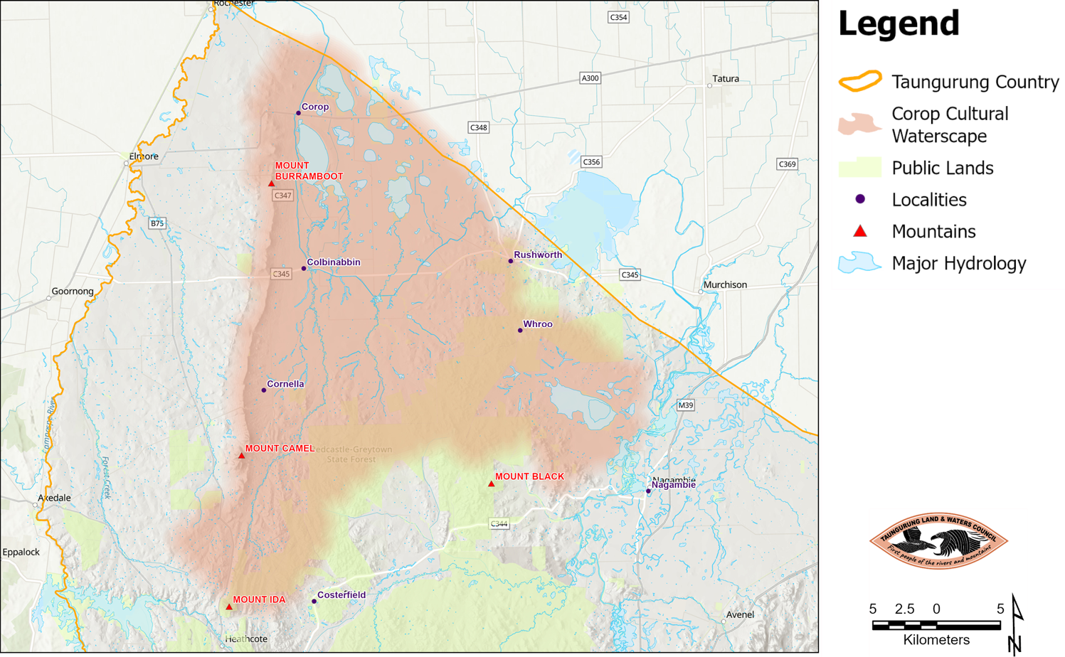
Figure 2: Reedy Lake. Source: TLaWC
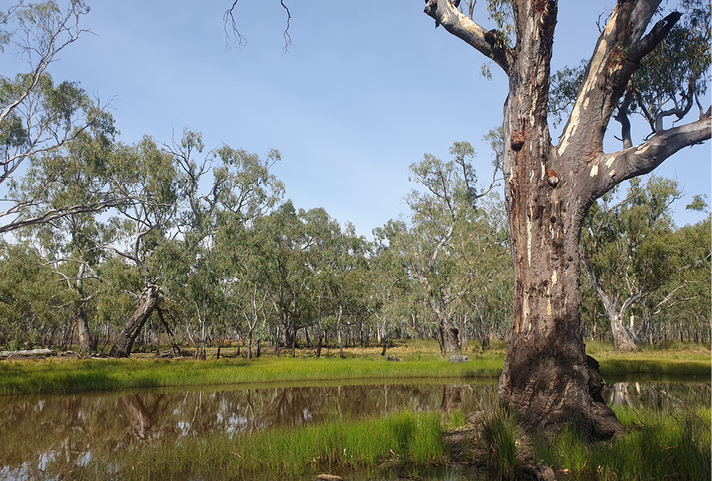

Proposed Reedy Lake Pilot (How):
Reedy Lake is a bioculturally important wetland system that forms a significant Place within the broader Corop Cultural Waterscape.
Reedy Lake Nagambie Wildlife Reserve is a 1320ha wetland, located in Bailieston, in north-central Victoria (see Figure 1 and Figure 2). The Reserve lies directly west of the Goulburn Weir within Taungurung Country and is part of a larger system of seasonal wetlands located north of the main Lake, through relationship with the Whroo box ironbark forests. Reedy Lake contains an enormous amount of oven mounds and scar trees. Biocultural values include medicinal plants, grasses for weaving and plant foods. Animals of cultural significance in the area include brolgas, yabbies, turtles, mussels, goannas, kangaroos, echidna and snakes.
During the colonisation period, the Bailieston area was subjected to mining activities which replaced the traditional uses, occupation patterns, and management practices that were implemented in the landscape in the precolonial period. In the colonial period, the Lake has suffered the impacts of logging and grazing activities and is currently surrounded by farmland.
Although the Lake shows remarkable resilience and capacity to sustain life under stressful conditions, its degradation and ecological decline will seriously increase unless practices to heal and strengthen Country are put in place.
Reedy Lake is in relationship with fringing woodlands (now largely occupied by farmland) and the extensive box ironbark forests of Whroo.
At Reedy Lake Taungurung seeks to:
- develop and apply a methodology for Collaborative Planning at Place, using Reedy Lake as a pilot
consider, adapt and apply the method in development of a Healthy Forest Plan for Rushworth State Forest.
This will consolidate and build on an existing partnership with DEECA to test the utility of the DEECA State Forest Management Planning Framework at Rushworth State Forest.
This will build on existing ecological, biocultural assessments and cultural heritage assessments at Reedy Lake that have been undertaken in partnership with the Goulburn Broken Catchment Management Authority. This will integrate with the existing governance arrangements involving relevant DEECA executives and staff on cultural waterscape and state forest management planning.
Figure 3 shows the Place-Centered Management Area (PCMA) for Reedy Lake that will form the area of interest for collaborative planning.
Figure 3: Reedy Lake Planning Area (area lined in blue, considered as a Place Centred Management Area) and its relationship with the Rushworth State Forest
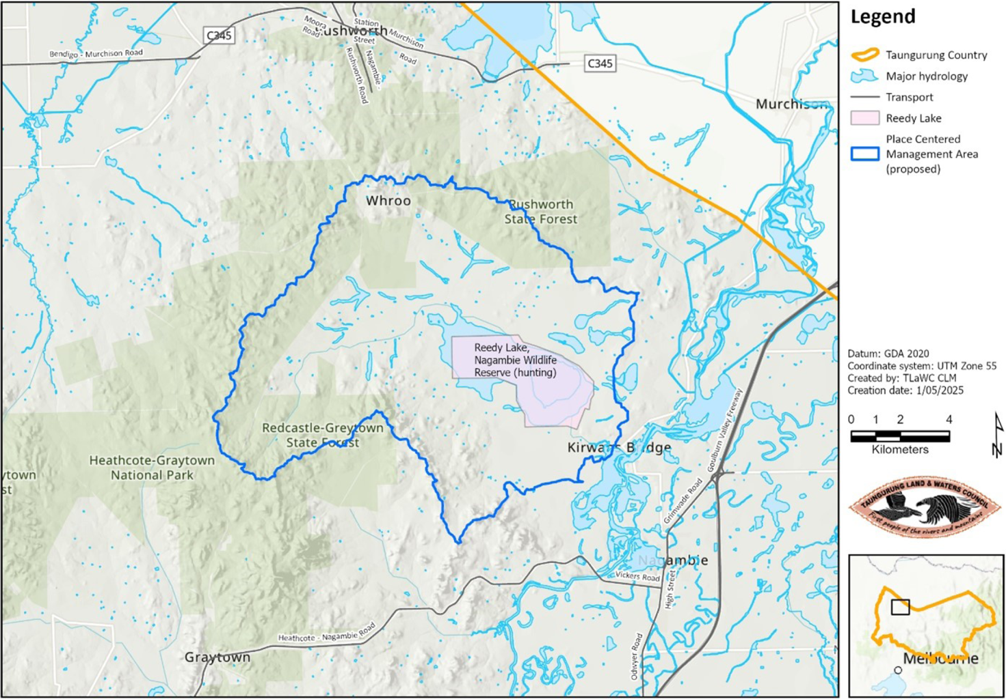

Resourcing:
There is a need for resourcing as follows:
- Commitment to underpin governance arrangements of the Forest Partnership for five years, through a DEECA-led enabling environment.
- Commitment to resource completion of a Healthy Forest Plan for Reedy Lake PCMA.
- Commitment to resource completion of a Healthy Forest Plan for Rushworth State Forest.
- Commitment to resource on Country gatherings and biocultural assessments over 5 years, including broader community gatherings.
- Commitment from all partnering agencies to resource implementation of the plan.
- TLaWC would be pleased to discuss in more detail the resourcing and governance arrangements necessary to undertake this pilot. Term of commitment, scope and intent will guide resourcing requirements.

Publication information

Acknowledgements
We acknowledge and respect Victorian Traditional Owners as the original custodians of Victoria’s land and waters, their unique ability to care for Country and deep spiritual connection to it.
We honour Elders past and present whose knowledge and wisdom has ensured the continuation of culture and traditional practices.
We are committed to genuinely partnering with Victorian Traditional Owners to progress their aspirations.

Copyright
© The State of Victoria Department of Energy, Environment and Climate Action, June 2025.

Creative Commons
This work is licensed under a Creative Commons Attribution 4.0 International licence, visit the Creative Commons website (http://creativecommons.org/licenses/by/4.0/).
You are free to re-use the work under that licence, on the condition that you credit the State of Victoria as author. The licence does not apply to any images, photographs or branding, including the Victorian Coat of Arms, and the Victorian Government and Department logos.

Disclaimer
This publication may be of assistance to you but the State of Victoria and its employees do not guarantee that the publication is without flaw of any kind or is wholly appropriate for your particular purposes and therefore disclaims all liability for any error, loss or other consequence which may arise from you relying on any information in this publication.

Accessibility
To receive this document in an alternative format, phone the Customer Service Centre on 136 186, email customer.service@delwp.vic.gov.au, or contact National Relay Service on 133 677. Available at DEECA website (www.deeca.vic.gov.au).
End of document.

Department of Energy, Environment and Climate Action
Economic analysis commissioned by the Great Outdoors Taskforce.
Victoria is home to one of the most culturally diverse societies in the world. According to Australian Bureau of Statistics data, one third of Victoria’s population is born overseas and more than half from a migrant or refugee background. The Australian Institute of Health and Welfare’s People with disability in Australia report (2024) found 18% of Australians (4.4 million) have a disability and 22% (5.5 million), have a long-term health condition.
Economic analysis commissioned by the Great Outdoors Taskforce.
⁵ Economic analysis commissioned by the Great Outdoors Taskforce based on Tourism Research Australia data.
Victorian Environmental Assessment Council
Victorian Environmental Assessment Council
The Victorian Government has defined collaborative management in the Victorian Traditional Owner Cultural Landscapes Strategy: “Collaborative management (also referred to as co-management, or joint, participatory or multistakeholder management) is a partnership in which government agencies, local communities and resource users, nongovernmental organisations and other stakeholders negotiate, as appropriate to each context, the authority and responsibility for the management of a specific area or set of resources.” This definition of collaborative management is an extract of an International Union for Conservation of Nature Resolution agreed by the parties, in Montreal, in 1996.
Committees of management by the Victorian Government https://www.deeca.vic.gov.au/boards-and-governance/committees-of-management
A framework for place-based approaches by the Victorian Government. https://www.vic.gov.au/place-based-approaches-guide-victorian-public-service/chapter-one-what-are-pba
Experience Victoria 2033, https://tourism.vic.gov.au/about/experience-victoria-2033
Economic analysis commissioned by the Great Outdoors Taskforce
Economic analysis commissioned by the Great Outdoors Taskforce
Economic analysis commissioned by the Great Outdoors Taskforce based on Tourism Research Australia data.
Alpine Resorts 2024, Alpine resorts economic significance study, https://www.alpineresorts.vic.gov.au/about-arv/publications/alpine-resorts-economic-significance-study
Analysis from the ABS Census in 2021.
Economic analysis commissioned by the Great Outdoors Taskforce.
Listed as endangered under the Environment Protection and Biodiversity Conservation Act 1999
https://www.deeca.vic.gov.au/__data/assets/pdf_file/0022/413095/2-Rainforest-factsheet-FINAL.pdf.
https://www.parliament.vic.gov.au/get-involved/inquiries/inquiry-into-ecosystem-decline-in-victoria/
Yorta Yorta Whole of Country Plan 2021–2030

