|  |
| --- |
| Image Web Server |
| ArcMap v10.x |

#### Introduction

As of late March 2023, the DEECA’s Image Web Server (IWS) will move to cloud based hosting. Existing users will need to update their connection url.

Only authorised users can access the IWS.

To register as an authorised user of the IWS please refer to the User Registration section.

#### Connecting to a Web Map Service

1. Open ArcCatalog
2. Double click or expand the GIS Servers entry from the Catalog Tree
3. Double click the Add WMS Server option
4. Copy and paste the following into the URL text window of the Add WMS Server menu:  
     
   https://iws.maps.vic.gov.au/erdas-iws/ogc/wms/RDP?SERVICE
5. Click the Get Layers button to display a list of layers available. If you don’t see any layers, you have most likely entered the URL incorrectly.
6. 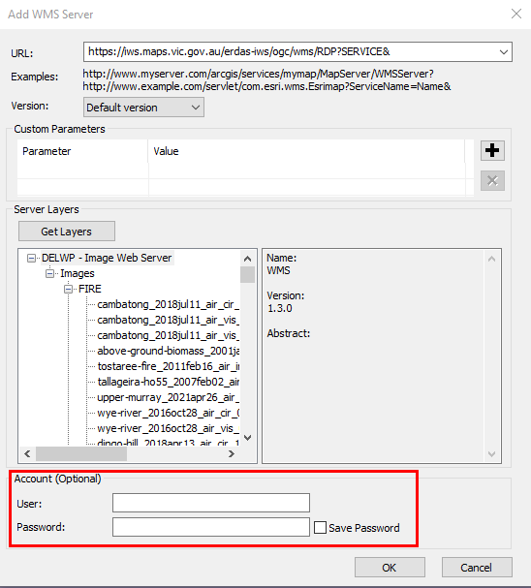Click the OK button. Don’t enter account details.

Due to a known bug in ArcMap 10.x you will need to enter your username and password as follows:

1. Right click on the newly added service in the ArcCatalog Tree and then select the Properties menu option.
2. 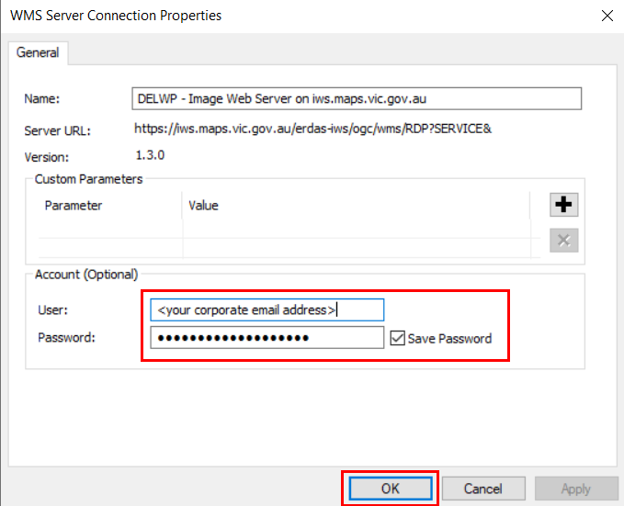Enter your “corporate email address” and password in the menu provided. Be sure to tick the Save Password box.

#### Add an Image to ArcMap

1. In ArcMap
2. Open the Catalog tab
3. 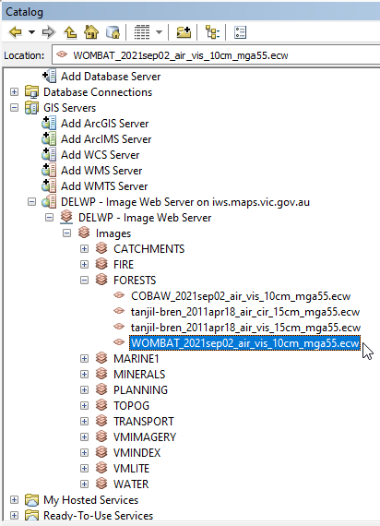Expand the IWS option under GIS servers and drag the image required to the Table of Contents panel
4. Tick on layer visibility to display image
5. Select the image name (using the right mouse button) and choose the “Zoom to layer” option.

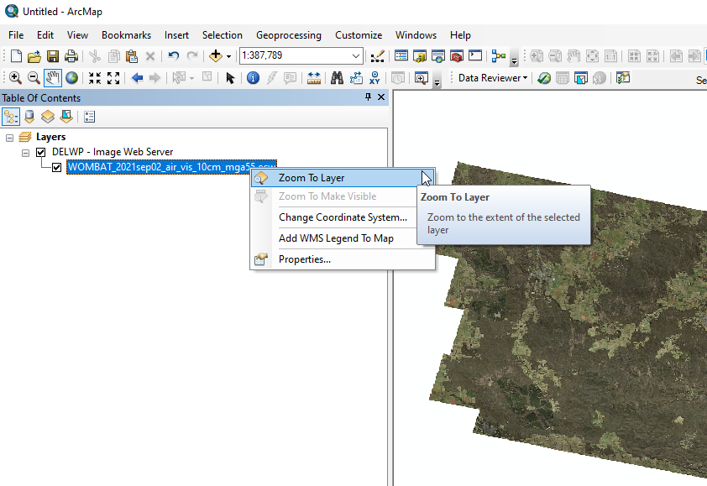

#### Image Footprints layer

The image footprints layer is a spatial index of all georeferenced images stored on the Image Web Server. The layer contains information about the image file which will support basic searching for appropriate images.

Internal users can access the footprints layer via ArcGIS as an ESRI file geodatabase via the VSDL on:

J:\Gis_Public\CSDL\CORPORATE.gdb\IWSFOOTPRINT

External users can order and download the footprints layer via [DataShare](https://datashare.maps.vic.gov.au/), which supports both MapInfo tab and mid/mif as well as ESRI shp formats.

#### User Registration

Approved customers need an account in the identity management system (idam), to access the IWS.

##### DEECA staff

If you have previously created a DataShare account then you will already have an account in the identity management system. You will be able to log into the Image Web Server using your “corporate email address” and your single sign on password.

DEECA staff without an account in the identity management system (eg you don’t have an existing DataShare account (<https://datashare.maps.vic.gov.au/>)) need to create one via the DataShare login option

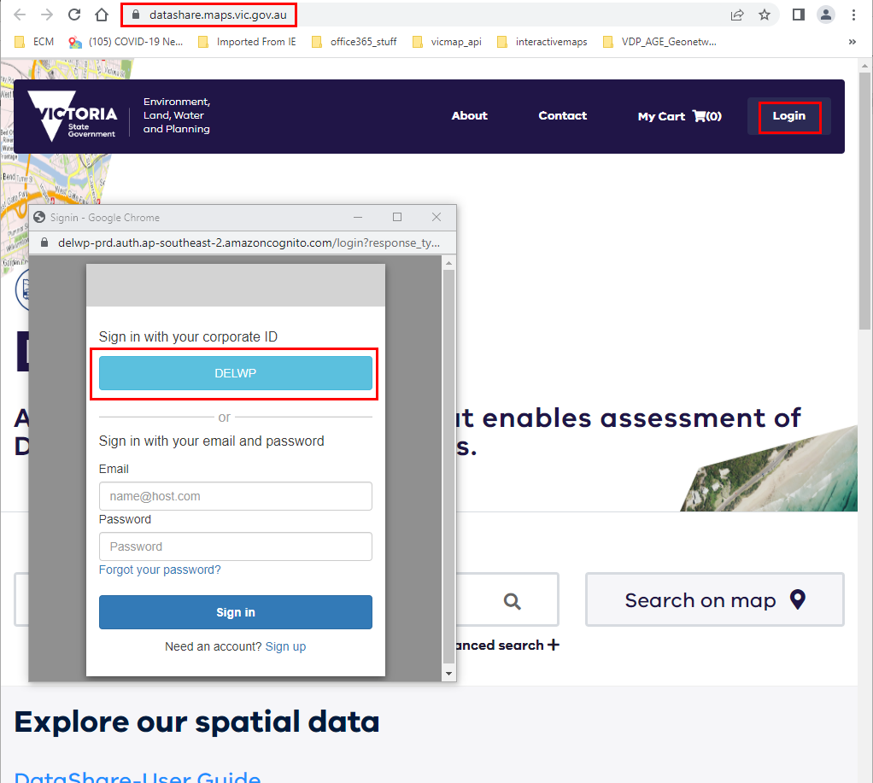

NOTE: once complete you can log out of DataShare

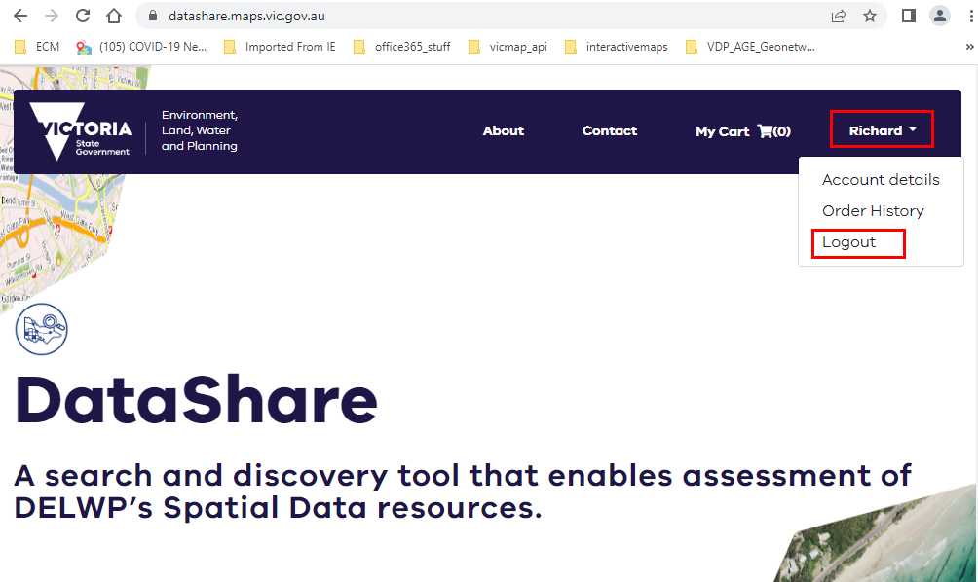

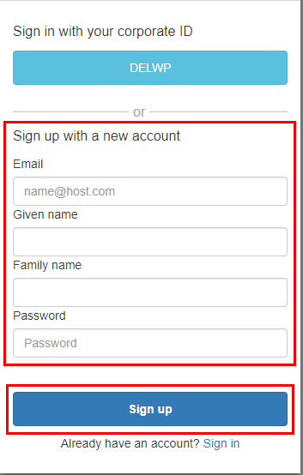You can now log into the Image Web Server using your “corporate email address” and your single sign on password.

##### Non DEECA staff

If you have previously created a DataShare account (created using your corporate email address) then you will already have an account in the identity management system. You will be able to log into the Image Web Server using your “corporate email address” and your Datashare password.

Non DEECA staff without an account in the identity management system (eg you don’t have an existing DataShare account (<https://datashare.maps.vic.gov.au/>)) need to create one via the DataShare login option. Use your corporate email address.

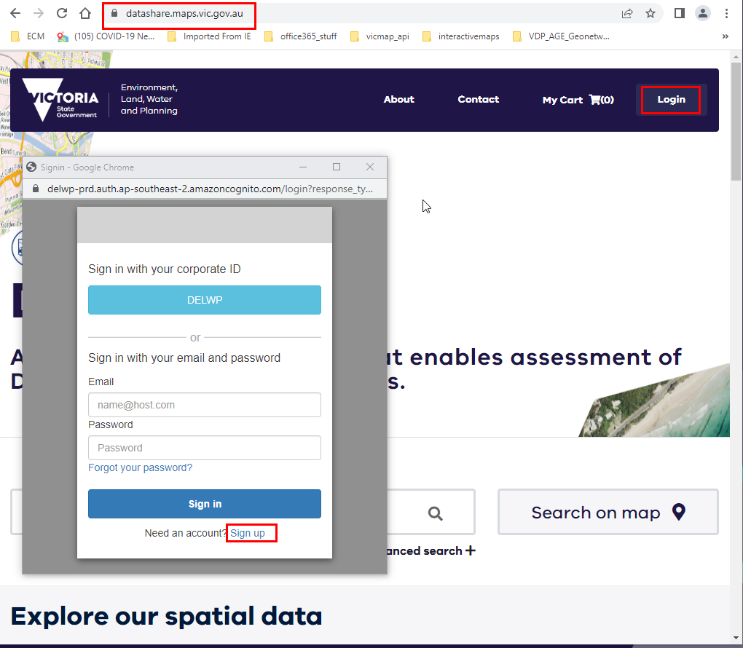

NOTE: once complete you can log out of DataShare



You can now log into the Image Web Server using your “corporate email address” and your DataShare password.

#### Coming Soon

The ability to identify view and save a list of Image Web Server imagery, so that you can differentiate between all the imagery on the image web server and those that you have access to is currently being developed and will be available soon.

#### Image Web Server Contact Details

The Information Services Division (DEECA) manages the IWS. Please address any feedback or queries to [GIS.Helpdesk@delwp.vic.gov.au](mailto:GIS.Helpdesk@delwp.vic.gov.au)

|  |  |
| --- | --- |
| © The State of Victoria Department of Energy, Environment and Climate Action 2023  Creative Commons BYThis work is licensed under a Creative Commons Attribution 4.0 International licence. You are free to re-use the work under that licence, on the condition that you credit the State of Victoria as author. The licence does not apply to any images, photographs or branding, including the Victorian Coat of Arms, the Victorian Government logo and the Department of Energy, Environment and Climate Change (DEECA) logo. To view a copy of this licence, visit http://creativecommons.org/licenses/by/4.0/  Disclaimer  This publication may be of assistance to you, but the State of Victoria and its employees do not guarantee that the publication is without flaw of any kind or is wholly appropriate for your particular purposes and therefore disclaims all liability for any error, loss or other consequence which may arise from you relying on any information in this publication. | Accessibility  If you would like to receive this publication in an alternative format, please telephone the DEECA Customer Service Centre on 136186, email [customer.service@delwp.vic.gov.au](mailto:customer.service@delwp.vic.gov.au) or via the National Relay Service on 133 677 [www.relayservice.com.au](http://www.relayservice.com.au). This document is also available on the internet at [www.deeca.vic.gov.au](http://www.deeca.vic.gov.au). |

.