|  |
| --- |
| ArcGIS Pro |
| Adding a Web Map Service (WMS) |

Introduction

Web Mapping Services (WMS) can be used in ArcMap as map layers. A WMS is a standard protocol for distributing georeferenced map images over the internet. WMS are ”pre-styled” (ie outline colour, fill colour and labelling styles are fixed and cannot be changed by the end user). ISD produces WMS using ArcGIS server and Geoserver (open source).

## Loading Geoserver WMS layers into ArcGIS Pro

1. To access Geoserver web map data (WMS)
2. Run ArcGIS Pro
3. Open any map or blank template
4. Click the Insert tab
5. Click Connections
6. Add **New WMS Server**

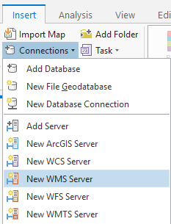

1. Paste the following URL into the Server URL field: <https://opendata.maps.vic.gov.au/geoserver/ows?service=WMS&request=getCapabilities>

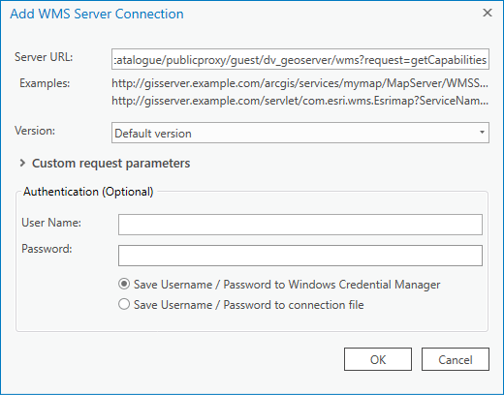

**Note:** Do not enter a Username or Password

1. Click *OK*
2. This will create a WMS Server connection called “DELWP Web Map Service on services.land.vic.gov.au” Expanding this connection will give a long list of layers that can be added to your map.   
   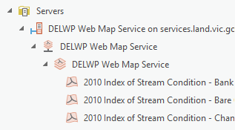
3. To add a WMS layer Drag and drop into the Contents pane

For more help please email:

[GIS.Helpdesk@delwp.vic.gov.au](mailto:GIS.Helpdesk@delwp.vic.gov.au)

|  |  |
| --- | --- |
| © The State of Victoria Department of Environment, Land, Water and Planning 2023  LogoThis work is licensed under a Creative Commons Attribution 4.0 International licence. To view a copy of this licence, visit http://creativecommons.org/licenses/by/4.0/ |  |