|  |
| --- |
| Connecting QGIS to WFS |
| QGIS 3.22.11 – Web Feature Service |

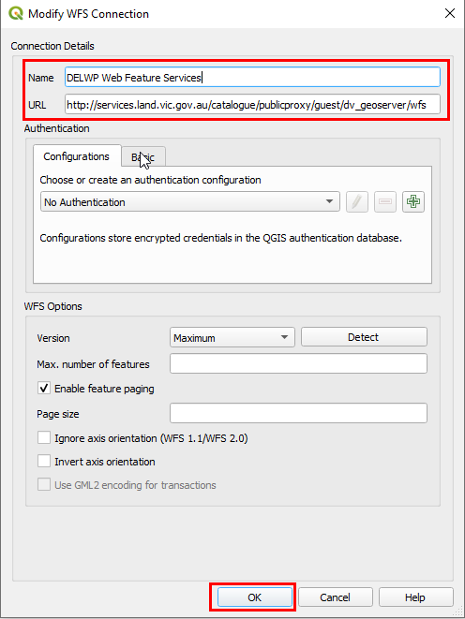Introduction

Accessing DELWP’s Web Feature Services (WFS) in **QGIS 3.22.11** is an alternative to downloading datasets from Datashare or using the J drive file geodatabases.

Connecting to a Web Feature Service

1. Run QGIS Desktop (from Start>All Programs>QGIS)
2. From the Browser Panel, right-click on WFS / OGC API - Features
3. 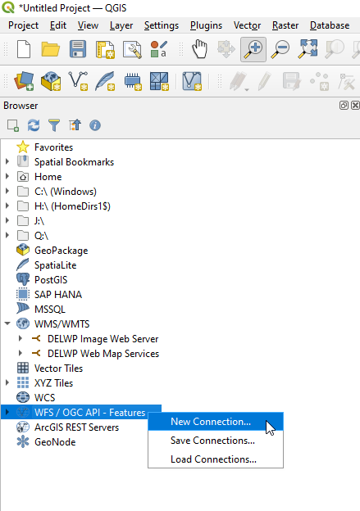Select “New Connection…”
4. In the window that opens, copy and paste the following text into their respective fields:

Name: DELWP Web Feature Services

URL: https://opendata.maps.vic.gov.au/geoserver/ows?service=WFS&request=getCapabilities

**Note:** You do not need to enter any login credentials as these are public WFS

1. Now click the OK button. A list of available images will appear in the browser panel (under the WFS > DELWP Web Feature Services heading).

## Loading a WFS layer into QGIS

1. From the Browser panel, double click the “DELWP Web Feature Service” to expand the directory tree (you will repeat this to expand each level)
2. 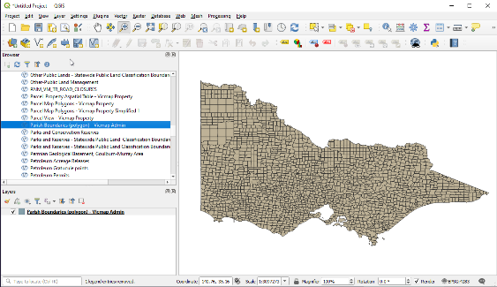Now double click on the layer name to add it to your “Layers” panel in QGIS. The layer should now appear in your QGIS map window

Note: There are “feature limits” attached to WFS (of 10,000 features) This limits the number of features downloaded and displayed. Please consider this when displaying detailed datasets (eg Vicmap Property or Vicmap Address).

For more help please email: [GIS.Helpdesk@delwp.vic.gov.au](mailto:GIS.Helpdesk@delwp.vic.gov.au)

|  |  |
| --- | --- |
| © The State of Victoria Department of Environment, Land, Water and Planning 2023  LogoThis work is licensed under a Creative Commons Attribution 4.0 International licence. To view a copy of this licence, visit http://creativecommons.org/licenses/by/4.0/ |  |