# Privacy Complaint Form

Privacy and Data Protection Act (2014)

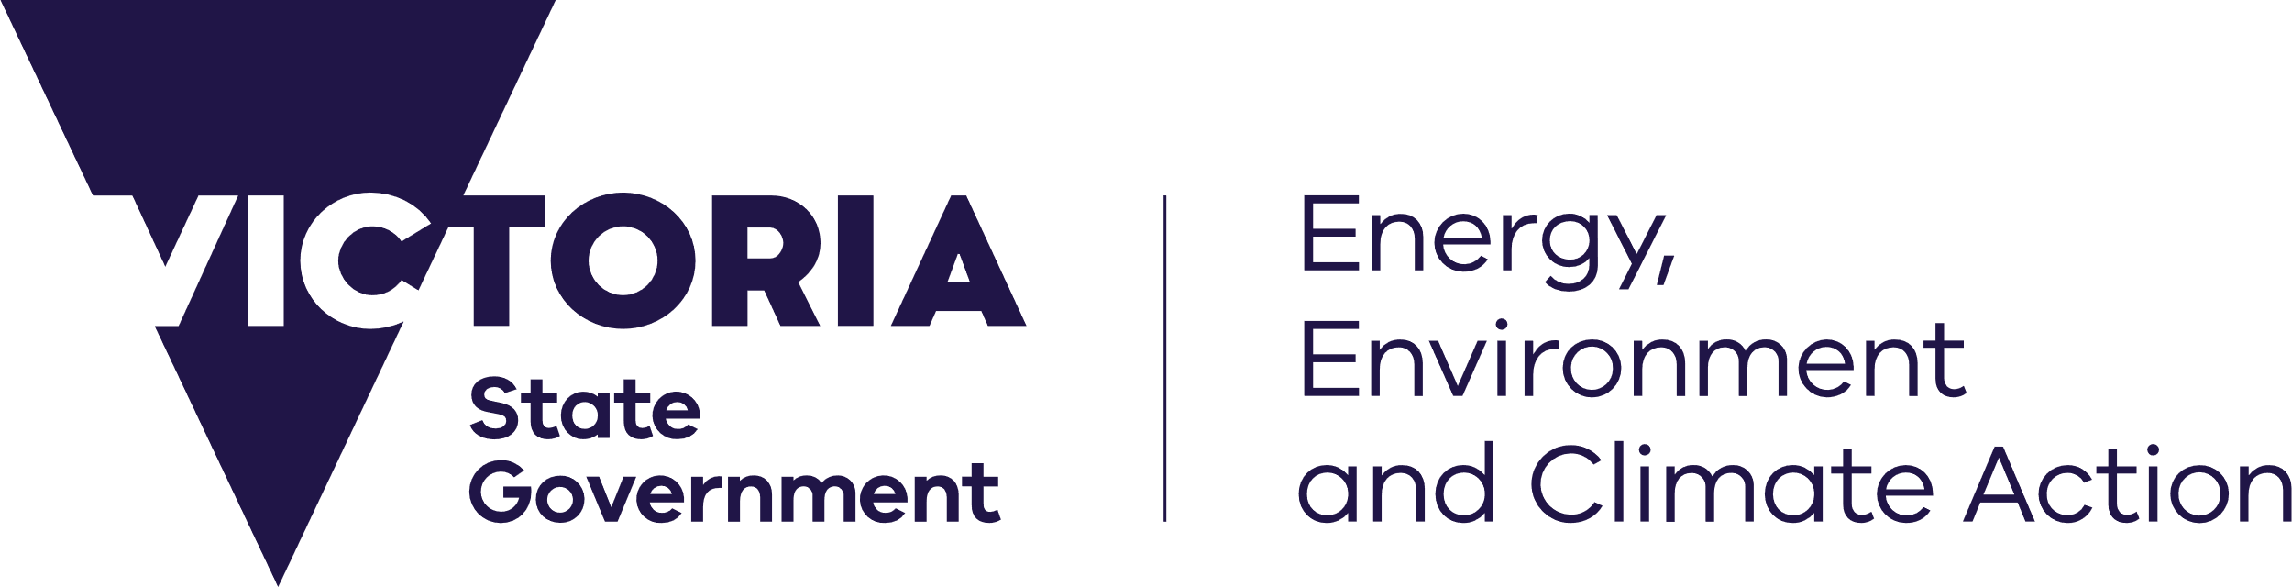

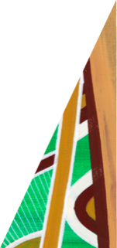

deeca.vic.gov.au

This form is to assist you in making a complaint about the handling of your personal information by the Department of Energy, Environment and Climate Action under the *Privacy and Data Protection Act 2014*.

Complete this form and send to: Manager Information Access, DEECA, PO Box 500, East Melbourne 8002 or

Email: [foi.unit@deeca.vic.gov.au](mailto:foi.unit@deeca.vic.gov.au)

## Your contact details

|  |
| --- |
|  |
| Name: |
| Address: |
| Phone: |
| Email: |

## Your complaint

You may only complain about the mishandling of your own personal information; not about anyone else’s information. Parents of minors, legal guardians and those with a legal authority may complain on behalf of their children or wards etc. If you are complaining on behalf of someone else please provide proof of your authority to do so.

## I am complaining about –

|  |
| --- |
| **Organisation:** |
| **Individual/Region/Office:** |
| **Contact details (if known):** |
| **How do you believe your information privacy has been breached?** |
|  |
|  |
|  |
|  |

|  |
| --- |
| **How has this affected you?** |
|  |
|  |
|  |
|  |
|  |
|  |
|  |
|  |
|  |
|  |
|  |

**Have you taken this complaint to another organisation?**

|  |  |
| --- | --- |
| **Organisation:** |  |
| **Contact:** |  |

## Documents

Please give us with copies (not the original) of any documents that may help us to investigate your complaint (for example, any correspondence or records of conversations you have had with department officers or contracted service providers).

____________________________ / /

Signature Date

If you wish to discuss your complaint or any privacy matters you may contact the Information Access and Privacy Unit at [foi.unit@deeca.vic.gov.au](mailto:foi.unit@deeca.vic.gov.au).