Introduction
The Image Web Server Viewer (https://images.maps.vic.gov.au/iws allows the quick and easy viewing of images stored on DEECA’s Image Web Server (IWS) within a browser. The resolution of each image is improved and optimised with each zoom level. It is useful for browsing the range of images that cover an area of interest and for viewing the coverage of each image. You need to be a registered user before you can access the Image Web Server. Refer to the Username / Password section at the end of this information sheet to register as an authorised user of these services.

Accessing the IWS Viewer
- Ensure your browser version is up-to-date (we recommend Chrome)
- Go to https://images.maps.vic.gov.au/iws. Make sure your connection is secure (by including https://), otherwise you will not be able to view any imagery.
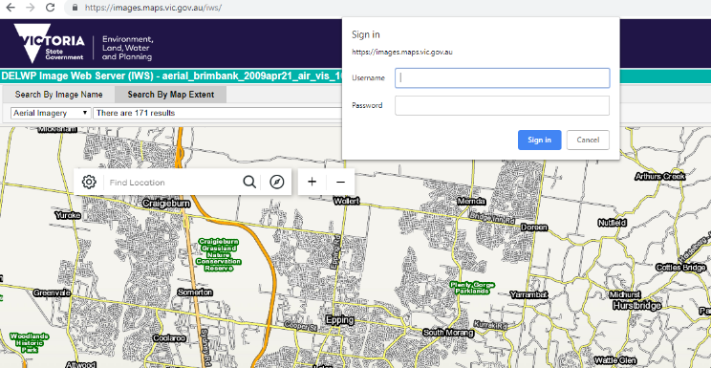
- You will be prompted to enter your IWS username and password after selecting an image. Note that if you enter your password incorrectly, you will need to close and re-open your browser window before re-attempting.

Searching for an image by name
Note: Images are found by IWS Viewer using the IWS Image Footprints spatial dataset. If an image is not appearing when searched for, it is likely due to an issue with this dataset.
Departmental staff can contact GIS Help Desk via the DEECA Service Portal. External customers can contact the GIS Helpdesk via email: GIS.Helpdesk@deeca.vic.gov.au for assistance.
.
- Click on the Search By Image Name tab at the top of the application.
- Enter the image name (or a part of it) as it appears in the filename for the image. Refer to the List of Accessible Imagery section at the end of this information sheet to find out how to view and save a list of all IWS imagery accessible to you.
- Select an image from the drop-down list. This list will automatically populate as you type in the image name.
- The selected image will now appear on the map.
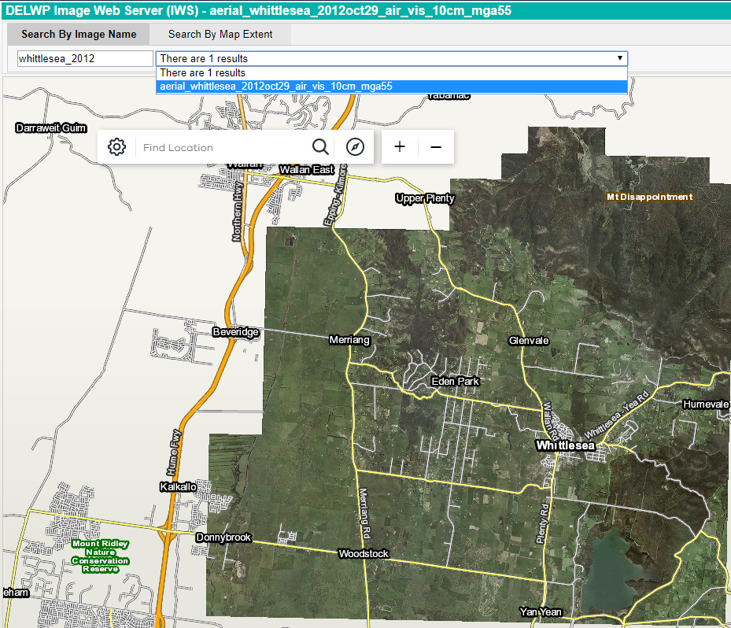

Searching for an image by map extent
- Click on the Search By Map Extent tab at the top of the application.
- Using the base map as a reference, zoom in (using the mouse wheel or by using the +/- buttons) to your area of interest.
- As you zoom in, the drop-down list of images will be populated by those that cover all or part of the current extent of the map.
- View an image by selecting it from the drop-down list. You can use the second drop-down list to the left to switch between aerial, ground-based, merged, satellite or thematic imagery.
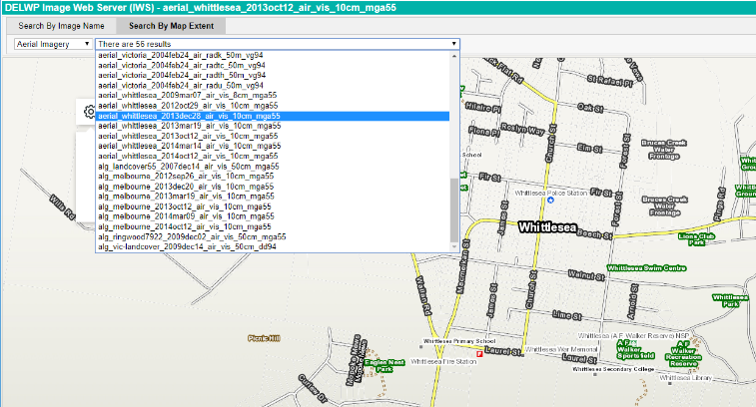

Search for an image using address or locality
- You can search for imagery using an address or locality name by using the search bar on the map.
- Entering an address/locality will centre the map at that location. You can also select the compass icon to the right of the search bar to automatically centre the map at your current location (if you give the site permission).
- You can then select imagery that covers that particular address/locality by using the Search By Map Extent tab.
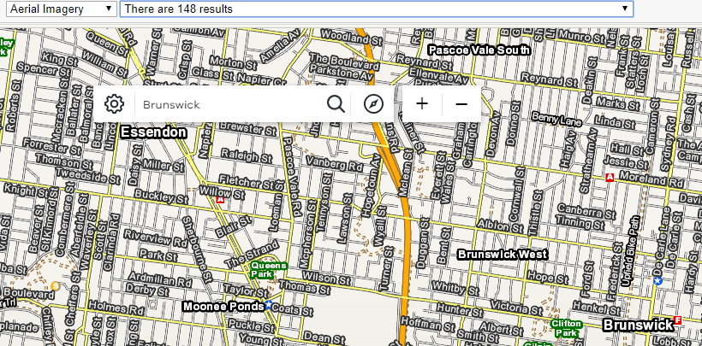

List of Accessible Imagery
It is possible to view and save a list of Image Web Server imagery in order to differentiate between all the imagery on the image web server and those that you have access to.
a. Go to the Image Web Server Administration Interface (click Yes on the Security Alert pop-up)
b. Login using your IWS username and password
c. Select the View Permissions menu option (top left of the page)
d. The result will be a page that displays a list of Users Images. This is a list of images that you have been granted access to (in accordance with your data license agreement).
e. Tick the “Include All Available Resources” box to list all the other images on the IWS which you do not have access to.
f. Save the list in either TXT or PDF formats by selecting the appropriate button.
g. If you would like to purchase a license to view other images or if you think there is a discrepancy between your license agreement and what you have access to please contact the GIS.helpdesk@deeca.vic.gov.au

Username / Password
Viewing imagery via the Image Web Server requires a username and password. If you don’t have a username and password for the Image Web Server you will need to apply for one. Refer to the Register a User information sheet for detailed instructions.

Forgotten your Password?
Click here to reset your password.

Image Web Server Contact Details
The Enterprise Spatial Services team (DEECA) manages the IWS. Departmental users can address any feedback or queries to GIS Help Desk via the DEECA Service Portal. External users can provide feedback via the GIS.Helpdesk@deeca.vic.gov.au email address.

© The State of Victoria Department of Environment, Land, Water and Planning 2026    This work is licensed under a Creative Commons Attribution 4.0 International licence. You are free to re-use the work under that licence, on the condition that you credit the State of Victoria as author. The licence does not apply to any images, photographs or branding, including the Victorian Coat of Arms, the Victorian Government logo and the Department of Environment, Land, Water and Planning (DEECA) logo. To view a copy of this licence, visit http://creativecommons.org/licenses/by/4.0/  Disclaimer  This publication may be of assistance to you but the State of Victoria and its employees do not guarantee that the publication is without flaw of any kind or is wholly appropriate for your particular purposes and therefore disclaims all liability for any error, loss or other consequence which may arise from you relying on any information in this publication. | Accessibility  If you would like to receive this publication in an alternative format, please telephone the DEECA Customer Service Centre on 136186, email customer.service@deeca.vic.gov.au, or via the National Relay Service on 133 677 www.relayservice.com.au. This document is also available on the internet at www.deeca.vic.gov.au.

