|  |
| --- |
| Connecting QGIS to WMS |
| QGIS 3.22.11 – Web Map Service |

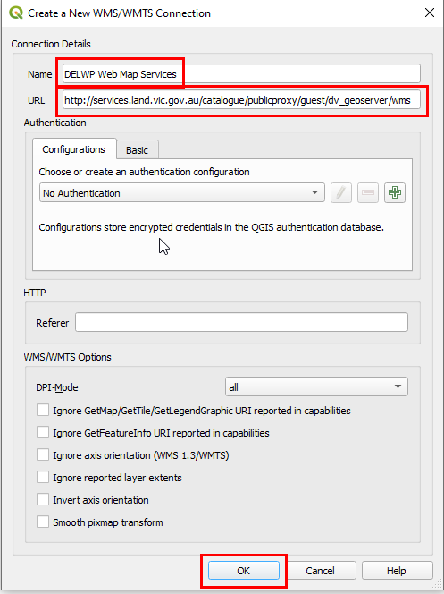Introduction

Accessing DELWP’s Web Map Services (WMS) in **QGIS 3.22.11** is an alternative to downloading datasets from Datashare.

Connecting to a Web Map Service

1. Run QGIS Desktop (from Start>All Programs>QGIS)
2. From the Browser Panel, right-click on WMS / WMTS
3. 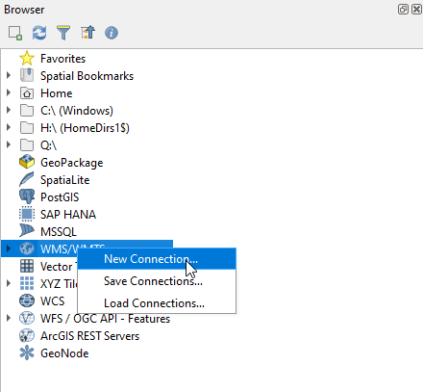Select “New Connection…”
4. In the window that opens, copy and paste the following text into their respective fields:

Name: DELWP Web Map Services

URL: <https://opendata.maps.vic.gov.au/geoserver/ows?service=WMS&request=getCapabilities>

You do not need to enter any login credentials as these are public WMS.

1. Now click the *OK* button.
2. A list of available images will appear in the browser panel (under the WMS / WMTS > DELWP Web Map Services heading).

## Loading a WMS layer into QGIS

1. From the Browser panel, double click the “DELWP Web Map Service” to expand the directory tree (you will repeat this to expand each level
2. Now double click on the image name to add it to your “Layers” panel in QGIS
3. The image should now appear in your QGIS map window

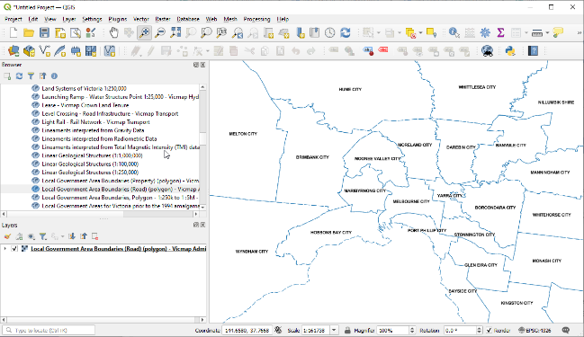

|  |  |
| --- | --- |
| © The State of Victoria Department of Environment, Land, Water and Planning 2023  LogoThis work is licensed under a Creative Commons Attribution 4.0 International licence. To view a copy of this licence, visit http://creativecommons.org/licenses/by/4.0/ |  |

For more help please email : [GIS.Helpdesk@delwp.vic.gov.au](mailto:GIS.Helpdesk@delwp.vic.gov.au)