Introduction
Accessing DEECA’s Web Map Services (WMS) in QGIS 3.40.0 is an alternative to downloading datasets from Datashare.

Connecting to a Web Map Service
- Run QGIS Desktop (from Start>All Programs>QGIS)
- From the Browser Panel, right-click on WMS / WMTS
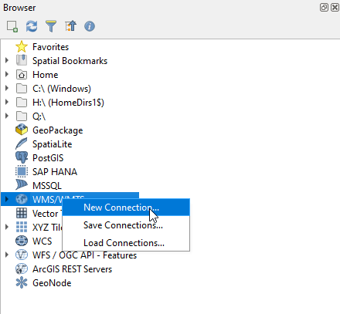
- Select “New Connection…”
- In the window that opens, copy and paste the following text into their respective fields:
Name: DEECA Web Map Services
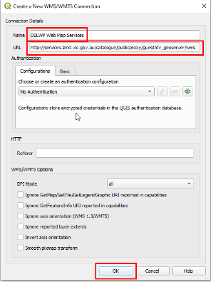
URL: https://opendata.maps.vic.gov.au/geoserver/ows?service=WMS&request=getCapabilities
You do not need to enter any login credentials as these are public WMS.
- Now click the OK button.
- A list of available images will appear in the browser panel (under the WMS / WMTS > DEECA Web Map Services heading).

Loading a WMS layer into QGIS
- From the Browser panel, double click the “DEECA Web Map Service” to expand the directory tree (you will repeat this to expand each level
- Now double click on the image name to add it to your “Layers” panel in QGIS
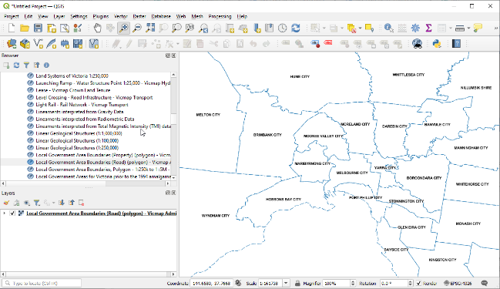
The image should now appear in your QGIS map window

Support
The Enterprise Spatial Services team (DEECA) manages the Open Data Platform. Departmental users can address any feedback or queries to GIS Help Desk via the DEECA Service Portal. External users can provide feedback via the GIS.Helpdesk@deeca.vic.gov.au email address.

