Pupangarli Marnmarnepu ‘Owning Our Future’
  - DEECA’s First Peoples Self-Determination Reform Strategy 2026–2031

Table of Contents
Acknowledgments 4
Mirring – ‘Country’ 7
Explanation of terms 10
Secretary’s foreword 13
Chapter 1. Introduction 15
1.1 Purpose of Pupangarli Marnmarnepu 15
1.2 First Peoples self-determination 19
1.3 Government’s obligations and commitments to First Peoples self-determination 21
1.4 Building on our foundations 32
1.5 Review, reflection and the next phase 35
Chapter 2. Domains 37
2.1 People 40
2.2 Systems 42
2.3 Country 45
2.4 Accountability 48
Chapter 3. Implementation 52
3.1 Governance 54
3.2 Outcomes and Accountability Framework 61
3.3 Planning and delivery 81
3.4 DEECA reporting 83
Appendices 86
Appendix 1: The 11 self-determination guiding principles 86
Endnotes 89

Acknowledgments
We acknowledge and respect Victorian Traditional Owners as the original custodians of Victoria’s land and waters, and their unique ability to care for Country and deep spiritual connection to it. We honour Elders past and present whose knowledge and wisdom have ensured the continuation of culture and traditional practices.
We are committed to genuinely partnering and meaningfully engaging with Traditional Owners and Aboriginal Communities in Victoria to support the protection of Country, the maintenance of spiritual and cultural practices, and their broader priorities in the 21st century and beyond.

Disclaimer
Aboriginal and Torres Strait Islander readers are warned that this document may contain quotes and images of First Peoples people who have passed.

Copyright
© The State of Victoria Department of Energy, Environment and Climate Action, August 2026.

Creative Commons
This work is licensed under a Creative Commons Attribution 4.0 International licence, visit the Creative Commons website.
You are free to re-use the work under that licence, on the condition that you credit the State of Victoria as author. The licence does not apply to any images, photographs or branding, including the Victorian Coat of Arms, and the Victorian Government and Department logos.
ISBN 978-1-76176-007-5 (pdf/online/MS word)

Publication disclaimer
This publication may be of assistance to you but the State of Victoria and its employees do not guarantee that the publication is without flaw of any kind or is wholly appropriate for your particular purposes and therefore disclaims all liability for any error, loss or other consequence which may arise from you relying on any information in this publication.

Accessibility
To receive this document in an alternative format, phone the Customer Service Centre on 136 186, email customer.service@deeca.vic.gov.au, or contact National Relay Service on 133 677 or visit the National Relay Service website. This document is available on the DEECA website.
The name of the strategy, Pupangarli Marnmarnepu is Wadi Wadi and Mutti Mutti language for ‘Owning Our Future’ and embodies what it means for Traditional Owners to be self-determining.
Mutti Mutti, Tati Tati and Wadi Wadi language is used throughout Pupangarli Marnmarnepu. The Mutti Mutti, Tati Tati and Wadi Wadi Kulingi (people) are Murray River First Nations. Their Tyalingi (language) is part of the Western Kulin/Murray River languages. DEECA thanks Mutti Mutti, Tati Tati and Wadi Wadi Traditional Owners for providing their language to name this strategy.

Cultural knowledge, consent and use of information
Any cultural knowledge shared through engagement remains with Traditional Owners and knowledge holders. Pupangarli Marnmarnepu incorporates Traditional Owner feedback. However, it does not reproduce sensitive cultural information. Notes were taken to accurately capture feedback to inform drafting. When attribution or details were sought for inclusion, consent was requested and provided. Feedback has been reported in a de-identified manner to protect Indigenous Cultural Intellectual Property and Indigenous Data Sovereignty.
DEECA would like to thank the many Traditional Owner groups across Victoria who generously shared their time, insights and lived experiences to help refresh and shape Pupangarli Marnmarnepu. Through open, honest and respectful engagement, Traditional Owners spoke about their priorities, interests and rights on Country. Their openness has been critical in informing the direction of Pupangarli Marnmarnepu and strengthening its focus on genuine self-determination.

Mirring – ‘Country’
DEECA honours and pays our deepest respect to Tom Day III, a proud Gunditjmara, Yorta Yorta and Wemba Wemba man. Our Aboriginal cultural identity, Mirring (Country) is one of Tom’s many incredible legacies. DEECA is both privileged and honoured to have collaborated with Tom to co-design Mirring, and his impact across our department will not be forgotten.
The Mirring artwork is a visual reminder of our ongoing commitment to working in full partnership with Traditional Owners and Aboriginal Victorians. It also represents our commitment to creating a culturally safe and respectful environment for Aboriginal staff and visitors.
The Mirring artwork
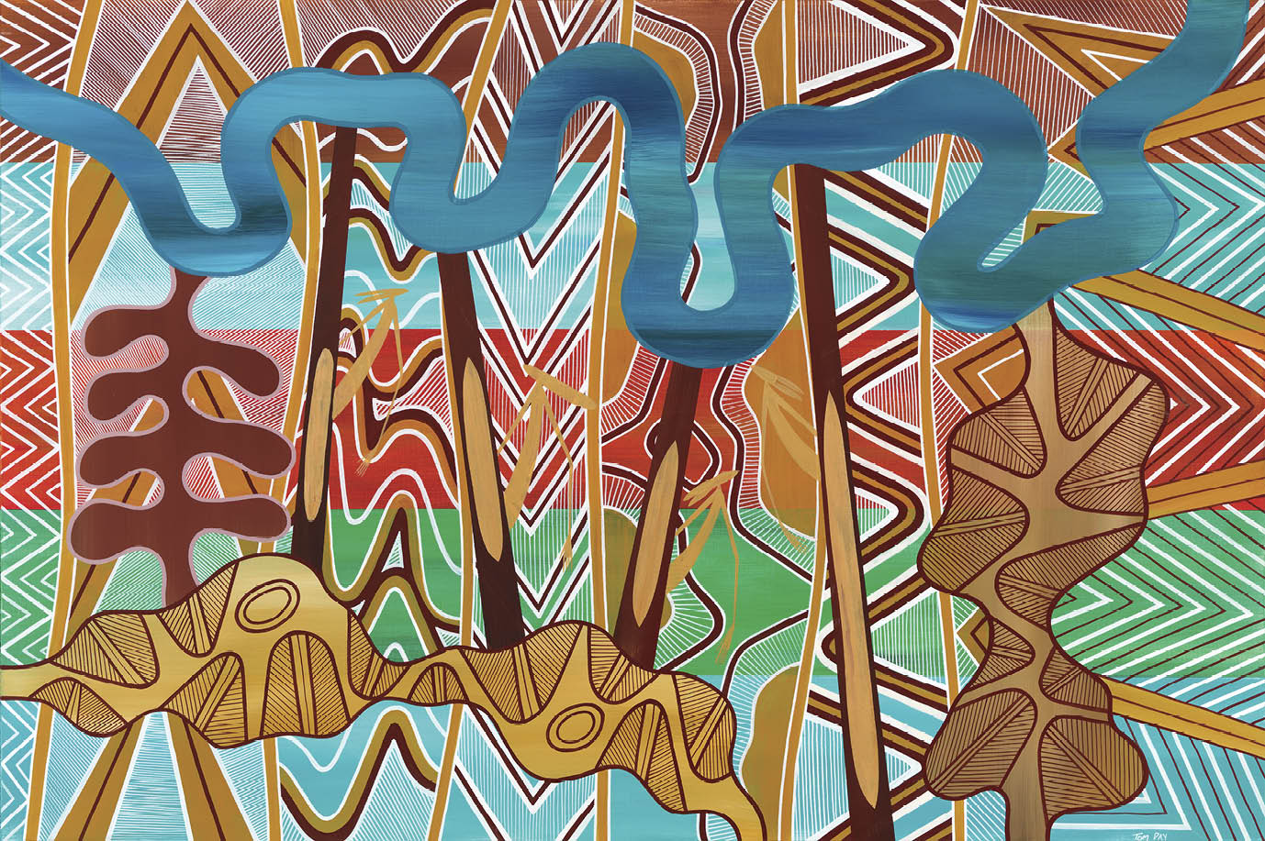
The three layers of the Mirring artwork and what they represent
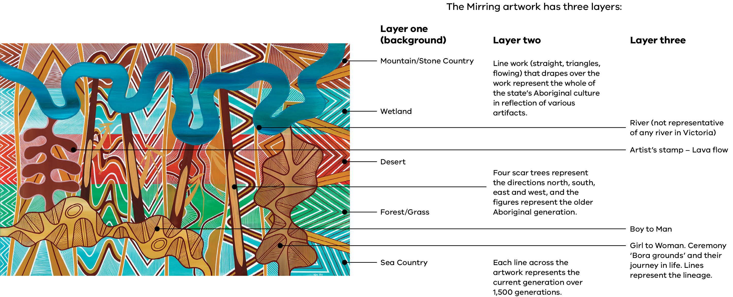

The labels on the diagram on the previous page link parts of the painting to their meaning across three layers:
- Layer one (background): the horizontal bands represent, from top to bottom, Mountain/Stone Country, Wetland, Desert, Forest/Grass and Sea Country.
- Layer two: the line work (straight, triangles and flowing) that drapes over the work represents the whole of the state’s Aboriginal culture, in reflection of various artifacts. Four scar trees represent the directions north, south, east and west, and the figures represent the older Aboriginal generation. Each line across the artwork represents the current generation over 1,500 generations.
- Layer three: the river (not representative of any river in Victoria), the artist’s stamp (lava flow), Boy to Man, and Girl to Woman, including Ceremony ‘Bora grounds’ and their journey in life. The lines represent the lineage

Explanation of terms
Aboriginal Community refers to and acknowledges all First Peoples living in Victoria. Community can be used to describe the entire Victorian First Peoples Community or smaller, specific communities.
Cultural awareness is about respect and ownership. It is awareness of how cultural experiences (values, knowledge, skills and attitudes) are formed and affect others.
Cultural capability refers to the skills, knowledge and behaviours that are required to plan, support, improve and deliver services in a culturally respectful and appropriate manner. It is also how we recognise, support, value and embrace First Peoples decision-making to embed self-determination.
Cultural safety refers to an environment that is safe for people, where there is no assault, challenge or denial of their identity, of who they are and what they need. It is about shared respect, shared meaning, shared knowledge, and experience of learning, living and working together with dignity, and truly listening. For First Peoples staff working at DEECA, and the department’s partnerships with Traditional Owners, cultural safety means creating environments, relationships, and systems free from racism and discrimination so that people feel safe, valued, and able to participate. In this way, cultural safety makes space for culture to live and for spiritual and belief systems to exist and thrive. Cultural safety is everyone’s responsibility.
Indigenous is used in reference to the United Nations Declaration on the Rights of Indigenous Peoples, and unless otherwise noted, is inclusive of both Aboriginal and Torres Strait Islander peoples. However, the term Indigenous may not be the term preferred by individuals or specific groups of Aboriginal or Torres Strait Islander peoples.
Indigenous data is any information or knowledge, in any format or medium, which is collected or recorded from and/or is about Traditional Owners, both collectively and individually. This may include information, interviews, surveys, statistics, reports, sound recordings, films, photographs, health records, mapping of Country, samples of plants and animals, languages, knowledge, art and stories.
Indigenous Data Sovereignty is the right of Aboriginal and Torres Strait Islander peoples to govern the collection, ownership and use of data about their communities, people, land and resources.
First Peoples, or First Nations people, refer to peoples or nations of people connected to an area prior to colonisation. These terms have some general acceptance but may not be the term preferred by individuals or specific groups of Aboriginal or Torres Strait Islander peoples.
Formal recognition refers to the legal process by which Traditional Owner groups are recognised as the appropriate group to speak on behalf of land and waters within a specific area. Traditional Owners can be formally recognised under various Acts. This recognition is typically accompanied by the appointment of a corporate entity to perform the functions under the relevant Act:
- Native Title Act 1993 (Cth)
- Traditional Owner Settlement Act 2010 (Vic)
Aboriginal Heritage Act 2006 (Vic).
Self‑determination is about having the right to choose. The Australian Human Rights Commission explains self-determination as the right of Indigenous peoples to freely determine their political status and pursue economic, social and cultural development, based on their own values and way of life. For Traditional Owners, this includes the right to make choices that best reflect their cultures and identities.
A Traditional Owner is an Aboriginal or Torres Strait Islander person who has traditional connections to an identified geographical area of Country.
A Traditional Owner Corporation is an incorporated group that represents the interests of Traditional Owners in a particular area. They may hold rights under the Native Title Act 1993, Traditional Owner Settlement Act 2010 or Aboriginal Heritage Act 2006 on behalf of the Traditional Owners they represent, or they may have no formal agreements in place.
Treaty is a negotiated agreement between First Peoples and the State to establish a renewed relationship and practical ways of working together. Treaty is intended to support a better and fairer future by ensuring First Peoples have a say in decisions and policies that affect them and their communities:
- Statewide Treaty Act 2025 (Vic).

Commonly used acronyms
FPSDD – First Peoples Self-Determination Division
IAP – Implementation Action Plan
SCfCPF – Statewide Caring for Country Partnership Forum
SDRF – Self-Determination Reform Framework
TOACEF – Traditional Owner and Aboriginal Community Engagement Framework
TOC – Traditional Owner Corporation
UNDRIP – United Nations Declaration on the Rights of Indigenous Peoples
VAAF – Victorian Aboriginal Affairs Framework

Secretary’s foreword
Enabling self-determination for the Victorian Aboriginal Community is essential to achieving enduring social, cultural and economic benefits for all Victorians.
Pupangarli Marnmarnepu sets out how DEECA will continue to transform the way we work with Traditional Owners and Aboriginal Victorians. It builds on the foundations laid over the past decade and responds to a changing environment, including:
- the work of the Yoorrook Justice Commission
- the commencement of Victoria’s first Statewide Treaty
- continuing efforts to meet national Closing the Gap commitments
growing expectations that government systems move beyond consultation and towards genuine shared authority.
DEECA holds significant responsibility for land, water, environment, energy and natural resource management. These responsibilities carry legal, moral and cultural obligations, including recognising Traditional Owners as rights holders and respecting their enduring connections to Country. This strategy makes clear that fulfilling those obligations requires more than good intent. It requires structural reform, consistent practice and accountability at every level of the organisation.
Pupangarli Marnmarnepu is for all DEECA staff. It sets clear expectations for how self-determination must be reflected in everyday decisions, behaviours and partnerships. It challenges us to move beyond individual relationships and goodwill and instead embed culturally safe, rights-based approaches into our systems, funding, governance and workforce practices.
I acknowledge and thank the Traditional Owners and First Peoples across the state who shared their time, knowledge and truth to inform this strategy. I also acknowledge the First Peoples staff within DEECA whose leadership continues to guide this work.
As Secretary, I am committed to ensuring DEECA is accountable for delivering on Pupangarli Marnmarnepu, not just in words but in action. By walking alongside Traditional Owners in partnership, and by holding ourselves to account, we can help create a future where First Peoples self-determination is realised in practice across all that DEECA does.
Kate Houghton PSM
Secretary

Chapter 1. Introduction

Purpose of Pupangarli Marnmarnepu
Pupangarli Marnmarnepu (2026–2031) is a strategy to enable First Peoples self-determination by transforming how DEECA works with Traditional Owners and Aboriginal Victorians.
This strategy is for all DEECA staff. It builds on the work of its predecessor, Pupangarli Marnmarnepu (2020–2025), to provide clear expectations for how self-determination must be reflected in everyday roles, decisions and behaviours across the department.
Pupangarli Marnmarnepu provides a framework to strengthen cultural authority and drive change across four interconnected domains: People, Systems, Country and Accountability. This enables decision-making power, leadership and resources to progressively transfer to Traditional Owners and First Peoples.
It embeds respect for rights, dignity and cultural authority into DEECA’s workforce, systems and partnerships, supporting Traditional Owners’ priorities for Country, culture, land and water, with clear accountability for outcomes.
Pupangarli Marnmarnepu also aligns DEECA’s responsibilities with international, national and state obligations and commitments to First Peoples self-determination (see section 1.3).
Figure 1: Purpose: the vision for Pupangarli Marnmarnepu and its four domains
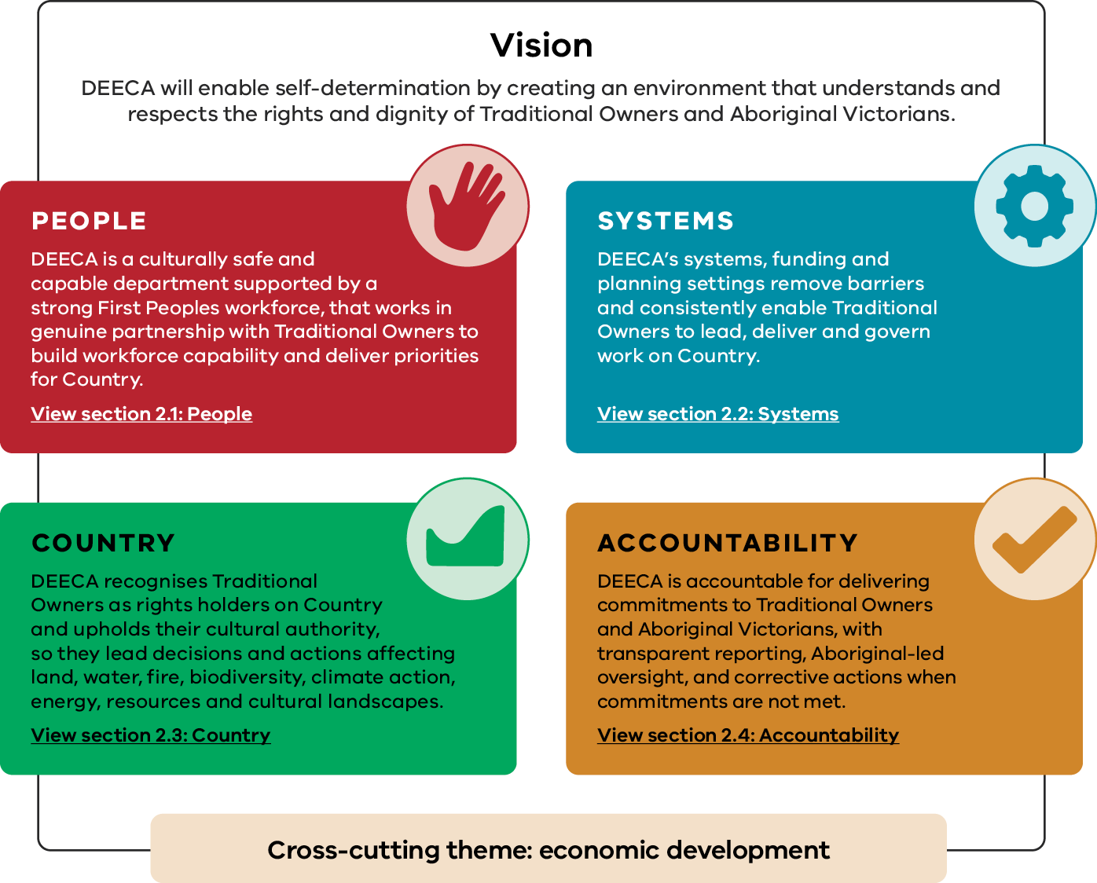
Figure 1 sets out the vision for Pupangarli Marnmarnepu and its four domains. The vision is: ‘DEECA will enable self-determination by creating an environment that understands and respects the rights and dignity of Traditional Owners and Aboriginal Victorians.’ The four domains are People, Systems, Country and Accountability. Table 1 describes each domain, from left to right and top to bottom as they appear in the figure. A cross-cutting theme of economic development applies across all four domains.
Table 1: Vision and domains of Pupangarli Marnmarnepu
Domain | Commitment | More information
People | DEECA is a culturally safe and capable department supported by a strong First Peoples workforce, that works in genuine partnership with Traditional Owners to build workforce capability and deliver priorities for Country. | Section 2.1: People
Systems | DEECA’s systems, funding and planning settings remove barriers and consistently enable Traditional Owners to lead, deliver and govern work on Country. | Section 2.2: Systems
Country | DEECA recognises Traditional Owners as rights holders on Country and upholds their cultural authority, so they lead decisions and actions affecting land, water, fire, biodiversity, climate action, energy, resources and cultural landscapes. | Section 2.3: Country
Accountability | DEECA is accountable for delivering commitments to Traditional Owners and Aboriginal Victorians, with transparent reporting, Aboriginal-led oversight, and corrective actions when commitments are not met. | Section 2.4: Accountability
Cross-cutting theme: economic development. This theme applies across all four domains.

How to use this strategy
Pupangarli Marnmarnepu is a practical guide for how DEECA does business. All staff are expected to use it to inform:
- day-to-day decision-making and advice
- policy, program and project design and delivery
- engagement with Traditional Owners and Aboriginal Victorians
- leadership, accountability and use of authority.
Delivery of this strategy will be supported through actions across DEECA's strategies, plans and initiatives.
This strategy should be applied early and consistently – not as a check at the end of processes. Staff should use it to ask:
- how to embed Traditional Owners’ perspectives into scoping, development and design of policies, programs, projects and initiatives
- who holds decision-making authority
- whether engagement transfers power or only seeks input
- how systems and processes may enable or block self-determination
how outcomes for Traditional Owners are defined, measured and reported.
The four domains provide a common structure to guide action across DEECA and support sustained, outcomes-focused change led by Traditional Owners.

First Peoples self-determination
First Peoples of Australia represent the oldest continuing cultures in the world, with enduring systems of governance, lore and authority grounded in Country. Colonisation disrupted these systems through dispossession and policies that explicitly sought to exclude First Peoples, their cultures and decision-making from public life.
From the early 1970s, government policy began to shift away from overt exclusion towards Aboriginal self-management, supporting Aboriginal organisations to deliver services to their communities. While this marked an important change, government largely retained power, resources and system control.
In recent decades, Aboriginal leadership has driven a further shift towards self-determination. This reflects a clear understanding that lasting change requires more than participation in government-designed systems. Self-determination places authority, choice and control back with Traditional Owners and Aboriginal Communities. It is about recognising First Peoples’ right to decide matters affecting their cultures, communities, Country and futures across political, economic, social and cultural domains.
Pupangarli Marnmarnepu is grounded in a self‑determination framework that aligns with Victoria’s overarching Aboriginal policy settings.
The Yoorrook Justice Commission has reinforced that self-determination must involve the genuine transfer of decision-making power, authority and resources at all levels of government.
Self-determination requires significant behaviour and cultural change across government, enacted through structural reform, shared authority and accountability.

Importance of self‑determination
Since colonisation, governments have exercised significant power over First Peoples, often excluding them from decision-making and authority. This has contributed to ongoing inequities and has too often ignored the inseparable link between Traditional Owners and Country.
It is widely recognised that when self-determination is properly resourced, First Peoples communities achieve stronger and more sustainable outcomes. Self-determined decisions and First Peoples leadership support more targeted and effective policy design and more impactful implementation across sectors. This strategy supports Traditional Owners in leading decisions that affect them and commits DEECA to removing barriers so that self-determination can be realised in practice.
Advancing self-determination underpins better outcomes for Country by supporting healthier land and waters on which we all live and rely. It strengthens relationships and communities and supports greater recognition of Traditional Owners’ knowledge and leadership, benefiting all Victorians.

DEECA’s role in enabling self-determination
Traditional Owners define what self-determination and self-governance mean for them. DEECA’s role is to respect that authority and remove barriers that prevent Traditional Owners in Victoria from exercising their right to self-determination.
‘It [self-determination] is not engagement. It is not a seat at the table. It is more than partnership or co-design. It is not service delivery or funding for individual programs. It is not subject only to government interpretation. It is not the state expecting First Peoples to realise self-determination without power and resources or to pick up the pieces when government has failed. It is not the transfer of inadequate resources, limited authority, broken Country, inferior title and failing systems to First Peoples, leaving it to First Peoples to fix these problems.’

Government’s obligations and commitments to First Peoples self-determination
The Victorian Government has made clear commitments to First Peoples self‑determination. Pupangarli Marnmarnepu sets out how DEECA will deliver its contribution.
DEECA will strengthen its outcomes-focused approach by:
- valuing and supporting First Peoples’ leadership and expertise
- embedding self-determination across its systems, policies, processes and projects relating to land, water and the built environment.
To align with the Victorian Government's Victorian Aboriginal Affairs Framework and Self-Determination Reform Framework, outcomes should be based on what matters to First Peoples, supporting strengths-based, equitable outcomes for Traditional Owners and Aboriginal Victorians.
The policy landscape shown below situates Pupangarli Marnmarnepu within broader state and national self-determination commitments. It also illustrates how this strategy’s implementation will drive system-wide reform across DEECA to support self-determination and improve outcomes.
Figure 2: First Peoples self-determination diagram
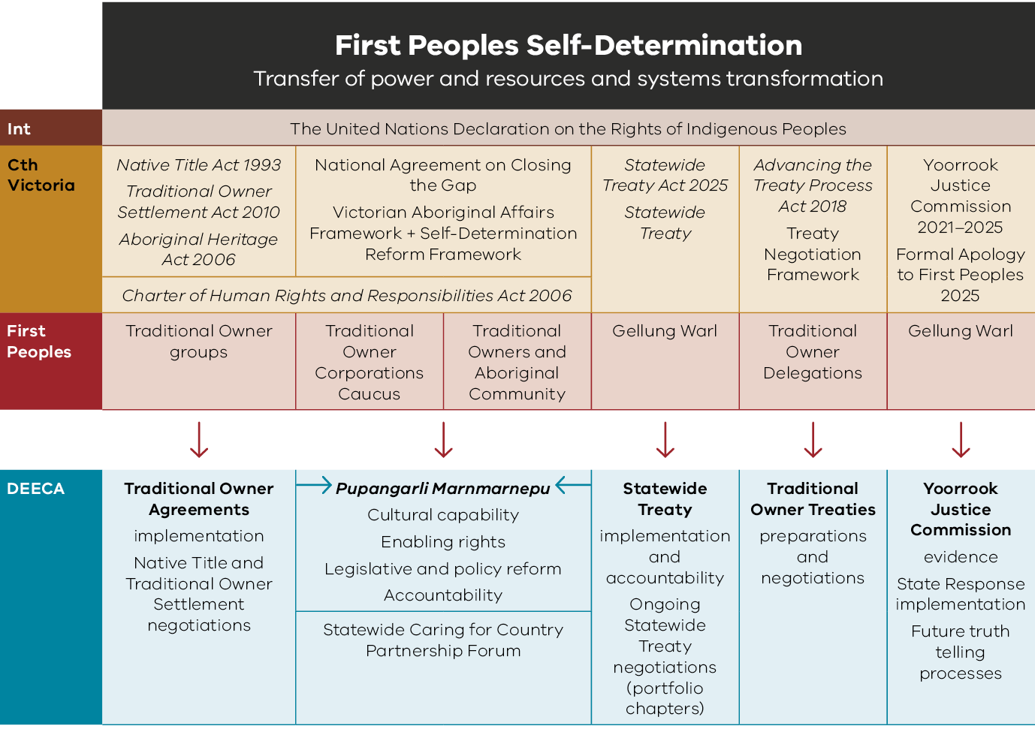
Figure 2 shows the policy landscape for First Peoples self-determination, under the heading ‘Transfer of power and resources and systems transformation’. The diagram has four levels. At the top, the United Nations Declaration on the Rights of Indigenous Peoples applies internationally and underpins all areas. Below it are Commonwealth and Victorian laws and policies, then the First Peoples groups connected to each area, and finally the DEECA actions that respond to each area. In the diagram, arrows point down from each First Peoples group to the related DEECA actions, and Pupangarli Marnmarnepu is shown at the centre of DEECA’s actions. The table below presents the five areas of the diagram, from left to right, as rows.
Table 2: Policy landscape for First Peoples self-determination – laws and policies, First Peoples groups and DEECA actions
Commonwealth and Victorian laws and policies | First Peoples groups | DEECA actions
Native Title Act 1993  Traditional Owner Settlement Act 2010  Aboriginal Heritage Act 2006  Charter of Human Rights and Responsibilities Act 2006 | Traditional Owner groups | Traditional Owner Agreements implementation  Native Title and Traditional Owner Settlement negotiations
National Agreement on Closing the Gap  Victorian Aboriginal Affairs Framework and Self-Determination Reform Framework  Charter of Human Rights and Responsibilities Act 2006 | Traditional Owner Corporations Caucus  Traditional Owners and Aboriginal Community | Pupangarli Marnmarnepu, which covers:  Cultural capability  Enabling rights  Legislative and policy reform  Accountability  Statewide Caring for Country Partnership Forum
Statewide Treaty Act 2025  Statewide Treaty | Gellung Warl | Statewide Treaty  implementation and accountability  Ongoing Statewide Treaty negotiations (portfolio chapters)
Advancing the Treaty Process Act 2018  Treaty Negotiation Framework | Traditional Owner Delegations | Traditional Owner Treaties  preparations and negotiations
Yoorrook Justice Commission 2021–2025  Formal Apology to First Peoples 2025 | Gellung Warl | Yoorrook Justice Commission evidence  State Response implementation  Future truth telling processes

Victorian context
This strategy builds on decades of advocacy and engagement between First Peoples in Victoria and the Victorian Government and responds to recent developments that continue to shape the legal and policy landscape in which it will be implemented.

Victorian Aboriginal Affairs Framework
The Victorian Aboriginal Affairs Framework 2018-2023 (VAAF) was released in 2018 after numerous conversations between the Victorian Government and Victorian Aboriginal Community.
Although this framework formally ran from 2018 to 2023, it remains in operation while engagement with First Peoples continues to develop the next framework.
The VAAF is the Victorian Government’s overarching framework for working with Aboriginal Victorians, organisations and the wider community to drive action and improve outcomes. It sets out whole-of-government self‑determination enablers and principles and commits the government to significant structural and systemic transformation.
It also sets out 11 guiding principles that underpin all Victorian Government action to progress self-determination and inform Pupangarli Marnmarnepu (see Appendix 1: The 11 self-determination guiding principles).
The VAAF’s shared vision is, ‘All Aboriginal Victorian people, families and communities are healthy, safe, resilient, thriving and living culturally rich lives.’ It outlines goals across six domains to work towards this vision. DEECA’s efforts in supporting self‑determination have the potential to impact all these domains:
- Children, family and home
- Learning and skills
- Opportunity and prosperity
- Health and wellbeing
- Justice and safety
- Culture and Country
The VAAF acknowledges that there are systemic and structural barriers to self-determination. It establishes four priority actions that the Victorian Government must commit to and act upon to enable self-determination:
- Prioritise culture
- Address trauma and support healing
- Address racism and promote cultural safety
Transfer power and resources to communities

Self-Determination Reform Framework
In 2019, the Victorian Government released the Self-Determination Reform Framework (SDRF) to support government in implementing the VAAF.
The SDRF provides a structure and guidance for Victorian Government departments and agencies to enact the VAAF’s self-determination priorities.
The SDRF includes four reform domains:
- People
- Outcomes
- Systems
- Accountability
Pupangarli Marnmarnepu maps out DEECA’s plan to support First Peoples self-determination, in alignment with these four domains.
In addition, the SDRF sets out a reporting framework to hold the government accountable through the annual Victorian Government Aboriginal Affairs Report, which is tabled in the Victorian Parliament.

Yoorrook Justice Commission and truth‑telling
Named after the Wemba Wemba/Wamba Wamba word for ‘truth’, the Yoorrook Justice Commission (Yoorrook) ran from 2021 to 2025 as Australia’s first formal truth-telling process. Through landmark inquiries and public hearings, it examined the systemic injustices experienced by First Peoples in Victoria as a result of colonisation.
Yoorrook created a lasting public record to support truth-telling, healing and transformation. This helped deepen understanding of the links between historical injustice and its ongoing impacts for future generations.
The Yoorrook Justice Commission’s final reports were tabled in the Victorian Parliament in July 2025:
- Yoorrook Justice Commission, Yoorrook for Transformation: Third Interim Report (2025)
Yoorrook Justice Commission, Yoorrook: Truth Be Told (2025)
These reports document the lived experience of First Peoples and set out 100 recommendations for transformational, whole-of-government reform. This work culminated in a formal State apology and a renewed commitment to truth-telling, structural reform and Treaty.
Yoorrook’s evidence and findings inform this refresh of Pupangarli Marnmarnepu and will continue to guide implementation priorities. They reinforce DEECA’s responsibility to treat truth-telling as an ongoing practice. DEECA upholds this work by listening to First Peoples, reflecting on past and present injustices, and embedding these learnings into policy, systems, decision-making and work on Country to strengthen self-determination, cultural authority and accountability.

Treaty
On 12 December 2025, Victoria commenced Australia’s first Treaty with First Peoples, marking a historic milestone grounded in generations of sustained advocacy and leadership by First Peoples. Victoria’s Statewide Treaty reflects nearly a decade of engagement, negotiation and institution-building to establish a renewed relationship based on self-determination, accountability and shared decision-making.
Statewide Treaty is enabled under the Statewide Treaty Act 2025 (Vic). It establishes Gellung Warl (Gullung-Warl, from Gunaikurnai language), as the democratically elected representative body for First Peoples in Victoria. Under the Act, the State has legal obligations to engage in good faith with Gellung Warl and give effect to its legislated powers and functions, including its role to inform, advise and make decisions on matters affecting First Peoples.
Treaty provides a critical pathway for advancing self-determination.
Statewide Treaty sets the overarching legal and governance framework. Pupangarli Marnmarnepu guides DEECA in embedding self‑determination in its roles, decisions, and ways of working, consistent with Statewide Treaty obligations and future treaty processes.

Traditional Owner rights
Traditional Owners may hold legally recognised rights under one or more Acts:
- Native Title Act 1993 (Cth)
- Traditional Owner Settlement Act 2010 (Vic)
- Aboriginal Heritage Act 2006 (Vic)
Each recognises Traditional Owners’ enduring connection to Country. The Native Title and Traditional Owner Settlement Acts provide rights to participate in cultural practice, decision-making and natural resource management on public land and waters. The Aboriginal Heritage Act appoints Registered Aboriginal Parties as primary decision-makers for the protection and management of Aboriginal cultural heritage within their appointed areas.
Over the past two decades, recognition of Traditional Owner rights under these frameworks has strengthened governance and partnership arrangements between Traditional Owners and the State.
DEECA’s obligations under Traditional Owner agreements are legally binding.
Existing agreements reflect established relationships, governance arrangements and shared ways of working that will inform future Treaty negotiations. Pupangarli Marnmarnepu sets the self-determination framework through which DEECA implements and negotiates these obligations in good faith, supporting respectful relationships, cultural authority and shared decision-making.

Victorian Charter of Human Rights and Responsibilities
The Charter of Human Rights and Responsibilities Act 2006 (Vic) (the Charter) protects civil, political and cultural rights in law. It specifically recognises the distinct cultural rights of Aboriginal people in Victoria, including the right to enjoy identity and culture, maintain and use language and maintain kinship ties.
Obligations under the Charter exist as standalone legal obligations. DEECA must not act in a way that is incompatible with Charter rights nor fail to properly consider those rights when making decisions.
The Charter guides DEECA’s approach to decision-making and engagement.
In parallel, Pupangarli Marnmarnepu ensures decision-making and engagement relating to First Peoples’ cultural rights are culturally safe, accountable, and respectful of established relationships between First Peoples and DEECA.

Federal context

Native Title Act 1993
Native Title is a federal legal framework that recognises some Traditional Owners’ rights and interests in land and waters based on their enduring connection to Country.
Where the Act applies, it can provide rights to practice culture, participate in decision-making, and be involved in managing natural resources on public land and waters. It can be progressed and implemented through negotiated agreements with government that create ongoing governance, partnership and legally binding obligations.
This Act is also mentioned in the Victorian context as legislation under which Traditional Owners may hold legally recognised rights.

Closing the Gap: Victorian Implementation Plan
The National Agreement on Closing the Gap (the National Agreement) commits Australian governments and First Peoples to genuine partnership to address systemic inequities. This includes supporting First Peoples economic development and maintaining their cultural, spiritual, physical and economic relationship with land and waters.
The National Agreement is driven by four priority reforms that change how governments operate to support lasting, self-determined change:
- Formal partnership and shared decision-making
- Building the Aboriginal community-controlled sector
- Transforming government organisations
- Shared access to data and information at a regional level
The Victorian Closing the Gap Implementation Plan translates the commitments into action and accountability. It sets out the responsibilities of the Victorian Government, including DEECA, to improve outcomes in partnership with Aboriginal Communities. There are two Closing the Gap socio‑economic targets relevant to DEECA’s portfolio of work:
- 15a: By 2030, a 15 per cent increase in Australia’s landmass subject to Aboriginal and Torres Strait Islander people’s legal rights or interests.
15b: By 2030, a 15 per cent increase in areas covered by Aboriginal and Torres Strait Islander people’s legal rights or interests in the sea.
The Victorian Implementation Plan anchors Pupangarli Marnmarnepu within statewide commitments to self-determination and the transfer of decision-making and resources into Aboriginal control.

International context
In 2009, Australia became a signatory to the United Nations Declaration on the Rights of Indigenous Peoples (UNDRIP). The UNDRIP outlines the rights of Indigenous peoples around the world. This legally binding document describes self-determination as the right of Indigenous peoples to ‘freely determine their political status and pursue their economic, social and cultural development’.

Building on our foundations

First Peoples Self‑Determination Division
Established in 2020 as the Aboriginal Self-determination Reform Branch, DEECA’s First Peoples Self-Determination Division (FPSDD) reflects the significant growth and increased investment in self-determination. This evolution signals the importance of self-determination as a central priority for the department.
This division advances DEECA’s work to strengthen First Peoples self-determination by partnering with Traditional Owners, strengthening culturally safe practices across the department, and ensuring government decisions uphold Traditional Owners’ rights and objectives.
The division provides strategic leadership, culturally sound advice, and direction to guide and empower staff to genuinely partner and meaningfully engage with Traditional Owners and Aboriginal Victorians, guided by DEECA's Traditional Owner and Aboriginal Community Engagement Framework (TOACEF).
Core functions of this division include:
- partnership building
- place-based engagement
coordination of the Statewide Caring for Country Partnership Forum (SCfCPF), providing a decision-making and accountability platform between Traditional Owners and senior government leaders.
Externally, the division’s work includes leading:
- DEECA’s participation in negotiations under the Native Title Act 1993 (Cth)
DEECA’s negotiation and implementation of Recognition and Settlement Agreements, under the Traditional Owner Settlement Act 2010 (Vic).
The division also supports:
- joint management arrangements and governance for Traditional Owner Land Management Boards
DEECA’s involvement in treaty and truth-telling processes, partnership with Gellung Warl and implementation of the State response to Yoorrook.
Internally, the division strengthens DEECA’s cultural capability through implementing the Aboriginal Cultural Capability Framework through:
- delivering cultural safety and cultural capability training
providing specialist advice on First Peoples employment, recruitment and retention.
The division also provides targeted advice and support on policy reform and project delivery. It oversees departmental systems and decision-making structures relating to First Peoples self-determination.
It further ensures accountability through department-wide monitoring and reporting against self-determination commitments, including:
- Pupangarli Marnmarnepu
- Yoorrook commitments
whole-of-government frameworks such as the VAAF and the National Agreement.

Embedding First Peoples Teams across DEECA
DEECA has also established specialised First Peoples-led teams who provide invaluable support, knowledge and expertise for portfolio areas, including:
- the First Peoples Energy Branch (Energy Group)
- the Traditional Owner Partnerships Team (Bushfire and Forest Services Group)
- the First Nations Water Branch (Water and Catchments Group).
DEECA Groups individually determine the design, priorities and role of their First Peoples teams, which work collaboratively with FPSDD on matters affecting First Peoples.

DEECA’s Aboriginal Staff Network
DEECA established the Aboriginal Staff Network (ASN) in 2015. In 2017 it became a self-governing professional network and by mid-2026, had over 130 members. It is a closed network for First Peoples employees, providing a culturally safe space for staff to come together, yarn, and build strong professional and cultural connections across DEECA.
The ASN aligns with Pupangarli Marnmarnepu, the Aboriginal Cultural Capability Framework, and DEECA’s commitments to safe and respectful workplaces. Its purpose is to:
- support First Peoples’ career development, leadership, and decision-making
strengthen retention while increasing workplace satisfaction and positive career outcomes.
‘The ASN provides a welcoming space for mob to come together, share knowledge and support each other. It creates opportunities to learn from one another, celebrate successes, and strengthen relationships. I have found it really valuable in creating connections with other mob across DEECA.’
– Caleb Weston, ASN Member
‘Being able connect with other First Nations staff across DEECA is so important. Many of us are working to achieve better outcomes for our people in a multitude of different ways and that can sometimes be a challenging and difficult space to navigate. I'm grateful for the ASN as a way come together, support one another and be able to share successes and challenges in a space where we know we'll be heard and respected.’
– Grace Hyett, ASN Member
‘I first got involved with ASN and attended my first forum when I started in a full-time role at DEECA a couple of years ago. Since then, it has provided a valuable opportunity to connect with mob from across the state working in a diverse range of roles. The relationships I've built have supported my day-to-day work, giving me a network of people I can reach out to for advice and guidance from different parts of the department. These connections have been especially important during emergency events, where having trusted relationships with staff from different regions, teams and incident management roles can make a real difference in high pressure situations.’
– Josh Cottier, ASN Member
‘The Aboriginal Staff Network, particularly the in-person gatherings, has been invaluable for someone like me coming to DEECA from outside of government. Getting to know other mob from across the Department means finding familiar faces in meetings, strengthening connections over time, and creating informal opportunities for mentorship and support. I’ve also seen fellow Aboriginal staff draw on this network for mutual support, networking, and seen how grounded people are during and after a get-together. For me, it’s also what happens out of the ASN gatherings that’s meaningful. When you know other mob across the Department, some incredible collaborations occur which benefits not just our members but the areas we work in, as we bring our relationships and connections across the Department with us. Having a strong ASN is very grounding culturally and professionally.’
– Jess McDonald, ASN member

Review, reflection and the next phase
Since the initial Pupangarli Marnmarnepu (2020–2025), the policy and institutional environment have shifted significantly. The work of Yoorrook and the commencement of Statewide Treaty in Victoria have heightened expectations around First Peoples authority, accountability and outcomes. This has increased both the momentum and complexity of implementation.
This refreshed five-year Pupangarli Marnmarnepu builds on the foundations of its predecessor while aligning with shifts in the policy environment. It strengthens cultural authority as the basis for setting DEECA’s strategic direction, outcomes and priorities to respond to First Peoples self-determination.
In addition to drawing on an independent evaluation of the first iteration of this strategy, this refresh was also guided by extensive engagement with Traditional Owners and DEECA staff.
Pupangarli Marnmarnepu outlines broad outcomes, indicators and measures that inform yearly priorities to be implemented in partnership with Traditional Owners and Aboriginal Victorians.

Chapter 2. Domains
This chapter expands on the challenges, opportunities and good practices for the domains:
- People
- Systems
- Country
- Accountability
It provides a foundation for the Outcomes and Accountability Framework (see Section 3.2). It includes a range of case studies to support increased understanding of self‑determination in practice.

Economic development as a cross‑cutting theme
The four domains of Pupangarli Marnmarnepu have economic development embedded throughout, recognising its critical role in:
- strengthening cultural authority and decision‑making
- enabling self-determination
- building organisational capability
strengthening long-term priorities for Country, community and prosperity.
The UNDRIP recognises the right of Indigenous peoples to pursue their economic, social and cultural development. In addition, Yoorrook’s findings emphasise that strengthening First Peoples’ control over resources is fundamental to realising self-determination.
Pupangarli Marnmarnepu recognises that economic development should be defined and led by Traditional Owners and supported through sustained structural change within DEECA.
Supporting Traditional Owner economic development strengthens self-determination by enabling Traditional Owners to build organisational capability, exercise authority and participate more fully in Victoria’s economy.
DEECA’s responsibilities for land, water, environment, and natural resource management place the department in a unique position to support Traditional Owner economic development, where opportunities are connected to Country, land management, and environmental stewardship.
This includes opportunities linked to Caring for Country, cultural land and water management, cultural fire, biodiversity and natural resource management, tourism and agriculture. Opportunities also exist in emerging areas with strong growth potential, including the energy transition and related place-based economic opportunities.
Economic development is fundamental for Traditional Owners to have the authority, organisational and workforce capabilities, and systems support to lead their own economic futures. This involves sustained investment in governance, legal, financial, and technical capabilities, secure employment, and leadership pathways.
Strong internal accountability is required to drive reform, embed economic development as a cross-cutting priority and deliver tangible outcomes for Traditional Owners, consistent with:
- Yuma Yirramboi (Invest in Tomorrow) – Victorian Aboriginal Employment and Economic Strategy
the Victorian Government’s economic agenda.
This approach recognises First Peoples as key contributors to Victoria’s prosperity, as custodians of Country, land managers, employees, employers, investors and decision-makers. Traditional Owners are also central to natural resource management, emerging industries and climate action.
‘Self-determined economic development and opportunities to engage in diverse economies and investment are essential to addressing historical deprivation and current disparities.’
Wungerwil weria tyalingi gundgal ja purinya kulingi
Our people speaking strong to make our Country and people healthy

People
DEECA is a culturally safe and capable department, supported by a strong First Peoples workforce that works in genuine partnership with Traditional Owners to build workforce capability and deliver priorities for Country.
DEECA’s practices are not consistently applied in a culturally safe or rights‑based way, which constrains Traditional Owner authority and First Peoples self-determination.
Pupangarli Marnmarnepu responds to these issues by prioritising coordinated, place-based workforce approaches that strengthen Traditional Owner capability and authority, and First Peoples self‑determination.
DEECA's commitments, aligned to government policy:
Strengthen the workforce capability and sustainability of Traditional Owner Corporations (TOCs) through coordinated, place-based support and partnership workforce models. DEECA will ground these approaches in local priorities and contexts and deliver them in partnership with Traditional Owners to build organisational capability, leadership and long-term workforce strength.
Embed culturally safe and rights-based practices across the organisation. Staff will work in ways that recognise and uphold Traditional Owner cultural authority and knowledges, supported by systems and behaviours that actively identify, address and prevent racism, and enable respectful, inclusive and accountable engagement.
Increase First Peoples workforce participation, progression and retention across all Groups and at all levels of DEECA. DEECA will enable this through prioritising culture, allocating resources, addressing systemic racism, and supporting healing and wellbeing through trauma-informed and culturally‑informed practice.
DEECA acknowledges the importance of a strong First Peoples workforce whose expertise and lived experiences are valued without creating disproportionate cultural or colonial load.
Departmental transformation requires a culturally capable workforce. DEECA’s workforce will engage respectfully and consistently over time, supported by DEECA leaders to maintain continuity where turnover risks disrupting trust between staff and with communities.
The stronger DEECA’s partnerships with Traditional Owners and Aboriginal Victorians, the better the outcomes for all Victorians.
‘The government must also enhance the cultural capability of its workforce, ensuring accountability and measurable outcomes based on Traditional Owners’ experiences.’

First Peoples fire training
DEECA held a five-day General Firefighter training camp. The camp’s purpose was to strengthen self-determination through capability building guided by Traditional Owner priorities and to provide clear pathways into fire management. The program brought together participants from Dja Dja Wurrung Clans Aboriginal Corporation, Wurundjeri Woi Wurrung Cultural Heritage Aboriginal Corporation, Bunurong Land Council Aboriginal Corporation, Wadawurrung Traditional Owners Aboriginal Corporation, Barengi Gadjin Land Council, Tati Tati Kaiejin and Yorta Yorta Nation Aboriginal Corporation.
The training responded to Traditional Owners’ aspirations for stronger involvement in fire management on Country and the need to build a skilled workforce that can support cultural land management practices alongside operational fire response. Delivered by Forest Fire Management Victoria (FFMVic), the targeted training opportunity aligned with these priorities, with participants building practical skills to prepare for employment in fire management.
The program was grounded in working on Country and built on the deep knowledge, practical skills and lived experience of Traditional Owners. Participants brought cultural knowledge, land management experience, and a strong understanding of local landscapes, conditions and connections to Country. It strengthened these capabilities through practical training in fire behaviour, fireground roles and responsibilities, environmental care, fireline safety, and the use of specialised equipment.
This initiative supported Traditional Owners to work alongside FFMVic during the bushfire season, creating opportunities to apply cultural and operational expertise close to home without needing to relocate. It also recognised and strengthened the existing leadership of Traditional Owners to protect Country and community, while supporting a stronger First Peoples presence in emergency management.

Systems
DEECA’s systems, funding and planning settings remove barriers and consistently enable Traditional Owners to lead, deliver and govern work on Country.
Fragmented systems limit First Peoples self-determination. DEECA must align governance, funding and delivery to enable shared decision-making and lasting partnerships with Traditional Owners.
Addressing fragmentation requires a deliberate shift towards systems that embed self-determination and Traditional Owner priorities at their centre.
DEECA's commitments, aligned to government policy:
- Embed Traditional Owner priorities within planning, policy, and program settings, ensuring programs, permit systems and approvals consistently enable Traditional Owner-led delivery and cultural practice. This will better align departmental systems with Traditional Owner priorities, knowledge systems and responsibilities with Country. Over time, DEECA systems will actively support continuation of culture, healing and outcomes led by Traditional Owners.
- Strengthen the consistency of engagement and decision-making across the department. DEECA will support Traditional Owners to influence decisions early, choose their preferred level of engagement, and experience streamlined processes that reduce duplication, administrative burden and consultation fatigue. Clear expectations, shared standards and coordinated approaches will improve transparency, trust and the quality of partnerships.
- Advance Traditional Owner economic development and prosperity by supporting long-term planning, enterprise growth and safe delivery of priorities on Country. This includes delivering more flexible, sustained and fit-for-purpose models that recognise Traditional Owners as enduring and self-determining economic partners. These settings will support greater economic independence, local employment and reinvestment in Country and community.
- Recognise and enable Indigenous Data Sovereignty by supporting Traditional Owner authority, control and decision-making over data relating to their people, Country and culture. This will include strengthening governance arrangements, data practices and partnerships, ensuring data is used in alignment with self-determination principles and Traditional Owner priorities. Improved data capability and shared accountability will support informed decision-making and long-term outcomes defined by Traditional Owners.
‘Self-determination requires the transfer of genuine power, authority and resources to First Peoples. This includes decisions about systems design, revenue raising, resource allocation and powers of and appointments to bodies and institutions, including accountability and oversight bodies, so that these are led by First People.’

Grants Online Portal for Traditional Owner Corporations
As part of a priority action under Pupangarli Marnmarnepu and feedback from the Traditional Owner Corporation Caucus (TOC Caucus) to simplify grants administration for TOCs, DEECA has developed a new Grants Online Portal.
The system provides real-time access to all current grants from DEECA and includes in-built dashboards to monitor milestones and reporting requirements. Its aim is to make the management of grants data, and reporting with DEECA, easier for TOCs.
Directly linked to DEECA’s grants management system (GEMS), the portal includes the following features:
- One-stop shop for secure, real-time access to all current grants data and funding agreements from DEECA at the organisational level.
- Comprehensive in-built dashboards and reports to monitor milestones and reporting requirements, and the ability to export or download data and dashboards for organisational reporting.
- Functions to navigate from overall project information, down to detailed milestone data, including reporting requirements.
Optional online grant reporting functionality, available for programs that choose to use it.
DEECA piloted the portal with Gunaikurnai Land and Waters Aboriginal Corporation, refining both the tool and associated processes based on feedback before offering it to all TOCs in 2025. The Grants Systems and Support team has since onboarded and trained nominated users, providing ongoing support as required. The First Peoples Self-Determination Division and DEECA grants managers continue to gather feedback through regular engagement with TOCs, sharing insights with grant and program managers via a dedicated Community of Practice.
Feedback from TOCs indicates that the Grants Online Portal is a valuable tool, providing a more efficient way to access grant funding information and associated requirements in one place, and supporting management reporting through the dashboard.
The portal’s effectiveness relies on keeping grant records in GEMS up to date. Continued commitment by DEECA grant managers to maintain good record-keeping will help maximise the long-term benefits of this system for TOC users.

Country
DEECA recognises Traditional Owners as rights holders on Country and upholds their cultural authority, so they lead decisions and actions affecting land, water, fire, biodiversity, climate action, energy, resources and cultural landscapes.
Traditional Owner rights and authority have not been consistently recognised or enabled, resulting in limited ability for Traditional Owners to lead decisions, access Country and deliver outcomes across land, water, fire and cultural landscapes.
Translating these priorities into practice requires tangible changes to how Traditional Owner rights and access to Country are recognised and enabled.
DEECA's commitments, aligned to government policy:
- Integrate Traditional Owner priorities into First Peoples-led strategies and plans for Country across all DEECA portfolio areas, ensuring decision-making is grounded in self-determination and cultural authority. This integration requires consistent, early and ongoing involvement of Traditional Owners in policy development, planning and implementation processes. This will strengthen alignment between government objectives and Traditional Owner aspirations, leading to more effective, culturally informed and enduring outcomes for Country.
- Facilitate access to, use of, and ownership of land for cultural, environmental and economic purposes to enable Traditional Owner rights and access to Country. This includes advancing land access and return pathways that respond to historical dispossession and ongoing barriers, including the Closing the Gap target: increase of 15% on 2020 levels in the area of land mass and sea Country subject to legal rights or interests by 2030. Strengthening land return pathways reinforces cultural connection, supports healing and enables Traditional Owners to undertake their responsibilities to care for Country.
- Align approval processes with Traditional Owner governance structures to support culturally appropriate access and affirm Traditional Owners as legitimate decision-makers on their land. Access to Country is currently enabled through permit and approval settings that recognise and respect Traditional Owner authority. Regulatory arrangements will be refocused to prioritise cultural decision-making, minimise administrative burden and remove unnecessary barriers to access.
- Enable Traditional Owner-led cultural fire through consistent decision-making frameworks, clear support mechanisms and defined escalation pathways. This approach ensures cultural fire practices are recognised as legitimate land management activities led by Traditional Owners, rather than treated as exemptions or exceptions. Clear and consistent frameworks build confidence, reduce delays and support the safe, effective application of cultural fire to achieve cultural, environmental and community outcomes.
- Strengthen water governance, cultural flows and economic opportunities by enabling Traditional Owner access, ownership and management of water, pursuant to the objectives of Water is Life. This includes recognising cultural flows as a core component of water planning and supporting Traditional Owners to partner with the water sector to design, deliver and manage water-related services. Enabling leadership in water governance supports healthier waterways, strengthens cultural connections and creates opportunities for long-term economic prosperity for Traditional Owners.
Traditional Owner access to and management of Country supports self-determination and promotes environmental sustainability, benefitting all Victorians.
‘Yoorrook heard that when First Peoples care for Country, it benefits everyone.’

Wadawurrung Wiyn – Healing Country with Fire
On Wadawurrung Dja (Country), Wadawurrung Traditional Owners Aboriginal Corporation (Wadawurrung) is putting self-determination into practice through Wadawurrung Wiyn (cultural fire), led by Wiyn Murrup Rangers.
In 2024–25, Wiyn Murrup Rangers delivered nine cultural burns across Wadawurrung Dja, working alongside DEECA, Country Fire Authority (CFA), Corangamite and Glenelg Hopkins Catchment Management Authorities, and Trust for Nature. In practice, Wadawurrung leads the work. Decisions about when, where and how cultural fire is used are made by Wadawurrung, based on knowledge, authority and cultural responsibility. Partner agencies support these decisions by aligning planning, approvals, logistics and safety requirements to Wadawurrung’s direction, rather than driving outcomes themselves.
Self-determination is also visible in the systems and assets that back cultural authority. Wadawurrung has invested in fit-for-purpose vehicles and equipment, including a fireline-compliant Land Cruiser and tanker, strengthening the ability to plan and deliver burns on Wadawurrung’s terms and timeframes.
Wadawurrung has set a long-term pathway for knowledge sharing and leadership through the Wadawurrung Wiyn – Cultural Fire Strategy: Healing Country with Fire, co-designed with Wadawurrung members and Wadawurrung staff. Guided by Wadawurrung’s Country Plan (Paleert Tjaara Dja – Let’s Make Country Good Together, 2020–2030), the strategy builds connections, shares knowledge, and supports community empowerment, showing what it looks like when cultural practice, planning and partnerships are led by Traditional Owners.

Accountability
DEECA is accountable for delivering commitments to Traditional Owners and Aboriginal Victorians, with transparent reporting, Aboriginal-led oversight, and corrective actions when commitments are not met.
DEECA’s commitment to self-determination risks relying on individual effort instead of delivering sustained, measurable change for Traditional Owners. Evidence shows that this can happen when outcomes, strong measures, and embedded leadership accountability are not clear, and when the real consequences of failing to deliver commitments are not considered.
To address this, DEECA must take a whole-of-department approach that embeds self-determination through capability, systems and leadership accountability.
DEECA's commitments, aligned to government policy:
- Strengthen capability across DEECA so self‑determination principles are consistently understood, applied and upheld at all levels. This includes embedding clear expectations through performance frameworks and learning and development requirements. It also includes being clear on the consequences for unsafe, inconsistent or non-compliant and culturally unsafe behaviour. Progress must be driven by fit-for-purpose systems and leadership accountability, rather than relying on individual staff or Traditional Owners to continually advocate for change.
- Embedding Traditional Owner decision-making authority in decisions affecting land, water, fire, biodiversity and cultural landscapes. This requires decision-making processes that recognise Traditional Owners as rights holders, not stakeholders, and that position their authority at the centre of policy and operational choices. This also fulfils legal obligations to Traditional Owners through Native Title and the Traditional Owner Settlement Act 2010 (Vic). Embedding this approach strengthens compliance with legal and policy obligations while supporting better outcomes for Country.
- Implement transparent tracking, reporting and agreed consequences when self-determination commitments are not met. Clear accountability mechanisms ensure progress can be measured, risks are identified early, and corrective action is taken where required. Without this transparency and follow-through, commitments risk becoming symbolic rather than delivering real and lasting change.
Deliver the SCfCPF, associated regional forums and other engagement processes, as self-determined by Traditional Owners. These forums enable genuine partnership and shared decision-making, and are platforms for Traditional Owner leadership, collective oversight and continuous improvement.
Self-determination is built on a relationship of trust and mutual accountability.
DEECA’s commitment to accountability requires reforms that are matched by action, visible progress, and sustained implementation, not just good intentions that stall in processes.
‘…a First Peoples-led accountability mechanism to hold government to account is essential to create change and engender trust and confidence in government systems and processes.’

Sea Country Partnership
The Sea Country Partnership is a formal monthly forum where TOCs with Sea Country and DEECA come together. It supports coordinated, transparent and accountable management of Sea Country, with clear lines of responsibility between the department and Traditional Owners.
The partnership establishes a consistent structure for DEECA to be accountable to Traditional Owners for the way commitments under legislation, strategies and funded programs are delivered across Sea Country. It provides a standing forum to track progress against agreed actions and monitor delivery through regular reporting, and a clear pathway for Traditional Owners to raise issues, influence priorities and hold the department to account over time.
This approach has shifted engagement from one-off consultation to an ongoing, relationship-based approach. DEECA reports back on progress, responds to feedback and demonstrates how input and leadership by Traditional Owners have led to decision-making. Transparency has improved across marine and coastal work with a consistent way to share information, document outcomes and track progress between meetings.
The Sea Country Partnership has supported more unified policy input, improved alignment between programs, and clarified roles and responsibilities for DEECA staff working on Sea Country. It also offers a platform for collective advocacy, including on matters beyond DEECA’s direct remit. For example, enabling collaboration among groups from Tasmania and South Australia to respond to the Commonwealth’s development of the South-east Marine Parks Network Management Plan. For staff, the partnership demonstrates how self-determination can be embedded through governance arrangements led by Traditional Owners, underpinned by shared accountability and ongoing oversight – not as a single isolated effort, but as a core way of working.

Chapter 3. Implementation
DEECA will target its approach to governance, planning, monitoring, evaluation and reporting by tracking meaningful indicators and measures towards First Peoples self-determination commitments.
DEECA will monitor progress against obligations, commitments and outcomes under Pupangarli Marnmarnepu to determine what is working well and where improvements are needed.
Data and reporting will be transparent, robust and shared with Traditional Owners, DEECA executives and ministers to strengthen accountability.
Figure 3: Implementation lifecycle
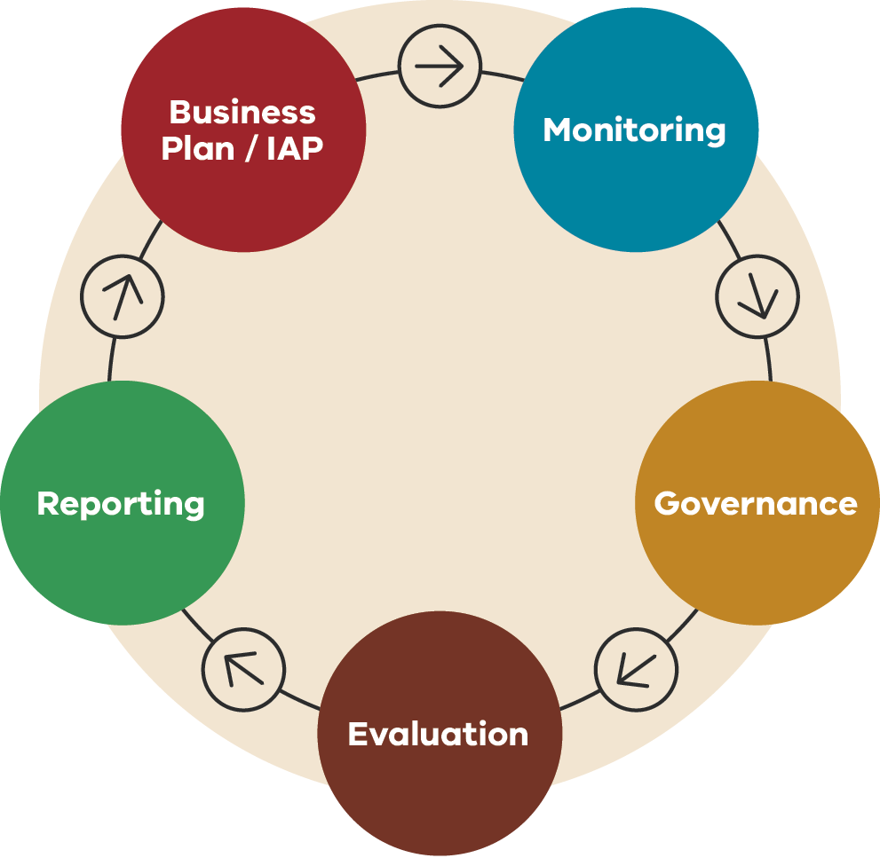
Figure 3 shows the implementation lifecycle as a continuous cycle of five stages, drawn as circles joined by arrows that run clockwise. The stages are Business Plan / IAP (Implementation Action Plan), Monitoring, Governance, Evaluation and Reporting. Reporting leads back to Business Plan / IAP, so the cycle repeats. Table 3 lists the stages in order.
Table 3: Implementation lifecycle – stages in order
Step | Stage | Leads to
1 | Business Plan / IAP | Monitoring
2 | Monitoring | Governance
3 | Governance | Evaluation
4 | Evaluation | Reporting
5 | Reporting | Business Plan / IAP (the cycle repeats)

Governance
Figure 4: Governance and accountability flowchart
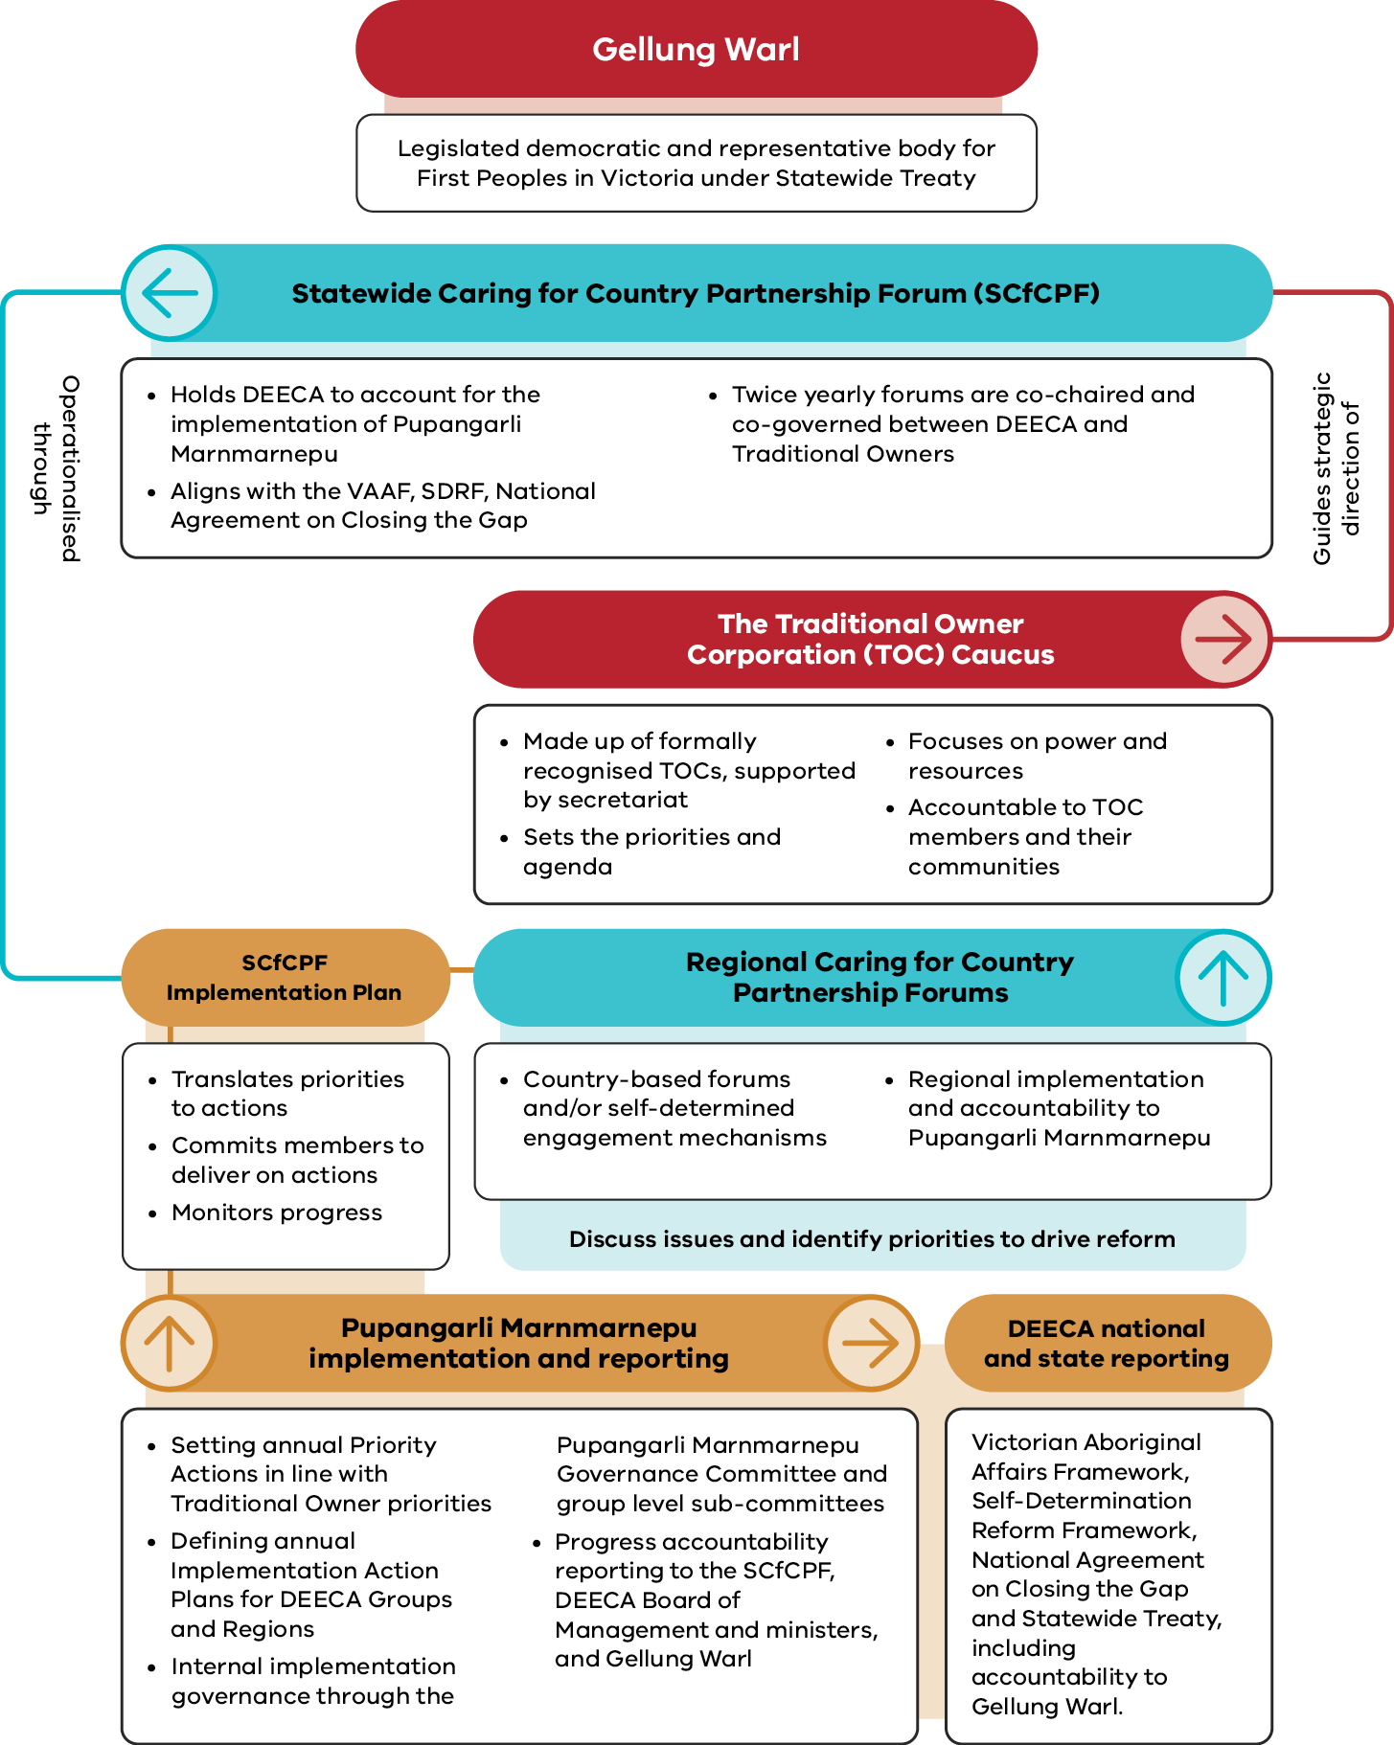
Figure 4 is a flowchart showing how governance and accountability work under Pupangarli Marnmarnepu. Gellung Warl is at the top. Below it, the Statewide Caring for Country Partnership Forum (SCfCPF) is linked to two other bodies by labelled arrows. The Traditional Owner Corporation (TOC) Caucus ‘guides strategic direction of’ the forum, and the forum is ‘operationalised through’ the SCfCPF Implementation Plan. Regional Caring for Country Partnership Forums sit beside the Implementation Plan. Below them, Pupangarli Marnmarnepu implementation and reporting leads to DEECA national and state reporting. Table 4 lists each part of the flowchart from top to bottom, with what the figure says about it and how it connects to the others.
Table 4: Governance and accountability – bodies, key points and connections
Body or group | What the figure says | Connections shown
Gellung Warl | Legislated democratic and representative body for First Peoples in Victoria under Statewide Treaty | Shown at the top of the flowchart, above the Statewide Caring for Country Partnership Forum.
Statewide Caring for Country Partnership Forum (SCfCPF) | - Holds DEECA to account for the implementation of Pupangarli Marnmarnepu  - Aligns with the VAAF, SDRF, National Agreement on Closing the Gap  - Twice yearly forums are co-chaired and co-governed between DEECA and Traditional Owners | Its strategic direction is guided by the TOC Caucus.  It is operationalised through the SCfCPF Implementation Plan.
The Traditional Owner Corporation (TOC) Caucus | - Made up of formally recognised TOCs, supported by secretariat  - Sets the priorities and agenda  - Focuses on power and resources  - Accountable to TOC members and their communities | Guides strategic direction of the SCfCPF.
Regional Caring for Country Partnership Forums | - Country-based forums and/or self-determined engagement mechanisms  - Regional implementation and accountability to Pupangarli Marnmarnepu  - Discuss issues and identify priorities to drive reform | Shown beside the SCfCPF Implementation Plan and linked to it.
SCfCPF Implementation Plan | - Translates priorities to actions  - Commits members to deliver on actions  - Monitors progress | The SCfCPF is operationalised through this plan.  Linked to the Regional Caring for Country Partnership Forums and to Pupangarli Marnmarnepu implementation and reporting.
Pupangarli Marnmarnepu implementation and reporting | - Setting annual Priority Actions in line with Traditional Owner priorities  - Defining annual Implementation Action Plans for DEECA Groups and Regions  - Internal implementation governance through the Pupangarli Marnmarnepu Governance Committee and group level sub-committees  - Progress accountability reporting to the SCfCPF, DEECA Board of Management and ministers, and Gellung Warl | Linked to the SCfCPF Implementation Plan above it.  Leads to DEECA national and state reporting.
DEECA national and state reporting | Victorian Aboriginal Affairs Framework, Self-Determination Reform Framework, National Agreement on Closing the Gap and Statewide Treaty, including accountability to Gellung Warl. | Follows Pupangarli Marnmarnepu implementation and reporting.

Gellung Warl
In accordance with the Statewide Treaty Act 2025 (Vic), DEECA is committed to working in partnership with the First Peoples Assembly of Gellung Warl, as the democratically elected ongoing representative body for First Peoples in Victoria responsible for implementing Treaty in Victoria in partnership with the State.
DEECA acknowledges that the relationship between First Nations governance bodies and Gellung Warl is a matter to be determined through Treaty processes between First Peoples and Gellung Warl.

Statewide Caring for Country Partnership Forum
In 2020, DEECA established the SCfCPF in partnership with the formally recognised TOCs, collectively known as the Traditional Owner Corporation Caucus (TOC Caucus).
The SCfCPF is a Traditional Owner-led forum that holds DEECA accountable for implementing Pupangarli Marnmarnepu. Held twice a year, the SCfCPF is co-chaired and co-governed by a senior executive of DEECA and a leader from the TOC Caucus, and adopts the strategic priorities of the TOC Caucus.
Through the SCfCPF, the TOC Caucus representatives engage with senior executives from DEECA and other government agencies. Together, they set and progress matters of high importance to them, in an active effort to transfer relevant decision-making powers and resources to Traditional Owners. This includes DEECA’s commitment to systemic reform that respects Traditional Owner decision-making, leadership, and self-governance.
The SCfCPF aligns with the VAAF, the SDRF and the National Agreement, which all highlight the need for Traditional Owner-led mechanisms to monitor and evaluate the implementation of government policies, ensuring the government is accountable to the community.
The SCfCPF Implementation Plan commits SCfCPF members to progress and deliver on actions that realise the strategic priorities of the TOC Caucus and SCfCPF. The plan aligns with Pupangarli Marnmarnepu.

Strengthening self‑determination through shared accountability
The SCfCPF Implementation Plan turns the shared priorities of the formally recognised Traditional Owner groups represented through the TOC Caucus into time-bound, government-wide commitments with clear ownership and reporting.
Led by the TOC Caucus and co-designed with DEECA, Parks Victoria and the Department of Premier and Cabinet, the plan aligns with Pupangarli Marnmarnepu by shifting decision-making power and resourcing towards Traditional Owners, so priorities for Country are set and progressed through Traditional Owner governance, not just input.
Accountability is built into the plan, actions have nominated owners, progress is reviewed through the SCfCPF, and government reports back on delivery, barriers and resourcing. In practice, this has enabled partners to move from broad intent to on-the-ground outcomes.
These include:
- supporting pilot programs to develop place-based, culturally significant species plans
- exploring the development of a Biocultural Diversity Strategy with the TOC Caucus
- improving investment pathways by aligning biodiversity funding with Traditional Owner outcomes for Country.
The plan also drives cross-group collaboration by tasking the Regions, Environment, Climate Action and First Peoples Group, and the Bushfire and Forest Services Group to identify pathways for Traditional Owner participation in emergency management decision-making and by embedding self-determined biocultural priorities into DEECA emergency plans, programs, policy and training.

Traditional Owner Corporation Caucus
The TOC Caucus was established by agreement between the formally recognised TOCs across Victoria. The TOC Caucus is a voice for self‑determination. It guides engagement with government on matters related to Country and on broader short, medium and long-term priorities for Country and the communities it represents.
The primary focus of the TOC Caucus is the transfer of power and resources from the government to Traditional Owners. Accordingly, the TOC Caucus is accountable only to its membership and communities.
The TOC Caucus meets before each SCfCPF to guide the SCfCPF business, develop agenda items, and prioritise matters for consideration.

One-DEECA approach: collective responsibility for self‑determination

DEECA leadership
DEECA leaders are responsible for setting the direction, expectations and conditions for self-determination to be embedded across the department. This includes providing clear strategic leadership, strong governance and decision-making, and being accountable for delivering Pupangarli Marnmarnepu.
Leaders are responsible for:
- overseeing progress, resourcing and performance
- ensuring alignment with government commitments, Treaty and Traditional Owner obligations
addressing systemic barriers where they arise.
Through active oversight, collaboration and continuous improvement, DEECA leadership sets the tone for collective accountability. It ensures self-determination is prioritised, consistent, and sustained across all Groups, Regions and functions.

All DEECA staff
All DEECA staff play a vital role in advancing First Peoples self-determination in how they plan, work, engage, make decisions and partner with Traditional Owners across all areas of DEECA’s business.
Traditional Owners in Victoria represent some of the world’s oldest continuing cultures, with deep knowledge, rights and responsibilities to Country. By working respectfully and in genuine partnership, DEECA staff contribute to better decision-making, stronger outcomes for Country and community, and a more just and inclusive Victoria.

Outcomes and Accountability Framework
Figure 5: Outcomes pathway model
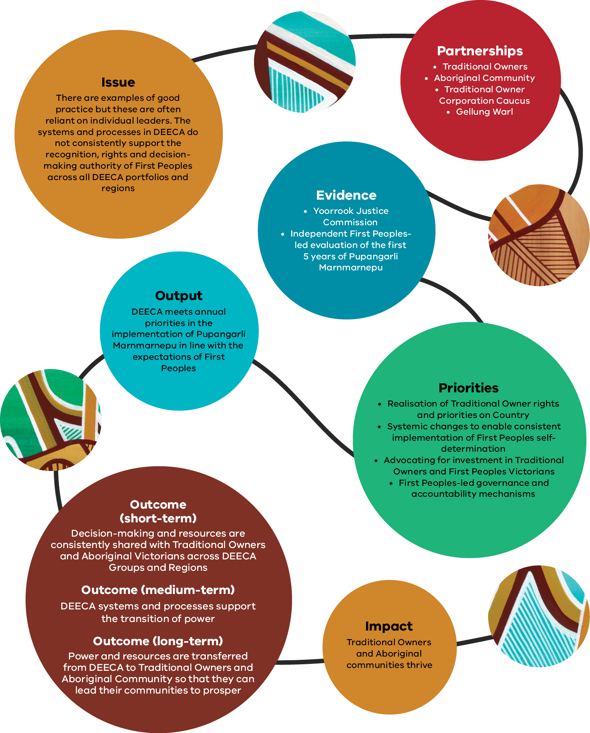
Figure 5 is a pathway model that shows how Pupangarli Marnmarnepu moves from an issue to an impact. It is drawn as a winding line linking nine circles, read in this order: Issue, Partnerships, Evidence, Priorities, Output, Outcomes (short-term, medium-term and long-term) and Impact. Decorative artwork between some circles is not described. Table 5 lists each stage in order with the text shown in the figure.
Table 5: Outcomes pathway model – stages in order
Stage | What the figure says
- Issue | There are examples of good practice but these are often reliant on individual leaders. The systems and processes in DEECA do not consistently support the recognition, rights and decision-making authority of First Peoples across all DEECA portfolios and regions
- Partnerships | - Traditional Owners  - Aboriginal Community  - Traditional Owner Corporation Caucus  - Gellung Warl
- Evidence | - Yoorrook Justice Commission  - Independent First Peoples-led evaluation of the first 5 years of Pupangarli Marnmarnepu
- Priorities | - Realisation of Traditional Owner rights and priorities on Country  - Systemic changes to enable consistent implementation of First Peoples self-determination  - Advocating for investment in Traditional Owners and First Peoples Victorians  - First Peoples-led governance and accountability mechanisms
- Output | DEECA meets annual priorities in the implementation of Pupangarli Marnmarnepu in line with the expectations of First Peoples
- Outcome (short-term) | Decision-making and resources are consistently shared with Traditional Owners and Aboriginal Victorians across DEECA Groups and Regions
- Outcome (medium-term) | DEECA systems and processes support the transition of power
- Outcome (long-term) | Power and resources are transferred from DEECA to Traditional Owners and Aboriginal Community so that they can lead their communities to prosper
- Impact | Traditional Owners and Aboriginal communities thrive
The Outcomes and Accountability Framework defines the outcomes under Pupangarli Marnmarnepu and how they will be measured to strengthen DEECA’s accountability to the strategy.
Outcomes and measures are informed by:
- existing national and state obligations (see section 1.3)
priorities of and feedback from Traditional Owners and DEECA staff.
This framework acknowledges the accountability role of Gellung Warl. DEECA will work with Gellung Warl to agree on reporting and accountability arrangements, including data sharing agreements.
Refreshed whole-of-Victorian government strategies will inform this work, including a new Victorian Closing the Gap Implementation Plan and the state response to the Yoorrook for Transformation final recommendations.
All domains are enabled by DEECA staff who adhere to and respect the DEECA Traditional Owner and Aboriginal Community Engagement Framework.
‘Measurable targets serve as benchmarks against which the State and First Peoples can assess progress, ensuring that commitments translate into tangible results.’
Outcomes, measures and enablers are listed in the tables on pages 65 to 77.
Outcomes are statements that describe a desired end state for individuals, organisations and communities. There is one overarching outcome statement per domain.
Contributing outcomes are important pre‑conditions for the overarching outcome statement to be achieved.
Three types of Measures track progress towards the outcomes:
- 'Targets' quantify the size, amount or degree of change required to contribute to an outcome (for example, a percentage amount by a certain date).
- 'Indicators' clarify the nature and direction of the desired change that contributes to an outcome. For example, it may increase or decrease.
'Qualitative measures' describe important, non-numeric performance expectations to contribute to an outcome.
Measures in bold align with existing systems and processes for collecting evidence and data, enabling progress to be monitored and evaluated.
Measures not in bold do not yet have established data collection systems, reflecting Pupangarli Marnmarnepu’s expanded focus on self-determination outcomes for First Peoples. DEECA will establish the necessary processes to collect, monitor and evaluate these measures in line with Traditional Owner expectations.

People outcomes and measures
Outcome 1: DEECA is a culturally safe and capable department, supported by a strong First Peoples workforce, that works in genuine partnership with Traditional Owners to build workforce capability and deliver priorities for Country.
Table 6: People domain – contributing outcomes, outcome measures and self-determination enablers
Contributing outcomes | Outcome measures | Self-determination enablers
- DEECA strengthens Traditional Owner Corporation workforce and capability through coordinated support, place-based approaches, and partnership workforce models. | - Increase in DEECA and Traditional Owner Corporation staff who have participated in Traditional Owner Corporation Knowledge Exchange program (Indicator).  - Capacity and capability support is planned, and funding is sought as core business and reviewed over time, and seeks to cover the cost of culturally safe delivery, including in remote areas (Qualitative). | - Prioritise culture  - Transfer power and resources
- DEECA staff consistently work in culturally safe ways that respect Traditional Owner cultural authority, and racism is identified, addressed and prevented. | - 100% of First Peoples staff report a culturally safe workplace (Target).  - 100% of DEECA staff complete Aboriginal Cultural Safety Training (Target).  - 100% of DEECA staff have Aboriginal Cultural Capability Goals as part of their Professional Development Plans (Target).  - All DEECA staff adhere to and apply the First Peoples Language Guide consistently and appropriately to their work (Qualitative).  - Executives and managers respond to cultural safety issues and instances of racism early and appropriately (Qualitative).  - First Peoples staff access supports (for example: the Aboriginal Staff Network) to ensure they are culturally safe at work (Qualitative). | - Prioritise culture  - Address racism and promote cultural safety
- Strong First Peoples workforce participation and retention in all DEECA Groups and at all levels. | - First Peoples staff make up 3% of DEECA employees (Target).  - 50% of the DEECA First Peoples workforce are women (Target).  - 20% of the DEECA First Peoples workforce are in VPS6 and executive positions (Target).  - Desirable roles are available for First Peoples, particularly roles relevant to the Aboriginal Community, such as in Treaty, engagement, employment, and cultural policy (Qualitative).  - Executives and line managers support First Peoples staff to undertake training matched to their learning and development goals (Qualitative).  - First Peoples staff develop skills and knowledge which support them to grow into more senior roles at DEECA (Qualitative). | - Address trauma and support healing  - Address racism and promote cultural safety  - Transfer power and resources
Progress on the People domain is aligned with and will be delivered in part through internal DEECA workforce and cultural capability strategies and guidance.
A suite of guidelines and frameworks is also being designed to support DEECA staff to consistently implement a culturally safe workplace. This includes:
- a culturally safe recruitment framework and supporting toolkit for hiring managers
guidance on Aboriginal cultural capability goals for all Victorian Public Service levels.

Systems outcomes and measures
Outcome 2: DEECA’s systems, funding and planning settings remove barriers and consistently enable Traditional Owners to lead, deliver and govern work on Country.
Table 7: Systems domain – contributing outcomes, outcome measures and self-determination enablers
Contributing outcomes | Outcome measures | Self-determination enablers
- Advance Traditional Owner economic development and prosperity by supporting long-term planning, enterprise growth and delivery of self-determined works on Country. | - Increase in the number of Aboriginal-owned businesses and Traditional Owner enterprises engaged (Indicator).  - Increase in spend on Aboriginal-owned businesses and Traditional Owner enterprises (Indicator).  - Increase in proportion of funding agreements that are multi-year and indexed, enabling Traditional Owner workforce stability (Indicator).  - Increase in multi-year, higher value agreements supporting funding to Traditional Owners for core, recurring programs (Indicator).  - Increase in funding models that include core operating costs in addition to direct program delivery (for example, administration, travel, vehicles, safety gear, insurance, governance time), resulting in fewer interruptions and less cost shifting onto Traditional Owners (Indicator).  - Removal of internal DEECA procurement barriers to engage Traditional Owner enterprises and Aboriginal-owned businesses (Qualitative). | - Transfer power and resources
- Embed Traditional Owner priorities in DEECA planning and policy settings, so programs and approvals enable Traditional Owner-led delivery and cultural practice on Country. | - DEECA budget submissions and work plans align with Traditional Owner-authored strategies (for example Country Plans), and Traditional Owners can see their priorities reflected in requested and funded activities (Qualitative).  - Policy, permit and approval frameworks and settings are consistent across DEECA sectors and Regions and remove unnecessary barriers to Traditional Owner-led activity (for example, clearer exemptions and streamlined pathways, fewer inappropriate third-party access approvals, and less red tape and rework) (Qualitative).  - Statewide frameworks for each sector for engaging with and enabling Traditional Owner delivery are developed, understood and consistently delivered (Qualitative). | - Prioritise culture  - Transfer power and resources
- Make engagement and decision-making consistent across DEECA, so Traditional Owners can influence early, choose their level of engagement, and avoid duplication and consultation fatigue. | - Traditional Owners can see DEECA’s forward agenda and decision points, with clear contacts and better lead times to self-determine their involvement and influence early (Qualitative).  - DEECA engagement with Traditional Owners and Aboriginal Community is purposeful and staged with appropriate timeframes, clear feedback and closure, and faster issue resolution through clear escalation pathways (Qualitative).  - DEECA staff understand the process for Traditional Owners to self-determine how they are involved in DEECA work, with DEECA executives accountable for ensuring staff capacity to enable this (Qualitative). | - Address racism and promote cultural safety  - Transfer power and resources
- Recognise and enable Indigenous Data Sovereignty. | - Guidance and direction for staff on how to respect Indigenous Data Sovereignty is implemented across DEECA’s policy settings by 2028 (Qualitative).  - Traditional Owners have authority over the collection, use, access, and reporting of data about Country and biocultural values, with joint data governance and management systems in place (Qualitative). | - Transfer power and resources
Progress on the Systems domain is aligned with internal DEECA policies and guidance relating to social procurement, Indigenous Data Sovereignty, and First Peoples monitoring and evaluation.
DEECA provides guidance to staff to support the consistent application of First Peoples self-determination across project planning and delivery. Requirements for embedding First Peoples’ priorities into the DEECA budget process are explained and refreshed annually. Guidance on good practice grants management with First Peoples is also under development.

Country outcomes and measures
Outcome 3: DEECA recognises Traditional Owners as rights holders on Country and upholds their cultural authority, so they lead decisions and actions affecting land, water, fire, biodiversity, climate action, energy, resources and cultural landscapes.
Table 8: Country domain – contributing outcomes, outcome measures and self-determination enablers
Contributing outcomes | Outcome measures | Self-determination enablers
- Traditional Owner priorities are integrated into co-led strategies and plans for all DEECA portfolio areas. | - DEECA Groups are working with relevant First Peoples-led governance to understand Traditional Owner priorities within their portfolio area (Qualitative).  - As self-determined by Traditional Owners, DEECA Groups have Traditional Owner-led strategies and/or plans in place as relevant to their portfolio areas and in response to Yoorrook Justice Commission evidence, findings and recommendations (Qualitative).  - Increase in the proportion of Traditional Owner priorities which are embedded in Pupangarli Marnmarnepu Implementation Action Plans (Indicator). | - Prioritise culture  - Transfer power and resources  - Address trauma and support healing
- Enable Traditional Owner-led cultural fire through consistent decision-making frameworks, support, and appropriate escalation pathways. | - Number of Cultural Burns planned and approved against a seasonal target set annually with Traditional Owners (Target).  - Number of Cultural Burns delivered against a seasonal target set annually with Traditional Owners (Target) – noting achieving targets may be limited by weather conditions.  - Reduced roadblocks, and fewer region-by-region negotiations through more consistent processes for Traditional Owner-led cultural fire (Qualitative).  - Traditional Owner-led burns occur without repeated re-negotiation, supported by consistent statewide standards, improved training access and clear escalation pathways (Qualitative). | - Prioritise culture  - Transfer power and resources  - Address trauma and support healing
- Strengthen water governance, cultural flows and economic prosperity by enabling Traditional Owner access, ownership and management of water. | - Increase in the water entitlements held by Traditional Owners (Indicator).  - Traditional Owners are recognised as decision-makers in caring for water landscapes (Qualitative).  - Address and remove barriers within the water sector and Victorian water entitlement framework to increase Traditional Owner access to water (Qualitative).  - Traditional Owners are supported to partner with the water sector to design, deliver and manage water-related services (Qualitative). | - Prioritise culture  - Transfer power and resources  - Address trauma and support healing
- Enable Traditional Owner rights and access to Country by advancing land access and return pathways. | - Closing the Gap Target 15: increase of 15% on 2020 levels on the area of land mass and sea Country subject to Aboriginal legal rights or interests by 2030 (Target).  - Increase in land under Aboriginal Title Area (Indicator).  - Increase in area jointly managed between DEECA and Traditional Owners (Indicator).  - Once land is returned, options within DEECA control are explored to transfer additional resources to Traditional Owners to support rehabilitation (Qualitative). | - Prioritise culture  - Transfer power and resources
- Enable access to Country in line with formal agreements or through approval processes that recognise Traditional Owner authority. | - Reduce the administrative burden associated with frequent permit re-approval requirements (Qualitative).  - Regulatory and permit frameworks and guidance embed the Traditional Owner role with clear rules to support cultural practices (for example, wildlife, native seed collection) (Qualitative). | - Address racism and promote cultural safety  - Transfer power and resources
Progress on the Country domain is aligned to and will be delivered in part through the implementation of the DEECA Water is Life Roadmap.
Other key Traditional Owners-led strategies that inform DEECA priorities on Country include:
- Victorian Traditional Owner Cultural Fire Strategy (PDF)
- Victorian Traditional Owner Cultural Landscapes Strategy (PDF)
- Victorian Traditional Owner Native Food and Botanicals Strategy (PDF)
More First Peoples-led portfolio-specific strategies are also under development, including the DEECA First Peoples Renewable Energy Strategic Plan. Work on Country will also be shaped by progressing the Victorian Critical Minerals Roadmap (Theme 4: Sharing the Benefits of Victoria’s Minerals).

Accountability outcomes and measures
Outcome 4: DEECA is accountable for delivering commitments to Traditional Owners and Aboriginal Victorians, with transparent reporting, Aboriginal-led oversight, and corrective actions when commitments are not met.
Table 9: Accountability domain – contributing outcomes, outcome measures and self-determination enablers
Contributing outcomes | Outcome measures | Self-determination enablers
- DEECA fulfils its legal obligations to relevant Traditional Owner Corporations in accordance with established agreements. | - 10% natural resource management minimum procurement spend is met for Traditional Owner Groups with a Natural Resource Agreement (Target).  - DEECA meets Traditional Owner Native Title and Traditional Owner Settlement Act 2010 procedural rights (LUAA, NRA processes) (Qualitative).  - DEECA meets government obligations under Statewide Treaty (Qualitative). | - Prioritise culture  - Transfer power and resources
- DEECA is accountable for delivery of self-determination, with transparent tracking, and agreed escalation when commitments are not met. | - DEECA Groups maintain a minimum of 70% Traditional Owner satisfaction with DEECA's approach to self-determination (Target).  - Gellung Warl and Traditional Owner Groups view DEECA as an exemplar partner that has addressed systemic injustice and transferred power and resources to enable self-determination (Qualitative).  - DEECA transparently reports commitments under the Closing the Gap reforms and targets (Qualitative).  - There is documented evidence of early involvement and Traditional Owner influence in DEECA business (Qualitative).  - There is documented evidence on the report back to Traditional Owners on the outcomes of engagements and partnerships (for example, ‘you said/we did’ reporting) (Qualitative).  - Agreed escalation pathways are used to resolve non-delivery, with corrective actions agreed and applied (Qualitative). | - Transfer power and resources  - Prioritise culture  - Address racism and promote cultural safety  - Address trauma and support healing
- DEECA operates in genuine partnership with Traditional Owners and demonstrates shared decision-making through Traditional Owner-led governance mechanisms. | - Statewide Caring for Country Partnership Forum, portfolio specific and regional forums focus on systemic reform and decision-making, with adequate time and authority to resolve or escalate issues (Qualitative).  - Statewide, portfolio specific and regional forum priorities are progressed and completed in line with Traditional Owner expectations (Qualitative).  - DEECA maintains a formal and ongoing partnership with Gellung Warl in accordance with Statewide Treaty and agreed governance arrangements (Qualitative). | - Transfer power and resources  - Prioritise culture  - Address trauma and support healing
Progress on the Accountability domain is aligned with, and will be delivered in part through:
- the implementation of the Traditional Owner Agreements Accountability Framework
reporting on the progress of DEECAs First Peoples commitments to the SCfCPF, and DEECA executive and ministers, as relevant to their portfolios.

Planning and delivery
To achieve progress towards the Outcomes and Accountability Framework, DEECA will develop annual Pupangarli Marnmarnepu Implementation Action Plans (IAPs). IAPs will be developed annually by DEECA Groups and Regions, in consultation with DEECA’s First Peoples Self-Determination Division, as part of the business planning process. They will be based on information gained through conversations with Traditional Owners and on the outcomes and priorities in Pupangarli Marnmarnepu. DEECA will also continue to work with the TOC Caucus to improve its oversight of the annual IAP process.
All groups will be responsible for supporting annual progress towards Shared Priority Actions and Group Specific Actions. For the first year of Pupangarli Marnmarnepu
(2026–27) all Groups have a responsibility to include the five Shared Priority Actions:
- As relevant to their portfolios, DEECA Groups:
- implement and acquit DEECA’s legal obligations to Traditional Owners (Treaty, Native Title, and Traditional Owner Settlement Agreements)
- implement and acquit DEECA tasks as part of national and state commitments to First Peoples self-determination.
- Recruit, support, develop and retain First Peoples staff at DEECA and support workforce development in TOCs through the implementation of the First Peoples Workforce Strategy.
- Enhance Aboriginal cultural capability within the department by implementing the Aboriginal Cultural Capability Framework.
- Enable Traditional Owner economic independence and prosperity through the DEECA Social Procurement Strategy and systems.
- Strengthen engagement and outcomes under the SCfCPF and in partnership with Traditional Owners in line with the TOACEF.
All Groups will also revise Group Specific Actions on an annual basis to ensure they are focused on:
- the priorities of the SCfCPF and portfolio-specific First Peoples-led governance groups
- transferring power and resources to First Peoples (self-determination)
- facilitating economic development for First Peoples
responding to Pupangarli Marnmarnepu evaluation and evidence and findings from Yoorrook.
DEECA Regions will continue to deliver place-based Pupangarli Marnmarnepu actions which are focused on:
- the priorities of Traditional Owners (including those outlined in relevant TOC Country Plans and other strategic documents)
- transferring power and resources to First Peoples (self-determination)
- facilitating economic development for First Peoples where it is a place-based priority
responding to Pupangarli Marnmarnepu evaluation and evidence and findings from Yoorrook.
Pupangarli Marnmarnepu IAPs will be revised annually to ensure they are embedded and aligned with the expectations and priorities of First Peoples and balanced with DEECA constraints (for example, resourcing and ministerial directions). Where DEECA constraints conflict with the priorities of Traditional Owners or the SCfCPF, DEECA will collaborate with them to advance or advocate for those priorities using available mechanisms.

DEECA reporting

First Peoples-led monitoring and evaluation
Acknowledging and committing to the State’s obligations under the Statewide Treaty Act (2025) and the accountability functions that sit with Gellung Warl, DEECA will continue to report progress and performance against Pupangarli Marnmarnepu through the SCfCPF and review these arrangements as required to align with Treaty.
The SCfCPF will receive an annual Pupangarli Marnmarnepu outcomes and highlights report and biannual updates on the implementation of SCfCPF priorities. DEECA will work with the SCfCPF to ensure reporting is meaningful and supports accountability.
All DEECA Groups will be supported to implement portfolio-level monitoring and evaluation in line with the standards set out in DEECA’s First Peoples Monitoring and Evaluation Guidelines. The guidelines support DEECA Groups in embedding consistent practices for implementing First Peoples self-determination in all monitoring and evaluation activities across the department.

Corporate reporting
To drive internal implementation and accountability:
- Shared Priority Actions in annual IAPs will be reported on quarterly
- Group Specific Actions will be reported on monthly (as part of the broader DEECA Business Plan).
Key risks and issues will be analysed, discussed and actioned through the Pupangarli Marnmarnepu Governance Committee and associated sub-committees quarterly.
DEECA’s progress on First Peoples commitments, including any issues or risks to implementation, will also be reported to ministers as relevant to their portfolio on a quarterly basis.
Monthly and quarterly reporting will also serve as the basis for acquitting whole-of-Victorian government First Peoples commitments and reporting (for example, DEECA commitments under the National Agreement).
DEECA will also submit an annual Pupangarli Marnmarnepu outcomes and highlights report, prepared for the SCfCPF, to the Department of Premier and Cabinet as input to reporting and accountability to First Peoples, including any Treaty-related reporting requirements set by Gellung Warl.

From obligations to accountability: Traditional Owner agreements in practice
DEECA has legal obligations under Recognition and Settlement Agreements made through the Traditional Owner Settlement Act 2010 (Vic). To support transparent and meaningful conversations with Traditional Owner Corporations about how these obligations are carried out, FPSDD developed the Traditional Owner Agreements Accountability Framework.
The framework is designed to strengthen partnerships, improve accountability and support better delivery of commitments. It includes quarterly reporting and a light touch evaluation planned for 2026. The framework will be expanded to include the Taungurung and Gunaikurnai agreements, as well as obligations under the Native Title Act 1993.
One accountability under the Dja Dja Wurrung Natural Resource Agreement (NRA) is to take all necessary steps to ensure that DJAARA members’ NRA take and use rights are recognised on Country.
To support effective accountability against this commitment, FPSDD and Conservation Regulator staff worked together to develop practical materials for DEECA staff – particularly Authorised Officers – to strengthen understanding of Traditional Owner rights enabled through agreements.
The materials clarified DEECA’s interpretation of NRA take and use rights under the Dja Dja Wurrung NRA and supported collaboration with DJAARA to confirm a shared understanding of these rights. This process also provided a forum to work through member relevant questions and real-world scenarios.
In addition, Authorised Officers from DEECA, Parks Victoria and other agencies completed DJAARA-led Cultural Competency and RSA training, strengthening their understanding of Djaara people, culture, history and the agreement.
DJAARA has indicated it would like to host a future meet and greet workshop involving Authorised Officers, State representatives and Members. DEECA will support the delivery of this workshop and advocate for it to become a regular forum.

Appendices

Appendix 1: The 11 self-determination guiding principles
The 11 guiding principles of Aboriginal self-determination were developed following extensive engagement with Aboriginal Victorians for the Victorian Aboriginal Affairs Framework. These principles underpin all action to progress Aboriginal self-determination.
DEECA action should be consistent with the guiding principles:

HUMAN RIGHTS
Self-determination initiatives honour the norms set out in the United Nations Declaration for the Rights of Indigenous Peoples and the Victorian Charter of Human Rights and Responsibilities.

CULTURAL INTEGRITY
As First Nations peoples, the rich, thriving cultures, knowledge and diverse experiences of Aboriginal people, including where they fit with family, community and society, will be recognised, valued, heard and celebrated.

COMMITMENT
Aboriginal self-determination will be advanced and embedded through planned action that is endorsed by, and accountable to, all parties.

ABORIGINAL EXPERTISE
Government and agencies will seek out, value and embed Aboriginal culture, knowledge, expertise and diverse perspectives in policies and practice.

INVESTMENT
Investment to support self-determination will be sustainable, flexible and appropriate to strengthen Aboriginal peoples’ aspirations and participation, including around economic participation, economic independence and building wealth.

EQUITY
Systemic and structural racism, discrimination and unconscious bias and other barriers to Aboriginal self-determination will be actively identified and eliminated.

ACCOUNTABILITY
All parties responsible for delivering outcomes involving Aboriginal people will be held accountable and subject to Aboriginal-led, independent and transparent oversight.

PARTNERSHIP
Partnerships will advance Aboriginal autonomy through equitable participation, shared authority and decision-making, and will be underpinned by cultural integrity.

DECISION-MAKING
Decision-makers will respect the right to free, prior and informed consent and individual choice and will prioritise the transfer of decision-making power to Aboriginal people in areas that impact their communities.

EMPOWERMENT
Aboriginal people will have autonomy and participation in the development, design, implementation, monitoring and evaluation of legislation, policies and programs that impact their communities.

CULTURAL SAFETY
Programs and services accessed by Aboriginal people will be inclusive, respectful, responsive and relevant, and informed by culturally safe practice frameworks.

Endnotes

Yoorrook Justice Commission, Yoorrook for Transformation: Third Interim Report (2025), Volume 1, p. 138
At the time of strategy development, a third socio-economic target relevant to the DEECA portfolio was also under development to clarify a Victoria-specific inland waters target.
Article 3, United Nations Declaration on the Rights of Indigenous Peoples, p. 8
Yoorrook Justice Commission, Yoorrook for Transformation: Third Interim Report (2025), Volume 5, p. 50
Yoorrook Justice Commission, Yoorrook for Transformation: Third Interim Report (2025), Volume 2, p. 298
Yoorrook Justice Commission, Yoorrook for Transformation: Third Interim Report (2025), Volume 1, p. 145
Yoorrook Justice Commission, Yoorrook for Transformation: Third Interim Report (2025), Volume 2, p. 35
Yoorrook Justice Commission, Yoorrook for Transformation: Third Interim Report (2025), Volume 1, p. 37
Yoorrook Justice Commission, Yoorrook for Transformation: Third Interim Report (2025), Volume 1, p. 37 End of document.

