Loading a WMS in ArcMap
  - Web Map Service (WMS)
Introduction
Web Mapping Services (WMS) can be used in ArcMap as map layers. A WMS is a standard protocol for distributing georeferenced map images over the internet. WMS are ”pre-styled” (ie outline colour, fill colour and labelling styles are fixed and cannot be changed by the end user). ISD produces WMS using Geoserver (open source).

Loading WMS layers into ArcMap
- To access Geoserver web map data (WMS)
  - Launch ArcMap and open your MXD
  - Open the Catalog window (Windows > Catalog)
  - Double click Add WMS Server (under GIS Servers)
  - Paste the following URL into the URL drop down list:
https://opendata.maps.vic.gov.au/geoserver/ows?service=WMS&request=getCapabilities

  - Click OK

  - This will create a WMS Server connection called “DELWP Web Map Service on services.land.vic.gov.au” Expanding this connection will give a long list of layers that can be added to your map. Drag the WMS of interest into the Table of Contents

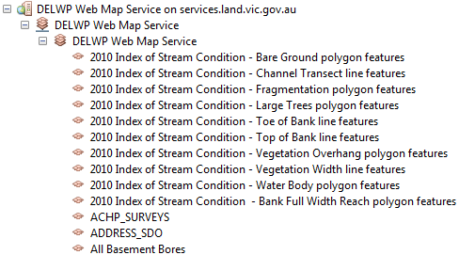

For more help please email:
GIS.Helpdesk@delwp.vic.gov.au

