Department of Jobs,
Precincts and Regions
Harvest Level in Victorian Regional Forest Agreement regions
NOVEMBER 2021

Table of contents
1 Executive summary 4
2 Introduction 6
3 Purpose 8
4 Regional Forest Agreements 9
4.1 Public forest tenures in Victorian RFAs 9
4.1.1 West Victoria 11
4.2 Bushfire Impacts 12
5 Ecologically Sustainable Forest Management 13
6 Victorian timber resources 15
6.1 Eastern forest area for timber harvesting 15
6.2 Timber harvesting in western Victoria 16
7 Forest resource modelling and methodology 17
7.1 Victoria’s Strategic Wood Supply Model 18
7.2 Forecasting structure and growth rates 19
7.3 Constraints 19
8 Harvest Level 21
9 Bushfire impacts 22
9.1 Timber volume reductions ash and mixed species 22
9.2 Modelled impacts of the 2019-20 bushfires 23
9.2.1 VicForests’ fire severity mapping 23
9.2.2 Salvage harvesting 24
10 Further policy and regulatory obligations 26
10.1 Ongoing detections and protections for threatened species and communities 26
10.2 Timber harvesting regulatory framework 27
11 Appendix A: Relevant clauses of the RFAs 28
11.1 Harvest Level 28
12 Appendix B: Text alternative for figures 2 to 6 and 9 29
12.1 Figure 2: Central Highlands 29
12.2 Figure 3: East Gippsland 29
12.3 Figure 4: Gippsland 29
12.4 Figure 5: North East 29
12.5 Figure 6: West Victoria 29
12.6 Figure 9: Eastern Victoria 30
13 Appendix C: Text alternative for flowchart of Victoria’s timber harvesting regulatory framework 31
13.1 Forests Act 1958 (Vic) 31
13.1.1 Forests (Licences and Permits) Regulations 2019 (Vic) 31
13.2 Conservation, Forests and Lands Act 1987 (Vic) 31
13.2.1 Code of Practice for Timber Production 31
13.3 Sustainable Forests (Timber) Act 2004 (Vic) 32
13.4 Flora and Fauna Guarantee Act 1988 (Vic) 32
14 Appendix D: Text alternative for constraints diagram 33
15 Appendix E: Glossary 34
16 References 36

List of Figures and tables
Figures
Figure 1: Map of Victoria's RFA regions including public and private forested area 9
Figure 2: Public forest tenure and proportion of State forest that is available and suitable for timber production in the Central Highlands RFA 10
Figure 3: Public forest tenure and proportion of State forest that is available and suitable for timber production in the East Gippsland RFA 10
Figure 4: Public forest tenure and proportion of State forest that is available and suitable for timber production in the Gippsland RFA 11
Figure 5: Public forest tenure and proportion of State forest that is available and suitable for timber production in the North East RFA 11
Figure 6: Public forest tenure in the West Victoria RFA region 12
Figure 7: Map of forest within the 2019-20 bushfire extent in Victorian RFA regions 12
Figure 8: Victoria’s State forest timber harvesting regulatory framework under Victoria’s Forest Management System. 13
Figure 9: Public forest tenure and proportion of State forest that is available and suitable for timber production in Victoria’s eastern RFA regions 15
Figure 10: Resource modelling process for eastern Victoria 18
Figure 11: Constraints to timber harvesting in east Victoria 20
Tables
Table 1: Forest area available and suitable for timber production in eastern Victorian RFA regions 16
Table 2: Maximum D+ sawlog volume (including margin) that is available for timber harvesting in each eastern Victorian RFA region per financial year (as at August 2021) 21
Table 3: Gross bushfire impact on the total operable inventory of ash and mixed species eucalypt D+ sawlog disaggregated by RFA region (as at August 2021) 22
Table 4: VicForests' fire severity classes and descriptions 23
Table 5: Nett bushfire impacts on operable D+ sawlog inventory for ash and mixed species following salvage harvesting operations (as at 30 June 2021) 25

Executive summary
This report meets Victorian commitments under the Victorian Regional Forest Agreements (RFAs) to:
- Forecast and make publicly available the Harvest Level from State forests in the RFA region; and
- Commence a review of the Harvest Level within 12 months of a Major Event with the potential to significantly impact the Harvest Level (Appendix A).
This report is not a resource outlook and does not represent the volume of commercial timber resources that will be made available to the market. The current timber supply commitments are less than Harvest Level volumes presented in this report. Harvest volumes will not be harvested at their maximum level. The margin between the Harvest Level volumes and supply volumes to the market does not represent capacity to reduce harvestable areas or increase supply, as there are further considerable restraints on volume beyond the forecasted maximum Harvest Level (for example, detection-based threatened species reservations). This margin must be maintained to retain flexibility in forestry operations.
In March 2020, the Commonwealth and Victorian governments modernised and extended the Victorian RFAs. The Victorian RFAs are agreements between the Victorian and Commonwealth governments that provide for sustainable management and use of Victoria’s forests (Department of Environment, Land, Water and Planning [DELWP] 2020); Department of Agriculture, Water and Environment [DAWE] 2020). There are five RFAs in Victoria: Central Highlands, East Gippsland, Gippsland, North East and West Victoria. Under the five RFAs, Victoria’s forest management system (including legislation, polices, codes, plans and management practices) provides for continuous improvement in relation to ecologically sustainable forest management (ESFM).
Fires impacted Victoria between November 2019 and March 2020, predominantly in the east and north-east of the state. Approximately 1.3 million hectares of public forest across Victoria was fire-affected (Victorian and Australian Governments 2021). East Gippsland was the most severely affected RFA region with 757,305 hectares of public forest within the bushfire extent. Figures for other RFAs were Gippsland, 277,729 hectares; North East, 270,369 hectares; Central Highlands, 4 hectares and West RFA, 10,823 hectares (Victorian and Australian Governments 2021).
The 2019-20 bushfires were identified as a Major Event for the purposes of conducting a Major Event Review. This decision triggered a review of the Harvest Level. Consequently, the Harvest Level in this report, which considers the bushfire impacts where relevant, is the first Harvest Level Victoria has published since the RFAs were modernised and extended in 2020.
Harvest levels are calculated differently in the east and west of the state. In the east of the state, VicForests uses a complex multi-stepped forest modelling process to forecast Harvest Levels. In the west of the state VicForests manages small-scale timber harvesting licences under a community forestry program. Due to the significant difference in resources and level of harvesting, harvest levels in the west are assessed on a cutting-cycle model. These are based on the Review of Commercial Forestry Management in Western Victoria Timber Resources, Harvest Levels, Silviculture, and Systems and Processes, published in 2013 (Department of Environment and Primary Industries [DEPI] 2013). Harvest levels in the west continue to be guided by the 2013 review under the modernised West Victoria RFA.
VicForests’ multi-stepped forest resource model that underpins the Harvest Level incorporates bushfire impacts. After considering the bushfire impacts on the available timber volume in eastern Victoria, Victoria’s annual timber supply commitments can still be met and support ecologically sustainable forest management. The timber resource in the West Victoria and Central Highlands RFAs were not impacted by the bushfires.
Harvest Levels in this report are expressed as D+ sawlog volume in the eastern RFA regions as at August 2021. The maximum potential Harvest Levels for D+ sawlog as at August 2021 are 172,000 cubic metres per financial year for ash and 144,000 cubic metres per financial year for mixed species. Timber resources harvested from the RFA regions over any five-year period from 1 July 2019 to 30 June 2030, will not exceed the cumulative total of the Harvest Level as calculated for each year of that five-year period, or in any given year, amount to more than 120 per cent of the annual Harvest Level for that year. Harvest Levels in this report will be in effect until formally reviewed once in a five-year period or after a Major Event that has the potential to significantly impact the Harvest Level (see clauses 69I and 69J in Appendix A).
VicForests continuously reviews its harvesting operations to consider supply risks caused by further protections or management actions required for biodiversity values, legal injunctions and any other factors such as bushfires to ensure supply remains under the Harvest Level and contractual supply obligations are met.

Introduction
The five Victorian RFAs are agreements between the Victorian and Commonwealth governments that provide for sustainable management and use of Victoria’s forests. Victoria’s five RFAs provide a robust framework for sustainable, active and adaptive management of Victoria’s forests for all uses and benefits including cultural, social, recreational, environmental, and economic (DELWP 2020).
The modernised RFAs bolster protections for forest biodiversity and threatened species and provide continued access to regulatory processes for the timber industry while Victoria phases out native harvesting as per the Victorian Forestry Plan.
The Victorian Government announced the Victorian Forestry Plan in November 2019 which commits to the cessation of native timber harvesting by 2030. The plan includes commitments to protect the environment while ensuring timber supply to industry during the transition from native timber to plantation-based supply (Department of Jobs, Precincts and Regions 2021).
Under the RFAs, Victoria commits to:
- Forecast and make publicly available the Harvest Level from State forests in RFA regions; and
- Commence a review of the Harvest Level within 12 months of a Major Event with the potential to significantly impact the Harvest Level (Appendix A).
In March 2020, the Commonwealth and Victorian governments extended the Victorian RFAs and identified the 2019-20 bushfires as a Major Event for the purposes of conducting a Major Event Review. This decision subsequently triggered a review of the Harvest Level.
The Harvest Level considers supply commitments under the Victorian Forestry Plan and a range of factors required under the RFAs. These include:
(a) the requirements of ESFM for the RFA region;
(b) the area available for timber harvesting;
(c) the inventory of timbers of each productive forest type (ash and mixed species eucalypt) in the area available for timber harvesting;
(d) the forecast structure and growth rates of forests in the RFA region having consideration to climate change, bushfires and other relevant factors;
(e) any policy and regulatory obligations; and
(f) any other relevant factors.
Harvest Level has a specific meaning in the context of the modernised RFAs and the cessation of native forest timber harvesting in June 2030. Harvest Level as defined in the RFAs means the volume of timber resources that can be harvested from native forests in the RFA region in any financial year, consistent with ESFM, until native forest harvesting ceases on 30 June 2030. Harvest Level in this report is calculated as at August 2021 for each eastern RFA region and is the maximum potential D+ ash and mixed species’ sawlog volume commercially available per financial year.
Harvest levels are calculated differently in the east and west of the state due to the significant difference in timber resource and harvesting levels. The Harvest Level for eastern Victoria (Central Highlands, Gippsland, East Gippsland and North East RFA regions) is forecast using a widely-used modelling approach to estimate Harvest Level (Victorian Environmental Assessment Council [VEAC] 2017). The Strategic Wood Supply Model (SWSM) incorporates industry-standard modelling tools (Woodstock and Stanley) with further adjustments based on variables applied to the output from the model (see Section 7 on “forest resource modelling and methodology”). Timber production in western Victoria (West Victoria RFA) is through licences to small-scale forestry operators (DEPI 2013). These licences provide local operators with access to firewood, sawlog, fencing materials and other specialty products. Harvest levels in the west of the state were forecast after a comprehensive review of timber resource information under the former Department of Environment and Primary Industries in 2013. Harvest levels in the West RFA following the 2019-20 bushfires continue to be guided by the 2013 review.
The Department of Jobs, Precincts and Regions prepared the report in consultation with VicForests.

Purpose
At the time the Victorian RFAs were extended in March 2020, the Commonwealth and Victorian governments identified the 2019-20 bushfires as a Major Event. This decision triggered a review of the Harvest Level. As a result, the Harvest Level in this report is the first Harvest Level Victoria has published since the RFAs were modernised in 2020.
Harvest Levels in this report for eastern Victoria, are expressed as available D+ sawlog volume in keeping with ESFM and the government commitment to ending timber harvesting in 2030 under the Victorian Forestry Plan.
This report is not a resource outlook and does not represent the volume of commercial timber resources that will be made available to the market. The current timber supply commitments are less than Harvest Level volumes presented in this report. Harvest volumes will not be harvested at their maximum level.
The margin between the Harvest Level volumes and supply volumes to the market does not represent capacity to reduce harvestable areas or increase supply, as there are further considerable restraints on volume beyond the forecasted maximum Harvest Level (for example, detection-based threatened species reservations). This margin must be maintained to retain flexibility in forestry operations.

Regional Forest Agreements
The RFAs establish a framework for the sustainable management and use of forests within their respective areas. The RFAs provide a streamlined approach to meeting regulatory and Commonwealth legislative requirements for environmental planning and assessment, and for conducting forestry operations to meet ESFM objectives.
Victoria has five RFA areas: East Gippsland, Central Highlands, North East, Gippsland and West Victoria (Figure 1).
Figure 1: Map of Victoria's RFA regions including public and private forested area
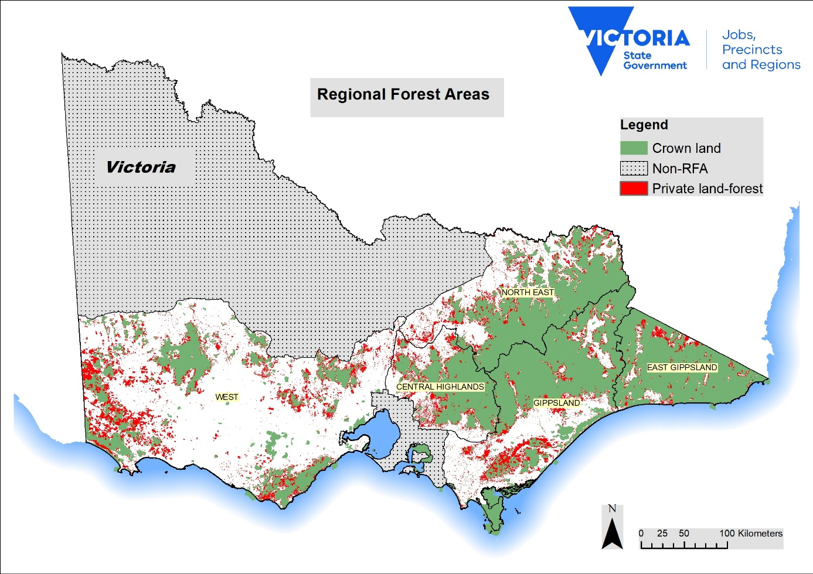

Public forest tenures in Victorian RFAs
Timber harvesting on public land is only undertaken in State forest, however with considerable areas set aside under various protections, less than 20 percent of State forest is categorised as suitable and available for harvesting. Only a portion of the suitable and available area will be harvested and regenerated prior to phasing out of native timber harvesting by June 2030.
Figure 2: Public forest tenure and proportion of State forest that is available and suitable for timber production in the Central Highlands RFA
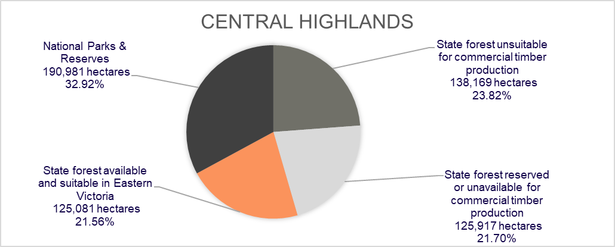Text alternative for Figure 2
Figure 3: Public forest tenure and proportion of State forest that is available and suitable for timber production in the East Gippsland RFA
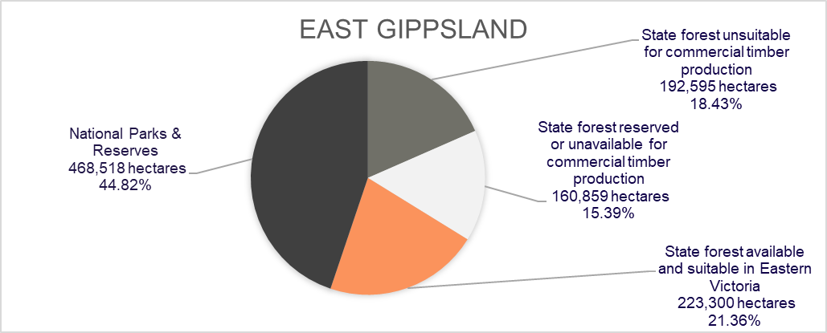Text alternative for Figure 3
Figure 4: Public forest tenure and proportion of State forest that is available and suitable for timber production in the Gippsland RFA
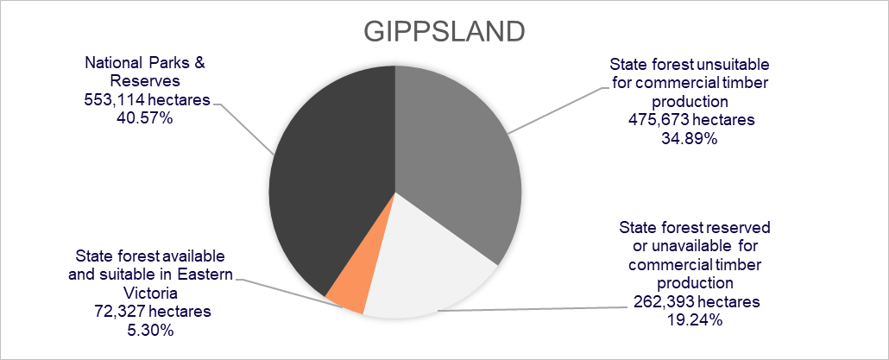Text alternative for Figure 4
Figure 5: Public forest tenure and proportion of State forest that is available and suitable for timber production in the North East RFA
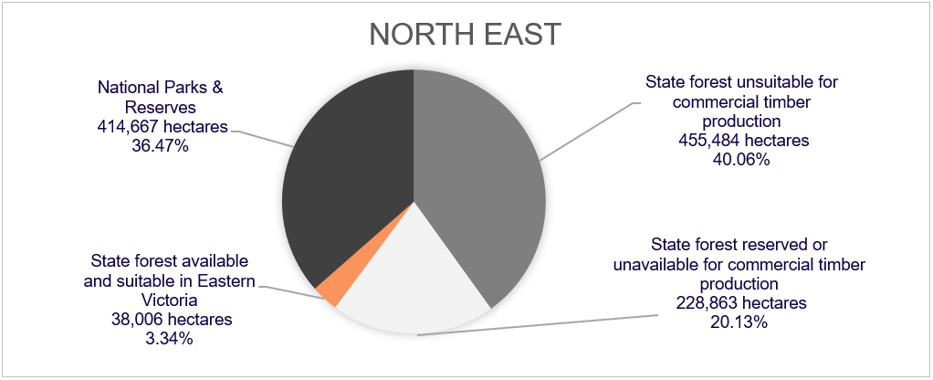Text alternative for Figure 5

West Victoria
The implementation of the Victorian Environmental Assessment Council’s (VEAC) 2019 Central West Investigation will result in additional reductions to the area available and suitable for harvesting in the West RFA region (VEAC 2019). These reductions will occur in stages through to 2030, when commercial timber harvesting native forests will cease. The impact of this has not been calculated for this report.
Figure 6: Public forest tenure in the West Victoria RFA region
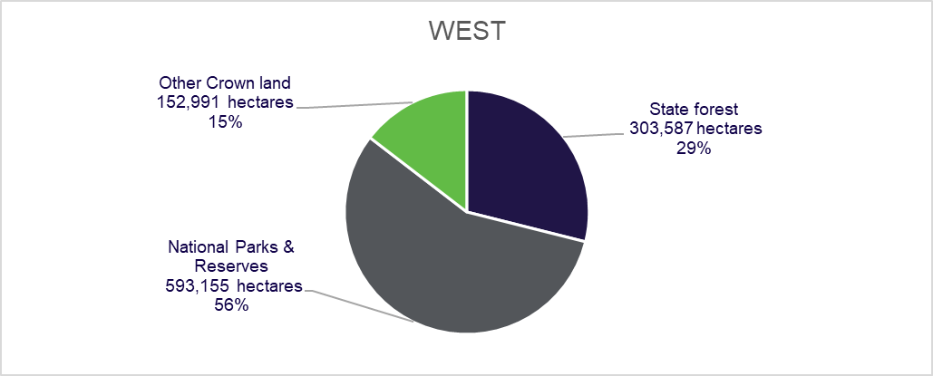Text alternative for Figure 6

Bushfire Impacts
The 2019-20 bushfires predominantly impacted public and private land in the North East, Gippsland and East Gippsland RFA regions (Figure 7). In East Gippsland, 67 per cent of land and 70 per cent of forest was within the bushfire extent (Victorian and Australian Governments 2021). Figures for other RFAs were Gippsland, 12 per cent of land and 19 per cent of forest; North East, 15 per cent of land and 22 per cent of forest; Central Highlands, approximately 0.01 per cent of forest; and West, 0.91 per cent of forest (Victorian and Australian Governments 2021).
Figure 7: Map of forest within the 2019-20 bushfire extent in Victorian RFA regions
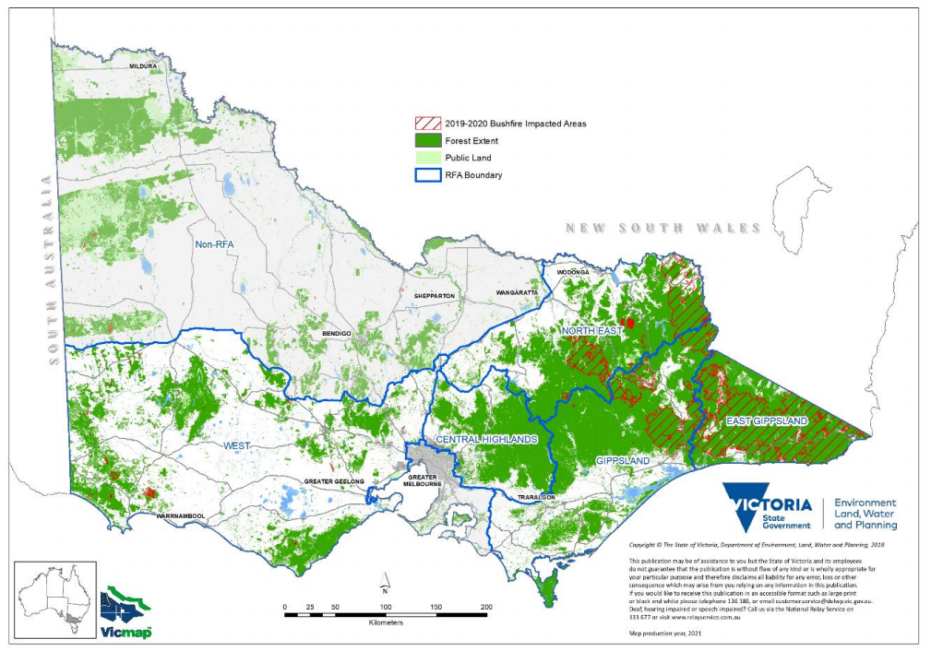

Ecologically Sustainable Forest Management
The RFAs state that the Harvest Level will have regard to the requirements of ESFM for the RFA region.
The RFAs define ESFM in the following terms:
“Ecologically Sustainable Forest Management” or “ESFM” means forest management and use in accordance with the specific objectives and policies for ecologically sustainable development as detailed in the National Forest Policy Statement.
Victorian forests are managed under Victoria’s Forest Management System. The system comprises legislation, policies, regulatory instruments, programs and institutional and administrative arrangements that regulate and support ESFM and the protection and management of environmental and heritage values in Victoria (Figure 8) (DELWP 2019).
Figure 8: Victoria’s State forest timber harvesting regulatory framework under Victoria’s Forest Management System.
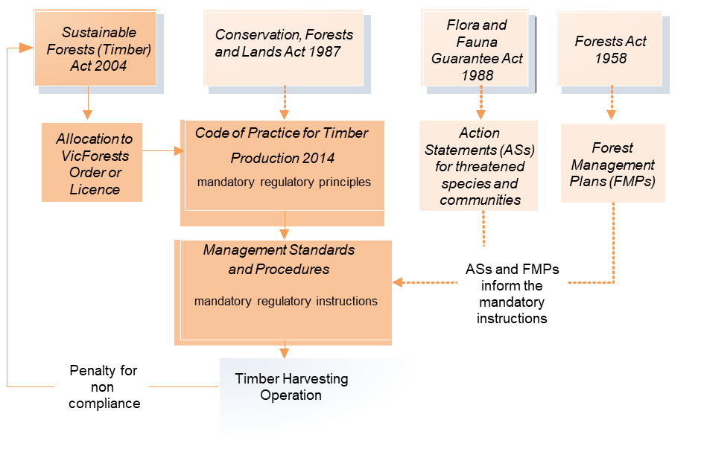Text alternative for flowchart of Victoria’s timber harvesting regulatory framework
Every part of the Forest Management System directs timber harvesting to ESFM. Timber harvesting must comply with regulatory and legislative requirements that form part of the broader forest management system. For example, timber harvesting can only occur in areas where the land tenure and forest zoning scheme allows for these operations.
The Comprehensive, Adequate and Representative (CAR) Reserve System includes reserves and other areas of public and private land protected by prescription or agreed management arrangements where conservation values are protected (DAWE 2019). Other zoning mechanisms, which seek to achieve a balance between biodiversity and economic values, include the Forest Management Zoning Scheme under the Code of Practice for Timber Production 2014 (amended 2021) (the Code). ESFM continues to apply through to the operational level, with detection-based zoning and the protection of particular environmental values in the field, where they are found.
Sound forest and timber harvesting planning ensures that the full range of State forest values are managed sustainably for current and future generations. These values include ecological diversity, cultural heritage, landscape, provision of recreation and educational opportunities as well as a range of renewable forest products (VicForests 2019).
VicForests is a state-owned enterprise established under the State-Owned Enterprises Act 1992 (Vic) and is responsible for the sustainable harvest, regeneration, and sale of timber from Victoria's public forests on behalf of the Victorian Government (VicForests 2020). VicForests operations are planned, managed, monitored and reviewed through an integrated suite of processes and systems.
At the strategic level, VicForests maintains a wood supply model that is used to evaluate long term sustainable supply and Harvest Level.

Victorian timber resources
VicForests undertakes activities across both eastern and western Victoria. Timber harvesting in eastern and western Victoria is managed through separate processes, although all forestry operations still fall under the framework of the RFAs and operate under ESFM principles. The difference in approach between the four eastern RFAs and the West Victoria RFA is historical and is reflected in the Victorian legislation governing access to timber.
Victoria has a large area of forest which is reserved through various mechanisms or is not available or suitable for timber harvesting for other reasons. Only a small area of State forest is potentially available for timber production.

Eastern forest area for timber harvesting
Eastern Victoria is covered by four RFA regions: Central Highlands, North East, Gippsland and East Gippsland.
While the forested area on public land in eastern Victoria is predominantly State forest (60.64 per cent), only 11.12 per cent of the forested public land estate is categorised as suitable and available for harvesting (Figure 9). Suitability and availability for timber harvesting is determined by several factors including but not limited to biodiversity protection requirements, the type and quality of trees and road access.
Table 1 shows that, of the four eastern RFAs, East Gippsland has the greatest available and suitable area for timber harvesting (223,300 hectares). East Gippsland is also the RFA region that was most severely impacted by the bushfires in area and volume (Victorian and Australian Governments 2021).
Figure 9: Public forest tenure and proportion of State forest that is available and suitable for timber production in Victoria’s eastern RFA regions
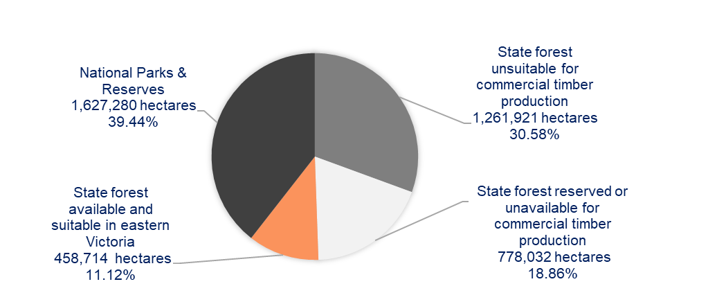Text alternative for Figure 9

Table 1: Forest area available and suitable for timber production in eastern Victorian RFA regions
RFA | Area (hectares)
Central Highlands | 125,081
East Gippsland | 223,300
Gippsland | 72,327
North East | 38,006
TOTAL | 458,714

Timber harvesting in western Victoria
The commercial timber forest resources in western Victoria are different to those in the east and timber harvesting is low intensity and small scale (VicForests 2015, 2019). Most traditional sawlog production has ceased in the West RFA. Timber production in the West RFA predominately focuses on commercial thinning and selective harvest operations (DEPI 2013).
Harvest levels continue to be guided by an independent review of forest resources in the west of the state completed in 2013, Review of Commercial Forestry Management in Western Victoria Timber Resources, Harvest Levels, Silviculture, and Systems and Processes. These levels are used conservatively and harvesting in these forests is well below maximum potential volumes.
In 2004, following the Victorian Environmental Assessment Council (VEAC) investigation, most of the Otway Ranges State forest areas were converted to national park and forest parks (VEAC 2004). All sawlog production from the forest parks was phased out over the next few years.
The 2017 VEAC Central West Investigation published in 2019 will result in further reductions in areas available for timber harvesting in western Victoria (VEAC 2019). The government accepted in full, in principle or in part 76 of 77 recommendations of the investigation, including the establishment of approximately 50,000 hectares of additional protected areas in the investigation area (DELWP 2021). Of the additional protected areas, 82 per cent (41,518 hectares) was made unavailable for timber harvesting on release of the government response in June 2021, with the remaining areas to be progressively unavailable by 2030 (DELWP 2021).

Forest resource modelling and methodology
Timber resource modelling involves a complex range of systems and processes. Described simply, the process considers how much forest is available, how much timber is currently contained in these forests, how much it will grow over time and how much timber is likely to be produced at the time of harvest age (VicForests 2019).
The modelling process can be considered as three main parts:
- VicForests identifies the available and suitable area of State forest for timber harvesting. This is a spatial layer and is restricted by forest zoning to areas in the General Management Zone (GMZ) and Special Management Zone (SMZ) (VicForests 2015). It excludes a number of areas for cultural and ecological preservation (Figure 11).
- VicForests uses the SWSM in the east of the state to develop forecasts of how much timber can be sustainably supplied from the available forest in the medium and long term (Figure 10) (VicForests, 2019). The operable inventory is an output from the SWSM that is the total available timber resource before further constraints are applied.
- VicForests undertakes a coupe planning process where further constraints can reduce the harvestable area and consequently volume. Coupes are individually assessed and may be unavailable due to things such as detection of threatened species. If permanent protection is required, this information is used to reduce the available and suitable area in future modelling.
Many constraints applied in the model are determined by regulatory and legislative requirements (Figure 11) that regulate and support ESFM. For example, the available and suitable area for timber harvesting is defined by a number of parameters including forest zoning, set by the Forest Management Zoning Scheme, and exclusions under the Code.
As new information becomes available, the modelling and scheduling is readjusted.
Figure 10: Resource modelling process for eastern Victoria
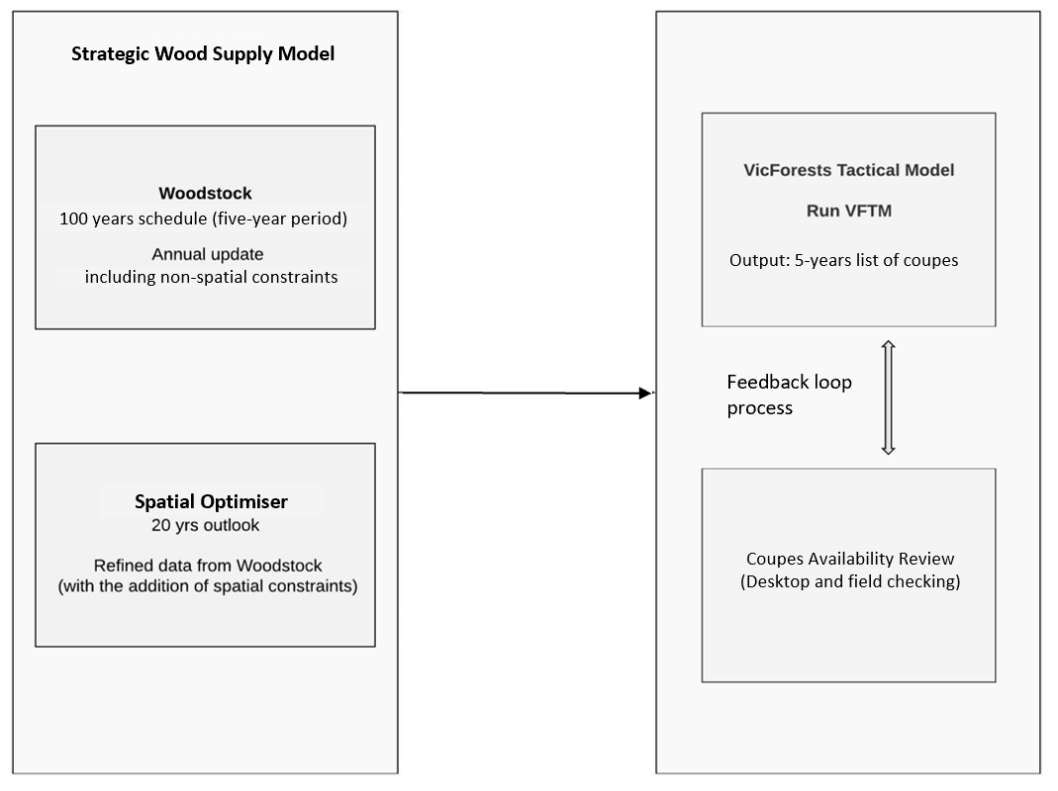

Victoria’s Strategic Wood Supply Model
For the eastern Victorian forest area, VicForests has developed a SWSM that is used to evaluate a range of forest management objectives and scenarios at different planning scales (VicForests 2019). The SWSM incorporates industry-standard modelling tools (Woodstock and Stanley) with further adjustments based on variables applied to the output from the model.
The SWSM only considers timber available within GMZ and SMZ in State forests and applies a number of constraints within the model (Figure 11).
The strategic modelling process uses linear programming to optimise long-term sustainable management and ensure that:
- the sustainable production of high-quality sawlog is maximised
- the harvesting of Victoria’s allocated State forests will not compromise the future environmental and social amenity of Victoria’s forests
- VicForests complies with its legislative and regulatory obligations, including those defined through the Sustainability Charter (VicForests 2019).
The SWSM implements operability rules which constrain the period when trees (or “forest stands”) may be considered available for harvest.
The SWSM produces the operable inventory which is the term used by VicForests to describe the volume of D+ ash and mixed species’ sawlogs that the SWSM shows as available in Victoria’s State forests.
The Spatial Optimizer is a module used to factor in the operational and spatial considerations for the coming 20 years (VicForests 2015). Areas identified as available for harvest in the SWSM are aggregated into potential harvest units (blocks and coupes) that meet regulatory requirements relating to coupe size, adjacency, and proximity to other harvested areas, as well as relevant and measurable constraints in the Code.
There have been a number of assessments of VicForests’ planning and modelling approaches, which have been found to be reasonable and appropriate (VEAC 2017; Victorian Auditor-General 2013).

Forecasting structure and growth rates
VicForests uses volume yield tables to support the SWSM. The yield or volume tables have been developed by combining a detailed description of the forest with biometric models and detailed breakdowns of log grade (VicForests 2015). Together, the yield tables enable the estimation of future timber volumes for a range of species, forest stand and site conditions, while considering the effect of past practices.
The wood supply volumes used in the model were compiled from measurements of growth plots and inventory sample plots. The projections consider the condition of forest stands as well as site quality characteristics according to the SFRI (Victoria’s State-wide Forest Resource Inventory) and event histories, including bushfires exacerbated by climate change, that inform the prediction of future growth.
VicForests updates the SFRI dataset annually to reflect harvesting activities and fire events based on severity. They also undertake an annual reconciliation between predicted and observed total merchantable and D+ volumes to adjust the scaling factors applied in their SWSM and VicForests Tactical Model (VFTM). The most recent update of the SFRI and the yields reconciliation was conducted in 2020.

Constraints
A number of constraints are applied both during and after the strategic wood supply modelling process. These are detailed in Figure 11.
Figure 11: Constraints to timber harvesting in east Victoria
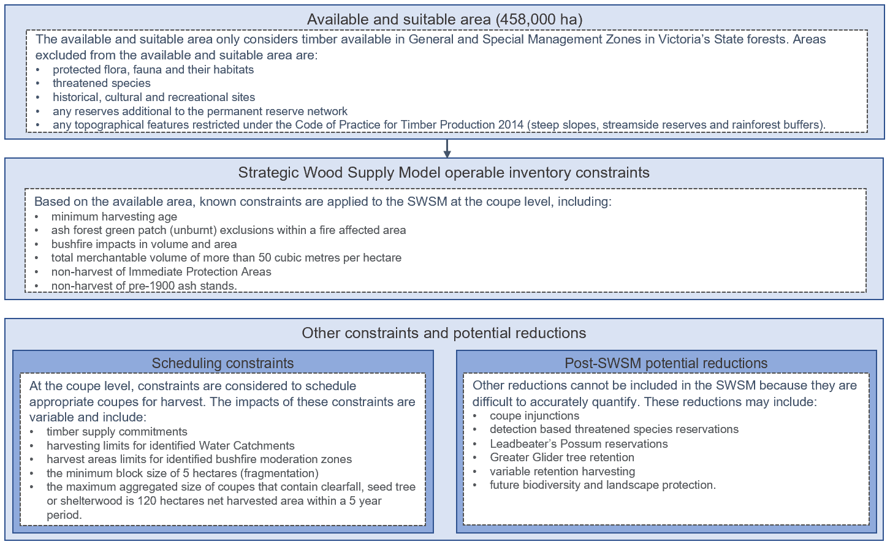 Text alternative for constraints diagram

Harvest Level
Harvest Level in this report, which considers the bushfire impacts where relevant, is the first Harvest Level Victoria has forecasted since the RFAs were extended in 2020.
The Harvest Level for each eastern RFA region for this report is the D+ ash and mixed species’ sawlog volume available per financial year as at August 2021. Harvest Levels are set below the operable inventory and consider the range of factors under the RFAs (Appendix A). This includes consideration of ESFM and policy obligations such as the Victorian Government commitment to end native timber harvesting in 2030.
The Harvest Level in Table 2 is expected to be greater than the volume that will be harvested as the calculation includes a margin that accounts for unquantifiable reductions (refer to “other constraints and potential reductions” in Figure 11) and allows scheduling flexibility to ensure delivery of timber supply commitments.
Victoria must review the Harvest Level at least once in a five-year period or after a Major Event which may have had a significant impact on the Harvest Level. Harvest Levels in this report will be in place for each financial year until formally reviewed.
VicForests continuously reviews its harvesting operations to consider supply risks caused by further protections or management actions required for biodiversity values, legal injunctions and any other factors such as bushfires to ensure supply remains under the Harvest Level and contractual supply obligations are met.
Table 2: Maximum D+ sawlog volume (including margin) that is available for timber harvesting in each eastern Victorian RFA region per financial year (as at August 2021)
RFA | Ash D+ Sawlog (m³) | Mixed Species D+ Sawlog (m³)
Central Highlands | 108,000 | 52,000
East Gippsland | 2,000 | 73,000
Gippsland | 35,000 | 13,000
North East | 27,000 | 6,000
Total | 172,000 | 144,000
On average, each year in eastern Victoria, approximately 3,000 hectares of the 458,000 hectares considered available and commercially suitable for timber production is harvested (VicForests 2019), with ash species making up one third and the remainder mixed species (VicForests 2019).
The harvest levels for the West Victoria RFA are consistent with the Review of Commercial Forestry Management in Western Victoria Timber Resources, Harvest Levels, Silviculture, and Systems and Processes, published in 2013 (VicForests 2019).

Bushfire impacts
The 2019-20 bushfires burnt approximately 1.3 million hectares of the total public native forest estate in Victoria (Victorian and Australian Governments 2021) and reduced the timber volume across the three most severely affected RFA regions by 1,034,699 cubic metres. The reduction of D+ sawlog operable inventory due to the bushfires has reduced the flexibility in scheduling areas for harvest to 2030. Despite these impacts, current wood supply commitments can still be met.

Timber volume reductions ash and mixed species
Table 3 shows the estimated gross volume impacts of the bushfires. The gross impact of the fires on timber volumes is the total burnt volume of ash and mixed species eucalypt, excluding salvaged timber. In mixed species the figures do not represent a complete loss of timber resources due to the resilience and capacity of the forest to recover (Victorian and Australian Governments 2021).
Importantly, there was no impact on timber volumes in the Central Highlands RFA, which is significant for maintaining ash sawlog volumes.
Table 3: Gross bushfire impact on the total operable inventory of ash and mixed species eucalypt D+ sawlog disaggregated by RFA region (as at August 2021)
Forest Type | RFA | Pre-fire (m³) | Post-fire (m³) | Gross Bushfire Impact (m³)
Ash | Central Highlands | 2,331,609 | 2,331,609 | 0
Ash | East Gippsland | 53,862 | 46,982 | 6,880
Ash | Gippsland | 896,033 | 741,294 | 154,739
Ash | North East | 760,645 | 551,202 | 209,444
Ash Total | All | 4,042,148 | 3,671,086 | 371,062
Mixed Species | Central Highlands | 1,488,137 | 1,488,137 | 0
Mixed Species | East Gippsland | 2,695,227 | 2,081,304 | 613,923
Mixed Species | Gippsland | 396,943 | 359,166 | 37,777
Mixed Species | North East | 408,474 | 396,537 | 11,937
Mixed Species Total | All | 4,988,781 | 4,325,145 | 663,637
Grand Total | All | 9,030,930 | 7,996,231 | 1,034,699

Modelled impacts of the 2019-20 bushfires
The determination of bushfire impacts on modelled available timber resources depends on fire severity and forest stand characteristics including eucalypt species, age and growth rates. Bushfire impacts are built into the SWSM, which adjusts the operable inventory appropriately.
A combination of satellite imagery, aerial photography and ground truthing is used to classify fire severity and the impacts are incorporated into both the forest description and the yield estimates. In severely affected areas, the stands may be killed, and the age reset. In areas where the fire has burned less severely, adjustments are made to the yield estimates to reflect a downgrade in the merchantable quality of the standing timber.

VicForests’ fire severity mapping
Following the 2019-20 bushfires, VicForests completed fire severity class mapping, including field verification, in accordance with the Code. The fire severity mapping considers a range of classes according to the severity level and percentage of crown burnt, as outlined in Table 4.
Table 4: VicForests' fire severity classes and descriptions
Fire Severity | Severity type | Description
1 | Crown burn | 90-100 per cent of eucalypt and non-eucalypt crowns are burnt.  An intense burn with widespread crown removal.
2 | Crown scorch | 60-100 per cent of eucalypt and non-eucalypt crowns are scorched some crowns are burnt.  An intense understorey fire with complete scorch of most eucalypt and non-eucalypts.
3 | Moderate crown scorch | 30-65 per cent of eucalypt and non-eucalypt crowns are scorched.  A variable intensity of fire ranging from a warm ground burn with no crown scorch to an intense understorey fire with complete crown scorch of most eucalypt and non-eucalypts.
4 | Light crown scorch | 1-35 per cent of eucalypt and non-eucalypt crowns are scorched.  A light ground burn with isolated patches of intense understorey fire and some crown scorch.
5 | No crown scorch | Less than 1 per cent of eucalypt and non-eucalypt crowns are scorched. Understorey may be burnt or unburnt.
Ash species are highly sensitive to fire (Victorian and Australian Governments 2021). The impact of the fires was added into the SWSM and the main assumptions are:
- Trees are killed when subject to fire severity class 1 and 2.
- Stands have a 20 per cent yield reduction when subject to fire severity class 3.
- Stands are not impacted by fire severity class 4 or 5.
On the other hand, mixed species are more resilient to fire (Victorian and Australian Governments 2021). The impacts of the fires on the modelled available volume are applied according to the following rules:
- Trees are killed when subject to fire severity class 1 and 2 if they are less than 20 years old.
- Stands have a 30 per cent reduction in yield when subject to fire severity class 1 and 2 if they are greater than 20 years old.
As a result of VicForests’ ongoing monitoring process of the Harvest Level and bushfire impacts, in May 2021 the second rule for mixed species changed from 30 to 50 per cent. This means that from May 2021, a 50 per cent reduction in yield can be expected when subject to fire severity class 1 and 2 if mixed species stands are greater than 20 years old.

Salvage harvesting
Salvage timber harvesting operations is a recognised silvicultural practice that recovers timber following events that cause significant tree mortality or damage, such as fires, disease or storms (VicForests 2015). It has been previously used after bushfires in Victoria and must be conducted within a suitable timeframe otherwise trees that experienced high levels of mortality or damage cannot be used for commercial purposes. Salvage harvesting must meet post-fire prescription standards to protect the environment as set out in the Code and incorporated documents (VicForests n.d.).
As detailed in Table 5, salvage harvesting operations reduced the volume of the timber resources lost due to the bushfires. After consideration of the salvaged timber volumes, the nett impact on the operable inventory was 320,697 cubic metres for ash species and 656,625 cubic metres for mixed species.
Table 5: Nett bushfire impacts on operable D+ sawlog inventory for ash and mixed species following salvage harvesting operations (as at 30 June 2021)
Forest Type | RFA | Pre-fire (m³) | Post-fire (m³) | Gross Bushfire Impact (m³) | Salvaged Volume (m³) at 30 June 2021 | Nett Bushfire Impact (m³)
Ash | Central Highlands | 2,331,609 | 2,331,609 | 0 | 0 | 0
Ash | East Gippsland | 53,862 | 46,982 | 6,880 | 0 | 6,880
Ash | Gippsland | 896,033 | 741,294 | 154,739 | 21,788 | 132,951
Ash | North East | 760,645 | 551,202 | 209,444 | 28,577 | 180,867
Ash Total | All | 4,042,148 | 3,671,086 | 371,062 | 50,365 | 320,697
Mixed Species | Central Highlands | 1,488,137 | 1,488,137 | 0 | 0 | 0
Mixed Species | East Gippsland | 2,695,227 | 2,081,304 | 613,923 | 5,486 | 608,437
Mixed Species | Gippsland | 396,943 | 359,166 | 37,777 | 1,526 | 36,251
Mixed Species | North East | 408,474 | 396,537 | 11,937 | 0 | 11,937
Mixed Species Total | All | 4,988,781 | 4,325,145 | 663,637 | 7,012 | 656,625
Grand Total | All | 9,030,930 | 7,996,231 | 1,034,699 | 57,377 | 977,322

Further policy and regulatory obligations
There are further policy and regulatory obligations that affect where and how timber can be harvested, potentially affecting the overall Harvest Level. Some examples of the types of policy and regulatory obligations that VicForests must consider when calculating the Harvest Level are detailed in the sections below.

Ongoing detections and protections for threatened species and communities
Ongoing threatened species and communities’ detections and protections can impact the available timber volume for harvest. The operable inventory does not consider potential future biodiversity protections, as the requirements of future protections are uncertain. However, estimates of future impacts are taken into account when VicForests contracts wood supply with the native timber industry.
The development and implementation of threatened species and communities’ protections are required under Victoria’s legislative and regulatory framework that supports biodiversity management and protection. They are an important component of Victoria’s forest management framework because they support ESFM. For example, under the modernised RFAs, Victoria must undertake a risk assessment for any newly listed species or community, or if there is a change in the conservation status of a listed species or community. Following the risk assessment, Victoria must determine whether interim and/or permanent protections and management actions are required for the species and/or communities in question. It is difficult to accurately predict when a species or community will be listed, or their conservation status changed, and therefore the impact on timber harvesting operations is unknown until the protection requirements are determined. Likewise, other protections made under Victoria’s environmental legislation, for example, the Flora and Fauna Guarantee Act 1988 (Vic), can impact the modelled available timber but the extent of the impact can only be determined once the requirements for the protections are known.
Similarly, the Code and incorporated documents contain hundreds of detection-based rules for protected flora and fauna. Many of these rules contain no specific prescriptions but VicForests is required, in the majority of cases where there is a detection, to:
Conduct a site inspection and detailed planning in consultation with [the Department of Environment, Land, Water and Planning] to ensure the species is adequately protected during timber harvesting operations.
For example, this may result in the creation of a Special Management Zone over the verified population which would also impact the harvestable volume. Other detection-based prescriptions may require the creation of a Special Protection Zone.
The Department of Jobs, Precincts and Regions, the Department of Environment, Land, Water and Planning, VicForests and Victoria’s Conservation Regulator continue to work closely together to evaluate how future forestry operations may be conducted in a way that protects species and communities of concern while ensuring timber supply commitments are met.

Timber harvesting regulatory framework
Any amendments to Victoria’s regulatory framework for forest management can also impact the Harvest Level. VicForests must consider any regulatory and policy changes that may impact timber volumes, for example, amendments to the Code.
The Code is a key instrument containing important rules that govern timber harvesting in Victoria. It is essential that the Code is clear, accurate and enforceable for both the operators and the regulator.
In 2020, the Victorian Government announced that it would conduct a review of the Code to strengthen its clarity and enforceability. The Code has subsequently been updated, along with its incorporated document, the Management Standards and Procedures for timber harvesting operations in Victoria’s State forests (MSPs), to ensure they are clear, accurate and enforceable. The updated Code of Practice for Timber Production 2014 (amended 2021) and MSPs came into force on 17 November 2021.
Any impacts to timber harvesting will be incorporated in VicForests’ planning and management processes.

Appendix A: Relevant clauses of the RFAs
Clause numbers are in the Central Highlands RFA. Equivalent clauses in other RFAs may be differently numbered.

Harvest Level
69F. Victoria will forecast and make publicly available the Harvest Level from State forests in the RFA Region. In determining the Harvest Level, Victoria will have regard to the following factors:
(a) the requirements of ESFM for the RFA Region;
(b) the area available for timber harvesting;
(c) the inventory of timbers of each productive forest type (ash and mixed species eucalypt) in the area available for timber harvesting;
(d) the forecast structure and growth rates of forests in the RFA Region having consideration to Climate Change, bushfires and other relevant factors;
(e) any policy and regulatory obligations; and
(f) any other relevant factors.
69G. When publishing and making available the Harvest Level, Victoria will specify the methodology and assumptions used to forecast the Harvest Level.
69H. Victoria commits to ensuring that the volume of Timber Resources harvested from State forest in the RFA Region over the period 1 July 2019 to 30 June 2030, for both ash and mixed species, will not:
(a) over any five year period from 1 July 2019 to 30 June 2030, exceed the cumulative total of the Harvest Level as calculated for each year of that five year period; or
(b) in any given year, amount to more than 120 per cent of the annual Harvest Level for that year.
69I. Up until 30 June 2030, Victoria will:
(a) review and, as necessary, adjust the Harvest Level at least once in every five-year period, taking into consideration the findings of the most recently completed RFA Five-yearly Review process and the findings of the most recent Major Event Review (if any); and
(b) make the outcomes of these reviews publicly available.
69J. Should a Major Event with the potential to significantly impact the Harvest Level occur, Victoria commits to commencing a review of the Harvest Level within 12 months. A review undertaken following a Major Event can constitute the next regular review required under clause 69I.

Appendix B: Text alternative for figures 2 to 6 and 9

Figure 2: Central Highlands
Figure 2 is a pie chart that shows 190,981 hectares or 32.92% of public forest in the Central Highlands RFA is national parks and reserves; 138,169 hectares or 23.82% is State forest that is unsuitable for commercial timber production; 125,917 hectares or 21.70% is State forest that is reserved or unavailable for commercial timber production; and 125,081 hectares or 21.56% is State forest that is available and suitable.
Back to Section 4.1 Public forest tenures in Victorian RFAs

Figure 3: East Gippsland
Figure 3 is a pie chart that shows 468,518 hectares or 44.82% of public forest in the East Gippsland RFA is national parks and reserves; 192,595 hectares or 18.43% is State forest that is unsuitable for commercial timber production; 160,859 hectares or 15.39% is State forest that is reserved or unavailable for commercial timber production; and 223,300 hectares or 21.36% is State forest that is available and suitable.
Back to Section 4.1 Public forest tenures in Victorian RFAs

Figure 4: Gippsland
Figure 4 is a pie chart that shows 553,114 hectares or 40.57% of public forest in the Gippsland RFA is national parks and reserves; 475,673 hectares or 34.89% is State forest that is unsuitable for commercial timber production; 262,393 hectares or 19.24% is State forest that is reserved or unavailable for commercial timber production; and 72,327 hectares or 5.30% is State forest that is available and suitable.
Back to Section 4.1 Public forest tenures in Victorian RFAs

Figure 5: North East
Figure 5 is a pie chart that shows 414,667 hectares or 36.47% of public forest in the North East RFA is national parks and reserves; 455,484 hectares or 40.06% is State forest that is unsuitable for commercial timber production; 228,863 hectares or 20.13% is State forest that is reserved or unavailable for commercial timber production; and 38,006 hectares or 3.34% is State forest that is available and suitable.
Back to Section 4.1 Public forest tenures in Victorian RFAs

Figure 6: West Victoria
Figure 6 is a pie chart that shows 593,155 hectares or 56% of public forest in the West Victoria RFA is national parks and reserves; 303,587 hectares or 29% is State forest; and 152,991 hectares or 15% is other crown land.
Back to Section 4.1.1 West Victoria

Figure 9: Eastern Victoria
A pie chart that shows 1,627,280 hectares or 39.44% of public forest in Victoria's eastern RFA regions is national parks and reserves; 1,261,921 hectares or 30.58% is State forest that is unsuitable for commercial timber production; 778,032 hectares or 18.86% is State forest that is reserved or unavailable for commercial timber production; and 458,714 hectares or 11.12% is State forest that is available and suitable.
Back to Section 6.1 Eastern forest area for timber harvesting

Appendix C: Text alternative for flowchart of Victoria’s timber harvesting regulatory framework
Key elements of Victoria’s timber harvesting regulatory framework under the Forest Management System include:

Forests Act 1958 (Vic)
The Forests Act 1958 (Vic) (Forests Act) provides for the management of State forests, including the development of working plans (currently represented by Forest Management Plans (FMPs)) to maintain and improve State forests, and for licensed occupations including grazing and taking away forest produce. It includes regulatory controls for Crown land subject to the Forests Act, except for the licensing of bee sites, which is controlled by the Land Act 1958 (Vic) (Land Act).

Forests (Licences and Permits) Regulations 2019 (Vic)
The Forests (Licences and Permits) Regulations 2019 (Vic) are under the Forests Act and prescribe certain activities which may not be undertaken within a reserved forest without a licence, permit or authority (for example, enter with cattle; fell a tree bearing a survey mark; or sell or offer for sale any goods, things or services). They also set out the manner in which applications for licences and permits granted or issued under the Forests Act must be made and the terms and conditions of those licences and permits. This includes the modes of branding of forest produce (whether with a Crown brand or a licensee’s brand, which has been registered with the Secretary to DELWP).

Conservation, Forests and Lands Act 1987 (Vic)
The Conservation, Forests and Lands Act 1987 (Vic) (CFL Act) provides for:
- a body corporate called the Secretary to Department of Environment, Land, Water and Planning;
- a framework for a land management system and to enable necessary administration, finance and enforcement; and
- a system of land management cooperative agreements.

Code of Practice for Timber Production
The CFL Act gives the responsible minister the power to make codes of practice, such as the Code of Practice for Timber Production 2014 (as amended 2021) (the Code) and its incorporated document the Management Standards and Procedures for timber harvesting in Victoria’s State forests 2021.
The purpose of the Code is to provide direction to timber harvesting managers, harvesting entities and operators to deliver sound environmental performance when planning for and conducting timber harvesting activities in a way that:
- permits an economically viable, internationally competitive, sustainable timber industry;
- is compatible with the conservation of the wide range of environmental, social and cultural values associated with forests;
- provides for the ecologically sustainable management of native forests proposed for cyclical timber harvesting operations; and
- enhances public confidence in the management of timber production in Victoria’s forests and plantations.
Penalties for non-compliance with the Code are applied in accordance with the Sustainable Forests (Timber) Act 2004 (Vic) (SFT Act).

Sustainable Forests (Timber) Act 2004 (Vic)
The SFT Act provides a framework for the sustainable management of timber harvesting in State forests. The Act contains three key components for the management of Victoria’s forests:
- the Sustainability Charter for Victoria’s State Forests, which sets the objectives for sustainable forest management in Victoria;
- Victoria’s State of the Forests report, which compiles monitoring data and assesses the State’s performance in achieving objectives for sustainable forest management in Victoria; and
- the Allocation Order (AO), which provides for the allocation and harvesting and sale; or harvesting or sale, of timber resources from State forests and sets conditions for those activities.

Flora and Fauna Guarantee Act 1988 (Vic)
The Flora and Fauna Guarantee Act 1988 (Vic) (FFG Act) establishes a legal and administrative structure to enable and promote the conservation of Victoria's native flora and fauna, and to provide for the conservation, management or control of flora and fauna and the management of potentially threatening processes. The FFG Act applies across all land tenures, including private land.
The FFG Act also establishes the Threatened List, comprised of threatened species and communities which have met established criteria for inclusion.
Mechanisms in the FFG Act to achieve its objectives, include:
- the preparation of Action Statements following listing of threatened species, communities and threats to native species;
- enabling the declaration of habitat critical to the survival of native plants and animals;
- the duty of public authorities to have regard to objectives of the Act in their operations;
- requiring permits for activities that could harm threatened animals, plants and communities; and
- requiring an overarching strategy for Victoria’s biodiversity.
Back to Section 5 Ecologically Sustainable Forest Management

Appendix D: Text alternative for constraints diagram
The available and suitable area only considers timber available in General and Special Management Zones in Victoria’s State forests. Areas excluded from the available and suitable area are:
- protected flora, fauna and their habitats; threatened species;
- historical, cultural and recreational sites;
- any reserves additional to the permanent reserve network; and
- any topographical features restricted under the Code of Practice for Timber Production 2014 (steep slopes, streamside reserves and rainforest buffers).
Based on the available area, known constraints are applied to the SWSM at the coupe level, including:
- minimum harvesting age;
- ash forest green patch (unburnt) exclusions within a fire affected area;
- bushfire impacts in volume and area;
- total merchantable volume of more than 50 cubic metres per hectare;
- non-harvest of Immediate Protection Areas; and
- non-harvest of pre-1900 ash stands.
At the coupe level, constraints are considered to schedule appropriate coupes for harvest. The impacts of these constraints are variable and include:
- timber supply commitments;
- harvesting limits for identified Water Catchments;
- harvest areas limits for identified bushfire moderation zones;
- the minimum block size of 5 hectares (fragmentation); and
- the maximum aggregated size of coupes that contain clearfall, seed tree or shelterwood is 120 hectares net harvested area within a 5 year period.
Other reductions cannot be included in the SWSM because they are difficult to accurately quantify. These reductions may include:
- coupe injunctions;
- detection based threatened species reservations;
- Leadbeater’s Possum reservations;
- Greater Glider tree retention;
- variable retention harvesting; and
- future biodiversity and landscape protection.
Back to Section 7.3 Constraints

Appendix E: Glossary
For the purpose of this report:
Ash Species Eucalypt refers to tall, open, wet forests dominated by Mountain Ash (Eucalyptus regnans), Alpine Ash (E. delegatensis) and/or Shining Gum (E. nitens). These forests are generally, dominated by a single overstory species but may be mixed with other species, most commonly Messmate (E. obliqua), Mountain Grey Gum (E. cypellocarpa) and Manna Gum (E. viminalis). Ash eucalypt forests depend on high intensity fires, abundant light and regular rainfall to regenerate and tend to occupy the mountainous regions of Victoria.
Ecologically Sustainable Forest Management or ESFM means forest management and use in accordance with the specific objectives and policies for ecologically sustainable development as detailed in the National Forest Policy Statement. Under the National Forest Policy Statement, in the definition of “ecologically sustainable development” there are three specified requirements for sustainable forest use: maintaining the ecological processes within forests (the formation of soil, energy flows, and the carbon, nutrient and water cycles); maintaining the biological diversity of forests; and optimising the benefits to the community from all uses of forests within ecological constraints.
General Management Zones or GMZs are zones in the forest that are managed for a range of uses and values, but timber harvesting operations will have a high priority.
Harvest Level as defined in the RFAs means the volume of timber resources that can be harvested from native forests in the RFA region in any financial year, consistent with ESFM, until native forest harvesting ceases on 30 June 2030. Harvest Level in this report is the D+ ash and mixed species’ sawlog volume available for each eastern RFA region per financial year as at August 2021.
Major Event as defined in the RFAs is a substantial change in circumstances within the RFA region(s) and includes (but is not limited to) natural events such as bushfires, floods and disease. The Major Event has the potential to significantly impact upon: (a) the objectives and operation of the RFAs; (b) the comprehensiveness, adequacy or representativeness of the Comprehensive, Adequate and Representative (CAR) Reserve System; (c) ESFM; (d) one or more matter of national environmental significance (MNES); or (e) the stability of forest industries.
Mixed Species Eucalypt refers to a combination of eucalypt species. For management purposes VicForests further divides mixed species eucalypt forests into low elevation and high elevation forest types, each with distinctive silvicultural needs related to their species composition and site characteristics.
- Low Elevation Mixed Species forests occupy extensive areas of VicForests’ North East, West Gippsland and East Gippsland regions, and comprise much of the coastal and foothill forests of Victoria. They are generally located at elevations less than 700 metres above sea level and contain key overstory species such as Silvertop (E. sieberi), Mountain Grey Gum (E. cypellocarpa), Messmate (E. obliqua), Yellow Stringybark (E. muelleriana) and White Stringybark (E. globoidea). This forest type is comparable to areas of Foothill Mixed Species and Coastal Mixed Species forest type in the Western Forest Area.
- High Elevation Mixed Species forests occupy extensive areas of East Gippsland. They are generally located at elevations greater than 700 metres above sea level and contain overstorey species mixtures of Messmate (E. obliqua), Cut-tail (E. fastigata), Errinundra Shining Gum (E. denticulata), Mountain Grey Gum (E. cypellocarpa) and/or Manna Gum (E. viminalis).
Operable inventory means the total amount of D+ ash and mixed species’ sawlog VicForests’ Strategic Wood Supply Model makes available for timber harvesting in Victoria’s State forests after a number of known constraints are applied to the area of State forest that is available and suitable for timber harvesting.
Resource outlook is a forecast that indicates how much sawlog timber is able to be commercially supplied from the State forests in eastern Victoria in the medium term on a sustainable basis.
Special Management Zones or SMZs are zones in the forest that are managed to conserve specific features, while catering for timber harvesting operations under special conditions specified in SMZ plans and the Planning Standards for Timber Harvesting Operations in Victoria’s State Forests 2014.
Special Protection Zones or SPZs are managed for particular conservation values, forming a network designed to complement the formal conservation reserve system. Timber harvesting operations are excluded from SPZs.
Strategic Wood Supply Model or SWSM is the forest resource model that VicForests uses to calculate the operable inventory.

References
Department of Agriculture, Water and Environment [DAWE]. (2019). Protecting our Forest Environment. https://www.agriculture.gov.au/forestry/policies/rfa/about/protecting-environment.
DAWE. (2020). Regional Forest Agreements. https://www.agriculture.gov.au/forestry/policies/rfa.
Department of Environment and Primary Industries. (2013). Review of Commercial Forestry Management in Western Victoria: Timber Resources, Harvest Levels, Silviculture, and Systems and Processes.
Department of Environment, Land, Water and Planning [DELWP]. (2021). Victorian Government Response to the Victorian Environmental Assessment Council's Central West Investigation Final Report.
DELWP. (2019). Overview of Victoria’s Forest Management System.
DELWP. (2020). Victorian Regional Forest Agreements. https://www.delwp.vic.gov.au/futureforests/what-were-doing/victorian-regional-forest-agreements.
Department of Jobs, Precincts and Regions. (2021). Victorian Forestry Plan. https://djpr.vic.gov.au/forestry/forestry-plan.
Victorian Environmental Assessment Council [VEAC]. (2019). Central West Investigation.
VEAC. (2017). Fibre and wood supply: Assessment report.
VEAC. (2004). Angahook-Otway Investigation: Final Report.
VicForests. (2020). 2019-20 Annual Report.
VicForests. (2019). Forest Management Plan.
VicForests. (2015). 2014-15 Annual Report.
VicForests. (2015). Ecologically Sustainable Forest Management Plan.
VicForests. (n.d.). VicForests Starts Post-Fire Timber Recovery. https://www.vicforests.com.au/fire-management-1/vicforests-starts-post-fire-timber-recovery.
Victorian Auditor-General. (2013). Managing Victoria’s Native Forest Timber Resources.
Victorian Government and Australian Government. (2021). Victorian Regional Forest Agreements Major Event Review of the 2019-20 bushfires: Summary report: Information and data to inform public consultation.
Authorised by the Hon. Mary-Anne Thomas MP and the Hon. Lily D’Ambrosio MP
Department of Jobs, Precincts and Regions
1 Spring Street Melbourne Victoria 3000
Telephone (03) 9651 9999
© Copyright State of Victoria,
Department of Jobs, Precincts and Regions 2021
Except for any logos, emblems, trademarks, artwork and photography this document is made available under the terms of the Creative Commons Attribution 3.0 Australia license.
This document is also available in an accessible format at djpr.vic.gov.au

“National Forest Policy Statement” or “NFPS” means the National Forest Policy Statement 1992 endorsed by the Commonwealth and all State and Territory governments.
Operable inventory in this table is indicative of total, not annual, amounts.
Other fire severity models have been developed for the 2019-20 bushfires (by parties external to VicForests), but their classes do not align with the Code.

