|  |
| --- |
| Loading a WFS in ArcMap |
| Web Feature Service (WFS) |

Introduction

Web Feature Service (WFS) services can be used in ArcMap as map layers. A WFS is an interface specified by the Open GIS Consortium (OGC) that allows for the exchange of geographic data over the internet. ISD produces WFS using Geoserver (open source).

You need the Data Interoperability extension installed and turned on, in order to access the WFS service

Loading WFS layers into ArcMap

1. To access Geoserver WFS
   1. Launch ArcMap and open your MXD.
   2. Open the Catalog window (Windows > Catalog)
   3. Got to Interoperability Connection
   4. Double click “Add Interoperability Connection”
   5. Enter connection details

Format: *WFS*

Dataset: https://opendata.maps.vic.gov.au/geoserver/ows?service=WFS&request=getCapabilities

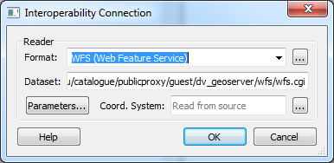

* 1. Click Parameters…

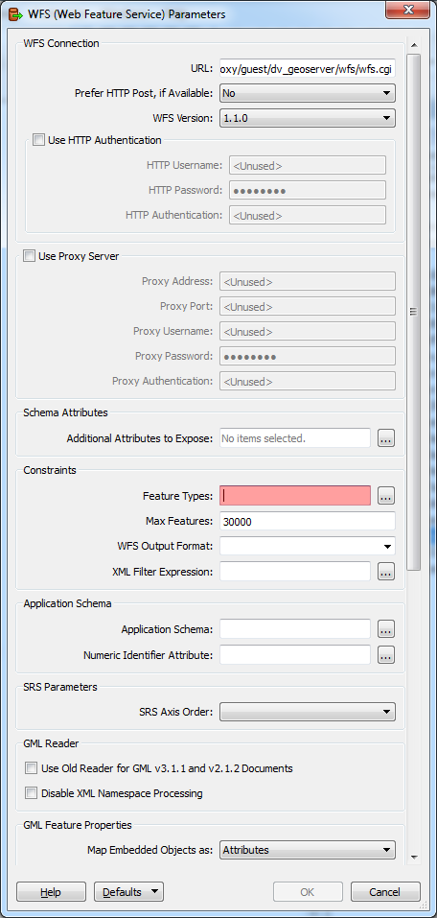

* 1. Click *Feature Types*:

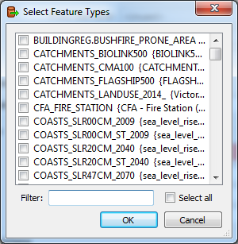

* 1. Select the layers you want with checkboxes
  2. Click *OK* to confirm Feature Type
  3. Click *OK* to confirm Parameters
  4. Click *OK* to establish the connection
  5. Drag the newly created connection into the Table Of Contents

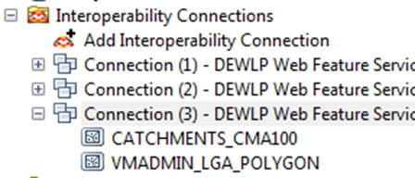

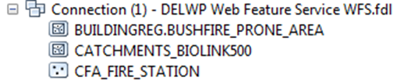

Note: Please be aware that there are “feature limits” attached to WFS (of 10,000 features) which limits the number of features downloaded and therefore displayed.

Therefore only the first 10,000 features within a dataset will be downloaded. This needs to be considered when displaying very detailed datasets (eg Vicmap Property or Vicmap Address) via a WFS.

For more help please email:

[GIS.Helpdesk@delwp.vic.gov.au](mailto:GIS.Helpdesk@delwp.vic.gov.au)

|  |  |
| --- | --- |
| © The State of Victoria Department of Environment, Land, Water and Planning 2023  LogoThis work is licensed under a Creative Commons Attribution 4.0 International licence. To view a copy of this licence, visit http://creativecommons.org/licenses/by/4.0/ |  |