Voluntary Committees of Management Newsletter

Edition 13 – March 2018

Mandurang Recreation Reserve

Hume: https://www.facebook.com/DELWPHume Port Phillip: https://www.facebook.com/DELWPPortPhillip Gippsland: https://www.facebook.com/DELWPGippsland Grampians: https://www.facebook.com/DELWPGrampians Loddon Mallee: https://www.facebook.com/DELWPLoddonMallee
Barwon South West: https://www.facebook.com/DELWPBarwonSouthWest

Lorne Sculpture Biennale, Barwon South West Region
From the 17th of March to 2nd of April the Lorne Sculpture Biennale takes place over 4km stretch of the Lorne foreshore.
The biennale has been running since 2007 on Crown land under a licence from the Great Ocean Road Coast Committee and consent from DELWP under the Coastal Management Act 1995.
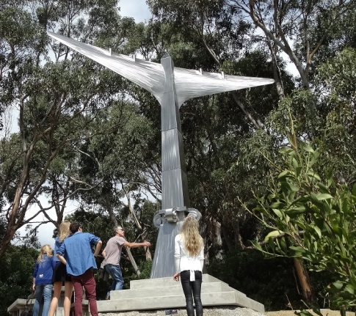
ot Tenjen by Rober Hague

It is Victoria's largest public outdoor sculpture event. The theme this year is 'landfall' a word that describes time and place where ocean meets land. The event will focus on highlighting the plight of the world’s natural assets including impacts of climate change.

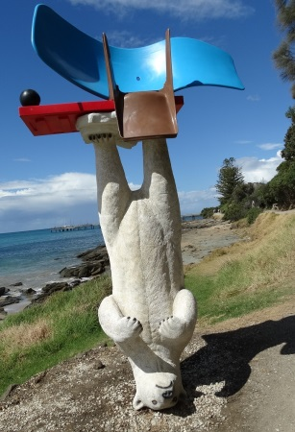
2014 Biennale winner: North Polar by Louise Paramor

It is free to attend and more information can be found on their website (http://www.lornesculpture.com/).

Durham Ox Recreation Reserve, Loddon Mallee Region
The iconic ‘Ox on a stick’ landmark in the small rural town of Durham Ox could soon be joined by another landmark in the making, the Durham Ox Recreation Reserve. A passionate group of locals have formed a new committee of management for the reserve which hadn’t had a committee since 2014.
When the future of the reserve was being reconsidered, many enthusiastic members of the Durham Ox community rallied local support for the continued use and management of the reserve. After a number of community meetings, a new committee was formed and the members are excited about the opportunities for recreation, education and the environment that this reserve holds.
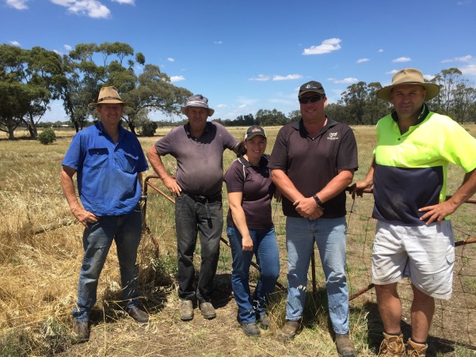
Committee members left to right: Murray Haw, Laurie Maxted, Karlee Gilmore, Travis Gilmore, and Wayne Maxted
Committee Secretary, Steve Maxted, said with the Durham Ox Recreation Reserve having a history dating back to the late 1800's, it would have been a shame to lose this piece of public land.
“The newly formed committee are glad to have the opportunity to manage and improve the reserve for the local residents and visitors to enjoy” Steve said.
“The reserve provides important social and environmental benefits to the local community.”
“Hopefully as a committee we can take the recreation reserve into the future and let it evolve into an area that can meet the needs of the local and wider community."

Crown Land Information Improvement Project (CLIIP) Update, State-wide
Work is progressing on the Crown Land Information Improvement Project. An Expression of Interest process for delivery of the new system was conducted in late 2017 resulting in a short list of vendors to be invited to tender for the new system in the coming months.
In parallel, work has been progressing to identify key functionality required in the new system. The new system will provide Committees of Management access to a web interface that will:
- Show reserves managed by the CoM (both in list and map form);
- Show licences and leases that exist over those reserves (including relevant details such as expiry dates);
- Provide access to relevant forms, templates, guidelines and policy documents;
- Provide the option to upload financial return information (rather than returning the printed form),
- And may also provide the ability to submit new Licence and Lease requests.
Access to the Committees of Management web interface will be restricted. Committee members will be provided with a unique login that will allow them to access information for their specific Committee.
At this stage, it is anticipated that the Committees of Management web interface will be available in early 2019. Further details will be available via the CoM newsletter throughout 2018.
For further details, email the Project Manager michael.black@delwp.vic.gov.au

Surprise for Chiltern Racecourse and Recreation Reserve committee member, Hume Region
On the 10th December 2017, the Chiltern Racecourse and Recreation Reserve CoM and Rodeo Committee surprised committee member Kelvin Duke with a life membership to the Rodeo Club and naming an arena in the reserve for him.

Kelvin is a member of the Chiltern Racecourse and Recreation Reserve and a past Chairperson of the reserve committee. Kelvin started the Chiltern Rodeo about 21 years ago, and is also active in the wider community.
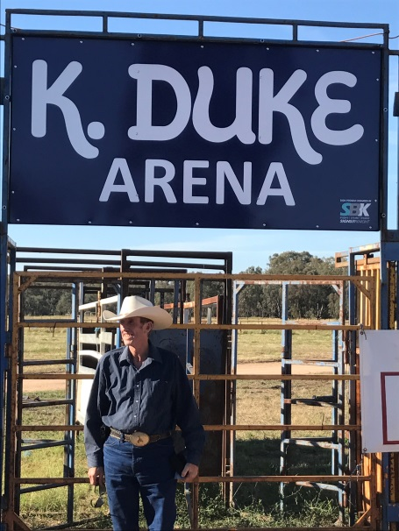
Kelvin Duke in front of the K Duke arena

The Rodeo committee and the committee of management managed to keep the whole day a surprise for Kelvin. At 5pm the community gathered in the arena and a friend drove Kelvin into the arena.

Among the people gathered to celebrate Kelvin and to give speeches were; Bill Tilley MLA; Mayor of Indigo shire, Jenny O’Connor; Deputy Mayor, Sophie Price; as well as Councillor Barbara Murdoch. MC for the day was Laurie Bould.

Following the speeches there was a celebration BBQ and live entertainment. It was a great afternoon and good to see a hardworking volunteer recognised for all his input to both the Rodeo and the Chiltern Committee of Management.

Locals rally to save Betley Mechanics Institute Hall, Loddon Mallee Region
The small hamlet of Betley, located approximately 20km north of Maryborough, was at risk of having the local mechanics institute removed and relocated.
Unable to find sufficient numbers in 2016 to re-elect a CoM, DELWP was also unsuccessful in an approach to the local shire to assume management of the reserve. The building and surrounds remained an unused asset within the small community for two years.
When locals became concerned that the hall could be removed, taking with it a large chunk of their history and memories of parties and events held there in past years, they galvanised into action.
Maree Gale, representing local residents, sought the advice of Melissa Dole, DELWP Land and Built Environment Program Officer, regarding requirements to re-establish a CoM to resume the responsibility of managing the reserve.

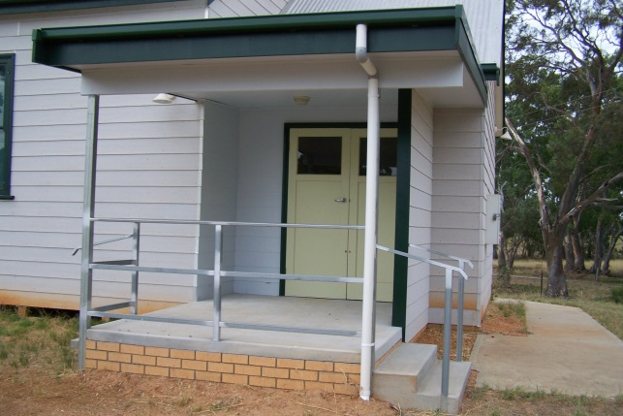
Entrance to Betley Hall

With the increased support of residents, a meeting was held at the hall on Monday 4 September 2017. Eleven enthusiastic community members and two DELWP staff (Melissa and Cathie Boschert) braved the cold and wet winter evening to attend the meeting in the hall, with lighting provided by a generator as electricity had been disconnected.

It was evident that the community wanted to retain their hall, with numerous questions on the roles and responsibilities of CoMs. Attendees also discussed ways in which they could promote the use of the hall within the local area for future activities, including as a venue for overflow activities connected with major events at nearby Maryborough.
With renewed interest in the future of the Betley Mechanics Institute, the Betley Mechanics Institute Committee of Management Incorporated, consisting of 11 locals, was appointed by the Minister for Energy, Environment and Climate Change on 30 October 2017.

Committees contacted about asbestos
The Victorian Asbestos Eradication Agency has been tasked by the state government to provide a comprehensive report about the presence of asbestos in state public sector buildings and a prioritisation schedule for its eradication.
As part of this work committees may be contacted in coming months to ascertain whether a committee manages a building(s) and, if so, the likelihood that there is a presence of asbestos. Where it is indicated that the presence of asbestos is likely there will be further contact by the agency.
Queries can be emailed to Dan.Meehan@DELWP.vic.gov.au

Helping Preserve a Bit of History, Loddon Mallee Region
Senior Property Officers Aaron Walder and Julie Jones have been hard at work helping Committees of Management (CoM) repair and update three community facilities in both the Mallee and Central Victoria.
The local CoM required help of the removal of the Meringur Public Hall to another reserve, with the department partly funding this move.
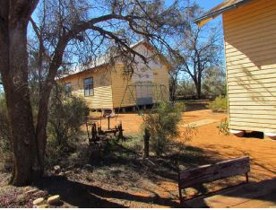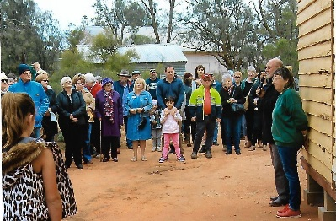
Meringur Hall on the new site and the community waiting for the official opening.
The works included the removal of a concrete slab and ramp, some building material and various pieces of concrete. After the building removal, the site was levelled off and left in a clean and tidy state.
The Hall is now part of the Millewa Community Pioneer Park in Meringur. Established in 1986, the Millewa Pioneer Park was established to recognise the efforts of early settlers creating a livelihood from humble beginnings. The Park is run by a voluntary committee committed to creating a visual hands-on-display of early Millewa district history and lifestyle. The emphasis of the display is to preserve the heritage, environment and the history of the wider Millewa community.
DELWP Voluntary Committees together on Facebook
DELWP Port Phillip and Grampians Regions have started two closed Facebook groups.
These groups provide a private space for volunteer committees. Members can ask questions of DELWP staff and other committee members as well as share photos, posts, stories and event information.
DELWP welcomes the use of this group as a place for our committees to ask questions, engage in discussion and share information.
If you are a member of a committee in either Port Phillip or the Grampians and you would like to join a group please contact voluntary.committees@delwp.vic.gov.au
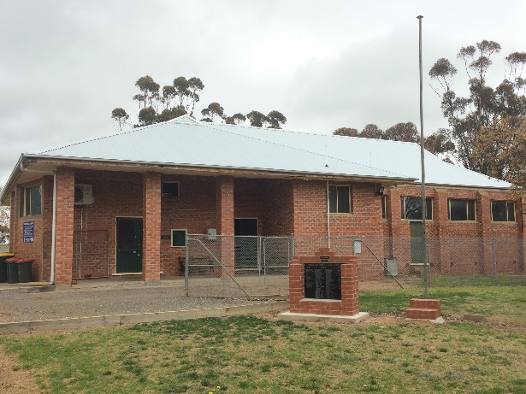
Nadaly Public Hall

Repair works for Nandaly Public Hall were required after water got into the roof and flooded the male toilets. It not only caused damage to the roof but also the light fittings and walls.
Aaron said it was great to be able to help the CoM fix the damage as the hall is regularly used for Buloke Shire Council meetings, local community group meetings and family celebrations. “The CoM is very active and has recently merged with the Nandaly Recreation Reserve CoM to manage both reserves.”
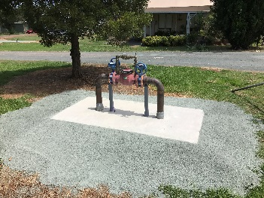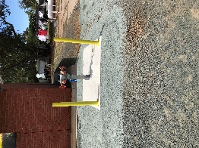
Fire hydrant and hose reel at Elmore Caravan Park

Moving south, the Elmore Recreating Reserve – Caravan Park had created an Emergency Management Plan. The plan required significant funding to install fire hydrants & hose reels to keep the caravan park registered.
Julie said the CoM completed the plumbing and relevant earth works at their own expense, approximately $47k, however they needed funding for the purchase and installation of five fire hydrants and hose reels, as per CFA requirements. “DELWP has provided them with $16, 500 to buy and install the hydrants.”

Tackling pests together, State-wide
There is an exciting project underway around Victoria taking a unique approach to improving weed and rabbit control. Rather than focusing on specific techniques like biological control or incentives schemes, it’s focusing on ‘people power’, with the goal of supporting people and community groups, who manage rabbits and weeds, to work better together.
The project is led by Agriculture Victoria in partnership with Victoria’s four community pest management groups for rabbits, blackberries, serrated tussock and gorse. The project team met and talked with individuals and community groups across the state to identify gaps, problems and opportunities with weed and rabbit management. Based on what they learnt, the project has invested in projects totalling $860,000.
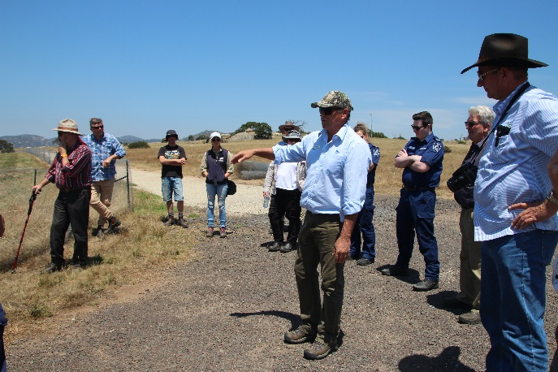
Rabbit learning network participants visiting the Mount Rothwell Conservation and Research Centre, to study their conservation and rabbit control efforts. The learning network is one of the project’s capacity building programs.

These projects are being delivered by the Victorian Blackberry Taskforce, the Victorian Rabbit Action Network, the Victorian Gorse Taskforce, and the Victorian Serrated Tussock Working Party. The projects are focused on making a real, lasting impact on the effectiveness of pest management by supporting community groups and organisations; they aim to boost participation, leadership, collaboration, capacity building and knowledge sharing across communities and government stakeholders.
Share your stories in Edition 14!
DELWP is seeking contributions for Edition 13, and any feedback on the frequency and content of the newsletter. Please send any comments, suggestions or articles and photos to voluntary.committees@delwp.vic.gov.au

There will be new opportunities in 2018 for community members to undertake leadership training, participate in mentor programs, join learning networks, and apply for funding to support local pest control efforts.
If you’d like to be part of this, subscribe to the Weeds and Rabbits Project e-newsletter by emailing pestanimalsandweeds@ecodev.vic.gov.au.
You can read the latest newsletter online.
The Weeds and Rabbits Project is funded through the Federal Government’s Agricultural Competitiveness White Paper.

Applying for a grant?
For letters of support for grants or to get consent to do works, committees should contact their local DELWP officers. They typically need the location of the works, details of the works proposed, whether you need a planning permit, and what grant you are applying for.
To get contact information for your local officer, visit our website: https://www2.delwp.vic.gov.au/ or email voluntary.committees@delwp.vic.gov.au

Grant name | Purpose | Amount | Key dates | Website
Victorian Heritage Restoration Funds | Restoration works to places of identified historical significance under a heritage overlay in the City of Melbourne, City of Yarra, and City of Ballarat. | Assessed on case by case basis | Various dates – see their website | http://www.vhrf.org.au/
Melbourne Water Corridors of green funding | To improve river health through the corridors of green program. | Up to $20,000 | Ongoing | https://melbournewater.smartygrants.com.au/corridorsofgreen
Recreational Fishing – Small Grants Program | To support actions or programs which aim to boost participation in recreational fishing and related activities. | Up to $5,000 | Ongoing | http://agriculture.vic.gov.au/fisheries/recreational-fishing/recreational-fishing-grants-program/small-grants-program
Inspiring Environmental Solutions community funding program – EPA | To enhance the environment in a public place, or undertake environmental activities for the benefit of the community. | Varies | Ongoing | http://www.epa.vic.gov.au/our-work/programs/inspiring-environmental-solutions
Living Heritage Program | Funding is provided to support projects that address the risk to the place or object and that deliver and demonstrate benefits for the community. Restricted to places and objects included on the Victorian Heritage Register and publicly accessible. | $20,000 to $200,000 | Closes 13 April 2018 | http://www.dtpli.vic.gov.au/heritage/about-heritage-in-victoria/living-heritage-program
PPWCMA Community Grants | To assist with projects and activities that protect environmental assets, address priority issues and improve the health of the environment. |  | 2018-19 grants open mid-2018 | http://www.ppwcma.vic.gov.au/grants/community-grants/
Public Safety on Public Land (major projects) | An annual grants initiative that provides support to Crown land managers to help reduce risk to and maintain safe access to public land. | Over $20,000 | Contact local DELWP officer  prior to 31 May 2018
Coastal Public Access and Risk Grants | An annual grants program that provides funding to coastal Crown land managers to undertake works that reduce public safety risk and improve access. | Up to $150,000 | Contact local DELWP officer  prior to 30 June 2018 | https://www.coastsandmarine.vic.gov.au/grants/coastal-public-access-and-risk-grants
Parks and Reserve Asset Grants | Provides funding for Crown land managers to improve infrastructure and public amenity, through environmental assessment, protection, restoration or improvement. |  | Contact local DELWP officer  prior to 31 March 2018
Community and Volunteer Action Grants | Aims to support practical community efforts to deliver conservation projects on public and private land. | $5,000 to $50,000 | Closes 30 April 2018 | https://www.environment.vic.gov.au/grants/community-action

