Victorian Forestry Plan

Community Transition Team Fact Sheet
The Forestry Transition Program has been developed to assist you and your community through the transition out of native forest harvesting.
As the industry transitions, the Forestry Transition Program includes dedicated support to ensure the continued strength of local communities. The support includes a team of locals that is working with towns that may be affected by the plan, with the team currently in place in Gippsland, Central Highlands and the North East.

How we will support you?
The team is ready to assist local communities in understanding the changes to the forestry industry. We will work with locals to develop long term partnerships to understand the level of support you need and provide advice on programs and services that will assist your community.

How will this support benefit your community?
A central point of contact for information and connections to the most appropriate services
Building knowledge and understanding of what is important to the community
Work together and build community strength by identifying new opportunities
Provide practical support and guidance through funding applications when it becomes available.

Support on offer

Local Development Strategy Grants
Grants of up to $500,000 are available to help 11 communities that are affected by the Forestry Transition Program.
The grants provide support for communities to plan for their future including how they can create different and sustainable jobs in their area.

Community Development Fund
The $22 million Community Development Fund supports the delivery of early Local Development Strategy outcomes.
The fund allocates financial support to 11 priority Local Development Strategy communities.

Forestry Transition Fund
The $36 million fund will support actions from the local development strategies as well as communities not eligible for a Local Development Strategy
Round 1 supports the immediate creation of jobs in towns and communities affected by the Forestry Transition Program, particularly jobs for displaced timber workers.

To learn more about the program
To stay up to date on the Forestry Transition Program, visit: Forestry Transition Program
Phone: 1800 318 182
Email: Forestry Transition

Local contacts

East Gippsland LGAs
Ruth Fitzclarence
Community Transition Support Officer
Phone: 0400 776 040
Email: Ruth Fitzclarence

Wellington Shire LGA
Jeff Svigos
Senior Project Manager
Phone: 0436 661 065
Email: Jeff Svigos

Yarra Ranges and Baw Baw LGAs
Yoshi De Wilde
Community Transition Support Officer
Phone: 0499 830 051
Email: Yoshi De Wilde

Murrindindi, Benalla, Towong and Gannawarra LGAs
Jenny Pena
Community Transition Support Officer
Phone: 0400 447 342
Email: Jenny Pena

Where we will work
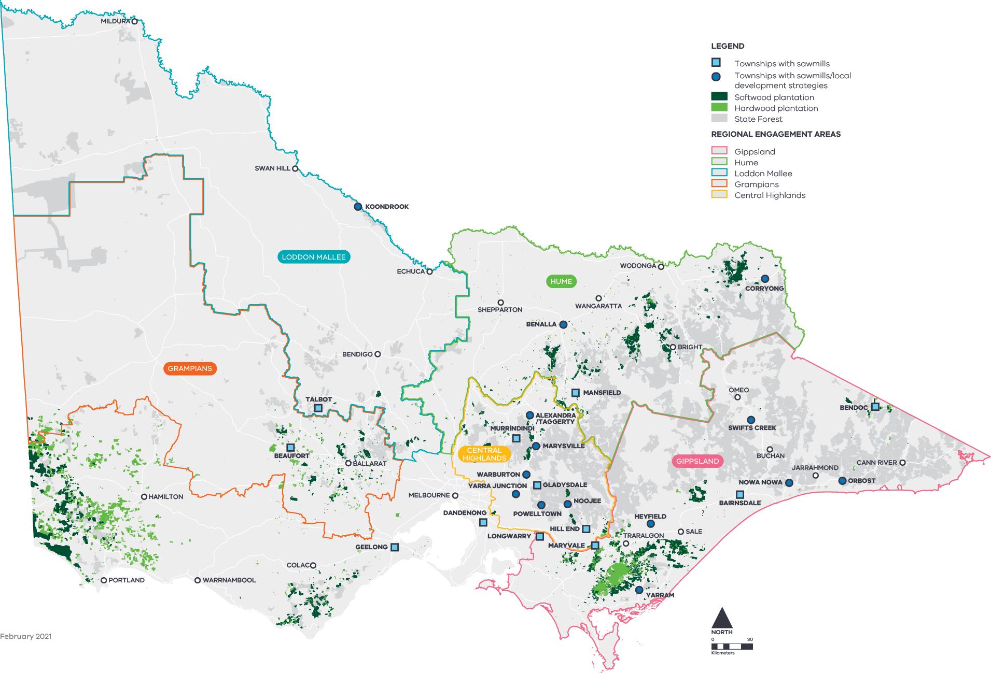

Regional engagement areas
Gippsland
Hume
Loddon Mallee
Grampians
Central Highlands

Townships with sawmills
Bairnsdale
Beaufort
Bendoc
Dandenong
Geelong
Gladysdale
Hill End
Longwarry
Mansfield
Maryvale
Murrindindi
Talbot

Townships with sawmills/Local Development Strategies
Alexandra/Taggerty
Benalla
Corryong
Heyfield
Koondrook
Marysville
Noojee
Nowa Nowa
Orbost
Powelltown
Swifts Creek
Warburton
Yarra Junction
Yarram

