# Board meetings and decisions

About the model policy

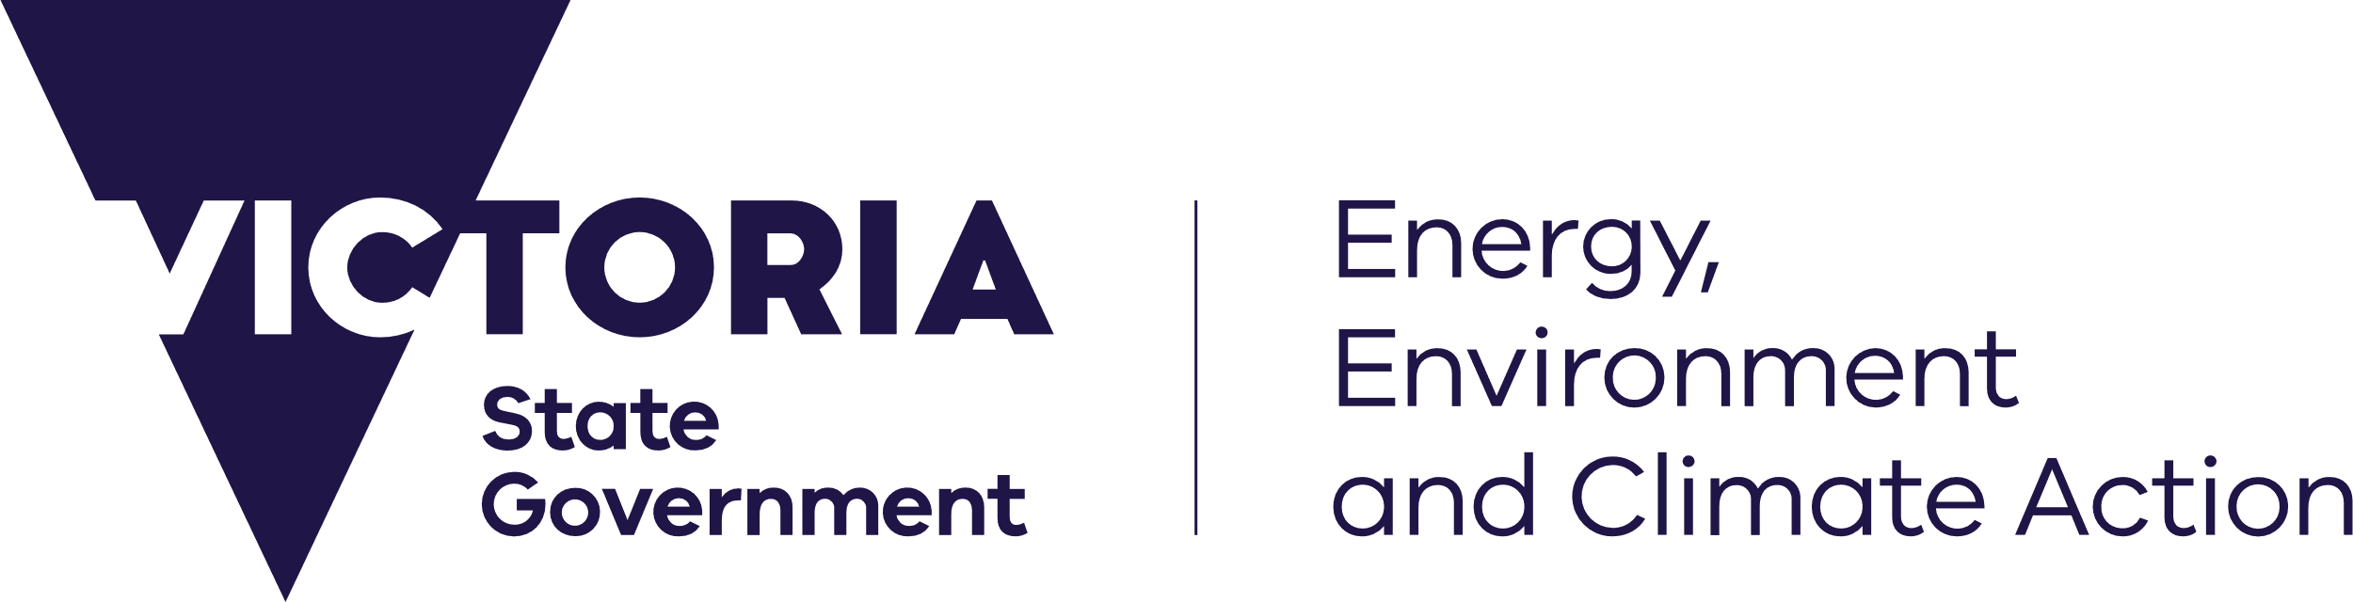



deeca.vic.gov.au

This guidance note is for use by board members of the over 100 major public entities and other statutory boards, committees, councils, panels, etc. in the Department of Energy, Environment and Climate Action (DEECA) portfolio, including large (category 1 and 2) committees of management of crown land reserves

## Introduction

Your board must have a *Board Meetings and Decisions* policy that complies with its governance obligations and with good public sector governance practice.

The board’s policy should include procedures for:

* the conduct of board meetings
* the making of board decisions
* the recording of board minutes.

## DEECA model policy

DEECA offers a model policy on Board Meetings and Decisions. Your board’s policy should be consistent with DEECA’s model policy.

If your agency’s establishing Act includes specific requirements in relation to meetings and decisions, adapt the model policy accordingly.

## Terms used

The model policy uses generic terms. Your board can substitute its own terms, for example:

* *board* - committee, council, panel, etc.
* *board member* - director, committee member, etc.

## Governance obligations and good practice

The model policy is based on governance obligations that are binding on most DEECA agencies – e.g. requirements in the *Public Administration Act 2004* (PAA).[1]

Even if these obligations are not legally binding on your agency, they are **basic good governance practice** for all DEECA agencies.

## Overview of model policy

For an overview of the model policy, see Appendix 1.

## Additional guidance

The guidance on the next pages relates to specific items in the model policy - e.g. explains why board decisions should be made by a formal vote that enables each individual board member’s vote to recorded in the minutes.

## Chair’s role (item 3)

In addition to the chair’s role in board meetings, his/her role includes:

* ensuring board members receive suitable induction
* developing the board as a team
* assisting board members to understand their role and responsibilities and those of key stakeholders (e.g. minister, DEECA, CEO)
* managing the board’s annual performance assessment process
* managing the continuing education process for board members
* guiding the dispute resolution process
* acting as key spokesperson and relationship-builder for the agency.

## Remote attendance at board meetings (item 6)

Barrett JA in the NSW Court of Appeal’s **James Hardie** judgement of November 2012 stated that if a board member is attending a board meeting remotely and a document is tabled to inform a proposed decision then, unless the board member can read (or be read) and properly comprehend the document, he/she should abstain from decision-making on the matter.[2]

## Due consideration (item 11)

As part of your duty to exercise due care, diligence and skill, *ask* *questions* – e.g. if you do not understand or you have a query about information presented in a report or other document, ask for clarification. This is particularly so for financial reports. The [Directors’ Code of Conduct](http://www.ssa.vic.gov.au/products/view-products/directors-code-of-conduct-and-guidance-notes.html) requires board members to:

‘Act in a financially responsible manner. Understand financial reports, audit reports and other financial material that comes before the board; actively inquire into this material’.

If you are unsure how to interpret financial reports, it is vital to seek assistance to improve your skills in this area.

## Information and Advice

There have recently been a number of high profile legal actions against boards (e.g. the board of James Hardie Industries Ltd.) which may have been avoided or had less adverse impact if the board had realised that the information being presented to it was not accurate and/or was not consistent with good governance.

A board *cannot* avoid its accountabilities simply by claiming that ‘it was not told of the true situation’. Rather, it has a duty to take appropriate measures to ensure that it is properly informed.

## Ensuring reports are suitable for purpose

The board needs to be active in setting the tone and format of the information presented to it. *Do not assume* that just because a report is in the usual style this means it is adequate for the board’s purposes.

The board has a duty to ensure that it receives accurate, digestible information that is sufficient to make an informed decision. It is not appropriate for a board to let itself be swamped with poorly defined detail, given too little information upon which to base its decision, or given inadequate time to read and consider information prior to making a decision (e.g. see ‘James Hardie’ and ‘Centro’ judgements).

If a report is not adequate for a particular decision, say so. Also ensure that at least once a year the board reviews the tone/style of the standard reports it receives, so as to determine whether these are suitable to the board’s needs and meet current governance standards.

## Financial reports – seeing the overall picture

It is recommended that for each budget item in a monthly financial report the board can clearly see:

* the amount budgeted for the month, the actual cost for that month, and the percentage difference
* the same information for the year-to-date.

It is also recommended that to enable the board to easily see how the budget is tracking it also be provided with:

* the budgeted end of year position
* the expected end of year position (based on the year-to-date and accurate projections for the remaining period)
* the variation between these two figures, expressed as both a percentage difference and a dollar amount.

Preferably, this will be accompanied by a simple, graphic representation - see example:

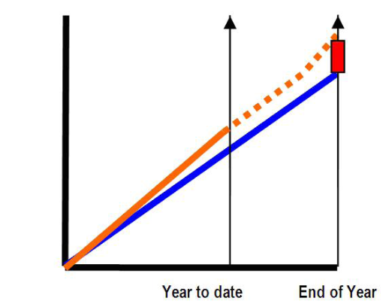

Blue = actual budget

Orange = year to date

Dashed = projections

Red = shortfall (% variation and dollar amount)

If the ‘year to date’ has a shortfall which is projected to reduce by the end of the year, a notation should be included which clearly states what the projected improvement is based on.

## Formal voting (item 13)

The purpose of collegiate discussion should be to ensure that each board member has the information necessary to make an informed vote, *regardless of whether this results in consensus..*.

Barrett JA in the NSW Court of Appeal’s **James Hardie** judgement of November 2012 stated that:

‘Value is often attached to collegiate conduct leading to consensual decision-making, with the chair saying, after discussion of a particular proposal, ‘l think we are all agreed on that’, intending thereby to indicate that the proposal has been approved by the votes of all present.

Such practices aredangerous unless supplemented by appropriate formality...

The aim is rather that the members of the board should consult together and the individual will of each member may be made known in a clearly communicated way.

The culmination of the process must be such that it [is] possible to see (and record) that each member, by a process of voting, actively supports the proposition before the meeting or actively opposes that proposition; or that the member refrains from both support and opposition. And it is the responsibility of an individual member to take steps to ensure that his or her will is expressed in one of those ways.’[3]

Other judgements have since quoted and strengthened this position, for example, the Federal Court’s decision in the **APC/Prime Trust** case.[4]

The chair should ensure that there is a **formal vote**.   
Each member should state whether he/she agrees with, or dissents from, the proposed decision. This will enable the vote to be properly recorded in the minutes.

## Ensuring decisions are valid (item 14)

The consequences of a board failing to follow its decision-making processes will depend on what aspect it has failed to comply with:

* Failure to follow a legal procedure required by the establishing Act or other law will usually make the board’s decision invalid – e.g. a contract or an Instrument of Delegation may need to be sealed, not just signed.
* Failure to follow any part of the decision-making process that is ‘board-generated’ (rather than required by law) will not usually invalidate the board’s decision.

## Board minutes (item 16)

## Contemporaneous record

As noted in the High Court’s **James Hardie** judgment (May 2012), board minutes are a formal and contemporaneous record of the proceedings at a board meeting. Unless there is clear evidence to the contrary, a court will consider the minutes to be evidence of what occurred and what was decided. [5]

Merely asserting that the minutes are inaccurate is not a good/safe defence in any legal proceedings against you.

It is basic governance practice to check the minutes and to only endorse them if you believe they are accurate.

## Proper recording

The NSW Court of Appeal’s **James Hardie** judgement of November 2012 and subsequent cases (e.g**. APC/Prime Trust**) show the importance of properly recording a formal vote for each board decision. It is good practice to record which members:

* voted in favour
* dissented
* abstained and/or were absent from the room due to a conflict of interest or other reason.

## Freedom of information

Almost all DEECA agencies are subject to the *Freedom of Information Act* 1982. This means that your agency’s documents, including its board’s minutes, may be subject to an FOI application. If this occurs, DEECA can provide advice - e.g. on whether parts of the minutes are exempt from disclosure.[6]

## Further information

On Board ([www.deeca.vic.gov.au/onboard](http://www.deeca.vic.gov.au/onboard)), in particular, the [Meetings and decisions](https://www.deeca.vic.gov.au/boards-and-governance/meetings-and-decisions) support module.

DEECA also offers support to its agencies through DEECA divisions and regional offices. Please contact your agency’s usual relationship manager or team or phone the Customer Service Centre on 136 186.

**Disclaimer**: this publication may be of assistance to you but the State of Victoria and its employees do not guarantee that the publication is without flaw of any kind or is wholly appropriate for your particular purposes and therefore disclaims all liability for any error, loss or other consequence which may arise from you relying on any information in this publication.

**Accessibility:** if you would like to receive this publication in an alternative format, please telephone DEECA Customer Service Centre 136 186, email [customer.service@deeca.vic.gov.au](mailto:customer.service@deeca.vic.gov.au), via the National Relay Service on 133 677 [www.relayservice.com.au](http://www.relayservice.com.au). This document is also available on the internet at [www.deeca.vic.gov.au](http://www.deeca.vic.gov.au)/onboard

This document is available from the internet at [www.deeca.vic.gov.au/onboard](http://www.deeca.vic.gov.au/onboard)

For more information contact the DEECA Customer Service Centre 136 186

22 June 2023 (version 3.0) – 56.00

© State of Victoria Department of Energy, Environment and Climate Action

ISBN 978-1-74287-744-0 (online - set)

by This work is licensed under a [Creative Commons Attribution 4.0 International licence](http://creativecommons.org/licenses/by/4.0/). To view a copy of this licence, visit http://creativecommons.org/licenses/by/4.0/

1. Almost all DEECA agencies are public entities and are therefore subject to the PAA and related codes – e.g. [Directors’ Code of Conduct](https://vpsc.vic.gov.au/ethics-behaviours-culture/codes-of-conduct/code-of-conduct-for-directors-of-victorian-public-entities/). Most, except usually small (category 3) committees of management of crown land reserves, are bound by Divisions 2 and 3 of Part 5 of the Act (s 79 to 85).

   Sections 79 to 85 bind public entities that were established after 1 July 2005 OR have had their establishing Act amended to deem that the agency is subject to such provisions (e.g. catchment management authorities and water corporations) OR are included in an Order made by the Governor in Council under section 75(a) of the PAA and published in the Government Gazette.
2. Gillfillan & Others v Australian Securities & Investments Commission [2012] NSWCA 370; also (2012) 92 ACSR 460.
3. Gillfillan & Others v Australian Securities & Investments Commission [2012] NSWCA 370; also (2012) 92 ACSR 460.
4. ASIC v Australian Property Custodian Holdings Limited (Receivers & Managers appointed) (In liquidation) (Controllers appointed) (No.3)
5. ASIC v Hellicar & Others [2012] HCA 17
6. Public sector board minutes are a public record. However, this does not mean they are automatically ‘open to the public’. Unless the board agrees, a member of the public who wants to see the register would need to lodge an application under the Freedom of Information Act.