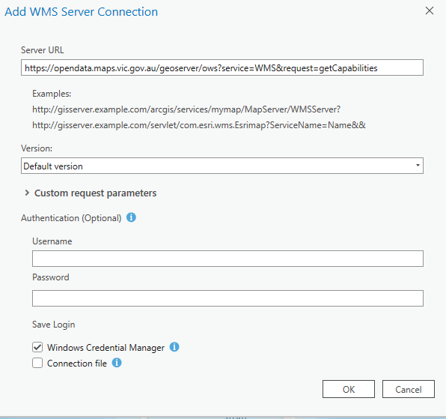

Introduction
Web Mapping Services (WMS) can be used in ArcGIS Pro as map layers. A WMS is a standard protocol for distributing georeferenced map images over the internet. WMS are ”pre-styled” (ie outline colour, fill colour and labelling styles are fixed and cannot be changed by the end user). ISD produces WMS using ArcGIS server and Geoserver (open source).

Loading Geoserver WMS layers into ArcGIS Pro
To access Geoserver web map data (WMS)
- Run ArcGIS Pro
- Open any map or blank template
- Click the Insert tab
- Click Connections
- Click Server
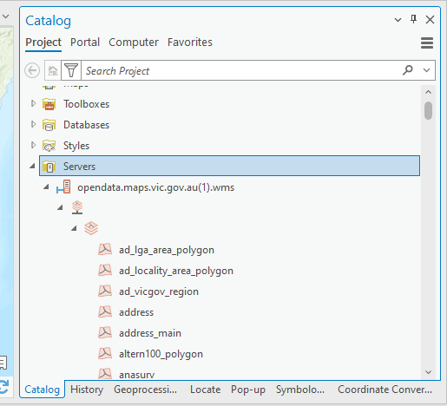
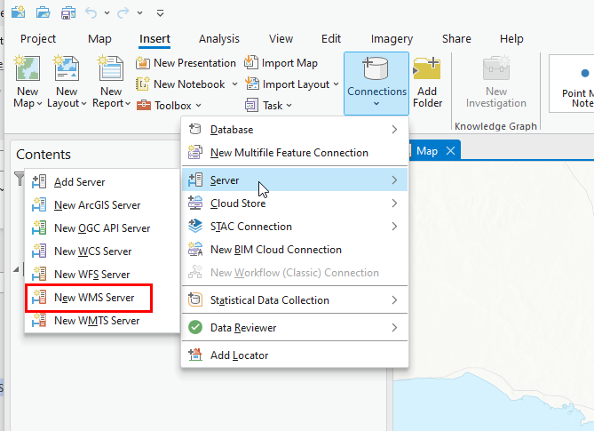
- Add New WMS Server
- Paste the following URL into the Server URL field: https://opendata.maps.vic.gov.au/geoserver/ows?service=WMS&request=getCapabilities
Note: Do not enter a Username or Password
- Click OK
- A new WMS server connection called “opendata.maps.vic.gov.au.wms is created in the Catalog pane under the Servers folder. Expanding this connection will give a long list of layers that can be added to your map.
- To add a WMS layer Drag and drop into the Contents pane

Support
The Enterprise Spatial Services team (DEECA) manages the Open Data Platform. Departmental users can address any feedback or queries to GIS Help Desk via the DEECA Service Portal. External users can provide feedback via the GIS.Helpdesk@deeca.vic.gov.au email address.

