Annual Report 2021-22
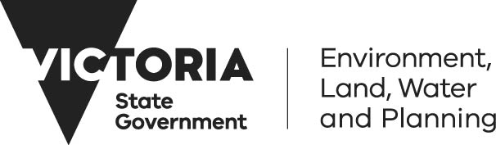
Responsible body’s declaration
In accordance with the Financial Management Act 1994, I am pleased to present the Department of Environment, Land, Water and Planning Annual Report for the year ending 30 June 2022.
John Bradley
Secretary
Department of Environment, Land, Water and Planning
9 September 2022
Acknowledgment
We acknowledge and respect Victorian Traditional Owners as the original custodians of Victoria's land and waters, their unique ability to care for Country and deep spiritual connection to it. We honour Elders past and present whose knowledge and wisdom has ensured the continuation of culture and traditional practices.
We are committed to genuinely partner, and meaningfully engage, with Victoria's Traditional Owners and Aboriginal communities to support the protection of Country, the maintenance of spiritual and cultural practices and their broader aspirations in the 21st century and beyond.
© The State of Victoria Department of Environment, Land, Water and Planning 2022
This work is licensed under a Creative Commons Attribution 4.0 International licence. You are free to re-use the work under that licence, on the condition that you credit the State of Victoria as author. The licence does not apply to any images, photographs or branding, including the Victorian Coat of Arms, the Victorian Government logo and the Department of Environment, Land, Water and Planning (DELWP) logo. To view a copy of this licence, visit http://creativecommons.org/licenses/by/4.0/
ISSN 2205-8931 (print)
ISSN 2205-894X (pdf)
Disclaimer
This publication may be of assistance to you but the State of Victoria and its employees do not guarantee that the publication is without flaw of any kind or is wholly appropriate for your particular purposes and therefore disclaims all liability for any error, loss or other consequence which may arise from you relying on any information in this publication.
Contents
Secretary’s message 3
Key initiatives and projects 2021-22 6
About DELWP 12
Departmental objectives, indicators and outputs 26
Net zero emissions, climate-ready economy and community 28
Healthy, resilient and biodiverse environment 34
Reliable, sustainable and affordable energy services 51
Productive and effective land management 65
Safe and sustainable water resources 80
A safe and quality built environment 95
Reduced impact of major bushfires and other emergencies on people,
property and the environment 110
Our People 120
Climate-related risk disclosure statement 141
Environmental performance 148
Financial Review 167
Legislative and other information 172
Financial Statements 222
Appendices 355
Appendix 1: Disclosure Index 355
Appendix 2: Comparative workforce data 359
Appendix 3: Occupational Health and Safety Performance Measures 370
Appendix 4: Budget portfolio outcomes 375
Appendix 5: Capital projects 382
Appendix 6: Disclosure of grants and transfer payments 383
Appendix 7: Environmental contributions 414
Appendix 8: Ministerial Statements of Expectations 415
Appendix 9: Municipal and Industrial Waste Levy (MIWL) Trust Account 422
Appendix 10: Sustainability Fund Account and Sustainability Fund Grants 423
Appendix 11: Feed-in tariff data 426
Appendix 12: Acronyms and Abbreviations 428

Secretary’s message
I am pleased to release the Department of Environment, Land, Water and Planning’s (DELWP) Annual Report 2021-22.
While this has been a significant year of delivery, it has been because of the dedicated work of the department’s 5,439 staff who responded to significant emergencies, worked in innovative hybrid working models and overcame the challenges caused by the COVID-19 pandemic for operational activities and staff availability.
DELWP teams have worked in close collaboration with First Nations peoples, local government and community representatives, industry and our portfolio entities to make significant progress in our seven outcome priorities across the energy, solar homes, environment and climate action, water and planning portfolios.
Enabling a secure, clean and affordable energy transition
In the energy portfolio, we met key priorities including the development of Victoria’s Renewable Energy Zones (REZ), commencing procurement of seven projects under the REZ Development Plan and establishing VicGrid. DELWP undertook the VRETII auction for at least 600 MW of renewable energy with successful proponents to be announced in 2022, creating approximately 2,000 jobs and unlocking approximately $1.0 billion in renewable energy investment. The Bulgana Green Power Hub, a major new wind farm and battery project, commenced operations generating more than 750,000 MWh of clean energy annually, enough to power around 150,000 homes. Victoria’s share of renewable electricity generation is at 34 per cent for 2021, a surge from 26.6 per cent in 2020, when the state exceeded its legislated renewable energy target of 25 per cent.
This year, the department led the development of Australia’s Offshore Wind sector with the Victorian Offshore Wind Policy Directions Paper released in March 2022, which set clear targets to commission 2 GW by 2032, 4 GW by 2035 and 9 GW by 2040. We supported the emerging hydrogen economy with grants under the Renewable Hydrogen Business Ready Fund and the Renewable Hydrogen Commercialisation Pathways Fund, which supports pilot programs, trials and demonstrations.
In April 2022, Solar Victoria increased the accessibility and reach of solar rebate schemes, including the introduction of zero-interest loans for rebates under the Solar for Business program. We ensured the ongoing safety and development of workers in the Victorian solar industry through delivery of training programs to more than 4,600 workers, exceeding the program target of 3,000 participants. Despite the impacts of COVID-19 and supply chain challenges, more than 41,000 Solar PV homes rebates were approved and 6,500 home battery rebates were approved.
Enabling climate action and a circular economy
We improved environment, biodiversity and resource recovery outcomes across the state in 2021-22. DELWP delivered important priorities in environment and climate action, such as launching and implementing the Zero Emissions Vehicle Subsidy program, involving 83 participating traders and ten different car brands., This program has now seen more than 5,300 subsidies allocated. Our work with local government resulted in 21 voluntary local council emission reduction pledges being made under the Climate Change Act 2017. Adaptation Action Plans were released in February 2022 to ensure Victoria’s climate resilience, now and in the future.
DELWP supported legislation establishing the new circular economy authority and waste industry regulator, Recycling Victoria, which commenced on 1 July 2022, including transfer of Waste and Resource Recovery Group staff and executives. All 79 councils have executed funding agreements for Kerbside Reform Support Funding and DELWP commenced procurement for the Container Deposit Scheme coordinator and network operators allowing its commencement in 2023. We progressed a statewide ban of certain single-use plastics, a container deposit scheme and a new four-stream waste and recycling system.
We delivered a range of biodiversity programs with the community during 2021-22 by facilitating almost 1,000 grants and contracts totaling $17.4 million. Work continued on improving the long-term sustainability of Victoria’s iconic species such as the Helmeted Honeyeater and supporting the rehabilitation of injured wildlife. We partnered with stakeholders including Traditional Owners, to protect and heal Victoria’s biodiversity by controlling pests and weeds and providing greater support for threatened species.
Meeting the challenges of a drying climate
We delivered an extensive program of works to ensure Victoria has safe and sustainable water resources to meet future urban, rural and environmental needs. The largest irrigation modernisation project in Australia’s history, the Connections Project, exceeded its water recovery target of 429 GL with water savings to be distributed to the environment, irrigators and Melbourne water retailers. Over 2021-22, more than 900 GL of water has been delivered for the environment at 89 river reaches and 81 wetlands.
Enabling Victoria’s digital revolution in spatial services
Our Digital Twin Victoria (DTV) team integrated over 4,000 datasets, which are now live in the DTV visualisation platform, and conducted beta testing with customers across industry, education and the public sector to inform the platform development. The Whole of Victorian Government Geospatial procurement panel is delivering savings and halving procurement timelines, while allowing for better data access. We launched the industry-leading ePlan Portal enabling surveying firms to undertake digital lodgement of plans of subdivisions.

Responding to unforeseen demands
In addition to delivering on transformational program objectives planned for 2021-22, DELWP staff were also responsive to the emergencies and unforeseen priorities not on the plan for 2021-22.
As just one example – the June and October 2021 storm and flood events saw DELWP staff responding during the emergency and in recovery. We worked with essential services as they restored power to 300,000 home and 520,000 businesses, rolling out two new relief packages including the prolonged power outage payments and small generator loan program. Our FFMVic crews cleared more than 6,600 kilometres of public land roads of hazardous trees, reopened 2,854 kilometres of the strategic fire access network and repaired and reinstated 88 bridges and crossings repaired and reinstated. 210 recreation sites and 167 walking tracks were made safe and reopened. Our Biodiversity staff supported wildlife with 430 hectares of pest animal control, 60 nest boxes and a trial of carved hollows for over 30 species reliant on hollows for breeding and nesting, plus a program to support recovery of threatened species. Our Water and Catchments teams ensured repairs to 23 damaged water monitoring gauges and supported Catchment Management Authorities in Gippsland to stabilise waterways and stream banks at over 177 sites and the Thomson River Fishway. Based on our learnings from recent emergencies, a permanent One-DELWP recovery model has been developed to ensure the effective and coordinated delivery of recovery activities. We made communities and the environment safer and more resilient to bushfire impacts through delivery of a targeted fuel management program and continued expansion of the strategic fuel breaks network across Victoria. The Office of Bushfire Risk Management commenced operation in July 2021 within DELWP to establish an end-to-end framework for policy, planning, delivery and reporting on fuel management activity across all land tenures in Victoria.
With Victoria facing the economic shock of a global pandemic, DELWP brought forward investment and jobs to support Victoria’s economic recovery while planning for the future growth and transformation of Victoria’s cities and regions. We streamlined planning and assessment processes for major road and rail projects and provided consistent planning requirements for all land required for transport services and facilities. Our Planning teams facilitated priority assessment pathways for 42 major projects worth a total of $7.3 billion and facilitated approval of 19 projects with a combined value of $3.3 billion.
Sustainability of our operations and our people
While our focus has been on delivering for community in 2021-22, we have also renewed our commitment to our own sustainability. We purchased 100 per cent renewable electricity for DELWP operations since April 2021, in advance of the whole of Victorian Government pledge commitment for 100 per cent renewable electricity for government operations by 2025. We have reduced total reported greenhouse gas emissions for DELWP operations by 76 per cent since 2014-15, primarily through the purchase of green power, Australian Carbon Credit Units and the ongoing installation of solar PV panels at DELWP sites.
In 2021-22, we continued to prioritise staff safety and wellbeing. We strengthened the department’s governance of safety and wellbeing through the Safety and Wellbeing Assurance Committee and delivered online initiatives to encourage our employees to continue focusing on their mental and physical health.
It was an active year for diversity and inclusion at DELWP. The department developed and released a new DELWP-wide Safe and Respectful Workplace Behaviours Policy and Safe and Respectful Response Procedure, with 500 people leaders attending First Responder webinar sessions. We are lucky to have vibrant staff-led networks – including our Aboriginal staff network, the Place of Pride network, our Multi-cultural@DELWP network, our All Abilities network, and the recently launched Women of Colour network. These volunteers play such a significant role giving voice to the lived experiences of our people, strengthening intersectionality, diversity, and inclusion. Our People Matters Survey results indicate our staff feel DELWP has a strong and increasing commitment to being an inclusive workplace.
Our accountability for enabling self-determination
Effective partnerships with Traditional Owners and our support for Aboriginal self-determination is fundamental to every aspect of our work – and we are accountable to the Caring for Country Partnership Forum, representing formally recognised Aboriginal parties and Traditional Owner Corporations, which met 17 times this year with DELWP’s leadership.
We released a range of initiatives that were informed by Traditional Owners, and where self-determination was a guiding principle, including the Access and Infrastructure Plan for the new Yallock-Bulluk Marine and Coastal Park in November 2021, the Burndap Birrarung burndap umarkoo (Yarra Strategic Plan) in February 2022 and a draft of the Water is Life: Traditional Owner Access to Water Roadmap in May 2022.
We are delivering the Traditional Owner Renewable Energy Program (TOREP) to empower Traditional Owners to be part of the renewable energy transition. In March 2022, the first of nine TOREP projects were completed by the Wadawurrung Traditional Owners Aboriginal Corporation.
In May 2022, DELWP announced the timetable for the transfer of 30,000 hectares of private land back to Ngintait Traditional Owners, the largest tract of private land to be returned to Indigenous management in the state’s history.
I would like to thank the dedicated DELWP staff and portfolio partners that made our work possible in 2021-22. We look forward to continuing to deliver government priority programs and services for Victoria’s community and environment, while enabling self-determination.
John Bradley
Secretary
Department of Environment, Land, Water and Planning
9 September 2022

Key initiatives and projects 2021-22
The DELWP Corporate Plan 2021-25 defines our outcomes and sets our focus and key directions over the medium term. This includes our contribution to shared government objectives and collaboration with partners and agencies to achieve Victoria’s broader goals.
In 2021-22, we focused on the following outcome priorities for Victorian communities:
- Net zero emission, climate-ready economy and community
- Healthy, resilient and biodiverse environment
- Reliable, sustainable and affordable energy services
- Productive and effective land management
- Safe and sustainable water resources
- A safe and quality built environment
- Reduced impact of major bushfires and other emergencies on people, property and the environment.
A full report of our performance against these outcomes (also known as our departmental objectives in Budget Papers) is included from page 26.
Listed below are a few of the key initiatives and projects delivered for Victorian communities in 2021-22:

Net zero emission, climate-ready economy and community
Climate Change Adaptation Action Plans: The seven Climate Change Adaptation Action Plans for 2022-2026 were tabled in Parliament on 9 February 2022, accompanied by publication of Building Victoria’s Climate Resilience which sets out what Victoria is doing to adapt to our changing climate. Victoria’s approach is centred around adaptation planning for statewide systems and complementary community-led action.
Regional Adaptation Strategies: Regional Adaptation Strategies were developed in each of the six DELWP regions of Greater Melbourne, Gippsland, Hume, Loddon Mallee, Grampians and Barwon South West. These were released in December 2021 accompanied by 54 on-ground community-led projects that will prepare the community for the impacts of climate change.
Work with local government on emission reductions: DELWP’s work with councils across Victoria led to 21 voluntary council emissions reduction pledges being made under the Climate Change Act 2017.

Healthy, resilient and biodiverse environment
Recycling Victoria: Significant milestones were achieved under the Recycling Victoria program, including: Royal Assent of the Circular Economy (Waste Reduction and Recycling) Bill 2021 in December 2021; release of the Victorian Waste to Energy Framework in November 2021; phase out of certain single-use plastic items from Victorian government departments and agencies in February 2022; and consultation on the regulations to enact a statewide ban of these single-use plastic items undertaken in April and May 2022.
Embedding of the new environment protection framework: Following commencement of the reformed Environment Protection Act on 1 July 2021, actions undertaken to embed the new environment protection framework included: release of draft guidelines to support Victorian landowners to comply with their new contaminated land duties; delivery of training on new land-use planning requirements in January 2022; public consultation on a proposed amendment to the Environment Protection Regulations to introduce a new registration for farms storing and using waste tyres; and development of draft guidance for businesses on managing greenhouse gas emissions.
Faunal emblems program: The release of 18 Helmeted Honeyeaters into the Yarra Ranges National Park in May 2022 marked a major milestone for Helmeted Honeyeater recovery. The new habitat is crucial to the Helmeted Honeyeater’s survival as it increases genetic diversity, and protects the species against disease and environmental disasters such as bushfire.
Bushfire Biodiversity Response and Recovery program: From the end of the 2019-20 bushfire season to 30 June 2022, more than 702,000 hectares of herbivore control, 207,000 hectares of predator control and 23,000 hectares of weed control have been delivered. This is reducing the impacts of invasive species on the survival and recovery of threatened species in fire-affected areas of Victoria.
Trust for Nature: Trust for Nature achieved protection of over 1,600 hectares of private land and announced a commitment to transfer Victoria’s largest private conservation reserve, Neds Corner, to its Traditional Owners, the First People of the Millewa-Mallee Aboriginal Corporation. This is the largest parcel of private land to be returned to Traditional Owners in the state.

Reliable, sustainable and affordable energy services
Power Saving Bonus: More than 400,000 applications were received through the Power Saving Bonus for concession recipients program since its commencement in February 2021, resulting in nearly $100 million in payments to vulnerable Victorian households.
Renewable Energy Zones: The establishment of Victoria’s Renewable Energy Zones (REZs) is underway. VicGrid, a new body tasked with coordinating the overarching planning and development of Victoria’s Renewable Energy Zones (REZs), was established in July 2021, and procurement for network upgrades to prepare Victoria’s energy grid for REZs progressed during 2021-22. A potential new approach to planning transmission infrastructure and transmission access was released for stakeholder input in July 2022 to help bring on transmission investment to host new renewable generation.
Victorian Big Battery: The Victorian Big Battery completed its first season of safeguarding the state’s energy supply through our hot summer months, driving down electricity prices and supporting the state’s massive renewable energy build. Each year between November and March the Victorian Big Battery will operate as a virtual transmission line enabling increased flows of up to 250MW over the Victorian/New South Wales interconnector. This service, called the System Integrity Protection Scheme, reduces the risk of unscheduled load shedding over the peak summer months. The first operational season concluded at the end of March 2022 with the battery successfully providing the required service and availability.
Electricity Distribution Network Resilience Review: The Electricity Distribution Network Resilience Review was initiated in response to the June and October 2021 windstorms to examine how distribution businesses can improve their preparedness for and response to prolonged power outages arising from extreme weather events, including how to strengthen community resilience. The Expert Panel’s final report was published in June 2022 and includes recommendations designed to reduce the likelihood and impact of prolonged power outages. This includes that distribution businesses are required to develop a Victorian Network Resilience Investment Strategy, and to participate in regional emergency management as well as provide customers with more timely and relevant information during a prolonged power outage event. DELWP is currently developing the government’s response to the Expert Panel’s final report, which is expected to be published in October 2022.
Transitioning to a distributed energy resources future: In April 2022, DELWP released Harnessing Victoria’s Distributed Energy Resources, a vision statement highlighting our goals and objectives in transitioning to a distributed energy resources dominant future. In line with the vision, DELWP implemented policy and regulatory reforms to modernise our electricity grid and support the roll-out of distributed energy resources in Victoria.
Gas Substitution Roadmap: Released in July 2022, Victoria’s Gas Substitution Roadmap provides strategic directions and actions for a coordinated and equitable transition to net zero emissions, that enables consumer choice and enhances energy affordability and reliability, while providing investment certainty for Victorian households and industry. Development of the Gas Substitution Roadmap was informed by technical investigations, analysis and significant industry and consumer consultation over 2021-22.
Victorian Energy Upgrades program: The Victorian Energy Upgrades program continues to support Victorians to reduce their energy use and bills. In 2021-22, more than 410,000 households and 45,000 businesses accessed incentives under the Victorian Energy Upgrades program.
Bulgana Green Power Hub: The Bulgana Green Power Hub wind farm and battery commenced commercial operations in December 2021. This project created 150 construction jobs and can now generate more than 750,000 MWh of cheap, clean energy annually – enough to power around 150,000 homes.
Accelerating the adoption of zero emission vehicles: Successful projects under the Destination Charging Across Victoria program were announced in December 2021. This will result in approximately 141 electric vehicle (EV) fast-charging stations within approximately 116 high-use areas and tourist spots across regional and metropolitan Victoria. During 2021-22, 5,316 Victorian residents and businesses purchased a zero emission vehicle with support from EV subsidies under the Zero Emission Vehicle program.
Solar for Business: Since April 2022, the program has offered interest-free loans to enable businesses to reduce the upfront cost of the installation of an approved small-scale solar PV system in addition to a rebate. During 2021-22, 1,508 solar rebate applications were approved for Victorian businesses, with 34 per cent of those applicants also applying for an interest-free loan.
Solar Homes rebates: During 2021-22, 48,642 rebates were provided to households to install solar panels, battery storage systems, solar and energy efficient hot water and 23,624 interest-free loans were provided to households.
Home Heating and Cooling Upgrades: During 2021-22, 35,367 rebates were approved for reverse cycle air conditioning units to replace inefficient heating systems for low income and vulnerable households.

Productive and effective land management
Marine and coastal policy reforms: Released in May 2022, the Marine and Coastal Strategy will support sustainable use and improve how we manage the health of the marine and coastal environment. Research projects with university partners on sea level rise impacts and coastal erosion have progressed and guidelines for the development of marine and coastal management plans are being drafted.
Supporting Traditional Owner self-determination in land management: In August 2021, the Victorian Traditional Owner Cultural Landscapes Strategy was launched by Victorian Traditional Owners with support from DELWP. The Strategy provides direction to the Victorian Government about how it can enable and empower Traditional Owner self-determination in land management. DELWP continued to support Traditional Owner Land Management Boards over 2021-22.
Supporting alpine resorts: Legislation to amend the Alpine Resorts (Management) Act 1997 to establish a single entity to manage Victoria’s six alpine resorts passed in March 2022. The amendments are scheduled to come into effect on 1 October 2022. The new entity, to be known as Alpine Resorts Victoria, will support alpine resorts and associated communities as they recover from the effects of the 2019-20 bushfires and the COVID-19 pandemic.
Yellingbo Conservation Area: The Yellingbo (Liwik Barring) Landscape Conservation Area 10-year Plan was released in December 2021 following consultation with a wide range of interested community and stakeholder groups. The plan articulates management directions for the conservation area over a 10-year time frame, aimed at enhancing its scenic beauty, biodiversity, cultural heritage and community enjoyment.
Management of the Great Ocean Road: A Bill to amend the Great Ocean Road and Environs Protection Act 2020 was passed by Parliament on 14 October 2021, making the Great Ocean Road Coast and Parks Authority the dedicated parks and public land manager for the Great Ocean Road coast and parks. The first step in developing the Great Ocean Road strategic framework plan was completion of a consultation draft in June 2022. The draft plan is expected to be finalised by December 2023.
Vicmap data services: ‘Vicmap as a Service’ has now achieved more than 10 million hits since its launch in September 2021, and is now streaming Vicmap data directly into numerous federal, state and local governments, private spatial service providers, and emergency service agencies’ spatial systems, including the Bureau of Meteorology, the Emergency Services Telecommunications Authority, the Country Fire Authority and Fire Rescue Victoria.
Digital Twin Victoria (DTV): A three-month beta testing program gathered customer insights to inform the development of the DTV platform, with more than 80 per cent of participants expressing a high level of satisfaction. The DTV platform now includes many new datasets and functionality, and is already providing benefits to state and local governments by providing easier access to data and delivering savings through the use of shared data storage, analytics and visualisation tools.

Safe and sustainable water resources
Environmental watering: More than 900 GL of water was delivered for the environment at 89 river reaches and 81 wetlands during 2021-22. The Koondrook Weir Fishway was completed in December 2021, connecting 55 kilometres of Gunbower Creek and 530 kilometres of Murray River for native fish, including the iconic Murray cod and golden perch.
Restoring waterways and catchments: During 2021-22, catchment management authorities commenced eight new regional flagship waterway projects across regional Victoria; completed works at priority Ramsar sites to address key threats; and commenced the first year of the refreshed Gippsland Lakes Priority Plan, which will see 30 projects delivered in collaboration with 12 delivery partners.
Integrated water package of works: An integrated water package of works completed during 2021-22 included installation of educational wetland boardwalks in Pakenham, a new stormwater irrigation system for greenspace in Sunshine North, the installation of recycled permeable pavers to reduce flooding in South Yarra and ecological restoration of Gunbower Creek.
Central and Gippsland Region Sustainable Water Strategy (CGRSWS): The CGRSWS will set the direction for securing the region’s long-term water supplies and protecting the jobs, farms, communities and Traditional Owners that rely on them, as we face the growing challenges of climate change and population growth. A discussion draft of the CGRSWS was released for public consultation from 8 October 2021 to 10 December 2021. Over 225 survey responses and more than 50 detailed submissions were received from the community. The final Strategy will incorporate changes made based on this feedback and is expected to be released later in 2022.
Improving the amenity and environment of Melbourne’s iconic waterways: The Burndap Birrarung burndap umarkoo (Yarra Strategic Plan), the Waterways of the West and the Rivers of the Barwon (Barre Warre Yulluk) Action Plans were released during 2021-22. These plans will support the protection of the health and amenity of these waterways and the landscapes through which they flow as living, integrated entities.
Supporting Aboriginal Victorians in accessing water: DELWP continued to support water returns to Traditional Owners across the state during 2021-22. In February 2022, the Victorian Government announced 1.36 GL of water would be returned to Traditional Owners in Northern Victoria and in March 2022, Gunditj Mirring Traditional Owner Aboriginal Corporation received a 2.5 GL water return in the Palawarra (Fitzroy River) system.
2019-20 bushfire recovery works: Catchment management authorities continued vital bushfire recovery activities during 2021-22. This included delivery of 476.4 hectares of weed control and continued work on repairing off-stream watering systems and addressing priority risks from erosion, debris and water quality.

A safe and quality built environment
Development Facilitation Program: DELWP is enabling a steady pipeline of major projects to drive the ongoing economic and social recovery of Victoria. Since commencement of the development facilitation program in October 2020 to 30 June 2022, the program has recommended priority assessment pathways for 42 major projects worth a total of $7.3 billion and facilitated approval of 19 projects with a combined value of $3.26 billion.
Planning reforms: A range of reforms have been implemented or are underway to bring forward investment and jobs supporting Victoria’s economic recovery including: collaboration with 12 councils through the Better Planning Approvals program to improve and simplify approval processes; support to rural and regional councils with statutory and strategic planning via the Regional Planning Hub program, with over 111 requests for support received from councils; and improved coordination of planning approvals for state infrastructure projects via a dedicated State Project Concierge, with the facilitation of 73 projects or programs since its commencement.
Review of Victoria’s building system: A comprehensive review of Victoria’s building legislative system is underway. Led by an Expert Advisory Panel working in partnership with DELWP, the review will be delivered across three stages ending in 2023. The panel canvassed reform options in the Framework for Reform paper and provided its report and recommendations for Stage 1 reforms to government in August 2021. The Building, Planning and Heritage Legislation Amendment (Administration and Other Matters) Bill 2022 was introduced into Parliament on 21 June 2022. The Bill will address some of the reforms to Victoria’s building system considered by the expert panel.
Victorian Planning Authority Fast Track program: The Victorian Planning Authority (VPA) completed eight projects in 2021-22 through the Fast-Track program, delivering zoned land for 28,000 homes and 27,000 jobs, and is working towards completing seven further planning and infrastructure projects in 2022-23.
Statewide Cladding Audit Intensive Inspection Initiative: Through the Statewide Cladding Audit, the Victorian Building Authority (VBA) works with owners and owners corporations to identify buildings with combustible cladding and assess risks. During 2021-22, 5,306 virtual reviews, 322 kerbside reviews, 167 inspections and 83 audits were undertaken through the VBA’s Statewide Cladding Audit Intensive Inspection Initiative.

Reduced impact of major bushfires and other emergencies on people, property and the environment
Supporting safe egress and access on the strategic fire access road network: To improve firefighter and vehicle accessibility on the strategic fire road network, DELWP replaced 10 crossing structures, and delivered 2,024 kilometres of road upgrades and improvements.
Bushfire, storm and flood recovery: Throughout 2021-22, recovery work continued in the regions affected by the 2019-20 bushfires and storm and flood events. This included: clearing and reopening 459 kilometres of bushfire-impacted public land roads, with a total of 8,979 kilometres reopened since the 2019-20 bushfire season; clearing 5,974 kilometres of storm debris from public land roads, out of a target 7,280 kilometres; and supporting threatened species and wildlife to recover, including repairing damaged aquatic barriers, installing nest boxes and conducting pest plant and animal control.
Supporting Traditional Owner-led cultural land and fire management practices: A total of 13 Traditional Owner cultural burns were delivered in 2021-22. DELWP also worked in partnership with 10 Traditional Owner Corporations to co-develop funding agreements, which will see the transfer of power and resources to them to implement their self-determined pathways for implementing cultural fire.
Safer Together: Safer Together is DELWP’s approach to reducing the risks of bushfire in Victoria that combines stronger community partnerships with the latest science and technology. Under the Safer Together program, DELWP commissioned a bushfire behaviour database in May 2022 to enable better understanding of bushfire, engaged with communities to improve access to bushfire risk information and build understanding and engaged with Traditional Owner groups to help shape the whole of sector bushfire strategy.
Strengthening partnerships to reduce bushfire risk: Established in July 2021, the Office of Bushfire Risk Management is working with fire and land management agencies to develop and coordinate an end-to end framework for policy, planning, delivery and reporting on bushfire risk management across all land tenures in Victoria.

Sustainability Fund
The Sustainability Fund, established under the Environment Protection Act 2017, receives money collected from the waste levy to support businesses, local governments and communities through a range of waste management, recycling, resource efficiency and climate change programs.
In 2021-22, DELWP recorded its third-highest expenditure in the Sustainability Fund’s history, with program payments made of $191.2 million in the legislated areas of:
- climate change mitigation and adaptation ($94.58 million)
- waste management and resource recovery ($93.35 million)
both climate change and waste management ($3.25 million).
Key achievements of the fund in the waste and recycling sector during 2021-22 include:
- more than 58,000 tonnes of organics waste and 36,000 tonnes of plastic waste diverted from landfill
- 137 e-waste collection services were upgraded (more than doubling the total since 2018-19)
glass, metal and e-waste collection added to the state’s recycling services.
Contributing to state-wide energy affordability, reliability and innovation, Sustainability Fund projects delivered the following achievements during 2021-22:
- 3,400 kW of renewable energy capacity installed
457,000,000 kWh of renewable energy generated.
An ongoing priority of Victoria’s sustainability agenda for 2021-22 was the engagement of community members in activities and the development of partnerships to deliver projects. Positive results were achieved throughout the year, including:
- more than 9,000 people participated in activities to protect Victoria’s coasts
- more than 450 schools adopted environmental actions
240 partnerships or collaborations were formed.

About DELWP
DELWP brings together Victoria’s climate change, biodiversity protection, resource recovery, water, energy, land management, planning and forest and fire management functions into a single department. We take an integrated approach to creating thriving environments and communities, as well as supporting Victoria’s economic recovery from the impact of the COVID-19 pandemic. Our portfolio priorities are underpinned by a commitment to Aboriginal self-determination, effective action on climate change and recovery from natural disasters.
Our challenge is to improve Victoria’s liveability with a population that is expected to increase to 11.2 million by 2056, while protecting our natural environment, infrastructure and heritage for future generations. These challenges require global and local responses, and immediate and long-term solutions. Our substantial reach allows us to take a holistic approach to these challenges.
Our positive organisational culture drives high performance through strong leadership, diversity, collaboration and innovation, enabling us to learn from each other, grow our understanding and find new ways of delivering results.
It is our legislated responsibility to provide environmental stewardship, but it is our enduring commitment to the Victorian people and environment that motivates our daily actions.
DELWP employs more than 5,400 staff in 87 locations across the state and is a key manager of Victoria’s public estate. DELWP directly manages $9 billion of assets, 79 per cent of the asset portfolio comprises various categories of public land. DELWP also owns and manages approximately $2 billion of other assets including 40,000 kilometres of roads and tracks, office buildings, depots, recreational facilities, firefighting and road maintenance equipment, crossings, water bores and mobile plant.

One-DELWP Strategic Framework 2021-25
The DELWP Corporate Plan 2021-25 defines our strategic framework:
Our vision: Thriving environments and communities
Our values: Teamwork, Service Excellence, Ownership, and Wellbeing and Safety
Our organisational pillars:
- High performance and delivery for government
- Aboriginal self-determination
- Trusted leadership and inclusive culture
- Strong engagement, partnerships, and service excellence
Empowered people with a One-DELWP mindset
Our outcomes:
- Net zero emissions, climate-ready economy and community
- Healthy, resilient and biodiverse environment
- Reliable, sustainable and affordable energy services
- Productive and effective land management
- Safe, sustainable and productive water resources
- A safe and quality-built environment
Reduced impact of major bushfires and other emergencies on people, property and the environment.

Our community charter and operating model
With diverse communities come diverse needs, DELWP takes a proactive, collaborative and accountable approach to responding to the needs of the communities we serve. DELWP engages with community partners, clients and stakeholders to deliver services that support liveable, inclusive and sustainable communities and thriving natural environments.
Our promise to Victorians – In all aspects of our work and interaction with the public we will:
Be available | Place-based community focus | Talk to you where you live, work and play and be visible in local communities
 | Accessibility | Make sure we are easy to contact, and our information is straightforward and available in a variety of ways
 | Flexibility | Respect the way you want to work with us, and adapt our approach according to local needs
Speak and listen | Active listening and understanding | Listen to and understand your views and needs  and respect different opinions
 | Honesty and transparency | Be honest about what’s driving our priorities, what we can and can’t promise to do, our timelines and why decisions have been made
 | Clarity and purposefulness | Be clear why and how we are engaging, making sure we give you real opportunities to influence and make a difference
Take action | Timely and proactive | Talk to the community as early as we can, responding quickly to issues and feedback
 | Consistency | Ensure we are consistent in the way we approach decisions
 | Closing the loop | Inform communities about the outcomes of projects and if our plans change we will let you know when this happens and why

Our partners, clients and stakeholders
Our community charter guides our formal and informal interactions with communities. This includes connecting with local networks, building capacity and improving the way we communicate. These changes will help us to achieve objectives for our shared environment and improve outcomes for local communities.
DELWP works closely with clients, partners and stakeholders to create liveable, inclusive and sustainable communities, supporting jobs and growth in Victoria.
Our partners include:
- Catchment management authorities
- Cooperative research centres
- Environment Protection Authority Victoria
- Local government
- Other state and federal government departments
- Parks Victoria
- Sustainability Victoria
- Water corporations
- Universities
- Traditional Owner Corporations and Aboriginal communities
- Victorian Building Authority
Victorian Planning Authority.
We also work closely with the Commissioner for Environmental Sustainability and the Victorian Water Trust Advisory Council.
Our customers and stakeholders include:
- Land and water managers, planners, developers and information users
- Animal welfare groups
- Environmental, tourism, sport and recreation groups
- Industry-based research and development corporations
- Building industry and real estate organisations
- Community and special interest groups
- Financial institutions
- Key employer associations and unions
- Local, state, territory and Commonwealth governments, agencies and authorities
- Media organisations and communication carriers
Local, national and international business organisations.

Sustainable Development Goals
DELWP’s vision is Thriving environments and communities. To achieve this, we are focussing on issues including sustainability, environmental protection, liveable cities, and climate change. Our actions may be local, but they contribute to a broader global shift and more sustainable development, as captured by the United Nations Sustainable Development Goals (SDGs).
The 17 SDGs and their associated 169 targets were agreed by 193 countries at the United Nations in 2015. They provide a global framework for sustainable development to 2030 and beyond.

Relevance to DELWP
In a purpose-driven organisation such as DELWP, the ability to harness passion and actions is critical. The SDG framework is credible, transparent, internationally accepted and offers us a unifying purpose for our work. Under the framework we can see how our varied activities fit together to contribute to Victoria’s sustainable future.
DELWP recognises the positive efforts already being undertaken across the organisation and our portfolio agencies towards sustainable development. DELWP’s support for the SDGs has been demonstrated in individual policies and programs (for example, Plan Melbourne, Biodiversity 2037, and Water for Victoria). Achieving the goals will require everyone to play their part – all countries, governments at all levels, civil society, and the private sector.
The framework also connects us to the international sustainability agenda. It allows us to see how our work contributes to a more sustainable world and provides guidance on where we should be focusing our future efforts to contribute to sustainable development.
Sustainable development goals
- No poverty
- Zero hunger
- Good health and well-being
- Quality education
- Gender equality
- Clean water and sanitation
- Affordable and clean energy
- Decent work and economic growth
- Industry, innovation and infrastructure
- Reduced inequalities
- Sustainable cities and communities
- Responsible consumption and production
- Climate action
- Life below water
- Life on land
- Peace, justice and strong institutions
Partnerships for the goals

A holistic and cohesive approach
DELWP is committed to taking a more holistic approach to promote the value of SDGs. We will contribute to the achievement of the SDGs in Victoria by:
- embedding the SDGs across relevant policies, programs, and service delivery work
- identifying targets and monitoring and reporting on our progress
collaborating with partners who are also committed to the SDGs
Our aim is that by clearly communicating our support for the SDGs:
- they increasingly inform DELWP’s general business
- our stakeholders, partners and the broader community are encouraged to contribute further to sustainable development
- our employees take pride in the work we are doing to contribute to the SDGs
we are better positioned to measure, monitor, and enhance our critical contribution to Victoria’s sustainable development.

DELWP’s immediate actions
DELWP’s major programs of work closely align to five of the Sustainable Development Goals:
- Clear water and sanitation
- Affordable and clean energy
- Sustainable cities and communities
- Climate action
Life on land
This annual report articulates how DELWP performs in relation to relevant SDGs. In many areas, readers will notice the inclusion of appropriate SDG tiles where DELWP’s performance aligns with SDG objectives. The associated analysis includes key performance indicators providing quantitative evidence of progress.
DELWP will continue to identify opportunities to embed the SDGs in its work and will seek to expand the presentation of data in future annual reports to further demonstrate our contribution to the goals.

Aboriginal self-determination
DELWP is committed to partnering with Traditional Owners and Aboriginal Victorians to advance self-determination. We recognise the relationship of Traditional Owners to Country and their contribution to the management of both built and natural environments, including natural resources such as land and water. Self-determination is woven into our strategic planning framework and represented by the organisational pillar: ‘Self-Determination of Traditional Owners and Aboriginal Victorians will be recognised and supported’.
Launched in August 2020, DELWP’s Pupangarli Marnmarnepu ‘Owning our Future’ Aboriginal Self-Determination Reform Strategy 2020-2025 formalises our commitment to support self-determination and outlines how the department will embed self-determination in its work from 2020 to 2025.
Key initiatives and actions delivered in 2021-22 that are informed or underpinned by the directions in Pupangarli Marnmarnepu, include:
- facilitating the transfer of power and resources to Traditional Owners from Trust for Nature: 30,000 hectares of private land, the largest in state history, was handed back to Ngintait Traditional Owners
- enabling Aboriginal talent-building, leadership, and decision-making: the Aboriginal Leadership Development Program was launched by the department in April 2022. The program aims to strengthen participants’ innate abilities to work between two worlds and build upon their existing capacity to lead during disruption and complexity whilst drawing on their Indigenous knowledge and cultural experience
- matching of 10 mentors with mentees under the Aboriginal Staff Mentoring Program
- increasing Aboriginal employment across DELWP: as at 30 June 2022, 1.78 per cent of DELWP’s workforce identified as Indigenous, up from 1.6 per cent in 2020-21 and reflecting an increase of 16 staff (not including casual members of staff)
- implementation of six new Aboriginal partnerships roles within the regions to drive Pupangarli Marnmarnepu actions
- development and implementation of the Traditional Owner and DELWP Exchange Policy, allowing for a two-way exchange of staff to assist Traditional Owner Corporations with important support functions that will enable them to achieve their objectives and aspirations in self-determination
- promotion and support for the advancement of Treaty and the work of the Yoorrook Justice Commission through the establishment of the DELWP Yoorrook Justice Commission Taskforce and numerous engagements/presentations throughout the state
- continued operation of Statewide Caring for Country Partnership Forums and Regional Partnership Forums to ensure delivery of agreed actions from these forums to enable self-determination
- launch of the DELWP Aboriginal Cultural Capability Framework in June 2022
- supporting the delivery of 13 cultural burns during 2021-22 to enable healing and caring for Country
- launch of the Victorian Traditional Owner Cultural Landscapes Strategy in August 2021 to provide direction to government about how it can enable and empower Traditional Owner self-determination in land management
- supporting Aboriginal people in accessing water for economic development and other self-determining purposes: in March 2022, Gunditj Mirring Traditional Owner Aboriginal Corporation received a 2.5 GL water return in the Palawarra (Fitzroy River) system
release of a draft of the Water is Life: Traditional Owner Access to Water Roadmap for consultation in May 2022. Water is Life will contribute to self-determination by identifying opportunities for Victorian Traditional Owners and First Peoples to access, manage and own water for spiritual, cultural, environmental, social and economic purposes.
Other highlights are included across the Departmental Objectives, Indicators and Outputs section on page 26 and the Our People section on page 97.

Our Ministers
Hon Lily D’Ambrosio MP
Minister for Energy;
Minister for Environment and Climate Action;
Minister for Solar Homes
Minister D’Ambrosio is also Coordinating Minister for the department. Minister D’Ambrosio previously held the positions of Minister for Energy, Environment and Climate Change, Minister for Industry, Minister for Energy and Resources and Minister for Suburban Development. Minister D’Ambrosio has been Member of the Legislative Assembly for Mill Park since 2002.
Hon Harriet Shing MP
Minister for Water
Minister Shing was appointed Minister for Water, Minister for Regional Development and Minister for Equality on 27 June 2022. Minister Shing has been Member of the Legislative Council for Eastern Victoria since 2014.
Hon Lisa Neville MP
Minister for Water (May 2016 – June 2022)
Minister Neville was Minister for Water, Coordinating Minister for DELWP and Minister for Police until 27 June 2022.
Hon Lizzie Blandthorn MP
Minister for Planning
Minister Blandthorn was appointed Minister for Planning on 27 June 2022. Minister Blandthorn has been Member of the Legislative Assembly for Pascoe Vale since 2014.
Hon Richard Wynne MP
Minster for Planning (December 2014 – June 2022)
Minister Wynne was Minister for Planning and Minister for Housing until 27 June 2022.

Our executive
DELWP is led by the Secretary John Bradley who reports to Our Ministers on page 16. The Secretary is supported by seven Deputy Secretaries and the Chief Executive Officer of Solar Victoria.

John Bradley PSM
Secretary
John Bradley was appointed the Secretary of DELWP in September 2017.
John is the President of the Institute of Public Administration Australia (IPAA) Victoria, a Non-Executive Director of Infrastructure Victoria and serves on the Victorian Secretaries Board.
Prior to becoming Secretary, John was CEO of Energy Networks Australia and previously served as Director General of the Queensland Department of Premier and Cabinet, and Director General of the Queensland Department of Environment and Resource Management. He was previously the CEO of Queensland Water Commission during the Millennium Drought and an Executive Director of the Western Australian Office of Energy.
John holds a Bachelor of Arts from the University of Queensland and a Master of Business Administration from the Queensland University of Technology.

Dr Graeme Emonson PSM
Deputy Secretary, Corporate Services
Graeme Emonson is the Deputy Secretary, Corporate Services. Graeme was appointed to the role in July 2020. Prior to this, Graeme held the role of Executive Director, Local Government Victoria within DELWP from February 2016 to June 2020. Prior to joining DELWP, Graeme held several roles at Chief Executive Officer level in the Victorian local government sector.
Graeme has a strong interest in leadership, organisational effectiveness and governance. He has a PhD in leadership, a Master of Business (Public Sector Management) and a Bachelor of Business.
He is a Victorian Fellow and Board Member of the IPAA Victoria, member of the International City and County Managers’ Association, and a Fellow of Local Government Professionals (LGPro). In June 2020, Graeme was awarded the Public Service Medal for distinguished public service to the Victorian local government sector.

Christine Ferguson PSM
Deputy Secretary, Forest, Fire and Regions
Christine Ferguson is the Deputy Secretary, Forest, Fire and Regions. She was appointed to the role in July 2020.
Prior to this, Christine held many key positions within DELWP. She was previously Executive Lead for Recycling Sector Reform during a crucial period in the industry’s history, Regional Director of the Grampians Region for three years, and Regional Director for Hume with the former Department of Environment and Primary Industries (DEPI) and DELWP for two years.
Before joining DELWP, Christine held leadership roles at the Victorian Department of Human Services. She is a member of the Australian Institute of Company Directors and a professional member of the IPAA Victoria.
In 2020, Christine was recognised with a Public Service Medal for her outstanding public service to policy and program delivery in Victoria.

Terry Garwood PSM
Deputy Secretary, Land Services and First Peoples
Terry Garwood is the Deputy Secretary, Land Services and First Peoples. Terry was appointed to the role in 2014.
Terry is one of Victoria’s most senior Aboriginal public servants. He has worked in the Victorian and Australian Public Service for over 40 years, serving in several departments in Canberra, Melbourne and regional Victoria. Terry has held senior executive positions across the Victorian Public Service, including in the Department of Transport and the Department of Human Services. Terry has also held senior operational and policy roles in the Australian Public Service, including the Aboriginal Development Commission, Aboriginal Hostels Limited and the Department of Employment, Education and Training.
Terry is a National Fellow of IPAA Victoria and holds a Diploma of Arts and a Graduate Diploma of Education (Secondary) from La Trobe University. In 2018, Terry was awarded the Public Service Medal for distinguished public service and was inducted into the Victorian Aboriginal Honour Roll, where he was recognised for his leadership, passion and commitment to community.

Anh Mai
Acting Deputy Secretary, Energy
Anh Mai is the Acting Deputy Secretary, Energy, since March 2022. She leads a broad range of programs and initiatives as part of Victoria’s energy transformation – embracing an energy system that is renewable, sustainable, reliable and affordable. Anh joined the Department as the Executive Director of VicGrid Division in November 2020. Prior to this, Anh held various leadership roles at AusNet Services, the Australian Competition and Consumer Commission and the Australian Energy Regulator. Anh has expertise in policy, transmission, capital management and economic regulation, and holds a Bachelor of Economics/Bachelor of Laws (Honours) from La Trobe University.

Anthea Harris
Former Deputy Secretary, Energy
Anthea Harris was the Deputy Secretary, Energy from May 2019 until March 2022 when she was appointed as CEO of the national Energy Security Board.

Julian Lyngcoln
Deputy Secretary, Planning
Julian Lyngcoln is the Deputy Secretary, Planning. Julian was appointed to the role in May 2019.
Julian is an experienced public sector executive with over 20 years working in state government. Prior to his current role, he was the Executive Director, Planning Implementation, where he was instrumental in the refresh of Plan Melbourne 2017-2050 and the delivery of key planning policy reforms. He has held senior roles across the Victorian Public Service, including in VicRoads and the Department of Transport.
Julian holds a Bachelor of Engineering (Honours) and Arts (Honours) from Monash University and is a graduate of the Executive Fellows Program from the Australian and New Zealand School of Government.

Helen Vaughan PSM
Deputy Secretary, Water and Catchments
Helen Vaughan is the Deputy Secretary, Water and Catchments. Helen was appointed as the Deputy Secretary in January 2018. She previously worked in executive roles as Regional Director, most recently for DELWP in south-western Victoria, and for the former DEPI and Department of Sustainability and Environment.
Helen has extensive experience in both the New South Wales and Victorian public service in policy, research and policy implementation roles, focussed mainly on natural resource and emergency management.
Helen holds a Bachelor of Science (Forestry) from the Australian National University and in June 2022 received a Public Service Medal for outstanding public service in policy and program delivery, particularly in the area of natural resource management.

Carolyn Jackson
Deputy Secretary, Environment
and Climate Change
Carolyn Jackson is the Deputy Secretary, Environment and Climate Change. Carolyn was appointed to the role in August 2021, leading the department’s response to climate change and reforms to the waste and recycling sector, public land legislation and environmental and biodiversity protections.
Previously Carolyn was the Executive Director, Energy Demand, Programs and Safety within DELWP, and was formerly the Executive Director, Finance and Planning (Chief Finance Officer) within the Corporate Services group of DELWP.
Carolyn holds a Bachelor of Commerce (Economics) and a Bachelor of Laws, as well as a Masters of Professional Accounting.

Stan Krpan PSM
Chief Executive Officer, Solar Victoria
Stan Krpan was appointed as the CEO of Solar Victoria in July 2019. Prior to this, he was CEO of Sustainability Victoria from 2012 to 2019. Stan previously also held positions as inaugural CEO of the Victorian Cladding Taskforce in 2017 and Co-Chair of Building Victoria’s Recovery Taskforce in 2020. His career as an executive in the public sector has involved significant policy and regulatory reform in across a diversity of sectors including workplace health, safety and environment, sustainability and climate change.
He is an experienced non-executive director of social enterprises, not-for-profit organisations and university advisory boards. He is a Fellow of the Australian Institute of Company Directors, a Fellow of the Institute of Public Administration and an Alumnus of the Williamson Community Leadership Program.
Stan holds a Bachelor of Economics Laws and a Master of Laws.
In June 2022, Stan received a Public Service Medal for his outstanding public service to policy and program delivery, particularly in the areas of environmental and social policy.

Our functions and services
DELWP is structured around eight business groups cooperating to support our ministers, the Secretary and portfolio partners in delivering the government’s priorities:
- Energy – delivers a range of policies, regulatory frameworks, programs, and initiatives to meet its five key policy goals: increase the affordability and accessibility of energy services; improve the reliability, security and stability of the energy system; reduce emissions from Victoria’s energy system; increase consumer control over household energy costs; and increase jobs and economic development in the energy sector. Together with service partners such as Solar Victoria and Sustainability Victoria, the group is responsible for delivering Victoria’s energy policies and programs, boosting jobs in emerging energy industries and growth in the clean economy, while ensuring the reliability, sustainability, and affordability of Victoria’s energy systems.
- Environment and Climate Change – leads the Victorian Government’s responses to climate change and provides advice to government on directions, principles, strategies, policies and actions related to environmental protection, the management of public land and protecting the state’s biodiversity. The group is responsible for delivering the Victorian Government’s significant investment in the circular economy through the delivery of ‘Recycling Victoria: A new economy’, which is expanding the state’s circular economy capacity, improving waste management and recycling, creating jobs and supporting economic growth. This work is continuing through the establishment of Recycling Victoria on 1 July 2022, a dedicated business unit to oversee and provide strategic leadership for the waste and recycling sector. The group works across DELWP, with Traditional Owners, portfolio agencies, external stakeholders and with ministers to implement DELWP’s statewide objectives.
- Forest, Fire and Regions – is DELWP’s main connection to Victorian communities, delivering integrated, accessible and high-quality programs, projects and services across all DELWP portfolio areas. The group employs around 2,570 people in every corner of Victoria, including a seasonal surge workforce of about 600 people. Forest, Fire and Regions works across DELWP, with Traditional Owners, communities, portfolio agencies, external stakeholders and with ministers to implement DELWP’s statewide objectives relating to coastal protection asset management and reform, forest management, conservation regulation, fire and emergency management and recovery, and to provide a range of services at place from more than 80 locations across the state. Forest, Fire and Regions employs people from the communities we serve in every part of the state, and fosters community and environmental sustainability and conservation to preserve the environment for generations to come.
- Land Services and First Peoples – provides authoritative, comprehensive and accessible land data and services, including the Victorian land registry, valuations, surveying and innovative spatial information, to support integrated, evidence-based decision making, and ensures confidence in the integrity and efficiency of the Victorian property system. The group leads implementation of the Victorian Government Land Use policy to deliver greater value from government-owned land, and works with agencies to ensure land is transacted in accordance with legislation, policy and probity standards, through the Victorian Government Land Monitor. The group also holds responsibility to drive the Aboriginal self-determination reform agenda across DELWP by building the cultural capability of the organisation, providing self-determination policy advice and strategic direction to guide DELWP’s partnerships and engagement with Traditional Owners and Aboriginal Victorians. Through the Yoorrook Justice Commission Taskforce, the group ensures that DELWP and its portfolio entities meet the requests and expectations of the Yoorrook Justice Commission.
- Planning – manages the state’s planning, building and heritage systems including developing long-term, integrated land use strategies and policies, administering statutory responsibilities, facilitating urban development and enabling government’s infrastructure strategies and programs. Under Victoria’s planning system, local councils and the Victorian Government develop planning schemes to control land use and development and ensure the protection and conservation of land. The group works collaboratively with local government and other key public and private stakeholders to lead programs that support Victoria’s growth and liveability, and to ensure that quality services and outcomes are delivered across the state.
- Water and Catchments – works to ensure that Victoria has safe, sustainable and productive water resources to meet current and future urban, rural and environmental needs. The group works in partnership with water corporations, catchment management authorities, government agencies, industry, community and Traditional Owners to balance the economic, environmental and social values of water. This work helps to deliver secure water supplies, greener and liveable cities and towns, healthy waterways and aquifers. The group is responsible for the implementation of the government’s long-term water plan, Water for Victoria, which sets the strategic directions for the state’s water management for decades to come.
- Solar Victoria – enables Victorians to access affordable, reliable, clean energy, now and into the future. Solar Victoria achieves this by boosting access to affordable energy, supporting industry growth and innovation, raising safety and quality standards and accelerating Victoria’s energy transition. Solar Victoria administers the Solar Homes and Solar for Business programs, which offer rebates to make solar panels, solar hot water, solar batteries and solar for rental properties more affordable and reduce energy bills for Victorian businesses. Solar Victoria also delivers the Victorian Government’s Home Heating and Cooling Upgrades and Zero Emissions Vehicle subsidy programs. By switching to solar and more energy efficient heating and cooling systems and water heating, Victorians reduce their energy bills, boost our renewable energy supply, support jobs and development of the industry, and improve our grid security.
- Corporate Services – enables good governance and partners with all DELWP Groups to deliver on the One-DELWP Strategic Framework and its associated outcomes. It provides services and support to build a capable workforce. The group partners with internal and external stakeholders to provide whole-of-department services, systems, processes, policies, strategies, standards, reporting and analysis across finance, people and culture, information services, digital and customer communications, legal and governance, strategic planning, operations and performance. The group also has a broader whole-of-Victorian Government view with a focus on public sector reform and future capability.

Organisational structure
The organisational chart shows the department’s structure and senior executives for delivery of functions as at 30 June 2022.
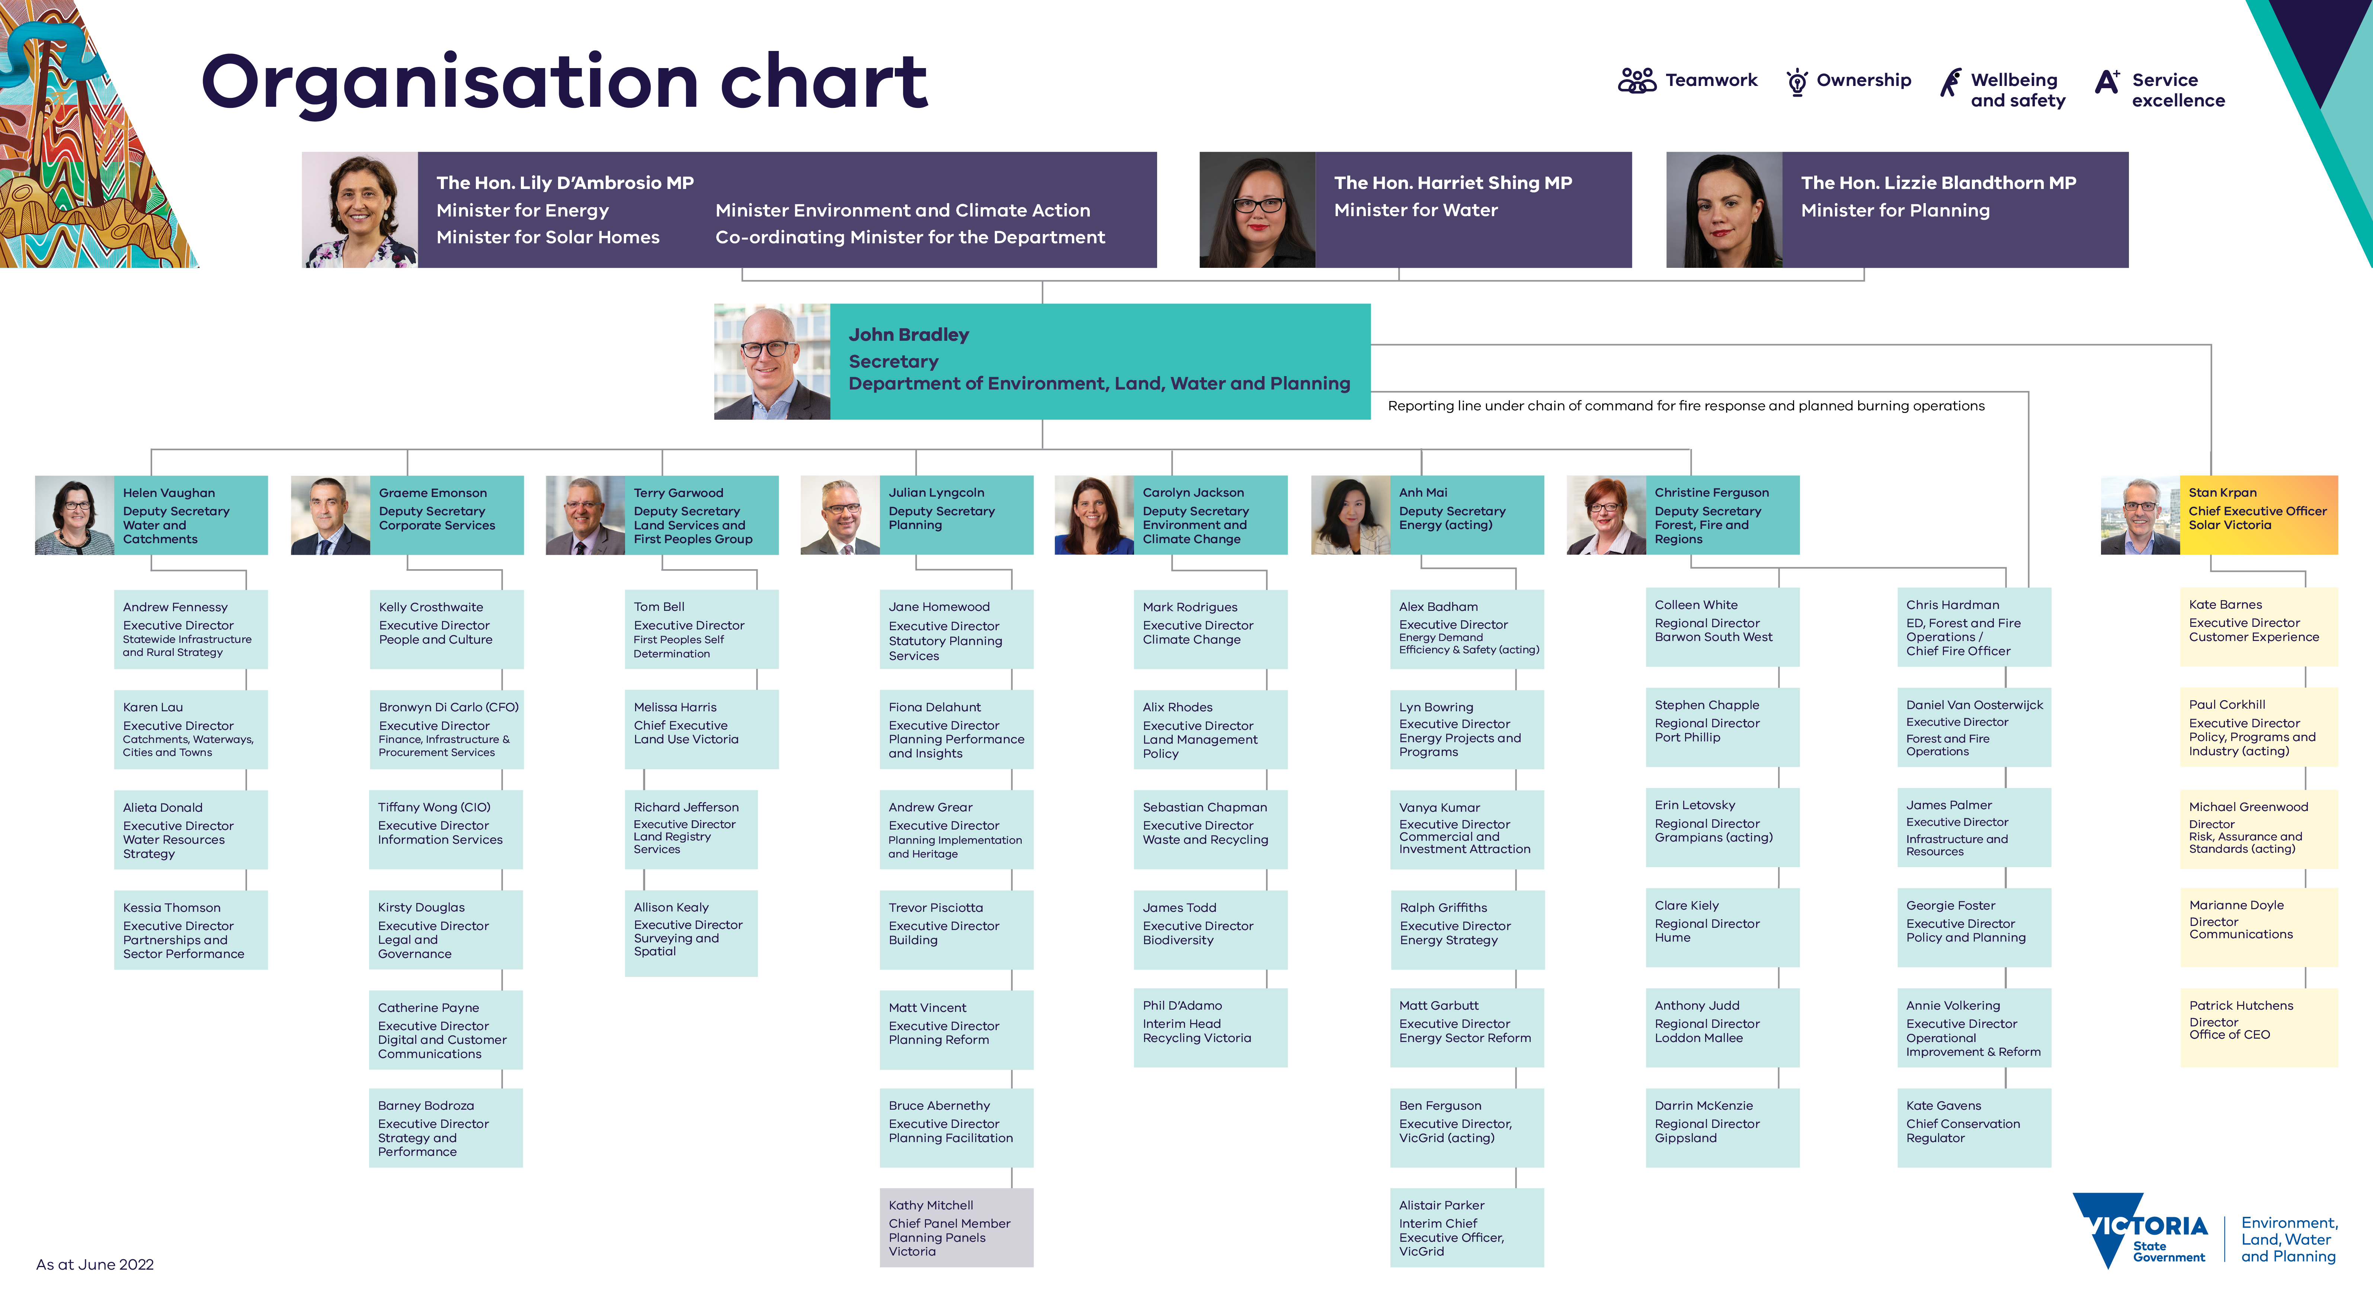

Governance
Under the Public Administration Act 2004, the Secretary is accountable to the Minister for Water, Minister for Energy, Minister for Environment and Climate Action, Minister for Solar Homes and the Minister for Planning. A number of departmental committees are in place to focus on governance. The below committees are those the department is required to report on under Financial Reporting Directive 22 (FRD22).

Executive Board
The DELWP Executive Board is responsible for leading the governance and stewardship of the department and includes the Secretary and Deputy Secretaries. The Board supports the Secretary to fulfil his statutory responsibilities and has three areas of strategic oversight:
Policy and Strategy – oversight of significant policy, program and strategy activities of the department.
Corporate Stewardship – oversight of key elements of finance, risk, information services and people and culture including provision of strategic advice and assurance to the Secretary that the appropriate capabilities, processes and systems of the department are in place.
Operations and Performance – oversight of the operational performance, trends and outlook to achieve effective and efficient delivery of the department’s services, policy, projects and programs.
The Board is supported by reform taskforces, stewardship committees and assurance committees that draw on the expertise of our senior leaders across the organisation to develop, inform and guide strategy and decisions through a One-DELWP approach.

Reform Taskforces
Three taskforces bring together expertise from across DELWP to consider opportunities to improve the way the department operates and develop ideas for the Executive Board to consider over the medium to long term. They are also responsible for delivering approved transformation initiatives.
The taskforces will be in place until their work programs are completed or they have transitioned into ‘business as usual’ functions within the department.
Transformation Taskforce
The Transformation Taskforce leads, coordinates and manages the delivery of existing and new transformation initiatives intended to shape the department’s culture and improve the way the organisation delivers its high priority work.
The Transformation Taskforce maintains program oversight of the projects and activities across the three taskforces.
End-to-end Operations Reform Taskforce
The End-to-end Operations Reform Taskforce investigates opportunities to improve the end-to-end planning, design and delivery of DELWP’s significant policy and program initiatives.
Customer, Stakeholder and Digital Experience Taskforce
The Customer, Stakeholder and Digital Experience Taskforce leads and manages the review and implementation of processes, systems and structures to enable improved customer-centred, and inclusive digital service delivery.

Stewardship Committees
The department’s eight stewardship committees focus on department-wide strategic priorities and provide strategic advisory support to the Executive Board across a suite of corporate and service delivery functions.
Self-determination Committee
The Self-determination Committee provides a forum for all groups to provide coordinated One-DELWP input into key self-determination enabling policy initiatives on behalf of the Secretary and the DELWP Executive Board.
People and Culture Committee
The People and Culture Committee leads, oversees and optimises DELWP’s strategic people capability and organisational culture to achieve the department’s strategic outcomes in a way that promotes the responsible stewardship of DELWP’s five organisational pillars.
Fire and Emergency Management Committee
The Fire and Emergency Management Committee oversees the delivery of DELWP’s fire and emergency management policy and operational work program, and ensures that the Secretary and the Executive Board have a clear line of sight of the department’s fire and emergency management activity.
Portfolio Governance and Integrity Committee
The Portfolio Governance and Integrity Committee leads and oversees the direction, management and review of DELWP’s portfolio governance and integrity, across the department and its portfolio agencies.
Finance and Procurement Committee
The Finance and Procurement Committee leads the department’s compliance with the requirements of the Victorian Government Financial Management and Procurement Frameworks to enable DELWP to achieve its strategic outcomes in an effective, efficient and economical manner.
Policy and Legislation Committee
The Policy and Legislation Committee leads and oversees DELWP’s, policy and legislative reform agenda on behalf of the Secretary and the Executive Board, and advises on its oversight, direction, monitoring and review for cabinet and government.
Data and Technology Committee
The Data and Technology Committee leads and oversees DELWP’s digital and Information and Communication Technology (ICT) capability, capacity, performance and strategic directions, including enabling it to leverage the advantages of data and technology, manage its strategic ICT risks and achieve its outcomes more effectively and efficiently.
Solar Victoria Committee
The Solar Victoria Committee oversees and provides advice to the Secretary on the strategic direction and delivery of the Solar Victoria Program.

Assurance committees
Three standalone committees support the DELWP Executive Board by providing advice on important responsibilities and functions.
Executive Staff and Remuneration Committee
The Executive Staff and Remuneration Committee ensures a fair and equitable approach to the employment and setting of remuneration at the Senior Executive Service (SES), Principal Scientist (PS) and Senior Technical Specialist (STS) classification.
Safety and Wellbeing Committee
The Safety and Wellbeing Committee leads and oversees the strategic risk management of staff safety and wellbeing across DELWP in line with its legislative and statutory obligations, on behalf of the Secretary and the DELWP Executive Board.
Risk and Audit Committee
The Risk and Audit Committee is an independent body established in accordance with the Standing Directions of the Minister for Finance under the Financial Management Act 1994. It provides assurance to the Secretary that the department’s risk and control environment is operating effectively and efficiently. The department’s Risk and Audit Committee Charter prescribes that meetings must be held every three months with separate meetings to consider the attestation under the Victorian Government Risk Management Framework and financial statements. In 2021-22, the Risk and Audit Committee met eight times.
In 2021-22, the Risk and Audit Committee members were:
Peter Lewinsky (Chair): Independent member
Linda McNeill: Independent member
Mark Peters: Independent member
Rachel Thomson: Independent Member
Dr Graeme Emonson PSM: Deputy Secretary, Corporate Services.
Helen Vaughan PSM: Deputy Secretary, Water and Catchments
Carolyn Jackson: Deputy Secretary, Environment and Climate Change

Departmental objectives, indicators and outputs
This section provides an overview of key activities that are important to the achievement of DELWP’s medium-term objectives (also known as Outcomes in the DELWP Corporate Plan). It also reports on the delivery of the department’s outputs, including performance results against the output measures published in the 2021-22 Budget Paper Number 3: Service Delivery (BP3) and performance of the key initiatives published in the Corporate Plan 2021-2025.
Note: Output costs reported under departmental objectives, indicators and outputs vary to the output costs reported in Note 4 of the financial statements. This is due to different methodologies being used in allocating department wide costs and is detailed from page 209.
The table below provides a summary of DELWP’s objectives, indicators, and outputs for 2021-22:
Departmental objectives | Indicators | Outputs
Net zero emission, climate-ready economy and community | Reduction in emissions from government operations  Percentage reduction in Victoria’s greenhouse gas emissions relative to 2005  Reduction in annual energy costs for Victorian schools participating in the Resource Smart Schools program | Climate Change
Healthy, resilient and biodiverse environment | Participation in community-based environmental programs  Reduction in pollutants from priority hotspots  Reduction in waste generation per person | Environment and Biodiversity  Statutory Activities and Environment Protection  Waste and Recycling
Reliable, sustainable and affordable energy services | Relative share of Victoria’s energy sourced from renewables  Percentage of surveyed users of the Victorian Energy Compare website who report that they plan to switch offers after using the website  Electricity generating capacity installed under the Solar Homes program  Solar systems installed under the Solar Homes program | Energy  Solar Homes
Productive and effective land management | Efficient provision of timely and authoritative land administration and property information services  Number of visits to the public land estate managed by the department’s portfolio agencies (Parks Victoria)  Bay and park assets rated in average to excellent condition  Consistent and timely provision of government land transaction approvals and advice  Traditional Owner satisfaction with progress on the Pupangarli Marnmarnepu Implementation Action Plan endorsed by the statewide Caring for Country Partnership Forum | Land Use Victoria  Management of Public Land and Forests  Parks Victoria
Safe and sustainable water resources | Proportion of intended properties (or equivalent) in the Goulburn Murray, Macalister, Werribee and Bacchus Marsh irrigation districts connected to a modernised irrigation delivery system  Number of river reaches/wetlands with maintained or improved environmental condition | Effective Water Management and Supply
A safe and quality built-environment | Improved liveability, sustainability and inclusiveness of public spaces and neighbourhoods  Effective protection of cultural and natural heritage | Planning, Building and Heritage
Reduced impact of major bushfires and other emergencies on people, property and the environment | Percentage of bushfires contained at first attack and/or under five hectares to suppress bushfires promptly, keep bushfires small and minimise loss  Area treated through planned burning and other treatments to maintain the statewide bushfire risk at or below 70 per cent  Percentage of agreed departmental emergency management obligations met on time and to standard  The economic impact of fire prevention and preparedness investment | Fire and Emergency Management

Net zero emissions, climate-ready economy and community

Progress towards achieving this objective
- Climate action
- Affordable and clean energy
- Sustainable cities and communities
- Responsible consumption and production

Context
DELWP leads the Victorian Government’s response to climate change, in line with the Climate Change Act 2017.
The Climate Change Act 2017 provides Victoria with a world-leading legislative foundation, which cements our net zero emissions goal in law. The Act establishes a comprehensive framework to achieve net zero greenhouse gas emissions by 2050 while we plan for and adapt to our changing climate, drive our transition to a climate resilient community and economy, and build the state’s resilience to climate change.
In May 2021 Victoria’s Climate Change Strategy was released which translates Victoria’s Climate Change Act 2017 into concrete action. The Strategy sets out a clear pathway for further reducing our emissions and building resilience to the impacts of climate change.
The Victorian Government has set ambitious but achievable interim emissions reduction targets for Victoria along the road to net zero emissions by 2050, including 15-20 per cent by 2020, 28-33 per cent by 2025 and 45-50 per cent by 2030. The 2020 target was met and exceeded in 2018 when Victoria’s emissions fell to 21.5 per cent below 2005 levels. The latest available Commonwealth data shows that by 2020, Victoria’s emissions had fallen further to 29.8 per cent below 2005 levels.
Key initiative | 2021-22 progress summary
Setting new targets and implementing pledges to reduce greenhouse gas emissions | An Independent Expert Panel was appointed in January 2022 to provide advice on a 2035 interim emissions reduction target for Victoria. DELWP is providing secretariat and analytical services for the Panel. The Panel ran a public consultation process from April to June 2022, seeking feedback on an issues paper to inform advice to government on setting the 2035 target. The Panel received 996 responses to the general survey, 381 responses to the youth survey and 109 submissions from organisations and individuals. Final advice from the Panel will be provided to the Minister for Environment and Climate Action by 1 March 2023 and will be tabled in Parliament within 10 sitting days as required under the Climate Change Act 2017.  DELWP worked with local governments across Victoria, resulting in 21 voluntary local council emission reduction pledges being made under the Climate Change Act 2017 to 30 June 2022.  The Victorian Government is on track to deliver 400 zero emission vehicles (ZEV) to the Government fleet by 2023. More than 100 ZEVs were ordered for use by Victorian Government departments and agencies during 2021-22. DELWP is contributing to this through its commitment to ‘ZEVs first’ for its shared passenger vehicle fleet as current vehicles leases expire. As at 30 June 2022, DELWP has 14 ZEVs in the shared passenger vehicle fleet.
Increasing government and community capacity to adapt to the impacts of climate change through implementation of Victoria’s Climate Change Strategy | Seven Climate Change Adaptation Action Plans for 2022-2026 were tabled in Parliament on 9 February 2022, accompanied by publication of Building Victoria’s Climate Resilience, which sets out what Victoria is doing to adapt to our changing climate. Victoria’s approach is centred around adaptation planning for statewide systems and complementary community-led action.  Regional Adaptation Strategies were developed in each of the six DELWP regions of Greater Melbourne, Gippsland, Hume, Loddon Mallee, Grampians and Barwon South West. These were released in December 2021 accompanied by 54 on-ground community-led projects that will prepare and adapt the community to the impacts of climate change. Many projects have been delivered already. Themes include preparing for and recovering from emergencies, caring for the natural environment, improving health and wellbeing, strengthening the economy and workforce, improving resilience of our built environment, and embracing renewable energy.  Building Victoria’s Climate Resilience and the seven Climate Change Adaptation Action Plans, together with Regional Adaptation Strategies include a range of commitments to strengthen Traditional Owner engagement and embed Aboriginal self-determination in adaptation activities.
Increasing action on climate change through Victorian Government operations and decision making | DELWP delivered two Local Government Train-the-Trainer sessions in March 2022 to support council staff in better integrating climate change considerations and risk into council operations, policies and programs. More than 40 council staff participated.  Victoria’s Future Climate Tool allows users to explore future climate information for their local region and to export climate data into other spatial tools. Regional summaries are also available. During 2021-22, more than 1,200 users accessed Victoria’s Future Climate Tool.  A range of resources developed in partnership with the Victorian Managed Insurance Authority (VMIA) are available on the VMIA website as part of the Climate Change Risk Management Service. A Climate Change Risk Foundations course is also available. During 2021-22, the Climate Risk Foundations Course was delivered to 95 participants. VMIA climate change resources were accessed over 3,000 times and guidance material downloaded more than 170 times.
Community Climate Change and Energy Action program | The Community Climate Change and Energy Action program was launched by Sustainability Victoria in July 2021 to support local community groups by funding energy efficiency upgrades to community facilities. To 30 June 2022, funding has been provided for114 energy assessments at community group facilities and 49 community group projects, 15 of which are already complete.

Indicator: Reduction in emissions from government operations
The Victorian Government released the whole-of-Victorian government emissions reduction pledge (the Pledge) in May 2021, with a commitment for all electricity used in government operations to be 100 per cent renewable from 2025, to introduce 400 zero emissions vehicles into the government fleet by 2023, to ensure new public buses are zero emissions from 2025, and to improve the environmental and energy performance of government buildings and facilities. These actions are expected to reduce total government operational emissions by an estimated 2.7 Mt CO₂-e by 2025 compared to 2018-19 levels and establish the foundations for further actions to reduce operational emissions in future years.
These commitments build on previously completed actions to reduce government emissions, such as the target for government departments to reduce their emissions 30 per cent below 2015 levels by 2020. Continued action to reduce emissions from government operations will ensure the government is at the forefront of the transition to net zero emissions, while supporting jobs and growth for Victoria’s industries that provide low-carbon products and services.

Indicator: Percentage reduction in Victoria’s greenhouse gas emissions relative to 2005
Graph showing that in 2020, Victoria’s emissions have fallen by 29.8% below 2005 net emission levels. 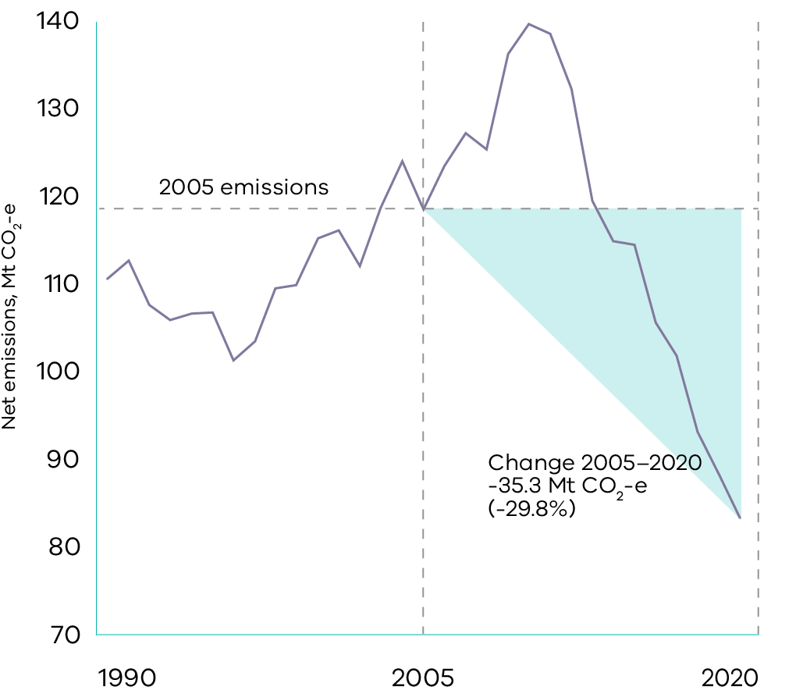
The Victorian Government is committed to reducing the state’s greenhouse gas emissions by:
- 15-20 per cent below 2005 levels by 2020
- 28-33 per cent below 2005 levels by 2025
45-50 per cent below 2005 levels by 2030
These targets keep Victoria on the path to net zero emissions by 2050.
A report is published every year by the Victorian Government on Victoria’s greenhouse gas emissions, based on the most recent data available. This draws on emissions data prepared by the Commonwealth Department of Industry, Science, Energy and Resources in accordance with internationally agreed rules. There is a two-year lag between reporting periods and when the data is available for use.9
The 2020 target was met and exceeded two years ahead of schedule (in 2018) when Victoria’s emissions fell to 21.5 per cent below 2005 levels. The latest available Commonwealth data shows that by 2020, Victoria’s emissions had fallen further to 29.8 per cent below 2005 levels. Most of these reductions occurred in the electricity sector, with the other key contributor being increased absorption of emissions in the land sector.

Indicator: Reduction in annual energy costs for Victorian schools participating in the ResourceSmart Schools program
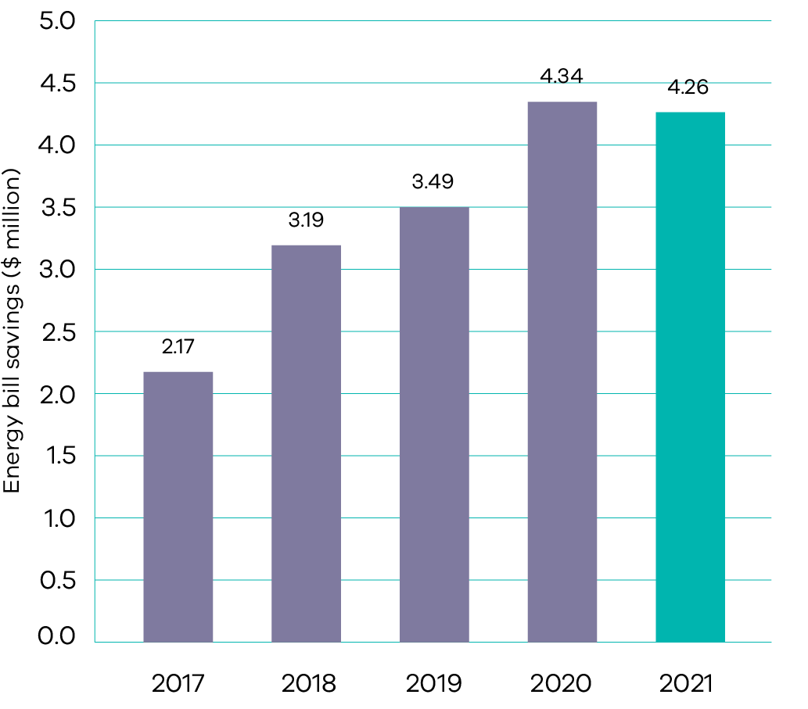
ResourceSmart Schools is delivered in partnership with Sustainability Victoria. Through the program Victorian schools are recruited and assisted to work through a sustainability framework with the aim of achieving five star sustainability status. Once a school has signed up to the program, activities undertaken, billing data, curriculum and other documentation is uploaded to an online platform as evidence the school is embedding sustainability into their operations, curriculum and community.
In 2021, Victorian schools saved $4.26 million on their energy bills through their participation in ResourceSmart Schools – a trend that has continued since 2017 due to benefits realised as schools embed sustainability in their curricula, and other actions such as replacing less efficient appliances and the upgrade and/or installation of energy saving infrastructure such as motion-sensor lighting and rooftop solar PV.
Periods of remote learning have contributed to cost savings in schools during 2020 and 2021. The decrease in energy bill savings between 2020 and 2021 reflects a decrease in the number of schools participating in the ResourceSmart Schools program.

Output performance measures

Climate Change
This output leads the development and implementation of strategic, whole of government climate change policy and programs, that contribute to Victoria’s 2050 target of net-zero greenhouse gas emissions and build the state’s resilience to climate change.
The performance measures below compare targets and expected or actual results from the delivery of programs and services as part of this output:
Output performance measures | Unit of measure | 2021-22 actual | 2021-22 target | Performance variation (%) | Result
Quantity
Victorian schools participating in the ResourceSmart Schools program | number | 457 | 700 | (35%) | Performance target not achieved – exceeds 5 per cent variance.
Performance is below target due to COVID-19 impacts on the education sector. This resulted in teacher shortages and lower levels of engagement with extracurricular activities such as the ResourceSmart Schools program.
Output performance measures | Unit of measure | 2021-22 actual | 2021-22 target | Performance variation (%) | Result
Annual energy saved by Victorian schools participating in the ResourceSmart Schools program | kWh | 14 585 144 | 8 500 000 | 72% | Performance target achieved or exceeded.
Performance is above target due to less energy being used by schools in 2021 as a result of the COVID-19 pandemic and remote learning arrangements.
Output performance measures | Unit of measure | 2021-22 actual | 2021-22 target | Performance variation (%) | Result
Quality
Stakeholder satisfaction with climate change engagement events | per cent | 95 | 75 | 21% | Performance target achieved or exceeded.
Performance is above target as survey respondents reported satisfaction and relevance to their work, reflecting effort in tailoring events to stakeholder needs following release of the Climate Change Strategy.
Output performance measures | Unit of measure | 2021-22 actual | 2021-22 target | Performance variation (%) | Result
Timeliness
Delivery of agreed milestones for climate change policy, advice and research within agreed timeframes | per cent | 100 | 80 | 25% | Performance target achieved or exceeded.
Performance is above target due to all agreed milestones being met, reflecting effort invested in timely delivery of policy, advice and research.
Output performance measures | Unit of measure | 2021-22 actual | 2021-22 target | Performance variation (%) | Result
Completion of Annual Greenhouse Gas Emissions Report | date | Oct 2021 | Oct 2021 | 0% | Performance target achieved or exceeded.
Cost
Total output cost | $ million | 39.1 | 32.9 | 19% | Performance target not achieved – exceeds 5 per cent variance.
The higher than budgeted output cost is primarily due to a change in the funding profile for the Taking Decisive Action on Climate Change and Protecting Port Phillip Bay and its Beaches initiatives.

Healthy, resilient and biodiverse environment
- Life on land
- Sustainable cities and communities
- Responsible consumption and production
- Climate action

Progress towards achieving this objective

Context
DELWP works with portfolio partners and external stakeholders to develop effective, evidence-based policies, programs, regulatory responses and compliance activities for improved outcomes across a range of areas. These include environment protection, waste and resource recovery, ecosystem resilience, native vegetation management, wildlife, threatened species and land management practices.
The inclusion of, and strong relationships with Traditional Owners and Aboriginal Victorians, as described in Pupangarli Marnmarnepu ‘Owning Our Future’ Aboriginal Self-Determination Reform Strategy 2020-2025 is crucial to delivering these outcomes.
Key initiative | 2021-22 progress summary
Delivery of programs under the circular economy policy, Recycling Victoria: a new economy | The Circular Economy (Waste Reduction and Recycling) Bill 2021 was introduced into Parliament in October 2021 and received royal assent on 14 December 2021.  The Victorian Waste to Energy Framework was approved and released on 1 November 2021.  The Victorian public service phased out single-use plastic drinking straws, cutlery, plates, drink-stirrers, expanded polystyrene food and drink containers, and cotton bud sticks on 1 February 2022.  Consultation on the regulations to enact a statewide ban of these single-use plastic items was undertaken in April and May 2022, with over 50 submissions and 1,600 responses received. This feedback is being considered as the regulations are finalised, ahead of the statewide ban commencing 1 February 2023.  Consultation on draft standard lists for the new four-stream waste and recycling system was held from November 2021 to January 2022. DELWP received 1,039 responses, comprised of 944 community responses and 95 industry and council responses. The updated lists will be available as part of the Regulatory Impact Statement.  The Container Deposit Scheme (CDS) Request for Tender for coordinator and network operator roles was released in April 2022. Draft regulations and the Regulatory Impact Statement covering CDS scheme details were released for public consultation in May 2022. The Container Deposit Scheme is expected to commence in 2023.  Recycling Victoria was established on 1 July 2022. Over 2021-22, DELWP prepared for the commencement of Recycling Victoria through overseeing the dissolution of all waste and resource recovery groups, the transfer of their staff, assets and resources to DELWP, alongside data and intelligence functions from Sustainability Victoria. Recycling Victoria is critical to establishing a thriving circular economy in Victoria. It will oversee and provide strategic leadership for the state’s waste and recycling sector.
Embedding of the new environment protection framework following commencement of the reformed Environment Protection Act | Following the commencement of the reformed Environment Protection Act  on 1 July 2021, amendments were progressed to:  clarify the operation of permissions granted under the previous Act and transitioned to the new Act  enable councils to appoint contractors as authorised officers to undertake their delegated functions, in line with the other legislation such as the Local Government Act 1989  improve the processes of the Environment Protection Authority (EPA) and councils and clarify their powers and functions under the Act to enhance the effectiveness of their role as regulator  protect the state’s ability to recoup site clean-up costs.  From 1 July 2021, contaminated land duties address risk of harm from contamination of land and groundwater. They work alongside the general environmental duty. To support Victorian landowners to comply with their new contaminated land duties, EPA developed and released two proposed draft guidelines for feedback during January and February 2022.  Public consultation commenced with a webinar on 7 June 2022 to hear from planners, consultants, developers and other relevant stakeholders on how the new planning framework for contaminated land is working. Consultation continued through June and July 2022 with workshops and submissions, with a report back to participants planned for August-September 2022. The consultation will help identify issues or gaps in the framework and prioritise further activities to improve the framework.  DELWP delivered a webinar training session on new land-use planning requirements in January 2022 to Major Road Projects Victoria and the Major Transport Infrastructure Authority.  Waste tyres present a risk of abandonment and significant fire risk if improperly stored. Focusing on the use and storage of waste tyres on farms, DELWP initiated work aimed at improving compliance with the general environmental duty and with the lawful place and permission requirements of the Environment Protection Act 2017 and the Environment Protection Regulations 2021. Public consultation was undertaken on the proposed Environment Protection Amendment (Waste tyres – silage production) Regulations 2022 and a regulatory impact statement for these amendments between 26 May and 27 June 2022. These amendments would allow farmers to store waste tyres for silage production under a new registration (a permission category under the new environment protection framework) with conditions.  DELWP supported EPA to develop draft guidance for businesses on managing greenhouse gas emissions under the general environmental duty in the Environment Protection Act 2017. Public consultation was undertaken and closed on 22 February 2022. Public feedback is being considered in the finalisation of the guidance.
Officers for the Protection of the Local Environment pilot program | EPA’s Officers for the Protection of Local Environment (OPLE) pilot program covers 23 councils, embedding 22 EPA authorised officers within Victorian communities to combat compliance issues impacting local amenity.  The OPLE program has been redesigned, with extensive engagement with local governments across Victoria, to incorporate OPLE access to all 79 councils.
Facilitating Innovative Contaminated Land Remediation and Spoil Management program | In 2021-22, the Facilitating Innovative Contaminated Land Remediation and Spoil Management program delivered:  a digital land contamination notification system to support the receipt, assessment, and management of notifications to enable efficient and timely land contamination duties compliance under the Environment Protection Act 2017.  dedicated resources to help determine disposal or reuse pathways for soils and spoils and develop additional guidance on risk-based contamination audits.  research on existing and potential future technology options for the safe treatment and remediation of PFAS-contaminated soil in Victoria.
Redevelopment of the Port Phillip EcoCentre | Building design works for the new Port Phillip EcoCentre in St Kilda were completed in June 2022 to deliver an updated, functional and sustainable building that meets compliance requirements. Tenders for construction were released in June 2022 with contract award anticipated in September 2022.
Port Phillip Bay Environmental Management Plan 2017-2027 | Development of reporting products to evaluate the condition of Port Phillip Bay and the delivery of the environmental management plan has continued through 2021-22. The upcoming release of the 2020-21 Port Philip Bay Environmental Management Plan (PPBEMP) Annual Report and 2021 Delivery Plan Update is scheduled for October 2022 and will include the first digital report cards for the PPBEMP’s priority areas, including ‘stewardship’ and ‘habitat and marine life’.
Victorian Government Air Quality Strategy | To support improvement of air quality within the state, the following actions were undertaken:  DELWP partnered with EPA to conduct a regional sensor pilot project, expanding on EPA’s existing network to monitor and publicly report on the levels of fine particles in the air from sources such as smoke, in an additional 49 regional Victorian towns. Deployment of the sensors took place between March and May 2021, with all sensors operating with stable performance. As of 30 June 2022, there are 49 sites reporting through EPA’s AirWatch website.  Amendments to the Environment Reference Standard (ambient air reference standards) were gazetted on 29 March 2022. These standards were amended to reflect new air quality standards for ozone, nitrogen dioxide and sulfur dioxide following a national review.
Strengthening Traditional Owner participation in waste management and resource recovery | In early 2021-22, information on key programs such as the Container Deposit Scheme and Single Use Plastics Ban was shared with Traditional Owner groups via the network of DELWP Regional Managers and Aboriginal Inclusion Officers. A presentation to the Eastern Marr Aboriginal Corporation was given on Tuesday 23 September 2021. Further opportunities to foster future partnerships in programs of Traditional Owner interest are being explored as Recycling Victoria program delivery continues.
Review of the Wildlife Act 1975 | An expert panel delivered its report to the Minister for Environment and Climate Action on the findings of their review of the Wildlife Act 1975 in December 2021. The review will provide recommendations to update the Wildlife Act 1975 so that it provides a best practice regulatory framework, operates consistently with other legislation related to wildlife and reflects contemporary values and expectations.
Faunal emblems program | A specific needs assessment was completed for the Lowland Leadbeater’s Possum in August 2020 and the Helmeted Honeyeater in December 2021 to assess the cost-effectiveness of a range of potential direct management interventions to inform future program delivery.  A major milestone for Helmeted Honeyeater recovery was reached in May 2022 with the release of 18 Helmeted Honeyeaters into the Yarra Ranges National Park.
Supporting Victorian wildlife centres and shelters | DELWP supported wildlife shelters and foster carers to rehabilitate and release injured and orphaned wildlife through its provision of $420,000 towards targeted wildlife projects and $290,000 to 120 wildlife rehabilitators during 2021-22.
Improving the protection of critical habitats for Victoria’s threatened species | Critical habitat guidelines were drafted under Section 20E of the Flora and Fauna Guarantee Act 1988. The guidelines will provide direction in identifying and protecting critical habitats for threatened species and are anticipated to be released in the first half of 2022-23.
Biodiversity response planning | Biodiversity response planning is a long-term, area-based planning approach to biodiversity conservation. It is designed to strengthen alignment, engagement and participation between government, Traditional Owners, non-government agencies and the community. As part of the biodiversity response planning process, each DELWP region developed a list of project ideas or a prospectus of project concepts based on 140 existing biodiversity response planning factsheets. This has provided a framework for discussion in 2022-23 about potential funding opportunities. Changes in Registered Aboriginal Parties boundaries within Port Phillip Region meant that some existing factsheets were updated to reflect the new boundaries for Bunurong and Wurundjeri.
Deer management | The first of the regional deer control plans was released in March 2022. Actions and delivery of the peri-urban deer control plan will expand in 2022-23 through projects delivered by local land managers, as well as through community-led projects. These deer control measures will protect agriculture, biodiversity and Aboriginal cultural heritage and address public safety issues caused by deer including vehicle access and property damage.
Bushfire Biodiversity Response and Recovery program | The Bushfire Biodiversity Response and Recovery program supports recovery of biodiversity and wildlife impacted by the 2019-20 Victorian Bushfires and improves capacity to be better prepared to respond to and recover from future events. The program consists of 261 activities to support persistence of biodiversity and threatened species.  The Strengthening Country program enabled employment opportunities for 22 Traditional Owners and Aboriginal Victorians – supporting economic stimulus, employment, and training opportunities alongside environmental restoration.  The reconnaissance work, post-fire release monitoring and emergency extraction significantly improved the level of understanding the government has about species habitat response and recovery to the impact of bushfires.  Several safe havens are under development including Wilsons Promontory and Neds Corner. Djaara have partnered with Bush Heritage to establish a sanctuary at Mt Buckrabunyule. Predator proof fencing is being upgraded at three sanctuary sites in the Barwon South West Region – Mt. Rothwell, Hamilton and Woodlands reserve – to support genetic mixing and improve source populations of threatened species such as the Southern Brown Bandicoot.  An integrated threat management program is reducing the impacts of invasive species on the survival and recovery of threatened species in fire-affected areas of Victoria. Since commencement of the program to 30 June 2022, more than 701,000 hectares of herbivore control, nearly 207,000 hectares of predator control and more than 22,000 hectares of weed control have been delivered.  Engagement with the wildlife welfare community has improved awareness of wildlife welfare management during fire and led to the revision of the state response plan. This has included revised and expanded training programs for improved animal welfare outcomes.
Biodiversity Community programs | A range of Biodiversity Community programs were delivered during 2021-22 with almost 1,000 grants and contracts totalling $17.4 million. These supported the environmental volunteering community in delivering on-ground action to protect, restore and enhance Victoria’s unique biodiversity, through the Victorians Volunteering for Nature – Environmental Volunteering Plan, Victorian Landcare Program, Community Action for Biodiversity Program and Port Phillip Bay Fund.
Nature restoration for carbon storage – BushBank program | The Bushbank program supports revegetation across public and private land to improve habitat for biodiversity while increasing carbon sequestration. Through the program:  $2.34 million was committed over five years to restore 560 hectares of public land across Victoria, with 30.9 hectares reseeded in 2021-22.  Grant offers of $7 million over four years will be provided to Traditional Owner Corporations to address biodiversity loss, climate change and to improve the capacity of Traditional Owners to participate in healing Country, carbon markets and to practice self-determination. Applications closed in May 2022 with successful grant applicants to be announced in August 2022.  Expressions of interest to select a delivery partner for habitat restoration on private land closed in May 2022. This will leverage significant co-investment to add to $30.9 million of government funding.
Office of the Conservation Regulator regulatory functions in relation to risks impacting Victoria’s biodiversity | The Conservation Regulator utilised a multi-pronged approach to prevent harm and protect biodiversity from timber harvesting. This approach included surveying coupes prior to harvesting through the Forest Protection Survey Program, and in 2021-22 more than 600 coupes were surveyed. A total of 53 proactive compliance inspections were also undertaken, exceeding the annual target of 30. Authorised officers received and assessed 98 threatened species reports and 31 allegations of non-compliance. The Conservation Regulator also published guidance for reporting detections of Greater Gliders in December 2021, to assist members of the public and other organisations when making a report to the regulator.  Significant investigations into the illegal take of timber on public land and the illegal clearing of vegetation on public land led to significant financial penalties for non-compliance with the law.  Protection of wildlife was a key focus which resulted in a new Statement of Regulatory Intent for the Protection of Wildlife published in March 2022. From February 2022, a transition to online applications for wildlife permits commenced, delivering a better customer experience for licence and permit holders.
Trust for Nature | The Victorian Government works in partnership with Trust for Nature to preserve biodiversity values on private land.  In 2021-22, funding assisted Trust for Nature in achieving:  protection of over 1,600 hectares of private land  announcement of the commitment to transfer Victoria’s largest private conservation reserve Neds Corner to its Traditional Owners, the First People of the Millewa-Mallee Aboriginal Corporation  restoration and maintenance of habitats on private land that support important biodiversity, as well as improved management of land under existing covenants through partnerships and incentives  increase of 9 per cent of area for the Yellingbo Nature Conservation Reserve, helping protect the critically endangered Helmeted Honeyeater and the endangered Leadbeater’s Possum  completion of Iconic Estates 1, delivered across 10 regional projects. Since commencement, these projects have secured more than 2,700 hectares of permanently protected private land with high biodiversity value.
Wildlife Victoria | In 2021-22, funding was provided to Wildlife Victoria to support:  maintenance of the efficiency and quality of the Wildlife Victoria hotline – providing community reporting and coordination for wildlife in distress. In the 2021 calendar year, Wildlife Victoria’s Emergency Response Service received more than 100,000 requests for assistance and supported almost 90,000 sick, injured or orphaned animals.  development and implementation of strategies to train and support Wildlife Victoria’s volunteer base of over 1,000 registered volunteers throughout Victoria  community engagement and outreach activities, with a focus on culturally and linguistically diverse communities.

Indicator: Reduction in pollutants from priority hotspots
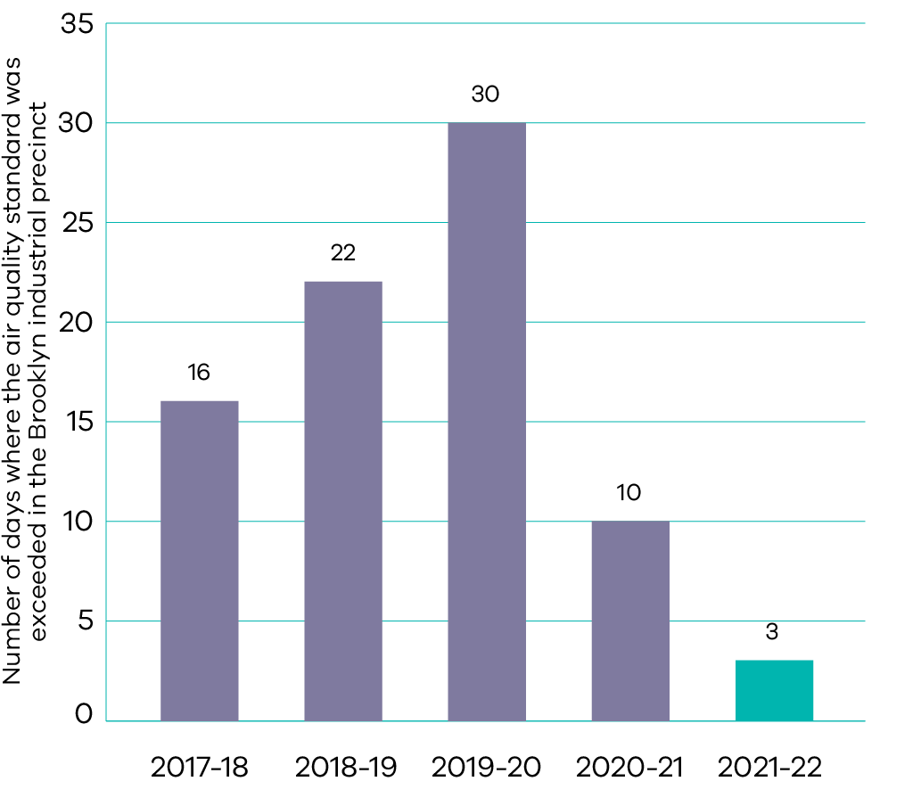
The residential area south of the Brooklyn industrial precinct has a long history of poor air quality events due to high dust levels from activities in the precinct. EPA has monitored the major component of dust in the air, PM₁₀ (particles smaller than 10 micrometres), in Brooklyn since October 2009. EPA has maintained its strategic regulatory focus on reducing air pollution in the precinct to lower environmental risk in the area and improve public health outcomes.
In 2021-22, the air quality standard was exceeded on three occasions and were all attributed to activities within the precinct. EPA provided five alerts to notify local industry of high-risk dust days, with EPA Officers conducting random inspections to ensure local industry enacted their dust management plans and implemented appropriate control measures. Where EPA Officers determined a non-compliance, remedial notices focused on: preventing dust by sealing unsealed traffic surfaces; preventing dust from materials handling activities; and preventing mud being driven onto public roads.
Odour from the precinct has seen a significant downward trend, with almost 50 per cent fewer odour reports than in 2020-21, the lowest level since EPA began logging reports electronically in 1996. Improvements in odour capture and treatment made in 2020-21 have been consolidated with actions taken against the main contributor to odour in Brooklyn in the first half of 2021-22.

Indicator: Participation in community-based environmental programs
Days of community participation in Landcare and other environmental volunteering programs
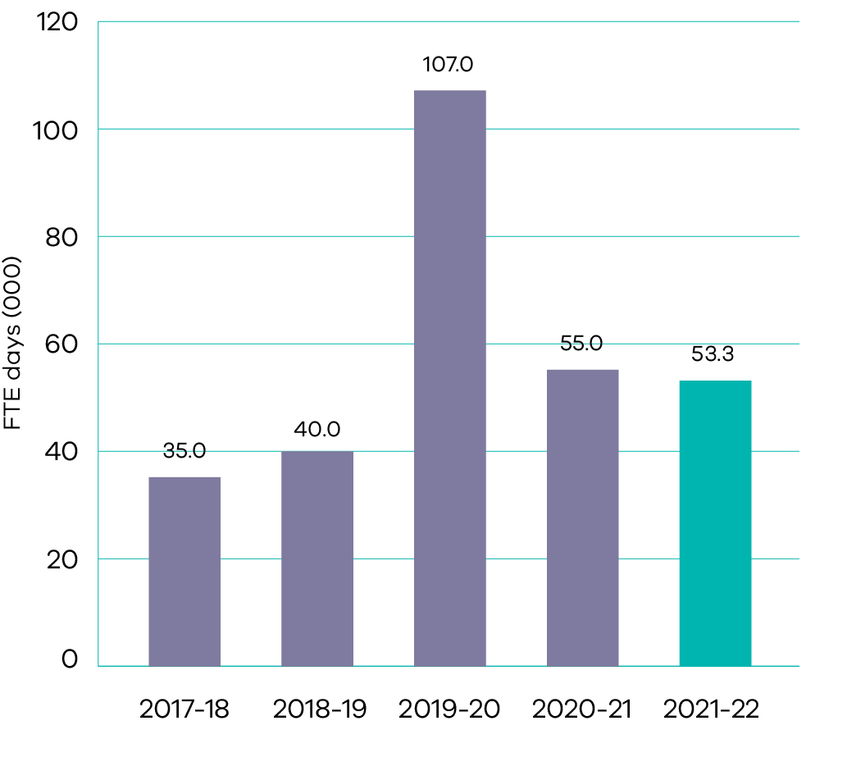
Under the Victorians Volunteering for Nature – Environmental Volunteering Plan (2018), an annual stocktake of active environmental volunteer numbers, groups and categories occurs across the state. Volunteering Naturally 2022 data is expected to become available in October 2022 following the receipt and analysis of data from portfolio partners and environmental volunteer groups.
Volunteering Naturally 2021 identified more than 160,970 active volunteers, 2,070 groups and reported almost 1.3 million volunteer hours in 2020-21. This was estimated to make a $48.36 million economic contribution to Victoria.
In 2021-22, community participation through the Landcare and other environmental volunteering equated to 53,279 full time equivalent days. COVIDSafe settings continued to impact environmental volunteering opportunities in 2021-22, however community participation in these activities is expected to increase in 2022-23.

Indicator: Reduction in waste generation per person
Recycling Victoria: A new economy is the Victorian Government’s 10-year circular economy plan delivering programs designed to reduce waste including household recycling reforms, a container deposit scheme, statewide education and behaviour change programs, the ban of light weight plastic bags, ban of certain single-use plastic items and support for communities and councils. Recycling Victoria: A new economy sets a target of 15 per cent reduction in waste generation per person by 2030.
Data for waste generation per person in 2020-21 is anticipated to be available by December 2022 and published in the department’s 2022-23 annual report. The most recent data from 2019-20 showed that the total waste generated per capita increased by 2 per cent from 2.32 tonnes per person in 2018-19 to 2.37 tonnes per person in 2019-20. With the release of Recycling Victoria: A new economy in February 2020. it is anticipated that less waste will be generated per capita as key actions are progressively implemented and benefits realised.

Output performance measures

Environment and Biodiversity
This output leads the development and implementation of strategic, whole of government environmental policy and delivers investment, regulatory and research functions that support Victoria’s diverse and resilient ecosystems.
The performance measures below compare targets and expected or actual results from the delivery of programs and services as part of this output:
Output performance measures | Unit of measure | 2021-22 actual | 2021-22 target | Performance variation (%) | Result
Quantity
Hours volunteered across all government funded environmental volunteering programs | number | 675 858  (estimate) | 965 350 | (30%) | Performance target not achieved – exceeds 5 per cent variance.
A final result will be available after September 2022 following analysis of environmental volunteering survey data. Performance is projected to be below target reflecting the ongoing impact of the COVID-19 pandemic reducing the number of events and opportunities for environmental volunteering.
Output performance measures | Unit of measure | 2021-22 actual | 2021-22 target | Performance variation (%) | Result
New permanently protected native vegetation on private land | hectares | 901 (estimate) | 800 | 13% | Performance target achieved or exceeded.
A final result will be available by early 2023 after completion of data analysis. Performance is projected to be above target due to more landholder agreements being finalised in 2021-22.
Output performance measures | Unit of measure | 2021-22 actual | 2021-22 target | Performance variation (%) | Result
Hectares of weed control in priority locations | hectares | 160 000 (estimate) | 140 000 | 14% | Performance target achieved or exceeded.
A final result will be available by early 2023 after completion of data analysis. Performance is projected to be above target due to re-focused effort towards optimum timing for weed control after bushfires.
Output performance measures | Unit of measure | 2021-22 actual | 2021-22 target | Performance variation (%) | Result
Hectares of pest predator control in priority locations | hectares | 700 000  (estimate) | 400 000 | 75% | Performance target achieved or exceeded.
A final result will be available by early 2023 after completion of data analysis. Performance is projected to be above target due to increased pest predator control through bushfire recovery activity. The continuation of existing programs has also created efficiencies in delivery and enabled a larger area of control than was initially planned.
Output performance measures | Unit of measure | 2021-22 actual | 2021-22 target | Performance variation (%) | Result
Hectares of pest herbivore control in priority locations | hectares | 700 000  (estimate) | 500 000 | 40% | Performance target achieved or exceeded.
A final result will be available by early 2023 after completion of data analysis. Performance is projected to be above target due to increased pest herbivore control through the adoption of new approaches allowing a greater area of control to be achieved than initially planned under the bushfire recovery activity and the deer control program.
Output performance measures | Unit of measure | 2021-22 actual | 2021-22 target | Performance variation (%) | Result
Hectares of revegetation in priority locations for habitat connectivity | hectares | 300  (estimate) | 1 000 | (70%) | Performance target not achieved – exceeds 5 per cent variance.
A final result will be available by early 2023 after completion of data analysis. Performance is projected to be below target due to reprioritisation of resources to bushfire recovery, pest and herbivore control activities, and additional time required for stakeholder engagement to plan the implementation of large-scale revegetation programs. This reprioritisation enabled a greater benefit to more species, in line with Biodiversity 2037 outcomes.
Output performance measures | Unit of measure | 2021-22 actual | 2021-22 target | Performance variation (%) | Result
Strategic compliance operations implemented by the Conservation Regulator | number | 8 | 6 | 33% | Performance target achieved or exceeded.
Performance is above target due to two additional strategic operations being undertaken in 2021-22 based on intelligence.
Output performance measures | Unit of measure | 2021-22 actual | 2021-22 target | Performance variation (%) | Result
Quality
Presentations made and scientific publications in peer reviewed journals | number | 60 | 60 | 0% | Performance target achieved or exceeded.
Annual Arthur Rylah Institute Client Survey respondents rank the level of overall satisfaction with ARI’s research as good, very good or excellent | per cent | 96 | 95 | 1% | Performance target achieved or exceeded.
Portfolio entity annual reports including financial statements produced in line with the Financial Management Act 1994 and free from material errors | per cent | 100 | 100 | 0% | Performance target achieved or exceeded.
Preharvest surveys of areas planned for timber harvesting completed | per cent | 81 | 80 | 1% | Performance target achieved or exceeded.
Timeliness
Native Vegetation Credit Extracts processed within 10 days | per cent | 99 | 95 | 4% | Performance target achieved or exceeded.
Planning referrals relating to native vegetation processed within statutory timeframes | per cent | 78 | 80 | (3%) | Performance target not achieved – within 5 per cent variance.
Wildlife Licence renewals processed by target dates | per cent | 97.2 | 96 | 1% | Performance target achieved or exceeded.
Cost
Total output cost | $ million | 274.8 | 162.3 | 69% | Performance target not achieved – exceeds 5 per cent variance.
The higher than budgeted output cost is primarily due to additional funding for Melbourne Strategic Assessment land purchases; the release of contingency funds for immediate recovery works; the Biodiversity Bushfire Response and Recovery initiative in response to the 2019-20 bushfires; as well as an increase in Commonwealth funding for the Regional Fund for Wildlife and Habitat Bushfire Recovery initiative.

Statutory Activities and Environment Protection
This output involves protecting the environment and people by preventing and reducing harm from pollution and waste through better regulation, conducting research and gathering intelligence to inform compliance and enforcement activities, collaboration and the provision of advice. These activities support a liveable and prosperous state by leveraging good environmental performance and a shared responsibility among all Victorians to maintain clean air, water and land, and enjoy minimal disturbance from noise and odour.
The performance measures below compare targets and expected or actual results from the delivery of programs and services as part of this output:
Output performance measures | Unit of measure | 2021-22 actual | 2021-22 target | Performance variation (%) | Result
Quantity
Inspections that assess premises compliance, including licenced premises, whose operations represent a significant risk to the environment and human health | number | 510 | 400-450 | 13%
Performance is above target due to a higher than forecast number of response inspections for pollution events deemed high risk to the environment or public health, including from water events driven by wetter La Niña conditions.
Output performance measures | Unit of measure | 2021-22 actual | 2021-22 target | Performance variation (%) | Result
Events that engage business and community in environment protection | number | 662 | 60-65 | 918%
Performance is above target due to a greater focus on direct engagement with local communities, EPA’s implementation of a more effective event and activity recording and reporting system, and a large uptake of online engagement opportunities by businesses since the commencement of EPA’s new legislative framework on 1 July 2021.
Output performance measures | Unit of measure | 2021-22 actual | 2021-22 target | Performance variation (%) | Result
Environment condition notifications provided to Victorians via digital channels | number | 1 111 | > 1 000 | 11%
Performance is above target due to additional environmental notifications associated with specific environmental incidents, such as the Cherry Creek and Lake incident.
Output performance measures | Unit of measure | 2021-22 actual | 2021-22 target | Performance variation (%) | Result
Quality
EPA prosecutions are selected using a risk based approach, focused on environmental outcomes and are successful | per cent | 76 | 90 | (16%) | Performance target not achieved – exceeds 5 per cent variance.
Performance is below target because 16 of 21 prosecutions were successful. EPA withdrew charges against three of six defendants in a single matter and two further defendants in separate matters.
Output performance measures | Unit of measure | 2021-22 actual | 2021-22 target | Performance variation (%) | Result
Environmental audits reviewed to ensure compliance with statutory requirements and guidelines | per cent | 98 | 90 | 9%
Performance is above target due to the continued prioritisation of resources to conduct timely administrative reviews of environmental audits.
Output performance measures | Unit of measure | 2021-22 actual | 2021-22 target | Performance variation (%) | Result
Remedial notices complied with by due date or escalated in line with EPA’s Compliance and Enforcement policy | per cent | 84 | 90 | (7%) | Performance target not achieved – exceeds 5 per cent variance.
Performance is below target due to an increased number of remedial notices issued by EPA as a result of a greater number of duty holders and new forms of remedial notices available to EPA under the Environment Protection Act 2017.
Output performance measures | Unit of measure | 2021-22 actual | 2021-22 target | Performance variation (%) | Result
Timeliness
Pollution reporters requesting follow-up by EPA receive contact within three working days | per cent | 86 | 85 | 1%
Applications for permissions completed within statutory timelines | per cent | N/A | 96 | N/A
A result for this measure will be available by October 2022 following implementation of a new system to manage the new permissions scheme under the amended Environment Protection Act 2017.
Output performance measures | Unit of measure | 2021-22 actual | 2021-22 target | Performance variation (%) | Result
Planning matters responded to within agreed timeframes | per cent | 90 | 80 | 13%
Performance is above target due to EPA’s concerted effort to provide planning advice to all matters within agreed timeframes, with triaging and prioritising of requests based on environmental risk.
Output performance measures | Unit of measure | 2021-22 actual | 2021-22 target | Performance variation (%) | Result
Applications for internal review of remedial notices completed within statutory timeframes | per cent | 100 | 90 | 11%
Performance is above target due to EPA’s commitment to the efficient review, where requested, of remedial notices for environmental improvements, prohibitions, actions and investigations.
Output performance measures | Unit of measure | 2021-22 actual | 2021-22 target | Performance variation (%) | Result
EPA provides technical advice to lead agencies within agreed timelines during emergency incidents | per cent | 100 | 90 | 11%
Performance is above target due to EPA’s commitment to provide timely technical advice to lead agencies during emergency incidents and reflects a continued focus on process and system improvement.
Output performance measures | Unit of measure | 2021-22 actual | 2021-22 target | Performance variation (%) | Result
EPA responds within one day of notification to waste crime incidents identified for priority response | per cent | 86 | 90 | (4%) | Performance target not achieved – within 5 per cent variance.
Cost
Total output cost | $ million | 207.4 | 236.5 | (12%) | Performance target not achieved – exceeds 5 per cent variance.
The lower than budgeted output cost is primarily driven by reallocation of expenditure across several other outputs to better reflect where the expenditure was incurred.

Waste and Recycling
This output delivers investment into reducing waste, transforming recycling services and increasing value from recycled materials. These activities support industry, innovation, research and development and clean technologies to create new markets and business opportunities for recycled materials.
The performance measures below compare targets and expected or actual results from the delivery of programs and services as part of this output:
Output performance measures | Unit of measure | 2021-22 actual | 2021-22 target | Performance variation (%) | Result
Quantity
Proportion of waste diverted away from landfill | per cent | 70 (estimate) | 70 | 0% | Performance target achieved or exceeded.
A final result will be available by 31 December 2022 after analysis of the 2021-22 Victorian Recycling Industry Annual Survey data.
Output performance measures | Unit of measure | 2021-22 actual | 2021-22 target | Performance variation (%) | Result
Proportion of Victorian households with access to organic food and garden waste recycling services | per cent | 31 (estimate) | 16 | 94% | Performance target achieved or exceeded.
A final result will be available by 31 December 2022 after analysis of the 2021-22 Victorian Local Government Annual Survey data. Performance is projected to be above target due to strong council participation in organic food and garden waste services.
Output performance measures | Unit of measure | 2021-22 actual | 2021-22 target | Performance variation (%) | Result
Proportion of Victorian households with access to separated glass recycling services | per cent | 6 (estimate) | 11 | (45%) | Performance target not achieved – exceeds 5 per cent variance.
A final result will be available by 31 December 2022 after analysis of the 2021-22 Victorian Local Government Annual Survey data. Performance is projected to be below target due to lower than expected early adoption of separated glass services.
Output performance measures | Unit of measure | 2021-22 actual | 2021-22 target | Performance variation (%) | Result
Victorian local council sites supported to upgrade infrastructure to safely collect and sort e-waste for recovery | number | 137 | 140 | (2%) | Performance target not achieved – within 5 per cent variance.
Quality
Cumulative increase in the capacity of Victoria’s resource recovery infrastructure | tonnes | 1 748 346 | 1 000 000 | 75% | Performance target achieved or exceeded.
Performance is above target due to additional capacity achieved following changes in the scope of some funded projects.
Output performance measures | Unit of measure | 2021-22 actual | 2021-22 target | Performance variation (%) | Result
Timeliness
Average assessment time (calendar days) for major investment grants from application closure to recommendation | days | 93 | 60 | (55%) | Performance target not achieved – exceeds 5 per cent variance.
Performance is below target due to a higher than expected demand for grants and a greater level of complexity in assessing grant applications than was anticipated when the target was set.
Output performance measures | Unit of measure | 2021-22 actual | 2021-22 target | Performance variation (%) | Result
Cost
Total output cost | $ million | 51.7 | 55.9 | (7%) | Performance target not achieved – exceeds 5 per cent variance.
The lower than budgeted output cost is primarily due to less than anticipated expenditure incurred for circular economy initiatives as a result of COVID-19 limiting the ability of councils to directly engage and consult with communities. This is partially offset by a change in funding profile for the Facilitating Innovative Remediation Solutions program; and additional funding made available for the Environment Protection Authority for remediation works at Lemon Springs.

Reliable, sustainable and affordable energy services
- Affordable and clean energy
- Sustainable cities and communities
- Responsible consumption and production
Climate action

Progress towards achieving this objective

Context
Reliable, affordable and clean energy is critical to a strong economy – and our transition away from fossil fuels to renewable energy is well underway.
Renewable energy will play a key role in achieving Victoria’s emissions reduction targets. Beyond the energy sector, renewable energy helps decarbonise transport and industrial sectors as they switch from burning fossil fuels to using clean electricity. One-third of Victoria’s electricity was produced from renewable sources in 2021, up from 27 per cent in 2020. In addition, incentives, standards and information are helping energy consumers to upgrade their equipment, appliances and buildings to be more efficient and reduce emissions. Improving energy efficiency cuts energy costs and improves the comfort of our homes and workplaces002E
DELWP provides policy advice to government on the delivery of reliable, sustainable and affordable energy services, as well as leading programs on renewable energy and improving energy efficiency and productivity. DELWP also plays a critical role in responding to and building resilience against events that impact Victoria’s energy system; from the changing energy demand, supply and prices, to bushfires, floods and extreme weather. It also works with market bodies, and national and state governments to design and implement reforms to ensure that governance and systems are fit-for purpose to support the energy transition.
Key initiative | 2021-22 progress summary
$250 Power Saving Bonus | More than 400,000 applications were received through the Power Saving Bonus for concession recipients program since its commencement in February 2021, resulting in nearly $100 million in payments to vulnerable Victorian households.  The Power Saving Bonus program is supported by a Community Outreach Program which assists customers without access to a computer or the internet. Since its inception, more than 45,000 households have been assisted.
Renewable Energy Zones | VicGrid, a new body tasked with coordinating the overarching planning and development of Victoria’s Renewable Energy Zones (REZs), was established in July 2021.  Seven ‘stage one’ projects will deliver network upgrades to prepare Victoria’s energy grid for REZs. Procurement processes for the projects progressed during 2021-22, with final investment decisions to occur in 2022-23.
Victorian Big Battery | The Victorian Big Battery completed its first season of safeguarding the state’s energy supply through our hot summer months, driving down electricity prices and supporting the state’s renewable energy build. Between November and March the Victorian Big Battery operates as a virtual transmission line enabling increased flows of up to 250MW over the Victoria – New South Wales interconnector. This service, called the System Integrity Protection Scheme, reduces the risk of unscheduled load shedding over the peak summer months. The first operational season concluded at the end of March 2022 with the battery successfully providing the required service and availability.
Transmission network upgrades | Work on major Integrated System Plan transmission projects continues to ensure energy security, reliability and affordability for Victorians, as the state transitions from traditional sources of electricity to renewables. The major focus of work during 2021-22 was on KerangLink, the Western Victoria Transmission Network Project and Marinus Link.
Trialling new technologies to improve grid resilience including microgrids and stand-alone power systems | DELWP and AusNet are working with communities in the fire-affected areas of Mallacoota, Omeo and Corryong to increase their bushfire and energy resilience through a $7 million Community Microgrids and Sustainable Energy Program.  During 2021-22, DELWP and AusNet undertook extensive community engagement with each of these communities to understand their experience of electricity supply. Energy resilient systems were then designed for each community, which will be delivered in 2022-23 to increase access to locally generated energy and storage.
Energy Innovation Fund | During 2021-22, round 1 of the Energy Innovation Fund (EIF) provided a total of $37.9 million in funding to support the initial development of three offshore wind projects. Together these projects could generate the equivalent of more than 40 per cent of Victoria’s electricity consumption, deliver more than 5,500 jobs and more than $18 billion in investment and bring significant benefits to the regions.  Round 2 of the EIF opened for applications in August 2021, with successful projects to be announced in 2022-23.
Business Recovery Energy Efficiency Fund | Since its establishment in 2020-21, the Business Recovery Energy Efficiency Fund (BREEF) has provided $26.9 million of the total grant funding of $27.2 million to businesses to deliver 98 of the 109 energy efficiency and energy demand management projects.  The remaining 20 BREEF projects will be completed by the end of 2022. It is estimated that the program will achieve:  $8.7 million in savings for business  54.2 ktCO₂-e in energy savings  creation of 54 jobs.
Energy Fairness Plan reforms | The Energy Fairness Plan reforms have been delivered over the period 2019 to 2022 through the National Energy Legislation Amendment Act 2020, Energy Legislation Amendment (Energy Fairness) Act 2021 and Essential Services Commission (Compliance and Enforcement Powers) Act 2021. These reforms aim to deliver lower energy prices for Victorians, increase transparency and competition in the market and maintain protection for consumers.  Implementation of consequential Orders and revised Energy Retail and Electricity Distribution Codes of Practice have also been completed. New Electricity Industry and Gas Industry (Penalty Regime) Regulations came into effect in July 2022.  Taken together, these reforms have enhanced consumer protection, ensured consumers are at the centre of the energy selection process and assisted with protecting vulnerable consumers from poor retailer practices.
Solar for Business | The Solar for Business program supports the economic recovery of Victorian small to medium businesses and the broader solar sector by providing 15,000 solar PV rebates over three years. Since April 2022, the program has offered interest-free loans to enable businesses to reduce the upfront cost of the installation of an approved small-scale solar PV system.  During 2021-22, 1,508 solar rebate applications were approved for Victorian businesses, with 34 per cent of those applicants also applying for an interest-free loan.
Energy efficiency upgrades | During 2021-22, DELWP continued to support Homes Victoria to deliver energy efficiency upgrades to social housing homes. This included overseeing technical requirements for upgrades and establishing links with Solar Victoria’s Home Heating and Cooling Upgrades program to maximise support for community housing organisations seeking to upgrade their heaters. Upgrades included the installation of efficient reverse cycle air conditioners for vulnerable public housing tenants living in the hotter climatic areas of north-western Victoria, and for residents with disability or health condition.  The Home Heating and Cooling Upgrades program supports low-income and vulnerable households to improve their thermal comfort and reduce the cost of home heating and cooling, by offering rebates to encourage households to switch from gas heaters, electric heaters, wood heaters and homes without heating to energy efficient electric reverse cycle split systems. During 2021-22, 35,367 applications were approved and 6,040 systems installed.
Delivering reforms to Victoria’s wholesale electricity and gas markets | During 2021-22, DELWP delivered reforms to Victoria’s wholesale electricity and gas markets including:  royal assent for the Energy Legislation Amendment Act 2021 in September 2021, which establishes a regulatory sandboxing framework in Victoria and reforms to enable the controlled use of hydrogen in Victoria’s gas network  initiation of the distribution connected facilities rule change to allow hydrogen blending facilities (once established) to participate in the Victorian Declared Wholesale Gas Market  continued input into the Energy Security Board’s post 2025 market design work, including design of a market wide capacity mechanism.
Supporting national energy efficiency processes and market reforms | During 2021-22, DELWP contributed to the progress of the Australian Building Code’s Board development of the National Construction Code 2022 energy efficiency provisions on residential buildings. This informed the analysis and development of the national regulatory impact statement of moving to a new 7 star NatHERS rating and a new whole of home approach to regulating the energy use of fixed household appliances.
Community power hubs | During 2021-22, seven Pilot Community Power Hubs were funded across Victoria. Through the program, Sustainability Victoria worked on more than 25 locally owned, cost-effective renewable energy projects and installed 1 MW of new solar panels – preventing 1,384 tonnes of CO₂-e emissions and reducing consumer electricity costs by up to $235,000 a year.
Private Overhead Electric Line Scheme | During 2021-22, the Private Overhead Electric Line (POEL) Scheme was expanded from the three Local Government Areas (LGAs) of Alpine, East Gippsland and Towong, to an additional 10 LGAs to increase community safety in surrounding and higher powerline bushfire risk areas.  The POEL Scheme will continue to fully fund the undergrounding of eligible bare-wire and defective private overhead electric lines into 2022-23.
Supporting government decision making on emergency management of the electricity, gas and liquid fuel sector | DELWP led the response to multiple energy emergencies, including flood risks to Yallourn Mine, an earthquake in September 2021, the October 2021 storm event that caused the most widespread network damage and outages experienced in Victoria, and the June 2022 gas and electricity market price shocks.  Post-event reviews were conducted to identify improvements to DELWP’s operational response and the response and emergency preparedness of distribution networks. Learnings have been applied to improve outcomes for Victorian communities.
Implementing policy and regulatory reforms to modernise our electricity grid and support the roll-out of distributed energy resources in Victoria | In April 2022, DELWP released Harnessing Victoria’s Distributed Energy Resources, a vision statement highlighting our goals and objectives in transitioning to a distributed energy resources dominant future. In line with this vision, during 2021-22 DELWP has:  undertaken public consultation on policy and regulatory barriers to deploying neighbourhood batteries and released a consultation outcomes summary in April 2022  delivered reforms to the planning system to better incorporate neighbourhood batteries, thereby removing regulatory barriers to development  commenced public consultation in May 2022 on voltage management in the distribution network to maximise the value of solar and batteries in Victoria’s energy transition  made public submissions to regulatory processes on increasing the availability of network data  protected solar owners via a public commitment to no export pricing on solar in Victoria  improved visibility of solar export constraints and worked closely with Victoria’s distribution businesses to improve solar enablement  met with the Australian Energy Market Operator (AEMO) and Victorian networks fortnightly to progress policy and regulatory responses to maintain system security at high levels of solar penetration.
Gas Substitution Roadmap | Released in July 2022, the Gas Substitution Roadmap was informed by a series of technical investigations, analysis and significant industry and consumer consultation.  The Roadmap will:  promote the electrification of homes and businesses  lower energy bills  maintain reliable gas supply for Victorians  enhance consumer choice by removing barriers to all-electric new homes  create jobs  drive investment in clean energy technologies by promoting the use of alternative gases such as hydrogen and biogas.
Supporting development of the renewable hydrogen sector | In January 2022, $7.2 million in grant funding was awarded across the Renewable Hydrogen Business Ready Fund and the Renewable Hydrogen Commercialisation Fund.  The Renewable Hydrogen Business Ready Fund provided grants to eight projects that will enable businesses to identify pathways to transition towards renewable hydrogen.  The Renewable Hydrogen Commercialisation Pathways Fund provided grants to six projects that support the building of hydrogen pilots, trials, and demonstrations.  In March 2022, the Victorian and NSW Governments announced the $20 million Hume Hydrogen Highway (HHH) Program. Each government is investing $10 million in grant funding to co-deliver the HHH program, which will support the development of hydrogen refuelling stations along the Hume Highway – including at least four stations in Victoria.
Setting energy standards in rental properties | A minimum energy efficiency standard for heaters in rented homes commenced in March 2021, with all new leases requiring a heater installed and new heaters meeting a minimum 2 star energy rating. Further energy efficiency standards for ceiling insulation and draught sealing continued to be prepared during 2021-22.
Expanding the Victorian Energy Upgrades program | The Victorian Energy Upgrades (VEU) program is Victoria’s flagship energy efficiency program and a major emission reduction measure. In 2021-22, more than 410,000 households and 45,000 businesses accessed incentives under the Victorian Energy Upgrades program.  The supply of certificates remained strong as Victoria continued to recover from the COVID-19 pandemic; by the end of 2021-22, all the certificates required to meet the 2021 and 2022 energy savings targets were already created.  DELWP led reforms to strengthen consumer protections, compliance and enforcement, including the introduction of a VEU Code of Conduct from 1 July 2022.The range of energy savings activities eligible for incentives was expanded, including cool rooms and commercial and industrial heat pumps. Consultation occurred on new incentives for additional activities including insulation of hot pipes, home energy ratings and replacing gas hot water and space heating appliances with efficient electric alternatives.  DELWP worked with the Essential Services Commission to monitor the performance of activities in the program to ensure outcomes are achieved. As part of this process incentives for refrigerated display cabinet activity were temporarily removed while the activity is reviewed to ensure all installations result in energy savings for participating businesses and greenhouse gas reduction.
Accelerating the adoption of zero emission vehicles | Successful projects under the Destination Charging Across Victoria program were announced in December 2021. This will result in the installation of around 141 electric vehicle (EV) fast-charging stations within approximately 116 high-use areas and tourist spots across regional and metropolitan Victoria.  The EV Charging for Council Fleets program was launched in December 2021 and aims to transition local council vehicle fleets to EVs. This was followed by launch of the EV Charging for Business Fleets program in June 2022, which aims to support business leadership in the transition to EVs, removing a large barrier to EV adoption.  During 2021-22, 5,316 Victorian residents and businesses were approved for EV subsidies through the Zero Emissions Vehicle program
Second Victorian Renewable Energy Target Auction | The Victorian Government announced the Second Victorian Renewable Energy Target Auction (VRET2) in November 2020, targeting at least 600 MW of new renewable energy capacity.  VRET2 opened in August 2021 and closed in December 2021, following a four-week extension in recognition of significant COVID-19 impacts on project development and global and local supply chains. The evaluation of proposals is ongoing and it is expected to announce successful proponents in the first quarter of 2022-23.
Bulgana Green Power Hub | The Bulgana Green Power Hub wind farm and battery commenced commercial operations in December 2021.  This project created 150 construction jobs and can now generate more than 750,000 MWh of cheap, clean energy annually – enough to power around 150,000 homes.
Traditional Owner Renewable Energy Program | During 2021-22, the Traditional Owner Renewable Energy Program (TOREP) received applications from nine out of the eleven Registered Aboriginal Parties (RAPs).  TOREP grants were awarded to all nine RAPs to implement and deliver their renewable energy projects and plans.  Three RAPs have successfully completed their projects, with relationships continuing to be fostered through increased engagement from the TOREP.
New Energy Jobs Fund | The New Energy Jobs Fund (NEJF) successfully delivered six round 5 projects during 2021-22, resulting in the installation of 375 kW of solar PV and 380 kWh of battery storage. Since commencement of the program in September 2016 to 30 June 2022, NEJF has invested $13 million in 70 new energy technology projects across Victoria. These projects will create long-term sustainable jobs, increase the uptake of renewable energy generation, reduce greenhouse gas emissions and drive innovation in new energy technologies.
Energy consumer protections | The final Embedded Networks Review report was published in January 2022 with recommendations for reforms to protect consumers in embedded networks, including for the Government to action its commitment to ban embedded networks in new residential apartment buildings. The Government’s formal response to the Embedded Networks Review was published in August 2022.  In March 2022, legislative reforms to enact the Government’s Energy Fairness Plan were completed. The reform package included bans on high-pressure sales tactics for energy retail contracts, increased penalties for energy businesses that contravene the energy rules and overhauled investigation and enforcement powers for the Essential Services Commission.  Throughout 2021-22, DELWP worked closely with the Essential Services Commission on its review of the implementation of the Payment Difficulty Framework. The final findings report was delivered in May 2022 and a better practice program is continuing into 2022-23 to improve outcomes for consumers experiencing payment difficulty.  In March 2022, DELWP commenced its review of the Victorian Default Offer Order in Council to ensure the reform remains effective to protect consumers who do not or cannot engage in the energy market. The consultation phase was completed in April 2022 and a final report will be completed early in 2022-23.  DELWP continued to provide information and active outreach to ensure consumers are aware of support available to manage energy prices.
Solar Homes rebates | During 2021-22, 48,642 rebates were provided to households to install solar panels, battery storage systems, solar and energy efficient hot water and 23,624 interest-free loans were provided to households.

Indicator: Relative share of Victorian energy sourced from renewables
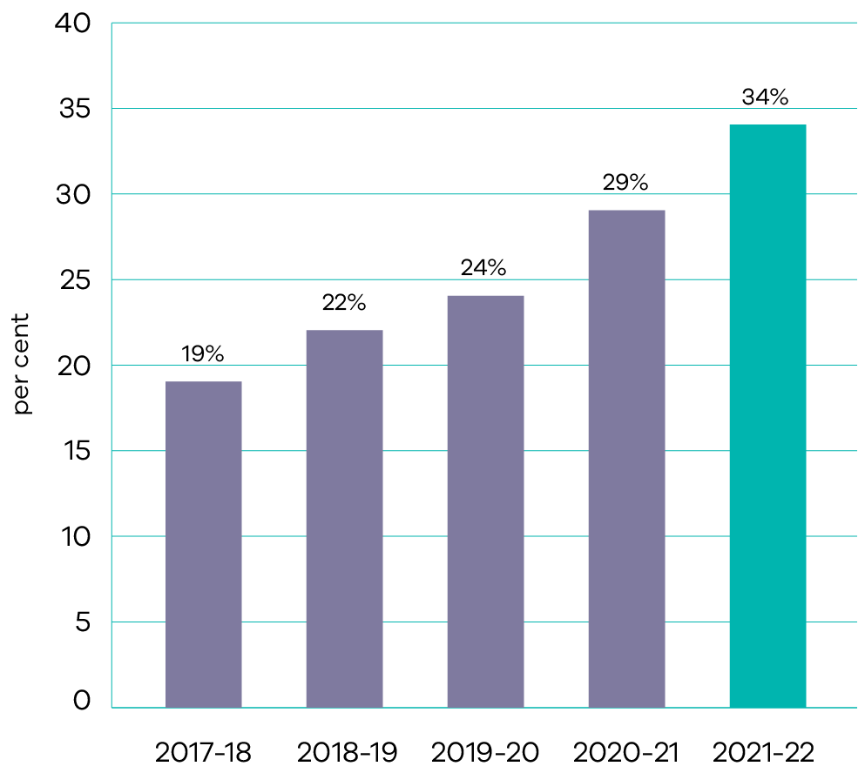
In 2021-22, the share of renewable energy in Victoria’s electricity generation reached 34 per cent, up from 29 per cent in 2020-21. This increase in share is reflective of increased output from new wind and solar projects, continued growth in rooftop solar PV, and reduced coal output.

Indicator: Electricity generating capacity installed under the Solar Homes program
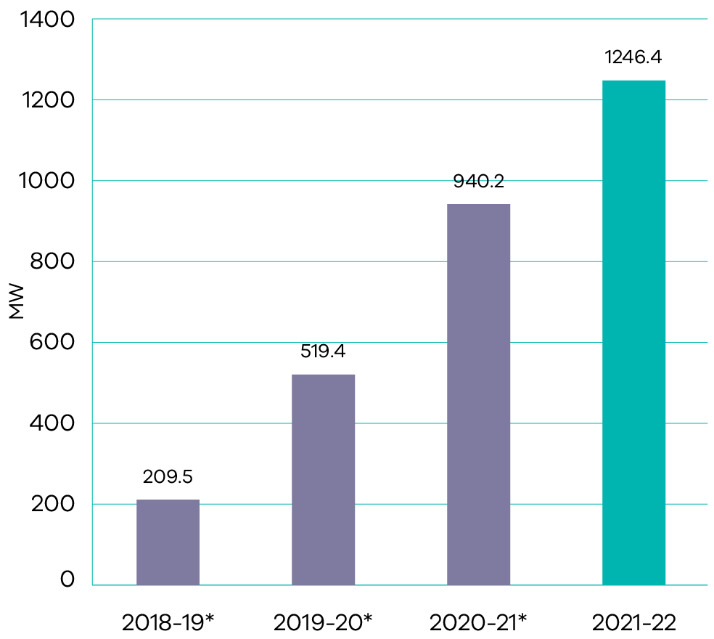
*Data has been adjusted to account for a change in the unit of measure from MWh to MW. The revised unit of measure is consistent with standard conventions for measuring generation capacity.
The total cumulative electricity generating capacity installed under the Solar Homes program as at 30 June 2022 was 1,246.4 MW, with the annual result for 2021-22 totalling 306.2 MW. This output represents the generating capacity from all solar PV systems installed under the Solar PV rebates for owner occupier households and rental properties program.
The lower increase rate in electricity generating capacity between 2020-21 to 2021-22 reflects lower than anticipated uptake of the solar PV rebate. This was due to a number of factors such as the ongoing impact of the COVID-19 pandemic on economic security and consumer demand, as well as labour shutdowns and shortages, supply chain limitations and increasing technology prices, coupled with a slightly lower solar PV rebate in 2021-22.

Indicator: Solar systems installed under the Solar Homes program
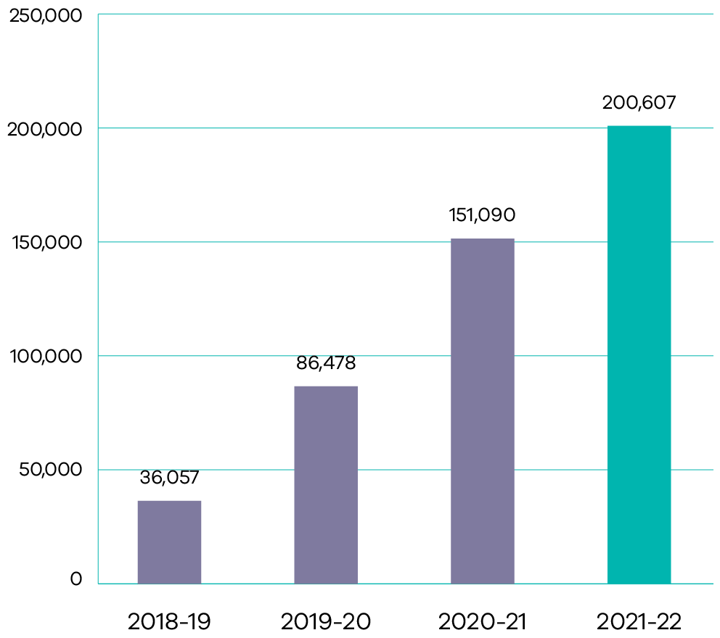
Note: this is a new indicator for 2021-22
This new objective indicator reports on the cumulative number of solar systems installed under the Solar Homes Program. It reflects progress towards providing 778 500 rebates for either solar panel energy systems, solar hot water systems, or battery storage for homes over 10 years.
The cumulative total number of installed solar systems under the Solar Homes program as at 30 June 2022 was 200,607, with the annual result for 2021-22 totalling 49,518 solar systems. The decrease in solar systems installations between 2020-21 and 2021-22 was due to a number of factors including the ongoing impact of the COVID-19 pandemic on consumer demand, as well as labour shutdowns and shortages, supply chain limitations and increasing technology prices, coupled with a slightly lower solar PV and battery rebate in 2021-22.

Indicator: Percentage of surveyed users of the Victorian Energy Compare website who report that they plan to switch offers after using the website
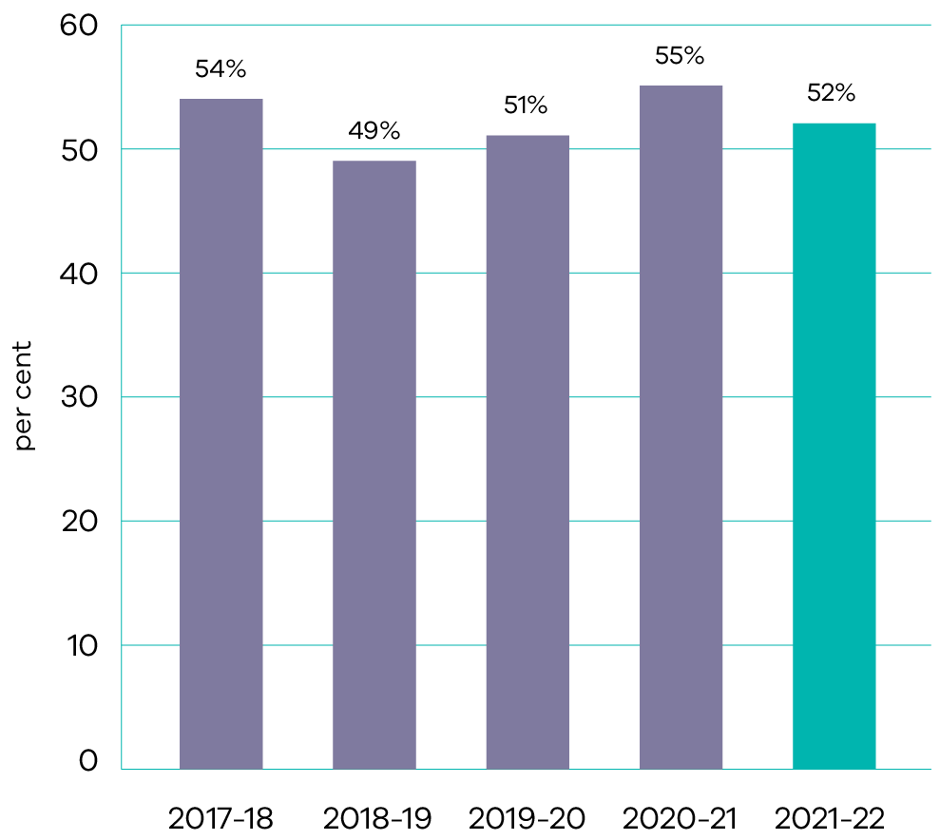
Of the 15,585 Victorian Energy Compare users who completed the online survey during 2021-22, 52 per cent reported they plan to change offers based on the information provided. This result is a reflection of volatile energy prices in the retail market, resulting in a reduction in the percentage of surveyed users who plan to switch after visiting the Victorian Energy Compare website. Overall, more than 78 per cent reported they had a positive experience and 59 per cent reported they understand usage and energy costs better.

Output performance measures

Energy
This output advocates for the provision of reliable, sustainable and affordable energy services through state-based energy programs, including renewable energy development, energy efficiency and affordability improvements, and facilitation of new investment.
The performance measures below compare targets and expected or actual results from the delivery of programs and services as part of this output:
Output performance measures | Unit of measure | 2021-22 actual | 2021-22 target | Performance variation (%) | Result
Quantity
Certificates surrendered to meet energy saving targets under the Victorian Energy Upgrades program | million certificates | 0 | 6.5 | (100%) | Performance target not achieved – exceeds 5 per cent variance.
Performance is reported as below target as at 30 June 2022, due to COVIDSafe settings limiting installations of energy efficiency upgrades in households and businesses. This resulted in some certificate providers not being able to meet their contracts with energy retailers. While sufficient energy efficiency certificates were created to meet the target, the liability surrender date was delayed to 31 July 2022 to allow more time for contracts to be renegotiated or retailers to source certificates from elsewhere. As at 31 July 2022, 6.6 million certificates have been submitted for surrender, which would exceed the 2021 target.
Output performance measures | Unit of measure | 2021-22 actual | 2021-22 target | Performance variation (%) | Result
Solar energy purchases sufficient to meet annual Melbourne tram network demand | per cent | 100 | 100 | 0.0% | Performance target achieved or exceeded.
Share of Victoria’s electricity generation from renewable sources | per cent | 34 | 31 | 10% | Performance target achieved or exceeded.
Performance is above target, reflecting increased output from new wind and solar projects and continued growth in rooftop solar PV.
Output performance measures | Unit of measure | 2021-22 actual | 2021-22 target | Performance variation (%) | Result
Large scale Generation Certificates procured under the Renewable Certificate Purchasing Initiative sufficient to meet annual electricity demand of participating government sites | per cent | 100 | 100 | 0.0% | Performance target achieved or exceeded.
Cumulative renewable electricity generation capacity under the Victorian Renewable Energy Target 2017 Auction | MW | 650 | 650 | 0.0% | Performance target achieved or exceeded.
New Energy Jobs Fund projects completed | number | 13 | 15 | (13%) | Performance target not achieved – exceeds 5 per cent variance.
Performance is below target due to COVID-19 impacts on one project, and another project requiring additional time for its participating energy retailer to register as a residential retailer. Both projects will be completed by 30 November 2022.
Output performance measures | Unit of measure | 2021-22 actual | 2021-22 target | Performance variation (%) | Result
Government-supported events that engage business and supply chains regarding the energy sector | number | 10 | 10 | 0% | Performance target achieved or exceeded.
Vulnerable Victorian energy consumers reached through consumer support programs | number | 25 543 | 10 000 | 155% | Performance target achieved or exceeded.
Performance is above target reflecting the significant reach of the Victorian Government’s $250 Power Saving Bonus program.
Output performance measures | Unit of measure | 2021-22 actual | 2021-22 target | Performance variation (%) | Result
Quality
Relative reduction in statewide powerline related bushfire risk | per cent | 44.1 | 45 | (2%) | Performance target not achieved – within 5 per cent variance.
Users of the Victorian Energy Compare website who report a better understanding of their usage costs after using the website | per cent | 59 | 65 | (9%) | Performance target not achieved – exceeds 5 per cent variance.
Performance is below target due to the impact of the $250 Power Saving Bonus program, which can bring users to the Victorian Energy Compare website for a purpose other than to compare energy offers and better understand their usage and costs. The result is also influenced by external factors such as retailer offer structures and billing approaches.
Output performance measures | Unit of measure | 2021-22 actual | 2021-22 target | Performance variation (%) | Result
Victoria is represented at each Energy Ministers’ meeting | per cent | 100 | 100 | 0% | Performance target achieved or exceeded.
Timeliness
Delivery of key Australian Energy Market Commission funding milestones, in line with funding agreements and agreed project deliverables | per cent | 100 | 100 | 0% | Performance target achieved or exceeded.
Cost
Total output cost | $ million | 323.2 | 278.3 | 16% | Performance target not achieved – exceeds 5 per cent variance.
The higher than budgeted output cost is primarily due to an increase in the fair value adjustment of derivative financial instruments, partially offset by a rephase for the Energy Efficiency Upgrades for Homes initiative.

Solar Homes
This output will, over 10 years, provide 778 500 rebates for either rooftop solar energy systems, solar and energy efficient hot water systems, or battery storage, as Victoria transitions to a lower emissions future – reducing fossil fuel usage and air pollution, and allowing independence from conventional energy supplies.
Through this output, Solar Victoria supports households to invest in money saving renewable energy technology, reduce emissions and contribute to meeting future energy demand.
The performance measures below compare targets and expected or actual results from the delivery of programs and services as part of this output:
Output performance measures | Unit of measure | 2021-22 actual | 2021-22 target | Performance variation (%) | Result
Quantity
Applications for Solar PV rebates for owner-occupied and rental households approved | number | 41 395 | 75 000 | (45%) | Performance target not achieved – exceeds 5 per cent variance.
Performance is below target reflecting reduced demand for Solar PV rebates caused by the impact of the COVID-19 pandemic on supply chains and workforce availability, and higher Solar PV prices in 2021-22.
Output performance measures | Unit of measure | 2021-22 actual | 2021-22 target | Performance variation (%) | Result
Applications for home battery rebates approved | number | 6 502 | 7 000 | (7%) | Performance target not achieved – exceeds 5 per cent variance.
Performance is below target due to slower than expected uptake of rebates allocated under the Virtual Power Plant pilot program combined with COVID-19 impacts on home battery sales.
Output performance measures | Unit of measure | 2021-22 actual | 2021-22 target | Performance variation (%) | Result
Applications for solar hot water rebates approved | number | 745 | 6 000 | (88%) | Performance target not achieved – exceeds 5 per cent variance.
Performance is below target reflecting low demand for solar hot water rebates and the impact of the COVID-19 pandemic on solar hot water sales activity. Although demand grew in the final months of 2021-22 following changes to eligibility, Solar Victoria is also developing strategies to increase demand.
Output performance measures | Unit of measure | 2021-22 actual | 2021-22 target | Performance variation (%) | Result
Applications for Solar PV rebates for small businesses approved | number | 1 508 | 5 000 | (70%) | Performance target not achieved – exceeds 5 per cent variance.
Performance is below target due to COVID-19 impacts on small businesses and solar retailer sales activity.
Output performance measures | Unit of measure | 2021-22 actual | 2021-22 target | Performance variation (%) | Result
Applications for Home Heating and Cooling Upgrade rebates for reverse cycle air conditioning units to replace inefficient heating systems approved | number | 35 367 | 70 000 | (49%) | Performance target not achieved – exceeds 5 per cent variance.
Performance is below target due to COVID-19 impacts on consumer demand and on reverse cycle air conditioning unit sales activity through supply chain impacts and labour shortages.
Output performance measures | Unit of measure | 2021-22 actual | 2021-22 target | Performance variation (%) | Result
Quality
Rebated installations audited by the Solar Homes Audit Program to be conducted in accordance with the Solar Homes Assurance Framework plan | per cent | 5 | 5 | 0% | Performance target achieved or exceeded.
Timeliness
Average number of weeks to process completed eligibility applications | weeks | 1.94 | 4 | 52% | Performance target achieved or exceeded.
Performance is better than target due to lower than expected numbers of rebate applications received during 2021-22.
Output performance measures | Unit of measure | 2021-22 actual | 2021-22 target | Performance variation (%) | Result
Cost
Total output cost | $ million | 187.5 | 322.2 | (42%) | Performance target not achieved – exceeds 5 per cent variance.
The lower than budgeted output cost is primarily due to a rephase of funding for the Home Heating and Cooling Upgrades, Solar Homes and Growing Victoria’s Solar Industry initiatives, as well as reduced expenditure reflecting the lower number of rebates taken up.

Productive and effective land management
- Sustainable cities and communities
- Life below water
- Life on land
Peace, justice and strong institutions

Progress towards achieving this objective

Context
Victoria’s public land, including its parks, forests, coasts, alpine resorts and Crown land reserves, has significant economic, environmental, cultural and recreational value. DELWP manages public land to both protect these values and optimise its use by all Victorians.
In partnering with other public land managers, including Traditional Owners, statutory agencies, and committees of management, we ensure that our public land and water assets are used in a sustainable manner and that their natural and built assets continue to be maintained and improved.
We partner and work closely with Traditional Owners and Registered Aboriginal Parties to ensure their connection to Country, recognise existing rights under agreements, and incorporate Aboriginal knowledge and culture into the management of land and natural values.
We ensure that all Victorians and visitors to the state have access to safe and appropriate infrastructure, and that development, particularly along Victoria’s coastline, is appropriate and takes full account of community, environmental, and economic values as well as Traditional Owner values and aspirations.
Key initiative | 2021-22 progress summary
Suburban Parks Program | DELWP acquired seven properties in 2021-22 to support creation of three new regional parks and Sandbelt Parklands. A further 32 properties are expected to be acquired by December 2022.  DELWP is supporting the delivery of 29 new pocket parks, 14 new off-leash dog parks and 41 park revitalisation projects. Four pocket parks, seven off-leash dog parks and 14 park revitalisation projects were completed in 2020-21. The majority of the remaining projects are expected to be completed by October 2022.
Cleaning up contaminated public land | During 2021-22, remediation works at five contaminated land sites were completed. This included remediation at Geelong Gun Club, and clean-up plans completed for Mitchell Lasry, Sebastopol Gun Club, California Gully and Marong Road. Brimbank and Truganina site assessments were previously completed, with Lysterfield site assessments due for completion in early 2022-23.  Completed in April 2022, the potentially contaminated public land identification and prioritisation screen tool identifies and prioritises potentially contaminated land based on past and present use, possibility of contamination, source-path-receptor considerations, and several other technical criteria. The tool was developed in-house by DELWP with input from Parks Victoria.
Yellingbo Conservation Area | The Yellingbo (Liwik Barring) Landscape Conservation Area 10-year Plan was released in December 2021 following consultation with a wide range of interested community, stakeholder groups. The plan articulates management directions for the conservation area for a 10-year time frame aimed at enhancing its scenic beauty, biodiversity, cultural heritage and community enjoyment.  During 2021-22, more than 25 site visits were conducted to discuss changes to the management of Crown land with adjacent landholders. The site visits addressed construction of boundary fences, weed management, revegetation and off stream watering systems.
Regional Forest Agreements | DELWP is progressing commitments made in the Regional Forest Agreements (RFAs) for improving the long-term sustainable management and conservation of forests. These include:  a second RFA annual meeting held in March 2022 between DELWP, the Department of Jobs, Precincts and Regions and the Commonwealth Government  completion of a Major Event Review in April 2022 assessing the impacts of the 2019-20 bushfires on RFA matters  introduction of interim protections and management actions for threatened species and communities in April 2021  commencement of a Comprehensive Review of the Code of Practice for Timber Production in January 2022, to be completed by December 2023.
Management of the Great Ocean Road | A Bill to amend the Great Ocean Road and Environs Protection Act 2020 was passed by Parliament on 14 October 2021, making the Great Ocean Road Coast and Parks Authority the dedicated parks and public land manager for the Great Ocean Road coast and parks.  The first step in developing the Great Ocean Road strategic framework plan was completed in June 2022 with the release of a consultation draft. The draft plan is expected to be finalised by December 2023.
Office of the Conservation Regulator regulatory functions in relation to timber harvesting, land use, and fire prevention | The Conservation Regulator delivered significant work to tackle key regulatory risks impacting land management including illegal campfires, illegal possession of wildlife, illegal commercial timber harvesting in state forests, illegal removal of firewood and illegal vehicle use on public land.  There has been a significant increase in visitation to public land as a result of the COVID-19 pandemic, and this has presented increased risks of environmental harm. To address this risk and ensure compliance with the law, more than 1,900 proactive patrols on public land were conducted across the state during 2021-22.
Building Works Program | The Solar on Public Buildings program installed 3,900 solar panels at 140 sites across Victoria over 2021-22. This produced 1540kW of capacity and will save committees of management an estimated $300,000 per year.  The Improving Public Visitor and Recreation Sites program continued to deliver improvements to walking tracks and campgrounds. During 2021-22, improvements were made at sites such as Forrest Mountain Bike Trails, O’Hagens to Staceys Bridge, the Timber Workers High Country Huts, the Mill Campground, Knowsley State Forest Smart Track Camp Area and Fontainbleu Campground. Visitor experiences at the Kyabram Fauna Park were improved through the program’s delivery of extensive upgrades to the park’s visitor entrance, education and conservation centre and reptile house.  The Safeguarding Marine and Coastal Assets program completed essential remediation works at Lakes Entrance, Mallacoota and Jam Jerrup in 2021-22 to protect vulnerable coastal and community assets under pressure from severe weather and changes in environmental conditions.  The Building Works program also facilitated the development of 17 dog parks under the Local Parks program (of which six were completed in 2021-22), and delivered innovative infrastructure that will reduce aircraft turn-around times and improve effectiveness of fire-bombing operations through the Securing Water Supplies in Remote Areas for Firefighting project.
Safeguarding Marine and Coastal Environments in the Face of Climate Change | Grants were awarded to six pilot projects in June 2022 for technical, engagement and strategic planning activities aligned to the Victoria’s Resilient Coast framework. Six Traditional Owner groups were supported to develop self-determined marine and coastal projects through the Sea Country projects grants program. Through the Coastal Public Access and Risk Grants program, in January 2022, 20 grants were awarded to Victorian coastal Crown land managers for reduction of coastal risk and public access improvements.  Coastal protection works were completed at Altona in April 2022. Stage 2 of coastal protection works were delivered at Apollo Bay in May 2022 and at Mallacoota and Lakes Entrance in June 2022.
Melbourne Zoo, Healesville Sanctuary and Werribee Open Range Zoo ‘Kids Free’ policy | The ‘Kids Free’ policy provided 260,000 children aged under 16 free access to Zoos Victoria’s three sites during 2021-22.  Total visitation to the three zoos was 1.64 million in 2021-22, an increase of 110,000 from the 1.53 million visitors in 2020-21.
Marine and coastal policy reforms | The Marine and Coastal Strategy was released in May 2022. It will support sustainable use and improve how we manage the health of the marine and coastal environment. Research projects with university partners on sea level rise impacts and coastal erosion have progressed. Guidelines for the management of existing bathing boxes and boatsheds on marine and coastal Crown land were released in March 2022 and guidelines for the development of marine and coastal management plans are also being drafted.
Port Phillip Bay Beach Renourishment Program | The Port Phillip Bay Beaches Renourishment program met its target of 12 beach renourishments over four years. The final year of the program delivered six beach renourishments at:  St Leonards North in November 2021  Sandringham in December 2021  Blairgowrie and Rye in March 2022  Tootgarook and St Leonards South in April 2022.
Coastcare Victoria | Coastcare Victoria delivered the Summer by the Sea program to more than 9,000 participants in January 2022 using an innovative hybrid delivery model (face to face and online). Face to face volunteer engagement resumed in May and June 2022 with the delivery of three regional volunteer forums.  The Coastcare Community Grants program issued 32 grants to community organisations in September 2021, enabling protection and enhancement of the coastal and near-shore marine environment.
Renewing Victoria’s public land legislation | Progress continues to be made on policy proposals to deliver the Government’s commitment to renew Victoria’s public land legislation to improve land use and management, streamline approval processes and remove barriers that limit self-determination for Traditional Owners. Public feedback was sought on a consultation paper, ‘Realising the value of Victoria’s public land: Renewing Victoria’s public land legislation’ over April and May 2021 with feedback being used to inform and refine the policy proposals.
Victorian Traditional Owner Cultural Landscapes Strategy | In August 2021, the Victorian Traditional Owner Cultural Landscapes Strategy was launched by Victorian Traditional Owners, supported by DELWP and Parks Victoria. The Strategy provides direction to the Victorian Government about how it can enable and empower Traditional Owner self-determination in land management.
Identifying processes by which Traditional Owners have greater say in the way heritage is protected on Country | Under the direction of the Caring for Country Partnerships forum Traditional Owner caucus, DELWP commenced an in-depth review of Aboriginal heritage management in the context of Pupangarli Marnmarnepu. An interim report was provided to the caucus in late 2021 with feedback being used to inform an Aboriginal Cultural Heritage reform roadmap. The roadmap will enable Traditional Owners to set the strategic agenda for Aboriginal Cultural Heritage management.
Regional Caring for Country Partnership Forums | Regional Caring for Country Partnership forums were delivered to support four Traditional Owner groups in progressing self-determination:  First People of the Millewa-Mallee Aboriginal Corporation (held on 23 March 2022 and 1 June 2022)  Dja Dja Wurrung Clans Aboriginal Corporation (held on 10 March 2022 and 2 June 2022)  Gunaikurnai Land and Waters Aboriginal Corporation (held on 24 March 2022)  Wurundjeri Woi Wurrung Cultural Heritage Aboriginal Corporation (held on 9 June 2022).  DELWP continues to support Traditional Owner groups in the preparation and delivery of the forums. Priorities discussed at the forums include increasing exposure of the forums to younger members of the communities, amending place names, recognising relationships and cultural fire.
Supporting Traditional Owner Land Management Boards | Ongoing support to the three Traditional Owner Land Management Boards who oversee joint management continues. DELWP provided oversight with a focus on advice and administration in public sector governance including appointments, annual reports and financial management compliance. During 2021-22, DELWP met regularly with the chairs and executive officers of each board.  In addition, DELWP participated in joint management workshops and board meetings on Country. DELWP continues to provide in-kind administrative support to the Yorta Yorta Traditional Owner Land Management.
Partnering with Traditional Owners in the planning and management of Victoria’s marine environment coastlines | DELWP released an Access and Infrastructure Plan for the new Yallock-Bulluk Marine and Coastal Park in November 2021. The plan was developed in consultation with Traditional Owner partners and includes information about Aboriginal heritage places, visitor areas, facilities, and proposed trail routes to be constructed in phases based on funding.
Victoria’s Great Outdoors | In 2021-22, the Victoria’s Great Outdoors program delivered $3 million in reduced campground fees in state and national parks, nine new campgrounds, six walking trails and upgrades to nine existing campgrounds.  The third and final round of Camping and Caravan Grants were awarded in November 2021 with 20 successful applicants. Out of the 44 round 1 and 2 grants, 31 projects have been completed.
Supporting alpine resorts | Legislation to amend the Alpine Resorts (Management) Act 1997 to establish a single entity to manage Victoria’s six alpine resorts passed in March 2022. The amendments are scheduled to come into effect on 1 October 2022.  The new entity, to be known as Alpine Resorts Victoria, will support alpine resorts and associated communities as they recover from the effects of the 2019-20 bushfires and the COVID-19 pandemic.
Strategic land use assessments | Strategic land use assessments considering future land use opportunities were completed on two government owned sites. These assessments involved significant whole of government collaboration and engagement to ensure delivery of robust advice and exploration of all potential land use options. Land use advice on approaches to maximise public value from the sites was delivered to government in December 2021.
Land Utilisation Assessment program | During 2021-22, 53 Rapid Assessments were completed on government held land across the state and 10 Strategic Investigations were completed to support key government priorities. These include Homes Victoria for the Big Housing Build, the Department of Jobs, Precincts and Regions for the Commonwealth Games and the Footscray Business Precinct, and the Department of Health for the Ambulance Station Program and Collaborative Centre for Mental Health.
Vicmap data services | As part of DELWP’s commitment to provide emergency services with authoritative mapping tools, DELWP’s online Vicmap Topographic Maps continue to be maintained and provided to emergency response organisations at no cost. During 2021-22, total map downloads exceeded 80,000 (including usage from the Vicmap Viewer mobile app).  In December 2021, Vicmap developed a statewide open update to Vicmap Vegetation, published via Vicmap as a Service. This project was recognised for its contribution to Environment and Sustainability as the recipient of the annual Asia Pacific Spatial Enablement Awards (APSEA) Victoria award in March 2022.  Vicmap as a Service has now achieved over 10 million hits since its launch in September 2021 and is now streaming Vicmap data directly into numerous federal, state and local governments, private spatial service providers, and emergency service agencies’ spatial systems, including the Bureau of Meteorology, the Emergency Services Telecommunications Authority, the Country Fire Authority and Fire Rescue Victoria.
Maintenance and enhancement of survey control and positioning infrastructure | The Global Navigation Satellite System ground station network was upgraded with new infrastructure, enhanced communications equipment reducing costs for the department, migration of data services to a new cloud-based environment in June 2022, and 11 new stations installed during 2021-22 to support major infrastructure projects and development in growth areas.  The survey control network was upgraded to support major infrastructure projects including Suburban Rail Loop in April 2022 and North East Link in June 2022, and targeted ground control point surveys were performed throughout January to June 2022 to support airborne LiDAR acquisition and creation of digital elevation models for Digital Twin Victoria.
Digital Cadastre Modernisation project | During 2021-22, 2.2 million land parcels were turned into a fully digital format and added into the newly created Digital Cadastre Data Base. Thirty-three municipalities also underwent an initial spatial adjustment to increase the accuracy of their position in Vicmap.  Automated updating of the cadastre underwent a successful proof of concept demonstration, which was the first step in enabling automated upload of new land parcels into the Cadastre as the land development process occurs.
Digital Twin Victoria | Significant progress was made in establishing core capabilities and engagement with key stakeholders to progress the Digital Twin Victoria (DTV) program. The DTV platform now includes many new datasets and functionality. A three-month beta testing program gathered customer insights to inform the development of the platform, with over 80 per cent of participants expressing a high level of satisfaction. The platform is already providing benefits to state and local governments by providing easier access to data and delivering savings through the use of shared data storage, analytics and visualisation tools.  A proof of concept commenced in June 2022 to design the DTV Utility Data Portal. The portal will be an industry-first, government-led tool that will streamline access to utility information throughout the lifecycle of major infrastructure projects in Victoria and ensure the data developed during these projects can be reused.
Australian Geospatial Reference System modernisation | To enable accurate and reliable positioning to support spatial applications across Victoria, DELWP:  developed a deformation modelling project agreement and identified locations for subsidence monitoring network marks throughout the Latrobe Valley  commenced airborne gravity survey data capture in March 2022. As at 30 June 2022, 23.1 per cent of data capture has been completed.  is continuing a consultation and communications process with government and industry to help them transition to the Geocentric Data of Australia 2020 (GDA2020) datum, the new official coordinate system for Australia.

Indicator: Efficient provision of timely and authoritative land administration and property information services
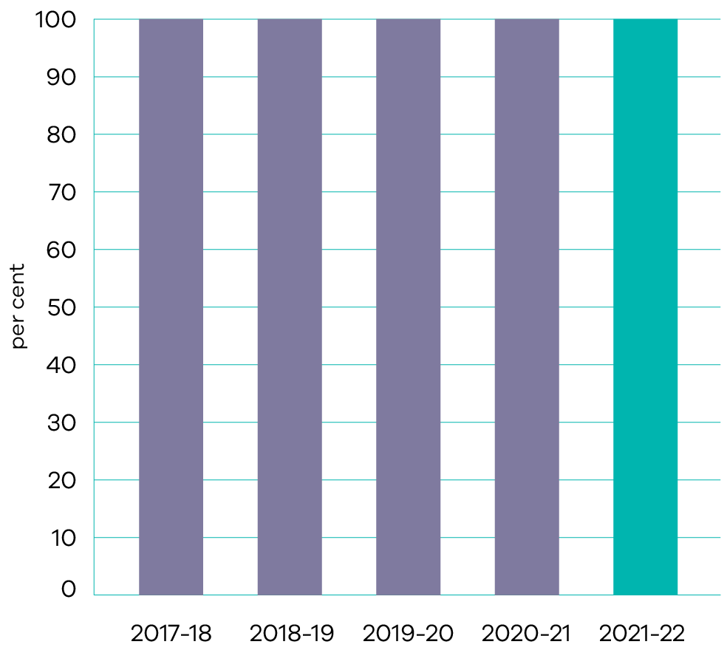
DELWP’s Land Registry Services processed more than one million transactions (1,018,201 registered) in 2021-22 (the highest on record) and delivered nearly three million (2,977,311) title searches. Full year revenue exceeded $492 million. Electronic dealings made up over 97 percent of all dealings lodged and electronic transfers made up 99 per cent of all transfers.
The Office of the Valuer-General Victoria (VGV) completed the 2022 annual rating and taxation valuation, which was the fourth year of the centralised and annual rating valuation. The total value of Victorian property has grown from $2.55 trillion in 2021 to $2.98 trillion in 2022. The total number of valuations completed increased from 3.22 million in 2021 to 3.27 million in 2022. There was an average increase of 17 per cent in the total capital improved value (CIV) of Victoria. However, there was a larger average increase in values in regional Victorian CIVs, of 27 per cent compared to a 14.6 per cent average increase in metropolitan Melbourne.

Indicator: Consistent and timely provision of government land transaction approvals and advice
Provision of government land transaction approvals and advice continues to be delivered at a consistent and timely standard.
During 2021-22, VGV received over 3,800 requests for valuations from government departments and agencies, including DELWP. Many of these have been for the Big Housing Build and other priority infrastructure projects such as the West Gate Tunnel project, the North East Link project and the Suburban Rail Loop project. VGV also processed a large volume of work for financial reporting valuations for many Victorian Government agencies.
Through the Victorian Government Land Monitor (VGLM), the department developed and implemented the 2022 Victorian Government Land Transaction Policy, which became effective on 4 April 2022. The VGLM conducted training and information sessions with Victorian government agencies to ensure that agencies understand the framework and have the support they need to maintain accountability and transparency when conducting land transactions. VGLM continues to experience significant engagement and submissions by agencies. Key transactions reviewed and approved include the following government infrastructure projects and initiatives: Big Housing Build (Homes for Victorians), North East Link Project, Level Crossing Removal Projects, Development Victoria – housing developments, Victorian School Building Authority – 100 schools program, Victorian Health Building Authority – Community hospitals program, and Fire Rescue Victoria – new station sites.

Indicator: Number of visits to the public land estate managed by the department’s portfolio agencies (Parks Victoria)
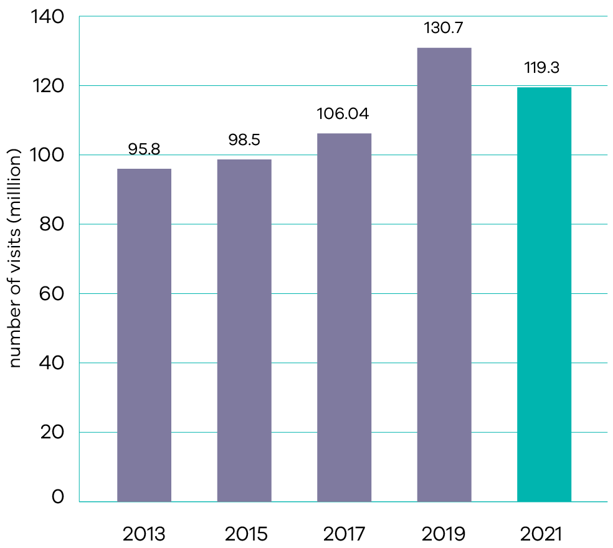
Results for this measure are captured every two years.
The biennial visitor number survey in 2020-21 indicated that the Parks Victoria estate received 119.3 million visitors to national, state, urban and other terrestrial parks, and piers and jetties, against a target of 115 million visitors.
While this appears to be a decrease in visitors since 2018-19, improvements to the survey in 2020-21 have enabled greater accuracy in reporting visits, and this saw a decrease in estimated visits to Parks Victoria managed piers and jetties. Visitation to national parks, state parks and conservation reserves remained consistent and visitation to Melbourne metropolitan parks increased by 39 per cent. The number of visitors to Park Victoria’s estate is evidence of the community choosing to make use of the natural, built, and cultural assets within the estate.
As in 2020-21, increased visitation to many areas of public land during the 2021-22 summer created challenges and risks requiring careful management, including preparing for a COVIDSafe summer and messaging to encourage Victorians to get outdoors safely. DELWP continued to implement the Public Safety on Public Land and Waterways COVIDSafe Summer Plan to ensure a consistent and coordinated approach to the COVIDSafe management of public land and waterways. This was maintained until the conclusion of the April 2022 school holiday period.

Indicator: Bay and park assets rated in average to excellent condition
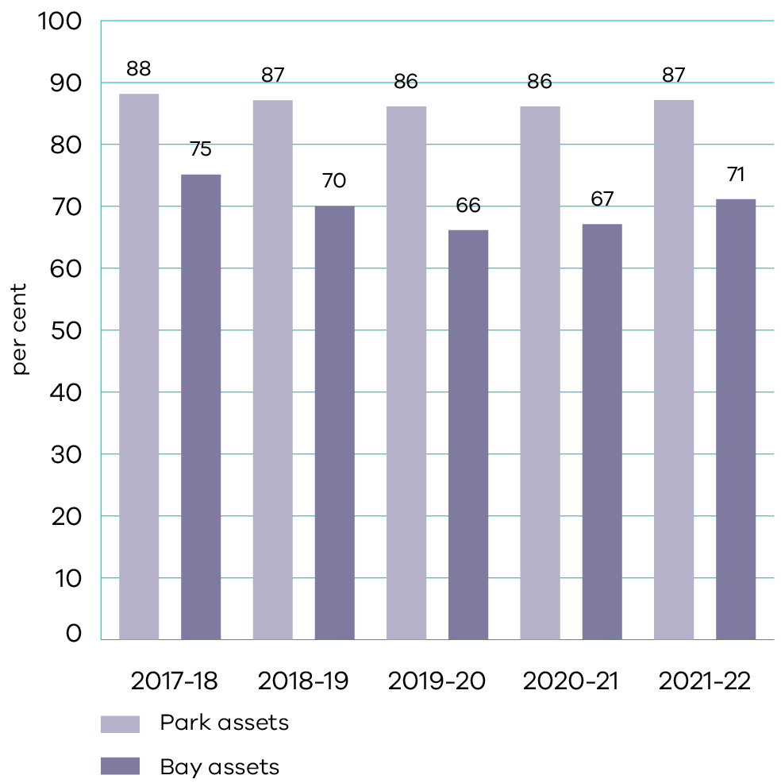
Parks Victoria manages one of the most diverse park and waterway networks in the world. The network contains natural and cultural resources that provide a wide range of benefits to the environment, the community and the economy. Each year, Parks Victoria measures the condition of bay and park assets to inform asset investment and maintenance.
In 2021-22, 87 per cent of park assets (against a target of 88 per cent) and 71 per cent of bay assets (against a target of 80 per cent) were rated in average to excellent condition. The lower than targeted result for bay assets is due to deterioration through ageing and storm impacts. Works are underway to support the improvement of asset condition, including under the Better Piers and Waterside Facilities program. The result for bay assets has however improved by four percentage points since 2020-21 due to completion of major repair works at Cowes and Middle Brighton piers and Queenscliff South pier and shed. Parks Victoria has received funding for asset maintenance for high-risk assets and is continuing works on a number of piers as part of the Victorian Government Stimulus program. Parks Victoria is also working with the Department of Transport to develop a strategic investment plan for the local ports of Port Phillip and Western Port, which will assist future funding prioritisation.

Indicator: Traditional Owner satisfaction with progress on the Pupangarli Marnmarnepu Implementation Action Plan endorsed by the Statewide Caring for Country Partnership Forum
During this first year of reporting on this indicator, time was taken to develop an appropriate mechanism to measure Traditional Owner satisfaction with progress on the Pupangarli Marnmarnepu Implementation Action Plan. DELWP worked with the State-wide Caring for Country Partnership Forum Secretariat to develop an appropriate survey, which was launched with Traditional Owners in June 2022.
These initial survey results indicate a positive to neutral level of satisfaction with systems and processes that are changing across the department (being a key objective of Pupangarli Marnmarnepu), including the transition of power and resources to Traditional Owners.
An example of this is the successful facilitation of the timetable for the transfer of 30,000 hectares of private land back to Ngintait Traditional Owners in May 2022. This will be the largest tract of private land to be returned to Indigenous management in the state’s history.
Further to this, the department coordinated two Yorta Yorta Nation Aboriginal Corporation (YYNAC) Forums on Country in Echuca and Barmah to protect the sacred cultural site of Ghow (Kow) Swamp. Forums are held quarterly and demonstrate DELWP’s commitment to bringing government agencies together to look at Country holistically and to serve Traditional Owners’ interests.

Output performance measures

Land Use Victoria
This output delivers high quality and authoritative land administration and property information services, including the registration of land titles under the Torrens system, survey, valuation and land information services. Land Use Victoria also incorporates the State’s foundational spatial data services and government land policies. The probity of the government’s property transactions is overseen by the Government Land Monitor.
The performance measures below compare targets and actual results from the delivery of programs and services as part of this output:
Output performance measures | Unit of measure | 2021-22 actual | 2021-22 target | Performance variation (%) | Result
Quantity
Property transfers, discharge of mortgages and registration of new mortgages | number (000) | 1 018 | 850 | 20% | Performance target achieved or exceeded.
Performance is above target reflecting heightened property market activity in 2021-22.
Output performance measures | Unit of measure | 2021-22 actual | 2021-22 target | Performance variation (%) | Result
Rapid Land Use Assessments completed | number | 53 | 40 | 33% | Performance target achieved or exceeded.
Performance is above target due to a focussed effort on delivering a package of rapid assessments, including for sites identified by landholding agencies.
Output performance measures | Unit of measure | 2021-22 actual | 2021-22 target | Performance variation (%) | Result
Quality
Audited Vicmap digital map base not requiring correction | per cent | 98.9 | 98 | 1% | Performance target achieved or exceeded.
Government owned properties sold, bought or leased within 10 per cent of valuation | per cent | 80 | 80 | 0% | Performance target achieved or exceeded.
Timeliness
Delivery of updated Vicmap Foundation Data within one week | per cent | 100 | 98 | 2% | Performance target achieved or exceeded.
Land dealings registered within five days | per cent | 99.3 | 99 | 0% | Performance target achieved or exceeded.
New titles (subdivisions) created within three weeks | per cent | 92.7 | 95 | (2%) | Performance target not achieved – within 5 per cent variance.
Update transactions for the Vicmap digital map base processed within the required timeframes | per cent | 98 | 98 | 0% | Performance target achieved or exceeded.
Cost
Total output cost | $ million | 287.0 | 255.4 | 12% | Performance target not achieved – exceeds 5 per cent variance.
The higher than budgeted output cost is primarily due to an increase in property market activity which has caused an increase in Land Registry Services revenue with a reciprocal increase in payments to the private operator; as well as a release of contingency funding for Digital Twin Victoria. This is partially offset by reduced expenditure for several activities due to the redirection of resources to core services to meet the increase in property transaction volumes.

Management of Public Land and Forests
This output provides for the improved stewardship of Victoria’s forests, coasts and Crown land reserves. Through this output, the department manages the natural, built and historic assets on public land, and incorporates management of public land in partnership with statutory agencies, Committees of Management and local government.
The performance measures below compare targets and expected or actual results from the delivery of programs and services as part of this output:
Output performance measures | Unit of measure | 2021-22 actual | 2021-22 target | Performance variation (%) | Result
Quantity
Crown land leases directly managed by the Department | number | 658 | 720 | (9%) | Performance target not achieved – exceeds 5 per cent variance.
Performance is below target reflecting a transfer of leases to other agencies, some leases not being renewed by tenants and other leased parcels of land being reclassified as reserves to be managed by Committees of Management.
Output performance measures | Unit of measure | 2021-22 actual | 2021-22 target | Performance variation (%) | Result
Crown land licenses directly managed by the Department | number | 45 300 | 45 000 | 1% | Performance target achieved or exceeded.
Native Title and Traditional Owner Settlement Act 2010 negotiations the Department supports with data and information services | number | 4 | 4 | 0% | Performance target achieved or exceeded.
Native Title and Traditional Owner Settlement Act 2010 agreements being implemented by the Department | number | 6 | 6 | 0% | Performance target achieved or exceeded.
Participants in Coastcare activities | number | 9 094 | 10 000 | (9%) | Performance target not achieved – exceeds 5 per cent variance.
Performance is below target due to COVIDSafe settings impacting face to face delivery of Coastcare activities.
Output performance measures | Unit of measure | 2021-22 actual | 2021-22 target | Performance variation (%) | Result
Visitors to the Royal Botanic Gardens in Melbourne and Cranbourne | number (million) | 1.78 | 2.0-2.2 | (11%) | Performance target not achieved – exceeds 5 per cent variance.
Performance is below target due to significantly reduced international and interstate tourism to Melbourne Gardens and a reduction in the amount of public programming at both sites due to COVIDSafe settings.
Output performance measures | Unit of measure | 2021-22 actual | 2021-22 target | Performance variation (%) | Result
Specimens curated in the State Botanical Collection | number | 26 984 | 30 000 | (10%) | Performance target not achieved – exceeds 5 per cent variance.
Performance is below target due to COVIDSafe settings limiting on-site curation works.
Output performance measures | Unit of measure | 2021-22 actual | 2021-22 target | Performance variation (%) | Result
Visitors to Zoos Victoria at Melbourne, Werribee and Healesville | number (million) | 1.64 | 2.85 | (43%) | Performance target not achieved – exceeds 5 per cent variance.
Performance is below target due to periods of zoos closures and visitor caps as a result of COVIDSafe settings, significantly reduced international and interstate tourism and school group visits.
Output performance measures | Unit of measure | 2021-22 actual | 2021-22 target | Performance variation (%) | Result
Beaches renourished in Port Phillip Bay | number | 6 | 3 | 100% | Performance target achieved or exceeded.
Performance is above target due to completion in 2021-22 of three projects delayed from 2020-21.
Output performance measures | Unit of measure | 2021-22 actual | 2021-22 target | Performance variation (%) | Result
Contaminated crown land sites assessed/prepared for remediation | number | 5 | 5 | 0% | Performance target achieved or exceeded.
Suburban dog parks and pocket parks under development | number | 43 | 43 | 0% | Performance target achieved or exceeded.
Quality
Publicly elected Committees of Management that have a current statutory appointment | per cent | 91 | 90 | 1% | Performance target achieved or exceeded.
Recreational facilities in state forests with a life expectancy greater than five years | per cent | 78 | 75 | 4% | Performance target achieved or exceeded.
Timeliness
Rent reviews of Department-managed Crown land leases undertaken within specified time frames | per cent | 99 | 95 | 4% | Performance target achieved or exceeded.
Investigations of alleged non-compliance with the Code of Practice for Timber Production 2014 and other relevant laws are completed within the statute of limitations of two years | per cent | 100 | 100 | 0% | Performance target achieved or exceeded.
Cost
Total output cost | $ million | 438.1 | 294.0 | 49% | Performance target not achieved – exceeds 5 per cent variance.
The higher than budgeted output cost is primarily due to additional funding for flood and storm recovery works and a reallocation of costs from capital to output for the Great Ocean Road Management Reforms and Coastal Trail initiative and Safeguarding Marine and Coastal Environments in the Face of Climate Change initiatives.

Parks Victoria
This output provides for the improved stewardship of Victoria’s parks. Through this output, Parks Victoria manages the development and protection of natural, cultural and community assets for safe enjoyment and sustainable use by all Victorians. Parks Victoria works to ensure the state’s park assets are managed efficiently and effectively.
The performance measures below compare targets and expected or actual results from the delivery of programs and services as part of this output:
Output performance measures | Unit of measure | 2021-22 actual | 2021-22 target | Performance variation (%) | Result
Quantity
Area treated to minimise the impact of pest plants, pest animals and over abundant native animals in parks managed by Parks Victoria | hectares (000) | 2 400 | 2 200 | 2% | Performance target achieved or exceeded.
Visits to national, state, urban and other terrestrial parks | number (million) | N/A | 80 | N/A | N/A
Not measured in 2021-22. Results for this measure are captured every two years.
Output performance measures | Unit of measure | 2021-22 actual | 2021-22 target | Performance variation (%) | Result
Visits to piers and jetties | number (million) | N/A | 35 | N/A | N/A
Not measured in 2021-22. Results for this measure are captured every two years.
Output performance measures | Unit of measure | 2021-22 actual | 2021-22 target | Performance variation (%) | Result
Total area of estate managed by Parks Victoria | hectares (000) | 4 120 | 4 120 | 0% | Performance target achieved or exceeded.
Quality
Significant built bay assets managed by Parks Victoria rated in average to excellent condition | per cent | 71 | 80 | (11%) | Performance target not achieved – exceeds 5 per cent variance.
Performance is below target due to the decline of maritime assets from age and storm impacts. The result has however improved by four percentage points since 2020-21 due to completion of major repair works at Cowes and Middle Brighton piers and Queenscliff South pier and shed.
Output performance measures | Unit of measure | 2021-22 actual | 2021-22 target | Performance variation (%) | Result
Significant built park assets managed by Parks Victoria rated in average to excellent condition | per cent | 86.7 | 88 | (1%) | Performance target not achieved – within 5 per cent variance.
Cost
Total output cost | $ million | 170.5 | 207.6 | (18%) | Performance target not achieved – exceeds 5 per cent variance.
The lower than budgeted output cost is primarily driven by less than anticipated expenditure associated with less revenue collected from the Werribee Mansion; and the timing of payments from the Parks and Reserves Trust Account.

Safe and sustainable water resources
- Clean water and sanitation
- Sustainable cities and communities
- Climate action
- Life below water

Progress towards achieving this objective

Context
DELWP works to ensure that Victoria has safe, sustainable and productive water resources to meet future urban, rural, environmental and cultural needs. The department partners with water corporations, catchment management authorities, government agencies, industry, Traditional Owners and the community to balance the economic, environmental and social values of water. This helps to deliver healthy waterways and aquifers, secure water supplies across Victoria and ensure sustainable irrigation and agriculture, along with greener and more liveable cities and towns.
As part of the fifth tranche of the Environmental Contribution, the Victorian Government is investing $693.9 million over a four-year period to deliver Water for Victoria, our strategic plan for managing our water resources and to support a healthy environment, a prosperous economy and thriving communities.
As we deal with challenges of climate change and population growth, DELWP is taking action to ensure our water system is efficient and innovative so that we can reduce the detrimental impacts on our rivers and the environment. The Water for Victoria plan gives prominence to the cultural importance of water for Traditional Owners and Aboriginal people and the recreational values of water. Keeping water affordable for everyone is vital. Our challenge, and our opportunity, is to do more with less water and to reduce our reliance on traditional water sources.
Water for Victoria outlines the actions we are taking to create a modern and efficient, future-focused and affordable water system.
Key initiative | 2021-22 progress summary
Monitoring the water entitlement framework | New bulk metering guidelines were developed in November 2021. Storage manager and resource manager appointments were streamlined to simplify bulk water management arrangements, clarify roles and responsibilities, and reduce red tape.  DELWP worked with Traditional Owners to explore immediate and long-term options to support the issuing of water entitlements to Traditional Owners.  An approach to guide allocation of unallocated water was developed as part of the Central and Gippsland Region Sustainable Water Strategy that includes an explicit requirement that Traditional Owner water returns are considered in the process.  The operation of the water licencing framework was administered and improved to support water users and environmental values. Administrative improvements in the assessment and management of licences have been ongoing during this period. This supports greater certainty for users in how water is managed, and decisions are made in relation to their entitlements to water. The Statewide Licensing Committee was re-established to provide a community of best practice and develop consistency across the state.
Ensuring water is shared equitably and transparently | The Goulburn to Murray trade review was completed resulting in the Minister for Water announcing new permanent trade and operating rules in June 2022 to align trade opportunity to what can sustainably be delivered in the lower Goulburn River.  Legislative changes to the Water Act 1989 to better manage delivery shortfalls and to support entitlement holders to manage their own delivery risks were passed by the Legislative Council on 26 October 2021.  The names of companies who own 2 per cent or more of water were published in January 2022. In August 2022, together with Southern Rural Water, work commenced on the development of a market platform trial in the Macalister Irrigation District. The trial will support a greater understanding of the tools and resources required to improve water market transparency for water users in the southern Victorian water market.  DELWP worked with the Commonwealth and Basin Jurisdictions to support the development of a Water Market Reform Roadmap to deliver on the recommendations from the ACCC inquiry into the Murray-Darling Basin water markets.  Completion of the annual broker audit confirmed brokers who met their obligations to provide transparency of allocation trades and accurate price disclosure to all parties. The security of sensitive information and brokers’ knowledge of their responsibilities to their clients was also evaluated. The 2020-21 Victorian Water Trading Report was published in June 2022.
Supporting water compliance activities | Rural water corporations included compliance and enforcement statistics in their 2020-21 annual reports for the first time in accordance with updates to Ministerial Reporting Directions developed by the department.  In January 2022, Goulburn-Murray Water and Lower Murray introduced Penalty Infringement Notices (Fines) to deter small volume unauthorised take, following extensive implementation work led by the department. During this irrigation season DELWP coordinated targeted communications about fines to customers from both water corporations which has seen a reduction in small volume water theft.  In June 2022, DELWP finalised a cost benefit framework to support telemetry investment decision-making by rural water corporations. This work was initiated by the department in January 2021 to reinforce Victoria’s ability to benchmark metering requirements against compliance risk over time.
Victorian Water Register Transform Project | DELWP progressed work to transition the Victorian Water Register to a new technology platform. The contract to build and operate the new Victorian Water Register was awarded in April 2022. A series of targeted engagements with Victorian Water Register partner organisations and stakeholders was undertaken. A benefits realisation map was developed as part of the alignment to the 10-Year Strategy and business case. Transformation activities including engagement, development and delivery will continue until mid-2024.
Delivery of essential water availability information | During 2021-22, water monitoring data was collected at 942 surface water gauges and 1,504 key groundwater bores. All data collected was published to www.data.water.vic.gov.au  Engagement with the water sector took place throughout the year to support the application of the Guidelines for Assessing the Impact of Climate Change on Water Availability in Victoria in the next iteration of Urban Water Strategies and the Central and Gippsland Region Sustainable Water Strategy.  The 2020-21 Victorian Water Accounts (VWA) were published in June 2022. The annual VWA are a transparent resource that communicates annual water availability and use across the state.
Integrated water package of works | An integrated water package of works completed during 2021-22 include the installation of educational wetland boardwalks in Pakenham, a new stormwater irrigation system for greenspace in Sunshine North, the installation of recycled permeable pavers to reduce flooding in South Yarra and ecological restoration of Gunbower Creek. Construction is underway for a stormwater harvesting system in Narre Warren, a recycled water irrigation system for a community farm in Whittlesea and the naturalisation of a section of Moonee Ponds Creek.
Integrated Water Management | The first Integrated Water Management progress report was released in April 2022, highlighting the tangible benefits to the community of our collaborative approach to managing the urban water cycle. Works included drought-proofing 15 sporting ovals, three golf courses, 21 parks and open public spaces, nine schools and colleges, conservation parklands, Cranbourne Botanic Gardens and Werribee Open Range Zoo.
Improving the amenity and environment of Melbourne’s iconic waterways | The Burndap Birrarung burndap umarkoo (Yarra Strategic Plan), the Waterways of the West and the Rivers of the Barwon (Barre Warre Yulluk) Action Plans were published between November 2021 and February 2022. These plans will support the protection of the health and amenity of these waterways and the landscapes through which they flow as living, integrated entities.  In June 2022, the Iconic Urban Waterways grants program awarded $1.1 million for 11 projects that will support delivery of the Waterways of the West and Rivers of the Barwon Action Plans.
Waterways of the West and Rivers of the Barwon (Barre Warre Yulluk) | All short term, one-year actions for the Waterways of the West and Rivers of the Barwon (Barre Warre Yulluk) Action Plans have progressed, including:  establishing a pollution prevention taskforce for the waterways of the west; and  developing a collaborative governance structure for stormwater drainage infrastructure planning, development and management with City of Greater Geelong, Barwon Water and Corangamite Catchment Management Authority.
Yarra River Strategic Plan | The outcomes from five priority projects funded by Iconic Urban Waterways to deliver on Burndap Birarrung burndap umarkoo (Yarra Strategic Plan) included:  watering of the Annulus Billabong  quantifying polystyrene pollution in the Yarra  identifying options for reconnecting the Birrarung to its floodplain in the Yering area; and  and investigating designs for floating wetlands in the inner city.
Stormwater and recycled water as alternative sources of water | DELWP worked with stakeholders to address barriers to using more recycled water and stormwater including:  supporting the Environment Protection Authority (EPA) to update guidelines for recycled water for irrigation use and to increase the state of knowledge on emerging contaminants in recycled water through a field sampling project  ongoing capacity building and training activities to support planning assessors and the development industry to comply with Victoria’s stormwater planning requirements set out in the Victoria Planning Provisions  developing an informative integrated water management video.
Engaging with Traditional Owner groups to identify perspectives on water use | Engagement with Traditional Owners was undertaken on delivering Water for Victoria’s policy commitment to Water is Life. This included four Traditional Owner regional workshops, two Water is Life statewide forums, and two statewide Traditional Owner forums. Traditional Owners have also been contributing to Water is Life through the development and submission of Nation Statements.  In 2021-22, four Aboriginal Water Officer Network meetings were held.
Aboriginal Water Program and the Water, Country and Community Funding Program | Stage 1 of the Water, Country and Community Program directed $18 million to Traditional Owner water-related priorities, including 13 self-determined water projects and further funding through to 2024 for 17 Aboriginal Water Officers.  The stage 2 grant round, launched in December 2021, supports Traditional Owners and Aboriginal Victorians not previously funded with grants of up to $200,000 to lead projects, research, or employ an Aboriginal Water officer (or equivalent) between June 2022 and June 2024.
Supporting Aboriginal people in accessing water for economic development and other self-determining purposes | In February 2022, the Victorian Government announced 1.36 GL of water would be returned to Traditional Owners in Northern Victoria and in March 2022, Gunditj Mirring Traditional Owner Aboriginal Corporation received a 2.5 GL water return in the Palawarra (Fitzroy River) system.  The Water is Life: Traditional Owner Access to Water Roadmap: Draft was released for consultation in May 2022. Water is Life will contribute to self-determination by identifying opportunities for Victorian Traditional Owners and First Peoples to access, manage and own water for spiritual, cultural, environmental and social economic purposes.
Improving the health of Victoria’s regional waterways and catchments | Catchment management authorities (CMAs) delivered an integrated program of on ground works in priority waterways and catchments, critical water statutory functions and key partnership projects with regional partners including Parks Victoria and Landcare. Key outcomes in 2021-22 included:  processing over 5,000 waterway permits, licences and planning advice/approval actions for local councils and the general community  partnership projects to improve the environmental condition at Victoria’s internationally recognised Ramsar wetland sites  approximately 6,800 hectares of waterway vegetation improvement works across priority sites, including further works at existing Flagship Waterway sites  delivery of popular citizen science programs including Waterwatch, EstuaryWatch and River Detectives  construction of erosion control structures and fish habitat structures at key sites in priority waterways  continuation of major long-term monitoring programs in targeted rivers and wetlands.
Restoring waterways and catchments | During 2021-22, CMAs:  commenced eight new regional Flagship Waterway projects across regional Victoria  completed additional works at priority Ramsar sites to address key threats  commenced the first year of the refreshed Gippsland Lakes Priority Plan, which will result in 30 projects delivered in collaboration with 12 delivery partners  released the first round of the Gippsland Lakes Community Grants program in May 2022.
Water for the environment | More than 900 GL of water was delivered for the environment at 89 river reaches and 81 wetlands during 2021-22.  The Koondrook Weir Fishway was completed in December 2021, connecting 55 kilometres of Gunbower Creek and 530 kilometres of Murray River for native fish, including the iconic Murray cod and golden perch. The project was co-funded by the Victorian Government’s Building Works package and the Victorian Environmental Water Holder.
Improving the health of rivers and wetlands in recreational and tourism sites | West Gippsland CMA improved the visitor experience at the Lower Thomson River and Latrobe Wetlands through on-ground works including weed and vegetation control to improve fishing, boating and rowing access at Flooding Creek.  In February 2022, Glenelg Hopkins CMA commenced a project to improve recreational access and community connections to the Merri River. This will build on successful community-led weeding and planting initiatives along the Merri’s riverbanks.
Integrated catchment management and stewardship | As at 30 June 2022, seven new Regional Catchment Strategies are being implemented across Victoria.  CMAs worked closely with community, sector partners and Traditional Owners to deliver 17 new catchment stewardship projects. These projects have delivered 9,500 hectares of on-ground change across Victoria since July 2020.  CMAs built on strong foundations with partners and Landcare networks to complete stewardship plans and assessments for more than 700,000 hectares across Victoria since July 2020.
Restoring waterways and catchments impacted by bushfires and improving resilience climate change | In 2021-22, CMAs:  repaired over two kilometres of priority riparian fencing (119 kilometres out of an original target of 121 kilometres completed in total for the project)  completed 476.4 hectares of weed control (1,932 hectares completed out of an original target of 2312 hectares in total for the project)  continued work on repairing off-stream watering systems and addressing priority risks from erosion, debris and water quality.
Improving access to recreational opportunities on and around water-based natural spaces and water storages | During 2021-22:  works commenced on a new fishing access pontoon and new access walking track at Trawool Reservoir  planning and consultation commenced for infrastructure works at Merri River, Warrnambool to refurbish old and install new walking paths and install canoe facilities and new community benches.
Greater access to recreational water sites and protection for the Barwon and Yarra Rivers and Melbourne’s western waterways | Corangamite CMA and Wadawurrung Traditional Owners launched Kitjarra-dja-bul Bullarto Langi-ut (Barwon River Parklands Masterplan) in April 2022. Kitjarra-dja-bul will enable strategic consideration of waterway amenity, tourism opportunities, community wellbeing, and Traditional Owner values in recreation planning and coordinate future amenity investment.  Burndap Birrarung burndap umarkoo (the inaugural Yarra Strategic Plan) was released in February 2022. Building on the 50-year community vision for the Yarra River, Birrarung, the plan protects and enhances the river and its parklands as one living and integrated entity.  Melbourne Water will complement their waterway management functions by advocating for amenity outcomes along waterways and their lands in the Waterways of the West region. Melbourne Water also led the multi-agency collaboration for a Lower Werribee Waterway Amenity Action Plan that was released in January 2022.
Rural water infrastructure projects | Rural water infrastructure projects across the state are being implemented to improve water security, boost productivity/efficiency, provide significant regional community benefit, and in some cases recover water for the environment. These projects are typically co-funded by the State and Commonwealth Government, customers, and other beneficiaries. DELWP provides project governance and oversight of these projects.  In 2020-21, the following infrastructure projects reached practical completion:  Mitiamo and District Reticulated Water Supply Project  Macalister Irrigation District (MID) Phase 1B project  Werribee and Bacchus Marsh Irrigation District Modernisation  These further rural water infrastructure projects are currently underway or just commencing:  Victorian Murray Floodplain Restoration  GMW Water Efficiency Project  Western Irrigation Network  East Grampians Domestic and Stock Pipeline Project  Macalister Irrigation District Phase 2  Werribee Irrigation District Modernisation Project Stages 4 and 5  Recycled Water on the Bellarine  Victorian Connections Package that includes nine projects  Commonwealth funded Lindenow Valley Water Security Scheme.
Sustainable irrigation | CMAs and Agriculture Victoria continued to assist irrigators to be more water wise, improving water use efficiency and managing impacts of irrigation on the environment and third parties.  Extension services including webinars and a weekly Water Availability newsletter (covering the Southern Murray-Darling Basin) provided via Agriculture Victoria helped irrigators in improving knowledge on elements of the water market, prevailing climatic conditions and associated water availability.  The Sustainable Irrigation Program continued to be delivered including direct field officer support to irrigators, implementation of regional land and water management plans, review of irrigation development guidelines, and irrigation drainage projects. Additional complementary on farm support activities for the GMW Water Efficiency Project also progressed during the year.
Schools Water Efficiency Program | The Schools Water Efficiency Program continues to monitor water use and provides education on water use to more than 50 per cent of Victoria’s primary and secondary schools. As at 30 June 2022, the 1,320 registered schools have saved over 9.6 GL of water and over $30.6 million in water and wastewater charges since commencement of the program in 2012.
Behavioural change campaigns | Target 155 is encouraging Melbourne residents to use an average of 155 litres of water per person per day. The Melbourne water corporations reinvigorated the Make Every Drop Count campaign from January 2022 to April 2022 through development of new campaign materials and content amplification.  In regional Victoria, the water corporations are using the Target Your Water Use campaign to promote water efficiency to their customers.
Community Rebate Program and Community Housing Retrofit Pilot Programs | During 2021-22, the Community Rebate Program and Community Housing Retrofit Pilot Programs assisted more than 1,300 vulnerable and hardship households and more than 200 non-for-profit organisations’ properties in saving over 77 ML of water per year.
Central and Gippsland Regional Sustainable Water Strategy | The discussion draft of the Central and Gippsland Regional Sustainable Water Strategy (CGRSWS) was released for public consultation in October 2021. Feedback from the public consultation process was considered by the Consultative Committee and is shaping the final Strategy.  Funding of $56.5 million has been secured to assist with early implementation of the CGRSWS over the next two years.
Urban Water Strategies | Urban Water Strategies (UWS) are delivered by Victoria’s Urban Water Corporations for their service areas under their Statement of Obligations. They are renewed every five years. UWSs identify the best mix of actions to provide water and sewerage services in our towns and cities now and into the future. The latest update of UWSs will be released throughout the remainder of 2022.
Safety improvements to high-risk small dams | Funding was provided in 2021-22 to three councils to remediate three dams and reduce safety risks:  Central Goldfield Shire Council to remediate Goldfields dam  Frankston City Council to remediate Baxter Park dam  Latrobe City Council to remediate Traralgon Reserve large dam.
Contributing to the Murray-Darling Basin Agreement on behalf of Victoria | DELWP and the Murray Lower Darling Rivers Indigenous Nations (MLDRIN) co-led an interjurisdictional approach for consideration of Traditional Owner water as part of future Murray-Darling Basin Plan projects.  An Action Plan to address risks to the sustainable diversion limit adjustment mechanism (SDLAM) program was agreed by the Basin Officials Committee (BOC), which includes representatives from all Basin governments and is established under the Water Act 2007 (Cth). DELWP contributed to a pilot for SDLAM Assurance Reporting.  DELWP participated in a review to inform improvements to the Murray Joint Programs budget development process and continued to improve governance arrangements and decision making in resource management in the Basin by reviewing and updating terms of reference for all Tier One committees. Tier One committees are established by and report directly to the BOC.  DELWP led progress on a Memorandum of Understanding to facilitate the Inspector-General of Water Compliance’s performance of functions consistent with legislation and the role agreed by Ministerial Council.
Improving Victoria’s resilience to flooding | DELWP manages Victoria’s flood warning and mapping systems to ensure it is prepared for flood emergencies, can effectively assess risks, and provide authoritative information to communities.  DELWP partnered with the Bureau of Meteorology and local councils to advance flood warning systems for seven communities located across Victoria’s central and southwestern catchments.
Investment in locally prioritised flood prevention infrastructure | Commonwealth Government funding was secured for the Numurkah northern levee in April 2022, a project previously funded by the Victorian Government to the construction phase.  Flood levees in Seaspray will be upgraded with Commonwealth Government funding secured in 2021-22, following several years of local and state government investment in planning and design phases.
Implementation of regional floodplain management strategies | The Victorian and Commonwealth Government co-funded Risk and Resilience Grants Program for 2021-22 opened for applications in June 2022, with up to $6.6 million towards the next tranche of regional floodplain management strategy priority projects to be awarded.
Safeguarding Bendigo’s urban waterways | A long-term management approach to manage impacts of groundwater from mine voids beneath Bendigo was developed by DELWP with the support of project stakeholders. Funding for the solution was provided in the 2022-23 State Budget, which will be implemented over the next three years. Interim management continues to operate, safeguarding Bendigo’s urban waterways.
Supporting affected water corporations to address wastewater contamination and treatment plant outages | A Water and Wastewater Operational Plan was developed in October 2021 to support water corporations in addressing water and wastewater disruptions by facilitation of resources and to support recovery from emergencies that impact service continuity. This will ensure water supply to fire, flood and storm affected communities is minimally impacted.
Repairing and replacing essential water infrastructure assets to assist East Gippsland Water and North East Victoria recover from the impact of bushfires | Improvements and upgrades to the Flood Warning Gauge Network were completed and a final report delivered in October 2021. Funding agreements between DELWP and local councils to repair and construct new Emergency Water Supply Points were finalised and executed in June 2022. East Gippsland Water are nearing completion of a raw water storage tank in Buchan, and completed SCADA system upgrades at four of six sites, with both initiatives to be completed by December 2022.

Indicator: Proportion of intended properties (or equivalent) in the Goulburn Murray, Macalister, Werribee and Bacchus Marsh irrigation districts connected to a modernised irrigation delivery system
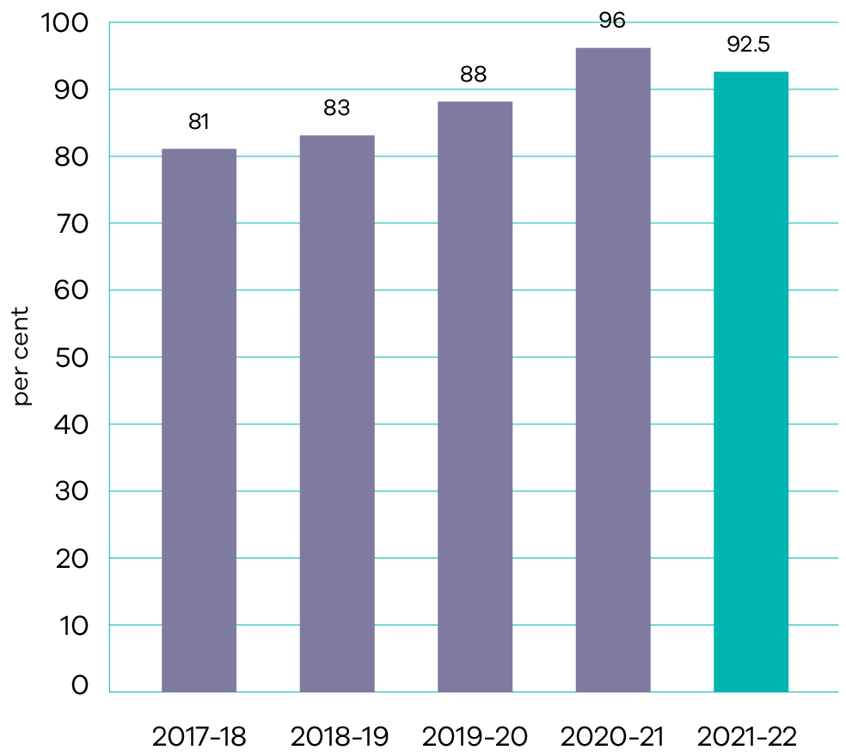
In 2021-22, 92.5 per cent of intended properties were connected to a modernised irrigation delivery system. The decrease compared to 2020-21 reflects the addition of new infrastructure projects in these irrigation districts, which has increased the baseline number of intended properties to be connected. As more modernisation projects are funded in these districts, the proportion of intended properties connected to a modernised irrigation delivery system will decrease until works are complete.
The $2 billion Goulburn-Murray Water Connections project is the most significant investment in modernising irrigation infrastructure in Australia. Announced as all works completed by the Victorian Premier and Minister for Water on 2 October 2020, the project has provided 279 GL long-term water savings to the environment. This was delivered to meet Victoria’s obligations under the Murray-Darling Basin Plan. The project exceeded its target of 429 GL long-term water savings, to be distributed to the environment, irrigators and Melbourne water retailers as set by the funding agreements.
In addition to the additional 2 GL long-term water savings distributed as part of the irrigators’ share in 2021, a further 681 ML was identified for distribution to irrigators in 2022, and 1.36 GL of long-term water savings are being set aside for Traditional Owners in northern Victoria.
The Melbourne water retailers who invested $300 million in Stage 1 of the Project received their 75 GL share of long-term water savings in July 2022.
DELWP also oversaw the successful completion of four other major water infrastructure projects: South West Loddon Rural Water Supply Project, Macalister Irrigation District Phase 1B, Sunraysia Modernisation Project 2 and the Mitiamo and District Reticulated Water Supply project.

Indicator: Number of river reaches/wetlands with maintained or improved environmental condition
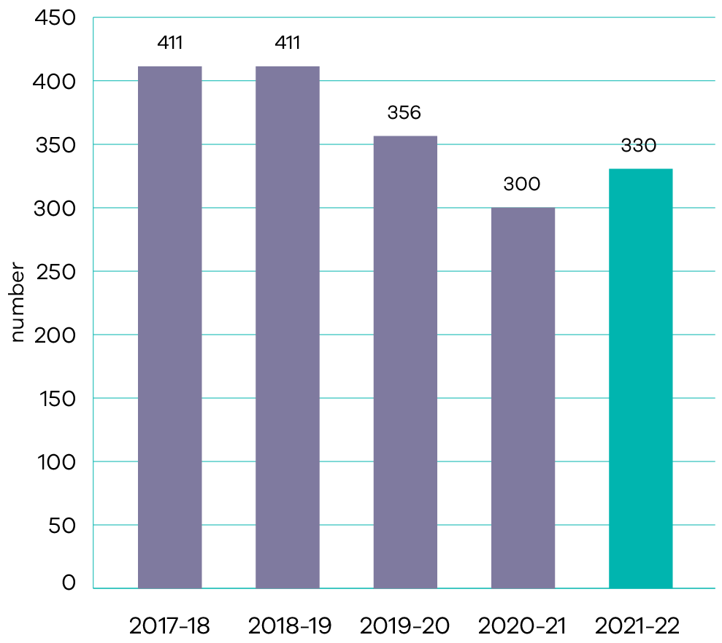
In 2021-22, on-ground works and watering programs were undertaken at 330 river reaches and wetlands to maintain or improve their environmental condition. This included 6,800 hectares of waterway vegetation works such as tree planting, weed control and fencing alongside waterways, and the completion of 86 per cent of planned environmental watering actions. The COVID-19 pandemic had several significant impacts on project delivery throughout 2021-22 including: increased cost of essential materials (including rock, concrete, timber, fuel) due to supply chain and availability issues; reduced and interrupted availability of regional contractors due to COVID-19 infections and isolation requirements; staff shortages in delivery agencies due to COVID-19 infections and isolation; and the reduced ability to complete required levels of community engagement leading to timeline delays for works approvals. Nonetheless, delivery agencies maintained strong performance throughout the year. The long-term yearly average delivery (over the last five years) is 362 sites.

Output performance measures

Effective Water Management and Supply
This output develops policies, provides strategic advice and oversees regulatory systems and institutional arrangements to effectively manage Victoria’s water resources. Through this output, the Department delivers on-ground environmental programs to improve the health of waterways; water industry reform, governance and performance oversight; integrated water management; sustainable irrigation programs; and makes water resource information accessible to enable informed decision making.
The performance measures below compare targets and expected or actual results from the delivery of programs and services as part of this output:
Output performance measures | Unit of measure | 2021-22 actual | 2021-22 target | Performance variation (%) | Result
Quantity
Area of waterway vegetation works undertaken to improve the health and resilience of waterways | hectares | 6 800 | 9 000 | (24%) | Performance target not achieved – exceeds 5 per cent variance.
Performance is below target due to an extended spring/summer wet season rendering planned project sites physically inaccessible and/or unsafe for works and COVID-19 impacts on project delivery.
Output performance measures | Unit of measure | 2021-22 actual | 2021-22 target | Performance variation (%) | Result
Cumulative water savings (permanent reduction in irrigation distribution system delivery losses) realised through water recovery projects | megalitres | 897 939.7 (estimate) | 909 902 | (1%) | Performance target not achieved – within 5 per cent variance.
Final results for this performance measure will be available after completion of the water savings audit in 2023. Water savings are not granted to water corporations until savings have been formally verified and recognised through an independent water audit process.
Output performance measures | Unit of measure | 2021-22 actual | 2021-22 target | Performance variation (%) | Result
Climate and hydrology research activities underway that focus specifically on Victoria | number | 2 | 1 | 100% | Performance target achieved or exceeded.
Performance is above target due to two research activities being developed under the Victorian Water and Climate Initiative. As implementation progressed, it was found that two funding agreements would deliver a better outcome for this investment.
Output performance measures | Unit of measure | 2021-22 actual | 2021-22 target | Performance variation (%) | Result
Long-term water monitoring sites maintained | number | 1 167 | 1 167 | 0% | Performance target achieved or exceeded.
Output performance measures | Unit of measure | 2021-22 actual | 2021-22 target | Performance variation (%) | Result
Interactions with Water Markets reporting and transparency information, including visits to the Water Markets insights webpage and other digital information, per month | number | 9 177 | 2 000 | 359% | Performance target achieved or exceeded.
Performance is above target reflecting strong demand for water market information. Demand can vary depending on seasonal conditions, water availability and water price among other factors.
Output performance measures | Unit of measure | 2021-22 actual | 2021-22 target | Performance variation (%) | Result
Schools signed up to Schools Water Efficiency Program (SWEP) | number | 1 320 | 1 500 | (12%) | Performance target not achieved – exceeds 5 per cent variance.
Performance is below target due to COVID-19 impacts on the education sector reducing engagement opportunities and the number of schools recruited to the Schools Water Efficiency Program.
Output performance measures | Unit of measure | 2021-22 actual | 2021-22 target | Performance variation (%) | Result
Place-based plans and actions underway for healthier communities and environments that encompass multiple values (Aboriginal, social, environmental and economic) | number | 8 | 8 | 0% | Performance target achieved or exceeded.
Households or community housing assisted in the Community Rebate and Housing Retrofit Program | number | 1 536 | 1 555 | (1%) | Performance target not achieved – within 5 per cent variance.
Area of active stewardship for catchment health and resilience | hectares | 5 832 | 12 000 | (51%) | Performance target not achieved – exceeds 5 per cent variance.
Performance is below target due to COVIDSafe settings limiting ability to meet with landholders and contractors, and undertake work. Wet conditions also made sites inaccessible and unsuitable for works for lengthy periods.
Output performance measures | Unit of measure | 2021-22 actual | 2021-22 target | Performance variation (%) | Result
New flood studies underway to ensure communities understand flood risk and to inform investment in flood warning and mitigation measures | number | 9 | 6 | 50% | Performance target achieved or exceeded.
Performance is above target due to nine submissions fully meeting the Risk and Resilience Grants criteria.
Output performance measures | Unit of measure | 2021-22 actual | 2021-22 target | Performance variation (%) | Result
Environmental watering actions achieved at planned sites | per cent | 85.9 | 90 | (4.6%) | Performance target not achieved – within 5 per cent variance.
Quality
Compliance with the salinity management actions agreed in the Murray Darling Basin Agreement | per cent | 100 | 100 | 0% | Performance target achieved or exceeded.
Victorian Water Register system availability per annum | per cent | 95 | 95.8 | (1%) | Performance target not achieved – within 5 per cent variance.
Waterway and catchment health priority projects delivered involving community and sector partners | per cent | 98 | 90 | 9% | Performance target achieved or exceeded.
Performance is above target reflecting Catchment Management Authorities’ commitment to engaging with community and sector partners.
Output performance measures | Unit of measure | 2021-22 actual | 2021-22 target | Performance variation (%) | Result
Timeliness
Waterway licenses and permits processed within statutory timeframes | per cent | 94 | 90 | 4% | Performance target achieved or exceeded.
Cost
Total output cost | $ million | 346.3 | 317.7 | 9% | Performance target not achieved – exceeds 5 per cent variance.
The higher than budgeted output cost is primarily due to an increase in Commonwealth funding for the Sustainable Rural Water Use and Infrastructure and Schedule Victoria – National Flood Mitigation Infrastructure programs.

A safe and quality built environment
- Sustainable cities and communities
- Decent work and economic growth
- Industry, innovation and infrastructure
Peace, justice and strong institutions

Progress towards achieving this objective

Context
Victoria’s DELWP shapes the long-term vision for the spatial pattern of land-use and built form for Victoria.
In doing so we unlock economic opportunity and optimise positive social and environmental outcomes for Victorians. The department leads cities and regional growth policy to deliver positive outcomes for everyone who lives, works, invests in and visits Victoria. We reform policy, legislation, regulation and systems to help protect our heritage and environment; build productive, sustainable and resilient communities, and achieve better outcomes for consumers and industry.
We shape the agenda and engage stakeholders in conversations and creative problem solving to develop innovative and practical approaches to maintaining Victoria’s liveability. We manage heritage issues in Victoria in a holistic manner to ensure consistency across neighbourhoods and the state. We identify opportunities to support future industries identified as having the potential to drive jobs growth and investment. An integrated approach to managing our built and natural environment is crucial to accommodating population growth and changes, in order to maintain our world class liveability and protect our heritage.
The quality of our built and natural environments influences Victoria’s ability to attract jobs, investment and skills.
Victoria is projected to reach a population of 11.2 million by 2056. It is therefore essential that planning processes work to maintain our liveability and give growing communities the services, transport links, and infrastructure they deserve.
Plan Melbourne guides the sustainable development of metropolitan Melbourne to 2050. It sets the strategy for supporting jobs, housing and transport, while building on Melbourne’s legacy of distinctiveness, liveability and sustainability. In addition, eight Regional Growth Plans provide long-term planning to guide growth and manage change across all of Victoria.
Key initiative | 2021-22 progress summary
Planning reforms | A range of reforms have been implemented in 2021-22 or are underway to bring forward investment and jobs supporting Victoria’s economic recovery, including:  collaboration with 12 councils through the Better Planning Approvals program to improve and simplify approval processes  support to rural and regional councils with statutory and strategic planning via the Regional Planning Hub program, with over 111 requests for support received from councils seeking assistance from the department  improved coordination of planning approvals for state infrastructure projects via a dedicated State Project Concierge, with the facilitation of 73 projects or programs since its commencement to 30 June 2022  creating a better Digital Planning System that makes it easier for community and councils by undertaking user research, upgrading Planning Schemes Online, implementing a new 3D visualisation tool (Vic3D) and releasing a new applications hub for lodgement of planning applications made to the Minister for Planning  streamlined planning and assessment of major road and rail projects and provided consistent planning requirements for all land required for transport services and facilities.
Development Facilitation Program | Since commencement of the program in October 2020 to 30 June 2022, the Development Facilitation Program has recommended priority assessment pathways for 42 major projects worth a total of $7.3 billion and facilitated approval of 19 projects with a combined value of $3.26 billion.
Assessment model for development proposals greater than $50 million | The role and function of the Development Facilitation Program has evolved since its inception in October 2020 to provide a short to medium-term response to the economic impact of the COVID-19 pandemic, with an objective to ensure a steady pipeline of major projects to drive the ongoing economic and social recovery of Victoria.  Priority project eligibility criteria originally focused on economic contribution, timing, policy alignment and significant public benefit, as a short-term response to the COVID-19 pandemic.  On 1 January 2022, the eligibility criteria were refined to align with existing Victorian government priorities, policies, and strategies. Specifically, the new criteria require projects to be shovel ready, associated with a prescribed priority sector and meet a minimum financial or scale threshold.
Facilitating major infrastructure projects through efficient, streamlined statutory assessment and planning approval processes | During 2021-22, impact assessment and approval processes for the Suburban Rail Loop East, Inland Rail, Western Outer Ring Main Gas Pipeline, Western Renewables Link and Willatook Wind Farm major infrastructure projects progressed.  A total of eight approvals for new health infrastructure projects were delivered to support new ambulance stations and hospitals. Four approvals were delivered for new water infrastructure, two approvals for sport and recreation infrastructure, and four approvals for new municipal infrastructure projects including a fire station, government and community buildings.
Plan Melbourne 2017-2050 | As at 30 June 2022, three-quarters of the 113 actions set out in the Plan Melbourne five-year implementation plan are complete, with one year left in the current implementation period. DELWP is responsible for leading the delivery of 66 actions, of which:  44 are completed or have transitioned to ‘business as usual’ planning and delivery functions  20 are progressing  two are in development.
Five-year review of Plan Melbourne 2017-2050 | A scoping exercise for the Plan Melbourne Update commenced at the end of 2021 to determine the focus areas of the review. The Plan Melbourne Update will consider the implications of COVID-19 on the 30-year vision for Melbourne, embed new state government policies and objectives, and review the approach taken for implementation of the plan.  Research and policy development will be undertaken throughout the remainder of 2022 in collaboration with relevant stakeholders, with public engagement to be held in 2023.  The final Plan Melbourne Update and revised Five Year Implementation Plan are expected to be delivered by the end of 2023.
Review of the Planning and Environment Act 1987 | The Building, Planning and Heritage Legislation Amendment (Administration and Other Matters) Bill 2022 was introduced into Parliament in June 2022, which includes amendments to the Planning and Environment Act 1987.
Unlocking New Communities and Affordable Housing program | Through the Unlocking New Communities and Affordable Housing program, three projects have been identified for funding, one each in Melton East, Casey Fields South and Devon Meadows. These projects will unlock and zone more land for housing and employment opportunities.
Simplification of growth area infrastructure coordination | In response to the Infrastructure Contributions Ministerial Advisory Committee’s recommendations for significant structural reform of the infrastructure contributions system, short term improvements are underway with medium to long-term initiatives to be progressively implemented in the coming years – subject to funding.
Improving the Victorian Civil, and Administrative Tribunal’s planning and environment case management | Targeted actions to improve the Victorian Civil and Administrative Tribunal’s (VCAT) planning and environment case management to unlock construction projects and support Victoria’s economic recovery included:  A Specialised Case Management Team was established to reduce member time spent on administrative tasks and increase availability for hearings. Planning is completed to expand the team to build on benefits already realised and enhance hearing processes.  Alternative Dispute Resolution (mediation) training was completed for 27 members in VCAT, with up to 500 cases per annum expected to benefit from earlier opportunities for settlement.
Supporting the Geelong Authority to deliver the Revitalising Central Geelong Action Plan | The Geelong Authority continues to play a leading role in advising government on changes that support long-term growth potential in central Geelong. In December 2021, the Geelong Authority was reappointed for a further three-year term with two new members bringing the membership to nine.  The 2021-22 State Budget provided $0.6 million for the continued operation of the Geelong Authority over the next two years. The Geelong Authority’s oversight of implementation of the Revitalising Central Geelong Action Plan continues, with funding secured to complete design and delivery of the second laneways strategy breakthrough project at Market Street South, Geelong to improve connection between the nearby health and education precincts to the commercial heart of the city.
Streamlining for Growth program | During 2021-22, 34 projects that benefitted councils were approved through the Streamlining for Growth program.  All available 2021-22 funds had been allocated to projects at the end of March 2022, inclusive of 28 council grant projects and six Victorian Planning Authority led projects for a total of 34 projects.
Victorian Planning Authority Fast Track program | The Victorian Planning Authority (VPA) completed eight projects in 2021-22 through the Fast-Track program, delivering zoned land for 28,000 homes and 27,000 jobs and is working towards completing seven further planning and infrastructure projects in 2022-23.  DELWP partnered with the VPA to develop the revised Precinct Structure Planning Guidelines: New Communities in Victoria, delivering action 20 of the Plan Melbourne Implementation plan. The new guidelines were released in November 2021.
Facilitating delivery of major transport infrastructure and city-shaping projects | During 2021-22, impact assessment and approval processes for the North East Link, Inland Rail, West Gate Tunnel Spoil Disposal and Suburban Rail Loop major transport infrastructure projects progressed.  DELWP facilitated over 130 primary and secondary planning approvals for other major transport infrastructure projects including 75 approvals for the Level Crossing Removal Project, 28 approvals for the Major Road Projects Victoria and 14 for Rail Projects Victoria and three approvals for tram, cycling and road infrastructure.
Supporting recovery for bushfire-affected communities | Following the 2019-20 bushfires, a suite of 11 priority strategic planning recovery projects were identified in consultation with staff from bushfire impacted councils and the Victorian Planning Authority (VPA). These projects focus on recovery priorities that deliver on multiple outcomes, enabling councils to move forward in a positive and more resilient way, and allowing the impacted communities to build back better.  Three projects have been completed to date:  Towong Planning Scheme Planning Policy Framework translation  Policy plans for inclusion in the East Gippsland Planning Scheme  Independent Planning Scheme Review – East Gippsland Planning Scheme  Across the bushfire and storm and floods programs, 102 assessments of historic heritage places were completed during 2021-22. The assessments focused on detailing the impacts of bushfire, storm and flood, providing advice to property owners and managers and recommending measures to mitigate the impact of future events.
Review of Victoria’s building system | An expert panel canvassed reform options in the Framework for Reform paper, published in April 2021, and provided its report and recommendations for Stage 1 reforms to government in August 2021. The Building, Planning and Heritage Legislation Amendment (Administration and Other Matters) Bill 2022 was introduced into Parliament on 21 June 2022. The Bill will address some of the reforms to Victoria’s building system considered by the expert panel.
Statewide Cladding Audit Intensive Inspection Initiative | During 2021-22, 5,306 virtual reviews, 322 kerbside reviews, 167 inspections and 83 audits were undertaken through the Victorian Building Authority’s Statewide Cladding Audit Intensive Inspection Initiative.
Cladding rectification program | In 2021-22, cladding rectification commenced on 29 government owned buildings and 33 private residential buildings. Rectification works were completed for 34 government owned buildings and 131 private residential buildings.
Victorian Building Authority building works inspections | In 2021-22, the Victorian Building Authority inspected 10.9 per cent of building works associated with new building permits issued to improve safety and ensure high quality outcomes, exceeding the annual target of 10 per cent.
Future Homes | A streamlined planning process was created to incentivise take up of the four exemplar designs created through the Future Homes design competition.  This new planning process will be introduced into Maribyrnong City Council’s planning scheme through an upcoming amendment, enabling more high-quality, liveable and sustainable apartments to be delivered, faster.
Strengthening protection of green wedges and agricultural land | Community consultation on the Planning for Melbourne’s Green Wedges and Agricultural Land Discussion Paper occurred over late 2020 to early 2021 and 879 submissions were received. These submissions are being considered as part of the development of an Action Plan that sets out the Victorian Government’s approach to the enhancing the protection of green wedges and agricultural land. The Action Plan sets out changes to legislation, planning policy and permissible uses, and provides more detailed guidance for local decision making.  A key reform, announced on 17 December 2021, is the establishment of the Agriculture Victoria Planning and Advisory Service. This statewide service, co-funded by DELWP and Agriculture Victoria, supports better agricultural planning outcomes for council planners and agribusiness.
Engaging and consulting with Traditional Owners on planning reform opportunities to support Aboriginal self-determination | DELWP progressed a number of planning reform initiatives in 2021-22 to support Aboriginal self-determination:  adding additional public mapping layers in VicPlan relevant to Traditional Owners  including a mandatory clause in Environment Effects Statement (EES) Inquiry Terms of Reference, EES scoping requirements and EES consultation plans to require consideration of Registered Aboriginal Parties (RAPs)/Traditional Owner views  establishment of an internal Aboriginal engagement community of practice to support and build engagement capability  active participation of RAPs on technical reference groups during the preparation of environmental effects statements  partnership with Wurundjeri Woi Wurrung Cultural Heritage Aboriginal Corporation to record cultural values associated with the Yarra River (Birrarung) as part of the Yarra River Action Plan.  Through release of government action plans for Waterways of the West and Rivers of the Barwon, DELWP has committed to investigating potential amendments to the Planning and Environment Act 1987 and the planning policy framework to embed Traditional Owners and their values in decision making. This will be supported by comprehensive tools and guidance materials.
Reforming policy, legislation, regulations and systems to protect heritage | Heritage Victoria focuses on protecting and conserving Victoria’s cultural heritage. In 2021-22 it has delivered policy, programs and initiatives to improve protection of Victoria’s significant heritage places and objects and to make it easier to be a good custodian.  This has included commencing the Incentivising Low Harm Proposals Project to develop standing permit exemptions for places and objects included in the Victorian Heritage Register to reduce the regulatory burden of the statutory approval process; delivering guidelines to better identify and assess low harm permit proposals and expedite the assessment of proposals for solar installations and heritage protection plans, and introducing dashboard functionality to improve visibility and management of the permit management system.
Living Heritage Grants Program | Round 7 of the Living Heritage Grants Program opened in February 2022 and closed 31 March 2022. Successful projects will be announced by August 2022.  In 2021-22, round 6 of the Living Heritage Program funded 19 new conservation projects totalling $2.4 million.  Since its inception in 2016, the program has funded more than 165 projects for the conservation of state-significant heritage places, and over 100 are complete.
Protecting heritage at Jacksons Hill | Jacksons Hill continued to be managed in 2021-22 by DELWP’s facilities manager provider in accordance with statutory obligations, including requirements under the Heritage Act 2017. Preparation of a Cultural Heritage Management Plan is underway and expected to be approved in early 2023. A conservation management plan was completed in December 2021. Negotiations with Hume City Council are continuing regarding gifting part of the site in the Community Arts Precinct.
World Heritage Management Plan for the Royal Exhibition Building and Carlton Gardens | A first draft of the World Heritage Management Plan was provided to the World Heritage Steering Committee for the Royal Exhibition Building and Carlton Gardens in April 2022 The final draft was publicly released in August 2022.
Protecting Victoria’s key distinctive areas and landscapes | A final draft Statement of Planning Policy was prepared by DELWP for the Surf Coast declared area and endorsements sought from responsible public entities and ministers responsible for those entities. The statement will become operational in 2022-23 subject to approval by the Governor in Council.  Draft Statements of Planning Policy for the Bass Coast (March-April 2022) and Bellarine Peninsula (July-August 2021) underwent public consultation. Final statements will be operational in 2022-23 subject to endorsement by responsible public entities and approval by the Governor in Council.
Protection of Aboriginal heritage | The DELWP Planning Group Traditional Owner Community of Practice was established in October 2021 and holds meetings approximately every six weeks. The group is involved in sharing best practice and enhancing knowledge regarding the protection of Aboriginal heritage. The Community of Practice also assists in setting goals and actions to support DELWP’s Pupangarli Marnmarnepu strategy.
New models for joined up, localised planning in priority urban areas | Coordinated government activity between DELWP, the Department of Jobs, Precincts and Regions and other departments has enhanced infrastructure and service planning relating to priority precincts with significant progress including:  precincts being identified in the draft Metropolitan Land Use Framework Plans including the Suburban Rail renewal precincts  release of the Arden Urban Renewal Precincts framework plan in August 2021 and amendment C407 to the Melbourne Planning Scheme  release of the Footscray Opportunities and Directions Paper in December 2021.
Land-use framework plans | Following a public consultation process in August and September 2021, draft land-use framework plans for the Inner, Western, Northern, Eastern, Southern and Inner South-East metro regions are being finalised for government’s consideration in late 2022.  The plans were developed with extensive engagement across state and local government, and in partnership with Traditional Owners. The final plans will explain what Plan Melbourne 2017-2050 means for each metropolitan region and provide direction on where future growth should be focussed while protecting Melbourne’s liveability.

Indicator: Improved liveability, sustainability and inclusiveness of public spaces and neighbourhoods
A key role of DELWP is to create liveable, inclusive and sustainable communities, as we work to accommodate population growth while responding to climate change and protecting our natural environment, infrastructure and heritage.
Plan Melbourne sets the vision of how we will develop over the next 30 years and is structured around six outcomes that are critical to achieving our vision of maintaining our status as a global city of opportunity and choice. Plan Melbourne will provide housing choice in locations close to jobs and services and enable an integrated transport system that connects people to jobs and services.
This is supported through two of the key Plan Melbourne outcomes:
- Creating affordable and accessible housing by delivering more housing affordability and choice with more of the housing needed delivered in the right locations
Connecting communities by creating a city of 20-minute neighbourhoods, supported by the 20-minute neighbourhoods pilot program to build pedestrian friendly neighbourhoods – measured by the distance of 800 metres.
DELWP reports on this indicator through the below two measures:
Proportion of major infill development in areas close to services and transport (within 800m of an Activity Centre or Train station)
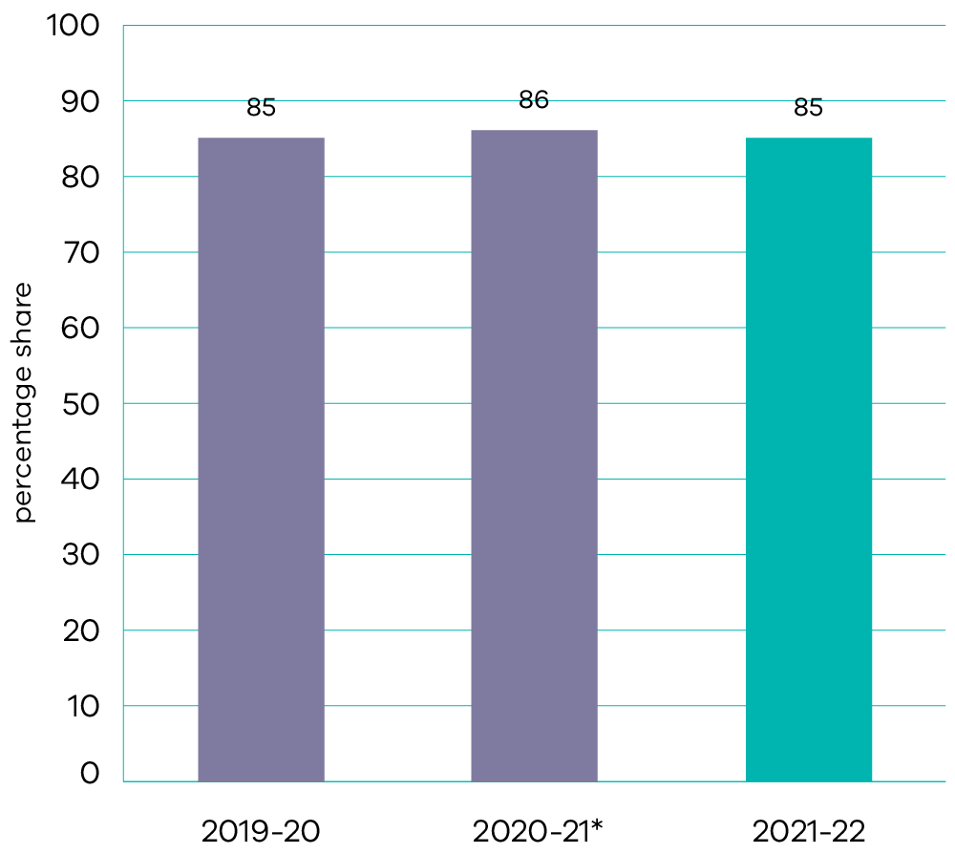
*Data for 2020-21 has been revised following an annual re-assessment of major infill redevelopment sites.
In line with Plan Melbourne principles, this measure shows the percentage share of new dwellings in and around Activity Centres and close to train stations (within 800 metres of these locations). The share of new dwellings in major residential infill projects in around these well serviced locations remained relatively stable from 2019-20 to 2021-22 at around 85 per cent. This is an outcome of planning policy that has promoted development in these areas.
Diversity of housing lots in growth areas (share of new lots under 300 square metres)
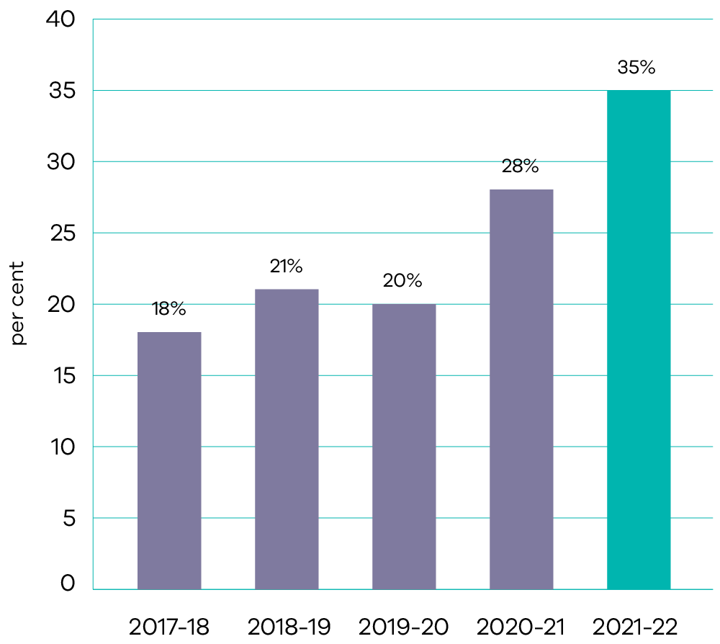
This measure on diversity of housing lots in growth areas has increased significantly to 35 per cent in 2021-22, up from 28 per cent in the previous year. New lots under 300m² are becoming more prevalent as compact housing forms, such as townhouses and units, and are becoming a more accepted choice of housing in growth areas.

Indicator: Effective protection of cultural and natural heritage
Victorians have a strong love of the state’s heritage places and objects. Our valued heritage places need to be protected and conserved for the enjoyment of current and future generations.
The protection of our historic heritage is supported through the Heritage Act 2017, which introduced streamlined processes for approvals and strengthened enforcement tools for the Victorian Heritage Register. The Register includes 2,376 historic places and objects of state level significance, ranging from Flinders Street Railway Station, the Murtoa Stick Shed, the Castlemaine Diggings and the Eureka Flag. The Heritage Act 2017 also provides for the protection of shipwrecks, and other underwater cultural heritage, and historical archaeological sites.
DELWP reports on this indicator through the below two measures:
Total number of registered places and objects in the Victorian Heritage Register
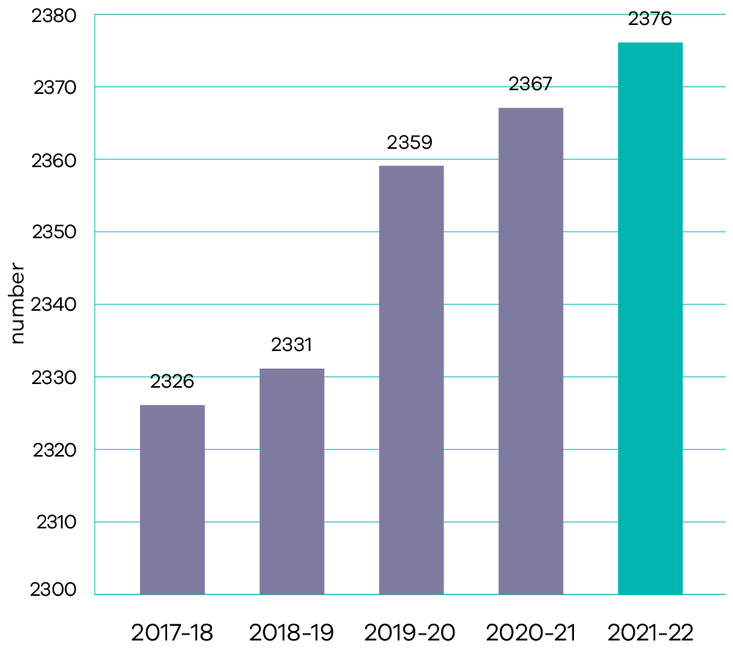
(i) This metric replaces the 2020-21 metric ‘Places or objects protected and managed by the Victorian Heritage Register’. The new metric improves performance transparency by providing the total number of heritage places or objects with legal protection through the Victorian Heritage Register.
Recent inclusions of places and objects in the Register such as the Lyceum Club, Edith Ingpen House and the Aids Memorial Quilt acknowledge the contribution of key communities to Victoria’s history.
Incidents of unauthorised works to State listed heritage places and objects
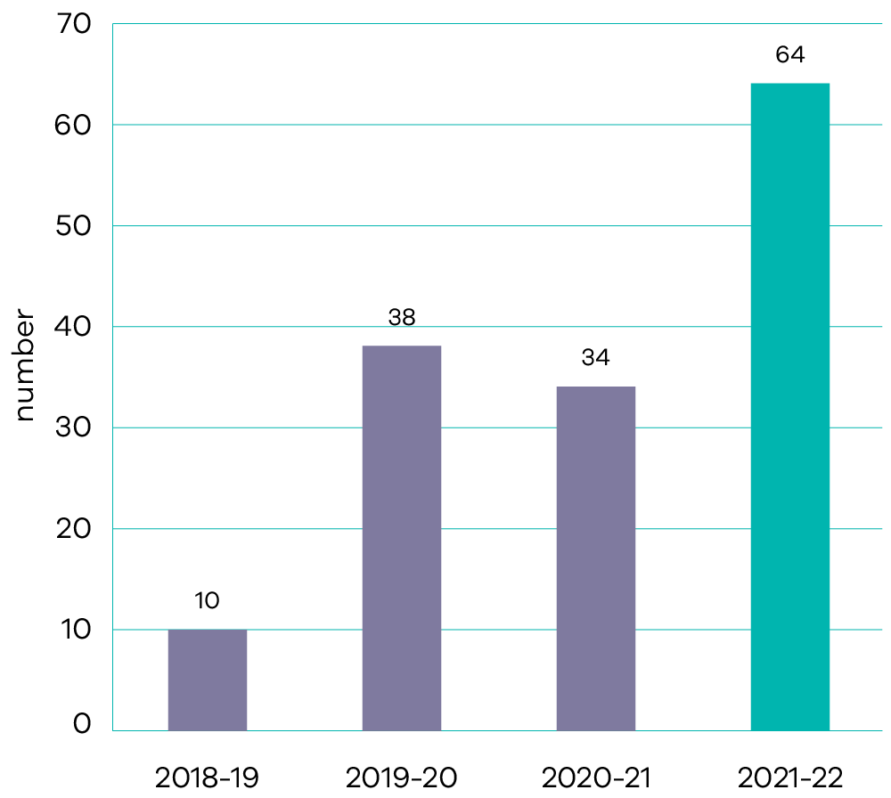
The Heritage Act 2017 protects heritage places and objects included in the Victorian Heritage Register and any works carried out to those places must be completed only with permits or permit exemptions in place.
During 2021-22, Heritage Victoria received 64 notifications of unauthorised works to registered places. Heritage Victoria has experienced an overall increase in reporting of these types of incidents. This is due to a number of factors including increased enforcement and investigation activities by Heritage Victoria following the easing of COVIDSafe settings in Victoria and an increase in the number of community reports/complaints.

Output performance measures

Planning, Building and Heritage
This output delivers programs to address the future growth and transformation of cities and regions through: strategic and integrated land use planning; urban development, design and renewal; land supply; heritage conservation and management; and regulatory reform. Through this output, the Department administers the statutory responsibilities of the Minister for Planning and provides for fair and transparent planning, building and heritage systems.
The performance measures below compare targets and expected or actual results from the delivery of programs and services as part of this output:
Output performance measures | Unit of measure | 2021-22 actual | 2021-22 target | Performance variation (%) | Result
Quantity
Local governments undertaking work to support strategic planning for coastal settlements and areas | number | 14 | 15 | (7%) | Performance target not achieved – exceeds 5 per cent variance.
Performance is below target because one eligible council did not apply for funding as anticipated due to resourcing constraints.
Output performance measures | Unit of measure | 2021-22 actual | 2021-22 target | Performance variation (%) | Result
Places or objects assessed for the Victorian Heritage Register | number | 40 | 40 | 0% | Performance target achieved or exceeded.
Conservation projects funded for ‘at risk’ State significant heritage places and objects | number | 19 | 20 | (5%) | Performance target not achieved – exceeds 5 per cent variance.
Performance is below target reflecting the number of projects funded through round 6 of the Living Heritage Program. These successful projects scored highest against the program criteria and were assessed as providing the strongest community and heritage conservation benefits.
Output performance measures | Unit of measure | 2021-22 actual | 2021-22 target | Performance variation (%) | Result
Projects approved through the Streamlining for Growth program that benefit councils | number | 34 | 30 | 13% | Performance target achieved or exceeded.
Performance is above target due to additional projects approved to support economic growth by accelerating strategic planning and infrastructure coordination.
Output performance measures | Unit of measure | 2021-22 actual | 2021-22 target | Performance variation (%) | Result
Planning projects initiated in regional cities and towns to unlock and deliver zoned land supply | number | 3 | 3 | 0% | Performance target achieved or exceeded.
Planning projects initiated to deliver zoned land supply for new 20-minute neighbourhoods in Greenfields Melbourne | number | 3 | 3 | 0% | Performance target achieved or exceeded.
Building inspections undertaken by the Victoria Building Authority to identify use of noncompliant cladding materials | number | 181 | 480 | (62%) | Performance target not achieved – exceeds 5 per cent variance.
Performance is below target due to COVIDSafe settings limiting building site access and inspections, and implementation of the Statewide Cladding Audit Intensive Inspection Initiative in August 2021.
Output performance measures | Unit of measure | 2021-22 actual | 2021-22 target | Performance variation (%) | Result
Building audits undertaken by the Victoria Building Authority to identify use of noncompliant cladding materials | number | 106 | 350 | (70%) | Performance target not achieved – exceeds 5 per cent variance.
Performance is below target due to COVIDSafe settings limiting building site access and inspections, and implementation of the Statewide Cladding Audit Intensive Inspection Initiative in August 2021.
Output performance measures | Unit of measure | 2021-22 actual | 2021-22 target | Performance variation (%) | Result
Building permits inspected by the Victorian Building Authority | per cent | 10.9 | 10 | 9% | Performance target achieved or exceeded.
Performance is above target due to the prioritisation of new building permit inspections by the Victorian Building Authority to adequately manage risk and to ensure early intervention.
Output performance measures | Unit of measure | 2021-22 actual | 2021-22 target | Performance variation (%) | Result
In-scope government buildings that have commenced cladding rectification | number | 29 | 7 | 314% | Performance target achieved or exceeded.
Performance is above target due to additional community housing and government buildings added to the program, and commencement of works delayed from 2020-21.
Output performance measures | Unit of measure | 2021-22 actual | 2021-22 target | Performance variation (%) | Result
In-scope government building that have completed cladding rectification works | number | 34 | 31 | 10% | Performance target achieved or exceeded.
Performance is above target due to a number of community housing buildings requiring minor rectification works, approved to be funded from the program in 2021-22 and completed in the same year.
Output performance measures | Unit of measure | 2021-22 actual | 2021-22 target | Performance variation (%) | Result
In-scope privately owned residential buildings that have commenced cladding rectification works | number | 33 | 150 | (78%) | Performance target not achieved – exceeds 5 per cent variance.
Performance is below target due to unforeseen delays associated with the execution of contracts with builders, additional time required to finalise fire safety design solutions, and delays caused by latent defects requiring remediation before cladding rectification works commenced. This was combined with a pause in the progression of new buildings through the program during the first half of 2021-22 as a result of implementation of the Statewide Cladding Audit Intensive Inspection Initiative from August to November 2021.
Output performance measures | Unit of measure | 2021-22 actual | 2021-22 target | Performance variation (%) | Result
In-scope privately-owned residential buildings that have completed cladding rectification works | number | 131 | 150 | (13%) | Performance target not achieved – exceeds 5 per cent variance.
Performance is below target due to shortages in scaffolding material and labour, longer than anticipated lead times for construction materials, and inclement weather.
Output performance measures | Unit of measure | 2021-22 actual | 2021-22 target | Performance variation (%) | Result
Quality
Environment effects statements, referrals and assessments are completed effectively and within the timeframes necessary to meet targets in the Ministerial Guidelines | per cent | 65 | 70 | (7%) | Performance target not achieved – exceeds 5 per cent variance.
Performance is below target due to a significant number of environment effects statements and projects required to be examined under the Environment Effects Act 1978 combined with resourcing constraints.
Output performance measures | Unit of measure | 2021-22 actual | 2021-22 target | Performance variation (%) | Result
Proportion of planning applications that proceed through the VicSmart process within 10 days | per cent | 15 | 16 | (6%) | Performance target not achieved – exceeds 5 per cent variance.
Performance is below target due to staff resourcing challenges faced by responsible authorities located in rural and regional Victoria.
Output performance measures | Unit of measure | 2021-22 actual | 2021-22 target | Performance variation (%) | Result
Planning Scheme Amendments that are correct upon submission for approval | per cent | 71 | 80 | (11%) | Performance target not achieved – exceeds 5 per cent variance.
Performance is below target due to staff turnover within some councils resulting in gaps in institutional knowledge that has reduced the accuracy of planning scheme amendment content.
Output performance measures | Unit of measure | 2021-22 actual | 2021-22 target | Performance variation (%) | Result
Timeliness
Average number of days to issue an archaeological consent | days | 19 | 20 | 5% | Performance target achieved or exceeded.
Performance is above target reflecting a high number of consents for minor works such as geotechnical testing that are more straight-forward to process than standard consents.
Output performance measures | Unit of measure | 2021-22 actual | 2021-22 target | Performance variation (%) | Result
Average number of days to issue heritage certificates | days | 7 | 7 | 0% | Performance target achieved or exceeded.
Heritage permits issued within initial 60 day statutory timeframes | per cent | 89 | 90 | (1%) | Performance target not achieved – within 5 per cent variance.
Median number of days taken by the Department to assess a planning scheme amendment | days | 49 | 35 | (40%) | Performance target not achieved – exceeds 5 per cent variance.
Performance is below target due to staff resources being allocated towards strategic assessment of authorisation requests, which affected the timeliness of final assessments but had the benefit of avoiding or reducing timelines for panel hearings.
Output performance measures | Unit of measure | 2021-22 actual | 2021-22 target | Performance variation (%) | Result
Urban Development Program Report on analysis of supply, consumption and adequacy of residential and industrial land completed | date | Jun 2022 | Jun 2022 | 0% | Performance target achieved or exceeded.
State population projections completed to inform State Budget delivery | date | Feb 2022 | Feb 2022 | 0% | Performance target achieved or exceeded.
Victoria in Future population projection data to support infrastructure and service delivery planning completed | date | Jun 2022 | Jun 2022 | 0% | Performance target achieved or exceeded.
Planning permit applications for new renewable energy facilities (excluding call ins) prepared for determination within 45 days after completion of public notice and receipt of council response to public notice | per cent | 45 | 70 | (36%) | Performance target not achieved – exceeds 5 per cent variance.
Performance is below target due to staff resourcing challenges and some decisions being delayed due to Cultural Heritage Management Plans not being prepared by the applicant in time.
Output performance measures | Unit of measure | 2021-22 actual | 2021-22 target | Performance variation (%) | Result
Cost
Total output cost | $ million | 341.7 | 321.1 | 6% | Performance target not achieved – exceeds 5 per cent variance.
The higher than budgeted output cost is primarily due to the allocation of funding from the Growth Areas Infrastructure Contribution fund to various initiatives: Berwick station bus interchange; bus interchange and cycle access to Tarneit station; Cranbourne station car parking; and the future police station at Wollert. This increase in funding is partially offset by less than anticipated expenditure for the Cladding Rectification Program initiatives arising from materials and labour shortages.

Reduced impact of major bushfires and other emergencies on people, property and the environment
- Sustainable cities and communities
- Climate action
- Life on land

Progress towards achieving this objective

Context
DELWP is one of several Victorian Government departments and agencies with responsibilities for emergency management. DELWP’s responsibilities include: the management of fire on public land; dam safety; whale and dolphin stranding or entanglement; as well as managing the impacts of emergencies on the environment and energy network infrastructure.
DELWP’s integrated approach to reducing the risk of bushfires and other emergencies in protecting people, property and the environment, is guided by Safer Together – A new approach to reducing the risk of bushfire in Victoria. This approach involves land and fire agencies working in partnership with local communities using world-leading science to manage bushfire risks and protect the things that communities value the most. Our integrated approach to bushfire planning and management also helps to make communities safer and more resilient to the impacts of climate change before, during and after bushfires.
DELWP provides end-to-end management of forests, fire and other emergencies, including planned burning and other bushfire fuel management operations.
Key initiative | 2021-22 progress summary
Evidence-based fuel management | Through Safer Together, DELWP:  commissioned a bushfire behaviour database in May 2022 to enable better understanding of bushfire risk  implemented an automated fuel management report to flag safe planned burning opportunities  engaged with communities to improve access to bushfire risk information and build understanding  engaged with Traditional Owner groups to help shape the whole of sector bushfire strategy.  DELWP planned and delivered the year-round fuel management program, maintaining Victoria’s residual bushfire risk on public land below the 70 per cent target. Due to the wet conditions experienced across 2021-22 because of the La Niña weather pattern, delivery of fuel management activities focused on areas where life and property protection could be best achieved. Through this targeted approach, DELWP substantially reduced bushfire risk in high bushfire risk areas such as the Otway and Midlands districts.
Fuel Management Program | The Fuel Management Program delivery continues year-round. From 1 July 2021 to 30 June 2022 a combined total of 78,292 hectares were treated comprising both planned burns (62,625 hectares) and mechanical treatments (15,667 hectares). The number of planned burns conducted peaked over April 2022, with 277 planned burns delivered in total across the financial year. The level of residual risk is 62 per cent as at 30 June 2022.  The Joint Fuel Management Program (JFMP) was published on the FFMVic website in October 2021, which sets out locations across public and private land where both FFMVic and the Country Fire Authority (CFA) intend to carry out fuel management operations.  All cultural burns on the JFMP were nominated and planned to be carried out by Traditional Owners with support from FFMVic. A total of 13 Traditional Owner cultural burns were delivered in 2021-22.
Emergency management preparedness | Through the Safer Together Community First program, staff and volunteers across agencies received training aimed at building their capacity and capability in community engagement skills and knowledge.  The Safer Together Community Based Bushfire Management (CBBM) program, which makes decisions related to bushfires in equal partnership with communities, has grown. This multi-agency program has 23 CBBM communities with 92 per cent classed as high functioning and a further six proposed communities being scoped for suitability.  DELWP released various public messaging in 2021-22 to support community preparedness and decision making in emergencies. For example, information on preparing for power outages was shared on social media when an emergency was likely to cause power disruptions.
Improving DELWP’s fire and emergency management capability and increasing the diversity of our workforce | Work towards developing modular approaches to fire and emergency training continued throughout 2021-22 and new and revised training programs have been issued. The modular approaches provide greater flexibility for participation. New approaches enable priority training to continue and provide a blend of online and face to face training.  DELWP maintained its strong focus on increasing diversity within its Forest, Fire and Regions Group. During 2021-22, two Crew Leader courses achieved around 50 per cent and 30 per cent female participation, an increase from the historical average of 20 per cent female participation.  DELWP delivered a pilot to train new Class 2 emergency State Controllers, with 23 participants in the 2021-22 program.
Upgrading analogue radios to an encrypted digital radio system | A project team was established in October 2021 to manage and deliver the radio communications project. Radio firmware for the regional mobile radio network was delivered in May 2022 to ensure interoperability and reliability of the radio system during emergencies.
Supporting safe egress and access on the strategic fire access road network | In 2021-22, 10 crossing structures were replaced with a focus on priority structures on strategic fire access roads and 2,024 kilometres of road upgrades and improvements delivered across our strategic fire access road network. This included 355 kilometres of verge and roadside vegetation management to support safe egress and access for firefighters and other road users.  A two-year road condition assessment project commenced in September 2021 to undertake on-ground condition assessment inspections of priority roads. This will update and validate our asset management data and contribute to the strategic management of our roading network.
Supporting Traditional Owner-led cultural land and fire management practices | The Victorian Government committed $22.5 million from 2021-22 to 2024-25 and $6.3 million ongoing to support Traditional Owner led cultural land and fire management practices. A key priority in 2021-22 was establishing equitable distribution principles and negotiating the transfer of funds directly to Traditional Owners.  DELWP worked in partnership with 10 Traditional Owner Corporations to co-develop funding agreements, which will see the transfer of power and resources to them to implement their self-determined pathways for implementing cultural fire.  The remaining funds are to be distributed through a competitive grants program – Cultural Fire Grants. Applications closed in May 2022, with applications now progressing through a two-stage assessment process. Successful applicants will be notified by September 2022.
Community engagement on bushfire management planning | DELWP held 24 stakeholder and community forums on bushfire management and planned burning during 2021-22.  Additional engagement was delivered to raise awareness of fallen debris and bushfire risk following storm events in June and October 2021, as well as regular engagement on planned burning.
Strengthening partnerships to reduce bushfire risk | The Office of Bushfire Risk Management (OBRM) was established in July 2021. Its purpose is to work with fire and land management agencies to develop and coordinate an end-to end framework for policy, planning, delivery and reporting on bushfire risk management across all land tenures in Victoria.  A review of governance was conducted for the Safer Together program and changes made effective from 1 December 2021, ensuring a stronger alignment with the newly established OBRM, as well as more fully embedding recommendations from the Inspector-General for Emergency Management Phase 1 Inquiry into the 2019-20 Victorian fire season, to expand the Safer Together model to other agencies involved in bushfire management.
Investing in and applying bushfire science and modelling to bushfire risk planning | New pilot metrics for the effects of fire on ecosystem resilience, threatened species, fire size and intensity, water yield and quality, critical infrastructure and agricultural values were developed through the Fire Ecology program and Risk 2.0 project. These metrics will be used by fire managers to better target actions to reduce bushfire risk and reduce impacts of bushfire on people, communities and the environment.  OBRM held more than 50 briefings with agencies and practitioners on the metrics and their potential application to land and fire management.
Leading and supporting the response to fire and other emergencies | During the 2021-22 bushfire season, Forest Fire Management Victoria (FFMVic) crews contained 97.5 per cent of fires at first attack. Crews attended 1,066 fires impacting 12,588.8 hectares, of which approximately 59 per cent were unattended campfires. FFMVic firefighters limited the spread of 92.7 per cent of fires this season to less than five hectares in area. FFMVic crews also assisted the Country Fire Authority (CFA) with the management and suppression of fires on private land.  FFMVic Crews responded to 58 non-fire emergency events. The majority of these events consisted of cetacean, wildlife, search and rescue and blue green algae events.  FFMVic crews were deployed to assist the response to flood and storm operations within Victoria and the March – April 2022 flood event in NSW. This involved the provision of incident management staff and on-ground operational personnel.
Partnering with and supporting the emergency management sector to build resilience | DELWP contributed to Emergency Management Victoria’s Coordinated Learning Review into the June 2021 storms. The review identified opportunities to improve emergency management operations, arrangements and community resilience.  DELWP undertook reviews into the energy emergencies that occurred as a result of the June 2021 storms. Implementation of recommendations from these reviews will support community resilience in future events.  Through the Safer Together program, DELWP partnered with the CFA and local communities to share knowledge and increase the role of communities in the planning and conduct of bushfire management.
One-DELWP emergency recovery model | A One-DELWP emergency recovery function has been in place since early 2020 to ensure the effective and coordinated delivery of continuous, overlapping recovery activities from significant emergencies.  Based on these learnings, and consultation across the department, a permanent One-DELWP recovery model was developed. It is expected that implementation of this model will ensure DELWP can continue to meet its recovery obligations in the face of climate change, minimise impacts to communities, the environment and the economy; and minimise costs.
Bushfire, storm and flood recovery | Key achievements in 2021-22 include:  reopening 6,490 kilometres (89 per cent of target) of public land roads following the June 2021 storm events, including 96 per cent of the impacted strategic fire access network to ensure critical access for emergency and firefighting services  clearing and reopening 459 kilometres of bushfire-impacted public land roads, with a total of 8,979 kilometres reopened since the 2019-20 bushfire season  clearing 6,696 kilometres of a target 7,419 kilometres (90 per cent) of storm debris from public land roads  making safe and reopening 210 of a target 218 storm impacted recreation sites (94 per cent) and 167 of a target of 177 (94 per cent) storm impacted walking tracks  structural completion of repairs to the Morwell River Diversion at Yallourn Power Station  supporting threatened species and wildlife to recover, including repairing damaged aquatic barriers, installing nest boxes and conducting pest plant and animal control. 87 grants, totalling $210,000, have been paid to wildlife rehabilitators in storm-affected areas  supporting Yarra Ranges Shire Council to establish a Rebuilding Support Service following the storms and floods in June 2021, which has had 173 program registrations to 30 June 2022.
Ecological burning | The Joint Fuel Management Program 2021-22–2023-24 identifies 158 ecological burns covering a total of 44,417 hectares. As at 30 June 2022, 28 ecological burns have been delivered, covering 2,507 hectares.

Indicator: Percentage of bushfires contained at first attack and/or under five hectares to suppress bushfires promptly, keep bushfires small and minimise loss
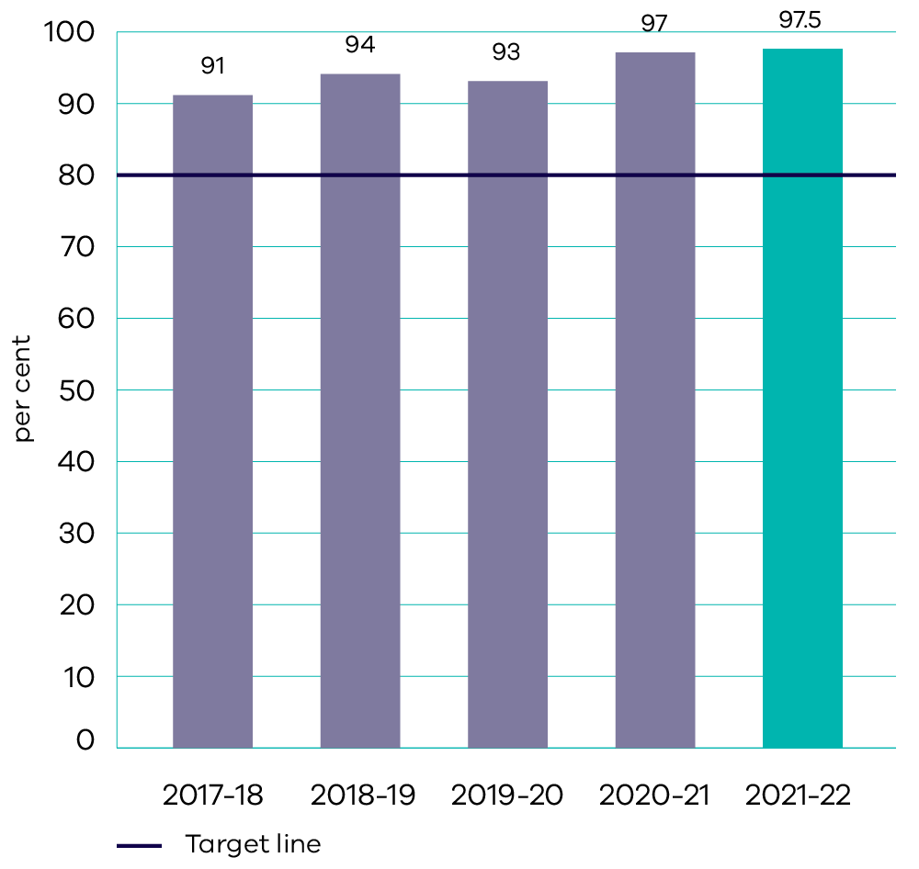
In 2021-22, 97.5 per cent of fires were contained at ‘first attack’ or by 0800 hours the day after detection (against a target of 80 per cent) and 92.7 per cent of fires were contained at less than five hectares in size (against a target of 80 per cent). Performance is above target due to low bushfire risk in 2021-22, with fires generally being smaller, less frequent and less likely to spread due to benign weather conditions before rapid first attack can suppress them. Contract extensions for seasonal workers and additional Forest Fire Operations Officers allowed for increased patrols and preparedness works significantly ahead of and into the bushfire season. FFMVic crews responded to 1,066 fires impacting 12,588.76 hectares of public and private land during the 2021-22 bushfire season. Enhanced preparedness activities ensured that resources were adequately placed to respond to fires in line with seasonal conditions and bushfire risk assessments for the fire season.

Indicator: Area treated through planned burning and other treatments to maintain the statewide bushfire risk at or below 70 per cent
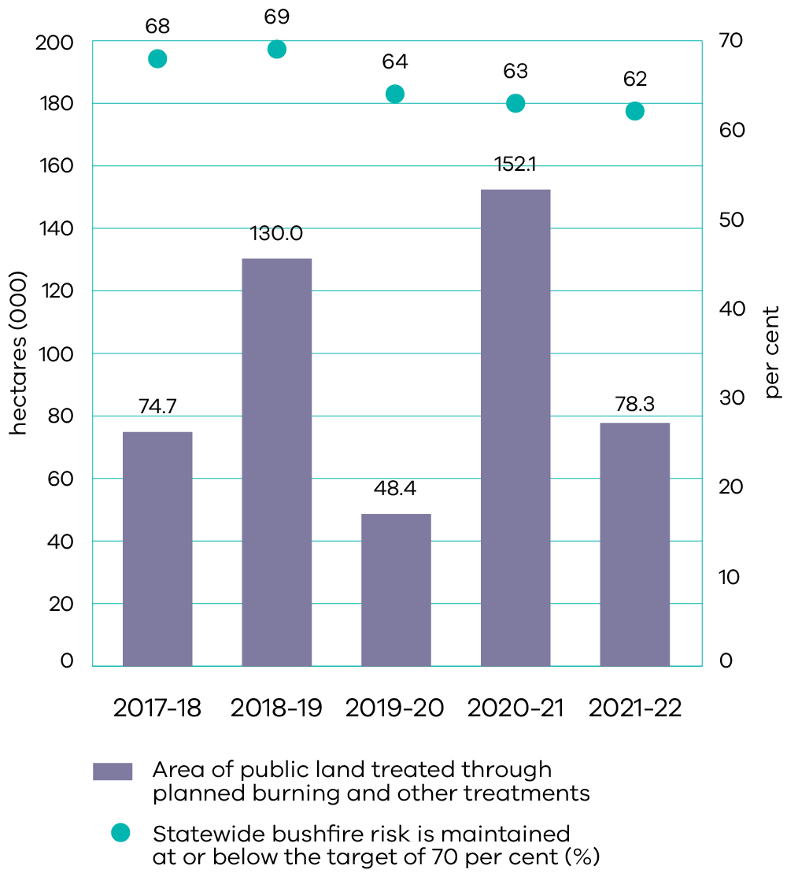
Note the result of 63 per cent for 2020-21 differs to the result published in the 2021-22 Annual Report of 64 per cent as final calculations were incorporated and completed in late 2021.
The provisional statewide bushfire residual risk for 2021-22 is 62 per cent (as at 30 June 2022), against a target of 70 per cent or less. Final calculations will be complete later in 2022 and published in the annual Fuel Management Report. This is a decrease (reduced level of risk) from 63 per cent in 2020-21 and 64 per cent in 2019-20. This has also led to a two per cent reduction from the projected statewide residual risk (64 per cent) in the absence of bushfire and planned burning. Due to climatic conditions limiting opportunities for planned burning, the focus for 2021-22 was on conducting fuel management in more densely populated central parts of the state where life and property could be best protected. This approach enabled FFMVic to reduce bushfire risk on public land in areas such as the Otways, Latrobe, Midlands, and Murrindindi districts. FFMVic conducted fuel treatment of 62,625 hectares via planned burning and a further 15,667 hectares by means of mechanical fuel treatment such as slashing, mowing and chaining.
In 2021-22, 66 per cent of priority burns were delivered (89 burns delivered from 135 planned priority burns). This compares to 74 per cent in 2020-21 (104 delivered from 141 planned priority burns) and 43 per cent in 2019-20 (60 delivered from 139 planned priority burns). Wet weather in 2021-22 affected the delivery of some priority burns, leading to the slight decrease from 2020-21. However, the priority burns delivered in 2021-22 were focussed on higher risk districts. The higher delivery rate of priority burns in 2020-21 was due to the cooler, drier weather conditions allowing for more burns to be delivered.

Indicator: Percentage of agreed departmental emergency management obligations met on time and to standard
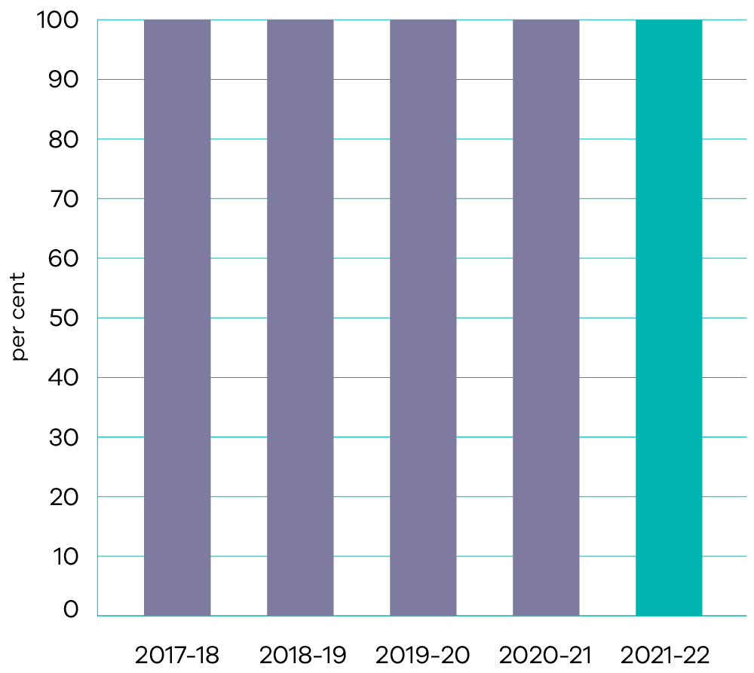
100 per cent of the department’s emergency management obligations were met on time and to standard, meeting its accountabilities under the State Emergency Management Plan. DELWP fulfilled its obligations as a support agency assisting VicSES and Emergency Management Victoria through the provision of Incident Management Team resources placed at Incident Control Centres, Regional Control Centres and within the State Control Centre.

Indicator: The economic impact of fire prevention and preparedness investment
As part of the Safer Together initiative, DELWP has invested in the uplift of existing bushfire risk models and data. This involved partnering with research institutions to support the development of new modelling capabilities. Data for the indicator will be available for publication in the 2022-23 annual report.
DELWP’s investment in bushfire prevention and preparedness activities addresses significant social, environmental and economic costs associated with response and recovery. Key activities delivered during 2021-22 included:
- delivering a targeted program of fuel treatment, including planned burning, mechanical fuel treatment and creating and upgrading strategic fuel breaks
- employing additional firefighters for fuel management and first attack
- improving bushfire risk modelling, smoke modelling, fire ecology capability and risk communication products to share bushfire risk knowledge, data and information with Victorians living in or visiting high bushfire risk areas
- delivering the Safer Together – Local Government Partnerships Grants program, which awarded $1.82 million in grants over three years to support local councils to develop and extend bushfire risk reduction programs with local communities
supporting communities to better understand and mitigate their bushfire risk through dedicated community-based bushfire officers and project officers across the state.

Output performance measures

Fire and Emergency Management
This output plans and delivers integrated bushfire management. Through this output, DELWP works with land and fire managers to plan and deliver bushfire management across public and private land; involves local communities in decision-making, drawing on local values and insights to promote resilience; invests in science and partnerships to build knowledge of the relationship between fire and the environment to better manage risk; monitors and assesses the impact and effectiveness of fire management operations; ensures its workforce is effectively trained and prepared; and maintains a strategic road network to facilitate fire and emergency related activities and provide access for the community, timber and tourism industries.
The performance measures below compare targets and expected or actual results from the delivery of programs and services as part of this output.
Output performance measures | Unit of measure | 2021-22 actual | 2021-22 target | Performance variation (%) | Result
Quantity
Strategic fuel breaks built or upgraded | km | 741.3 | 963 | (23%) | Performance target not achieved – exceeds 5 per cent variance.
Performance is below target due to some works being brought forward and undertaken at the end of 2020-21, seasonal factors that delayed some works commencing in 2021-22 and COVID-19 impacts on contractor availability.
Output performance measures | Unit of measure | 2021-22 actual | 2021-22 target | Performance variation (%) | Result
Strategic fire access roads improved | km | 2 024 | 2 000 | 1% | Performance target achieved or exceeded.
Bridges or crossings on the strategic fire access road network replaced or upgraded | number | 10 | 10 | 0% | Performance target achieved or exceeded.
Personnel with accreditation in a fire and emergency management role | number | 2 784 | 2 400 | 16% | Performance target achieved or exceeded.
Performance is above target largely due to a targeted and proactive approach to ensuring staff progress to accreditation as soon as practicable after completing training and demonstrating their ability to perform the role.
Output performance measures | Unit of measure | 2021-22 actual | 2021-22 target | Performance variation (%) | Result
State forests roads (Category 1) and bridges (on Category 1 roads) with documented inspections and/or maintenance programs to meet regulatory obligations | per cent | 100 | 100 | 0% | Performance target achieved or exceeded.
Statewide bushfire risk is maintained at or below the target | per cent | 62 (estimate) | 70 | 11% | Performance target achieved or exceeded.
The figure of 62 per cent is an interim figure. The final result will be published in the Fuel Management Report 2021-22. Performance is above target due to completion of planned burns that were of state and/or regional priority, and allocation of additional planned burning taskforces to regions and districts with the highest bushfire residual risk.
Output performance measures | Unit of measure | 2021-22 actual | 2021-22 target | Performance variation (%) | Result
Stakeholder and community forums on bushfire management and planned burning held | number | 24 | 12 | 100% | Performance target achieved or exceeded.
Performance is above target due to a requirement for stakeholder and community engagement on the impact of storm debris on bushfire management following the June 2021 storm and flood event.
Output performance measures | Unit of measure | 2021-22 actual | 2021-22 target | Performance variation (%) | Result
Quality
Fires contained at less than five hectares to suppress fires before they become established, minimising impact | per cent | 92.7 | 80 | 16% | Performance target achieved or exceeded.
Performance is above target due to low bushfire risk in 2021-22, with fires generally being smaller, less frequent and less likely to spread before rapid first attack can suppress them. Contract extensions for seasonal workers and additional Forest Fire Operations Officers allowed for increased patrols and preparedness works significantly ahead of and into the bushfire season.
Output performance measures | Unit of measure | 2021-22 actual | 2021-22 target | Performance variation (%) | Result
Personnel accredited to serve in a senior capacity (level 2 or 3) in a fire and emergency management role | number | 374 | 330 | 13% | Performance target achieved or exceeded.
Performance is above target largely due to a proactive approach to ensuring staff progress to accreditation as soon as practicable after completing training and demonstrating their ability to perform the role.
Output performance measures | Unit of measure | 2021-22 actual | 2021-22 target | Performance variation (%) | Result
Proportion of Community Based Bushfire Management partnerships rated as high functioning | per cent | 92 | 80 | 15% | Performance target achieved or exceeded.
Performance is above target due to additional staff resources to support Community-Based Bushfire Management partnerships.
Output performance measures | Unit of measure | 2021-22 actual | 2021-22 target | Performance variation (%) | Result
Timeliness
Assessment of model of cover completed to assess resource requirements and availability | date | Dec 2021 | Dec 2021 | 0% | Performance target achieved or exceeded.
Joint Fuel Management Plans completed | date | Oct 2021 | Sep 2021 | (8%) | Performance target not achieved – exceeds 5 per cent variance.
The target date of September 2021 was not met due to additional time required to finalise fire history spatial data.
Output performance measures | Unit of measure | 2021-22 actual | 2021-22 target | Performance variation (%) | Result
Fires contained at first attack to suppress fires before they become established, minimising impact | per cent | 97.5 | 80 | 22% | Performance target achieved or exceeded.
Performance is above target due to low bushfire risk in 2021-22, with fires generally being smaller, less frequent and less likely to spread before rapid first attack can suppress them. Contract extensions for seasonal workers and additional Forest Fire Operations Officers allowed for increased patrols and preparedness works significantly ahead of and into the bushfire season.
Output performance measures | Unit of measure | 2021-22 actual | 2021-22 target | Performance variation (%) | Result
Readiness and response plans completed prior to the upcoming fire season | date | Oct 2021 | Oct 2021 | 0% | Performance target achieved or exceeded.
Cost
Total output cost | $ million | 432.6 | 406.4 | 6% | Performance target not achieved – exceeds 5 per cent variance.
The higher than budgeted output cost is primarily due to additional funding provided for the Aviation Firefighting Resources initiative and 2021-22 Bushfire Preparedness initiative.

Our People
- Good health and well-being
- Gender equality
- Reduced inequalities
Peace, justice and strong institutions
At DELWP, our aspiration is to have a workforce that reflects the communities that we serve and live in. We are committed to fostering a culture where our employees are provided with opportunities to develop, are valued for their contribution, and can work flexibly and safely to deliver great value and services to Victorian communities and stakeholders.
On 30 June 2022, DELWP employed 5,186 full time equivalent (FTE) staff, with a total headcount of 5,439.
Figure 1. Staff distribution by age
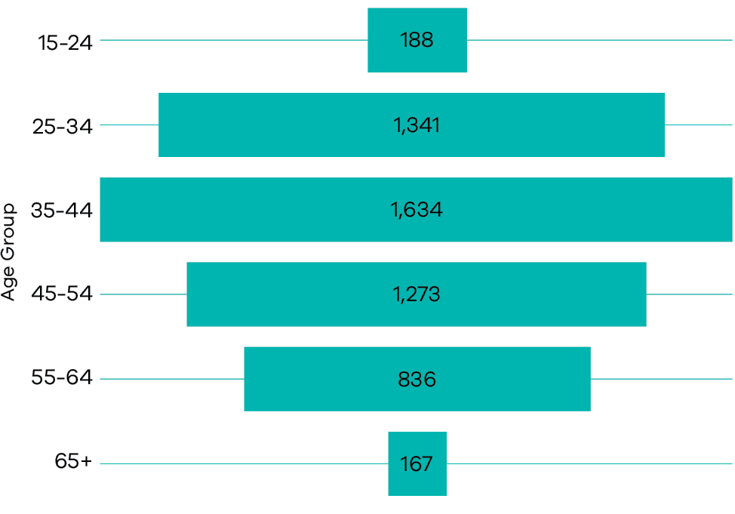
The largest age cohort is staff between 35-44 years of age, accounting for 30.0 per cent of total staff. The next largest is the 25-34 year age cohort, accounting for 24.7 per cent of staff.
Figure 1.1 Staff distribution by work status
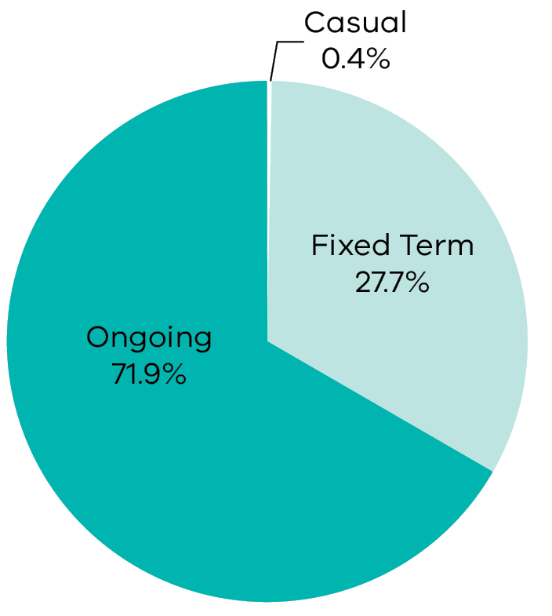
Most staff are in ongoing roles, representing 71.9 per cent of DELWP’s staff.
Figure 1.2 Staff distribution by working arrangement
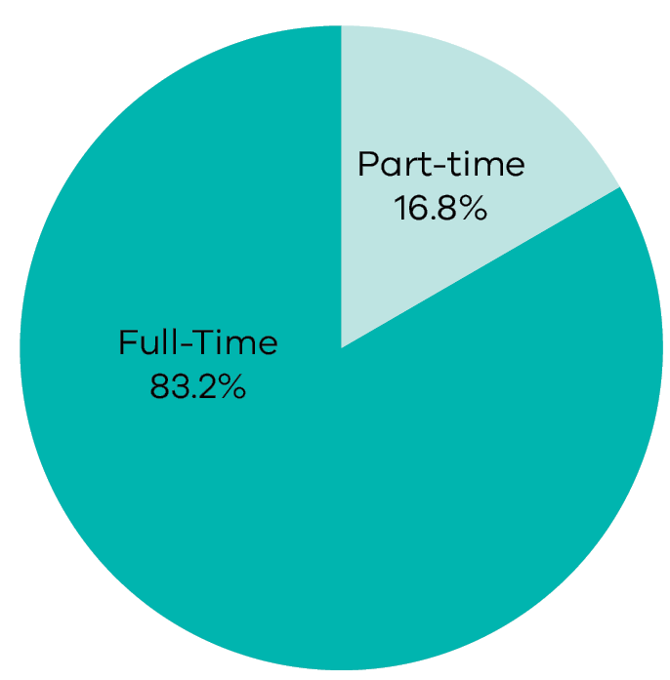
Reflecting the availability of flexible working arrangements, 655 (16.8 per cent) of 3,910 ongoing staff utilise part-time working arrangements.
Figure 2. Staff distribution by classification and gender
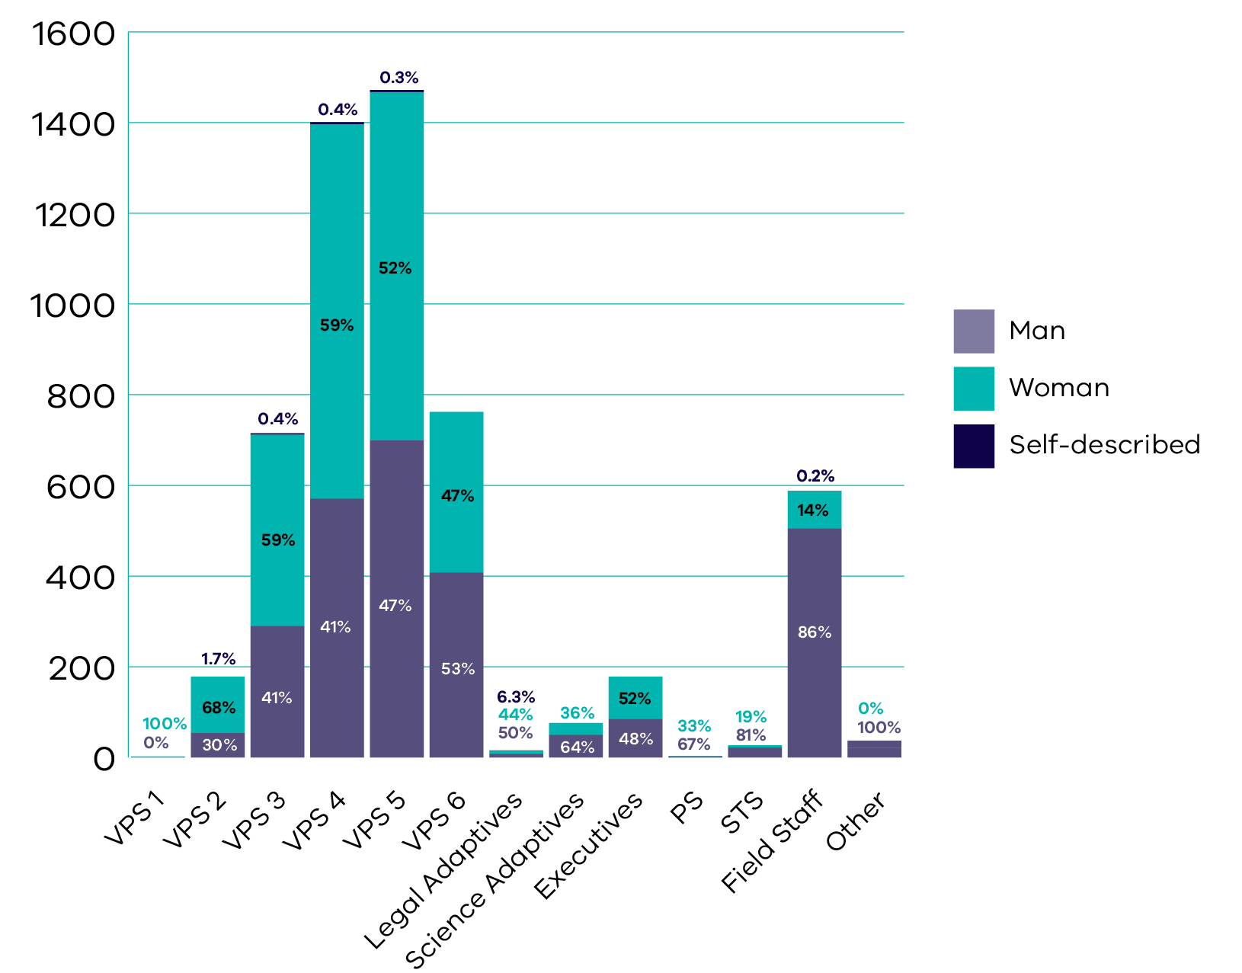
In the two classifications with the largest number of staff, VPS Grade 4 and VPS Grade 5, the representation of women is: 59.0 per cent of 1,401 VPS Grade 4 staff; and 52.2 per cent of 1,472 VPS Grade 5 staff.
Figure 3. Staff Distribution by region
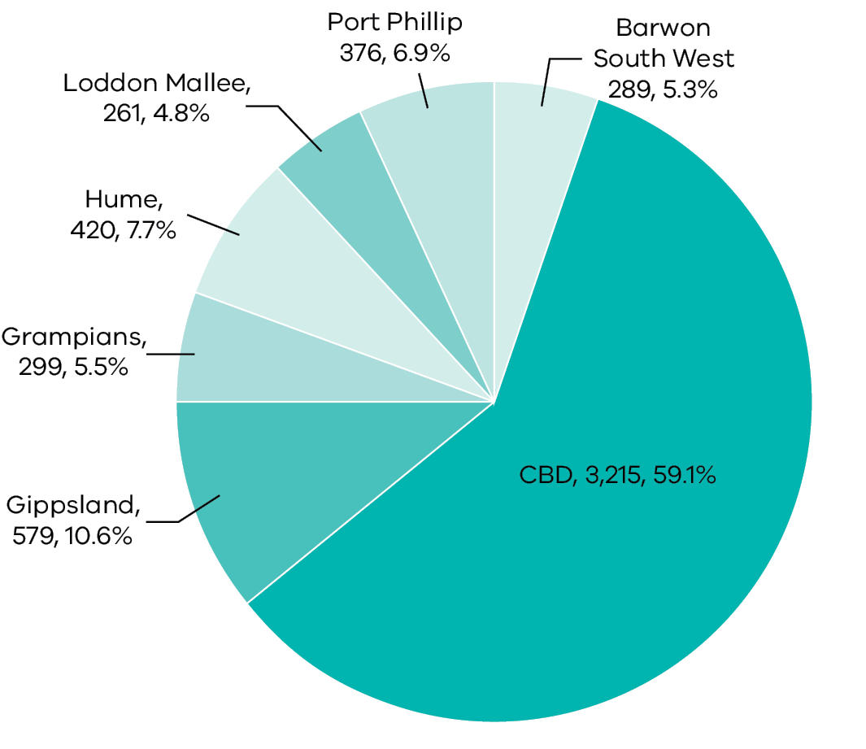
DELWP is geographically dispersed across 87 locations within Victoria, with 59 per cent of staff usually based in the Melbourne central business district (CBD) and 7 per cent in the Port Phillip region (which covers the Greater Melbourne area), and the remaining 34 per cent in regional Victoria. The largest regional staff population is in Gippsland where 11 per cent of staff are based. In 2021-22 most of our office-based staff worked remotely due to COVID-19.
Additional information on DELWP’s workforce profile is available at Appendix 2.

Our culture and values
- Peace, justice and strong institutions
How we work and interact with each other, and with our ministers, stakeholders and the community is critically important to achieve the best outcomes possible for the Victorian community. We are guided by the Victorian Public Sector Code of Conduct and our values: teamwork, ownership, wellbeing and safety, and service excellence. These values speak to the way we work as individuals and team members, from project firefighters to senior executives. Our values articulate clear expectations for the attitudes and behaviours required to successfully deliver for our community.

Teamwork
- We will respect and welcome different perspectives
- We will listen to others, give and actively seek constructive feedback
- We will lead, empower and trust others
- We will support and constructively challenge our colleagues
We are flexible when dealing with change and ambiguity

Wellbeing and safety
- We will create an environment where it is ok to speak up and where issues can be raised and resolved constructively
- We will each take personal responsibility for our own wellbeing and safety, and that of our colleagues
- We will lead by example and be an active role model in how we treat ourselves and others
We will think before acting, be caring, supportive and show empathy towards others

Ownership
- We will create a safe environment that encourages people to show initiative, learn from mistakes and grow
- We will support, trust, equip and empower people to make decisions
- We will value the experience and ideas of our people
- We will take pride in our work and the organisation, leading by example
We will own our actions and decisions that are made

Service excellence
- We will set clear objectives, be honest, transparent and timely
- We will take pride in our professional service delivery and engender excellence into everything we do
- We will look for opportunities to connect and work together to provide better service outcomes
- We will encourage innovation and different ways of working to improve service delivery
We will understand the customer and community needs by stepping into their shoes

People Matter Survey
The 2021 People Matter Survey was a full version of the survey, unlike the previous year’s shortened wellbeing-focused survey. DELWP had a response rate of 65 per cent, with 3,349 of our people completing the survey from 31 May to 2 July 2021. The results of the survey provided valuable insights into what our people are experiencing in the workplace and where we need to continue to focus our efforts.
In 2021, DELWP continued to lead the way with our engagement and satisfaction survey results amongst the highest across the VPS. Our people were feeling more engaged with an increase of four points on our index score. Our employee satisfaction score, while still high, reduced by 1 per cent to an overall total of 67 percent, compared to 2020 results. Overall, our people were enjoying their current jobs more (82 per cent) and had a higher sense of accomplishment (80 per cent) compared to when they were last surveyed in these areas in 2019.
Key highlights from the 2021 survey include:
- 75 per cent of people felt supported by our senior leaders (a 5 per cent increase from 2020)
- 84 per cent of people felt they were making a worthwhile contribution and achieving something important at work
- 91 percent of people were experiencing high levels of job enrichment and were clear on how their job contributes to our purpose
93 per cent agreed that people worked well together in their immediate work groups with 90 percent agreeing that people worked well together outside their immediate workgroups.
Work-related stress was 1 per cent higher in 2021 with 28 per cent of people saying they had high to severe stress. 91 per cent of people who completed the survey said they had experienced mild to severe stress. Of that 91 per cent, 51 per cent said it was from workload and 47 per cent said it was from time pressure. DELWP continues to implement a series of interventions with the aim of addressing these stress and workload issues across the department.
In 2021, 10 per cent of people who completed the survey (336 people) reported they had experienced bullying in the last 12 months. This is a decrease from the 2020 result of 13 per cent. Addressing bullying and other negative work behaviours has been, and continues to be, a key focus area for the department.

Flexible work and hybrid ways of working
DELWP has long been an adopter of flexible work with offerings of various formal and informal flexibility options including options such as a part-time, compressed work week, and nine-day fortnights. The COVID-19 pandemic accelerated, through necessity, the uptake of remote work arrangements for office-based roles. The use of flexible work options has continued at high levels since the beginning of the COVID-19 pandemic.
At the end of 2021-22, approximately 71 per cent of staff had completed a formal ‘flexibility agreement’ with their manager (which represents approximately 80 per cent of office-based employees). At that time, arrangements to work either two or three days per week in the workplace made up the majority of agreements (70 per cent).
As we return to our workplaces after two years of disruption and with new expectations of flexibility for workers in office-based roles, hybrid working is the norm for many of our teams. DELWP is taking the approach that hybrid working offers many benefits but requires intentional effort to design and implement to realise those benefits. We are developing our policies, procedures, and support tools to get the benefits of both working in person and working remotely.

Capability development
As DELWP transitions towards a hybrid workplace, we have kept pace and responded by refreshing the content of our training courses to reflect this new style of working. Training has focused on building leadership capability, developing core business skills, leading flexible and dispersed teams, and supporting a safe and inclusive workplace.
This year, we delivered 234 corporate Virtual Instructor Led Training sessions to 8,455 participants with an additional 1,102 participants completing DELWP’s eLearning courses.
The department has been particularly mindful of supporting new starters to DELWP, with so many of our people working remotely from their teams. In particular, the onboarding of new starters that commenced with Recycling Victoria was a priority and included the delivery of special training to enable business continuity as well as a ‘Welcome to DELWP’ event to introduce staff to their new department.
The department has invested in a range of programs aimed at supporting people leaders to navigate the transition to a flexible, dispersed and hybrid workforce. During 2021 the new FOCUS program introduced key habits for leaders to adopt and was delivered to 1,166 of DELWP’s leaders, including the DELWP Executive Board.
The Senior Leader Support Program, which supports directors and their teams with executive coaching services, was also launched in 2022. This program is expected to increase the capability of our leaders to support teams through a range of changes and challenges that the department will face in the future.

Employment and conduct principles
The department applies the public sector values and employment principles as set out in the Public Administration Act 2004, including the application of merit and equity principles when appointing staff.
The selection processes ensure the applicants are assessed and evaluated fairly and equitably based on the key selection criteria and other accountabilities without discrimination.

Workplace Relations and Investigations
The Workplace Relations and Investigations Team provides advice and support in relation to a range of industrial and employee relations matters including interpretation of the department’s enterprise agreements, performance management, investigating behavioural complaints and significant safety investigations. The team also provides advice and support to the department’s portfolio agencies on the Victorian Government’s Enterprise Bargaining process, wages, and general industrial relations policies. The role of Child Safety Officer, which is responsible for monitoring departmental compliance with Victoria’s Child Safe Standards and Reportable Conduct Scheme, is also within the team’s responsibilities. The team undertakes assessments and makes recommendations with respect to disclosable outcomes arising out of employment screening processes such as police checks and misconduct declarations.

Enterprise Bargaining
The Field Staff and Wild Dog Controllers Enterprise Agreement 2021 was approved by the Fair Work Commission on 4 March 2022 and became operational on 11 March 2022. This new enterprise agreement covers staff members engaged in undertaking fire suppression, prescribed burning, forestry, and feral animal control.
The department has constructive working relationships with both the Community and Public Sector Union and the Australian Workers’ Union. During 2021-22, the department recorded nil time lost through industrial disputes.

Occupational Health, Safety and Wellbeing
DELWP is committed to creating and maintaining a physically and mentally safe workplace. Our framework has systems in place to manage all hazards and we continue to improve our safety and wellbeing culture by revising our systems of work, regularly re-assessing and managing our risks, and creating an environment that empowers our people to recognise, raise and address issues.
The department’s approach includes the following features:
- strong leadership and commitment, for example Regional Directors or Deputy Chief Fire Officers chairing or co-chairing Regional Safety and Wellbeing Consultative Committees, and Deputy Secretary level chairing of the Metro Safety and Wellbeing Consultative Committee and Departmental Safety and Wellbeing Consultative Committee
- a safety and wellbeing management system based on policies, procedures, supporting guidance and services that our people use to address, promote, and protect safety, health, and wellbeing
- a strong consultative structure that facilitates direct engagement with elected health and safety representatives as well as management representatives on local matters being raised by our people
- consultative committees that support the safety and wellbeing management system through their collaboration on local safety and wellbeing action plans aimed at enhancing the department’s safety and wellbeing performance
a focus on continuous improvement through activities such as internal audits, independent reviews, investigations, safety advisor led assurance activities, workplace inspections and managers undertaking job safety observations of field operations.

Initiatives to support our people’s safety and wellbeing
During 2021-22 the department implemented several initiatives aimed at improving the physical and mental health, safety and wellbeing of our employees and other workplace participants.
Highlights from our health, safety and wellbeing initiatives for the year include:
- strengthening the department’s governance of safety and wellbeing through the Safety and Wellbeing Assurance Committee (SWAC) which reports to the DELWP Executive Board. With an independent chair, and on behalf of the Secretary and the DELWP Executive Board, the SWAC provides oversight of the strategic risk management of the safety and wellbeing of our people in line with legislative and statutory obligations.
- active participation in safety and wellbeing programs within the public sector through involvement in the VPS Interdepartmental Occupational Health and Safety Committee and Subcommittee, leading the Key Performance and Measurements Working Group and supporting the Annual Report Working Group as part of the requirements of the Victorian Government’s Leading the Way initiative
- finalising an independent evaluation of the department’s implementation of Leading the Way
- delivering a modified, voucher-based influenza (flu) vaccination program, allowing employees to choose a vaccination time and location that suited them, resulting in 1,148 (at a rate of 24.2 per 100 FTE) employees redeeming a voucher with a further 106 vaccination reimbursements claimed. While this is a small reduction from the previous year, the program was superseded by the Victorian government’s announcement of free flu vaccination for any Victorian up until 30 June 2022.
- delivering a variety of online initiatives to encourage our employees to continue focusing on their mental and physical health and supporting them in their remote working arrangements, including a self-care challenge, nutrition seminar and exercise programs
- development of a virtual Safety and Wellbeing Notice board to support staff working flexibly to access safety and wellbeing advice
- continuing to destigmatise mental health and wellbeing by supporting national wellbeing initiatives and delivering mental health and wellbeing literacy training, for an additional 910 of our employees
- developing and implementing specialist wellbeing support for groups within DELWP, such as a Wellbeing Plan for participants in the Yoorrook Justice Commission
- embedding our enhanced wellbeing reforms, such as the Critical Wellbeing Coordinator and Regional EAP Coordinators, following significant incidents
- monitoring and evaluating the safety of our people with 193 site and field safety assurance reviews across Victoria (at a rate of 3.7 reviews per 100 FTE). This was a reduction of 24 reviews from 2020-21 as a result of COVIDSafe settings and staff absences. This resulted in 136 corrective actions and safety improvements that focused on the greatest risk areas across the department.
to support staff that work alone or in isolation, a new Working Alone or in Isolation Policy, Guideline and web-based application (JourneyMate) was released in March 2022. These aim to provide direction and supporting tools to assess risks associated with working alone or in isolation and enables escalation and emergency response assistance in a timely manner.

Support and response during the COVID-19 pandemic
DELWP has continued to take a holistic approach to the health, safety, and wellbeing of our people throughout the COVID-19 pandemic. Initiatives included, but were not limited to:
- finalising the DELWP COVID-19 Vaccination Requirements Policy following an independent risk assessment and consultation with staff
- updating our COVIDSafe Plan as required to remain contemporary with changing public health arrangements and health advice
- continuation of a dedicated Critical Incident Controller under the Critical Incident Management Framework to provide leadership and manage the department’s response to COVID-19 cases within the workplace
- refining online and virtual health and wellbeing offerings in response to COVIDSafe settings, ensuring a contemporary and valuable set of resources was available to staff
- active encouragement for staff during periods of COVIDSafe settings to use special leave to manage home-schooling
- increasing our phone-based capacity in the Reach Out program with a dedicated role, where phone-based support was extended to staff in need, specifically in response to those affected by COVID-19, either directly or indirectly. A total of 119 staff were supported through Reach Out throughout the year, 30 of which were solely COVID-19 related.
implementing risk management approaches to support continued delivery of critical face-to-face training, and online delivery of other training.
As transition back into the workplace progressed, our safety and wellbeing guidance for staff was routinely updated, and staff sentiment relating to the safe return to our workplaces continued to be measured. This was demonstrated by:
- providing our people with an opportunity to tell us how they were experiencing the workplace via four pulse surveys in 2021-22
- conducting regular Secretary-led All Staff Forums to re-iterate the latest COVID-19 information and provide engagement for staff
- facilitating ongoing quarterly virtual Health and Safety Representative (HSR) briefings
- re-assessing our need for Designated First Aiders and Wardens and ensuring they were appropriately trained (and recruited where required) to support a return to the workplace
- reviewing and adapting our safety and wellbeing induction to accommodate for remote working and a requirement for our people to refresh their safety and wellbeing knowledge and be re-inducted into their workplace as part of their transition.

Employee Assistance Program
A personalised letter from the DELWP Secretary was mailed out to our employees in July 2021 to reinforce the importance of continuing to focus on their mental and physical health. This saw an increased uptake of support through the Employee Assistance Program (EAP), with a total of 732 new cases or 1,669 hours of support throughout the year. Overall, the annual utilisation rate for the department was 14 per cent, almost double (7.8 per cent) the rate recorded across the government and public administration industry.
During 2021-22, the department led a project with FFMVic agencies to review the current best practice in Peer Support Programs. Findings from the review will be implemented to uplift the department’s existing program.

Incident Management
The number of incidents reported across the department rose from 812 in 2020-21 to 2,318 in 2021-22, representing an increase of 185 per cent. This translates to a change from 16.68 incidents per 100 FTE to 44.70 per 100 FTE respectively and equates to 1,506 more incidents reported compared to 2020-21. As displayed below in Figure 1, overall incidents remained consistent throughout the first half of the financial year, with no notable spike throughout the fire response period (November 2021 to March 2022) compared to significant spikes in previous years. However, due to the department’s policy on COVID-19 incident reporting, all staff were required to make an entry when testing positive to COVID-19. This resulted in 1,632 COVID-19 event reports being logged into the system, with some staff submitting reports when they were being tested for COVID-19, in addition to positive staff notifications. As a result, the department experienced its highest number of incidents in a financial year since the implementation of our current incident reporting system in 2002.
If COVID-19 related incident reports were excluded, the data shows a slight increase from 659 incidents reports in 2020-21 to 686 in 2021-22.
Continuing the trend observed in the last two years, vehicle related incidents were elevated, being the second highest report after COVID-19 related incident reports. There were 123 vehicle incidents in 2021-22 (2.37 incidents per 100 FTE), four more than the previous year (119 incidents in total, at 2.58 incidents per 100 FTE).
There were also 87 notifiable incidents that occurred across the department. Notifiable incidents are those that require the Victorian WorkCover Authority (WorkSafe) who is the Occupational Health and Safety Regulator in Victoria, to be notified. These notifiable incidents included:
- 56 notifications related to COVID-19 reporting requirements; this reporting requirement ceased on 14 January 2022
- one fatal incident where a member of the public fell into a mine shaft on public land
- 14 incidents where a person needed immediate medical treatment, the resultant injuries included fractures, crush injury, lacerations requiring stitches, snake bite, concussion and other minor injuries
16 incidents that did not result in injuries.
The increase of non-COVID-19 related incidents being notified to WorkSafe Victoria rose from 12 in 2020-21 to 31 in 2021-2022. These can be attributed to the department taking a proactive approach to incident reporting to WorkSafe Victoria and to legislative changes resulting in the broadening of the definition of a notifiable incident.
Figure 1. Number of incidents by month (excluding COVID-19 incidents)
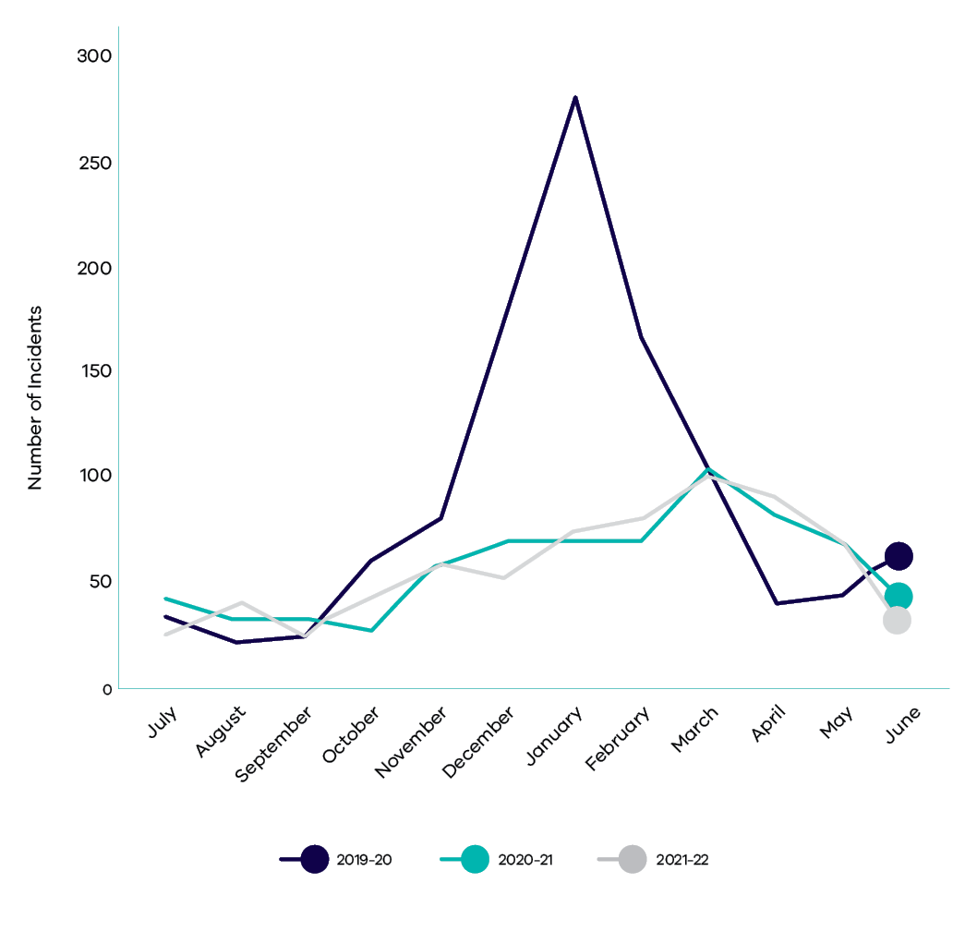
Figure 2. Number of Incidents and Rate per 100 FTE (excluding COVID-19 incidents)
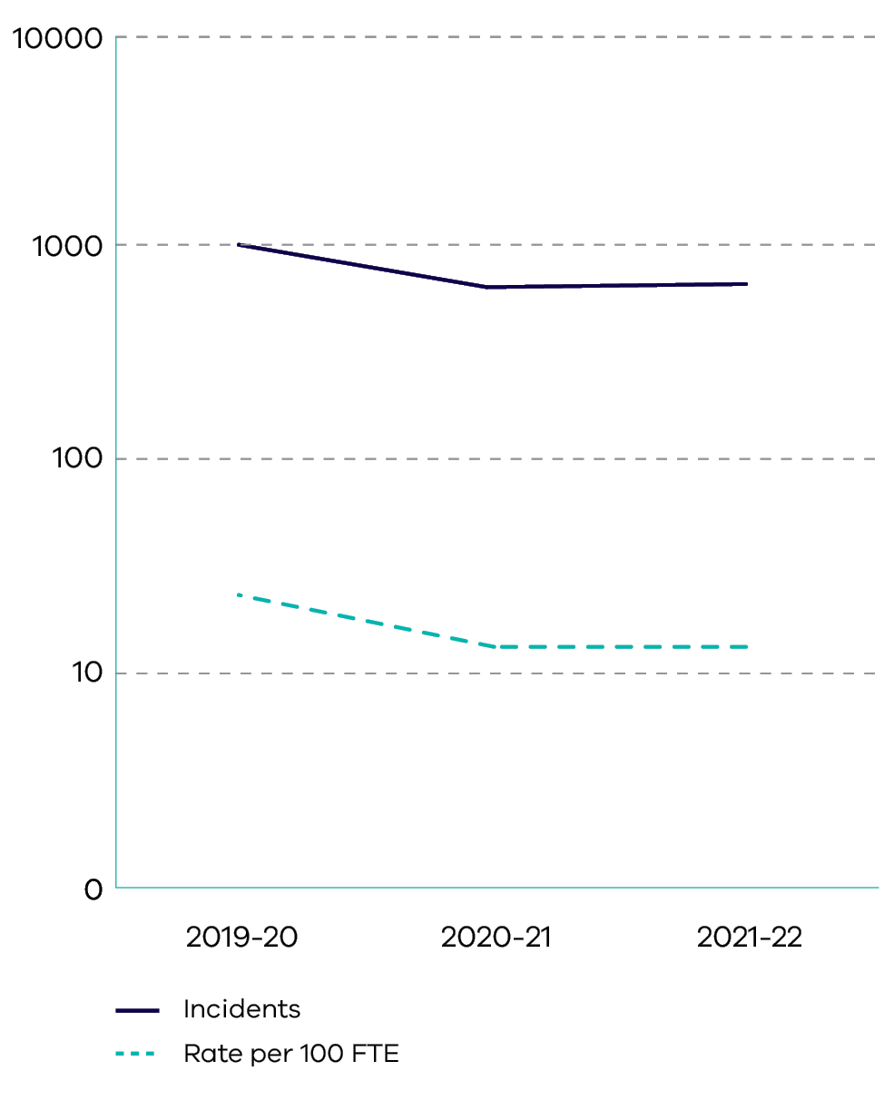

WorkCover claims
A total of 60 standard claims were lodged with DELWP’s WorkCover insurer in 2021-22. This is lower than the 74 claims accepted in 2020-21 due to a considerable decrease in fire activity. The number of overall claims in the previous three years remained stable, with a proportion of those claims involving significant lost time. Almost half of the 2021-22 claims have a full return to work with the remainder of claims on a partial return to work or no capacity to return. The injuries sustained mainly occurred during the planned burning season (mainly slips, trips, falls), with a small proportion of claims for mental injury. The most common cause cited in mental health injury claims was workplace conflict.
While there was a decrease in the total number of standard claims lodged with the department’s WorkCover insurer in 2021-22, the department’s WorkCover premium increased. The increase is influenced by the department’s increased salary base, claims costs from the previous two years and increases to premiums more broadly across industry groups. Whilst the number of mental health claims is relatively low, mental health claims are on average more complex and more costly.
Figure 3. Number of standard claims against number of lost time claims)
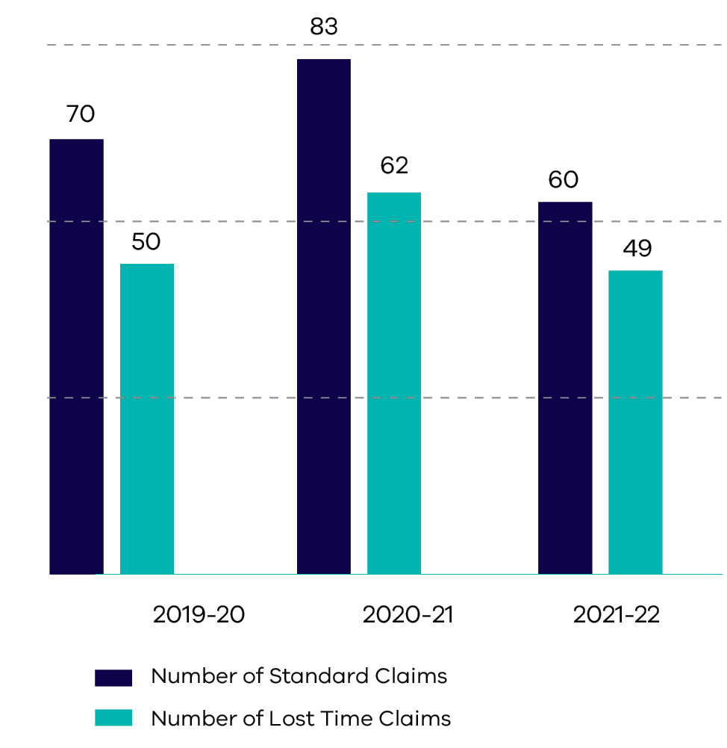
Figure 4. Number of Standard Claims and Rate per 100 FTE
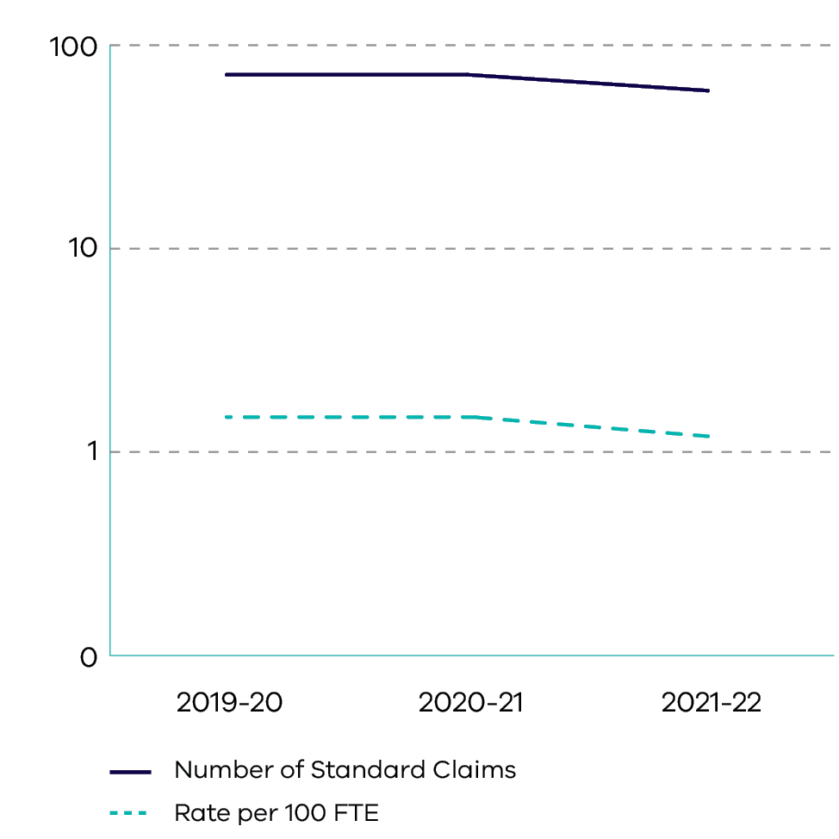
Figure 5. Accepted Lost Time Mental Claims vs. Non-Mental Injury
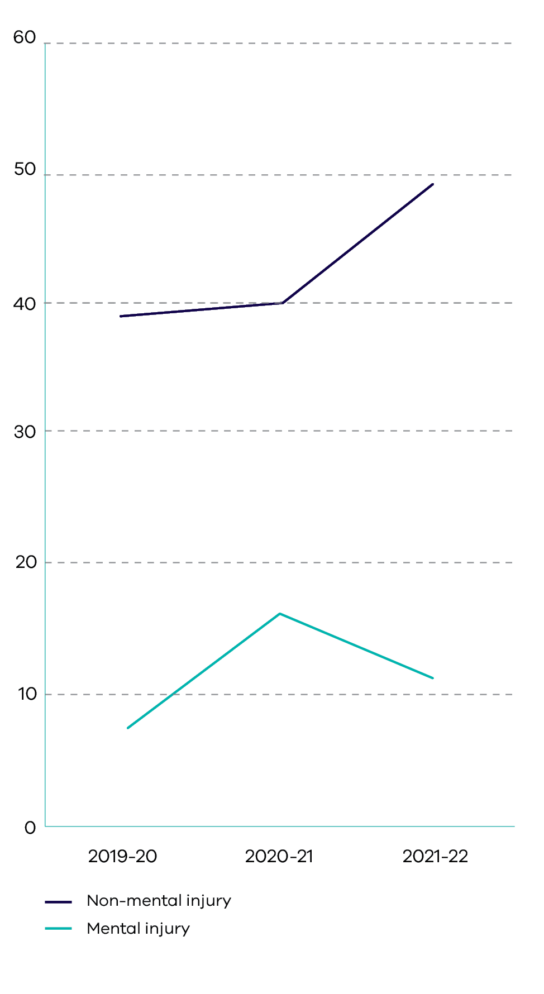
Figure 6. Number of Claims Exceeding 13 Weeks and Rate per 100 FTE
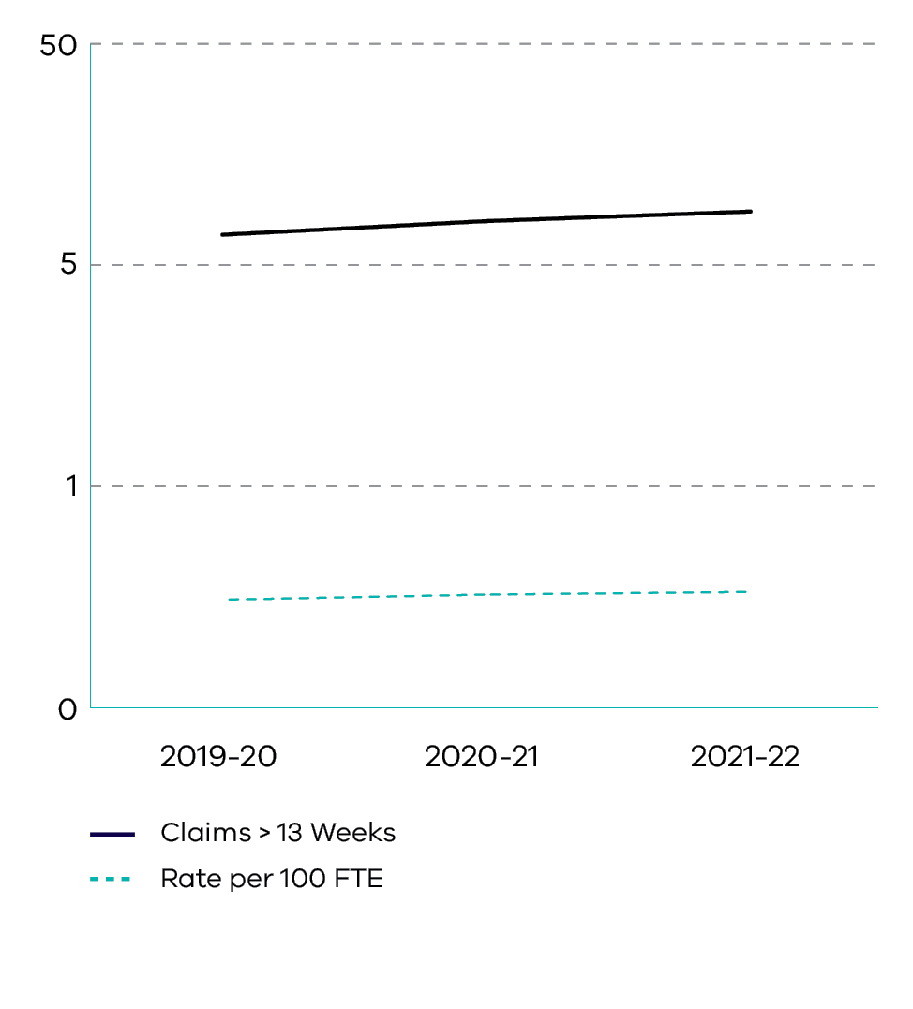
Figure 7. DELWP premium rate
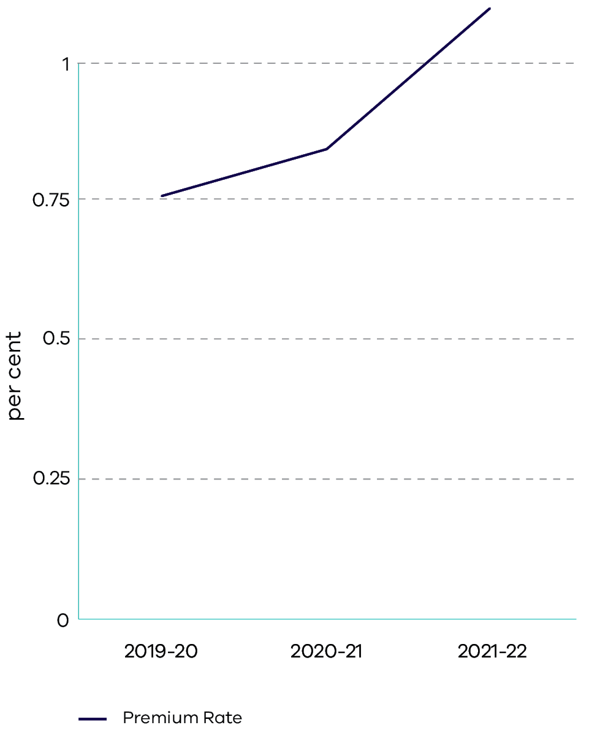

Preparation for upcoming changes in legislation
The Forests Amendment (Forest Firefighters Presumptive Rights Compensation) Act 2021 (the Act) was passed by the Victorian Parliament in October 2021 and is expected to be proclaimed in September 2022. Workers’ compensation claims for FFMVic forest firefighters under the Act will be assessed by each of the FFMVic agency WorkCover insurers and the appointed WorkSafe Advisory Committee.
The proposed OHS Amendment (Psychological Health) Regulations 2022 is expected to be introduced in the second half of 2022. The proposed regulations aim to strengthen the occupational health and safety framework by recognising that psychological hazards in the workplace are equally as harmful as physical hazards. The introduction of the Regulations will require significant effort from DELWP to identify and control hazards, and review reporting requirements, including the introduction of Prevention Plans for high-risk psychological hazards. Planning for the introduction of the Regulations has already commenced.

Further information
Additional information on the department’s performance against key Occupational Health and Safety performance indicators is at Appendix 3.

Diversity and inclusion
- Reduced inequalities
2021-22 was an active year for diversity and inclusion at DELWP. Of those who responded to the 2021 People Matter Survey (PMS), 83 per cent reported that their senior leaders championed diversity and inclusion across the department, up from 79 per cent the year before. Through targeted initiatives and programs, action plans and celebration of significant days on the diversity and inclusion calendar, DELWP has further elevated its focus on the importance of diversity and inclusion. Our staff-led networks played a significant part in capturing the lived experiences of our people, strengthening intersectionality, diversity, and inclusion. These networks have also contributed to organisational strategies and action plans.
2022 is the final year of DELWP’s first Diversity and Inclusion Strategy 2019-22. The department has set strong diversity targets, established new policies and procedures, and has committed to comprehensive action plans to ensure our workplace is a safe and inclusive one for our people. A new strategy is being prepared for 2023-27.

Aboriginal Self-Determination
In 2019, the Victorian Government released the Self-Determination Reform Framework (SDRF).
Under the SDRF, DELWP agreed to develop a plan that sets the direction, outcomes, and priorities for DELWP to respond to the cultural authority and needs of Aboriginal self-determination. That plan, Pupangarli Marnmarnepu: Aboriginal Self-Determination Reform Strategy 2020-25 (Pupangarli Marnmarnepu), was released in August 2020.
The second year of the implementation action plan for Pupangarli Marnmarnepu was completed in 2021-22. Actions taken highlight DELWP’s strength in collaborating across the department to continue our journey to embed true self-determination for Traditional Owner Corporations and Victorian Aboriginal and Torres Strait Islander communities. A major outcome of this effort has been the commencement of the Traditional Owner Corporation (TOC) Employee Exchange pilot in September 2021.
DELWP has continued to build on programs to support Aboriginal employment, engagement, and networking for new and existing staff, including an Aboriginal staff network, a mentoring program and leadership development programs. Aboriginal Cultural Safety training is made available to all staff and managers.

Aboriginal Cultural Safety
Fostering Aboriginal cultural safety within the department helps us to better understand our First Nations history and how all staff play a role in creating a culturally safe workplace. The following DELWP frameworks and associated programs set clear targets for Aboriginal cultural safety:
- Aboriginal Cultural Safety Framework – setting clear expectations for self-determination and safety
- Aboriginal Cultural Capability Framework – building capability for non-Aboriginal staff
- Aboriginal Cultural Safety training – setting a clear target for our people to attend training designed to educate on how we can build a culturally safe environment
Traditional Owner and Aboriginal Victorian Community Engagement Framework – outlining how we engage with Traditional Owner Corporations and ensure this is a key focus and viewpoint on important decisions affecting community.
During 2021-22, Aboriginal Cultural Safety Training was completed by 515 staff members. As at 30 June 2022, Aboriginal Cultural Safety Training has been completed by 42 per cent of our people leaders and 21 per cent of our staff.

Programs Supporting Aboriginal Employment
As at 30 June 2022, 1.78 per cent of DELWP’s workforce identified as Aboriginal and/or Torres Strait Islander. DELWP’s Aboriginal Staff network has 105 active members and continues to be a guiding voice towards self-determination. We understand that there are challenges when building a talent pipeline for Aboriginal and Torres Strait Islander staff, given the limited pool of job seekers across Victoria and other departments within the Victorian Government competing for talent. It requires delicate balancing of the need to meet DELWP’s targets and objectives in a meaningful manner, while ensuring the Traditional Owner Corporations and communities are supported in their self-determination. The department has focused on building a sustainable talent pipeline whilst listening to the needs of Traditional Owners, so that we are working in partnership to build capacity and can learn and grow together.
Key initiatives to attract Aboriginal people and grow our Aboriginal staff numbers are:
- Aboriginal Mentoring Program – in the 2021 pilot program, 12 Aboriginal mentees were connected with senior mentors to build capability, increase retention and create stronger relationships. In the second half of 2022, program participants will work to build their capability with an Aboriginal owned business, Black Wattle, that specialises in professional development from a culturally safe and inclusive perspective.
- First People’s Women’s Forum – in May 2022, DELWP held its inaugural conference for Aboriginal staff across Victoria. 14 Aboriginal women met from across the state to connect, share cultural knowledge and build on career aspirations. Sessions included basket weaving, financial empowerment and the importance of setting values based goals. The women were joined by two esteemed members of the community, Antoinette Gentile and Aunty (Dr.) Lois Peeler, who discussed their impressive accomplishments and lifetime experience.
- Aboriginal Leadership Program –13 staff participated in this structured program to develop Aboriginal leaders, providing learning opportunities in career development and assisting in the retention of the next cohort of Aboriginal leaders at DELWP.
- Baring Djinang Internships – utilising the Victorian Public Sector Commission’s internship program, in partnership with CareerTrackers, DELWP offers three-month internship placements to Aboriginal students, building a talent pipeline for future graduates within the department. In the most recent intake, seven interns within the Baring Djinang program commenced internships in August 2021.
Traditional Owner Corporation (TOC) Employee Exchange –piloted in 2021-22, six DELWP staff worked in TOC roles for up to 12 months to build capability and understanding of the important cultural impact of Traditional Owners.
In addition, during the year DELWP acknowledged Aboriginal days of significance through Secretary Messages to all staff, marking Reconciliation Week and celebrating NAIDOC Week. Due to COVIDSafe settings, there was a range of in person and online events in 2021-22.

Our Commitment to Access and Inclusion – Disability Under the Spotlight
As part of our ongoing commitment to ensure that disability inclusion is a priority across the department, in 2021 DELWP appointed a Senior Disability Adviser to enhance expertise and guide the department towards greater disability confidence and capability.
This appointment coincided with the release of our renewed Access and Inclusion Plan 2021-24. This plan delivered DELWP’s largest ever investment both in the inclusion of people with disability in our organisation and the inclusion of Victorians with disability who access and engage with our programs and services.

Our Data on Disability
According to 2021 PMS results, DELWP recorded a 2 per cent increase in the representation of people with disability in the department since 2019-20, from 4 per cent to just under 6 per cent.
DELWP’s PMS data also shows a positive trend in the number of staff with disability agreeing that DELWP is a supportive and inclusive workplace.

Inclusive Workplace Culture and Capability
In 2021-22, DELWP delivered several key initiatives against our Access and Inclusion Plan. The aim of these initiatives was to increase the disability confidence of our workforce, and to ensure DELWP is a safe and inclusive place for people with disability, health conditions and carers to work.
A key initiative was the renewal of our Workplace Adjustment Policy in December 2021. The policy outlines a collaborative approach between staff, managers and the Diversity and Inclusion team. This approach focuses on transparent and timely service delivery for staff accessing workplace adjustments, stronger privacy protocols for adjustment documentation, and dedicated support and resources to deliver adjustments. From when the policy was released in December 2021 to 30 June 2022, 49 formal adjustment requests were registered and 38 of those had been fully implemented. The most common types of adjustments made to support staff with disabilities are flexible work arrangements, provision of equipment, including assistive technology hardware and specialist coaching to support navigation of workplace challenges.
The department also contributed to actions under the Getting to work: Victorian public sector disability employment action plan 2018-25. To support existing DELWP staff living with disability to progress their careers, 18 were onboarded into the VPSC Mentoring Program Pilot – the second highest enrolment rate across the VPS. This pilot will inform future mentoring programs targeted at retaining and progressing the careers of people with disability currently working in the VPS.
DELWP launched the VPSC’s Disability Awareness e-learning on 2 June 2022 via a whole-of-DELWP communications campaign, with mandatory participation targets set for all people leaders across the department. Alongside the e-learning module, new resources relating to people with disability and carers were made available via the intranet for all DELWP staff. These resources are designed to provide staff with disability, health conditions, carers and their managers and supervisors with key information relating to disability supports at DELWP.
Raising awareness of disability across the department was another key priority. Through collaboration between key departmental staff and the staff-led All Abilities Network, DELWP staff enjoyed several key awareness day events. These included a keynote presentation with author and activist Carly Findlay and a disability and leadership panel on International Day of People with Disability, as well as a presentation and Q&A led by DELWP Secretary John Bradley on leadership and neurodiversity to celebrate Autism Awareness Day.

Inclusive information and communication
DELWP’s website complies with the Web Content Accessibility Guidelines Version 2.0 (WCAG) AAA standard, meaning our customers and community have access to the information they need. In addition, 129 team members across our Digital and Customer Communications and Information Services teams have been trained on accessible communication standards, with more than 13 courses delivered between February 2021 and May 2022.

Inclusive Places and Spaces
In preparing for the return to face-to-face events and engagement, with the support of the Australian Network on Disability, the DELWP Accessible Events Guidelines have been reviewed and updated. These new guidelines include protocols, processes, checklists, and resources to ensure DELWP staff planning an in-person event have everything they need to ensure an inclusive and accessible experience.

Inclusive Communities
DELWP is delivering against its commitments in the Inclusive Victoria: state disability plan (2022-26). In 2021-22, DELWP led the implementation of forthcoming mandatory accessible housing provisions within the National Construction Code 2022 across all Australian jurisdictions.
DELWP also delivered a full audit of the accessibility of its grant program guidelines and documentation, to ensure that all DELWP funding programs are accessible to all Victorians. Opportunities for inclusion outcomes to be embedded in grant funding guidelines are now being identified, with the aim of enhancing inclusion outcomes in DELWP grant opportunities.
The department, in partnership with Parks Victoria, is delivering more accessible opportunities to enjoy nature through the Victoria’s Great Outdoors program. This includes the completed and forthcoming construction of accessible campgrounds, viewing platforms and facilities in state forests across Victoria.

Gender Equality
The department recognises that a gender equal workplace is a crucial aspect of building a diverse workforce that fosters belonging and reflects the community it serves. DELWP prides itself as a safe employer within the Victorian Government, focusing on our people’s safety in addressing gender discrimination and inequality.
DELWP has a strong history of championing its gender equality framework which has been in place since 2015. Of the DELWP employees who participated in our 2021 PMS, 82 per cent said there is a positive culture within the department in relation to employees of different genders and 73 per cent believed gender was not a barrier to success at work. Women make up 52 per cent of our executive cohort. There is a higher proportion of women in the Corporate Services, Water and Catchments and Energy groups. Overall, the representation of women in the department has remained consistent at 48 per cent for the past two years.
In 2021, DELWP made a commitment to gender pay equality with a 2 per cent gender pay gap threshold and a gender pay gap analysis action plan.
In June 2021, the gender pay gap for all DELWP staff was 2 per cent in favour of women, compared to 2 per cent in favour of men across the Victorian Public Service (based on median total salaries, as published in the State of the Public Sector report). In June 2022, there was no gender pay gap based on median total salaries.

DELWP Gender Equality Action Plan 2021–22 – 2025–26
DELWP’s Gender Equality Action Plan (GEAP) 2021-22—2025-26 provides a critical platform to make the department more effective and a better workplace. It is our inaugural response to the new Gender Equality Act 2020 and has been assessed as fully compliant by the Victorian Gender Equality Commissioner, elevating DELWP’s commitment to gender equality.
DELWP has adopted a holistic and intersectional strategy lens to develop synergistic actions, streamline our response to the GEAP, and deliver material and reasonable progress to gender equality. We achieved this by leveraging our policies, stakeholder consultations, human resource processes, subject matter experts and peer advocacy groups. Our GEAP is mapped to the seven indicators of workplace gender equality outlined in the Gender Equality Act 2020. We aim to make reasonable and material progress in gender equality through 22 actions delivered over the next four years.

Gender Equality Focus Areas
We know from various sources including the 2021 PMS results, the VPS Women of Colour Network Diversity and Inclusion Survey and employee consultation sessions, that where you work within the department, your sexual orientation, gender identity and cultural background influences the experience you have.
DELWP’s Workplace Gender Audit 2021 data showed a higher percentage of women at VPS grades 2 to 4 for example, in junior clerical or administrative roles. In more senior roles women make up an average of 48 per cent.
Women made up 81 per cent of the part-time workforce across the department. DELWP recognises the need to further promote part-time and flexible work arrangements among men.
Data also shows that DELWP maintains gender balance in leadership roles, but has a higher proportion of men in technical, trade and community service roles, and a higher proportion of women in clerical and administrative roles.
These insights helped to identify ‘hot spots’ within the organisation that need targeted action and shaped the measures and strategies within our GEAP.
DELWP’s work on ‘hot spots’, and in particular the Women in Fire and Emergency Leadership program, aims to address gendered workforce segregation and is reflected in our GEAP, and in the state Gender Equality Strategy.

Intersectional gender inequality
The department has considered intersectionality in all strategies and measures in developing its gender equality initiatives. DELWP understands that gender inequality can be compounded by individual identity, and we have ensured that the voices of those with lived experience of protected attributes have been heard throughout our consultation.
DELWP also identified the need for better data collection across intersectional attributes and this will be addressed through actions in the GEAP.

FFMVic gender equality and inclusion
DELWP is actively addressing gender-based bias and challenging stereotypes in fire management roles. Through targeted projects and initiatives, DELWP is working to improve the presence of women in fire management roles and create a safe and respectful environment for women in the sector. This also extends to DELWP’s partnerships in emergency with Forest Fire Management Victoria (FFMVic). In 2021-22, training for all people leaders across DELWP’s forest and fire divisions and the FFMVic partnership was provided on gender-based discrimination and the importance of safe, respectful, and inclusive environments, ensuring the emergency management sector has leaders who are equipped to prevent and call out inequality in the workplace.
DELWP continues to support gender equality through the Aboriginal Women in Fire Pathway Program, State Regional Women in Fire Coordinator Group program priorities and the Regional Diversity, Equality and Inclusion working groups. With this targeted approach, DELWP will champion gender equality across the state, having a positive impact for the community in both metropolitan and regional areas.
Further achievements in 2021-22 include:
- an Accelerated Leadership program for 26 women working in operational fire roles within DELWP, focused on skills, personal and professional development to drive advancement into senior executive roles
- formal endorsement of the DELWP Women of Colour network, which provides peer support and advocacy to self-identifying women and non-binary people of colour across DELWP relating to the issues and barriers faced within the department
- leading a successful forum for the Autism Success Network on 21st Century Leadership during the week of Autism Awareness in April 2022 to support women with a disability
continuing to leverage the Champions of Change Coalition, which brings together senior leaders from diverse sectors to champion gender equality and inform targeted initiatives.

Community presence
DELWP continues to be a visible champion of gender equality in the public sector through a strong presence and participation across various forums. On International Women’s Day in March 2022, DELWP hosted a diverse panel of intersectional women who spoke to staff about breaking the gender bias in the workplace. The panel discussion was an enormous success with more than 1,600 staff attending the virtual event. DELWP also had a strong presence at external events such as the IPAA International Women’s Day Gala. In 2022 six DELWP staff were included in the ‘IPAA Top 50 Public Sector Women (Victoria)’ awards that recognised exceptional women leaders during the COVID-19 pandemic for their commitment, strength, and extraordinary contribution.
Events such as these strengthen DELWP’s reputation as an employer committed to progressing gender equality across all layers of the organisation.

Gender Impact Assessments
The department is embedding Gender Impact Assessments into current processes and structures. This is an obligation under the Gender Equality Act 2020 for the department. DELWP will achieve this by:
- including Gender Responsive Budget bidding into existing financial bidding templates
- running workshops for existing projects to include Gender Impact Assessments on projects that have direct and significant impact to community
update planning templates to include consideration of Gender Impact Assessments in initial proposals and budget bids.

Lesbian, Gay, Bisexual, Transgender, Intersex, Queer+ (LGBTIQ+) Inclusion – Championing a Place of Pride
DELWP continues to be a workplace that strives to create inclusion and belonging for our LGBTIQ+ employees. In the 2021 PMS, 10 per cent of DELWP staff self-identified as being members on the LGBTIQ+ community, with 1 per cent of participants self-identifying as transgender, non-binary or used a different term to man or women and a further 11 per cent preferring not to disclose.
With the launch of the Victorian Government’s Pride in our future: Victoria’s LGBTIQ+ Strategy 2022-32 in early 2022, DELWP commenced development of an implementation plan connected to the strategy. As part of this work, DELWP developed a new Affirming Gender at DELWP policy, procedure, and resource package to support employees affirming their gender, as well as their managers, and teams. A Gender Affirmation working group, consisting of trans and gender diverse employees was formed in May 2022, bringing a critical focus on lived and personal experience to the work. Through this work, DELWP has already supported several employees with the gender affirmation process.
The Victorian Government’s commitment to inclusion and diversity for the state’s LGBTIQ+ community continues to grow, as does DELWP’s work towards belonging and safety for our people. In addition to being members of Pride in Diversity and participating in the annual Australian Workplace Equality Index for LGBTIQ+ inclusion, the department’s Place of Pride employee-led network consists of 250 active members and has 15 dedicated employees on its steering committee, creating a sense of community at DELWP. The Place of Pride network has led several LGBTIQ+ events to celebrate all things queer, with DELWP having a visible presence at the Midsumma Festival 2022 and International Day Against Homophobia, Biphobia, Transphobia and Intersexism (IDAHOBIT), hosting and participating in events attended by employees across the VPS.
DELWP’s new LGBTIQ+ Awareness Training was developed, launched, and facilitated by members of DELWP’s Place of Pride network in April 2022. Aimed at raising awareness and understanding of the LGBTIQ+ community, this interactive training also provides participants with DELWP-specific content and context to build on belonging and inclusion.

Multicultural inclusion – elevating the voices of diverse communities
Our people are diverse; our teams are rich in cultural identity and are of multiple faiths. From DELWP’s 2021 PMS results, we know that 15 per cent of DELWP staff were born overseas, 28 per cent identified as having a cultural identity in addition to Australian and DELWP staff speak over 30 different languages. Of survey participants, 48 per cent of staff identified as having a faith.
DELWP’s Multicultural@DELWP and Women of Colour staff networks continue to grow, with 130 active members and allies, working towards elevating inclusion initiatives for people from cultural and linguistically diverse backgrounds. These networks also have a strong presence within the VPS Women of Colour working groups, ensuring DELWP contributes to inter-departmental activities. Members of these multicultural networks have helped shape DELWP’s Gender Equality Action Plan 2020-21 —2024-25, ensuring an intersectional approach to equality is actioned across the department.

Diversity and Inclusion Employment Programs – Future-proofing Diverse Talent
DELWP’s participation in a range of targeted employment programs helps us to achieve our commitment to increase the diversity of our workforce. During 2021-22 we built strong communities of practice, interdepartmental relationships and collaborated to embed pathways for diverse and high potential talent.
As well as supporting First Peoples employment targets and talent pipelines outlined in Pupangarli Marnmarnepu ‘Owning Our Future’ Aboriginal Self-Determination Reform Strategy 2020-2025, DELWP continues to use its employment programs to provide meaningful opportunities for new and emerging talent. Initiatives during 2021-22 assisted 173 young people enter the workforce during an economic downturn and helped to build a diverse and inclusive Victorian public sector, with a focus on intersectional representation.
In late 2021, with the involvement of the department’s staff-led networks, DELWP conducted an Inclusive Recruitment Review to put DELWP’s recruitment practices under the microscope. Through this process, 22 actions were aimed at adapting DELWP’s current practices to remove barriers to full participation of diverse talent.
To showcase some of the career opportunities available across the department, DELWP maintained a strong presence at key career expos and online forums and participated in several employment programs across the Victorian Public Service. We engaged with prospective students at 17 information and professional practice sessions, including career fairs at Victoria’s major universities. With COVIDSafe settings easing in early 2022, face to face engagement increased and the department held several forums, learning and development sessions and events for our graduates, including a regional forum in Eildon.
As part of DELWP’s commitment to building a diverse talent pipeline, opportunities were provided within the following employment programs:
 | Victorian Public Service Graduate Program 2021-22 | Science and Planning Graduate Program 2021-22 | Digital Jobs Internship Program | Victorian Public Service Internships Program | Youth Employment Program/ Youth Employment Scheme
First Peoples | 5 | 2 | – | 7 | –
Disability | 7 | 2 | – | 4 | 5
Culturally and Linguistically Diverse | – | No data | – | 5 | 8
Men | 10 | 12 | 2 | 6 | 32
Women | 17 | 18 | 7 | 9 | 56
Non-binary | 1 | 1 | - | 1 | 1
Total | 28 | 31 | 9 | 16 | 89

The In addition to hosting seven Barring Djinang CareerTrackers Aboriginal Interns over the summer of 2021-22, DELWP created additional opportunities for interns from diverse backgrounds, partnering with The Australian Network on Disability and CareerSeekers Refugee and Asylum Seeker candidates.

Youth Employment Program – Opportunities for Diverse Young People
In partnership with the Department of Jobs, Precincts and Regions, the Working for Victoria Fund Youth Employment Program (YEP) provided opportunities for 89 young unemployed or underemployed job seekers looking to gain industry experience within government. Of the 89 YEP employees, there was a strong representation of participants from diverse backgrounds, a key focus for the department.

Safe and Respectful Workplaces Program
DELWP’s safety and wellbeing programs, and our diversity and inclusion programs, are designed to be mutually reinforcing – in recognition that a safe workplace is more inclusive, and an inclusive workplace is safer. Therefore, creating an environment of safety, inclusion and respect is at the forefront of DELWP’s aspirations, and our Safe and Respectful Workplaces program is a priority vehicle for working towards these aspirations.
In April 2022, a new Safe and Respectful Workplace Behaviours Policy and Safe and Respectful Response Procedure were released in a format under one Framework, the Safe and Respectful Workplaces framework, which brings together a range of strategies to better prevent and respond to reports of sexual harassment and other harmful behaviours.
DELWP’s new approach reflects leading practice; it is person-centred and trauma informed. It establishes multiple and improved reporting pathways and support avenues available to all parties, removing the distinction between formal and informal reporting, to encourage an even stronger reporting culture.
First responder training to support the new policy and procedure has been delivered to key departmental staff and field-based leaders in locations and work environments that present a heightened risk of negative behaviours. As at 30 June 2022, 20 DELWP staff from across the state are trained as First Responders under the new Framework.
To build leadership capability, 500 people leaders attended Safe and Respectful Workplaces First Responder webinar sessions in June 2022 to understand their role in effectively supporting their teams within the new Framework. An additional 188 people leaders were trained in July 2022.
DELWP is also updating its Safe and Respectful Workplaces prevention focused learning and development programs to provide a more tailored and flexible set of learning interventions. During 2021-22, 36 workshops with 329 participants were delivered.

Climate-related risk disclosure statement
About this statement
This statement summarises DELWP’s response to climate-related risks and opportunities across its operations. It is the department’s second climate-related disclosure. The statement highlights key developments in DELWP’s approach to addressing climate-related risk through the 2021-22 period. This includes new strategies, plans, investments and reforms which contribute towards managing climate-related risks for DELWP such as Adaptation Action Plans, the Traditional Owner Cultural Landscapes Strategy, the Marine and Coastal Strategy and Heritage Victoria’s Emergency and Bushfire Recovery Program. The statement also describes progress on existing commitments such as the introduction of Zero Emissions Vehicles and the publication of guidance for Board members of public entities on climate risk.
The statement is informed by the recommendations of Task Force on Climate-related Financial Disclosures (TCFD). It addresses the TCFD themes of Governance, Strategy, Risk Management and Metrics and Targets. DELWP will continue to strengthen its approach to climate-related disclosure. Future statements will consider developments in international disclosure best practice, such as the International Sustainability Standards Board’s (ISSB) forthcoming global sustainability disclosure baseline.
Through this statement, the department aims to:
- communicate DELWP’s actions to understand and manage the impact of climate change on its assets, infrastructure and natural resources
- demonstrate that DELWP’s environmental impacts are responsibly managed and mitigated
- demonstrate the priority that DELWP places on community safety and emergency services; and
support the efficient allocation of resources for the transition to a zero emissions, climate-ready economy and community.
Climate change impacts on Victoria now and into the future
The latest Intergovernmental Panel on Climate Change report confirms that climate change is making many extreme weather events around the world worse, including flooding, heatwaves, droughts and catastrophic bushfires. In Victoria the climate has warmed by 1.2°C since records began, becoming hotter and drier with an increase in spring fire danger. These trends are projected to continue in the future, likely resulting in more frequent and intense heatwaves, extreme fire conditions, intense rainfall events, storm surges and coastal erosion.
Leading Victorian Government action on climate change
The Victorian Government is taking strong and lasting action to address climate change and its impacts. Through the Climate Change Act 2017, Victoria has legislated a long-term target of net zero emissions by 2050, consistent with the Paris Agreement ambition to limit the increase in global average temperatures to well below 2 degrees Celsius above pre-industrial levels, and to pursue efforts to limit the temperature increase to 1.5 degrees Celsius.
DELWP leads the Victorian Government response to climate change, overseeing legislative, regulatory and governance arrangements in the environment portfolio, and using economic, research and scientific expertise to develop policy responses to harness Victoria’s climate-related opportunities.
Victoria’s Climate Change Strategy sets out the Government’s interim emissions reduction targets for 2025 (28-33 per cent below 2005 levels) and 2030 (45-50 per cent below 2005 levels) and brings together actions to achieve those targets from the first set of five-yearly emissions reduction pledges, as required under the Climate Change Act 2017. The Strategy will keep Victoria on track to meet its long-term target for net zero emissions, while also seizing the opportunities of climate action through advancing clean and innovative technologies, investing in new industries and creating Victorian jobs and cost savings.
Released on 9 February 2022, the Victorian Government’s Adaptation Action Plans are a major step forward in ensuring Victoria is ready to respond to the risks and opportunities of a changing climate. The actions set out in the plans will help meet the Victorian Government’s five-year adaptation priorities in Victoria’s Climate Change Strategy. They address the current impacts of climate change, reduce the barriers to adaptation, and lay the foundations for transformational adaptation to ensure preparedness for future climate scenarios.
The Climate Change Act 2017 requires the Victorian Government to make a whole of government emissions reduction pledge every five years alongside emissions reduction pledges for key economic sectors. The first Whole of Victorian Government pledge sets out commitments to reduce emissions across the Victorian public sector by purchasing renewable electricity, investing in the environmentally sustainable design and energy performance of government buildings and infrastructure, and starting to transition its fleet to zero emissions vehicles (ZEV’s). The key action for all government operations to be powered by 100 per cent renewable electricity by 2025 is expected to reduce annual government emissions by an estimated 2.7 million tonnes of carbon dioxide equivalent (Mt CO₂-e) compared to 2018-19 levels.
Committed to addressing climate change across DELWP
DELWP is committed to playing its part in Victoria’s transition to net zero emissions and a climate resilient state. DELWP’s actions are guided by Victoria’s Climate Change Strategy and interim emissions reduction targets. DELWP has set an ambitious target to reduce reported emissions from its operations to net zero by 2025 and to build resilience to climate change impacts across its services and activities.
Recent extreme weather events demonstrate the importance of addressing climate change risk across DELWP’s operations. The 2021 June and October storms and floods impacted approximately 3.3 million hectares across Victoria, including 1.97 million hectares of public land managed by DELWP and its portfolio agencies. Over 7,000 kilometres of park and forest roads, almost 200 recreation sites and more than 300 walking tracks were affected. With climate change driving more frequent, intense and longer-lasting extreme weather around the world, DELWP is continuing to assist and support Victorian communities who are still recovering from recent local events and is adjusting its approach so that recovery builds resilience to future events.

Climate-related risk governance
The DELWP Executive Board leads the department’s risk management framework and is the collective owner of DELWP’s strategic risks. The Board actively manages multiple climate-related physical and transition strategic risks including:
- energy security, availability, affordability and safety
- emergency management
- water security; and
providing effective leadership to the Victorian community to enable the transition to a climate resilient and net zero emissions economy.
The Board monitors risk mitigation activities through quarterly executive risk management reporting, which includes updates of mitigation activities and briefings on strategic risk assessment workshops. The Board is supported in managing and monitoring climate-related risks by stewardship committees and assurance committees, as outlined in the About DELWP section of this Annual Report, drawing on expertise from across the department’s executive leadership team as required.
In particular, the Board is supported by the Policy and Legislation Stewardship Committee, which leads and oversees DELWP’s policy and legislative reform agenda on behalf of the Secretary and the Board, and advises on its oversight, direction, monitoring and review for the Victorian Government.
The DELWP Risk and Audit Committee provides independent assurance to the Secretary that the department’s risk and control environment is operating effectively and efficiently. This committee actively monitors the department’s risk profile, including climate-related risks, and assesses the risk management strategies adopted. The internal audit program provides further assurance through the assessment of key controls mitigating strategic risks.
DELWP is supporting its portfolio entities to improve climate risk governance. In 2021-22, DELWP developed whole-of-Victorian Government guidance for Board members of public entities on directors’ duties under the Public Administration Act 2004 and how these extend to managing climate risk. This guidance was published to the Victorian Government boards website in August 2022. DELWP has also developed director development materials on climate risk for portfolio entity Board member training.

Climate-related risk strategy
Climate change has a direct impact on the services and programs that the department delivers on behalf of the Victorian Government and requires sustained action to manage the risks, maximise opportunities and build resilience. Integral to this, is strengthening the ability of DELWP assets and operations to withstand, respond to and recover from extreme weather events.
The economic and social transition to a net zero emissions and climate resilient future may entail policy, legal, technological and market changes that impact DELWP’s operations. These transition risks and opportunities are being monitored by DELWP and reflected in DELWP’s planning.

Climate change is embedded in DELWP organisational planning
Climate change is one of four cross-cutting themes in the DELWP Corporate Plan. This shows how all groups within DELWP support the Government to deliver a net zero emissions, climate resilient Victoria.

Science informs DELWP’s understanding and response to climate-related risk
DELWP leverages the latest national and international climate change science knowledge to develop its response to climate-related risk. The Victorian Government’s ongoing investment in climate science has delivered projections of what Victoria’s future climate may look like at a statewide scale and for 10 regions. These projections inform planning and projects across the department.
Following release of Victoria’s Future Climate Tool in 2021, DELWP delivered ‘climate clinics’ to support teams and individuals within DELWP, and across Victorian Government departments and agencies, to interpret future climate information and apply the tool to inform risk assessments and adaptation decisions. In 2021-22, more than 20 sessions were conducted and over 350 participants were introduced to the tool.

Prioritising Traditional Owner expertise
DELWP recognises the intrinsic connection of Traditional Owners to Country and the value of their unique knowledge and expertise in the development of climate change responses. Pupangarli Marnmarnepu ‘Owning Our Future’ – Aboriginal Self-Determination Reform Strategy 2020-2025 is DELWP’s five-year roadmap that enables self-determination by honouring the rights and dignity of Traditional Owners and Aboriginal Victorians. Pupangarli Marnmarnepu requires DELWP to work in partnership with Traditional Owners to progress self-determination, including by valuing Traditional Owner expertise in climate change programs, increasing the number of Traditional Owner groups involved in climate change planning and response, and recognising and implementing the decisions that Traditional Owners make over cultural fire practices and traditional lands, waters and resources.
DELWP’s land management approach in the context of climate change is informed by Traditional Owner voices, articulated in the Victorian Traditional Owner Cultural Landscapes Strategy, launched in 2021, and the Victorian Traditional Owner Cultural Fire Strategy.
Both strategies provide direction to the Victorian Government and a strategic foundation for Traditional Owners to articulate an Indigenous management paradigm that is underpinned by cultural values, knowledge and expertise associated with their Country in Victoria and elevate Traditional Owners’ role in the policy, planning and management of Country.
They also provide a cultural strategic framework based on cultural objectives and possible actions which help Traditional Owners repatriate management practices and begin the complex task of restoring and redressing harms to Country and, in doing so, bring healing to Country and community. First Peoples stress that cultural knowledge and practice is for the purpose of achieving cultural objectives but will also support the management of risk reduction as a complementary outcome.
In 2021-22, the Victorian Government provided $11 million to Traditional Owner Corporations to implement the Cultural Landscape Strategy on Country and a further $22.5 million over four years with $6.3 million ongoing, to reinvigorate Traditional Owner-led cultural land and fire management practices.
Released in 2022, the Yarra Strategic Plan, Burndap Birrarung burndap umarkoo seeks to protect the Yarra River corridor as one living and integrated entity for future generations from key threats, including climate change, while promoting opportunities for self-determination among the Birrarung’s Traditional Owners the Bunurong and Wurundjeri Woi-wurrung. Through the Birrarung Council – the independent voice of the river – and shared governance arrangements established by the Wilip-gin Birrarung murron (Yarra River Protection Act) 2017, Traditional Owner voices will inform climate change responses implemented through Burndap Birrarung burndap umarkoo.

Mitigating climate impacts from DELWP operations
DELWP is committed to mitigating its climate and broader environmental impacts. DELWP has set a target of net zero reported emissions by 2025 with measures to reduce greenhouse gas emissions across its operations.
DELWP has achieved 100 per cent renewable electricity since April 2021 and in advance of the whole of Victorian Government pledge commitment for 100 per cent renewable electricity for government operations by 2025. This has been accomplished by purchasing 100 per cent Green Power across all DELWP sites and by installing solar panels at select sites. 1,319 kW of photovoltaic (PV) solar panels have been installed at 27 sites reducing annual greenhouse gas emissions by an estimated 1,112 tonnes CO₂-e, with an additional 429kW of PV solar panels to be installed before 2025. DELWP will continue to purchase Green Power to maintain net zero emissions for its electricity consumption.
Adding to commitments in the whole of Victorian Government pledge to introduce 400 Zero Emission Vehicles (ZEVs) into the government fleet by 2023, DELWP has established a policy of ZEVs first for its shared passenger vehicle fleet from 2021-22 onwards and is installing charging infrastructure at DELWP sites to support this policy. During 2021-22, DELWP introduced 14 ZEVs into its fleet.
More information on these and other measures is provided under ‘Environmental Performance’.

Building resilience through advanced bushfire management and storm, flood and bushfire recovery
In response to climate change, DELWP continues to expand and adapt its emergency management capability across preparedness, response and recovery.
Responding to recommendations from the Phase 1 inquiry into the 2019-20 bushfires by the Inspector-General for Emergency Management (IGEM), DELWP is expanding Victoria’s risk-based approach to fuel management. This includes strengthening bushfire risk modelling and evaluation, funding more mechanical fuel treatments and firefighters, preparing a long-term strategy to retain skilled forest-based contractors and working with Traditional Owners to lead cultural fire practices. These investments support the department to undertake bushfire management more efficiently and effectively in the context of a rapidly changing climate.
DELWP is integrating climate adaptation throughout recovery programs to increase the resilience of communities, the natural environment, built infrastructure and local economies to future, more frequent and severe, events. Throughout 2021-22, DELWP has delivered storm, flood and bushfire recovery activities across the state. Capital works delivered as part of recovery activities seek to build resilience to climate change. For example, new bridges and crossings are designed to withstand fire and 1 in 100-year floods using concrete and steel components. By integrating climate sensitive design into bridge and crossing infrastructure built since 2008, including approximately 40 new concrete bridges since 2018, the government has seen a return on investment in terms of insurability, with infrastructure experiencing substantially reduced damage as a result of extreme events, quicker return to service and reduced cost of reinstatement. For example, an East Gippsland bridge built in 2018 has proved resilient through several events including the 2019-20 bushfires and two floods in July 2020 and April 2022.

Strategically managing coastal hazards
Victoria’s coast and marine areas including DELWP’s vast portfolio of natural and built coastal assets are increasingly susceptible to climate change impacts such as sea level rise and changes to long-term weather patterns. Many built coastal assets such as sea walls, groynes, piers and jetties are also losing integrity due to age.
Following a consultation process in 2021, the Marine and Coastal Strategy was released in May 2022. The Strategy is the first of three five-year action plans to give effect to the Marine and Coastal Policy 2020, and achieve the vision for a healthy, dynamic and biodiverse marine and coastal environment that is valued in its own right and benefits the Victorian community now and in the future. Adapting to climate change and strategically managing coastal assets are key priorities of the strategy.
Under the Strategy, DELWP has embedded climate change adaptation and mitigation into a long-term statewide asset management plan for coastal protection assets, both nature-based and built. The plan identifies priority assets for maintenance, replacement or adaptation and satisfies the requirements of the Victorian Asset Management Accountability Framework. The plan has modelled costs for managing these assets from 2022-2042, allowing for proactive investment into assets and reducing the frequency of fix-on-fail approaches and also aligns with the statewide approach to coastal hazard risk management and adaptation planning developed in 2021-22 by the Victoria’s Resilient Coast – Adapting to 2100+ (VRC) project.
The Marine and Coastal Strategy will also see climate change adaptation embedded as a core component of planning and management in the marine and coastal environment using a range of statewide and local approaches. Statewide approaches include the VRC project, implementation of the Marine Spatial Planning Framework and updates to statewide land use planning tools and policies. Local approaches include the Regional and Strategic Partnerships, Coastal and Marine Management Plans, Environmental Management Plans, marine plans (where developed) and statutory planning mechanisms.
As an example, the Inverloch Regional and Strategic Partnership (RaSP), is bringing together Traditional Owners and nine agencies with responsibility for managing coastal land, assets and infrastructure in the region to proactively plan for future changes to the coastline around Inverloch, Venus Bay and Anderson Inlet via the Cape to Cape Resilience Project. In 2021-22, the Cape to Cape Resilience Project delivered new research through a coastal hazard assessment and adaptation options modelling, a Cultural Values Assessment, a coastal risk and vulnerability assessment and adaptation framework.

Managing the impact of climate change on our built environment
Climate change is anticipated to increase management and maintenance costs for Victoria’s built environment, particularly in areas exposed to natural hazards and sea-level rise. In response, the planning system is undergoing reform to support planning practitioners and improve the long-term resilience of the built environment.
In 2021-22, reforms to the Victoria Planning Provisions (VPP) included:
- Amendment VC171, which strengthens coastal hazard planning and implements the Marine and Coastal Policy 2020, came into operation on 6 September 2021
Amendment VC216, which updates the Planning Policy Framework of the VPP to better support Environmentally Sustainable Development (ESD), came into effect on 10 June 2022. This amendment adds additional responses to ESD within relevant planning policy themes and incorporates consideration of climate change into the purpose of Victoria Planning Provisions and all planning schemes.
The Built Environment Adaptation Action Plan outlines a five-year program of climate change adaptation responses across DELWP portfolio areas. The plan outlines a range of initiatives to update policies and standards and extend a range of programs to support the resilience of communities across the state.
In 2022, DELWP also released the Guideline for effective stakeholder engagement: Planning for settlements exposed to natural hazard and climate change risks. Developed for strategic land use planners, the guideline provides a resource for how to undertake and achieve effective engagement outcomes. Involving stakeholders in settlement planning will contribute to safer and more resilient communities, build technical understanding in identifying and mitigating risk and improve preparation and response to natural hazards.
DELWP continues to support local governments in updating their planning schemes to reflect best available coastal hazard data. DELWP’s Coastal Planning Grants Program assists local government with the planning scheme implementation of:
- state-funded local coastal hazard assessments
- the land use planning components of any coastal adaptation planning; or
hazard assessment and risk analysis undertaken by councils and supported by the state.

Protecting historic heritage sites
Victorian places and objects of heritage significance protected under the Heritage Act 2017 are being affected by climate change, including over 100 places impacted by the June 2021 storms and floods.
In response, Heritage Victoria has established the Emergency and Bushfire Recovery Program. Under the program, Heritage Victoria assesses heritage places affected by disasters and natural hazards and provides advice to heritage asset owners and managers about management and remediation. The program also delivers projects contributing to heritage recovery and public safety goals. In 2021-22, the program conducted site visits to storm-affected heritage places and continued bushfire recovery heritage site audits.
Heritage Victoria, in partnership with the Heritage Council, are also implementing the Heritage and Climate Change Project. In 2021-22, the project began development of a risk matrix and associated guidelines for owners and managers of places on the Victorian Heritage Register. The risk matrix assesses and identifies risks for a place or object in the face of climate driven and natural extreme events while the guidelines include advice on mitigation measures to assist future decision making. The project, including guidelines and risk matrix, is due for completion in December 2022.

Climate-related risk management
DELWP’s risk management framework provides the foundations and organisational arrangements to ensure that climate-related risks are effectively identified, assessed, and managed throughout the department. The framework is aligned to the Victorian Government Risk Management Framework and provides guidance for designing, implementing, monitoring, reviewing and continually improving risk management throughout DELWP.
DELWP’s risk management framework requires DELWP’s businesses to consider their operating context, including climate change, and identify and assess risks and opportunities with a view to managing any risks within the department’s risk appetite. Climate-related risks are assessed and managed at the strategic, operational and program/project levels.
DELWP’s risk management framework also requires all risks to be assessed for potential impacts on the environment, with extreme impacts being outside the department’s risk appetite. The department mitigates the impacts of climate-related risks through business adaptation strategies, delivery of climate-related programs, and associated operational risk management activities.

Climate-related metrics and targets
DELWP reports climate-related metrics and targets in line with the Victorian Government’s Financial Reporting Direction (FRD) 24: Reporting of office-based environmental data by government entities, while including a wider environmental performance reporting scope. DELWP’s reporting against these metrics and targets are detailed in the next section of the Annual Report – Environmental Performance.
Over the past year, DELWP has led an update to FRD 24 to strengthen environmental reporting requirements, with all government entities required to report on all office and non-office activities across a range of environmental indicators in their annual reports from 2022-23 onwards.
The new environmental information will provide greater transparency for the Victorian community of the environmental impacts of public services and illustrate how they are being responsibly managed. Improved reporting will also support delivery of five-yearly whole of government emissions reduction pledges required by the Climate Change Act 2017.
The updated Financial Direction 24: Reporting of environmental data by government entities is available on the Department of Treasury and Finance website. DELWP will implement these requirements in its 2022-23 annual report and will continue to lead work across the Victorian Government to support implementation by all departments and agencies.

Environmental performance
- Clean water and sanitation
- Affordable and clean energy
- Sustainable cities and communities
- Responsible consumption and production
- Climate action

Net zero reported emissions by 2025
- Sustainable cities and communities
DELWP expects to achieve net zero emissions by 2025 ahead of the 2050 Victorian Government target. Some of the key measures DELWP will take to achieve this include the following:
- installation of a further 550kW of Solar photovoltaic (PV) panels at DELWP sites by 2025
- transition to zero emissions vehicles (ZEVs) for the shared passenger vehicle fleet by 2025
net zero reported electricity emissions from April 2021 onwards
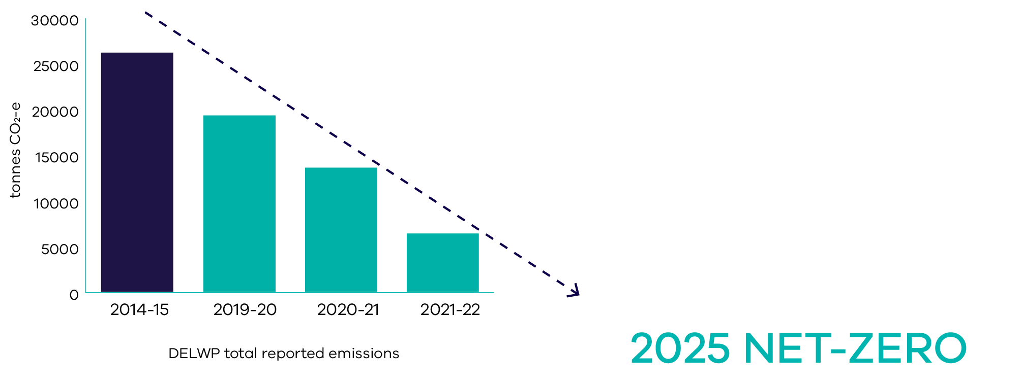
DELWP continues to make significant progress towards reducing emissions from the 2014-15 baseline year (the first reporting year after previous significant Machinery of Government changes) through the implementation of its 2025 net zero action plan.

Environmental performance reporting scope
The mandated FRD24 environmental performance reporting scope has a focus on office-based activities. Many aspects of DELWP’s environmental performance reporting are not covered under the reporting scope of FRD24. At the recommendation of the Commissioner for Environmental Sustainability Victoria (CES), DELWP has reported against a wider environmental performance reporting scope since 2008. Details of this extended environmental reporting at DELWP are shown below.
 | FRD24 environmental performance reporting | DELWP environmental performance reporting
Building energy consumption and emissions | Offices | Offices, airbases, depots and warehouses, fire towers, research centres and mixed-use sites
Water consumption | Offices | Offices, airbases, depots and warehouses, research centres and mixed-use sites
Vehicle travel and emissions | Shared passenger vehicle fleet | Shared passenger vehicle fleet, and the operational vehicle fleet (including utility vehicles and Ultralight Tankers)
Air travel and emissions | Staff air travel | Staff air travel
Building waste generation and emissions | Office kitchen and stationery room waste | Offices and mixed-use sites kitchen and stationery room waste
Paper purchasing | All paper purchasing | All paper purchasing and associated emissions

DELWP reports environmental data from 1 April to 31 March to allow for a full reporting year and provide greater accuracy for the annual report. Data is captured through consumption reports, surveys, and audits at DELWP sites.
While many office-based elements of environmental reporting can be more clearly managed, other operational environmental impacts can be dictated by seasonal events, such as fire response activities.
The reportable site list excludes residences and sites where DELWP staff are located within another department’s facility. Non-DELWP staff accommodated within a DELWP-managed facility are counted towards the DELWP reported consumption figures (but not FTE figures). Staff numbers and office tenancy net lettable area (NLA) details used for reporting calculations are shown below.
Indicator | 2021-22 | 2020-21 | 2019-20 | 2014-15 (baseline)
DELWP FTE | 5,186 | 4,868 | 4,529 | 2,960
DELWP Office FTE | 3,662 | 3,381 | 3,042 | 1,983
DELWP Office NLA (m²) | 55,032 | 51,387 | 51,375 | 51,100
Number of DELWP Office sites | 18 | 18 | 19 | 20

DELWP’s Environment Management System (EMS) was set up to meet government requirements under Financial Reporting Directive 24 (FRD24), with a range of reporting indicators enabling departments to monitor and improve environmental performance over time. The EMS is externally audited every two years and audit recommendations are submitted to the Commissioner for Environmental Sustainability Victoria (CES).
CES use both FRD24 annual report data and EMS audit findings from all departments (along with Sustainability Victoria and the Environment Protection Authority) to assess government’s overall environmental performance in the CES Strategic Audit Report.

Environmental performance reporting summary^{(i)}
 | 2021-22 | 2020-21 | Difference to 2020-21 | 2014-15 baseline | Difference to baseline
Total reported emissions (tonnes of CO₂-e)^{(ii)} | 6,374 | 13,683 | -53% | 26,321 | -76%
Total FRD24 emissions (tonnes of CO₂-e) | 566 | 3,012 | -81% | 12,164 | -95%
Total electricity emissions | 0 | 6,557 | -100% | 17,290 | -100%
Total natural gas and LPG emissions | 513 | 687 | -25% | 768 | -33%
Total passenger vehicle emissions | 309 | 222 | 39% | 876 | -65%
Total operational vehicle emissions^{(ii)} | 5,488 | 6,160 | -11% | 6,326 | -13%
Total air travel, building waste and paper purchasing emissions | 64 | 57 | 14% | 1,061 | -95%
Explanatory notes:
- Due to COVID-19, there has been an increase in staff working from home from the 2020-21 reporting period onwards. This has had an impact on environmental performance reporting indicators, as detailed in the following sections.
- All operational vehicles are now included in reporting. Further detail is proved in the travel and transport section of the report.

Green Team program
DELWP’s Green Team Program aims to promote awareness of environmental objectives by encouraging positive environmental behaviours across the department. A group of staff Green Team volunteers help develop, implement, and refine a range of site-based initiatives and activities aimed at raising staff awareness to improve environmental performance.

Greenhouse gas emissions
- Affordable and clean energy
DELWP has reduced total reported greenhouse gas emissions by 53 per cent since the 2020-21 reporting period and by 76 per cent since the 2014-15 baseline. A significant part of the reduction since the 2019-20 reporting period can be attributed to an increase in staff working from home due to COVIDSafe settings. The long-term reduction on the 2014-15 baseline has been achieved primarily through the purchase of green power, Australian Carbon Credit Units (ACCUs) and the ongoing installation of solar PV panels at DELWP sites.
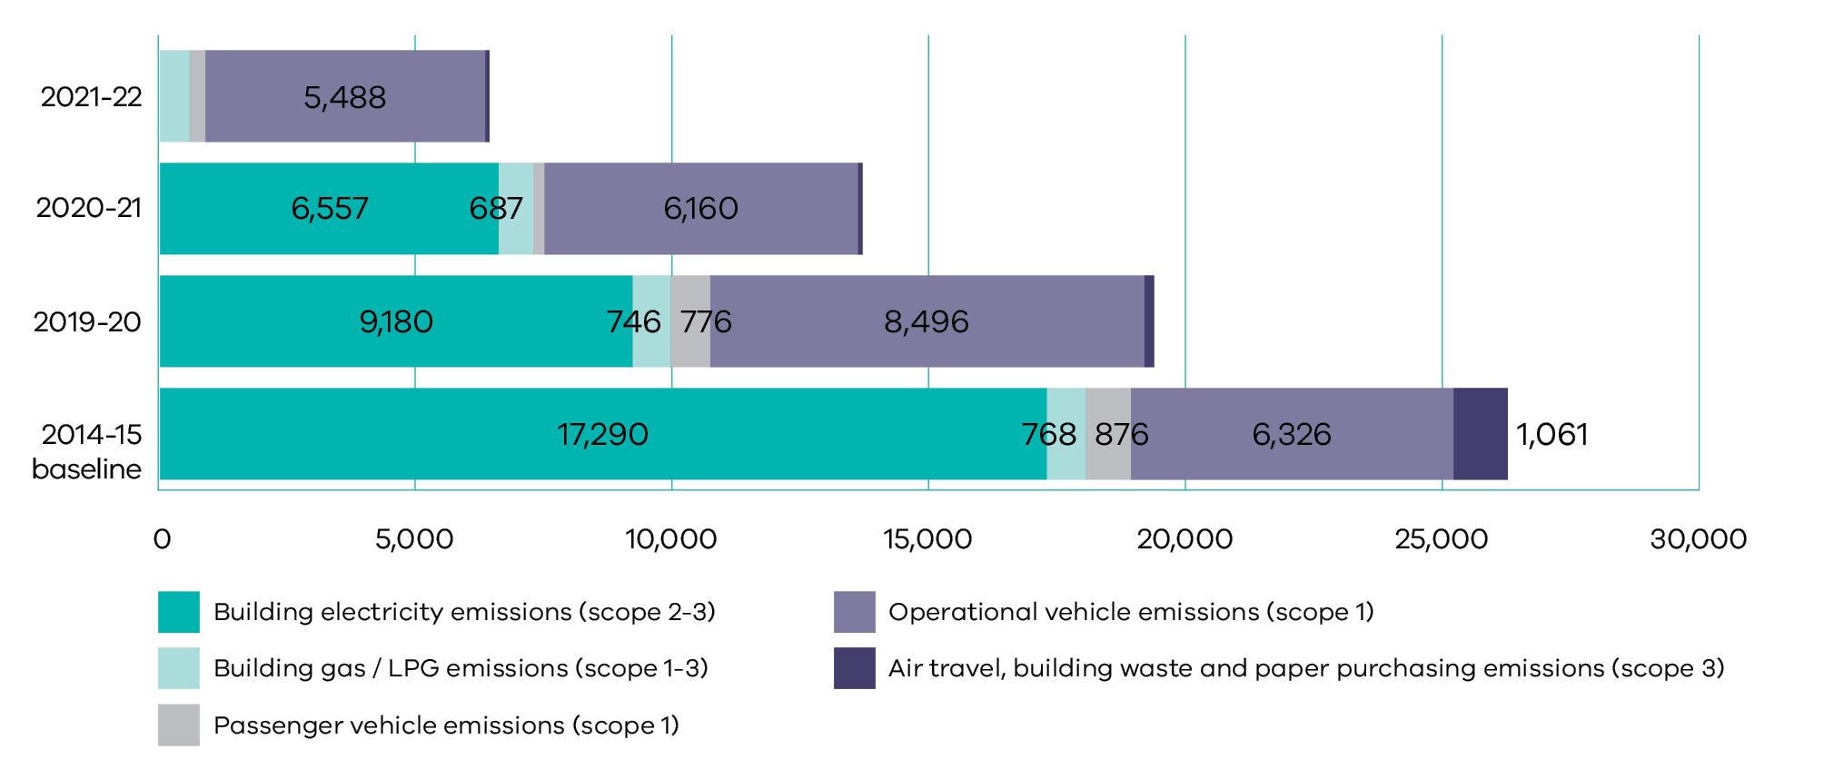

Actions undertaken:
- DELWP has committed to achieving net zero emissions by 2025 with a plan finalised over the 2021-22 reporting period.
- DELWP has committed to net zero reported electricity emissions from 2021-22 onwards. This has been achieved primarily through the purchasing of 100 per cent Green Power across all DELWP sites.
- 1,319 kW of solar PV panels have now been installed at 27 DELWP sites. These will reduce emissions by an estimated 1,112 tonnes CO₂-e per year.
- All DELWP managed new builds and significant rebuilds have LED lighting and solar installation as a standard requirement and will be built to both 6-star NABERS ratings and Green Star principles.
- DELWP has committed to a policy of ‘zero emissions vehicles (ZEVs) first’ for the shared passenger vehicle fleet as current vehicles leases expire. As at 30 June 2022, DELWP has 14 ZEVs in the shared passenger vehicle fleet.
- ACCUs have been purchased to offset 25 per cent of both operational vehicle emissions and building gas/LPG emissions.
DELWP has continued offsetting all departmental air travel through the state purchasing contract.

Future objectives:
- An additional 429kW of solar PV panels (out of the 2021 commitment of 550KW) will be installed at sites before 2025.
- DELWP will continue to purchase ACCUs towards offsetting emissions for both operational vehicles and building gas/LPG consumption to meet the 2025 net zero commitment.
- In the Hume region, DELWP is working with the Taungurung Land and Waters Council to put in place Power Purchase Agreements resulting in up to an additional 100kW of solar installations.

Total reported greenhouse gas emissions summary (tonnes CO₂-e):
 | 2021-22 | 2020-21 | 2019-20 | 2014-15 (baseline)
Total reported greenhouse gas emissions(i) | 6,374 | 13,683^{(ii)(iii)} | 19,393^{(ii) (iii)} | 26,321^{(iii)}
Total electricity emissions (scope 2 and scope 3) | 0 | 6,557^{(ii)} | 9,180^{(ii)} | 17,290
Total natural gas and LPG emissions (scope 1 and scope 3) | 513 | 687 | 746 | 768
Total passenger vehicle emissions (scope 1) | 309 | 222 | 776 | 876
Total operational vehicle emissions (scope 1) | 5,488 | 6,160^{(iii)} | 8,496^{(iii)} | 6,326^{(iii)}
Total air travel emissions (scope 3) | 0 | 0 | 0 | 850
Total building waste emissions (scope 3) | 44 | 42 | 70 | 72
Total paper purchasing emissions (scope 3) | 21 | 15 | 125 | 139
Explanatory notes:
(i) The total reported greenhouse gas emissions include FRD24 emissions (G1-G4), and emissions from non-office sites, operational vehicles and paper purchasing. A definition of emissions is provided below.
Scope 1: Emissions released to the atmosphere as a direct result of an activity
Scope 2: Emissions released to the atmosphere from the indirect consumption of an energy commodity. For example, ‘indirect emissions’ come from the use of electricity produced by the burning of coal in another facility.
Scope 3: Indirect emissions that are generated in the wider economy. They occur because of the activities of a facility, but from sources not owned or controlled by that facility’s business. For example, the indirect emissions attributable to the electricity lost in delivery in the transmission and distribution network.
(ii) These figures have been updated to include previously unavailable electricity data for 8 Nicholson Street, 2 Lonsdale Street, 1 Spring Street, Geelong and Laverton North.
(iii) Figures updated to include the full operational vehicle fleet. Previously emissions were only reported for the 4WDs and ultra-light tankers.

Total reported electricity emissions:
DELWP purchases 100 per cent Green Power for all sites to achieve net zero electricity emissions.
Total reported building electricity emissions (tonnes CO₂-e)
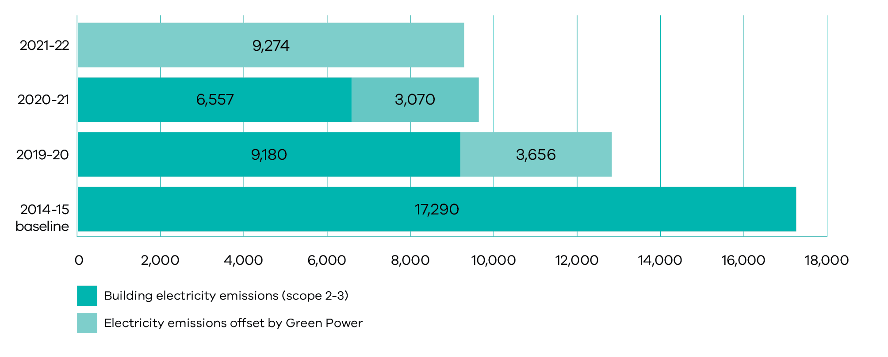
 | 2021-22 | 2020-21 | 2019-20 | 2014-15 (baseline)
Total reported electricity emissions (scope 2 and scope 3) | 0 | 6,557^{(ii)} | 9,180^{(ii)} | 17,290
Electricity emissions (scope 2) | 8,356 | 8,656^{(ii)} | 11,690^{(ii)} | 15,340
Electricity emissions (scope 3) | 918 | 972^{(ii)} | 1,146^{(ii)} | 1,950
Electricity emissions (scope 2 and scope 3) | 9,274 | 9,628^{(ii)} | 12,836^{(ii)} | 17,290
Electricity emissions offset by Green Power | 9,274 | 3,070^{(ii)} | 3,656^{(ii)} | 0
Explanatory notes:
(ii) These figures have been updated to include previously unavailable electricity data for 8 Nicholson Street, 2 Lonsdale Street, 1 Spring Street, Geelong and Laverton North.

Total reported gas and LPG emissions:
DELWP used ACCUs to offset 25 per cent of building gas and LPG emissions over 2021-22.
Total reported building gas/LPG emissions (tonnes CO₂-e)
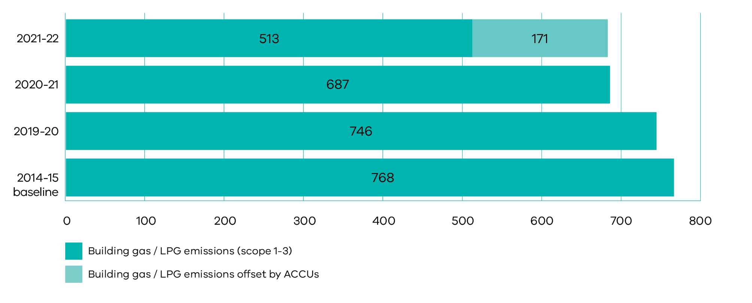
 | 2021-22 | 2020-21 | 2019-20 | 2014-15 (baseline)
Total reported natural gas and LPG emissions (scope 1 and scope 3) | 513 | 687 | 746 | 768
Natural gas emissions (scope 1) | 587 | 594 | 631 | 662
Natural gas emissions (scope 3) | 46 | 46 | 48 | 50
LPG emissions (scope 1) | 49 | 45 | 63 | 52
LPG emissions (scope 3) | 3 | 3 | 4 | 4
Natural gas and LPG emissions (scope 1 and scope 3) | 684 | 687 | 746 | 768
Natural gas and LPG emissions offset by ACCUs | 171 | 0 | 0 | 0

Total reported passenger vehicle emissions:
 | 2021-22 | 2020-21 | 2019-20 | 2014-15 (baseline)
Total reported passenger vehicle emissions (scope 1) | 309 | 222 | 776 | 876
Diesel emissions (scope 1) | 66 | 59 | 56 | 225
LPG emissions (scope 1) | 0 | 0 | 0 | 54
Unleaded emissions (scope 1) | 138 | 123 | 575 | 434
Hybrid emissions (scope 1) | 104 | 41 | 145 | 163

Total reported operational vehicle emissions:
DELWP used ACCUs to offset 25 per cent of operational vehicle emissions over 2021-22.
Total reported operational vehicle emissions (tonnes CO₂-e)
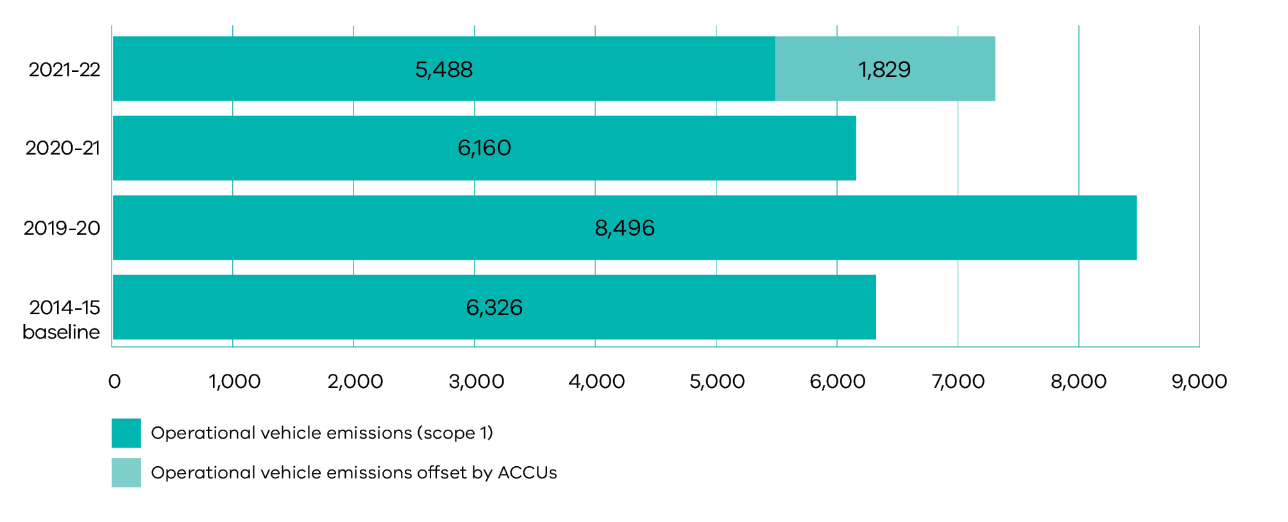
 | 2021-22 | 2020-21 | 2019-20 | 2014-15 (baseline)
Total reported operational vehicle emissions (scope 1) | 5,488 | 6,160^{(iii)} | 8,496^{(iii)} | 6,326^{(iii)}
Diesel emissions (scope 1) | 7,307 | 6,148 | 8,546 | 6,320
Unleaded emissions (scope 1) | 10 | 12 | 40 | 7
All operational vehicle emissions (scope 1) | 7,317 | 6,160^{(iii)} | 8,496^{(iii)} | 6,326^{(iii)}
Operational vehicle emissions offset by ACCUs | 1,829 | 0 | 0 | 0
Explanatory notes:
(iii) Figures updated to include the full operational vehicle fleet. Previously emissions were only reported for the 4WDs and ultra-light tankers.

Total reported air travel, building waste and paper purchasing emissions:
 | 2021-22 | 2020-21 | 2019-20 | 2014-15 (baseline)
Total reported air travel, building waste and paper purchasing emissions (scope 3) | 64 | 57 | 195 | 1,061
Air travel emissions (scope 3) | 37 | 3 | 580 | 850
Air travel emissions offset through the State Purchasing Contract | 37 | 3 | 580 | 0
Total reported air travel emissions (scope 3) | 0 | 0 | 0 | 850
Total reported building waste emissions (scope 3) | 44 | 42 | 70 | 72
Total reported paper purchasing emissions (scope 3) | 21 | 15 | 125 | 139

FRD24 greenhouse gas emissions:
 | 2021-22 | 2020-21 | 2019-20 | 2014-15 (baseline)
FRD24 greenhouse gas emissions (tonnes CO₂-e)^{(iv)} | 566 | 3,012^{(ii)} | 4,908^{(ii)} | 12,164
G1. Office energy emissions (including Green Power and ACCUs) (scope 1-3) | 213 | 2,748^{(ii)} | 4,062^{(ii)} | 10,366
G2. Passenger vehicle emissions (scope 1) | 309 | 222 | 776 | 876
G3. Air travel emissions (after SPC offsets) (scope 3) | 0 | 0 | 0 | 850
G4. Building waste emissions (scope 3) | 44 | 42 | 70 | 72
Explanatory notes:
(ii) These figures have been updated to include previously unavailable electricity data for 8 Nicholson Street, 2 Lonsdale Street, 1 Spring Street, Geelong and Laverton North.
(iv) FRD24 office based environmental reporting covers the mandated reporting performance indicators only.

ACCUs purchased:
 | 2021-22 | 2020-21 | 2019-20 | 2014-15 (baseline)
ACCUs used to offset emissions  8,329,076,344 – 8,329,078,343 | 2,000 | 0 | 0 | 0
ACCUs purchased  8,329,076,344 – 8,329,078,843 | 2,500 | 0 | 0 | 0
ACCUs banked for 2022-23  8,329,078,344 – 8,329,078,843 | 500 | 0 | 0 | 0
Explanatory notes:
- The total reported greenhouse gas emissions include FRD24 emissions (G1-G4), and emissions from non-office sites, operational vehicles and paper purchasing. A definition of emissions is provided below.
Scope 1: Emissions released to the atmosphere as a direct result of an activity
Scope 2: Emissions released to the atmosphere from the indirect consumption of an energy commodity. For example, ‘indirect emissions’ come from the use of electricity produced by the burning of coal in another facility.
Scope 3: Indirect emissions that are generated in the wider economy. They occur because of the activities of a facility, but from sources not owned or controlled by that facility’s business. For example, the indirect emissions attributable to the electricity lost in delivery in the transmission and distribution network.
- These figures have been updated to include previously unavailable electricity data for 8 Nicholson Street, 2 Lonsdale Street, 1 Spring Street, Geelong and Laverton North.
- Figures updated to include the full operational vehicle fleet. Previously emissions were only reported for the 4WDs and ultra-light tankers.
- FRD24 office based environmental reporting covers the mandated reporting performance indicators only.

Energy consumption
- Affordable and clean energy
Total grid energy consumption over the 2021-22 reporting period increased by 3 per cent since 2020-21 but decreased by 25 per cent since the 2014-15 baseline. The 2021-22 increase can be attributed to some staff transitioning back to the office after an extended period of working remotely. Overall the 2021-22 and 2020-21 reporting periods show reduced energy consumption compared to prior years due to staff working remotely due to COVIDSafe settings. Grid energy consumption has also fallen at sites where solar PV panels have been recently installed.
Total building grid energy consumption (MJ)
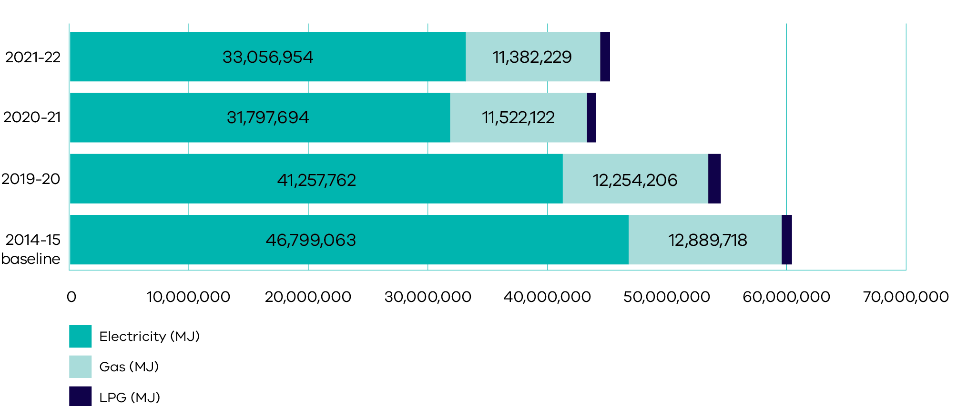

Actions undertaken:
- 1,319 kW of solar PV panels have been installed at 27 DELWP sites.
- All DELWP new builds and significant rebuilds have LED lighting and solar installation as a standard requirement and are built to both 6-star NABERS ratings and Green Start principles.
Participation in the global ‘Earth Hour’ event to promote and improve office energy efficiency.

Future objectives:
- An additional 429kW of solar PV panels (out of the 2021 commitment of 550KW) will be installed at sites before 2025.
- In the Hume region, DELWP is working with the Taungurung Land and Waters Council to put in place Power Purchase Agreements resulting in up to an additional 100kW of solar installations.
- DELWP will undertake an audit of gas and LPG use and work with sites and facility management to phase out gas and LPG consumption at DELWP managed sites wherever practical by 2025.
- DELWP will continue to purchase ACCUs towards offsetting emissions for building gas / LPG consumption to meet the 2025 net zero commitment.
DELWP will continue to evaluate energy use across the regions and remains committed to implementing measures to reduce overall energy consumption.

Performance:
 | 2021-22 | 2020-21 | 2019-20 | 2014-15 (baseline)
E1. Total energy usage segmented by primary source (MJ)^{(i)} | 45,245,924 | 44,056,344^{(ii)} | 54,555,001^{(ii)} | 60,549,860^{(iii)}
Electricity | 33,056,954 | 31,797,694^{(ii)} | 41,257,762^{(ii)} | 46,799,063^{(iii)}
Natural gas | 11,382,229 | 11,522,122 | 12,254,206 | 12,889,718
LPG^{(iv)} | 806,741 | 736,528 | 1,043,033 | 861,079
Office energy consumption | 24,446,830 | 24,158,800^{(ii)} | 30,418,243^{(ii)} | 34,692,053^{(iii)}
Non-Office energy consumption^{(v)} | 20,799,093 | 19,897,544^{(ii)} | 24,136,759^{(ii)} | 25,857,807
E2. Total greenhouse gas emissions from energy consumption, including Green Power and ACCUs (tonnes CO₂-e) | 513 | 7,244^{(ii)} | 9,926^{(ii)} | 18,057^{(iii)}
Total reported electricity emissions^{(vi)} | 0 | 6,557^{(ii)} | 9,180^{(ii)} | 17,290^{(iii)}
Total reported natural gas and LPG emissions^{(vii)} | 513 | 687 | 746 | 768
E3. Percentage of electricity purchased as Green Power^{(vi)} | 100% | 32% | 29% | 0%
Total electricity purchased as Green Power (MJ) | 33,056,954 | 10,140,480^{(ii)} | 11,751,509^{(ii)} | 0
E4. Units of office energy used per FTE (MJ/FTE) | 6,676 | 7,146^{(ii)} | 10,000^{(ii)} | 17,493^{(iii)}
E5. Units of office energy used per office area (MJ/m2) | 444 | 470^{(ii)} | 592 | 679
Cumulative installed Solar PV systems (kW) | 1,319 | 1,198 | 343 | 76
Cumulative number of sites with Solar PV systems | 27 | 25 | 16 | 7
Explanatory notes:
- Energy data is sourced directly from the government energy suppliers.
- These figures have been updated to include previously unavailable electricity data for 8 Nicholson Street, 2 Lonsdale Street, 1 Spring Street, Geelong and Laverton North.
- These figures have been updated to include previously unavailable electricity data for Geelong.
- This figure is based on LPG delivered to site (either as canisters or refilled into site LPG storage tanks). Canisters and tanks can remain unused for long periods of time.
- Under FRD24, departments are only required to report energy consumption and emissions for offices. DELWP reports beyond this, by including sites classified as non-offices.
- DELWP has committed to net zero reported electricity emissions from 2021-22 onwards. This has been achieved primarily through the purchasing of 100 per cent Green Power across all DELWP sites.
- ACCUs have been purchased to offset 25 per cent of building gas / LPG emissions.

Water consumption
- Clean water and sanitation
Total water consumption over the 2021-22 reporting period increased by 2 per cent since 2020-21 but decreased by 29 per cent since the 2014-15 baseline. The slight increase in 2021-22 is attributed to some staff transitioning back to the office after an extended period of working remotely. Overall, the 2021-22 and 2020-21 reporting periods show reduced water consumption compared to prior years due to staff working remotely due to COVIDSafe settings.
Total building water consumption (kL)
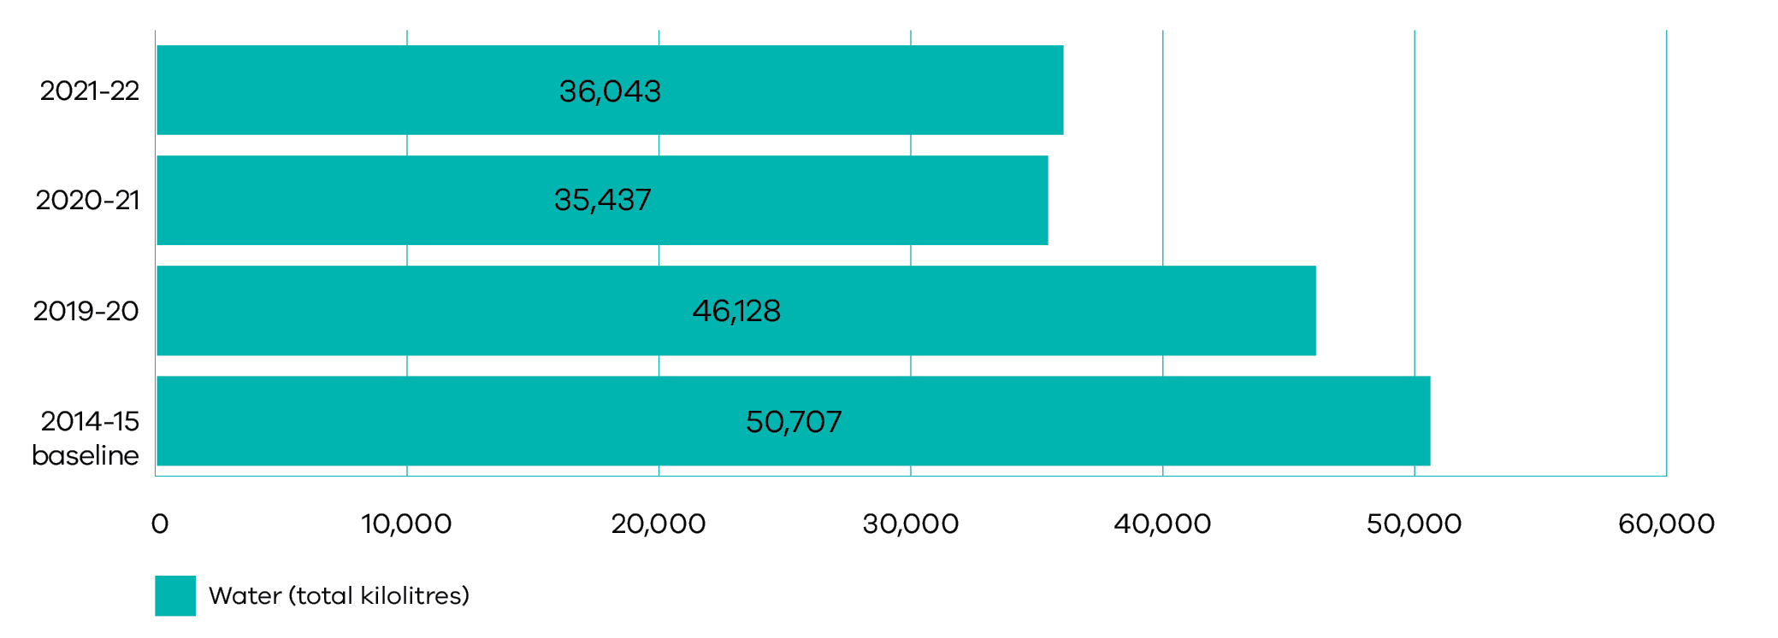

Actions undertaken:
- DELWP continued to track daily water consumption across 32 sites through the VicFacilities portal. This enabled faults to be identified in advance of billing data.
- All DELWP new builds and significant rebuilds have water efficient fixtures, water efficient appliances and rainwater systems as a standard requirement and are built to both NABERS 6 star and Green Star 6 star principles.
Water storage tanks continued to be installed at sites to both support firefighting operations and reduce the demand for mains water.

Future objectives:
DELWP will continue to actively evaluate water use across the regions and remains committed to reducing overall water consumption.

Performance:
 | 2021-22 | 2020-21 | 2019-20 | 2014-15 (baseline)
W1. Total water consumption (kilolitres)^{(i)} | 36,043 | 35,437^{(ii)} | 46,128^{(ii)} | 50,707
Office water consumption | 23,261 | 20,944 | 28,612 | 18,952
Non-office water consumption^{(iii)} | 12,782 | 14,494^{(ii)} | 17,516^{(ii)} | 31,755
W2. Units of office water used per FTE (kilolitres/FTE) | 6.4 | 6.2 | 9.4 | 9.6
W3. Units of office water used per office area (kilolitres/m2) | 0.4 | 0.4 | 0.6 | 0.4
Explanatory notes:
- Water data is sourced directly from water corporations, building managers, or estimated where data is unavailable. Water consumption for multi tenanted CBD sites (and some regional offices) is taken as a proportion of the total building water consumption. When a single water meter covers the whole building, data fluctuations are out of the control of DELWP.
- These figures have been updated to include revised data at the Laverton North site.
- Under FRD24, departments are only required to report water consumption for offices. DELWP reports beyond this, by including sites classified as non-offices.

Travel and transport
Total vehicle energy use over the 2021-22 reporting period has increased by 20 per cent since 2020-21 and increased by 6 per cent since the 2014-15 baseline. There was greater use of the operational vehicle fleet in 2021-22 than the previous year due to extended tenures of seasonal staff for increased patrols and preparedness works significantly ahead of and into the bushfire season. As at the end of the 2021-22 reporting period, 96 per cent of vehicle energy use is from the operational vehicle fleet, which includes the ultra-light tankers and the heavy fleet.

Actions undertaken:
- The Digital First program enabled greater collaboration and efficiency in the way staff work through technological innovations such as virtual meetings. DELWP aims to minimise travel whenever possible, and staff are also encouraged to utilise public transport options.
- DELWP has mandated a policy of ‘ZEV first’ for the shared passenger vehicle fleet. This vehicle fleet will transition to ZEVs by 2025 as current leases expire with supporting charging infrastructure also installed to assist this transition. The ZEV transition does not cover the executive vehicle fleet or the DELWP use of the Victorian Government carpool.
- A Forest and Fire Mixed Fleet strategy has been developed to consider the operational fleet capability and capacity required to meet DELWP’s land management and emergency response obligations. It will also investigate lower emissions vehicle options for future consideration.
- DELWP purchased ACCUs to offset 25 per cent of operational vehicle emissions.
- DELWP offsets all staff air travel through the state purchasing contract.
The Bicycle User Group continued to be widely promoted to help increase the profile of cycling across the department.

Future objectives:
- The remaining shared passenger vehicle fleet will transition to ZEVs by 2025 as part of the 2025 net zero commitment.
- DELWP will continue to purchase ACCUs towards offsetting emissions for the operational vehicle fleet to meet the 2025 net zero commitment.
DELWP will continue to offset air travel emissions through the state purchasing contract.
Total vehicle energy use (MJ)
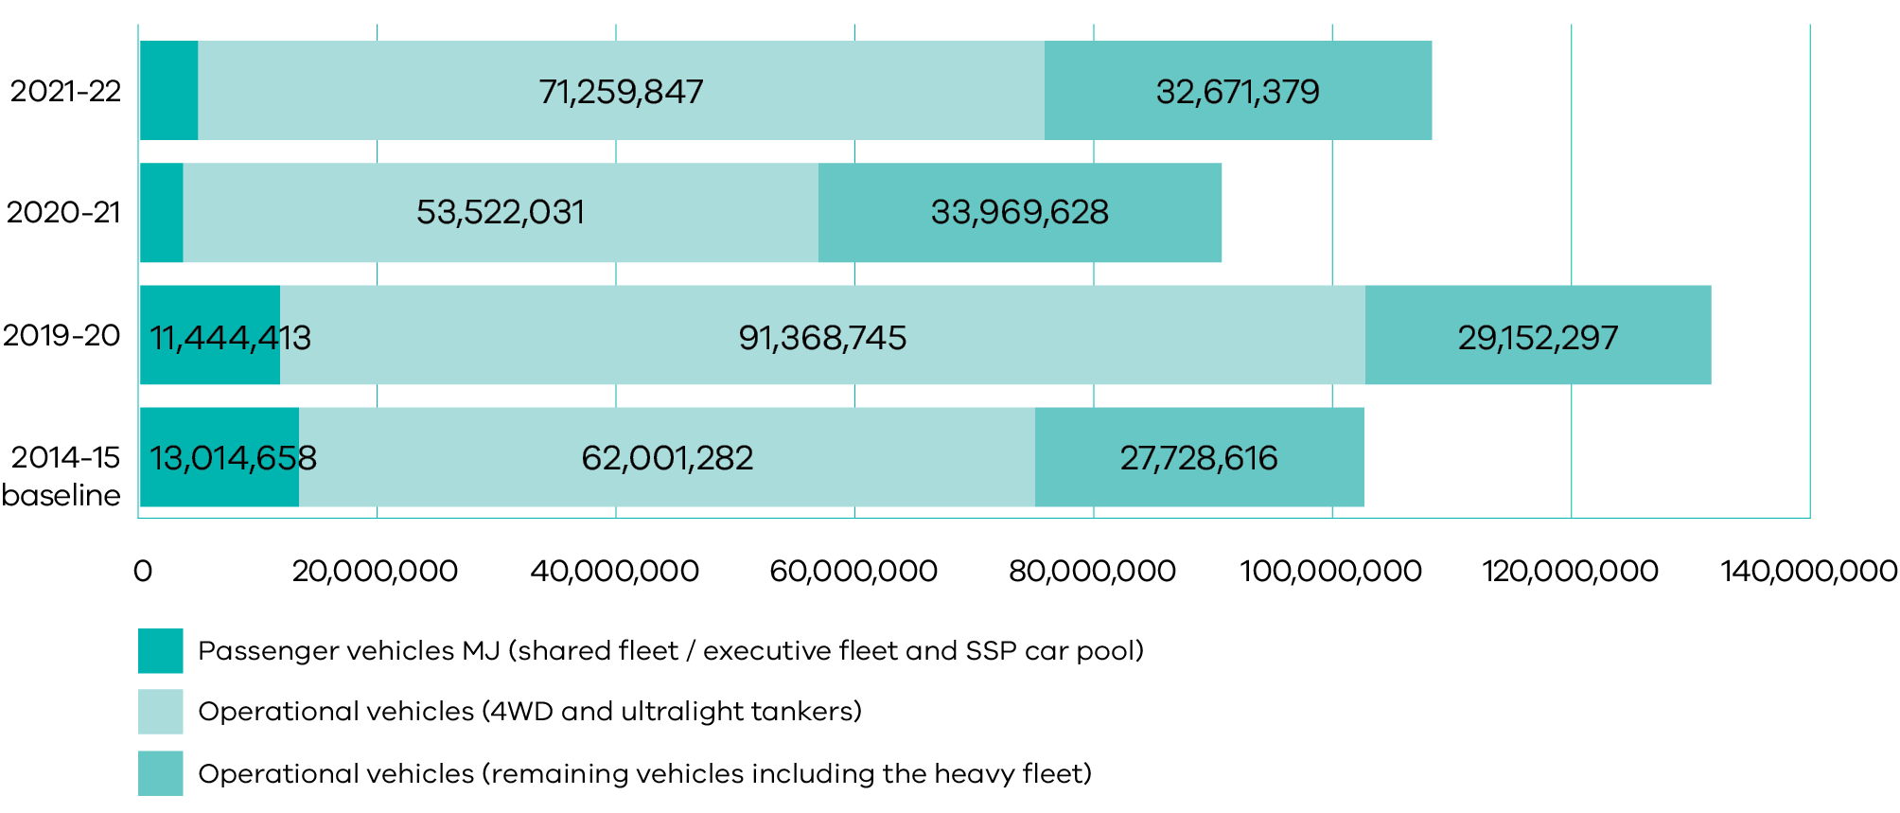
Number of fleet vehicles
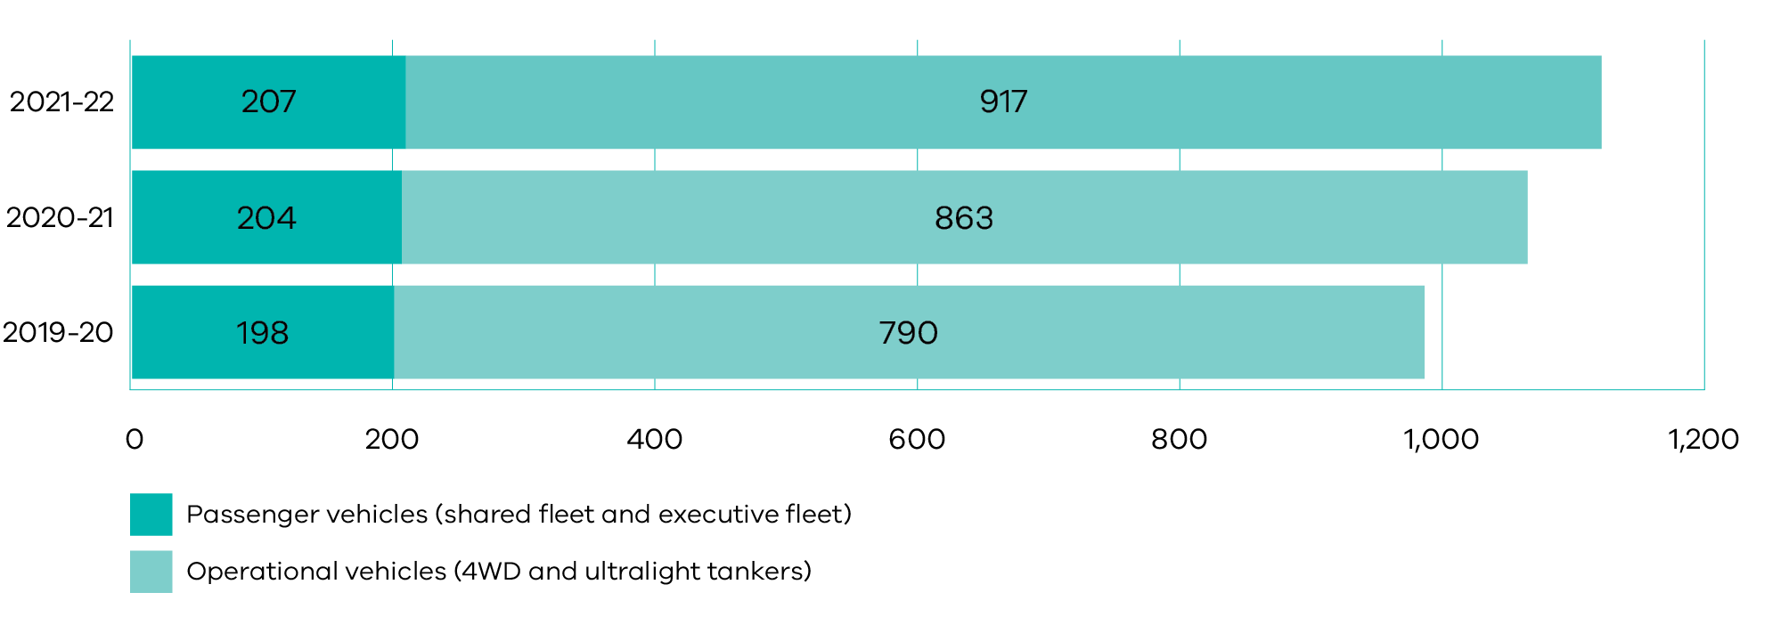

Performance:
 | 2021-22 | 2020-21 | 2019-20 | 2014-15 (baseline)
T1. Total energy consumption by fleet vehicles (MJ) | 108,459,485 | 90,742,224^{(ii)} | 131,965,454^{(ii)} | 102,744,556^{(ii)}
Total passenger vehicles | 4,528,259 | 3,250,566 | 11,444,413 | 13,014,658
Total operational vehicles | 103,931,226 | 87,491,658^{(ii)} | 120,521,042^{(ii)} | 89,729,898^{(ii)}
Diesel (passenger vehicles) | 935,860 | 837,850 | 798,251 | 3,187,266
LPG (passenger vehicles) | 0 | 0 | 0 | 895,201
Unleaded (passenger vehicles) | 2,044,922 | 1,812,263 | 8,497,693 | 6,491,421
Hybrid (passenger vehicles) | 1,545,326 | 600,452 | 2,148,468 | 2,440,770
ZEVs (passenger vehicles) | 2,150 | 0 | 0 | 0
Operational vehicles: 4WD and ultralight tankers | 71,259,847 | 53,522,031 | 91,368,745 | 62,001,282
Operational vehicles: remaining vehicles including the heavy fleet | 32,671,379 | 33,969,628 | 29,152,297 | 27,728,616
T2. Total distance travelled by fleet vehicles (km)^{(iii)} | 15,686,698 | 12,617,559 | 20,298,608 | 17,411,748
Passenger vehicles | 1,460,772 | 1,100,292 | 4,074,779 | 5,138,213
Operational vehicles | 14,225,926 | 11,517,267 | 16,223,829 | 12,273,535
Diesel (passenger vehicles) | 265,542 | 191,676 | 396,316 | 953,669
LPG (passenger vehicles) | 0 | 0 | 0 | 416,924
Unleaded (passenger vehicles) | 653,024 | 586,969 | 2,652,520 | 2,205,660
Hybrid (passenger vehicles) | 538,529 | 321,647 | 1,025,943 | 1,561,960
ZEVs (passenger vehicles) | 3,677 | 0 | 0 | 0
Operational vehicles: 4WD and ultralight tankers | 14,225,926 | 11,517,267 | 16,223,829 | 12,273,535
T3. Total greenhouse gas emissions from fleet vehicles (tonnes CO₂-e) | 5,797 | 6,382^{(ii)} | 9,272^{(ii)} | 7,203^{(ii)}
Passenger vehicles | 309 | 222 | 776 | 876
Operational vehicles | 5,488^{(iv)} | 6,160^{(ii)} | 8,496^{(ii)} | 6,326^{(ii)}
Diesel (passenger vehicles) | 66 | 59 | 56 | 225
LPG (passenger vehicles) | 0 | 0 | 0 | 54
Unleaded (passenger vehicles) | 138 | 123 | 575 | 434
ZEVs (passenger vehicles) | 0 | 0 | 0 | 0
Hybrid (passenger vehicles) | 104 | 41 | 145 | 163
T4. Greenhouse gas emissions from fleet vehicles per 1000km (tonnes CO₂-e)^{(iii)} | 0.21 | 0.20 | 0.19 | 0.17
Diesel (passenger vehicles) | 0.25 | 0.31 | 0.14 | 0.24
LPG (passenger vehicles) | N/A | N/A | N/A | 0.13
Unleaded (passenger vehicles) | 0.21 | 0.21 | 0.22 | 0.20
Hybrid (passenger vehicles) | 0.19 | 0.13 | 0.14 | 0.10
Operational vehicles: 4WD and ultralight tankers | 0.35 | 0.33 | 0.40 | 0.36
Total vehicle numbers | 1,124 | 1,067 | 988 | 867
Shared passenger fleet | 148 | 159 | 148 | Breakdown not available
Executive passenger fleet | 59 | 45 | 50 | 33
Operational vehicles: 4WD and ultralight tankers^{(v)} | 917 | 863 | 790 | Breakdown not available
Explanatory notes:
- DELWP reports on both the passenger vehicle fleet and operational vehicle fleet. The passenger vehicle fleet includes shared vehicles, executive vehicles and departmental use of the vehicle fleet managed through the Shared Services Provider. The operational vehicle fleet includes use of 4WD utility vehicles and Ultralight Tankers. Heavy Tankers, dozers and other heavy-duty vehicles and equipment are also now included in the report (with data added dating back to the 2014-15 baseline year). Data was obtained from fuel purchase records, lease data for vehicles and VicFleet. Accuracy is dependent on staff completing vehicle log sheets.
- Figures updated to include the full operational vehicle fleet. Previously emissions were only reported for 4WD and ultra-light tankers.
- This data is based on staff vehicle log sheets. Fuel efficiency estimates are used to calculate kilometres travelled when data sets are incomplete.
- ACCUs have been purchased to offset 25 per cent of operational vehicle emissions.
- The increase in numbers of operational vehicles was to meet the needs of an increased seasonal workforce, engaged to ensure a sufficient fire suppression response and recovery efforts following the 2019-20 bushfire season.

Air travel^{(i)}:
 | 2021-22 | 2020-21 | 2019-20 | 2014-15 (baseline)
T5. Total distance travelled by aeroplane (km) | 188,258 | 21,418 | 2,706,334 | 3,171,978
Total reported air travel emissions (tonnes CO₂-e) | 0 | 0 | 0 | 850
Explanatory notes:
- Air travel data is sourced from the government travel agent, Corporate Travel Management.
- All DELWP emissions from air travel have been offset since July 2016 through the government travel agent.

Staff travel^{(i)}:
 | 2021-22^{(ii)} | 2020-21^{(ii)} | 2019-20 | 2014-15 (baseline)
T6. CBD staff: Percentage using sustainable transport to get to work | N/A^{(ii)} | N/A^{(ii)} | 95% | 89%
T6. Metro staff: Percentage using sustainable transport to get to work | N/A^{(ii)} | N/A^{(ii)} | 17% | 30%
T6. Regional staff: Percentage using sustainable transport to get to work | N/A^{(ii)} | N/A^{(ii)} | 21% | 22%
Explanatory notes:
- Staff travel data is sourced from the annual staff travel survey in March.
- Due to COVIDSafe settings, most staff were working remotely in March 2021 and March 2022, so the survey did not take place.

Waste and recycling
- Responsible consumption and production
Total waste over the 2021-22 reporting period decreased by 30 per cent since 2020-21 and by 74 per cent since the 2014-15 baseline. A significant part of the reduction since the 2019-20 reporting period can be attributed to an increase in staff working remotely due to COVIDSafe settings.
Office based waste generation (kg)
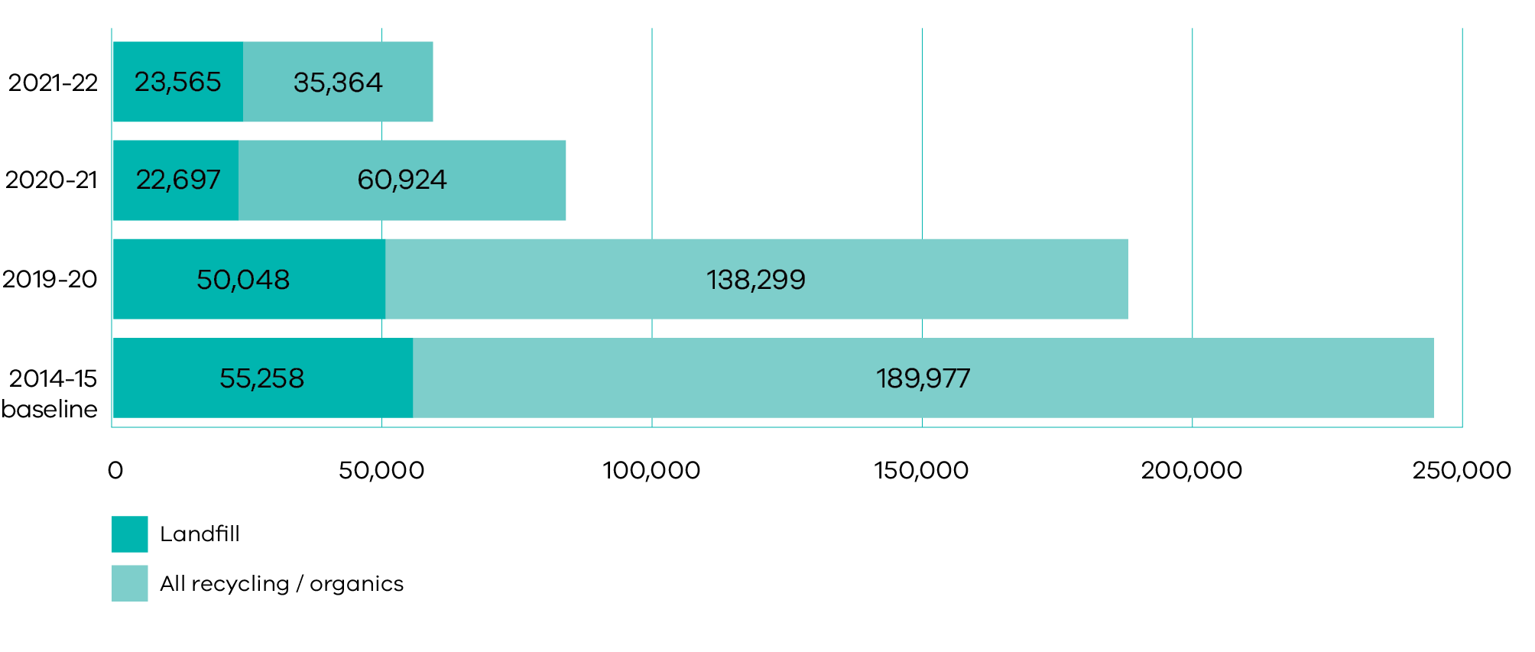

Actions undertaken:
- DELWP diverted 551 kilograms of metal, plastics, batteries, mobile phones, and stationery through the Green Collect recycling scheme.
- DELWP has phased out the use of specific single-use plastics at all sites and for all operations, including straws, cutlery, plates, drink stirrers, polystyrene food and drink containers and plastic cotton bud sticks. This aligns with the Tackling Plastic Pollution: single-use plastics ban and associated statewide Victorian Government commitment.
- DELWP continued to participate in the take-away coffee cup recycling scheme at 8 Nicholson Street.
- All redundant IT equipment was collected through the ReTech scheme, securely wiped and repurposed throughout the wider community.
- Excess office furniture and fit-out materials continued to be reused and recycled, reducing waste generated by office moves across all sites.
- Green Team volunteers managed soft plastics recycling at many DELWP sites throughout the state.
All office sites participated in used toner cartridge recycling collections.

Future objectives:
- DELWP will establish separate organic and glass collections at all sites as services become available within local councils. This will support an 80 per cent recycling rate target of kitchen and stationery room waste by 2025 (in advance of the 2030 Recycling Victoria (RV) targets).
- DELWP will also reduce the total volume of kitchen and stationery room waste by 15 per cent per FTE by 2025.
DELWP will continue to participate in a range of other additional voluntary recycling schemes.

Performance:
 | 2021-22 | 2020-21 | 2019-20 | 2014-15 (baseline)
Ws1. Total units of waste disposed of by destination (kg)^{(i)} | 58,929 | 83,620 | 188,347 | 245,235
Landfill (kg) | 23,565 | 22,697 | 50,048 | 55,258
Comingled recycling (kg) | 7,760 | 15,926 | 29,607 | 58,132
Paper and card (kg) | 16,592 | 13,992 | 50,502 | 65,911
Secure documents (kg) | 8,158 | 28,550 | 32,822 | 40,621
Organics (kg) | 2,853 | 2,456 | 25,368 | 25,313
Ws2. Total units of waste disposed of per FTE by destination (kg/FTE) | 11.4 | 17.2 | 41.6 | 82.9
Landfill (kg/FTE) | 4.5 | 4.7 | 11.1 | 18.7
Comingled recycling (kg/FTE) | 1.5 | 3.3 | 6.5 | 19.6
Paper and card (kg/FTE) | 3.2 | 2.9 | 11.2 | 22.3
Secure documents (kg/FTE) | 1.6 | 5.9 | 7.2 | 13.7
Organics (kg/FTE) | 0.6 | 0.5 | 5.6 | 8.6
Ws3. Recycling rate (%) | 60% | 73% | 73% | 77%
Ws4. Greenhouse gas emissions associated with waste (tonnes CO₂-e) | 44 | 42 | 70 | 72
Green Collect donations (kg) | 551 | 1,951 | 4,118 | 1,739
Explanatory notes:
- In accordance with FRD24, DELWP waste and recycling data is calculated from annual audits at 11 locations where 70 per cent total staff are located. Waste volumes were lower than previous years due to reduced staff numbers at sites because of COVIDSafe settings. The results are extrapolated to cover all DELWP FTEs. Due to FRD24 methodology, data can be subject to significant fluctuations. FRD24 reporting requires that waste and recycling data be collated for kitchens and stationery rooms only. Through signage and behavior change, DELWP can influence the proportions of waste and recycling to some extent. However, DELWP has minimal influence or control over the total volume of kitchen waste and recycling as this primarily consists of items that staff bring into the workplace.

Paper purchasing
Total paper purchasing over the 2021-22 reporting period increased by 40 per cent since 2020-21 but decreased by 86 per cent since the 2014-15 baseline. This increase can be attributed to the transition of some staff back to the office after an extended period of working remotely. Overall, the 2021-22 and 2020-21 reporting periods show reduced paper consumption compared to prior years due to staff working remotely due to COVIDSafe settings.
Total units of A4 equivalent copy paper purchased (reams)
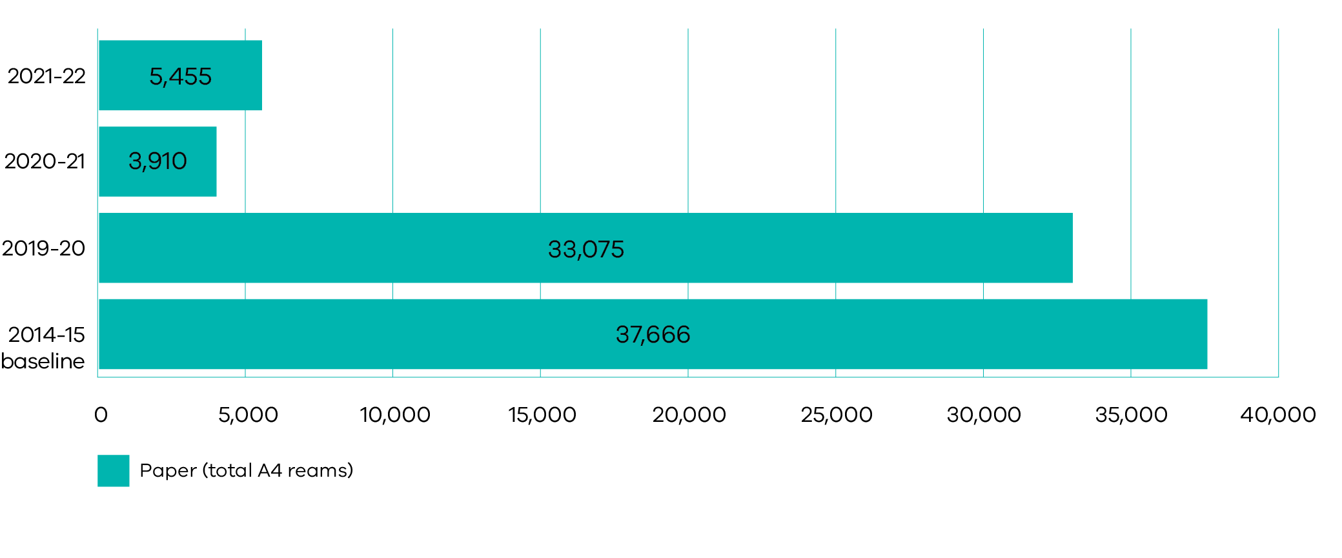

Actions undertaken:
- Completion of the Digital First program has enabled greater collaboration and efficiency in the way staff work.
- A printer policy has been implemented to both support the transition to a paperless office and reduce the number of printers across all sites.
- The default A4 white printer paper has 100 per cent recycled content.
- DELWP continued to ensure that staff can utilise the 100 per cent recycled paper wherever possible, by replacing old and outdated printers.
The Green Team continued to raise awareness of the volume of paper purchasing through staff behaviour change tools.

Future objectives:
The complete rollout of swipe card printing across all sites, which will reduce the amount of printer paper wastage commenced in March 2022.

Performance:
 | 2021-22 | 2020-21 | 2019-20 | 2014-15 (baseline)
P1. Total units of A4 equivalent copy paper purchased (reams)^{(i)} | 5,455 | 3,910 | 33,075 | 37,666
P2. Units of A4 equivalent copy paper used per FTE (reams/FTE) | 1.1 | 0.8 | 7.3 | 12.7
P3. 75-100% recycled content^{(ii)} | 98.3% | 98.6% | 97.6% | 81.7%
P3. 50-74% recycled content | 0% | 0% | 0% | 3.4%
P3. 0-49% recycled content | 1.7% | 1.4% | 2.4% | 14.9%
Total reported paper purchasing emissions (tonnes CO₂-e) | 21 | 15 | 125 | 139
Explanatory notes:
- DELWP paper purchasing is calculated using data from the government stationery supplier, Complete Office Supplies (COS)
- Restrictions are now in place to prevent any white paper being purchased with less than 100 per cent recycled content. All coloured paper available for purchasing continues to have no recycled content.

Greener procurement
- Responsible Consumption and production

Actions undertaken:
- DELWP has phased out use of specific single-use plastics at all sites, and for all operations, including straws, cutlery, plates, drink stirrers, polystyrene food and drink containers and plastic cotton bud sticks. This aligns with the Tackling Plastic Pollution: single-use plastics ban and associated statewide Victorian Government commitment.
- DELWP’s Procurement Team provides internal procurement advice to support and strengthen environmental procurement practices. Departmental templates for tendering and contracting are being finalised to incorporate requirements for tenders to demonstrate their environmental credentials and allow tender evaluation teams to weight and score this as a separate assessment criterion, where relevant.
- Staff seeking approval from the Chief Procurement Officer for significant procurement activities (of $200,000 and greater) are required to demonstrate how sustainability was considered in the evaluation.
- DELWP continued to implement its Social Procurement Strategy as a requirement of the Victorian Social Procurement Framework. This strategy includes measurable objectives on environmentally sustainable outputs and environmentally sustainable business practices for all procurement over $1 million.
- 73 per cent of printing jobs through Finsbury Green have used printers with a minimum two-star (out of five) environmental rating. This is a scheme established by Finsbury Green (who hold the state purchasing contract) to help improve environmental printing standards across the industry.
The default A4 white printer paper has 100 per cent recycled content.

Future objectives:
DELWP will continue to promote greener procurement and strengthen environmentally sustainable practices when procuring stationery, IT equipment, fleet vehicles and office furniture.

Financial Review
Table 1. Five-year financial summary
 | 2022  $’000 | 2021  $’000^{(iii)} | 2020  $’000^{(iv)} | 2019  $’000 | 2018  $’000
Income from government ^{(i)} | 2,373,698 | 2,477,285 | 2,168,943 | 1,987,429 | 1,603,784
Total income from transactions | 3,246,486 | 3,157,203 | 2,782,305 | 2,976,910 | 2,319,590
Total expenses from transactions | 3,114,827 | 3,184,016 | 2,785,079 | 2,800,466 | 2,165,945
Net result from transactions ^{(ii)} | 131,659 | (26,813) | (2,774) | 176,464 | 153,645
Net result for the period | 613,586 | 769,765 | (97,689) | 186,546 | 316,965
Net cash flow from operating activities | 215,478 | (31,678) | 69,824 | 17,991 | 134,556
Total assets | 12,210,155 | 10,344,722 | 8,487,868 | 9,029,020 | 11,664,496
Total liabilities | 894,127 | 740,993 | 430,920 | 416,018 | 382,475
Notes:
- Income from government includes both output and special appropriations.
- The ‘net result from transactions’ is identical to the ‘net operating balance’ for the general government sector.
- The comparative amounts in the five-year financial summary are not restated for the Machinery of Government change.
- Total income and expenses from transactions have been revised for 2020 following a review of the department’s chart of accounts and reclassifications to reflect classifications used by the Department of Treasury and Finance whole-of-government reporting.

Current year financial review

Overview
The Victorian Government considers the net result from transactions to be the appropriate measure of financial management that can be directly attributed to government policy. This measure excludes the effects of revaluations (holding gains or losses) arising from changes in market prices and other changes in the volume of assets shown under ‘other economic flows’ on the comprehensive operating statement, which are outside the control of the department.
In 2021-22, DELWP recorded a net result from transactions of $131.7 million, higher by $158.5 million on the 2020-21 net deficit of $26.8 million.

The coronavirus (COVID-19) pandemic and its impact on the financial statement
In 2020 and 2021 the Victorian government introduced COVIDSafe settings across Victoria to slow the spread of COVID-19 by reducing the number of people leaving their homes and moving around Victoria. This has had an impact on the operating and economic environment for the department and a number of policies and directions were introduced to assist, such as providing rent relief to lessees, establishing remote working environments for employees, and managing the distribution of funds for portfolio agencies and key stakeholders.
The impacts of COVID-19 on the department’s financial performance and financial position have been considered in the preparation of the 2021-22 Annual Report. Detailed impacts of the pandemic have been disclosed in the financial statements section of this report.

Financial performance and business review
In 2021-22, DELWP recorded a net surplus from transactions. The increase in total income of $89 million and a decrease in total expenses from transactions of $69 million resulted in total income exceeding total expenses.
The observed increase in total income is largely attributable to the increase in Municipal and Industrial Waste Levy, special appropriations and initial recognition income from financial instruments. This is partly offset by reductions in output appropriations and grants revenue.
The increase in total income is primarily due to the following:
- An increase of $169 million for Municipal and Industrial Waste Levy due to the increase in waste levy rates which came into effect on 1 July 2021. The metro rate increased from $65.90 in 2020-21 to $105.90 in 2021-22. Likewise, the regional rate increased from $33 (municipal) and $57.76 (industrial) to $53 and $93.20 respectively.
- Initial recognition income from financial instruments of $55 million for the initial recognition of the Bulgana derivative financial instrument following achievement of commercial operation in December 2021.
- An increase of $59 million in special appropriations for the Growth Areas Infrastructure Contribution.
An increase on other income by $17 million relating to habitat compensation associated with the Melbourne Strategic Assessment Program.
The increase in total income was partly offset by:
- Reductions of $163 million in output appropriations in line with annual parliamentary appropriations.
Grant income also decreased, by $57 million, mainly due to the wind down of the Goulburn Murray Water Connections Project – Stage 2 and one-off grant payments made in 2020-21 relating to recovery following the 2019-20 bushfires and COVID-19 pandemic.
The decrease in expenditure of $69 million is driven by prior year expenditure including:
- The initial recognition expense from financial instruments of $200 million relating to support to secure Victoria’s energy supply and support for the transition to renewable energy generation.
- A decrease in the capital asset charge of $96 million also contributed to the decline, following discontinuance on 1 July 2021.
A decrease in grants and other transfers of $54 million.
This has been partly offset by:
- An increase in supplies and services by $118 million predominantly due to compensation payments to landowners.
- An increase in employee expenses by $83 million mainly due to increased salaries and wages expenditure attributable to an increase in employee numbers, particularly for emergency management, Enterprise Bargaining Agreement salary increases of 2.75 percent and early retirement packages offered to employees impacted by restructuring arrangements.
The first-time repayment of loans under the Solar Home scheme to the Department of Treasury and Finance, of $74 million.
Other economic flows included in the net result had a gain of $482 million, a decrease of $315 million from 2020-21. A gain on financial instruments of $381 million was recorded in 2021-22 due to an increase in the fair value of derivative financial instruments resulting from the Victorian Renewable Energy Targets, an increase of $470 million.

Financial position – balance sheet
DELWP’s net assets increased by $1.7 billion from the 2021 financial year to $11.3 billion.
The observed increase in total assets, by $1.9 billion to $12.2 billion, is largely attributable to the increase in property, plant and equipment, derivative financial instruments and receivables.
Property, plant and equipment increased by $1.3 billion due to the managerial revaluation of land resulting from the 17 percent increase in land values and, to a lesser extent, land purchases in progress relating to compulsory land acquisitions for the Suburban Parks program. Derivative financial instruments increased by $349 million attributable to the fair value assessment of the derivatives relating to the Victorian Renewable Energy Targets which resulted in a gain for 2021-22. The increase in receivables of $193 million is largely due to the waste levy receivable from the Environment Protection Authority which is linked to the rise in waste levy rates which came into effect on 1 July 2021.
Total liabilities increased by $153 million primarily due to an increase in the provision for compulsory land acquisition relating to the Suburban Parks program ($133 million) and an increase in employee benefit provisions ($16 million), Enterprise Bargaining Agreement salary increases of 2.75 percent and a rise in oncosts for superannuation and the mental health and wellbeing surcharge.

Cash flows
DELWP’s net cash inflow from operating activities increased by $247.2 million resulting in an overall net cash inflow of $215.5 million. This increase reflects DELWP’s net result from transactions for the year, adjusted for the impact of non-cash items such as depreciation.

Subsequent events

Establishment of Recycling Victoria
On 14 December 2021, the Circular Economy (Waste Reduction and Recycling) Act 2021 received royal assent. The Act saw the establishment of Recycling Victoria on 1 July 2022, a dedicated business unit within DELWP that provides strategic leadership and oversight of the waste and recycling sector. On commencement, the seven Waste and Resource Recovery Groups (WRRGs), as well as the infrastructure planning function performed by Sustainability Victoria transferred to DELWP. The assets and liabilities of the WRRGs and the Sustainability Victoria function will transfer to DELWP via contributed capital as per the requirement of Financial Reporting Direction 119 on 1 July 2022. The estimated amount of total net assets to be transferred is $7 million.

Financial governance
The department diligently exercises its various financial management obligations which include compliance with the provisions of the Financial Management Act 1994, the Standing Directions 2018 under the Financial Management Act 1994 (directions) and taxation legislation.
The department’s compliance with the directions is formally assessed at 30 June each year. The department prepares and publishes in its annual report, a public attestation of its material compliance with direction requirements. There is also a rolling internal audit program in place to review the department’s compliance with the directions.
The department also maintains financial policies and procedures to ensure good governance, effective internal controls and consistency with financial reporting. These documents are reviewed regularly and updated as appropriate to ensure ongoing relevance and conformance to external reporting requirements.
Financial transactions are subject to regular compliance reviews by the Financial Compliance team within the Finance, Infrastructure and Procurement Services division in DELWP.
Governance of Financial Management (GOFM) training is mandatory for all new financial delegates within the department. Refresher GOFM training is to be undertaken every four years for financial delegations to be maintained. Governance and integrity training is available online and compulsory for all staff.
Leadership teams throughout the department actively participate in financial management. Financial compliance continues to be embedded into work practices. Regular communication of the requirements will continue through financial forums and daily work practices.
These activities form part of the department’s commitment to championing a culture of integrity within the public sector.

Budget portfolio outcome statements
A comparison of the budget portfolio outcome statements for the department, as published in the 2021-22 Budget Paper No. 5, and the actual results for the year can be found at Appendix 4.

Attestation for financial management compliance with Ministerial Standing Directions 5.1.4
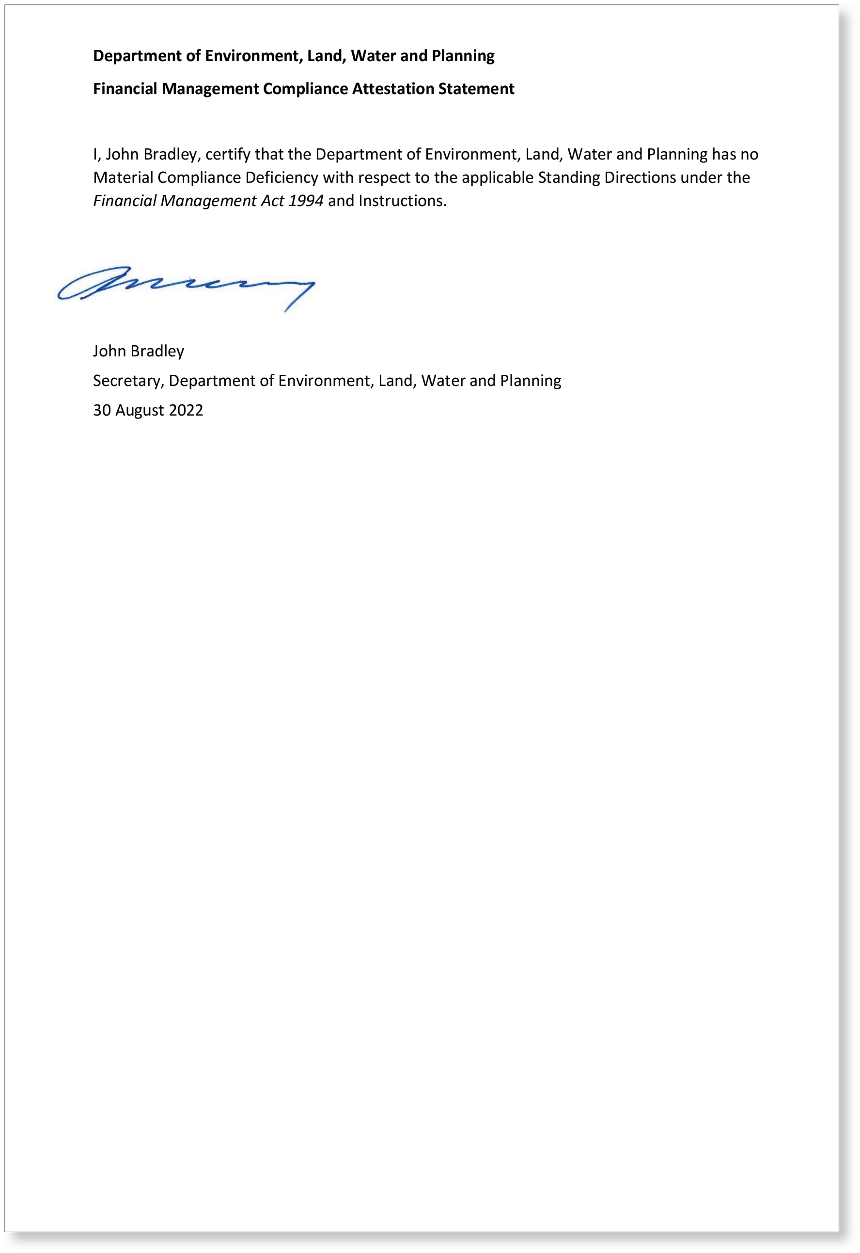

Legislative and other information

Major Entities

Energy, Environment and Climate Action
Environment Protection Authority
Parks Victoria
Energy Safe Victoria
Sustainability Victoria
Commissioner for Environmental Sustainability
Zoological Parks and Gardens Board
Royal Botanic Gardens Board Victoria
Trust for Nature (Victoria)
Budj Bim Council
Dhelkunya Dja Land Management Board
Gunaikurnai Traditional Owner Land Management Board
Yorta Yorta Traditional Owner Land Management Board
Barwon South West Waste and Resource Recovery Group ^{(i)}
Gippsland Waste and Resource Recovery Group ^{(i)}
Goulburn Valley Waste and Resource Recovery Group ^{(i)}
Grampians Central West Waste and Resource Recovery Group ^{(i)}
Loddon Mallee Waste and Resource Recovery Group^{(i)}
North East Waste and Resource Recovery Group ^{(i)}
Metropolitan Waste and Resource Recovery Group ^{(i)}
Falls Creek Alpine Resort Management Board
Mount Buller and Mount Stirling Alpine Resort Management Board
Mount Hotham Alpine Resort Management Board
Southern Alpine Resort Management Board
Phillip Island Nature Parks Board of Management
Caulfield Racecourse Reserve Trust
Director of National Parks
Alpine Resorts Coordinating Council
Great Ocean Road Coast and Parks Authority
Marine and Coastal Council
National Parks Advisory Council
Victorian Environmental Assessment Council
Electric Line Clearance Consultative Committee
Victorian Electrolysis Committee
Reference Areas Advisory Committee
Scientific Advisory Committee
Committees of Management (various) and trustees appointed under restricted Crown grants^{(ii)}
Ministerial advisory committees (various)

Planning
Victorian Planning Authority
Heritage Council
Architects Registration Board of Victoria and Panel List
Surveyors Registration Board of Victoria
Geographic Place Names Advisory Panel
Growth Areas Infrastructure Contribution Hardship Relief Board
Victorian Building Authority
Building Appeals Board
Building Regulations Advisory Committee
Cladding Safety Victoria
Plumbing Advisory Council
Royal Exhibition Building World Heritage Area Steering Committee
Planning panels and advisory committees established under the Planning and Environment Act 1987 (various)
Environmental Effects Inquiries established under the Environmental Effects Act 1978 (various)

Water
Birrarung Council
Border Groundwater Agreement Review Committee
Barwon Region Water Corporation
Central Gippsland Region Water Corporation
Central Highlands Region Water Corporation
Coliban Region Water Corporation
East Gippsland Region Water Corporation
Gippsland and Southern Rural Water Corporation
Goulburn-Murray Rural Water Corporation
Goulburn Valley Region Water Corporation
Grampians Wimmera Mallee Water Corporation
Greater Western Water^{(iii)}
Lower Murray Urban and Rural Water Corporation
Melbourne Water Corporation^{(iv)}
North East Region Water Corporation
South East Water Corporation
South Gippsland Region Water Corporation
Wannon Region Water Corporation
Westernport Region Water Corporation
Yarra Valley Water Corporation
Corangamite Catchment Management Authority
East Gippsland Catchment Management Authority
Glenelg Hopkins Catchment Management Authority
Goulburn Broken Catchment Management Authority
Mallee Catchment Management Authority
North Central Catchment Management Authority
North East Catchment Management Authority
West Gippsland Catchment Management Authority
Wimmera Catchment Management Authority
Victorian Environmental Water Holder
Note:
- The seven Waste and Resource Recovery Groups were abolished on 30 June 2022 under the Circular Economy (Waste Reduction and Recycling) Act 2021. Recycling Victoria commenced operating on 1 July 2022.
- In the DELWP portfolio there are approximately 1,000 committees of management established under the Crown Land (Reserves) Act 1978 and approximately 35 restricted Crown grants where trustees manage one or more Crown land reserves. Major incorporated committees of management include Barwon Coast Committee of Management, Bellarine Bayside Foreshore Committee of Management; Working Heritage; and Winton Wetlands Committee of Management.
- On 1 July 2021, Western Region Water Corporation and City West Water. were integrated, and Greater Western Water was established.
- On 1 January 2022, the Port Phillip and Westernport Catchment Management Authority (PPWCMA) was integrated into Melbourne Water, and PPWCMA ceased to exist.

Acts administered

Minister for Energy
Electricity Industry Act 2000
Electricity Safety Act 1998
Energy Safe Victoria Act 2005
Fuel Emergency Act 1977
Gas Industry Act 2001
Gas Safety Act 1997
National Electricity (Victoria) Act 2005
National Gas (Victoria) Act 2008
Pipelines Act 2005
Renewable Energy (Jobs and Investment) Act 2017
Except sections 8 and 10 which are jointly and severally administered with the Minister for Solar Homes in so far as these provisions relate to the Solar Homes program
State Electricity Commission Act 1958
Section 107 only, the Act is otherwise administered by the Treasurer.
Victorian Energy Efficiency Target Act 2007
Victorian Renewable Energy Act 2006

Minister for Environment and Climate Action
Aboriginal Lands Act 1991
The Act is jointly and severally administered with the Minister for Treaty and First Peoples
Alpine Resorts Act 1983
Alpine Resorts (Management) Act 1997
Catchment and Land Protection Act 1994
The Act is jointly and severally administered with the Minister for Water.
Caulfield Racecourse Reserve Act 2017
Circular Economy (Waste Reduction and Recycling) Act 2021
Climate Change Act 2017
Except certain provisions jointly administered with the Premier and jointly and severally administered with the Minister for Solar Homes in so far as those provisions relate to the Solar Homes program.
Commissioner for Environmental Sustainability Act 2003
Conservation, Forests and Lands Act 1987
Except certain provisions administered by the Minister for Fishing and Boating and jointly and severally administered with the Minister for Water or jointly administered with, jointly and severally administered with, or solely administered by, the Minister for Agriculture.
Crown Land (Reserves) Act 1978
Except certain provisions for Crown Allotments administered by the Premier, the Assistant Treasurer, the Minister for Business Precincts, the Minister for Ports and Freight, the Minister for Tourism, Sport and Major Events, the Minister for Corrections and the Minister for Health.
Cultural and Recreational Lands Act 1963
Dental Hospital Land Act 2011
Environment Protection Act 1970
Environment Protection Act 2017
Flora and Fauna Guarantee Act 1988
Except certain provisions jointly administered with the Minister for Agriculture.
Forests Act 1958
Except certain provisions jointly and severally administered with the Minister for Agriculture or solely administered by the Minister for Agriculture.
Geelong Lands (Steampacket Place) Act 1996
Geelong Market Site Act 1983
Great Ocean Road and Environs Protection Act 2020
Heritage Rivers Act 1992
Land Act 1958
Except certain provisions for Crown Allotments jointly administered with the Assistant Treasurer, or administered by the Assistant Treasurer, the Attorney-General, the Minister for Corrections, the Minister for Health, the Minister for Government Services, the Minister for Ports and Freight, Minister for Roads and Road Safety and the Minister for Creative Industries.
Land Conservation (Vehicle Control) Act 1972
Except section 3 which is jointly administered with the Minister for Agriculture.
Land (Further Miscellaneous Matters) Act 1990
Land (Goonawarra Golf Course) Act 1988
Land (Miscellaneous Matters) Act 1988
Land (Miscellaneous Matters) Act 2005
Land (Reservations and other Matters) Act 1997
Land (Reservations and other Matters) Act 1999
Land (Revocation of Reservations – Metropolitan Land) Act 2016
Land (Revocation of Reservations – Regional Victoria Land) Act 2016
Land (Revocation of Reservations) Act 2008
Land (Revocation of Reservations) Act 2012
Land (Revocation of Reservations) Act 2016
Land (Revocation of Reservations) Act 2019
Land (Revocation of Reservations and Other Matters) Act 2009
Land (Revocation of Reservations) (Convention Centre Land) Act 2008
Land (St. Kilda Sea Baths) Act 2000
Land (St Kilda Triangle) Act 2006
Lands (Miscellaneous Matters) Act 1984
Marine and Coastal Act 2018
Melbourne and Olympic Parks Act 1985
Sections 24-28 only, the Act is otherwise administered by the Premier, the Minister for Business Precincts and the Minister for Tourism, Sport and Major Events.
Melbourne Strategic Assessment (Environment Mitigation Levy) Act 2020
Melbourne (Yarra Park) Land Act 1980
Except sections 8 and 18 which are jointly and severally administered with the Minister for Business Precincts.
National Environment Protection Council (Victoria) Act 1995
National Parks Act 1975
Parks and Crown Land Legislation (Mount Buffalo) Act 2010
Parks Victoria Act 2018
Planning and Environment Act 1987
Parts 1A, 2, 3, 4, 6, 7, 8 and 9 are jointly and severally administered with the Minister for Planning in so far as they related to decisions relating to the activities or interests of Director of Housing or the Minister for Housing. The Act is otherwise administered by the Minister for Planning and the Treasurer.
Pollution of Waters by Oil and Noxious Substances Act 1986
Sections 8, 9, 10, 11, 12, 13, 18, 19, 20, 21, 22, 23, 23B, 23D, 23E, 23G, 23J, 23K, 23L and 24E. Sections 30 and 47 are jointly administered with the Minister for Ports and Freight. The Act is otherwise administered by the Minister for Ports and Freight.
Queen Victoria Market Lands Act 1996
Reference Areas Act 1978
Royal Agricultural Show-grounds Act 1931
Royal Agricultural Showgrounds Act 2003
Royal Botanic Gardens Act 1991
Royal Children’s Hospital (Land) Act 2007
Royal Women’s Hospital Land Act 2012
Safety on Public Land Act 2004
South Melbourne Land Act 1986
Southgate Project Act 1994
State Owned Enterprises Act 1992
Division 2 of Part 2 in so far as it relates to the Victorian Plantations Corporation. The Act is otherwise administered by the Minister for Government Services, the Minister for Multicultural Affairs, the Minister for Water and the Treasurer.
Sustainable Forests (Timber) Act 2004
Part 2, section 45, Division 1 of Part 6 and Part 8.
Sections 3, 22, 23(1) and 24 and Part 9 are jointly administered with the Minister for Agriculture and the Act is otherwise administered by the Minister for Agriculture.
Sustainability Victoria Act 2005
Swan Hill Pioneer Settlement Authority (Repeal) Act 1994
Temperance Halls Act 1958
University of Melbourne Land Act 2000
Victorian Conservation Trust Act 1972
Victorian Environmental Assessment Council Act 2001
Victorian Plantations Corporation Act 1993
Water Industry Act 1994
Parts 4, 4A, 7 and 8.
Section 184 is administered jointly and severally with the Minister for Water and the Act is otherwise administered by the Minister for Water.
Wildlife Act 1975
Except for certain provisions jointly administered with the Minister for Agriculture or administered solely by the Minister for Agriculture.
Zoological Parks and Gardens Act 1995

Minister for Planning
Architects Act 1991
Building Act 1993
Building and Construction Industry Security of Payment Act 2002
Casino Control Act 1991
Sections 128H-128L, except section 128K(2). The Act is otherwise administered by the Assistant Treasurer and the Minister for Consumer Affairs, Gaming and Liquor Regulation.
Cladding Safety Victoria Act 2020
Electronic Conveyancing (Adoption of National Law) Act 2013
Electronic Conveyancing National Law (Victoria)
Environment Effects Act 1978
Geographic Place Names Act 1998
Heritage Act 2017
Instruments Act 1958
Only in so far as it relates to the functions of the Registrar-General and the management of the Office of the Registrar-General. The Act is otherwise administered by the Attorney-General.
Local Government Act 1989
Part 8B only. The Act is otherwise administered by the Attorney-General, the Minister for Local Government, and the Minister for Roads and Road Safety.
Nudity (Prescribed Areas) Act 1983
Planning and Environment Act 1987
Except Part 9B which is jointly and severally administered with the Treasurer and Parts 1A, 2, 3, 4, 6, 7, 8 and 9, which are jointly and severally administered with the Minister for Energy, Environment and Climate Action in so far as they related to decisions relating to the activities or interests of the Director of Housing or the Minister for Housing.
Planning and Environment (Planning Schemes) Act 1996
Project Development and Construction Management Act 1994
Section 46, Part 7, and Part 5A in so far as Part 5A relates to the exercise of powers and functions under Part 9A of the Planning and Environment Act 1987. The Act is otherwise administered by the Premier, the Assistant Treasurer, the Minister for Business Precincts and the Minister for Transport Infrastructure.
Property Law Act 1958
Only in so far as it relates to the functions of the Registrar-General and the management of the Office of the Registrar-General. The Act is otherwise administered by the Attorney-General.
Residential Tenancies Act 1997
Part 14 only. The Act is otherwise administered by the Attorney-General, the Minister for Consumer Affairs, Gaming and Liquor Regulation, the Minister for Disability, Ageing and Carers and the Minister for Housing.
South Yarra Project (Subdivision and Management) Act 1985
Subdivision Act 1988
Except Part 5, section 43 (in so far as it relates to Part 5) which are administered by the Minister for Consumer Affairs, Gaming and Liquor Regulation.
Survey Co-ordination Act 1958
Surveying Act 2004
Transfer of Land Act 1958
Only in so far as it relates to the functions of the Registrar of Titles and the management of the Office of Titles. The Act is otherwise administered by the Attorney-General.
Valuation of Land Act 1960
Except Divisions 1 and 2 of Part III, Divisions 4 and 5 of Part III where they relate to the determination of appeals by a Land Valuation Division of the Victorian Civil and Administrative Tribunal and Part IV in so far as it relates to the administration of the above provisions which are administered by the Attorney-General.
Victorian Planning Authority Act 2017
Except section 36 which is jointly and severally administered with the Minister for the Suburban Rail Loop and the Minister for Transport Infrastructure in so far as it relates to seeking advice in relation to functions and powers of the Suburban Rail Loop Authority, and jointly and severally administered with the Minister for Business Precincts and the Minister for Transport Infrastructure in so far as it relates to seeking advice in respect of Major Urban Renewal Precincts.

Minister for Solar Homes
Climate Change Act 2017
Part 4, Division 1 of Part 5 and section 97 which are jointly and severally administered with the Minister for Energy, Environment and Climate Action in so far as these provisions relate to the Solar Homes program. The Act is otherwise administered by the Minister for Energy, Environment and Climate Action and the Premier.
Renewable Energy (Jobs and Investment) Act 2017
Sections 8 and 10 which are jointly and severally administered with the Minister for Energy in so far as those provisions relate to the Solar Homes program. The Act is otherwise administered by the Minister for Energy.

Minister for Water
Catchment and Land Protection Act 1994
The Act is jointly and severally administered with the Minister for Energy, Environment and Climate Action
Conservation, Forests and Lands Act 1987
In so far as it relates to the exercise of powers for the purposes of the Catchment and Land Protection Act 1994 the powers are jointly and severally administered with the Minister for Energy, Environment and Climate Action The Act is otherwise administered by the Minister for Agriculture, the Minister for Energy, Environment and Climate Action and the Minister for Fishing and Boating.
Groundwater (Border Agreement) Act 1985
Murray-Darling Basin Act 1993
State Owned Enterprises Act 1992
Division 2 of Part 2 in so far as it relates to the Water Training Centre. The Act is otherwise administered by the Minister for Government Services, the Minister for Energy, Environment and Climate Action, the Minister for Multicultural Affairs and the Treasurer.
Water Act 1989
Except section 324 which is jointly and severally administered with the Minister for Fishing and Boating in so far as it relates to the making of regulations for houseboats.
Water (Commonwealth Powers) Act 2008
Water Efficiency Labelling and Standards Act 2005
Water Industry Act 1994
Except section 184 which is jointly and severally administered with the Minister for Energy, Environment and Climate Action and Parts 4, 4A, 7 and 8 which are administered by the Minister for Energy, Environment and Climate Action.
Yarra River Protection (Wilip-gin Birrarung murron) Act 2017

Land Titles and Registry Functions of Land Use Victoria
The commercialisation of part of land registry functions in September 2018 requires that the private operator, Secure Electronic Registries Victoria Pty Ltd (SERV) (formerly Victorian Land Registry Services Pty Ltd), report on key performance measures as detailed in the signed concession deed.
The key performance measures below compare the targets in the Operating Concession Deed and the actual results from the delivery of services provided by SERV.
Performance measures | Unit of measure | 2021-22 actual | 2021-22 target | Performance variation (%) | Result
Availability of call centre in the land registration business | per cent | 100 | 100 | 0
Availability of call centre in the Landata business | per cent | 100 | 100 | 0
Timeliness of calls answered in the land registration business | per cent | 89 | 80 | 11
Timeliness of calls answered in the Landata business | per cent | 95 | 90 | 6
Timeliness of response to enquiries from the public in the Landata business where direct contact is made | per cent | 100 | 99 | 1
Timeliness of providing information to State arising from Freedom of Information (FOI) requests | per cent | 100 | 99 | 1
Availability of online title searches | per cent | 100 | 99 | 1
Delivery of online title search products | per cent | 100 | 99 | 1
Timeliness of online planning certificate delivery | per cent | 100 | 99 | 1

There have been no reported data breaches.
The total of statutory fees collected and paid into consolidated revenue in 2021-22 was $492 million.
SERV receives revenue from statutory and non-statutory search services and a service fee for registration services. In 2021-22 SERV received $135 million from statutory fees and $48.5 million from non-statutory fees.

Implementation of the Local Jobs First Policy
The Local Jobs First Act 2003 brings together the Victorian Industry Participation Policy (VIPP) and Major Project Skills Guarantee (MPSG) policy, which were previously administered separately.
Departments and public sector bodies are required to apply the Local Jobs First Policy in all projects valued at $3 million or more in metropolitan Melbourne or for statewide projects, or $1 million or more for projects in regional Victoria.
The MPSG applies to all construction projects valued at $20 million or more.
The MPSG guidelines and VIPP guidelines will continue to apply to MPSG-applicable and VIPP applicable projects respectively, where contracts were entered prior to 15 August 2018.

Projects commenced – Local Jobs First Standard
During 2021-22, the department commenced 86 Local Jobs First standard projects totalling $654.55 million to which a Local Industry Development Plan (LIDP) was required. Of those projects, 56 were located in regional Victoria with an average local content commitment of 69 per cent, and 30 in metropolitan Melbourne with an average local content commitment of 91 per cent. No standard projects were commenced that occurred statewide. The MPSG applied to seven of these projects.
The outcomes expected from the implementation of the Local Jobs First policy to these projects where information was provided, are as follows:
- an average local content commitment of 77 per cent
- a total of 813 jobs (annualised employee equivalent (AEE)), including the creation of 163 new jobs and the retention of 650 existing jobs (AEE)
- a total of 62 positions for apprentices, trainees and cadets, including the creation of 27 new apprenticeships, traineeships and cadetships, and the retention of 35 existing apprenticeships, traineeships and cadetships
engagement of 2,461 small to medium-sized businesses through the supply chain on commenced standard projects.

Projects completed – Local Jobs First Standard
During 2021-22, the department completed 19 Local Jobs First standard projects, totalling $96.23 million to which a LIDP was required. Of those projects, 12 were located in regional Victoria with an average local content commitment of 79 per cent, six in metropolitan Melbourne with an average local content commitment of 94 per cent, and one statewide with no local content committed. The MSPG applied to one of these projects.
The outcomes achieved from the implementation of the Local Jobs First policy to these projects where information was provided, were as follows:
- an average local content of 80 per cent
- a total of 93 jobs (AEE), including the creation of nine new jobs and the retention of 84 existing jobs (AEE)
- a total of three positions for apprentices and cadets, including the creation of two new cadetships and the retention of one existing apprenticeship; no new apprenticeships or traineeships were created, or existing cadetships or traineeships retained
engagement of 81 small to medium-sized businesses through the supply chain on completed standard projects.

Projects commenced – Local Jobs First Strategic
During 2021-22, the department commenced two Local Jobs First strategic projects, valued at $177.13 million to which a LIDP was required. The projects were based in metropolitan Melbourne with an average local content commitment of 96 per cent. The MPSG applied to both projects.
The outcomes expected from the implementation of the Local Jobs First policy where information was provided, are as follows:
- an average local content commitment of 96 per cent
- a total of 85 (AEE) positions were committed, including the creation of 24 new jobs and the retention of 61 existing jobs (AEE)
- a total of nine positions for apprentices, trainees and cadets, including the creation of seven new apprenticeships, traineeships and cadetships, and the retention of two existing apprenticeships, traineeships and cadetships
engagement of 146 small to medium-sized businesses through the supply chain on commenced strategic projects.

Projects completed – Local Jobs First Strategic
During 2021-22, the department completed one Local Jobs First strategic project, valued at $50.00 million to which a LIDP was required. The project was based in metropolitan Melbourne with an average local content commitment of 97 per cent. The MSPG applied to this project.
The outcomes achieved from the implementation of the Local Jobs First policy were not available at the end of the reporting period.

Reporting on grants provided
Local Jobs First applies to grant and loan projects, including but limited to grant agreements or loan arrangements to private, non-government and local government organisations for a single or group of projects. The Industry Capability Network manages the Local Jobs First Management Centre, which administers Local Jobs First on behalf of the Victorian Government at https://icn.org.au/content/victoria/local-jobs-first.
For grants provided during 2021-22, a total of 10 interaction reference numbers were required, which entailed a conversation with the Industry Capability Network (Victoria) Ltd on how to best maximise local engagement on the grants that were provided during the financial year.

Victoria’s Social Procurement Framework
Victoria’s Social Procurement Framework enables departments and agencies to deliver greater benefits from their procurement spend. The policy harnesses the government’s buying power to increase the value of goods, services and construction by delivering social and sustainable outcomes that benefit all Victorians.
The Social Procurement Framework is administered by the Department of Jobs Precincts and Regions, with support from the Department of Treasury and Finance.
Victoria’s Social Procurement Framework identifies ten objectives, as listed below – seven relate to social procurement and three relate to sustainable procurement:
- opportunities for Victorian Aboriginal people
- opportunities for Victorians with a disability
- equality and safety for women
- opportunities for disadvantaged Victorians
- support for safe and fair workplaces
- support for sustainable Victorian social enterprises and Aboriginal businesses
- sustainable Victorian regions
- environmentally sustainable outputs
- environmentally sustainable business practices
implementation of Climate Change Policy objectives.
The social procurement objectives apply to all individual purchases of goods, services and construction-related services, and they contribute to DELWP’s social procurement commitments.
DELWP developed and implemented its first Social Procurement Strategy in October 2020, in response to Victoria’s Social Procurement Framework.
During 2021-22, the strategy focused on three of the ten objectives:
- support for sustainable Victorian social enterprises and Aboriginal businesses
- environmentally sustainable outputs through procurement-specific requirements to use sustainable resources, manage waste and pollution and use recycled content in construction works
adoption of sustainable business practices by suppliers
In 2021-22, DELWP spent a total of $9.22 million through direct engagement of 120 verified social benefit suppliers, including a total of $3.26 million with 46 verified Victorian Aboriginal businesses.
DELWP’s Social Procurement Strategy 2020-22 outlines some of the ways the department is progressing to meet its social procurement obligations. Actions underway include:
- purchasing from certified Victorian social enterprises
- purchasing from certified Victorian Aboriginal business and granting a standing exemption from some procurement processes for direct selection of an Aboriginal business for contracts with a value less than $200,000
- maintaining a current register of Victorian Aboriginal businesses
incorporating requirements for environmentally sustainable outputs and business practices in DELWP’s requests for tender and quotation documents.

Consultancies
In 2021-22, there were 57 consultancies where the total fees payable to the consultants were $10,000 or greater. The total expenditure incurred during 2021-22 in relation to these consultancies was $9.13 million (excluding GST).
In 2021-22, there were 19 consultancies where the total fees payable to the consultants were less than $10,000. The total expenditure incurred during 2021-22 in relation to these consultancies was $0.1 million (excluding GST).
Details of individual consultancies are available on request, subject to the provisions of the Freedom of Information Act 1982.

Disclosure of major contracts
During 2021-22, the department entered into three contracts greater than $10 million in value (excluding GST). Details of the contracts are published on the Victorian Government Contract Publishing System and can be viewed online at http://www.tenders.vic.gov.au.

Disclosure of government advertising expenditure
In 2021-22, there were three advertising campaigns with a total media spend of $100,000 or greater (exclusive of GST). The details of each campaign are outlined below.
Campaign name | Start/end date | Advertising (media expenditure  ($ ex GST) | Creative and campaign development expenditure  ($ ex GST) | Research and evaluation expenditure  ($ ex GST) | Print and collateral expenditure  ($ ex GST) | Other campaign expenditure  ($ ex GST) | Total
Power Saving Bonus | November 2021 to January 2022 | $449,805.52 | $0.00 | $0.00 | $0 | $0 | $449,805.52
The $250 Power Saving Bonus for eligible concession cardholders was designed to provide immediate financial assistance to Victorian energy consumers who need it most. The $250 Power Saving Bonus campaign was developed to highlight to eligible pensioner concession card holders, or those receiving JobSeeker, Austudy, Abstudy or Youth Allowance, that they could receive a one-off Power Saving Bonus of $250 by visiting the Victorian Energy Compare (VEC) website, calling the Victorian help line, or reaching out to a Community Outreach Partner. The campaign also was designed to create awareness of the VEC comparison tool, which has the capacity to save consumers money by accessing their cheapest energy deal on an ongoing basis.
Campaign name | Start/end date | Advertising (media expenditure  ($ ex GST) | Creative and campaign development expenditure  ($ ex GST) | Research and evaluation expenditure  ($ ex GST) | Print and collateral expenditure  ($ ex GST) | Other campaign expenditure  ($ ex GST) | Total
Public Safety on public land and waterways | December 2021 to February 2022 | $97,018 | $0 | $0 | $0 | $3,756 Translations | $100,774
The 2021-22 COVIDSafe Summer (public land and waterways) campaign ran through the peak visitation summer period. This campaign supported the Victorian Government’s master COVID-19 campaign: Stay Safe Stay Open. As in the previous summer, high rates of visitation were expected on Victoria’s 7.2 million hectares of public land, beaches, lakes, parks and tourist hotspots. The 2021-22 campaign leveraged the broad coverage of other government pandemic messaging and focused on culturally and linguistically diverse communities, and inexperienced first-time visitors to public land. Management of public land during the 2020-21 summer indicated the need to target specific public land safety messages to these demographics. The campaign had above average reach and provided consistent, effective, and timely information to the community about how to stay safe (led by public health advice) while visiting public spaces during summer.
Campaign name | Start/end date | Advertising (media expenditure  ($ ex GST) | Creative and campaign development expenditure  ($ ex GST) | Research and evaluation expenditure  ($ ex GST) | Print and collateral expenditure  ($ ex GST) | Other campaign expenditure  ($ ex GST) | Total
Home Heating and Cooling Upgrades (HHCU) Program | November 2021 to June 2022 | $396,013.77 | $343,892.73 | $0 | $0 | $3,075 Translations | $742,981.50
Solar PV rebate | December 2021 to June 2022 | $160,000 | $5,006.81 | $0 | $0 | $1,330 (Translation inclusive of Solar PV and Solar battery rebates) | $166,336.81
Solar hot water rebate | December 2021 to June 2022 | $90,000 | $0 | $0 | $0 |  | $90,000
Solar batteries rebate | December 2021 to June 2022 | $90,000 | $0 | $0 | $0 |  | $90,000
Solar for rentals rebate | December 2021 to June 2022 | $145,000 | $0 | $0 | $0 | $726 Translations | $145,726
Solar for Business rebate | December 2021 to June 2022 | $100,000 | $0 | $0 | $0 | $1,485  (Translation inclusive of Solar for Business, Solar for rentals and Solar hot water rebates) | $101,485
Solar Victoria delivered a public campaign aimed at building awareness of the Home Heating and Cooling Upgrades (HHCU) Program, encouraging eligible Victorians to replace outdated, unsafe and inefficient heating and cooling systems with energy-efficient reverse-cycle air conditioners. Solar Victoria also delivered multiple campaigns promoting rebates and interest free loans available for installing solar panels, batteries and solar hot water systems at Victorian homes, rental properties and businesses, through the Victorian Government’s Solar Homes Program and Solar for Business Programs.

Details of Information and Communications Technology (ICT) expenditure
ICT expenditure refers to the department’s costs in providing business enabling ICT services. It comprises Business as Usual (BAU) ICT expenditure and Non BAU ICT expenditure. Non BAU ICT expenditure relates to extending or enhancing the department’s current ICT capabilities. BAU ICT expenditure is all remaining ICT expenditure, which primarily relates to ongoing activities to operate and maintain the current ICT capability.
For the 2021-22 reporting period, the department had a total ICT expenditure of $173.2 million with the details shown below.
 | $’000
Operational expenditure | 31,582
Capital expenditure | 6,545
Non Business as Usual (non BAU) (Total = Operational expenditure and Capital Expenditure) | 38,127
Business as Usual (BAU) (Total) | 135,083
Total ICT expenditure | 173,210

Freedom of Information
The Freedom of Information Act 1982 allows the public a right of access to documents held by the department. The purpose of the Act is to extend as far as possible the right of the community to access information held by government departments, local councils, Ministers and other bodies subject to the Act.
An applicant has a right to apply for access to documents held by a department. This comprises documents both created by the department or supplied to the department by an external organisation or individual, and may also include maps, films, microfiche, photographs, computer printouts, computer discs, tape recordings and videotapes. Information about the type of material produced by DELWP is available on the department’s website under its Part II Information Statement.
The Act allows a department to refuse access, either fully or partially, to certain documents or information. Examples of documents that may not be accessed include cabinet documents; some internal working documents; law enforcement documents; documents covered by legal professional privilege, such as legal advice; personal information about other people; and information provided to a department in-confidence.
The prescribed processing time for requests is 30 days. When external consultation is required under ss29, 29A, 31, 31A, 33, 34 or 35, the processing time automatically increases to 45 days. Processing time may also be extended by periods of 30 days, in consultation with the applicant. With the applicant’s agreement this may occur any number of times. However, obtaining an applicant’s agreement for an extension cannot occur after the expiry of the timeframe for deciding a request.
If an applicant is not satisfied by a decision made by the department, under section 49A of the Act, they have the right to seek a review by the Office of the Victorian Information Commissioner within 28 days of receiving a decision letter.

Making a request
Freedom of Information (FOI) requests must be made in writing. A request can be submitted online at www.foi.vic.gov.au or by sending a written request to email: foi.unit@delwp.vic.gov.au
When making an FOI request, applicants should ensure requests are in writing, and clearly identify what types of material/documents are being sought.
An application fee of $30.60 applies. Access charges may also be payable.
The department’s FOI Unit can be contacted by email: foi.unit@delwp.vic.gov.au

FOI statistics and timeliness
For the period from 1 July 2021 to 30 June 2022, the department received 162 new FOI requests. They came from:
 | Number | Per cent (%)
Individuals | 84 | 52
Members of Parliament | 21 | 13
Lawyers | 33 | 20
Journalists | 3 | 2
Community groups | 6 | 4
Companies | 15 | 9
Total | 162 | 100

For the same period, the department made decisions on 139 requests. Eighteen of these requests were received during prior financial years. The outcomes were:
 | Number | Per cent (%)
Full access granted | 57 | 41
Partial access granted | 62 | 45
Access denied | 10 | 7
No relevant documents found | 10 | 7
Total | 139 | 100

The processing time for the FOI requests is shown below, with an average of 57 days for 2021-22.
 | Number | Per cent (%)
Within statutory timelines | 109 | 79
1-45 days overdue | 21 | 15
46 days or more overdue | 9 | 6
Total | 139 | 100

The department closed 17 requests, including two received during the previous financial year, with the outcomes shown below:
 | Number
Request not processed^{(i)} | 15
Unreasonable diversion | 2
Total | 17
Note:
- Request not processed includes: all requested documents released outside the Act; request withdrawn by applicant; deposit not paid.
The department also responded to an additional 45 requests, including four received during the previous financial year, with the outcomes shown below:
 | Number
Invalid request^{(i)} | 16
Transferred | 29
Total | 45
Note:
- Application fee not paid or request terms unclear and applicant did not provide clarification.

Further Information:
Further information regarding the operation and scope of FOI can be obtained from the FOI Act, regulations made under the FOI Act and www.foi.vic.gov.au

Office of the Victorian Information Commissioner

Reviews
The Office of the Victorian Information Commissioner (OVIC) received notifications of 20 requests for a review of an FOI decision made by the department between 1 July 2021 and 30 June 2022.

Complaints
The department was advised by OVIC of 10 complaints made about the processing of FOI requests, or decisions where no relevant documents were identified.

Victorian Civil and Administrative Tribunal
Two applications for a review of FOI decisions made by the department were lodged at the Victorian Civil and Administrative Tribunal during this reporting period.

Planning
DELWP is responsible for managing the state’s planning, heritage and building systems. This includes driving the implementation of Plan Melbourne, and developing policies to support resilient communities, administering statutory planning responsibilities, and facilitating urban development.
More information is available on DELWP’s planning and heritage websites at www.planning.vic.gov.au and www.heritage.vic.gov.au. These websites provide single points of access for planning and heritage information. This includes policies, information, services and forms. DELWP’s urban design guideline website www.urban-design-guidelines.planning.vic.gov.au provides urban design guidelines in an interactive format.
All Victorian planning schemes including exhibited and approved amendments are published on the planning website. The Minister’s Planning Permit Application Register Online provides access to up-to-date information on the status of permit applications where the Minister for Planning is the Responsible Authority. The Planning Property Report provides easy access to planning scheme information for any property in Victoria, including property details like zoning and overlay controls, and state heritage information where it applies to land. The report can be accessed from the website or from the VicPlan interactive mapping tool.
Planning publications, including all documents incorporated into Victorian planning schemes, can be found in the Resource Library on the Planning website. Search pages provide easy access to planning panels and advisory committees, to information about projects that have been referred to the department for environmental impact assessment and the Find a Planning Service provides a consolidated view of the planning services offered by the department.
For assistance with finding information, using any of our web services or general planning enquiries, please contact the DELWP Customer Contact Centre on 136 186 (local call cost).
For more detailed information about planning scheme amendments, please contact the relevant DELWP regional office or email: planning.schemes@delwp.vic.gov.au.

Compliance with the Public Interest Disclosure Act 2012
The Public Interest Disclosure Act 2012 (the Act) encourages and assists people in making disclosures of improper conduct by public officers and public bodies. The Act provides protection to people who make disclosures in accordance with the Act and establishes a system for the matters disclosed to be investigated and rectifying action to be taken.
The department does not tolerate improper conduct by employees, nor reprisals against those who come forward to disclose such conduct. It is committed to ensuring transparency and accountability in its administrative and management practices and supports the making of disclosures that reveal corrupt conduct, conduct involving a substantial mismanagement of public resources, or conduct involving a substantial risk to public health and safety or the environment.
The department will take all reasonable steps to protect people who make such disclosures from any detrimental action in reprisal for making the disclosure. It will also afford natural justice to the person who is the subject of the disclosure to the extent it is legally possible.

Reporting Procedures
Disclosures of improper conduct or detrimental action by departmental employees or contractors may be made to any of the following department personnel:
- Secretary of the department
- Public Interest Disclosure Coordinator
- manager or supervisor of the discloser
- manager or supervisor of the person who is the subject of the disclosure.
a person acting in any of the above roles.
Department of Environment, Land, Water and Planning, PO Box 500,
East Melbourne Victoria 8002
Telephone: 1800 903 877
email: disclosures@delwp.vic.gov.au
Alternatively, disclosures may also be made directly to the Independent Broad-based Anticorruption Commission (IBAC):
The Independent Broad-based Anti-corruption Commission (IBAC)
Level 1, North Tower 459 Collins Street
Melbourne Victoria 3000
GPO Box 24234, Melbourne Victoria 3001
Telephone: 1300 735 135
Website: www.ibac.vic.gov.au

Further information
The Public Interest Disclosure Policy and Procedures, which outline the system for reporting disclosures of improper conduct or detrimental action by the department or any of its employees and/or officers, are available on the department’s website.
Disclosures under the Public Interest Disclosure Act 2012 | 2021-22 number | 2020-21 number
The number of disclosures made by an individual to the department and notified to the Independent Broad-based Anti-Corruption Commission. | 1 | 0

Further information about making and handling public interest disclosures is available at www.delwp.vic.gov.au.

Compliance with the Carers Recognition Act 2012
DELWP recognises the role that many of our staff have as carers and supports them to balance their work and care responsibilities. Around 40 per cent of staff identify as having caring responsibilities. This includes staff that care for and support people with a mental illness, disability, chronic illness or complex care needs as well as older people with specific needs, children and young people with additional care needs, and people who have terminal illness.
Carers as they are defined under the Carer Recognition Act 2012 are included in DELWP’s Workplace Adjustment Policy, which ensures they can access the supports they need to manage both work and caring responsibilities. The department has taken all practical measures to comply with its obligations under the Carers Recognition Act 2012. Our program of work to support carers is informed by the carer relationship principles set out in the Act and the priority actions outlined in the Recognising and supporting Victoria’s carers: Victorian Carers Strategy 2018-2022. The department’s actions aim to reduce the barriers to workforce participation for carers and ensure carers can make choices about work and their carers role, are enabled to participate socially and economically, and are supported with their health and wellbeing.
Access to special leave to support remote learning during periods of school closures was encouraged and supported by managers. The department’s peer support network, Employee Assistance Program and Reach Out programs are available to support staff to manage their work and caring responsibilities. The department has a number of staff-led networks, including the Parents and Carers Staff Network and the All-Abilities staff network which supports disability inclusion and awareness.

Compliance with the Disability Act 2006
The Disability Act 2006 reaffirms and strengthens the rights of people with a disability and recognises that this requires support across the government sector and within the community.
The department has complied with its obligations under the Disability Act 2006 to prepare a Disability Action Plan through the completion of the Access and Inclusion Plan 2018-2020, and more recently the release of the Access and Inclusion Plan 2021-2024. Reporting against our Disability Action Plan can be found in the ‘Our People’ section of this report.

Compliance with the Building Act 1993
The Department of Treasury and Finance’s Shared Service Provider (DTF SSP) manages, maintains and reports on the leased and part-owned accommodation portfolio occupied by DELWP.
DELWP has responsibility for the management of its owned portfolio assets via an outsourced facilities management service provider. The owned portfolio includes offices, combined office/depot sites, depots, residences, airbases and fire lookout towers.
DELWP complies with the Building Act 1993, the Building Regulations 2018 and associated statutory requirements and amendments. Annual Essential Safety Measures Reports are undertaken by the facilities provider and a certificate is issued and displayed at each site. Dependent on the category of the building, an occupancy permit or a Certificate of Final Inspection is obtained when construction is completed. This includes new buildings and upgrades to existing facilities.

Combustible cladding
The department is an occupant of 8 Nicholson Street, East Melbourne where combustible cladding was identified. The building owner embarked on a voluntary remedial program to remove external cladding. The initial program of works was completed in September 2019. Since the completion of the initial works, the building owner has made a further voluntary decision to replace all cladding on the exterior of the building. The north, west and south faces have all been completed, with the completion of the east side expected in late 2022.

Major Works Projects
Major works projects (over $50,000) commenced or completed in 2021-22 include:
Projects commenced:
- Altona concrete works
- Electric vehicle charging infrastructure installations
Heyfield office and depot roof upgrade.
Project completed:
- Chemical shed extension at Beaufort
- Casterton depot upgrade
- Cavendish amenities upgrade
- Erica shed replacement
- Ovens depot upgrade
- Marysville office and staff amenities refurbishment
- Rushworth staff amenities upgrade
- St Arnaud depot upgrade
- Dangerous goods and hazardous substances storage upgrade at Bairnsdale
2 Lonsdale Street Melbourne tenancy upgrades.

Maintenance of buildings in a safe and serviceable condition
DTF SSP and DELWP are responsible for maintaining buildings in a safe and serviceable condition and for providing annual essential safety measures reports for the assets, along with condition assessments.
Quality assurance, performance measures and governance are incorporated into the contract with the department’s directly managed outsourced facilities provider, to ensure that contract requirements are met and standards are maintained in accordance with legislative requirements.

Compliance with the Caulfield Racecourse Reserve Act 2017
The Caulfield Racecourse Reserve Act 2017 became effective in November 2017. On 1 August 2018, pursuant to Section 2(3) of the Act, management was vested in the Caulfield Racecourse Reserve Trust. Trustees were appointed effective 1 August 2018. Section 32 of the Act provides for DELWP to include in its annual report of operations for each financial year, details regarding the use of the Caulfield Racecourse Reserve for the purposes of recreation and for public park purposes during that year.
The Caulfield Racecourse Reserve Land Management Plan outlines long term directions for the use of the reserve for the purposes of racing, recreation and as a public park. Work and approvals with Heritage Victoria are in progress to facilitate and secure funding for the first stage of projects outlined in the plan. This includes further public access in the north of the reserve consisting of landscaping, a new mounting yard and administration building.
Use of the Caulfield Racecourse Reserve for the purposes of recreation and public park purposes over 2021-22 was largely for passive recreation and racing events.
The reserve is open to the public every day of the year (except race days), from 9:45 am to sunset.

Compliance with the Heritage Act 2017

Guidelines and practices to improve heritage works and activities approvals
Section 92(1) of the Heritage Act 2017 allows for the Heritage Council, on the recommendation of the Executive Director Heritage Victoria, to determine categories of works or activities that may be undertaken to a registered place or object without a permit. The Incentivising Low Harm Proposals Project, which commenced in 2022, aims to reduce the regulatory burden of the statutory approval process by introducing 13 categories of permit exempt works or activities in accordance with section 92(1) of the Act. To 30 June 2022, seven of the 13 standing exemption categories are complete, and a further four have commenced. The project has also delivered guidelines for solar installations and heritage protection plans to improve the processing of low harm permit applications, and a guideline for subdivision is scheduled for completion by August 2022.

Compliance with World Heritage provisions
The Act requires the preparation of a World Heritage Management Plan for a place included in the Victorian Heritage Register and the World Heritage List and for that plan to be reviewed every seven years. The review of the World Heritage Management Plan for the Royal Exhibition Building and Carlton Gardens commenced in 2020-21 with the review of the Plan’s component parts and continued in 2021-22 with the development of a new draft Overview Site Management Plan. The Overview Site Management Plan is expected to form Part 1 of the World Heritage Management Plan and will be available for public submissions in accordance with section 185 of the Act later in 2022.

Exemptions
Section 34(4) and 131(5) of the Heritage Act 2017 requires that details of any exemptions to issue notices of nominations, or notices of recommendation for sites of archaeological value are included in the department’s report of operations. In 2021-22, no exemptions to issue notices were made under s34(4) or s131(5) of the Heritage Act 2017.

Compliance with the Marine and Coastal Act 2018
The Marine and Coastal Act 2018 (the Act) sets objectives and guiding principles for the planning and management of the state’s marine and coastal environments. It establishes an integrated and coordinated whole-of-government approach to work with Traditional Owners, industry and the community to protect and manage our marine and coastal environments.
To achieve the objectives of the Act, DELWP released the Marine and Coastal Strategy 2022 in May 2022. The Strategy consists of six actions to improve marine and coastal management and planning across the state over the next five years. The Strategy was developed with input from other state government departments, local government, peak bodies and community groups. The Strategy will put into practice the Marine and Coastal Policy 2020.

Regional and Strategic Partnerships
Under the Act, the Inverloch Regional and Strategic Partnership was created to address ongoing and future erosion and inundation impacts. Stage 1 of the Inverloch Regional and Strategic Partnership’s Cape to Cape Resilience Project was completed in June 2022. This stage produced a comprehensive body of work including new research on coastal processes, detailed coastal hazard mapping, risk and vulnerability assessment, economics and community values, all presented in a series of reports drafted to align with Victoria’s Resilient Coast 2100+ Framework and Guidelines. The significant research dataset created through the work of the Regional and Strategic Partnership will be used in the development of the Cape to Cape Resilience Plan during 2022-23 as part of Stage 2 to enable the partners, community and stakeholders to collaboratively respond to erosion and inundation facing the Inverloch region over the next 80+ years.

Environmental Management Plans
Under the Act, DELWP, in collaboration with Melbourne Water and the Environment Protection Authority Victoria, is responsible for implementing the Port Phillip Bay Environmental Management Plan 2017-2027 (Port Phillip Bay EMP). The Port Phillip Bay EMP represents the Victorian Government’s ongoing commitment to ensuring that Port Phillip Bay remains healthy and resilient over the coming decade.
The 2020-21 Port Phillip Bay EMP Annual Report and 2021 Delivery Plan Update is scheduled for release in October 2022. Released in a new interactive format, for the first time this publication will include report cards for stewardship and marine biodiversity. The Delivery Plan update includes an additional 46 new projects bringing the total to 237 projects. These projects will be delivered by key Victorian Government agencies and community stakeholder groups to achieve the EMP’s three goals: improved stewardship of the Bay, improved water quality and thriving marine biodiversity.

Coastal and Marine Management Plans
A Coastal and Marine Management Plan is prepared under the Act to establish an agreement between the Victorian Government, the land manager and community about how an area of coastal Victoria will be managed. Victoria currently has eight approved Coastal and Marine Management plans:
- Barwon Coast Coastal and Marine Management Plan 2020-2025
- Bells Beach Surfing Recreation Reserve Coastal and Marine Management Plan 2015-2025
- Great Ocean Road Coasts and Parks Authority Coastal and Marine Management Plan 2020-2025
- Mount Martha Coastal and Marine Management Plan 2019
- Northern Bellarine Coastal and Marine Management Plan 2020-2025
- Sorrento Foreshore Coastal and Marine Management Plan 2018
- Whitecliffs to Camerons Bight Foreshore Reserve Coastal and Marine Management Plan 2019-2024
Wyndham Coastal and Marine Management Plan 2020-2025.

Consents
All use, development or works on marine and coastal Crown land by any party, including committees of management and local government, requires consent under the Act. There are three DELWP regions that cover the marine and coastal environment: Gippsland, Port Phillip, and Barwon South West. In 2021-22:
- Barwon South West region granted 82 consents
- Gippsland region granted 52 consents; and
Port Phillip region granted 124 consents.

Compliance with the Melbourne Strategic Assessment (Environment Mitigation Levy) Act 2020
The Melbourne Strategic Assessment (Environment Mitigation Levy) Act 2020 provides a legislative framework for the Melbourne Strategic Assessment program. It imposes a levy to fund mitigation measures for impacts on biodiversity caused by the development of Melbourne’s growth corridors. The levy is paid into the Melbourne Strategic Assessment Fund and goes towards conservation reserves and programs.
Details of the income and expenditure of the Melbourne Strategic Assessment Fund and the balance of the fund for the financial year (ending 30 June 2022) are set out in the table below:
Melbourne Strategic Assessment Fund | ($ million)
Opening Balance | 64.30
Income | 51.70
Expenditure | (44.59)
Closing Balance | 71.41

Compliance with the Flora and Fauna Guarantee Act 1988
The Flora and Fauna Guarantee Act 1988 (the Act) establishes the legal and administrative structure to enable and promote the conservation of Victoria’s native flora and fauna. The Act, including its objectives, was amended in 2019 to strengthen it and improve its effectiveness.
A Biodiversity Strategy must be prepared that outlines the proposals for achieving, the targets for measuring and the framework for monitoring the objectives under section 4 of the Act. Protecting Victoria’s Environment – Biodiversity 2037 is the current Biodiversity Strategy. The most recent assessment on the implementation of Biodiversity 2037 can be found on the department’s website.
In addition, the following DELWP Corporate Plan 2021-25 initiatives contribute toward delivering the objectives of the Flora and Fauna Guarantee Act 1988:
- Port Phillip Bay Environmental Management Plan 2017-2027
- Review of the Wildlife Act 1975
- Faunal emblems program
- Improving the protection of critical habitats for Victoria’s threatened species
- Biodiversity response planning
- Deer management
- Bushfire Biodiversity Response and Recovery program
- Biodiversity Community Programs
- Nature restoration for carbon storage – BushBank program
- Office of the Conservation Regulator regulatory functions
Trust for Nature
Progress against DELWP’s corporate plan initiatives is detailed in the Departmental Objectives, Indicators and Outputs section on page 26.

Compliance with DataVic Access Policy
Consistent with the DataVic Access Policy issued by the Victorian Government in 2012, DELWP made 2,398 datasets available in a variety of formats on the DataVic website in 2021-22. Information included in this Annual Report will also be available at www.data.vic.gov.au in electronic readable format.

National Competition Policy
Under the National Competition Policy (NCP), the guiding legislative principle is that legislation, including future legislative proposals, should not restrict competition unless it can be demonstrated that:
- the benefits of the restriction to the community as a whole outweigh the costs
the objectives of the legislation can only be achieved by restricting competition.
The department continues to comply with the requirements of the NCP by assessing proposed legislation and regulation against the NCP requirements and including this in Legislative Impact Assessments and Regulatory Impact Statements.
Competitive neutrality requires government businesses to ensure where services compete, or potentially compete with the private sector, any advantage arising solely from their government ownership be removed if it is not in the public interest. Government businesses are required to cost and price these services as if they were privately owned. Competitive neutrality policy supports fair competition between public and private businesses and provides government businesses with a tool to enhance decisions on resource allocation. This policy does not override other policy objectives of government and focuses on efficiency in the provision of service.
The department is working to ensure Victoria fulfils its requirements on competitive neutrality reporting for technological based businesses against the enhanced principles as required under the Competition Principles Agreement and Competition and Infrastructure Reform Agreement.

Compliance with the Planning and Environment Act 1987
The Growth Areas Infrastructure Contribution (GAIC) program has been designed to address the infrastructure challenges facing new and growing communities in Victoria’s growth areas within the municipalities of Cardinia, Casey, Hume, Melton, Mitchell, Whittlesea and Wyndham.
A GAIC levy is payable by landowners (GAIC Liable Entity (GLE)) developing urban communities on land within growth areas that have been rezoned since 2005, and after undertaking certain events associated with urban development including the sale of land, sub-dividing land and applying for a building permit. GAIC collects some of the increased value of the land and uses these contributions to fund delivery of state funded infrastructure necessary for the successful development of the land into a new community. Projects are allocated through both a funding round mechanism administered by DELWP and state budget allocations. These allocations are assessed on a project-by-project basis, with funding decisions being directed to projects of the highest priority overall, independent of municipality.
In 2020, the GAIC program was subject to an audit conducted by the Victorian Auditor-General’s Office. This audit highlighted that disconnected funding decision processes limit DELWP’s ability to strategically direct project funding towards greatest benefit and perform financial management of GAIC trusts. The audit report and program evaluation provided a valuable opportunity to clarify the process of allocating funds to give greater confidence that projects meet the program outcomes and address needs.
In response to this audit, DELWP has commenced work to deliver a series of program improvements, including the development of a strategic pipeline of investments as well as ongoing communications, monitoring and evaluation to provide greater transparency and ensure program outcomes are being met.
Administrative responsibilities for other aspects of the GAIC program are shared between DELWP, the Department of Treasury and Finance (DTF), the State Revenue Office (SRO) and the Victorian Planning Authority (VPA). The SRO maintains a record of those properties that fall within GAIC areas and is responsible for assessing outstanding GAIC liability and interest, then collecting those GAIC amounts when due. The SRO is reimbursed for its expenses from the Growth Areas Public Transport Fund (GAPTF).
DELWP is responsible for GAIC program delivery, policy, legislation, GAIC reductions and exemptions, and the Hardship Relief Board (HRB) appointments. The VPA is responsible for facilitation and the management of GAIC Work-in-Kind (WIK) agreements, investigating any planning and zoning anomalies that may be raised as they relate to GAIC, and preparing staged payment arrangements (SPA) for landowners or developers. The VPA also provide secretarial support to the HRB and calculates GAIC rates and the excluded building works value threshold, for approval by the Minister for Planning.

Legislative Landscape
GAIC was introduced as Part 9B of the Planning and Environment Act 1987 (the Act) in 2010. Under section 201RH of the Act, Part 9B is to be read together with the Taxation Administration Act 1997. Under the general and supplementary administrative orders issued by the Premier in 2017, the Minister for Planning and the Treasurer are jointly and severally responsible for the administration of GAIC under the provisions of Part 9B of the Act. Under the Act, the Minister for Planning’s role is to authorise projects for funding under both the GAPTF and the Building New Communities Fund (BNCF). The Treasurer’s approval is required for all expenditure from the GAPTF, and for expenditure amounts of $2 million or more from the BNCF.
Under section 45 of the Financial Management Act 1994 and section 201VC of the Act, the VPA and DELWP are required to report annually on the operation of GAIC. GAIC rates for each financial year are adjusted in accordance with section 201SG of the Act (Table 1). GAIC is collected by the SRO, including any interest applicable and any refunds made, then paid into the consolidated fund by section 201SZJ of the Act. Under section 201V (2) of the Act, these funds are periodically drawn down equally into the two special purpose funds, the BNCF and the GAPTF.
Table 1: GAIC rates per hectare of contribution area
Land Type | Year Ended  30 June 2022 ($) | Year Ended  30 June 2021 ($)
A | 100,020 | 99,230
B-1, B-2 & C | 118,810 | 117,870

Table 2: Land type definitions
Land Type | Criteria
A | Brought within an urban growth boundary between 28 November 2005 to 31 December 2006 inclusive  Is within an urban development area (within a growth area and zoned for residential, industrial, or business purposes, or specified development zone) on or after 2 December 2008
B-1 | Investigation areas 1 to 6 (refer schedule 1 of the Act)  Brought within a growth area, an urban growth boundary and an urban growth zone on or after 2 December 2008
B-2 | Investigation area 7 (refer schedule 1 of the Act)  Brought within a growth area, an urban growth boundary and an urban growth zone on or after 19 May 2009
C | Any land, not being type A, B-1, and B-2,  Brought within a growth area and an urban growth zone on or after 1 July 2010

More information about the collection of GAIC is available on the DELWP, VPA and SRO websites.

Financial Summary
Since its commencement in 2010, GAIC has collected cash receipts of $1.013 billion in development contributions and earned $20.34 million interest. The Victorian Government has committed $642.74 million from GAIC funds and as at 30 June 2022, payments totalling $580.03 million have been expended on BNCF and GAPTF projects.
Figure 1. Accumulated cash receipts and expenditure as at 30 June 2022 ($ million)
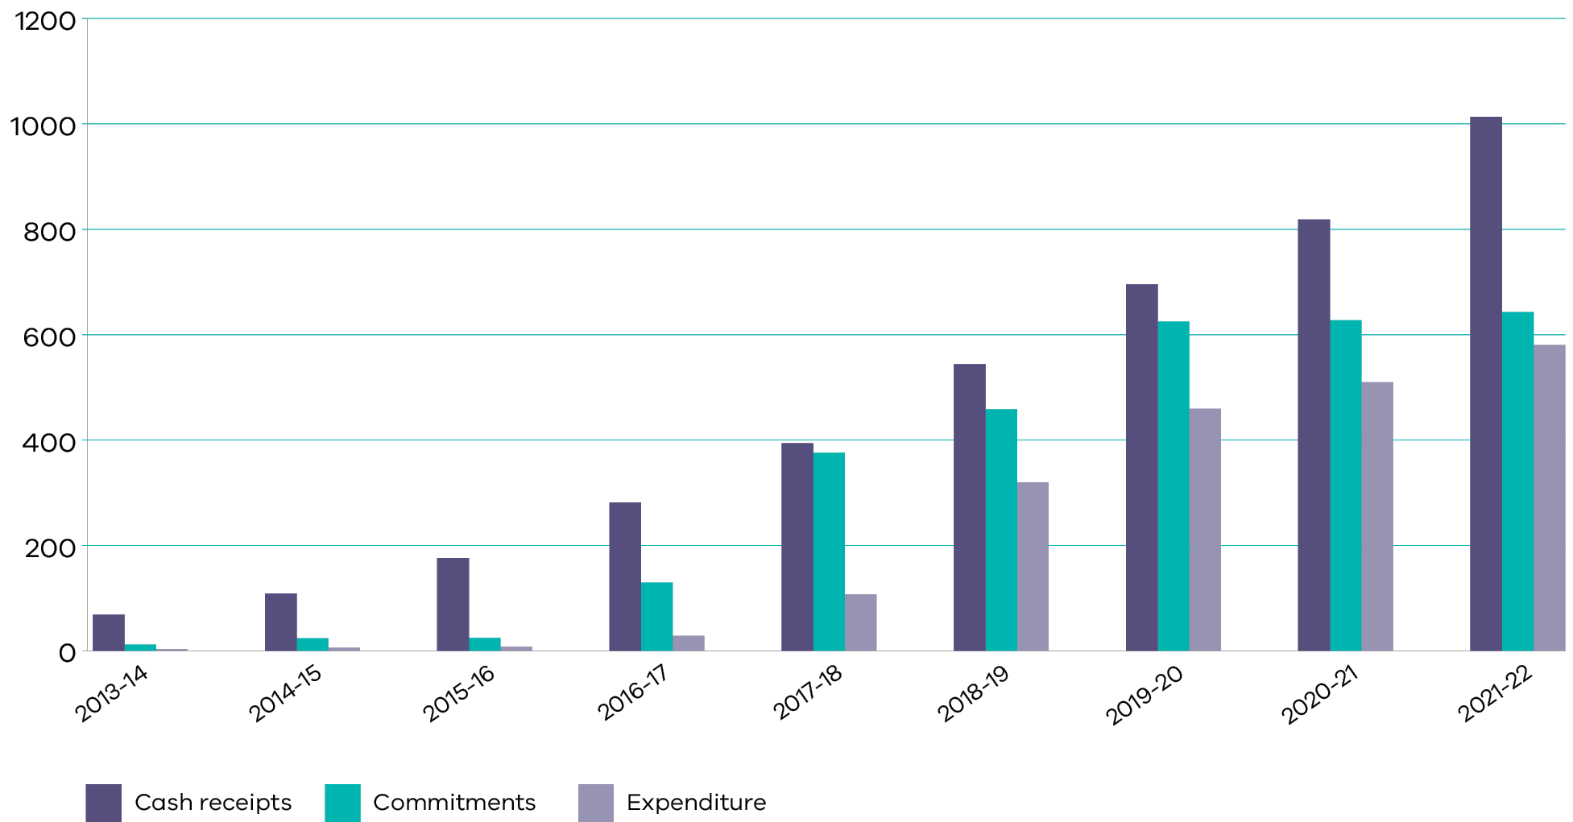
Table 3. Accumulated receipts and expenditure as at 30 June 2022^{(i)}
 | Accumulated receipts  ($m) | Accumulated commitments ($m)^{ii} | Commitments/ receipts  (%)^{iii} | Expenditure ($m)^{v} | Expenditure/ receipts  (%)^{iv} | Uncommitted ($m)^{vi}
30 June 2014 | 68.30 | 11.70 | 17 | 3.42 | 5.0 | 56.60
30 June 2015 | 108.67 | 23.66 | 22 | 5.95 | 5.5 | 85.01
30 June 2016 | 176.01 | 24.30 | 14 | 7.59 | 4.3 | 151.71
30 June 2017 | 281.54 | 129.65 | 46 | 28.28 | 10.0 | 151.89
30 June 2018 | 393.68 | 375.66 | 95.4 | 107.10 | 27.2 | 18.02
30 June 2019 | 543.77 | 458.34 | 84 | 319.72 | 59 | 85.43
30 June 2020 | 695.55 | 624.87 | 90 | 458.91 | 66 | 70.68
30 June 2021 | 818.26 | 626.99 | 77 | 509.38 | 62 | 191.27
30 June 2022 | 1,013.19 | 642.74 | 63 | 580.03 | 57 | 370.45
Notes:
- This table does not include interest on GAIC funds received since GAIC was established.
- Accumulated committed funds include expenditure and SRO costs.
- Percentage of committed cash receipts compared to cash receipts.
- Expenditure includes SRO expenses.
- Percentage of expenditure compared to cash receipts.
- Uncommitted funds exclude interest earned from investments in Treasury Corporation of Victoria term deposits. Total interest earned to 30 June 2022 is $20.34 million.
Table 4. Summary of income, approvals and expenditure by growth area
Growth Area | Income received from 1 July 2010 to 30 June 2021 ($) | Income for FY 2021-22 ($) | Total Income received as at 30 June 2022  ($) | Total approved funding by 30 June 2022ª  ($) | Total expenditure as at  30 June 2022^{b}  ($) | Proportion of Income received  (%) | Proportion paid as at 30 June 2022^{c}  (%)
Cardinia | 8,348,052 | 0 | 8,348,052 | 8,422,657 | 7,322,657 | 1% | 1%
Casey | 198,067,040 | 44,942,977 | 243,010,017 | 214,868,831 | 189,498,831 | 24% | 33%
Hume | 157,203,136 | 15,987,679 | 173,190,815 | 115,128,951 | 108,343,951 | 17% | 19%
Melton | 198,034,590 | 78,110,817 | 276,145,407 | 125,768,869 | 105,168,869 | 27% | 18%
Mitchell | 9,038,281 | 558,774 | 9,597,055 | 6,901,768 | 6,901,768 | 1% | 1%
Whittlesea | 38,604,095 | 17,181,476 | 55,785,571 | 68,577,038 | 67,737,038 | 6% | 12%
Wyndham | 208,968,511 | 38,141,642 | 247,110,153 | 103,069,286 | 95,053,986 | 24% | 16%
TOTAL | 818,263,705 | 194,923,365 | 1,013,187,068 | 642,737,399 | 580,027,099 | 100% | 100%
a. Includes $5.48 million in SRO expenses.
b. Includes SRO expenses paid in proportion to GAIC funds received per growth area.
c. Reported under section 201VC(b) of the Act.

Contributions from developers
GAIC cash receipts are historically received after GAIC accrual as a result of developers being able to defer their liabilities and enter into a staged payment arrangement (SPA) or Work-In-Kind (WIK) agreement. GAIC cash revenue has increased from $123 million in 2020-21 to $194.92 million in 2021-22. This increase is reflective of the surge in the property market and recovery from the COVID-19 pandemic.
SPAs allow the payment of GAIC liability in stages over time as land is developed. Any outstanding liability is subject to interest. The Minister for Planning approves any new GAIC SPA for a GAIC liability of $10 million and over. The VPA Chief Executive Officer (CEO) has delegation to approve a new SPA for a GAIC liability of less than $10 million and an amended SPA. SPAs are amended for change of owner, stage areas, dates, number or order. All SPAs are reviewed by the SRO before approval.
Table 5. Summary of GAIC transactions for the 2021-22 financial year
 | 2021-22 ($) | 2020-21 ($)
GAIC paymentsª | 187,923,479 | 118,847,701
Interest received (associated with GAIC payments) | 6,999,886 | 3,781,201
GAIC refunds | – | –
Net cash GAIC receipt^{b} | 194,923,365 | 122,628,905
WIK fulfilment – SPA | 4,468,159 | 666,599
WIK fulfilment – SPA interest | 107,320 | 104,963
WIK fulfilment Full payment | – | –
WIK Suspense | – | –
Total GAIC Revenue | 199,498,845 | 123,400,466
a. The GAIC cash receipts are paid into the Consolidated Fund by the SRO, after interest received with the GAIC payments and refunds made within the Fund. It does not include interest received once the monies are in the GAIC Funds, this is reported separately in the table above. GAIC revenue received includes payments that were subsequently refunded and excludes GAIC interest received.
b. When GAIC is due, the landowner can elect to pay 30 per cent upfront and enter an SPA for the balance of the 70 per cent of their liability. The Minister for Planning, or the CEO of the VPA under delegated authority up to $10 million, approves each SPA. The SRO is responsible for processing approved SPAs.
Table 6. GAIC deferrals and future payments for the 2021-22 financial year
 | Transaction value for 2021-22 ($) | Transaction value for 2020-21 ($)
GAIC deferredª | 145,002,496 | 56,626,696
Staged payment arrangements^{b} | 140,334,781 | 120,062,827
Net staged payments outstanding^{c} | 303,905,911 | 287,065,388
a. Deferrals arise from purchase transactions whereby the liable party elects to defer all, or part of their GAIC liability until the next GAIC event. Should the liable party elect to defer part of the liability, then a payment of the non-deferred portion of the total liability is due. The reported total GAIC deferred for the year is the total amount elected to have been deferred during the financial year. Some of those amounts may have subsequently been paid or have been converted into a SPA.
b. When GAIC is due, the landowner can seek approval of a SPA. SPAs require the first payment to be a minimum of 30 per cent of the remaining liability to be paid pro-rata by area of each stage. The Minister for Planning, or the CEO of the VPA under delegated authority to no more than $10 million or amendment, approves each SPA. The SRO is responsible for processing approved SPAs.
c. The outstanding amounts in relation to an approved SPA, are progressively reduced in accordance with the agreed payment arrangements and increased by applicable interest.

Approvals and allocations
No additional GAIC funding commitments were made during the 2021-22 financial year.

Receipts and Expenditure by Growth Area

Building New Communities Fund for the year ending 30 June 2022
At 30 June 2022, the BNCF had a total balance of $165.10 million, with existing commitments for projects totalling $43.8 million. These projects will have future outflows to 2022-23. The BNCF has $121.31 million pending future allocation.
Table 7. Building New Communities Fund by Growth Area in the 2021-22 financial year
Growth Area | Opening fund balance as at 1 July 2021  ($) | Interest earned for the year to 30 June 2022  ($) | Amount paid into the fund for the year 30 June 2022 ($) | Amount paid from the fund for the year to 30 June 2022  ($) | Balance of the fund as at 30 June 2022  ($) | Commitments yet to be paid ($) | Balance yet to be committed ($)
Cardinia | -2,981,252 | – | – | – | -2,981,252 | 1,100,000 | -4,081,252
Casey | 18,849,005 | 31,541 | 22,471,488 | 1,600,000 | 2,054,024 | 13,270,000 | 11,215,976
Hume | 9,775,357 | 11,220 | 7,993,840 | 925,525 | 16,854,891 | 1,785,000 | 15,069,891
Melton | 57,023,084 | 54,817 | 39,055,408 | 1,400,000 | 94,733,310 | 20,600,000 | 74,133,310
Mitchell | -2,218,674 | 392 | 279,387 | – | -1,938,895 | – | -1,938,895
Whittlesea | -7,160,020 | 12,058 | 8,590,738 | 11,950,795 | -10,508,019 | 840,000 | 11,348,019
Wyndham | 53,077,294 | 26,767 | 19,070,821 | 5,283,900 | 66,890,982 | 6,200,000 | 60,690,982
Total | 88,666,784 | 136,795 | 97,461,683 | 21,160,220 | 165,105,042 | 43,795,000 | 121,310,042

Growth Areas Public Transport Fund for the year ending 30 June 2022
At 30 June 2022, the GAPTF had a total balance of $288.56 million, with existing commitments from projects totalling $18.92 million. The GAPTF has $269.65 million pending future allocation.
Table 8. GAPTF by Growth Area in the 2021-22 financial year
Growth Area | Opening fund balance as at 1 July 2021  ($) | Interest earned for the year to 30 June 2022  ($) | Amount paid into the fund for the year 30 June 2022 ($) | Amount paid from the fund for the year to 30 June 2022  ($) | Balance of the fund as at 30 June 2022  ($) | Commitments yet to be paid ($) | Balance yet to be committed ($)
Cardinia | 4,081,294 | – | – | 2,419 | 4,078,875 | – | 4,078,875
Casey | 58,670,479 | 134,991 | 22,471,488 | 22,641,918 | 58,635,041 | 12,100,000 | 46,535,041
Hume | 45,715,742 | 48,021 | 7,993,840 | 2,558,786 | 51,198,816 | 5,000,000 | 46,198,816
Melton | 43,594,048 | 234,615 | 39,055,408 | 2,014,420 | 80,869,652 | – | 80,869,652
Mitchell | 4,431,752 | 1,678 | 279,387 | 2,781 | 4,710,036 | – | 4,710,036
Whittlesea | -1,748,727 | 51,607 | 8,590,738 | 4,119,251 | 2,774,367 | – | 2,774,367
Wyndham | 85,259,998 | 114,563 | 19,070,821 | 18,148,743 | 86,296,639 | 1,815,300 | 84,481,339
Total | 240,004,586 | 585,475 | 97,461,683 | 49,488,317 | 288,563,427 | 18,915,300 | 269,648,127

Allocations and Expenditure in the 2021-22 financial year
From 1 July 2021 to 30 June 2022, $70.65 million was spent on approved projects and SRO expenses. The details of these projects are provided in the tables below. Details of projects completed in previous years are published in previous DELWP Annual Reports. Completed projects that have been paid less than the amount they were allocated were under budget. The difference is returned to the GAIC funds to be allocated to future projects.

Cardinia Shire Council
Table 9: BNCF-funded projects in Cardinia
Agency | Purpose | Year Announced | Allocated | Amount paid to 30 June 2021 | Amount paid in 2021-22 | Amount yet to be paid | Status
DH | Pakenham Ambulance Station | 2016-17 | 1,100,000 | – | – | 1,100,000 | Active
DJCS | Emergency Services facility program for Officer | 2019-20 State Budget | 1,920,000 | 1,920,000 | – | – | Active
Total |  |  | 3,020,000 | 1,920,000 | – | 1,100,000

Table 10. GAPTF-funded projects in Cardinia
Agency | Purpose | Year Announced | Allocated | Amount paid to 30 June 2021 | Amount paid in 2021-22 | Amount yet to be paid | Status
DoT | Pakenham Bus Interchange | 2017-18 | 1,000,000 | 120,000 | – | – | Cancelled
Total |  |  | 1,000,000 | 120,000 | – | –
* Project cancelled as upgrade works are no longer required due to a new Pakenham Station being built.

Casey City Council
Table 11. BNCF-funded projects in Casey
Agency | Purpose | Year Announced | Allocated | Amount paid to 30 June 2021 | Amount paid in 2021-22 | Amount yet to be paid | Status
VicRoads | Berwick-Cranbourne Rd intersection | 2018-19 | 3,800,000 | 3,800,000 | – | – | Active
FRV | Clyde North Fire Station construction | 2018-19 | 8,520,000 | – | 1,050,000 | 7,470,000 | Active
DET | Clyde Primary School (improving existing schools | 2019-20 State Budget | 2,280,000 | 2,280,000 | – | – | Active
DET | Cranbourne Secondary College | 2019-20 State Budget | 662,000 | 662,000 | – | – | Complete
DJCS | Emergency Services facility program for Cranbourne | 2019-20 State Budget | 2,130,000 | 1,580,000 | 550,000 | – | Active
DJCS | Emergency Services facility program for Clyde | 2019-20 State Budget | 2,410,000 | 610,000 | – | 1,800,000 | Active
Total |  |  | 19,802,000 | 8,932,000 | 1,600,000 | 9,270,000

Table 12. GAPTF-funded projects in Casey
Agency | Purpose | Year Announced | Allocated | Amount paid to 30 June 2021 | Amount paid in 2021-22 | Amount yet to be paid | Status
DoT | Merinda Park Railway Station | 2016–17 | 9,000,000 | 1,000,000 | – | 8,000,000 | Active
DoT | Cranbourne East Railway Station | 2017–18 | 3,000,000 | 3,000,000 | – | – | Active
DoT | Cranbourne Station car parking and pedestrian amenity upgrade | 2018–19 | 4,800,000 | – | 4,800,000 | – | Active
DoT | Cranbourne – 100 new spaces car parks | 2019–20 State Budget | 1,694,000 | – | 1,094,000 | 600,000 | Active
PTV | Route 889 Clyde North – Berwick bus route | 2018–19 | 4,300,000 | 3,870,000 | 430,000 | – | Complete
PTV | Route 888 Clyde – Berwick bus route | 2018–19 | 3,700,000 | 3,515,000 | 185,000 | – | Complete
PTV | Metro Bus Service Improvements at Cranbourne – Casey | 2018–19 State Budget | 2,100,000 | 2,100,000 | – | – | Complete
PTV | Metro Bus Service Improvements at Narre Warren North – Casey | 2018–19 State Budget | 1,200,000 | 1,200,000 | – | – | Active
DoT | Cranbourne Rail Corridor Duplication Shared User Path | 2019–20 | 15,000,000 | 13,500,000 | – | 1,500,000 | Active
DoT | Extension of 881 Merinda Park to Clyde North bus route | 2019–20 | 10,455,000 | 9,409,500 | 1,045,500 | – | Active
DoT | Berwick Station Bus Interchange | 2019–20 | 20,817,000 | 3,800,000 | 15,017,000 | 2,000,000 | Active
Total |  |  | 76,066,000 | 41,394,500 | 22,571,500 | 12,100,000

Hume City Council
Table 13. BNCF-funded projects in Hume
Agency | Purpose | Year Announced | Allocated | Amount paid to 30 June 2021 | Amount paid in 2021-22 | Amount yet to be paid | Status
DH | Craigieburn Ambulance Station | 2016–17 | 1,200,000 | – | 1,200,000 | – | Active
DH | Mickleham Ambulance Station | 2017–18 | 1,500,000 | 1,500,000 | -274,475 | – | Complete
DJCS | Emergency Services facility program for Craigieburn North/Kalkallo | 2019–20 State Budget | 1,785,000 | – | – | 1,785,000 | Active
Total |  |  | 3,285,000 | 1,500,000 | 925,525 | 1,785,000

Table 14. GAPTF-funded projects in Hume
Agency | Purpose | Year Announced | Allocated | Amount paid to 30 June 2021 | Amount paid in 2021-22 | Amount yet to be paid | Status
DoT | Sunbury Station Improvement Works | 2018-19 | 7,000,000 | 2,000,000 | – | 5,000,000 | Active
DoT | Parking and amenity improvements – Craigieburn Station | 2018-19 State Budget | 11,000,000 | 11,000,000 | – | – | Active
DoT | Parking and amenity improvements – Sunbury Station | 2018-19 State Budget | 3,000,000 | 3,000,000 | – | – | Active
DoT | Extension of Craigieburn Central Shopping Centre to Craigieburn 528 bus route & Craigieburn North to Craigieburn 529 bus route | 2019-20 | 8,362,000 | 5,853,400 | 2,508,600 | – | Active
Total |  |  | 29,632,000 | 21,853,400 | 2,508,600 | 5,000,000

Melton City Council
Table 15: BNCF-funded projects in Melton
Agency | Purpose | Year Announced | Allocated | Amount paid to 30 June 2021 | Amount paid in 2021-22 | Amount yet to be paid | Status
DH | Melton Ambulance Station | 2016-17 | 1,200,000 | – | – | 1,200,000 | Active
DH | Hillside Ambulance Station | 2016-17 | 2,000,000 | – | – | 2,000,000 | Active
DH | Melton South Ambulance Station | 2017-18 | 3,600,000 | 1,500,000 | 1,400,000 | 700,000 | Active
DET | Cobblebank (Aintree) 7-12 land acquisition | 2018-19 State Budget | 16,200,000 | 16,200,000 | – | – | Active
DET | Grasslands P6 land acquisition | 2018-19 State Budget | 11,300,000 | 11,300,000 | – | – | Active
DJCS | Emergency Services facility program for Caroline Springs | 2019-20 State Budget | 2,900,000 | 2,900,000 | – | – | Active
Total |  |  | 37,200,000 | 31,900,000 | 1,400,000 | 3,900,000
Table 16: GAPTF-funded projects in Melton
Agency | Purpose | Year Announced | Allocated | Amount paid to 30 June 2021 | Amount paid in 2021-22 | Amount yet to be paid | Status
RPV | Toolern Railway Station – early works | 2016-17 | 6,800,000 | 6,788,358 | – | – | Complete
PTV | Route 454 Cobblebank (Toolern) Station – Melton Station bus route | 2018-19 | 3,500,000 | 3,150,000 | 350,000 | – | Complete
PTV | Route 444 Rockbank – Aintree bus route | 2018-19 | 2,700,000 | 2,430,000 | 270,000 | – | Complete
DoT | 425 Melton to Weir Views bus route | 2019-20 | 6,572,000 | 5,257,600 | 1,314,400 | – | Active
DoT | Cobblebank Station Future Proofing | 2019-20 | 8,500,000 | 8,500,000 | – | – | Active
DoT | Melton Station – 100 new and upgrade car parks | 2019-20 State Budget | 1,976,000 | 1,976,000 | – | – | Complete
Total |  |  | 30,048,000 | 28,101,958 | 1,934,400 | –

Mitchell Shire Council
Table 17: BNCF-funded projects in Mitchell
Agency | Purpose | Year Announced | Allocated | Amount paid to 30 June 2021 | Amount paid in 2021-22 | Amount yet to be paid | Status
DET | Beveridge Primary School – New Campus | 2019-20 State Budget | 2,800,000 | 2,800,000 | – | – | Active
Total |  |  | 2,800,000 | 2,800,000 | –

Whittlesea City Council
Table 18: BNCF-funded projects in Whittlesea
Agency | Purpose | Year Announced | Allocated | Amount paid to 30 June 2021 | Amount paid in 2021-22 | Amount yet to be paid | Status
PV | Merri Creek Marran Baba Parklands | 2017-18 | 1,700,000 | 1,360,000 | – | 340,000 | Active
DET | Edgars Creek Secondary School (Stage 2) | 2019-20 State Budget | 22,800,000 | 13,000,000 | 9,300,000 | 500,000 | Active
Victoria Police | Wollert Police site | 2021-22 | 3,200,000 | – | 2,650,795 | – | Complete
Total |  |  | 27,700,000 | 14,360,000 | 11,950,795 | 840,000

Table 19: GAPTF-funded projects in Whittlesea
Agency | Purpose | Year Announced | Allocated | Amount paid to 30 June 2021 | Amount paid in 2021-22 | Amount yet to be paid | Status
DoT | Wollert Rail Corridor | 2017-18 | 3,800,000 | 3,800,000 | – | – | Active
DoT | Parking and amenity improvements – Epping Station | 2018-19 State Budget | 1,900,000 | 1,900,000 | – | – | Complete
DoT | Donnybrook Station Car Park | 2019-20 | 7,790,000 | 7,790,000 | – | – | Active
DoT | WIK Supplementary Payment – Wollert Rail Corridor | 2021-22 | 4,103,085 | – | 4,103,085 | – | Complete
Total |  |  | 17,593,085 | 13,490,000 | 4,103,085 | –

Wyndham City Council
Table 20: BNCF-funded projects in Wyndham
Agency | Purpose | Year Announced | Allocated | Amount paid to 30 June 2021 | Amount paid in 2021-22 | Amount yet to be paid | Status
DH | Werribee Ambulance Station | 2016-17 | 1,500,000 | – | 1,283,900 | – | Active
DH | Tarneit Ambulance Station | 2017-18 | 1,500,000 | 1,500,000 | – | – | Active
CFA | Wyndham Vale Fire Station | 2017-18 | 3,750,000 | – | – | 3,750,000 | Active
CFA | New Truganina Fire Station | 2017-18 | 3,750,000 | 1,500,000 | – | 2,250,000 | Active
DET | Wollahra P6 land acquisition | 2018-19 State Budget | 9,100,000 | 9,100,000 | – | – | Active
DELWP | Greening the Pipeline – Werribee early works and design | 2018-19 State Budget | 1,000,000 | 1,000,000 | – | – | Complete
DET | Davis Creek Primary School | 2019-20 State Budget | 2,200,000 | 2,200,000 | – | – | Active
DET | Wyndham, South (River Walk) Primary School | 2019-20 State Budget | 3,000,000 | 3,000,000 | – | – | Active
DET | The Grange P-12 College | 2019-20 State Budget | 9,500,000 | 5,500,000 | 3,800,000 | 200,000 | Active
DET | Warringa Park School | 2019-20 State Budget | 12,400,000 | 12,200,000 | 200,000 | – | Active
DJCS | Emergency Services facility program for Pt Cook | 2019-20 State Budget | 855,000 | 855,000 | – | – | Active
Total |  |  | 48,555,000 | 36,855,000 | 5,283,900 | 6,200,000

Table 21: GAPTF-funded projects in Wyndham
Agency | Purpose | Year Announced | Allocated | Amount paid to 30 June 2021 | Amount paid in 2021-22 | Amount yet to be paid | Status
PTV | 182 Werribee Station – Tarneit Station bus route | 2018-19 | 10,200,000 | 9,180,000 | 1,020,000 | – | Complete
PTV | Route 152 Tarneit Station – Williams Landing Station bus route | 2018-19 | 7,200,000 | 6,480,000 | 720,000 | – | Complete
DoT | Bus and Cycle Access to Tarneit Station (including additional funding announced in 2021-22) | 2019-20 | 18,847,000 | 694,563 | 16,337,137 | 1,815,300 | Active
Total |  |  | 36,247,000 | 16,354,563 | 18,077,137 | 1,815,300

Hardship Relief Board
Persons may in some circumstances apply to the HRB for relief from their GAIC liability. During 2021-22, there were no applications for hardship received or considered by the HRB. DELWP managed the appointment of three board members for a three-year term.
Members for the period 1 July 2021 to 30 June 2024 are:
- Melissa Harris, DELWP Secretary nominee
- Craig Findlay, Commissioner nominee
Lily Tell, Chair Governor in Council appointment.

GAIC Works-In-Kind
A WIK agreement with the Minister for Planning may be entered into by a person liable to pay GAIC under which they agree to provide land and/or works (construction of state infrastructure) instead of a cash payment, to meet the GAIC liability in whole or in part. During the year ended 30 June 2022, there were two new WIKs approved. These were the WIK agreement for a supplementary payment for the future Wollert Police Station and for the supplementary payment for the Wollert Rail Corridor. Both WIK agreements are in the Whittlesea growth area and the transfers of land for both projects were completed in 2021-22. Details of current WIK agreements, guidelines and model agreements are available on the VPA website www.vpa.vic.gov.au.
Table 22. Current GAIC WIK Agreements
Receiving agency | Growth area | Purposeª | Estimated value of agreement^{b} ($) | GAIC credit to 30 June 2021  ($) | Supplementary payments made to 30 June 2021  ($) | GAIC credit in year to 30 June 2022  ($) | Supplementary payments made in year to 30 June 2022  ($) | Value not agreed or amount not paid as at 30 June 2022  ($)
DET | Hume | Merrifield South P6 School land | 7,830,000 | 3,444,105 | 2,430,000 | – | – | –
DET | Wyndham | Werribee secondary school land | 20,900,000 | 16,656,762 | 4,243,238 | – | – | –
Victoria Police | Whittlesea | Wollert Police Station | 6,900,780 | – | – | 4,249,985 | 2,650,795 | –
DoT | Whittlesea | Wollert Rail Corridor | 4,400,000 | – | – | 325,495 | 4,103,085 | –
Total |  |  | 40,030,780 | 20,100,867 | 6,673,238 | 4,575,480 | 6,753,880
a Some WIKs may require a supplementary payment from GAIC funds, with the fund shown in parenthesis (refer to appropriate BNCF or GAPTF projects table above for approved maximum amount, with actual amounts expected to be less).
b Agreed GAIC credit values are determined according to the terms of each WIK at the time an assessment is made and may be used by the GAIC liable entity to meet the whole or part of their GAIC liability.
The total value of WIK agreements completed prior to 30 June 2021 was $26,774,105. Details of these agreements are available in past DELWP Annual Reports.

Water Resource Assessment Program
Under Section 22 (1) of the Water Act 1989 (the Act), the Minister for Water is required to ensure that a continuous program of assessment of the water resources of the state is undertaken. Under Section 22 (2), the water resources assessment program must provide for the collection, collation, analysis and publication of information about:
(a) the availability of water, including surface water and groundwater
(ab) the use of one water source as a substitute for another water source
(ac) the environmental water reserve
(b) the disposal of wastewater (including trade waste, sewage and saline water)
(c) the use and re-use of water resources
(d) floodwaters
(e) drainage and waterway management
(f) water quality (including salinity)
(g) in-stream uses of water
(ga) current and historic levels of allocation and use of surface water and groundwater
(gb) current and historic condition of waterways and aquifers
(h) anything else that the Minister decides is appropriate.
Section 26 of the Act requires the Department of Environment, Land, Water and Planning (DELWP) to report annually on these areas.
DELWP provides information on Victoria’s water resources through a range of comprehensive reporting mechanisms, including a weekly update on the state’s water resources published on the DELWP Water and Catchments website, along with more comprehensive information published on the Water Measurement Information System and Victorian Water Register websites, and in the Victorian Water Accounts (VWA).
The VWA is an annual statewide summary of Victoria’s water resources. It documents water availability and provides assessments of rainfall, streamflow and groundwater levels, as well as information on water storages and re-use of treated wastewater. Information on water taken for consumptive use, and water set aside for environmental purposes, is provided within the context of the Victorian water allocation framework, which sets out entitlements to water.
The VWA sources data from the state’s surface water and groundwater monitoring networks, and draws on information from water corporations, DELWP, the Essential Services Commission, the Murray-Darling Basin Authority (MDBA) and catchment management authorities. The VWA is published annually in hard copy and is available online on the Victorian Water Register website, available at www.waterregister.vic.gov.au.
The Victorian Water Register is a public register of water entitlement ownership in Victoria. It holds water shares that are recorded by the Victorian Water Registrar. It also holds water licences and delivery shares recorded by the rural water corporations. It records and enables seasonal determinations against water shares and provides for the trading and other dealings with water entitlements. The Victorian Water Register captures information on water availability and price, and makes this publicly and freely available via the water register website. The website can also be used to generate statistics and reports on levels of use, directions of trade, and prices paid for water. All water monitoring data collected by DELWP and its partners is made accessible on the Water Measurement Information System, available at data.water.vic.gov.au.
Research through the Victorian Water and Climate Initiative is helping to build an understanding of how the water cycle has been changing over time and the influence of climate change on water resources. The second phase of the research initiative was launched in July 2021. The new research projects expand on the knowledge gained from the previous phase of the research initiative and will improve understanding of current and future water availability. One of the outputs from the program in 2021-22 was the development by the Bureau of Meteorology of a new method for assessing how much influence climate change is having on Victorian rainfall (Rauniyar S.P. and Power S.B., Climate Dynamics, May 2022), which is helping to better understand declines in Victorian cool season rainfall. A key objective of the research program is to ensure it remains user focussed to inform any future iterations of the Guidelines for Assessing the Impact of Climate Change on Water Availability in Victoria and facilitate the application of the best available science for water management in Victoria.
As well as these reporting tools, there are numerous processes in place to collect and provide specific information as required under the Water Act 1989. These are briefly summarised below, with references to sites and resources containing further and more detailed information.

a) Availability of water

Surface water
The state’s surface water resources assessment network includes 942 sites that were monitored in 2021-22 through three regional water monitoring partnerships. These partnerships comprise 52 public and private organisations that procure their monitoring requirements under this program. The partnerships include state government departments, water corporations, catchment management authorities, local councils (with a flood management function), the Bureau of Meteorology and the MDBA.
Surface water monitoring services are procured by DELWP on behalf of the regional water monitoring partnerships to ensure efficiency and statewide consistency in data quality.
The program delivers legislative obligations under Section 22 of the Water Act 1989 and Section 126 of the Commonwealth Water Act 2007 and contributes to a range of business needs across the partnership including:
- operational decision making
- compliance reporting
- flood warning
- statewide policy development for water resources
- river health management
reporting for the monthly water report, the annual water quality reports and the longer-term water quality trend reports.
All surface water data collected through the partnerships, summary reports on historical longer-term trends of surface water quality and the current status of water quantity are available on the Water Measurement Information System (data.water.vic.gov.au) and the Monthly Water Report on the DELWP Water and Catchments website: www.water.vic.gov.au/water-reporting/water-resource-reporting

Groundwater
Victoria’s State Observation Bore Network (SOBN) is underpinned by a program that involves monitoring of around 1,504 bores. This monitoring program is jointly managed by DELWP and the rural water corporations.
All groundwater data is available via the Water Measurement Information System. Summary reports on historical longer-term trends in groundwater levels across the state are available on the DELWP website (www.water.vic.gov.au). Information on groundwater use and trends is also provided in the annual Victorian Water Accounts.
Accurate monitoring data is crucial for the sustainable management of groundwater resources and can help resolve management issues, questions or disputes raised by groundwater users.

ab) Use of one water source as a substitute for another water source
Under Ministerial Reporting Direction 03, water corporations are required to provide information in their annual reports on how they are promoting the integrated and sustainable use of water resources in their region. This includes projects undertaken in line with targets set in the entity’s corporate plan to deliver water recycling, water conservation, sustainable and resilient water services systems and sustainable water strategies. Water corporations’ annual reports are tabled in Parliament and are available on water corporations’ websites.

ac) Environmental Water Reserve
DELWP oversees the Victorian Environmental Water Program in conjunction with the Victorian Waterway Management Program (see Section e) to maintain or improve the condition of Victoria’s rivers, estuaries and wetlands, through provision and protection of water for the environment. The program is delivering priority actions from the Victorian Government’s Water Plan, Water for Victoria, including responding to climate change, management of environmental water, strengthened monitoring and reporting, partnering with Traditional Owners, clear and transparent environmental water charging arrangements, and strong governance. The program is a partnership between catchment management authorities, the Victorian Environmental Water Holder (VEWH), Traditional Owners, water corporations and other delivery partners.
The Environmental Water Reserve (EWR) is the legal term for water set aside for the environment under the Water Act 1989. The EWR comprises, or is contributed to, by:
- entitlements for the environment that are called either bulk entitlements or environmental entitlements; and
the operation of caps on licensed consumptive water use (such as sustainable diversion limits or permissible consumptive volumes) and conditions on consumptive bulk entitlements, licences and permits, and as set out in management plans.
In regulated systems, environmental water consists of environmental entitlements, environmental bulk entitlements and various operational conditions on consumptive water use (noting that under some of these conditions, the water is not exclusively for the environment – for example, passing flow requirements). The environmental entitlements and environmental bulk entitlements refer to water usually held in and released from storages. The VEWH holds these entitlements on behalf of the Minister for Water. The VEWH is an independent statutory body responsible for making decisions on the most efficient and effective use of Victoria’s environmental water entitlements.
Potential watering actions are documented by VEWH in its annual seasonal watering plan, which is informed by seasonal watering proposals prepared by each of the catchment management authorities and Melbourne Water. The VEWH then commits water to these actions throughout the year via seasonal watering statements, which authorise waterway managers to use environmental water.
The VEWH is established under Part 3AA of the Water Act 1989. Further details about the VEWH, including its annual report and water holdings, can be found on its website: www.vewh.vic.gov.au.
At 30 June 2022, the VEWH water holdings comprised 25 entitlements and 107 water shares. During 2021-22, the VEWH worked with catchment management authorities (CMAs) and Melbourne Water to manage this water to meet environmental objectives at 89 river reaches and 81 wetlands, including:
- Gippsland: Thomson, Macalister and Snowy rivers, and the lower Latrobe wetlands (Sale Common, Dowd Morass and Heart Morass).
- Central Victoria: Yarra, Tarago, Maribyrnong, Werribee, Upper Barwon and Moorabool rivers, Pyrites Creek, the lower Barwon wetlands (Hospital Swamps and Reedy Lake) and one wetland in the Yarra system (Annulus Billabong).
- Western Victoria: Wimmera, MacKenzie and Glenelg rivers and the Burnt and lower Mount William Creeks, as well as 37 wetlands via the Wimmera-Mallee Pipeline.
Northern Victoria: Goulburn, Broken, Ovens, Campaspe and Loddon Rivers, and the upper and lower Broken Creek, four Living Murray icon sites (Barmah Forest, Hattah Lakes, Lindsay, Mulcra and Wallpolla Islands and Gunbower Forest) and 18 wetlands in the Goulburn, Broken Loddon, central and lower Murray systems.
Highlights from 2021-22 include:
- Delivery of a coordinated spring watering event in the Murray system from Lake Hume and Murray River tributaries to the sea; a joint action by the Commonwealth Environmental Water Holder, VEWH, NSW Department of Planning, Industry and Environment and South Australian Government with the MDBA as manager of The Living Murray. The event focused on outcomes in the Murray River channel and supported outcomes at Barmah Forest and numerous floodplain wetlands in the central and lower Murray region.
- Watering of off-stream lagoons, billabongs and wetlands that are connected to the mid-Goulburn River as part of a new flow trial, which provided increased habitat and refuge areas for native fish, plants and animals.
Socio-economic shared benefits were also supported through the delivery and timing of environmental flows across Victoria, including supporting fishing competitions on the Wimmera River, water skiing events on the Loddon River and kayaking on the Thomson River.
During 2021-22 waterway managers sought opportunities to increase the involvement of Traditional Owners in environmental water planning, management and monitoring. Examples of this include:
- Delivering water for the environment to Annulus Billabong in the Yarra system in spring 2021. These events supported cultural values identified by Traditional Owners, vegetation growth, and provide habitat and feeding conditions for waterbirds.
- Supporting values identified by the Taungurung Land and Waters Council at Horseshoe Lagoon in the Goulburn system.
Supporting the First People of the Millewa Mallee Aboriginal Corporation’s restoration of a site of high cultural significance at Robertson Creek in the lower Mallee.
In unregulated rivers, environmental water is protected through conditions on licences and bulk entitlements, caps or through statutory water management plans and non-statutory local management plans. Water corporations are responsible for ensuring that these conditions are met. During 2021-22, environmental water was protected through input into numerous reviews in unregulated systems.
Other environmental water program highlights from 2021-22 include:
- Completion of the Koondrook Weir Fishway in the North Central region. The fishway connects 55 kilometres of fish habitat in Gunbower Creek and 530 kilometres of Murray River to allow recolonisation of Gunbower Creek with native fish species, including the iconic Murray cod and golden perch. The project was co-funded by the Victorian Government’s Building Works capital stimulus package 2020 (Waterway Environmental Works) and the VEWH.
- Implementing Murray-Darling Basin Plan environmental watering obligations (Chapter 8, Environmental Watering Plan) in partnership with the VEWH and CMAs. This included annual reporting and updating Victoria’s Environmental Water Management Plan Guidelines to reflect best-practice waterway management, continue supporting Victoria’s Long-Term Watering Plans, and to provide better guidance on partnering with Traditional Owners.
Delivery of 85.9 per cent of environmental watering actions at planned sites from a target of 90 per cent. This is a positive outcome. Due to slightly wetter than anticipated conditions in most systems, fewer sites required environmental water. Environmental watering actions at many sites were met in 2021-22 by natural high flows and/or releases from water storages for other purposes.

b) Disposal of wastewater (including trade waste, sewage and saline water)
All urban water corporations are required to report on wastewater disposals, as part of the report of operations in their annual reports. The performance report includes indicators related to financial, service delivery and environmental performance. Specific wastewater indicators are prepared for reliability of collection services, quality of disposal and management. The annual reports are tabled in Parliament and available on water corporations’ websites.

c) Use and re-use of water resources
See section ab) above, ‘The use of one water source as a substitute for another water source’. All urban water corporations are required to report on total use of alternative water sources such as recycled wastewater and stormwater re-use as part of the report of operations in their annual reports. The performance report includes indicators related to environmental performance for effluent re-use and greenhouse gas emissions. The annual reports are tabled in Parliament and available on water corporations’ websites.

d) Floodwaters
DELWP is the lead agency for the coordination of floodplain management in Victoria. The Victorian Floodplain Management Strategy 2016 (VFMS) is the principal government policy for continuously building Victoria’s flood risk resilience. Building on lessons learned from flood emergencies in 2010, 2011 and 2012, the strategy clarifies and confirms government and government agency roles and accountabilities. The VFMS supports agencies to deliver their respective accountabilities by specifying clear actions against each Victorian Government policy set out in the strategy. The VFMS includes 56 actions assigned to agencies across the floodplain management sector, including DELWP, local councils, CMAs and the Victorian State Emergency Service (VICSES). These actions are now all complete and/or embedded as part of agencies’ business as usual practice. The strategy will continue to inform consistent decisions and actions for the management of flood-related issues over its ten year term from 2016. A third biennial implementation progress report is due for publishing in 2022.
Regional Floodplain Management Strategies (RFMS) are in place for Victoria’s nine rural catchment management regions and delivery of these strategies is being led by CMAs and Melbourne Water in partnership with local councils, VICSES and other agencies. The purpose of the RFMS is to support communities to identify, prioritise and implement mitigation activities, reduce existing flood risks, and manage residual risk. The RFMS have identified more than 400 locally prioritised and led actions for mitigating the effects of flooding for Victorian communities. Work to deliver RFMS implementation plans to 2021-22 has typically included detailed flood studies, flood mitigation works, flood warning system upgrades and planning scheme amendments.
In 2021-22 CMAs worked with local government, VICSES and others to prepare the next tranche of competitive funding applications to implement their highest priority actions through the Risk Resilience Grants Program 2021-22 (RRGP). This work included securing a commitment from funding applicants that they will contribute local funding equal to at least one third of the proposed project budget in line with government policy on investing in flood mitigation. The program will receive federal government funding through the National Partnership Agreements on Disaster Risk Reduction and will be administered by Emergency Management Victoria.
FloodZoom is a web-based tool that incorporates current flood spatial data, live rainfall and stream level data to enable clear consequence planning, making it a single source of riverine flood information in Victoria to support flood readiness and response. A significant task for the FloodZoom program is ensuring flood data and intelligence products are continually updated as flood studies are completed and delivered by local councils and CMAs. This work has been a high priority throughout 2021-22, with the ongoing La Niña driven weather patterns leading to several periods of flash and riverine flooding, particularly in Gippsland catchments.
In addition to its role as a key decision support tool for core emergency functions during flood events, FloodZoom also hosts a planning system module used by CMAs to streamline management of land use planning application referrals and permits, an algal module for reporting blue green algae outbreaks, and dam and risk management modules designed to assist water corporations. Continual improvements to the platform in 2021-22 now sees current flood warnings automatically displayed on the ‘current situation’ dashboard as well as several enhancements to search and data validation functions.

e) Waterway management and drainage
DELWP oversees the Victorian Waterway Management Program that aims to maintain or improve the condition of Victoria’s waterways (rivers, estuaries and wetlands). The program is a partnership between state government, Traditional Owners, regional agencies and authorities, other management partners and local communities.
As part of the program, DELWP is responsible for establishing the state policy framework for waterway management. Regional implementation is led by waterway managers from CMAs, and Melbourne Water in the Port Phillip and Westernport region, via the Regional Waterway Strategies.
Through Water for Victoria, the Victorian Government is investing $248 million over four years (2020-24) to improve the health of waterways and catchments. This includes:
- significant on-ground works across regional Victoria to implement Regional Waterway Strategies and Regional Catchment Strategies
- management of environmental water entitlements and projects
- funding to support and improve Ramsar sites (including the Gippsland Lakes)
service delivery to provide advice to the public regarding flood risks and processing of thousands of permits and licenses related to works and developments along waterways.
Funding of approximately $33.8 million provided by the Victorian Government in 2021-22 for improving the health of Victoria’s waterways and catchments has been invested by CMAs according to these agreed programs. The delivery of projects and services through these programs is tracked and reported annually. Over the past 12 months CMAs have:
- completed 6,800 hectares of waterway vegetation works including tree planting, weed control and fencing alongside waterways
- delivered seven out of 10 new Regional Catchment Strategies for regions across Victoria (three pending final review)
- progressed the renewal of Victoria’s key policy for the management of waterways, the Victorian Waterway Management Strategy (VWMS)
- maintained or improved the environmental condition of approximately 330 river reaches and wetlands
- commenced a second set of eight new Flagship Waterway projects at priority sites around the state, building on the first set that was launched in 2018 (which are continuing)
- processed 94 per cent of waterway licenses and permits within statutory timeframes
- initiated 17 new Catchment stewardship projects working closely with community, sector partners and Traditional Owners
- further developed foundations with partners and Landcare networks to complete stewardship plans and assessments for over 700,000 hectares across Victoria
- continued delivery of major long term statewide monitoring programs in targeted rivers and wetlands to assess and improve the value and success of the program
continued delivery of a range of citizen science programs that focus on waterway health, including EstuaryWatch and Waterwatch Victoria, school-based programs including River Detectives, and a range of other programs including monitoring frogs, waterbirds and litter.
Highlights from 2021-22 delivery include:
- A key focus for progressing the new Victorian Waterway Management Strategy (VWMS) was undertaking significant Traditional Owner engagement to understand waterway management priorities and to start early conversations. Additionally, a major piece of social research (titled the My Victorian Waterway Survey) was launched in May 2022, with more than 6,000 responses received.
- Highlights at new Flagship Waterway sites included the launch of the Glenelg Hopkins CMA Rivers of Warrnambool project in February 2022. The project will see works to protect and improve habitat along the lower reaches of the Merri and Hopkins rivers and Brucknell Creek. The Mallee CMA Kings Billabong project launched in June 2022. The project will protect and improve around 60 hectares of critical habitat along the Murray River, which is a significant home to several locally threatened and internationally recognised species. On the Loddon River at North Central CMA’s Flagship Waterway site, a further 60 hectares of floodplain has been protected and revegetated, adding to the 60 hectares of the previous year. The area provides refuge pools for pygmy perch and other significant species.
- A new series of the popular Native Fish Report Cards were released in late 2021.The Native Fish Report Cards are brief overviews of the health of target fish populations, which present survey summaries from priority rivers and streams. This project is a collaboration between DELWP, including its Arthur Rylah Institute, and the Victorian Fisheries Authority, in partnership with recreational fishing license holders.
- West Gippsland CMA released a set of high-quality videos via their YouTube channel in May 2022 related to various elements of the investment in regional catchments and waterways. They provide a range of inspiring snapshots of what this broad program looks like on the ground, and what it means to individuals. They also feature the unsung heroes of our programs – CMA Project Officers. See below for links:
- Headwater willow treatment
- Chain of Ponds (Perry catchment)
- Rainbow Creek flood recovery works
- Thomson River Flagship
- Citizen science and monitoring programs
- West Gippsland CMA has also completed significant landscape scale stewardship planning with sector partners, Traditional Owners and the broader community on over 101,000 hectares covering the whole Powlett River Catchment.
- Led by East Gippsland CMA, regional partners across the Gippsland Lakes landscape have finalised an integrated program of works for the next two years and presented this to the Gippsland Lakes Coordinating Committee. A new term of the committee was established, and new agency and community representatives appointed. The program will see 30 projects delivered in collaboration with 12 delivery partners, including habitat protection and enhancement, protection of threatened flora and fauna species, mapping and protection of culturally significant areas and improving water quality. In addition, the next round of the Gippsland Lakes Community Grants program closed in June 2022. Approximately $300,000 in grants will provide funds to community groups that support the Lakes allowing them to complete environmental and community projects.
- Delivery of new projects at all Ramsar sites commenced as planned in January 2022. Highlights included: start of the Sanderling Tracking project at Discovery Bay Ramsar site, which involved tagging of 112 birds; over 3,000 hectares of rabbit and fox control at the Kerang wetlands Ramsar site in North Central CMA.
Goulburn Broken CMA is continuing the Bogies and Beyond project with a public call for ideas to deliver stewardship, which has resulted in over 30 expressions of interest and more than 350 hectares of works being sought by landholders.
More information on these programs and achievements can be found at https://water.vic.gov.au/waterways-and-catchments including a report card assessing progress against statewide waterway management targets. The report shows that all ten targets are on track or exceeded at the midpoint for the Victorian Waterway Management Strategy. This significant progress demonstrates what can be achieved through sustained investment in waterway health.
Major drainage systems in the Melbourne region are the responsibility of Melbourne Water, managed under their Waterways and Drainage Strategy and reported against in the Melbourne Water Annual Report.

f) Water quality (including salinity)
Water quality monitoring was conducted at 445 partnership sites across the state in 2021-22. A range of water quality parameters are either continuously monitored or sampled at regular intervals from these sites, and cover a range of physical, chemical, nutrient, metal, anion, cation, organic load and algal analyses. Data from the monitoring network is made publicly available through the Water Measurement Information System (data.water.vic.gov.au). Water quality across the state is generally good. However, it can vary depending on location, weather conditions, land use and land use practices.

g) In-stream uses of water
Refer to section ac) above, ‘Environmental Water Reserve’, for details regarding the in-stream use of water.

ga) Current and historic levels of allocation and use of surface water and groundwater
The Victorian Water Accounts provides a comprehensive annual overview of the state’s water resources. This includes providing an annual statewide and system picture of water availability and use for each of Victoria’s 29 river basins and 20 groundwater catchments, and for each of the state’s rural and urban distribution systems.
The 2020-21 Accounts were released in June 2022 and have been published online as a digital product, available in a hardcopy format, and are also available on the Victorian Water Register website: www.waterregister.vic.gov.au. The 2021-22 Accounts are expected to be completed in the first half of 2023. Comprehensive historic information on allocations and water use is also available in Water Accounts and State Water Reports dating back to 2003-04.
Details of Victoria’s water availability and use in 2021-22 will be provided in the 2021-22 Victorian Water Account.

Surface water
In 2021-22, more rainfall was received in the majority of the state than the previous year. Above average rainfall was received in most of the north, near Cape Otway and over Werribee. Rainfall was above average in the north-east and most of the east. Rainfall was below average in the south west and south east.
All Northern and Southern regulated systems received 100 per cent allocation against high reliability water entitlements in 2021-22. For the first time since 2012-13, all northern Victorian systems received a non-zero opening seasonal allocation. All northern regulated systems reached 100 per cent allocation against high reliability water entitlements by October 2021. In addition, 100 per cent allocation against low reliability water entitlements was received in three northern systems, the Murray, Broken and Bullarook. This is only the second year that a Murray low reliability water share (LRWS) allocation has been made since LRWSs were established in 2007-08. In 2016-17, a 5 per cent Murray LRWS was allocated.
The Thomson-Macalister and Werribee regulated systems in the south both received 100 per cent against high reliability entitlements by end December 2020 and 100 per cent against low reliability entitlements by March 2022.
The Wimmera-Mallee Pipeline Product allocation reached 59 per cent by May 2021.
In the Coliban rural system, entitlement holders had access to 100 per cent of their entitlement for the entire year for the eleventh year in a row.

Groundwater
Seasonal restrictions are announced in accordance with the groundwater management plans developed for Water Supply Protection Areas (WSPAs) and Groundwater Management Areas (GMAs). A restriction may be used to reduce the risks from falling groundwater levels; allow the resource to be shared between all users; or recognise and reduce the social and environmental costs of lowering groundwater levels.
In 2021-22, restrictions on groundwater use were in place in the Barnadown, Elmore-Rochester, Bamawn and Echuca Zones in the Lower Campaspe Valley WSPA) (75 per cent), Katunga WSPA (70 per cent), Deutgam WSPA (50 per cent) and the West Wimmera GMA Neuarpur Sub-Zone 1 (80 per cent).

gb) Current and historic condition of waterways and aquifers
DELWP has reviewed and improved Victoria’s existing waterway health monitoring programs to have a greater focus on monitoring the changes that result from management actions – an action in Water for Victoria. Management interventions should over time result in improvements to overall waterway resource condition. Statewide condition monitoring programs such as the Index of Stream Condition (ISC) provide information about the overall condition of Victoria’s waterways and guide state policy and regional investment programs. Three previous ISC assessments have been undertaken. A key lesson from these assessments is that changes in resource condition in response to management interventions may take many decades to emerge as the benefits of management interventions accumulate and ecological systems have time to recover. Water for Victoria acknowledges that the full benefits of investments to improve waterway health may not be realised for 30 years or more. Responses to management interventions need to be measured at relevant scales and assessed against specific management targets. As such, the schedule of broad scale condition monitoring of rivers, wetland and estuaries has been revised to occur less frequently.
The first statewide Index of Estuary Condition assessment was completed and launched on time in September 2021. The extensive data collection and analysis (of the over 100 estuaries of Victoria) took over three years to complete, and provides the most comprehensive assessment ever undertaken of these special places. Overall results showed that 13 per cent of estuaries had excellent condition, whereas 30 per cent had poor or very poor condition. Results, maps, fact sheets and interpretation of data is available on DELWP’s Waterways and catchments website.
An important milestone was reached in 2021 for the Riparian Intervention Monitoring Program, which has been running since 2014, and monitors 34 intervention and control site pairs across nine CMA regions. Three years after management interventions were implemented, encouraging improvements in riparian condition have been observed at treatment sites including:
- a 41 per cent decrease in bare ground
- a dramatic increase in the density of native woody plants
a 76 per cent increase in the number of native plant species.
The results of the third and most recent ISC assessment were released during 2013 and are available at mapshare.vic.gov.au and data.vic.gov.au. The results from the most recent statewide wetland assessment in 2010 that looked at 827 wetlands are also available at mapshare.vic.gov.au. An updated assessment of statewide wetland condition is due for reporting in 2024.
Aquifer condition is monitored through Victoria’s State Observation Bore Network. See section (a) ‘Availability of Water – Groundwater’ for more information.
Long Term Water Resource Assessments
The Water Act 1989 requires a Long-Term Water Resource Assessment (LTWRA) every 15 years to determine whether water availability has declined or if waterway health has deteriorated for reasons related to changes in flow.
The LTWRA for Southern Victoria was published in March 2020. This is the first comprehensive technical assessment of how surface water and groundwater availability has already changed across southern Victoria, and the first large-scale effort to measure long-term changes in waterway health due to flow.
The Central and Gippsland Region Sustainable Water Strategy (CGRSWS) will consider and identify actions required in response to the LTWRA, having regard to relevant economic, environmental, social, recreational and Traditional Owner values of water.
In October 2021, the ‘Technical Guide to Figures in Central and Gippsland Region Sustainable Water Strategy Discussion Draft’ was published to accompany the CGRSWS Discussion Draft. The technical guide sets out the data sources and methods used to provide a robust evidence-base for long-term planning. To ensure consistency, water-resource assessment methods applied in the LTWRA have also been applied in the CGRSWS, with refinement, such as extending data sets where new data have become available. The LTWRA for northern Victoria will commence in 2025 and align with the Murray-Darling Basin Plan review scheduled for 2026.
Sustainable Water Strategies
Sustainable Water Strategies (SWSs) are a legislative requirement under Division 1B of the Water Act 1989 and fulfil Victoria’s commitment under the National Water Initiative to carry out open, statutory-based water planning. Four SWSs covering the state were produced between 2006 and 2011. These strategies set out long-term plans to secure each region’s water future, identifying and managing threats to the supply and quality of the region’s water resources and identifying ways to improve waterway health. Opportunities for achieving shared benefits, including those related to Aboriginal values of water and recreational values, are also considered.
Water for Victoria commits to maintaining Victoria’s planning framework, including the role of SWSs. In 2021-22, DELWP continued the preparation of a new CGRSWS.
The discussion draft of the CGRSWS was released for public consultation from 8 October 2021 to 10 December 2021. Feedback from the public consultation process was considered by the Consultive Committee and will shape the final Strategy.
The CGRSWS has identified policies and actions for a climate-resilient future so that even in a drying climate, there will be enough water for cities and towns, farms, industry, rivers, recreation and tourism, while returning water to Traditional Owners.
The final CGRSWS is expected to be released later in 2022. Funding of $56.5 million has been allocated from the 2022-23 State Budget to assist with early implementation of the CGRSWS over the next two years.
More information on the SWSs and further details on the status of each individual SWS action is available on the DELWP website.

Additional information available on request
In compliance with the requirements of the Standing Directions of the Minister for Finance, details of the items listed below have been retained and are available to Ministers, Members of Parliament and the public on request (subject to the provisions of the Freedom of Information Act 1982).
- A statement that declarations of pecuniary interests have been duly completed by all relevant officers of the department
- Details of shares held by senior officers as nominee or held beneficially in a statutory authority or subsidiary
- Details of publications produced by the department about the activities of the department and where they can be obtained
- Details of changes in prices, fees, charges, rates and levies charged by the department for its services, including services that are administered
- Details of any major external reviews carried out in respect of the operation of the department
- Details of any major research and development activities undertaken by the department that are not otherwise covered either in the report of operations or in a document which contains the financial statement and report of operations
- Details of overseas visits undertaken including a summary of the objectives and outcomes of each visit
- Details of major promotional, public relations and marketing activities undertaken by the department to develop community awareness of the services provided by the department
- Details of assessment and measures undertaken to improve the occupational health and safety of employees, not otherwise detailed in the report of operations
- General statement on industrial relations within the department and details of time lost through industrial accidents and disputes, which are not otherwise detailed in the report of operations
- List of major committees sponsored by the department, the purpose of each committee and the extent to which the purposes have been achieved
- Details of all consultancies and contractors including
- consultants/contractors engaged
- services provided
- expenditure committed to for each engagement.
The information is available on request from the DELWP Customer Contact Centre on 136 186, via email customer.service@delwp.vic.gov.au or on the internet at www.delwp.vic.gov.au.

Financial Statements

How this report is structured
The Department of Environment, Land, Water and Planning (DELWP) has presented its audited general purpose financial statements for the financial year ended 30 June 2022 in the following structure to provide users with the information about the department’s stewardship of resources entrusted to it.

Financial Statements 30 June 2022
Page
Accountable Officer’s and Chief Finance Officer’s declaration 223
Auditor-General’s report 225
Comprehensive operating statement 229
Balance sheet 230
Statement of changes in equity 231
Cash flow statement 231

Notes to the Financial Statements
Page
Note 1. About this report
The basis on which the financial statements have been prepared and compliance
with reporting regulations. 231
Note 2. Funding delivery of our services
Revenue and income recognised from appropriations, sales of goods and services,
levies, rates , grants and other sources. 233
Note 3. The cost of delivering services
Operating expenses of the department. 241
Note 4. Disaggregated financial information by output
Department outputs and Administered (non-controlled) items. 247
Note 5. Key assets available to support output delivery
Property, plant and equipment, intangible assets as well as fair value determination. 281
Note 6. Other assets and liabilities
Other key assets and liabilities arising from the department’s operations. 302
Note 7. How we financed our operations
Cash flow information, borrowings, lease liabilities, trust account balances
and commitments. 312
Note 8. Risks, contingencies and valuation uncertainties
Financial risk management, contingent assets and liabilities as well as
fair value determination. 325
Note 9. Other disclosures 343

Accountable Officer’s and Chief Finance Officer’s declaration
The attached financial statements for the Department of Environment, Land, Water and Planning have been prepared in accordance with Directions 5.2 of the Standing Directions of the Assistant Treasurer under the Financial Management Act 1994, applicable Financial Reporting Directions, Australian Accounting Standards including Interpretations, and other mandatory professional reporting requirements.
We further state that, in our opinion, the information set out in the comprehensive operating statement, balance sheet, statement of changes in equity, cash flow statement and accompanying notes, presents fairly the financial transactions during the year ended 30 June 2022 and financial position of the department at 30 June 2022.
At the time of signing, we are not aware of any circumstance which would render any particulars included in the financial statements to be misleading or inaccurate.
We authorise the attached financial statements for issue on 30 August 2022.
John Bradley
Secretary
Department of Environment, Land,
Water and Planning
Melbourne
30 August 2022
Bronwyn Di Carlo
Executive Director, Finance
Department of Environment, Land, Water and Planning
Melbourne
30 August 2022
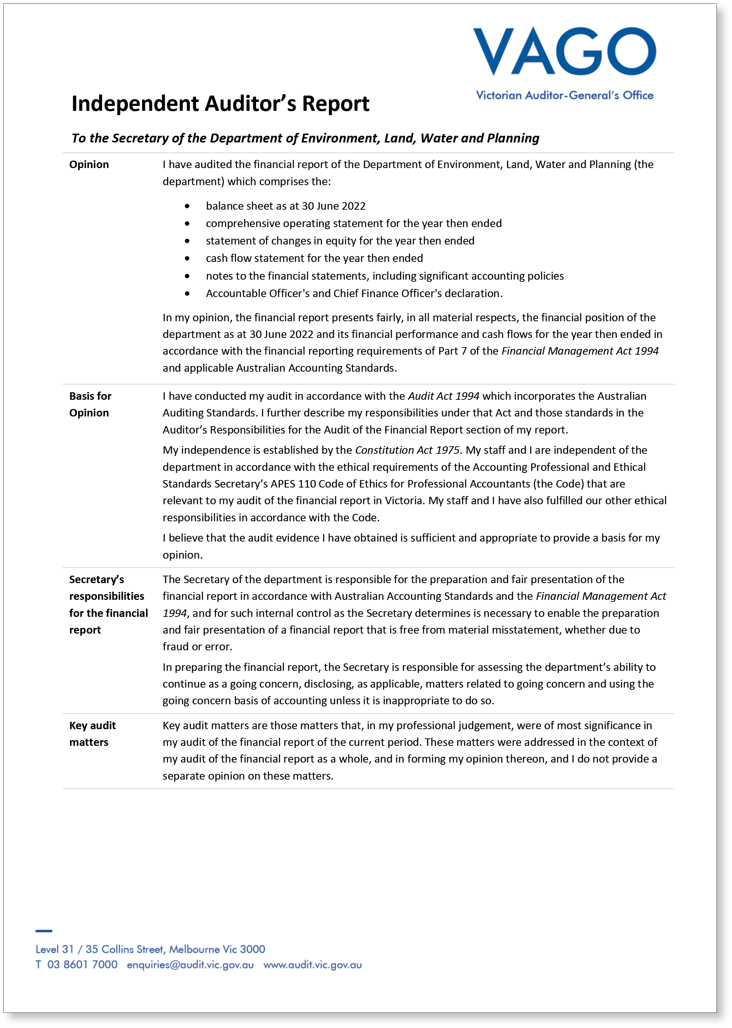
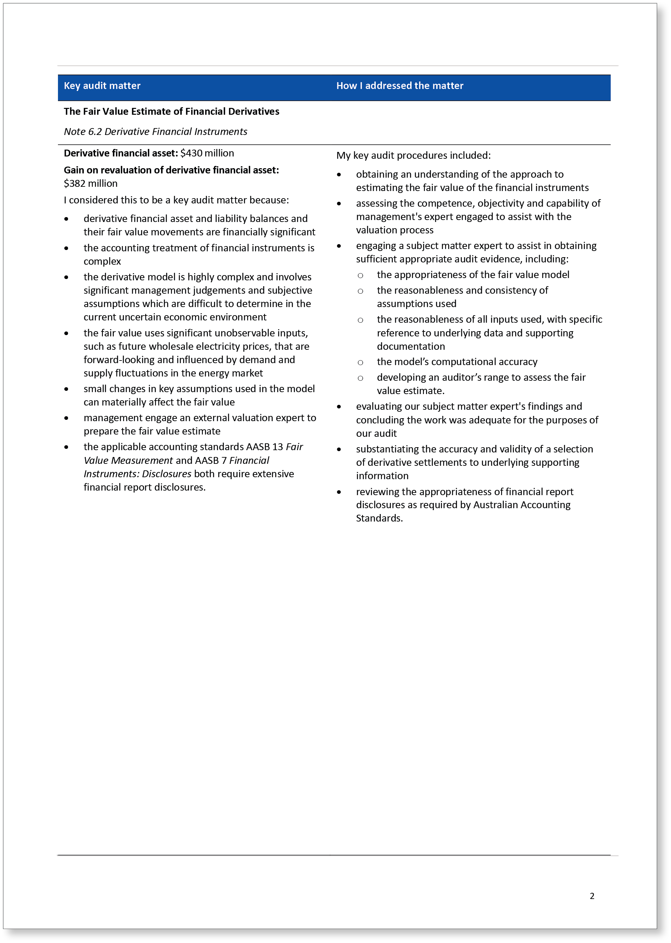
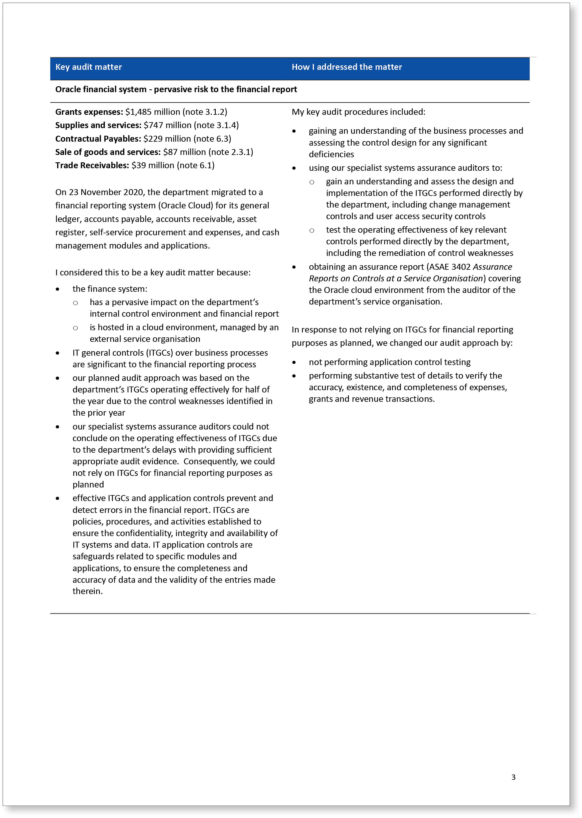
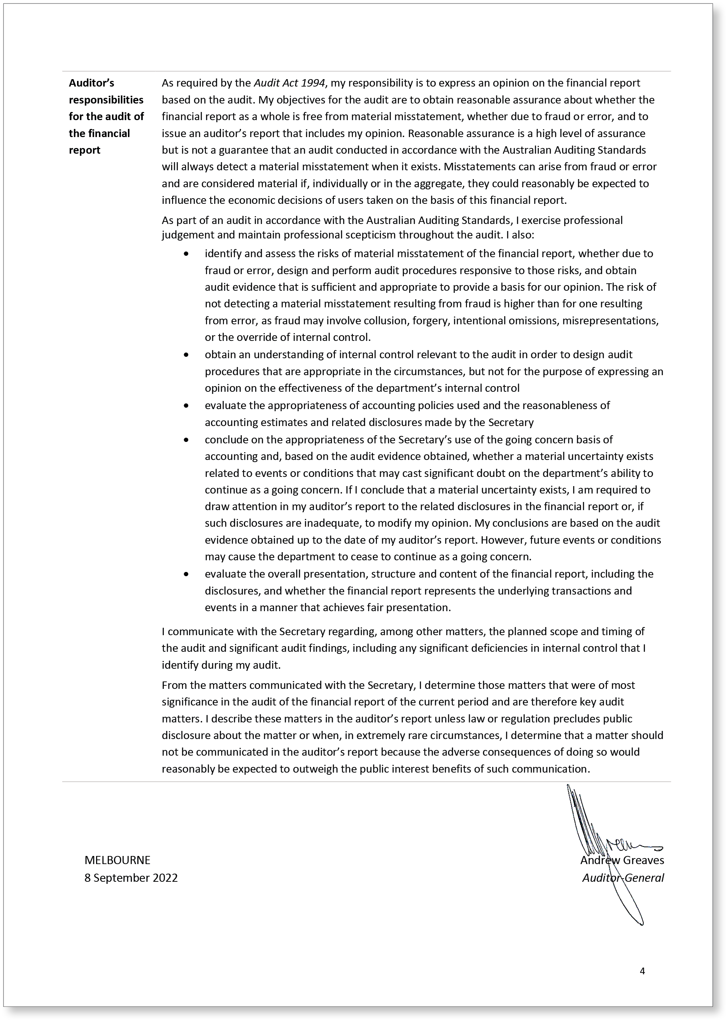

Comprehensive operating statement for the financial year ended 30 June 2022^{(i)}
 | Notes | 2022  $’000 | 2021  $’000
Revenue and income from transactions
Output appropriations | 2.2, 2.2.1 | 2,191,978 | 2,354,656
Special appropriations | 2.2, 2.2.2 | 181,720 | 122,629
Sale of goods and services | 2.3.1 | 86,695 | 89,106
Municipal and Industrial Waste Levy^{(ii)} | 2.3.2 | 424,915 | 256,032
Metropolitan Parks Improvement Rate | 2.3.3 | 200,061 | 190,679
Grants | 2.3.4 | 41,677 | 98,227
Interest income | 7.1.2 | 9,540 | 8,874
Initial recognition income from financial instruments | 2.3.6 | 55,245 | –
Other income | 2.3.5 | 54,655 | 37,000
Total revenue and income from transactions |  | 3,246,486 | 3,157,203
Expenses from transactions
Employee expenses | 3.1.1 | (708,708) | (625,869)
Grants and other transfers | 3.1.2 | (1,485,515) | (1,539,599)
Supplies and services | 3.1.4 | (747,295) | (629,312)
Depreciation and amortisation | 5.1.2 | (87,658) | (80,076)
Capital asset charge | 3.1.3 | – | (96,066)
Initial recognition expense from financial instruments | 3.1.5 | – | (200,072)
Interest expense | 7.2.2 | (11,401) | (13,022)
Loan repayments transferred to the administered entity^{(iii)} |  | (74,250) | –
Total expenses from transactions |  | (3,114,827) | (3,184,016)
Net result from transactions (net operating balance) |  | 131,659 | (26,813)
Other economic flows included in net result
Net gain on non–financial assets | 9.2 | 91,055 | 872,624
Net gain/(loss) on financial instruments | 9.2 | 381,066 | (88,808)
Other gains from other economic flows | 9.2 | 9,806 | 12,762
Total other economic flows included in net result |  | 481,927 | 796,578
Net result |  | 613,586 | 769,765
Other economic flows – other comprehensive income
Items that will not be classified to net result
Net change in physical asset revaluation surplus | 9.3.1 | 1,050,979 | 702,045
Total other economic flows – other comprehensive income |  | 1,050,979 | 702,045
Comprehensive result |  | 1,664,565 | 1,471,810

The comprehensive operating statement should be read in conjunction with the accompanying notes to the financial statements.
Note:
- This format is aligned to AASB 1049 Whole of Government and General Government Sector Financial Reporting.
- From 1 July 2021, as a result of the Environment Protection Act 1970 being repealed and superseded by the Environment Protection Act 2017, the Municipal and Industrial Waste Levy replaced the Municipal and Industrial Landfill Levy.
- Relates to the transfer of customer loan repayments under the Solar Victoria scheme to the administered entity to be remitted to the Department of Treasury and Finance.

Balance sheet as at 30 June 2022^{(i)}
 | Notes | 2022  $’000 | 2021  $’000
Assets
Financial assets
Cash and cash deposits | 7.1 | 1,281,536 | 1,242,681
Receivables | 6.1 | 1,104,847 | 911,782
Derivative financial instruments | 6.2 | 429,933 | 80,669
Total financial assets |  | 2,816,316 | 2,235,132
Non-financial assets
Inventories | 6.5 | 22,058 | 24,575
Non-financial physical assets classified as held for sale | 5.2 | 10,206 | 10,974
Property, plant and equipment | 5.1 | 9,251,912 | 7,991,729
Intangible assets | 5.3 | 46,000 | 39,853
Prepayments | 6.4 | 63,663 | 42,459
Total non-financial assets |  | 9,393,839 | 8,109,590
Total assets |  | 12,210,155 | 10,344,722
Liabilities
Payables | 6.3 | 260,315 | 260,674
Other financial liabilities | 6.7 | 204,383 | 201,146
Borrowings | 7.2 | 49,664 | 50,812
Provisions | 3.1.1 (a), 6.6 | 371,636 | 220,736
Derivative financial instruments | 6.2 | – | 1,931
Other liabilities |  | 8,129 | 5,694
Total liabilities |  | 894,127 | 740,993
Net assets |  | 11,316,028 | 9,603,729
Equity
Accumulated surplus |  | 4,508,735 | 3,895,149
Physical asset revaluation surplus | 9.3.1 | 6,615,663 | 5,564,684
Contributed capital |  | 191,630 | 143,896
Net worth |  | 11,316,028 | 9,603,729
The balance sheet should be read in conjunction with the notes to the financial statements.
Note:
- This format is aligned to AASB 1049 Whole of Government and General Government Sector Financial Reporting.

Statement of changes in equity for the financial year ended 30 June 2022^{(i)}
 | Notes | Accumulated surplus/ (deficit)  $’000 | Physical asset revaluation surplus  $’000 | Contributed capital  $’000 | Total  $’000
Balance at 1 July 2020 |  | 3,125,384 | 4,862,639 | 68,925 | 8,056,948
Net result for the year |  | 769,765 | – | – | 769,765
Other comprehensive income for the year | 9.3.1 | – | 702,045 | – | 702,045
Additions to Net Asset Base | 2.2.1 | – | – | 166,222 | 166,222
Capital contributions of assets^{(ii)} |  | – | – | (11,760) | (11,760)
Capital contributions transferred to portfolio entities | 9.3.2 | – | – | (74,582) | (74,582)
Administrative restructure – net assets transferred |  | – | – | (4,909) | (4,909)
Balance at 30 June 2021 |  | 3,895,149 | 5,564,684 | 143,896 | 9,603,729
Balance at 1 July 2021 |  | 3,895,149 | 5,564,684 | 143,896 | 9,603,729
Net result for the year |  | 613,586 | – | – | 613,586
Other comprehensive income for the year | 9.3.1 | – | 1,050,979 | – | 1,050,979
Additions to Net Asset Base | 2.2.1 | – | – | 244,492 | 244,492
Capital contributions of assets^{(ii)} |  | – | – | (89,108) | (89,108)
Capital contributions transferred to portfolio entities | 9.3.2 | – | – | (107,650) | (107,650)
Balance at 30 June 2022 |  | 4,508,735 | 6,615,663 | 191,630 | 11,316,028

The statement of changes in equity should be read in conjunction with the notes to the financial statements.
Note:
- This format is aligned to AASB 1049 Whole of Government and General Government Sector Financial Reporting.
- The movement relates to asset transfers to and from the department and transfer of gain and loss on disposal of assets to the administered entity. Refer to Note 5.1.1 Reconciliation of movements in carrying values.

Cash flow statement for the financial year ended 30 June 2022^{(i)}
 | Notes | 2022  $’000 | 2021  $’000
Cash flows from operating activities
Receipts
Receipts from government |  | 2,381,439 | 2,289,246
Receipts from other entities |  | 496,966 | 407,099
Goods and Services Tax recovered from the Australian Tax Office (ATO)^{(ii)} |  | 79,958 | 71,783
Derivative settlements |  | 92,375 | –
Interest received |  | 9,555 | 13,487
Total receipts |  | 3,060,293 | 2,781,615
Payments
Payments of grants and other transfers |  | (1,524,771) | (1,466,900)
Payments to suppliers and employees |  | (1,293,686) | (1,236,366)
Capital asset charge payments | 3.1.3 | – | (96,066)
Derivative settlements |  | (14,704) | (938)
Interest and other costs of finance paid |  | (11,654) | (13,023)
Total payments |  | (2,844,815) | (2,813,293)
Net cash flows from/(used in) operating activities | 7.1.1 | 215,478 | (31,678)
Cash flows from investing activities
Purchases of non-financial assets |  | (310,647) | (47,656)
Sales of non-financial assets |  | 22,935 | 15,474
Net cash flows from/(used in) investing activities |  | (287,712) | (32,182)
Cash flows from financing activities
Cash from activity transferred (out) – Machinery of Government changes |  | – | (4,761)
Owner contributions by state government | 2.2.1 | 244,492 | 166,222
Capital contributions transferred to portfolio entities | 9.3.2 | (107,650) | (74,582)
Repayments of principal portion of lease liabilities |  | (11,451) | (33,778)
Proceeds from/(repayments of) advances |  | (14,302) | 9,335
Net cash flows from/(used in) financing activities |  | 111,089 | 62,436
Net increase/(decrease) in cash and cash equivalents |  | 38,855 | (1,424)
Cash and cash equivalents at the beginning of the financial year |  | 1,242,681 | 1,244,105
Cash and cash equivalents at the end of the financial year | 7.1 | 1,281,536 | 1,242,681

The cash flow statement should be read in conjunction with the notes to the financial statements.
Note:
- This format is aligned to AASB 1049 Whole of Government and General Government Sector Financial Reporting.
- Goods and Services Tax recovered from the ATO is presented on a net basis.

Note 1. About this report
The Department of Environment, Land, Water and Planning (the department) is a government department of the State of Victoria, established on 1 January 2015 after Machinery of Government changes were implemented by the Victorian government. It is an administrative agency acting on behalf of the Crown.
Its principal address is:
Department of Environment, Land, Water and Planning
8 Nicholson Street
East Melbourne Victoria 3002
A description of the nature of the department’s operations and its principal activities is included in the Report of Operations, which does not form part of these financial statements.

Basis of preparation
These financial statements are in Australian dollars and prepared using the historical cost convention unless a different measurement basis is specifically disclosed in the note associated with the item measured on a different basis.
The accrual basis of accounting has been applied in the preparation of these financial statements whereby assets, liabilities, equity, income and expenses are recognised in the reporting period to which they relate, regardless of when cash is received or paid.
Consistent with the requirements of AASB 1004 Contributions, contributions by owners (that is, contributed capital and its repayment) are treated as equity transactions and, therefore, do not form part of the income and expenses of the department.
Additions to net assets which have been designated as contributions by owners are recognised as contributed capital. Other transfers that are in the nature of contributions to or distributions by owners have also been designated as contributions by owners.
Transfers of net assets arising from administrative restructurings are treated as distributions to or contributions by owners. Transfers of net liabilities arising from administrative restructurings are treated as distributions to owners.
Judgements, estimates and assumptions are required to be made about the carrying values of assets and liabilities that are not readily apparent from other sources. The estimates and associated assumptions are based on professional judgements derived from historical experience and various other factors that are believed to be reasonable under the circumstances. Actual results may differ from these estimates.
Revisions to accounting estimates are recognised in the period in which the estimate is revised and also in future periods that are affected by the revision. Judgements and assumptions made by management in the application of Australian Accounting Standards (AASs) that have significant effects on the financial statements and estimates relate to:
- the type of joint arrangement in which the department had an interest during the reporting period (refer to Note 4.2 Administered (non-controlled) items and Note 4.2.3 Administered investments in joint operation)
- the recognition and measurement of the service concession intangible assets associated with the commercialisation of land titles and registry function (refer to Note 4.2 Administered (non-controlled) items and Note 4.2.4 Commercialisation of land titles and registry functions of Land Use Victoria.
- the recognition and measurement of the Victorian Desalination Project (refer to Note 4.2 Administered (non-controlled) items and Note 4.2.5 Victorian Desalination Project.
- the fair value of land, buildings, infrastructure, plant and equipment (refer to Note 5.1.3 Fair value determination)
- the impairment of non-financial assets (refer to Note 5.1.2 Depreciation, amortisation and impairment)
- the estimated useful lives over which non-financial assets are depreciated
- the estimation of amounts required to be provisioned or disclosed as contingent liabilities (refer to Note 4.2 Administered (non-controlled) items and 8.2 Contingent assets and contingent liabilities)
- assumptions for employee benefit provisions based on likely tenure of existing staff, patterns of leave claims, future salary movements and future discount rates (refer to Note 3.1.1 (a) Employee benefits in the balance sheet).
- the estimation of contractual receivables recoverability (refer to Note 6.1 Receivables)
- the estimation of the fair value of derivative financial instruments (refer to Note 6.2 Derivative financial instruments, Note 2.3.6 Initial recognition income from financial instruments and Note 9.2 Other economic flows included in net result)
the recognition of grant revenue (refer to Note 2 Funding delivery of our services)
These financial statements cover the department as an individual reporting entity and include all the controlled activities of the department.
Consolidated financial statements have not been prepared as the department does not control any other entities under AASB 10 Consolidated Financial Statements.
There are no administrative offices of the department that require inclusion in this report.
All amounts in the financial statements have been rounded to the nearest $1,000 unless otherwise stated.

Compliance information
These general-purpose financial statements have been prepared in accordance with the Financial Management Act 1994 (FMA) and applicable Australian Accounting Standards (AAS) which include Interpretations, issued by the Australian Accounting Standards Board (AASB). In particular, they are presented in a manner consistent with the requirements of AASB 1049 Whole of Government and General Government Sector Financial Reporting.
Where appropriate, those AAS paragraphs applicable to not-for-profit entities have been applied. Accounting policies are selected and applied in a manner which ensures that the resulting financial information satisfies the concepts of relevance and reliability, thereby ensuring that the substance of the underlying transactions or other events is reported.
To gain a better understanding of the terminology used in these financial statements, please refer to Note 9.12 Glossary of technical terms.

Coronavirus (COVID-19) pandemic and the impact on the financial statement
In 2020 and 2021 the Victorian government introduced restrictions across Victoria to slow the spread of COVID-19 by reducing the number of people leaving their homes and moving around Victoria. This has had an impact on the operating and economic environment for the department and a number of policies and directions were introduced to assist, such as providing rent relief to lessees, establishing remote working environments for employees, and managing the distribution of funds for portfolio agencies and key stakeholders.
Management have considered the impacts of COVID-19 on the judgements and assumptions applied to accounting policies and estimates used in the measurement of assets and liabilities. The impacts and assessments have been considered on assets and liabilities which are detailed in Note 5.1.4 Fair value determination, Note 5.1.3 Depreciation, amortisation and impairment, Note 6.1 Receivables, Note 6.2 Derivative financial instruments, Note 8.1 Financial instruments specific disclosures, Note 8.2 Contingent assets and liabilities and Note 8.3 Fair value determination.
Additional financial impacts have been considered on revenue and expense items in line with the government’s announcements and department policies. The department received additional funding during the year under the Building Works package to stimulate the state’s economy and recover from the COVID-19 pandemic. The delivery of a number of initiatives has been affected by the COVID-19 pandemic and their funding was re-cashflowed across the forward estimates Refer to Note 2.2.1(a).
The rent relief policy will have an impact on the revenue collected on Crown land leases and licences within Note 4.2.1 Administered income and expenses.
Some of the department’s portfolio agencies have experienced reduced revenue due to the COVID-19 pandemic. The department received additional funding to provide these agencies with financial support grants, which are reported within Note 3.1.2 Grants and other transfers.

Note 2. Funding delivery of our services

Introduction
The department’s purpose is to shape and support liveable, inclusive and sustainable communities, and thriving natural environments across Victoria by: listening, working alongside and partnering with the community in everything we do; leveraging the connectivity between our portfolios to respond to the impacts of climate change in a productive, collaborative and coordinated way. We maximise opportunities for attracting investment and jobs through supporting the development of new, low-carbon industries; and protecting, enhancing and strengthening our State’s liveability, protecting our natural environment, infrastructure and heritage for future generations.
The department contributes to the Victorian government’s commitment to a stronger, fairer, better Victoria by supporting our natural and built environment, to ensure economic growth, liveable, sustainable and inclusive communities that are resilient to the impacts of climate change.
To enable the department to fulfil its purpose and provide outputs as described in Note 4, it receives income (predominantly accrual based parliamentary appropriations). The department also receives fees for various goods and services, levies and parks charges.

Significant judgement: Grants revenue
The department has made judgement on the recognition of grant revenue as income of not-for-profit entities where they do not contain sufficiently specific performance obligations. Income from grants that are enforceable and with sufficiently specific performance obligations and accounted for as revenue from contracts with customers is recognised when the department satisfies the performance obligation.

Structure
2.1 Summary of revenue and income that funds the delivery of our services
2.2 Appropriations
2.2.1 Summary of compliance with annual parliamentary appropriations
2.2.2 Summary of compliance with special appropriations
2.2.3 Annotated income agreements
2.3 Income from transactions
2.3.1 Sale of goods and services
2.3.2 Municipal and Industrial Waste Levy
2.3.3 Metropolitan Parks Improvement Rate
2.3.4 Grants
2.3.5 Other income
2.3.6 Initial recognition income from financial instruments

2.1 Summary of revenue and income that funds the delivery of our services
Revenue and income that fund delivery of the department’s services are accounted for consistently with the requirements of the relevant accounting standards disclosed in the following notes.

2.2 Appropriations
Once annual Parliamentary appropriations are applied by the Treasurer, they become controlled by the department and are recognised as income when applied for the purposes defined under the relevant Appropriations Act.

Output appropriations
Income from the outputs the department provides to the government is recognised when those outputs have been delivered and the relevant minister has certified delivery of those outputs in accordance with specified performance criteria.
The department has access to various parliamentary appropriations income under the Appropriation Act, the Administrative Arrangements Act 1983 and under sections of the FMA (sections 29: Appropriation of certain revenue and asset proceeds, 30: Transfer between items of departmental appropriation, and 32: Unused Appropriation). Details of the various parliamentary appropriations received by the department for the year are outlined in Note 2.2.1 Summary of compliance with annual parliamentary appropriations.

Special appropriations
Under section 28 of the FMA, income is recognised when the amount appropriated for that purpose is due and payable by the department.

2.2.1 Summary of compliance with annual parliamentary appropriations
The following table discloses the details of the various parliamentary appropriations received by the department for the year. In accordance with accrual output-based management procedures ‘provision for outputs’ and ‘additions to net assets’ is disclosed as ‘controlled’ activities of the department. Administered transactions are those that are undertaken on behalf of the state over which the department has no control or discretion.
 | Appropriation Act Annual appropriation  $’000 | Appropriation Act Advance from Treasurer  $’000 | Financial Management Act 1994 Section 29  $’000 | Financial Management Act 1994 Section 30^{(iv)}  $’000 | Financial Management Act 1994 Section 32  $’000 | Financial Management Act 1994 Section 35  $’000 | Total parliamentary authority  $’000 | Appropriation applied  $’000 | Variance  $’000
2022
Controlled
Provision of outputs ^{(i)} | 1,879,359 | 101,579 | 250,018 | 16,482 | 50,676 | – | 2,298,114 | 2,191,978 | 106,136
Additions to net assets base (ATNAB) ^{(ii)} | 238,475 | – | 48,500 | (27,150) | 2,446 | – | 262,271 | 244,492 | 17,779
Administered
Payments made on behalf of the state (POBOS) ^{(iii)} | 662,426 | – | – | 2,542 | – | – | 664,968 | 648,174 | 16,794
POBOS – state contribution under the Murray Darling Basin Act 1993 | 21,800 | – | – | 8,126 | – | – | 29,926 | 29,926 | –
Total | 2,802,060 | 101,579 | 298,518 | – | 53,122 | – | 3,255,279 | 3,114,570 | 140,709
2021
Controlled
Provision of outputs | 2,092,086 | 118,325 | 192,239 | 45,761 | 16,305 | – | 2,464,716 | 2,354,656 | 110,060
ATNAB | 271,863 | 341 | 45,000 | (45,761) | 2,000 | – | 273,443 | 166,222 | 107,221
Administered
POBOS | 663,336 | – | – | – | – | – | 663,336 | 661,322 | 2,014
POBOS – state contribution under the Murray Darling Basin Act 1993 | 21,800 | – | – | – | – | – | 21,800 | 21,800 | –
Total | 3,049,085 | 118,666 | 237,239 | – | 18,305 | – | 3,423,295 | 3,204,000 | 219,295

(a) Variance analysis

(i) Provision of outputs
The 2022 variance predominately relates to the recashflow of funding available in 2021-22 for use in future years for the Energy Innovation Fund ($27.8 million) to align with an Expenditure Review Committee decision and the following programs which experienced delays due to disruption to supply chains, COVIDSafe settings and/or adverse weather events:
- Energy Efficiency Upgrades for Homes Program ($44.2 million),
- Bushfire Biodiversity Recovery – Supporting economic growth ($8.0 million),
- Strategic Fuel breaks to respond to Climate Change ($9.5 million),
- Solar Victoria Virtual Power Plant rephase ($7.5 million),
- Accelerating Adoption of Zero Emission Vehicles ($4.7 million), and
Victorian Forestry Plan ($4.2 million).

(ii) Additions to net assets base (ATNAB)
The 2022 variance primarily relates to the carryover of funding to 2022-23 for the department’s Strategic Asset Management plan which experienced delivery delays due to COVID-19 restrictions, supply and labour shortages.

(iii) Payments made on behalf of the state (POBOS)
The 2022 variances primarily relates to the following the recashflow of funding available in 2021-22 for use in future years for the Victorian Desalination Project. It is anticipated that all banked Renewable Energy Certificates accumulated from prior years will be fully utilised by 2024-25, therefore increasing costs to meet future water orders from 2025-26 onwards.

(iv) Section 30
The transfer between capital and output expenditure, pursuant to section 30 of the Financial Management Act 1994, predominantly relates to the following:
- Higher depreciation expenditure associated with the revaluation of assets ($8.5 million).
Great Ocean Road Management Reforms and Coastal Trail to enable a grant to be provided to Great Ocean Road Coast and Parks Authority under a funding agreement ($11.8 million).
The transfer between output and State contributions under the Murray Darling Basin Act 1993 ($6.9 million) was to ensure the appropriate level of resources to continue the Murray Darling Basin Authority program in line with the Government’s commitment.

2.2.2 Summary of compliance with special appropriations
Authority | Purpose | Appropriation Applied 2022  $’000 | Appropriation Applied 2021  $’000
Output special appropriations
Section 201V of the Planning and Environmental Act 1987 | Growth Area Infrastructure Contributions | 181,720 | 122,629
Total special appropriations |  | 181,720 | 122,629

2.2.3 Annotated Income agreements
The department is permitted under section 29 of the Financial Management Act 1994 (FMA) to have certain income annotated to the annual appropriation. The income which forms part of a section 29 agreement is recognised by the department as an administered item and the receipts paid into the consolidated fund. If a section 29 agreement is in place, the relevant appropriation item will be increased by the equivalent amount at the point of income recognition.
The following is a listing of the FMA section 29 annotated income agreements approved by the Treasurer:
 | Note | 2022  $’000 | 2021  $’000
Commonwealth specific purpose payments – output
BushBroker |  | 422 | 187
Cleaning Up The Yarra – Installation of Litter Traps |  | 150 | –
Consumer Data Right |  | 984 | –
COVID-19 National and World Heritage Projects |  | – | 3,437
Goulburn-Murray Water – Water Efficiency Project |  | 28,000 | 17,000
Lindenow Water Security |  | 929 | 7,430
Miscellaneous Industry Contributions |  | 34 | 221
Murray Darling Basin Plan Implementation |  | 6,380 | 1,700
National Energy Productivity Measure |  | 940 | 698
National Water Grid |  | 1,470 | –
Recycling Infrastructure |  | 6,816 | –
Regional fund for wildlife and habitat bushfire recovery |  | 6,641 | 3,419
Sustainable Rural Water Use and Infrastructure Program |  | 28,962 | 16,298
National Flood Mitigation Infrastructure Program |  | 6,917 | –
National Water Infrastructure Development Fund – Feasibility Studies |  | – | 100
Total Commonwealth specific purpose payments – output |  | 88,645 | 50,490
Commonwealth specific purpose payments – capital
Goulburn-Murray Water – Water Efficiency Project |  | 34,000 | 18,000
National Partnership Agreement for the National Water Infrastructure Development Fund |  | 9,000 | 27,000
National Water Grid |  | 5,500 | –
Total Commonwealth specific purpose payments – capital |  | 48,500 | 45,000
User charges or sales of goods and services
Bushfire recovery for four fauna species in East Gippsland |  | 555 | –
Land Registration Services |  | 19,496 | 21,860
Land Use Victoria – Land Registry Commercialisation |  | 138,504 | 118,527
Mapping |  | 154 | 232
Miscellaneous Industry Contributions |  | 240 | 273
Multi-regional species coordination |  | 626 | –
Revenue retained on behalf of the Environmental Protection Authority |  | 1,344 | 492
Water Register – Planning |  | 454 | 365
Total user charges or sales of goods and services |  | 161,373 | 141,749
Total annotated income agreements | 2.2.1 | 298,518 | 237,239

2.3 Income from transactions

2.3.1 Sale of goods and services
 | 2022  $’000 | 2021  $’000
Sale of goods and services
Regulatory fees | 108 | 94
Rendering of services | 86,193 | 88,148
Sales of goods and livestock | 394 | 864
Total sale of goods and services | 86,695 | 89,106

The sale of goods and services included in the table above are transaction that the department has determined to be classified as revenue from contracts with customers in accordance with AASB 15.
Performance obligations and revenue recognition policies
Revenue is measured based on the consideration specified in the contract with the customer. The department recognises revenue when it transfers control of a good or service to the customer, i.e. when, or as, the performance obligations for the sale of goods and services to the customer are satisfied.
- The goods and services provided by the department are mainly valuation, environmental impact assessment, and transaction processing services.
Revenue from the rendering of these services is recognised at a point in time when the performance obligation is satisfied when the service is completed; which is generally at the end of the contracts when the services have been delivered and/or the valuation report has been issued.
For contracts that permit the customer to return an item, revenue is recognised to the extent it is highly probable that a significant cumulative reversal will not occur. Therefore, the amount of revenue recognised is adjusted for the expected returns, which are estimated based on the historical data. The right to recover the returned goods asset is measured at the former carrying amount of the inventory less any expected costs to recover goods. The department has assessed that there is no refund liability or right to recover returned goods for the financial year.
The department’s sale of goods and services are made with a short credit term, there is no financing element present. There has been no change in the recognition of revenue from the sale of goods as a result of the adoption of AASB 15.
Consideration received in advance of recognising the associated revenue from the customer is recorded as contract liabilities under other liabilities. Where the performance obligations are satisfied but not yet billed, a contract asset is recorded. As the department generally invoice on or shortly after meeting the performance obligations, there is no contract asset balance at 30 June 2022.

Income recognised under AASB 1058

2.3.2 Municipal and Industrial Waste Levy
The department has determined that the Municipal and Industrial Waste Levy is recognised under AASB 1058 as the income received is not linked to specific performance obligations.
The department is entitled to receive (through Environmental Protection Authority as its collecting agent) the levy amounts at the end of the period during which the levy applies under the Environment Protection Act 2017.
The department recognises income at the time when the levy amounts become receivable from the Environmental Protection Authority. In the current financial year, a total amount of $424.915 million (2021: $256.032 million) has been recognised as income from the Municipal and Industrial Waste Levy.
The levy was previously known as the Municipal and Industrial Landfill Levy. The Environment Protection Act 1970 was repealed and superseded by the Environment Protection Act 2017.
From 1 July 2021, as a result of the Environment Protection Act 1970 being repealed and superseded by the Environment Protection Act 2017, the Municipal and Industrial Waste Levy replaced the Municipal and Industrial Landfill Levy.

2.3.3 Metropolitan Parks Improvement Rate
The Metropolitan Parks Improvement Rate, commonly known as the ‘parks charge’, is an annual levy on all commercial and residential properties in the Melbourne and metropolitan areas. The parks charge is billed and collected by the three metropolitan retail water corporations and is paid directly into the Parks and Reserves Trust Account controlled by the department on behalf of the Minister for Environment and Climate Action.
The Water Industry Act 1994 determines how the parks charge is to be levied. For 2021-22 the minimum charge was levied at the rate of $80.20 (2021: $79.02) and the rate in the dollar of Net Annual Value was 0.478 cents (2021: 0.471 cents).
The department recognises income when the annual levy is received under AASB 1058 as the income has been earned under arrangements that are either not enforceable and/or linked to sufficiently specific performance obligations.
In accordance with the Water Industry Act 1994, the Metropolitan Parks Improvement Rate of $200.061 million (2021: $190.679 million) is recognised as income.
The Water Industry Act 1994 requires that money collected be spent on controlling, developing and managing open space, parks, waterways and bays within the metropolitan area. During the 2021-22 financial year, a total of $195.074 million was disbursed from the trust (in 2020-21, $159.229 million was disbursed for the full financial year) for the following activities:
- Park management services in the metropolitan area including the management of bays, maintenance and construction of park assets. These include National and State parks, Zoological parks, State gardens and the Shrine of Remembrance
- Purchase of public open space for conservation, recreation, leisure or tourism
Management and maintenance of public beaches and renourishment works.
The disbursements is disclosed in Note 3.1.2 Grants and other transfers.

2.3.4 Grants
 | 2022  $’000 | 2021  $’000
Grants
Income recognised under AASB 1058:
Specific purpose grants | 38,553 | 95,155
General purpose grants | 3,124 | 3,072
Total grants | 41,677 | 98,227

The department has determined that the grant income included in the table above is recognised under AASB 1058, given that the income has been earned under arrangements that are either not enforceable and/or linked to sufficiently specific performance obligations.
Income from grants without any sufficiently specific performance obligations, or that are not enforceable, is recognised when the department has an unconditional right to receive cash which usually coincides with receipt of cash. On initial recognition of the asset, the department recognises any related contributions by owners, increases in liabilities, decreases in assets, and revenue (‘related amounts’) in accordance with other Australian Accounting Standards. Related amounts may take the form of:
- contributions by owners, in accordance with AASB 1004;
- revenue or a contract liability arising from a contract with a customer, in accordance with AASB 15;
- a lease liability in accordance with AASB 16;
- a financial instrument, in accordance with AASB 9;
a provision, in accordance with AASB 137 Provisions, Contingent Liabilities and Contingent Assets.
Income received for specific purpose grants for on-passing is recognised simultaneously as the funds are immediately on passed to the relevant recipient entities on behalf of the Commonwealth government.
Specific purpose grants of the department are funding obtained for development, capital construction and operation of specific projects. The grant arrangements have been assessed and there are no specific performance obligations for the department. As a result, the department recognise income when the grant is received.
The department’s general purpose grant arrangements do not have sufficient specific performance obligation. Therefore, income is recognised when the grant is received by the department.

2.3.5 Other income
 | 2022  $’000 | 2021  $’000
Other income
Land leases and licences | 427 | 491
Insurance settlements | 714 | 10,365
Other miscellaneous income | 53,514 | 26,144
Total other income | 54,655 | 37,000

2.3.6 Initial recognition income from financial instruments
 | 2022  $’000 | 2021  $’000
Initial recognition income from financial instruments
Initial recognition income from financial instruments | 55,245 | –
Total initial recognition income from financial instruments | 55,245 | –

The initial recognition income from financial instruments relates to the department’s contracts to support contracts designed to bring forward investment in renewable energy generation to support the achievement of Victoria’s renewable energy targets.
The financial instruments were initially recognised at fair value on the date on which all contractual obligations under Conditions Precedent are met or the commercial operation commences. The income recognised represents the fair value of the expected future settlements at the initial recognition.
Initial recognition of off-market instruments may be delayed until such point in time when the Department is able to reliably estimate the fair value for those derivatives for which unobservable data inputs are used as part of the valuation techniques.
The department’s policy in managing the risks inherent in these arrangements is disclosed in Note 6.2.

Note 3. The cost of delivering services

Introduction
This section provides an account of the expenses incurred by the department in delivering services and outputs. In Note 2, the funds that enable the provision of services were disclosed and in this note the cost associated with provision of services are recorded. Note 4 discloses aggregated information in relation to the income and expenses by output.

Structure
3.1 Expenses incurred in delivering of services
3.1.1 Employee benefits in the comprehensive operating statement
3.1.2 Grants and other transfers
3.1.3 Capital asset charge
3.1.4 Supplies and services
3.1.5 Initial recognition expense from financial instruments

3.1 Expenses incurred in delivering of services

3.1.1 Employee benefits in the comprehensive operating statement
 | 2022  $’000 | 2021  $’000
Employee expenses
Salaries and wages | (510,074) | (462,330)
Defined contribution superannuation expense | (56,668) | (49,991)
Defined benefit superannuation expense | (3,959) | (4,492)
Termination benefits | (9,853) | (344)
Leave expenses (annual leave and long service leave) | (89,817) | (70,615)
Other on-costs (fringe benefits tax, payroll tax and WorkCover levy) | (38,337) | (38,097)
Total employee expenses | (708,708) | (625,869)

Employee expenses include all costs relating to employment including salaries and wages, fringe benefits tax, leave entitlements, termination payments, defined benefit superannuation plans, defined contribution superannuation plans and WorkCover premiums.
The amount recognised in the comprehensive operating statement in relation to superannuation is employer contributions for members of both defined benefit and defined contribution superannuation plans that are paid or payable during the reporting period. The department does not recognise any defined benefit liabilities because it has no legal or constructive obligation to pay future benefits relating to its employees. Instead, the Department of Treasury and Finance (DTF) discloses in its annual financial statements the net defined benefit cost related to the members of these plans as an administered liability (on behalf of the state as the sponsoring employer).
Termination benefits are payable when employment is terminated before normal retirement date, or when an employee accepts an offer of benefits in exchange for the termination of employment. The department recognises termination benefits when it is demonstrably committed to either terminating the employment of current employees according to a detailed formal plan without the possibility of withdrawal or providing termination benefits as a result of an offer made to encourage voluntary redundancy.

3.1.1 (a) Employee benefits in the balance sheet
Provision is made for benefits accruing to employees in respect of wages and salaries, annual leave, fatigue management leave (previously earned emergency recreational leave) and long service leave (LSL) for services rendered to the reporting date and recorded as an expense during the period the services are delivered.
 | 2022  $’000 | 2021  $’000
Current provision for employee benefits
Annual leave^{(i)}
Unconditional and expected to settle within 12 months | 46,801 | 50,075
Unconditional and expected to settle after 12 months^{(ii)} | 8,587 | 1,102
Long service leave ^{(i)(iii)}
Unconditional and expected to settle within 12 months | 8,471 | 9,316
Unconditional and expected to settle after 12 months^{(ii)} | 76,636 | 72,958
Fatigue management leave^{(i)}
Unconditional and expected to settle within 12 months | 1,484 | 1,893
Total current provision for employee benefits | 141,979 | 135,344
Provisions for on-costs:
Unconditional and expected to settle within 12 months | 9,484 | 9,289
Unconditional and expected to settle after 12 months^{(ii)} | 15,071 | 11,936
Total provisions for on-costs | 24,555 | 21,225
Total current provisions for employee benefits | 166,534 | 156,569
Non-current provisions for employee benefits
Employee benefits^{(i)(ii)} | 22,437 | 17,382
On-costs^{(ii)} | 3,984 | 2,803
Total non-current provisions for employee benefits | 26,421 | 20,185
Total provisions for employee benefits | 192,955 | 176,754
Note:
- Provisions for employee benefits consist of amounts for annual leave, LSL and fatigue management leave accrued by employees, not including on-costs.
- The amounts disclosed are discounted to present values.

Reconciliation of movement in on-cost provision
2022
$’000
Opening balance | 24,028
Additional provisions recognised | 12,489
Reductions arising from payments/other sacrifices of future economic benefits | (9,572)
Unwind of discount and effect of changes in the discount rate | 1,594
Closing balance | 28,539
Current | 24,555
Non-current | 3,984
Total provision for on-cost | 28,539

Salaries and wages, annual leave and sick leave
Liabilities for salaries and wages (including non-monetary benefits, annual leave and on-costs) are recognised as part of the employee benefit provisions as current liabilities, because the department does not have an unconditional right to defer settlements of these liabilities.
The liability for salaries and wages are recognised in the balance sheet at remuneration rates which are current at the reporting date. As the department expects the liabilities to be wholly settled within 12 months of reporting date, they are measured at undiscounted amounts.
Depending on the expectation of the timing of settlement, liabilities for wages and salaries, and annual leave are measured at:
- undiscounted value – if the department expects to wholly settle within 12 months
present value – if the department does not expect to wholly settle within 12 months.
No provision has been made for sick leave as all sick leave is non-vesting and it is not considered probable that the average sick leave taken in the future will be greater than the benefits accrued in the future. As sick leave is non-vesting, an expense is recognised in the statement of comprehensive income as it is taken.
Employment on-costs such as payroll tax, workers compensation and superannuation are not employee benefits. They is disclosed separately as a component of the provision for employee benefits when the employment to which they relate has occurred.

Fatigue management leave
Fatigue Management Leave (FML) is provided to staff for the management of long-term fatigue that can result from extended involvement in emergency management over a 12-month period.
FML is accrued based on overtime and standby performed outside of normal hours when the Emergency Provision in Appendix 6 of the VPS Agreement 2020 or Section II of the Field Staff Services and Wild Dog Controller Agreement 2021 have been enacted. FML is calculated over a 12-month period being, from 1 September to 31 August. Any entitlement must be accrued and used within each 12-month period. Leave entitlements that have been accrued and yet to be taken are paid out to staff upon termination if the staff leaves prior to the end of the FML period each year (31 August).
Provisions are recognised as current liabilities (undiscounted) for unpaid fatigue management leave at reporting date.

Long service leave
Unconditional long service leave (LSL) is disclosed as a current liability, even where the department does not expect to settle the liability within 12 months, because it will not have the unconditional right to defer the settlement of the entitlement should an employee take leave within 12 months.
The components of this current LSL liability are measured at:
- undiscounted value – if the department expects to wholly settle within 12 months
present value – if the department does not expect to wholly settle within 12 months.
Conditional LSL is disclosed as a non-current liability. There is an unconditional right to defer the settlement of the entitlement until the employee has completed the requisite years of service. This non-current LSL liability is measured at present value.
The department has used the DTF 2008 Long Service Leave Model to calculate the present value of the LSL provision and also to split the provision between “settle within 12 months” and “settle after 12 months” for the current financial year. Any gain or loss following revaluation of the present value of non-current LSL liability is recognised as a transaction, except to the extent that a gain or loss arises due to changes in bond interest rates for which it is then recognised as an ‘other economic flow’ in net result (refer to Note 9.2 Other economic flows included in net result).

3.1.1 (b) Superannuation contributions
The amount recognised in the comprehensive operating statement in relation to superannuation is the employer contributions for members of both defined benefit and defined contribution superannuation plans that are paid or payable during the reporting period. The defined benefit plan provides benefits based on years of service and final average salary.
The name, details and amounts expensed in relation to the major employee superannuation funds and contributions made by the department are listed in the below table as follows:
 | Paid contribution for the year 2022  $’000 | Paid contribution for the year 2021  $’000 | Contribution outstanding at year end 2022  $’000 | Contribution outstanding at year end 2021  $’000
Fund
Defined benefit plans^{(i)}
Emergency Services Superannuation Scheme | 3,764 | 4,303 | 129 | 123
Other | 64 | 64 | 2 | 2
Defined contribution plans
Victorian Superannuation Fund – Vic Super Scheme | 28,236 | 27,252 | 941 | 850
Various other | 26,550 | 21,163 | 941 | 726
Total superannuation contributions | 58,614 | 52,782 | 2,013 | 1,701
Note:
- The bases for determining the level of contributions is determined by the various actuaries of the defined benefit superannuation plans.

3.1.2 Grants and other transfers
 | 2022  $’000 | 2021  $’000
Grants and other transfers
Grants to portfolio agencies (other than catchment management authorities) | (801,023) | (814,409)
Grants to catchment management authorities | (100,839) | (83,467)
Grants to non-portfolio agencies | (185,806) | (226,291)
Grants to the Commonwealth, other state, territory and local governments | (61,720) | (54,080)
Grants to private individuals, businesses and non-profit organisations | (330,245) | (360,255)
Other grants and transfers | (5,882) | (1,097)
Total grants and other transfers | (1,485,515) | (1,539,599)

Grants and other transfers are contributions of the department’s resources to another party for specific or general purposes where there is no expectation that the amount will be repaid in equal value (either by money, goods or services).
Grants can either be operating or capital in nature. Grants that are capital in nature are treated as contributed capital transfers and recognised in equity.
Grant expenses are recognised in the reporting period in which they are paid or payable. Grants can take the form of money, assets, goods, services or forgiveness of liabilities.
The department provided financial support grants to some portfolio agencies during the COVID-19 pandemic in line with whole-of-government directions.

3.1.3 Capital asset charge
A capital asset charge (CAC) was a charge levied on the budgeted written-down value of controlled non-current physical assets in a department’s balance sheet. In previous years, CAC had been used to demonstrate the opportunity cost of utilising government assets.
It should be noted that the capital asset charge policy was discontinued in 2021-22 (2021: $96.066 million) and also reflected in the 2021-22 Budget. While the inclusion of CAC was previously reflected in output cost, it did not reflect a net distribution of funds from the department because the department was funded from the budget for its CAC expense, and the department then immediately paid the same amount back into the Consolidated Fund.

3.1.4 Supplies and services
 | 2022  $’000 | 2021  $’000
Supplies and services
Community awareness and publicity | (6,927) | (6,890)
Contract and professional services | (431,080) | (394,084)
Equipment maintenance and hire | (55,397) | (39,160)
Cost of goods sold/provided | (5,902) | (6,734)
Statutory fees, learning and development costs and general expenses | (19,606) | (31,039)
Insurance expenses | (19,727) | (16,232)
IT costs | (36,998) | (40,904)
Other operating expenses | (88,093) | (11,587)
Motor vehicle costs | (15,400) | (13,556)
Office and accommodation | (44,049) | (44,296)
Payments for shared services | (10,125) | (8,219)
Postage and telephone | (13,544) | (15,961)
Short-term lease expense | (447) | (287)
Settlement of litigation | – | (363)
Total supplies and services | (747,295) | (629,312)

Supplies and services generally represent the day-to-day running costs that are incurred in the normal operations of the department. Supplies and services are recognised as an expense in the reporting period in which they are incurred.
The following lease payments are expensed on a straight-line basis.
- Short-term leases – leases with a term less than 12 months; and
Low value leases – leases with the underlying asset’s fair value (when new, regardless of the age of the asset being leased) is no more than $10,000.
Variable lease payments are not included in the measurement of the lease liability (i.e. variable lease payments that do not depend on an index or a rate, initially measured using the index or rate as at the commencement date). These payments are recognised in the period in which the event or condition that triggers those payments occur.

3.1.5 Initial recognition expense from financial instruments
 | 2022  $’000 | 2021  $’000
Initial recognition expense from financial instruments
Initial recognition expense from financial instruments | – | (200,072)
Total initial recognition expense from financial instruments | – | (200,072)

The 2021 initial recognition expense from financial instruments relates to support to secure Victoria’s energy supply and support for the transition to renewable energy generation.
The financial instruments are recognised on the date on which DELWP entered into these contracts and the instruments are measured at amortised cost.
The department’s policy in managing the risks inherent in these arrangements is disclosed in Note 8.1.3.

Note 4. Disaggregated financial information by output

Introduction
The department is predominately funded by accrual based parliamentary appropriations for the provision of outputs. This section provides a description of the departmental outputs performed during the year ended 30 June 2022 along with the objectives of those outputs.
This section disaggregates revenue and income that enables the delivery of service (described in Note 2) by output and records the allocation of expenses incurred (described in Note 3) also by output.
The aggregation in this section also provides information on controlled and administered items in connection with these outputs.

Significant judgement: Controlled and administered items
The distinction between controlled and administered items is drawn on whether the department has the ability to deploy the resources in question for its own benefit (controlled items) or whether it does so on behalf of the state (administered). The department remains accountable for transactions involving administered items, but it does not recognise these items in its primary financial statements.
The department is administering the desalination project arrangement and Land Use Victoria commercialisation on behalf of the state and therefore recognises the associated income, expenses, assets, liabilities and off balance sheet disclosures as administered items.
Other administered items include fees from land title transactions, environmental contributions from Victorian water businesses, the state’s share of the Murray-Darling Basin Authority’s jointly controlled assets, proceeds from the sale of administered surplus land and buildings, and grants provided by the Commonwealth to assist the state government in meeting general or specific delivery obligations.
Judgement is required in allocating income and expenses to specific outputs, including judgements made in making allocations for shared services expenses and corporate costs such as insurance expenses. Allocation of expenses are made on a percentage basis in line with the delivery of the output.

Structure
4.1 Departmental outputs
4.1.1 Description and objectives
4.1.2 Departmental Outputs – Controlled comprehensive operating statement
4.1.3 Departmental Outputs – Controlled assets and liabilities
4.2 Administered (non-controlled) items
4.2.1 Administered income and expenses
4.2.2 Administered assets and liabilities
4.2.3 Administered investment in joint operation
4.2.4 Commercialisation of land titles and registry functions of Land Use Victoria
4.2.5 Victorian Desalination Project

4.1 Departmental outputs

4.1.1 Description and objectives
A description of the seven departmental outputs performed during the year ended 30 June 2022, and the objectives of these outputs, is summarised below.

Net zero emission, climate-ready economy and community
Objective
This objective leads the government’s response to climate change, in line with the Climate Change Act 2017. The government’s response includes reducing greenhouse gas emissions, adapting to the impacts of a climate change, and supporting the economic and social transition to a net-zero emissions and climate resilient future.
Climate Change
This output leads the development and implementation of strategic, whole of government climate change policy and programs that contribute to Victoria’s 2050 target of net-zero emissions and build the state’s resilience to climate change.

A safe and quality built environment
Objective
This objective plans for the future growth and transformation of Victoria’s cities and regions and provides leadership and advice on heritage protection and the built environment.
Planning, Building and Heritage
This output delivers programs to address the future growth and transformation of cities and regions through strategic and integrated land use planning; urban development, design and renewal; land supply; heritage conservation and management and regulatory reform.

Healthy, resilient and biodiverse environment
Objective
This objective leads the development and implementation of strategic regulation and investment in environmental and natural resource programs across Victoria.
Environment and Biodiversity
This output develops and implements environmental policy and delivers investment, regulatory and research functions.
Waste and Recycling
This output delivers investment into reducing waste, transforming recycling services and increasing value from recycled materials. These activities support industry, innovation, research and development and clean technologies to create new markets and business opportunities for recycled materials.
Statutory Activities and Environmental Protection
This output protects the environment and people by preventing and reducing harm from pollution and waste through better regulation, conducting research and gathering intelligence to inform compliance and enforcement activities, collaboration and provision of advice.

Productive and effective land management
Objective
This objective delivers effective management and governance of Victoria’s public land to protect its social, economic and environmental values and maximise its use by all Victorians.
Land Use Victoria
This output delivers high quality and authoritative land administration and property information services, including the registration of land titles under the Torrens system, survey, valuation. and land information services. Land Use Victoria also incorporates the state’s foundational spatial data services and government land policies
Management of Public Land and Forests
This output provides stewardship of Victoria’s forests, coasts and Crown land reserves, to ensure that natural, built and historic assets are managed responsibly.
Parks Victoria
This output manages the development and protection of Victoria’s natural, cultural and community assets for safe enjoyment and sustainable use by all Victorians.

Safe and sustainable water resources
Objective
This objective increases the efficiency of supply and use of water in cities and towns and improves environmental conditions of waterways to ensure Victoria has safe and sustainable water resources to meet future urban, rural and environmental needs.
Effective Water Management and Supply
This output develops policies, provides strategic advice and oversees regulatory systems and institutional arrangements to effectively manage Victoria’s water resources.

Reduced impact of major bushfires and other emergencies on people, property and the environment
Objective
This objective delivers an integrated approach to reducing the risk of bushfires and other emergencies to protect people, property and the environment.
Fire and Emergency Management
This output plans and delivers integrated bushfire management and the provision of emergency response. Through this output, the department works with land and fire managers to plan and deliver bushfire management across public and private land; involves local communities in decision making, drawing on local values and insights to promote resilience; invests in science and partnerships to build knowledge of the relationship between fire and the environment to better manage risk; monitors and assesses the impact and effectiveness of fire management operations; ensures its workforce is effectively trained and prepared; and maintains a strategic road network to facilitate fire and emergency-related activities and provide access for the community, timber and tourism industries.

Reliable, sustainable and affordable energy services
Objective
This objective delivers programs on renewable energy, improving energy efficiency and productivity. It also provides policy advice to government on the delivery of reliable, sustainable and affordable energy services to households and business consumers.
Energy
This output delivers state-based energy programs, including renewable energy development, energy efficiency and affordability improvements, and facilitation of new investment.
Solar Homes
This output will over ten years, provide 778,500 households with either solar panel energy systems, solar hot water systems, or battery storage for homes with existing solar energy systems. Solar panels rebates for small businesses and financial subsidies to vulnerable and low-income households to upgrade heating and install high-efficiency reverse cycle air conditioners are also provided.

Changes in outputs
There were no changes to outputs during the 2021-22 financial year.

4.1.2 Departmental Outputs – Controlled comprehensive operating statement
 | Planning, Building and Heritage^{(i)} 2022  $’000 | Planning, Building and Heritage^{(i)} 2021  $’000 | Environment and Biodiversity^{(i)} 2022  $’000 | Environment and Biodiversity^{(i)} 2021  $’000 | Statutory Activities and Environmental Protection^{(i)(ii)} 2022  $’000 | Statutory Activities and Environmental Protection^{(i)(ii)} 2021  $’000
Revenue and income from transactions
Output appropriations | 254,243 | 292,126 | 184,112 | 82,042 | 1,019 | 852
Special appropriations | 181,720 | 122,629 | – | – | – | –
Sale of goods and services | 12 | 89 | 20,149 | 26,853 | 10 | –
Municipal and Industrial Waste Levy | – | – | – | – | 424,915 | 256,032
Metropolitan Parks Improvement Rate | – | – | – | – | – | –
Grants | 11,370 | 16,045 | 4,309 | 6,390 | – | –
Interest income | 722 | 739 | – | 90 | 265 | 1,125
Initial recognition income from financial instruments | – | – | – | – | – | –
Other income and transfers | (238) | 2,316 | 188,358 | 47,544 | (385,879) | (62,543)
Total revenue and income from transactions | 447,829 | 433,944 | 396,928 | 162,919 | 40,330 | 195,466
Expenses from transactions
Employee expenses | (86,077) | (70,041) | (63,353) | (58,286) | (843) | (1,036)
Grants and other transfers | (203,939) | (217,183) | (112,363) | (93,428) | (206,923) | (270,859)
Supplies and services | (47,741) | (44,014) | (94,468) | (28,093) | (1,558) | (1,391)
Depreciation and amortisation | (3,970) | (3,419) | (2,836) | (3,033) | – | –
Capital asset charge | – | (16,188) | – | (3,136) | – | –
Initial recognition expense from financial instruments | – | – | – | – | – | –
Interest expense | 26 | (15) | (56) | (100) | – | –
Loan repayments transferred to the administered entity | – | – | – | – | – | –
Total expenses from transactions | (341,701) | (350,860) | (273,076) | (186,076) | (209,324) | (273,286)
Net result from transactions (net operating balance) | 106,128 | 83,084 | 123,852 | (23,157) | (168,994) | (77,820)
Other economic flows included in net result
Net gain/(loss) on non-financial assets | (3,921) | (6) | 164 | 127 | – | –
Net gain/(loss) on financial instruments | 8 | (53) | 4 | (45) | – | –
Other gains from other economic flows | 1,324 | 1,404 | 686 | 1,021 | – | –
Total other economic flows included in net result | (2,589) | 1,345 | 854 | 1,103 | – | –
Net result | 103,539 | 84,429 | 124,706 | (22,054) | (168,994) | (77,820)
Other economic flows – other comprehensive income
Items that will not be classified to net result
Changes in physical asset revaluation surplus | – | – | – | – | – | –
Total other economic flows – other comprehensive income | – | – | – | – | – | –
Comprehensive result | 103,539 | 84,429 | 124,706 | (22,054) | (168,994) | (77,820)
Note:
- Information about the objectives of these departmental outputs is located in the Report of Operations under the ‘Operational and budgetary objectives and performance against objectives’ section.
- The Sustainability Fund Trust Account and the Municipal and Industrial Waste Levy within the Statutory Activities and Environmental Protection Output makes transfer payments to fund onground works to other DELWP Outputs.

4.1.2 Departmental Outputs – Controlled comprehensive operating statement (continued)
 | Land Use Victoria^{(i)} 2022  $’000 | Land Use Victoria^{(i)} 2021  $’000 | Management of Public Land and Forests^{(i)(ii)} 2022  $’000 | Management of Public Land and Forests^{(i)(ii)} 2021  $’000 | Effective Water Management and Supply^{(i)} 2022  $’000 | Effective Water Management and Supply^{(i)} 2021  $’000
Revenue and income from transactions
Output appropriations | 228,578 | 209,995 | 294,619 | 247,011 | 319,877 | 274,424
Special appropriations | – | – | – | – | – | –
Sale of goods and services | 44,557 | 39,915 | 971 | 2,480 | 10,213 | 14,235
Municipal and Industrial Landfill Levy | – | – | – | – | – | –
Metropolitan Parks Improvement Rate | – | – | 101,814 | 190,679 | – | –
Grants | 5 | 195 | 1,816 | 19,904 | 6,662 | 24,937
Interest income | – | 34 | 513 | 761 | 72 | 169
Initial recognition income from financial instruments | – | – | – | – | – | –
Other income and transfers | 2,219 | (6,927) | 120,518 | 4,240 | (5,010) | 5,171
Total revenue and income from transactions | 275,359 | 243,212 | 520,251 | 465,075 | 331,814 | 318,936
Expenses from transactions
Employee expenses | (65,565) | (61,228) | (91,445) | (72,927) | (64,840) | (61,968)
Grants and other transfers | (1,729) | (346) | (232,287) | (191,194) | (213,282) | (195,461)
Supplies and services | (217,465) | (185,458) | (103,070) | (60,848) | (55,213) | (67,570)
Depreciation and amortisation | (2,290) | (2,619) | (11,143) | (11,634) | (10,160) | (4,280)
Capital asset charge | – | (906) | – | (19,148) | – | (2,186)
Initial recognition expense from financial instruments | – | – | – | – | – | –
Interest expense | (13) | (19) | (14) | (57) | 24 | (13)
Loan repayments transferred to the administered entity | – | – | – | – | – | –
Total expenses from transactions | (287,062) | (250,576) | (437,959) | (355,808) | (343,471) | (331,478)
Net result from transactions (net operating balance) | (11,703) | (7,364) | 82,292 | 109,267 | (11,657) | (12,542)
Other economic flows included in net result
Net gain/(loss) on non-financial assets | 60 | 141 | 99,387 | 632,741 | (72) | (14)
Net gain/(loss) on financial instruments | 3 | (20) | 7 | (60) | 8 | (97)
Other gains from other economic flows | 441 | 383 | 1,128 | 1,914 | 1,275 | 1,914
Total other economic flows included in net result | 504 | 504 | 100,522 | 634,595 | 1,211 | 1,803
Net result | (11,199) | (6,860) | 182,814 | 743,862 | (10,446) | (10,739)
Other economic flows – other comprehensive income
Items that will not be classified to net result
Changes in physical asset revaluation surplus | – | – | 1,050,979 | 702,045 | – | –
Total other economic flows – other comprehensive income | – | – | 1,050,979 | 702,045 | – | –
Comprehensive result | (11,199) | (6,860) | 1,233,793 | 1,445,907 | (10,446) | (10,739)
Note:
- Information about the objectives of these departmental outputs is located in the Report of Operations under the ‘Operational and budgetary objectives and performance against objectives’ section.
- In 2021 the Parks Victoria Output recorded an operating loss and negative cash and cash deposits due to grant payments to Parks Victoria from the Parks and Reserve Trust Account (PRTA) being incurred against the Parks Victoria Output while the Metropolitan Parks Improvement Rate was recorded under the Management of Public Land and Forests Output. In 2022, a transfer of cash and cash deposits from the Management of Public Land and Forests Output to the PV Output was processed to return the PV Output cash and cash deposits balance to surplus.

4.1.2 Departmental Outputs – Controlled comprehensive operating statement (continued)
 | Climate Change^{(i)} 2022  $’000 | Climate Change^{(i)} 2021  $’000 | Solar Homes^{(i)} 2022  $’000 | Solar Homes^{(i)} 2021  $’000 | Parks Victoria^{(i) (ii)} 2022  $’000 | Parks Victoria^{(i) (ii)} 2021  $’000
Revenue and income from transactions
Output appropriations | 21,974 | 17,699 | 178,137 | 222,181 | 56,638 | 55,367
Special appropriations | – | – | – | – | – | –
Sale of goods and services | 648 | 209 | 9 | 81 | 4 | 24
Municipal and Industrial Waste Levy | – | – | – | – | – | –
Metropolitan Parks Improvement Rate | – | – | – | – | 98,247 | –
Grants | 333 | 261 | 10 | 651 | 5 | 195
Interest income | – | 45 | 7,790 | 5,347 | – | 34
Initial recognition expense from financial instruments | – | – | – | – | – | –
Other income and transfers | 16,265 | 6,189 | (449) | 1,870 | 17,719 | 1,416
Total revenue and income from transactions | 39,220 | 24,403 | 185,497 | 230,130 | 172,613 | 57,036
Expenses from transactions
Employee expenses | (15,306) | (15,252) | (37,672) | (29,250) | (7,567) | (3,735)
Grants and other transfers | (10,995) | (6,013) | (118,062) | (171,657) | (156,965) | (161,982)
Supplies and services | (12,459) | (13,894) | (24,066) | (21,991) | (5,384) | 433
Depreciation and amortisation | (335) | (357) | (1,107) | (1,249) | (545) | (262)
Capital asset charge | – | (168) | – | (420) | – | (126)
Initial recognition expense from financial instruments | – | – | – | – | – | –
Interest expense | 7 | (3) | (6,548) | (10,334) | 11 | (2)
Loan repayments transferred to the administered entity | – | – | (74,250) | – | – | –
Total expenses from transactions | (39,088) | (35,687) | (261,705) | (234,901) | (170,450) | (165,674)
Net result from transactions (net operating balance) | 132 | (11,284) | (76,208) | (4,771) | 2,163 | (108,638)
Other economic flows included in net result
Net gain/(loss) on non-financial assets | 1 | (16) | (87) | (40) | (52) | (12)
Net gain/(loss) on financial instruments | 2 | (26) | (730) | (774) | 3 | (20)
Other gains from other economic flows | 294 | 510 | 981 | 1,277 | 490 | 383
Total other economic flows included in net result | 297 | 468 | 164 | 463 | 441 | 351
Net result | 429 | (10,816) | (76,044) | (4,308) | 2,604 | (108,287)
Other economic flows – other comprehensive income
Items that will not be classified to net result
Changes in physical asset revaluation surplus | – | – | – | – | – | –
Total other economic flows – other comprehensive income | – | – | – | – | – | –
Comprehensive result | 429 | (10,816) | (76,044) | (4,308) | 2,604 | (108,287)
Note:
- Information about the objectives of these departmental outputs is located in the Report of Operations under the ‘Operational and budgetary objectives and performance against objectives’ section.
In 2021, the Parks Victoria (PV) Output recorded an operating loss and negative cash and cash deposits due to grant payments to PV from the Parks and Reserve Trust Account being incurred against the PV Output while the Metropolitan Parks Improvement Rate was recorded under the Management of Public Land and Forests Output. In 2022, a transfer of cash and cash deposits from the Management of Public Land and Forests Output to the PV Output was processed to return the PV Output cash and cash deposits balance to surplus.

4.1.2 Departmental Outputs – Controlled compre8hensive operating statement (continued)
 | Fire and Emergency Management^{(i)} 2022  $’000 | Fire and Emergency Management^{(i)} 2021  $’000 | Energy^{(i)} 2022  $’000 | Energy^{(i)} 2021  $’000 | Waste and Recycling^{(i)} 2022  $’000 | Waste and Recycling^{(i)} 2021  $’000 | Total 2022  $’000 | Total 2021  $’000
Revenue and income from transactions
Output appropriations | 409,885 | 474,389 | 225,284 | 472,801 | 17,612 | 5,769 | 2,191,978 | 2,354,656
Special appropriations | – | – | – | – | – | – | 181,720 | 122,629
Sale of goods and services | 10,032 | 5,115 | 88 | 89 | 2 | 16 | 86,695 | 89,106
Municipal and Industrial Waste Levy | – | – | – | – | – | – | 424,915 | 256,032
Metropolitan Parks Improvement Rate | – | – | – | – | – | – | 200,061 | 190,679
Grants | 17,154 | 28,651 | 10 | 868 | 3 | 130 | 41,677 | 98,227
Interest income | 69 | 273 | 109 | 234 | – | 23 | 9,540 | 8,874
Initial recognition expense from financial instruments | – | – | 55,245 | – | – | – | 55,245 | –
Other income and transfers | 10,729 | 2,854 | 37,696 | 13,748 | 52,727 | 21,122 | 54,655 | 37,000
Total revenue and income from transactions | 447,869 | 511,282 | 318,432 | 487,740 | 70,344 | 27,060 | 3,246,486 | 3,157,203
Expenses from transactions
Employee expenses | (202,099) | (194,849) | (59,423) | (46,735) | (14,518) | (10,562) | (708,708) | (625,869)
Grants and other transfers | (55,858) | (71,458) | (145,187) | (151,485) | (27,925) | (8,533) | (1,485,515) | (1,539,599)
Supplies and services | (119,636) | (144,514) | (57,279) | (56,299) | (8,956) | (5,673) | (747,295) | (629,312)
Depreciation and amortisation | (53,894) | (52,080) | (1,099) | (964) | (279) | (179) | (87,658) | (80,076)
Capital asset charge | – | (53,242) | – | (462) | – | (84) | – | (96,066)
Initial recognition expense from financial instruments | – | – | – | (200,072) | – | – | – | (200,072)
Interest expense | (1,159) | (1,317) | (3,684) | (1,161) | 5 | (1) | (11,401) | (13,022)
Loan repayments transferred to the administered entity | – | – | – | – | – | – | (74,250) | –
Total expenses from transactions | (432,646) | (517,460) | (266,672) | (457,178) | (51,673) | (25,032) | (3,114,827) | (3,184,016)
Net result from transactions (net operating balance) | 15,223 | (6,178) | 51,760 | 30,562 | 18,671 | 2,028 | 131,659 | (26,813)
Other economic flows included in net result
Net gain/(loss) on non-financial assets | (1,394) | 242,575 | (3,005) | (2,864) | (26) | (8) | 91,055 | 872,624
Net gain/(loss) on financial instruments | 12 | (117) | 381,748 | (87,583) | 1 | (13) | 381,066 | (88,808)
Other gains from other economic flows | 1,961 | 2,297 | 981 | 1,404 | 245 | 255 | 9,806 | 12,762
Total other economic flows included in net result | 579 | 244,755 | 379,724 | (89,043) | 220 | 234 | 481,927 | 796,578
Net result | 15,802 | 238,577 | 431,484 | (58,481) | 18,891 | 2,262 | 613,586 | 769,765
Other economic flows – other comprehensive income
Items that will not be classified to net result
Changes in physical asset revaluation surplus | – | – | – | – | – | – | 1,050,979 | 702,045
Total other economic flows – other comprehensive income | – | – | – | – | – | – | 1,050,979 | 702,045
Comprehensive result | 15,802 | 238,577 | 431,484 | (58,481) | 18,891 | 2,262 | 1,664,565 | 1,471,810
Note:
- Information about the objectives of these departmental outputs is located in the Report of Operations under the ‘Operational and budgetary objectives and performance against objectives’ section.

4.1.3 Departmental Outputs – Controlled assets and liabilities
 | Planning, Building and Heritage 2022  $’000 | Planning, Building and Heritage 2021  $’000 | Environment and Biodiversity 2022  $’000 | Environment and Biodiversity 2021  $’000 | Statutory Activities and Environmental Protection 2022  $’000 | Statutory Activities and Environmental Protection 2021  $’000
Assets
Financial assets
Cash and cash deposits | 466,209 | 358,399 | 161,808 | 71,515 | 67,447 | 353,478
Receivables | 101,436 | 79,593 | 48,316 | 51,907 | 236,237 | 138,245
Derivative financial instruments | – | – | – | – | – | –
Total financial assets | 567,645 | 437,992 | 210,124 | 123,422 | 303,684 | 491,723
Non-financial assets
Inventories | 8 | 6 | 6 | 6 | – | –
Non-financial physical assets classified as held for sale | 188 | 5,249 | 73 | 68 | – | –
Property, plant and equipment | 168,239 | 168,539 | 110,899 | 74,745 | – | –
Intangible assets | 18,715 | 16,240 | 1,866 | 2,725 | – | –
Prepayments | 547 | 566 | 263 | 413 | (1) | –
Total non-financial assets | 187,697 | 190,600 | 113,107 | 77,957 | (1) | –
Total assets | 755,342 | 628,592 | 323,231 | 201,379 | 303,683 | 491,723
Liabilities
Payables | 10,424 | 12,304 | 7,692 | 8,449 | 41,130 | 60,175
Other financial liabilities | – | – | – | – | – | –
Borrowings | 1,885 | 1,423 | 3,395 | 3,075 | – | –
Provisions | 22,097 | 18,076 | 21,261 | 20,978 | 136 | 129
Derivative financial instruments | – | – | – | – | – | –
Other liabilities | 404 | 680 | 204 | 511 | – | 1
Total liabilities | 34,810 | 32,483 | 32,552 | 33,013 | 41,266 | 60,305
Net assets | 720,532 | 596,109 | 290,679 | 168,366 | 262,417 | 431,418

4.1.3 Departmental Outputs – Controlled assets and liabilities (continued)
 | Land Use Victoria 2022  $’000 | Land Use Victoria 2021  $’000 | Management of Public Land and Forests^{(i)} 2022  $’000 | Management of Public Land and Forests^{(i)} 2021  $’000 | Effective Water Management and Supply 2022  $’000 | Effective Water Management and Supply 2021  $’000
Assets
Financial assets
Cash and cash deposits | 55,281 | 49,292 | 156,485 | 279,177 | 49,964 | 56,079
Receivables | 29,043 | 31,275 | 89,176 | 96,597 | 89,029 | 96,620
Derivative financial instruments | – | – | – | – | – | –
Total financial assets | 84,324 | 80,567 | 245,661 | 375,774 | 138,993 | 152,699
Non-financial assets
Inventories | 361 | 361 | 643 | 645 | 8 | 9
Non-financial physical assets classified as held for sale | 63 | 34 | 5,109 | 2,475 | 181 | 172
Property, plant and equipment | 14,465 | 12,251 | 7,784,578 | 6,521,893 | 129,351 | 141,535
Intangible assets | 11,745 | 5,972 | 211 | 243 | – | –
Prepayments | 158 | 155 | 459 | 773 | 530 | 773
Total non-financial assets | 26,792 | 18,773 | 7,791,000 | 6,526,029 | 130,070 | 142,489
Total assets | 111,116 | 99,340 | 8,036,661 | 6,901,803 | 269,063 | 295,188
Liabilities
Payables | 11,045 | 13,368 | 26,489 | 17,644 | 29,078 | 37,377
Other financial liabilities | – | – | – | – | – | –
Borrowings | 1,312 | 1,101 | 2,242 | 2,298 | 1,409 | 1,612
Provisions | 20,172 | 17,797 | 158,939 | 24,863 | 19,584 | 18,759
Derivative financial instruments | – | – | – | – | – | –
Other liabilities | 131 | 212 | 335 | 918 | 379 | 910
Total liabilities | 32,660 | 32,478 | 188,005 | 45,723 | 50,450 | 58,658
Net assets | 78,456 | 66,862 | 7,848,656 | 6,856,080 | 218,613 | 236,530
Note:
- In 2021, the Parks Victoria (PV) Output recorded an operating loss and negative cash and cash deposits due to grant payments to PV from the Parks and Reserve Trust Account being incurred against the PV Output while the Metropolitan Parks Improvement Rate was recorded under the Management of Public Land and Forests Output. In 2022, a transfer of cash and cash deposits from the Management of Public Land and Forests Output to the PV Output was processed to return the PV Output cash and cash deposits balance to surplus.

4.1.3 Departmental Outputs – Controlled assets and liabilities (continued)
 | Climate Change 2022  $’000 | Climate Change 2021  $’000 | Solar Homes 2022  $’000 | Solar Homes 2021  $’000 | Parks Victoria^{(i)} 2022  $’000 | Parks Victoria^{(i)} 2021  $’000
Assets
Financial assets
Cash and cash deposits | 2,653 | 2,320 | 4,999 | 39,507 | 98,758 | (104,883)
Receivables | 24,099 | 25,719 | 176,489 | 162,498 | 34,246 | 19,326
Derivative financial instruments | – | – | – | – | – | –
Total financial assets | 26,752 | 28,039 | 181,488 | 202,005 | 133,004 | (85,557)
Non-financial assets
Inventories | 2 | 2 | 6 | 6 | 3 | 2
Non-financial physical assets classified as held for sale | 43 | 48 | 139 | 115 | 69 | 34
Property, plant and equipment | 5,695 | 7,450 | 18,839 | 18,468 | 9,287 | 5,544
Intangible assets | – | – | – | – | – | –
Prepayments | 118 | 207 | 60,193 | 37,818 | 215 | 154
Total non-financial assets | 5,858 | 7,707 | 79,177 | 56,407 | 9,574 | 5,734
Total assets | 32,610 | 35,746 | 260,665 | 258,412 | 142,578 | (79,823)
Liabilities
Payables | 6,302 | 4,307 | 37,351 | 24,043 | 7,447 | 3,674
Other financial liabilities | – | – | – | – | – | –
Borrowings | 345 | 391 | 1,044 | 881 | 454 | 261
Provisions | 4,040 | 3,996 | 33,593 | 40,066 | 2,243 | 1,274
Derivative financial instruments | – | – | – | – | – | –
Other liabilities | 87 | 246 | 292 | – | 146 | 176
Total liabilities | 10,774 | 8,940 | 72,280 | 64,990 | 10,290 | 5,385
Net assets | 21,836 | 26,806 | 188,385 | 193,422 | 132,288 | (85,208)
Note:
- In 2021, the Parks Victoria (PV) Output recorded an operating loss and negative cash and cash deposits due to grant payments to PV from the Parks and Reserve Trust Account being incurred against the PV Output while the Metropolitan Parks Improvement Rate was recorded under the Management of Public Land and Forests Output. In 2022 a transfer of cash and cash deposits from the Management of Public Land and Forests Output to the PV Output was processed to return the PV Output cash and cash deposits balance to surplus.

4.1.3 Departmental Outputs – Controlled assets and liabilities (continued)
 | Fire and Emergency Management 2022  $’000 | Fire and Emergency Management 2021  $’000 | Energy 2022  $’000 | Energy 2021  $’000
Assets
Financial assets
Cash and cash deposits | 102,020 | 76,875 | 83,008 | 58,014
Receivables | 135,142 | 116,518 | 121,311 | 80,600
Derivative financial instruments | – | – | 429,933 | 80,669
Total financial assets | 237,162 | 193,393 | 634,252 | 219,283
Non-financial assets
Inventories | 21,014 | 23,531 | 6 | 6
Non-financial physical assets classified as held for sale | 279 | 208 | 4,027 | 2,548
Property, plant and equipment | 987,248 | 1,017,220 | 18,615 | 20,388
Intangible assets | 13,463 | 14,673 | – | –
Prepayments | 656 | 928 | 417 | 568
Total non-financial assets | 1,022,660 | 1,056,560 | 23,065 | 23,510
Total assets | 1,259,822 | 1,249,953 | 657,317 | 242,793
Liabilities
Payables | 17,176 | 33,583 | 63,463 | 43,802
Other financial liabilities | – | – | 204,383 | 201,146
Borrowings | 36,361 | 38,611 | 942 | 989
Provisions | 60,374 | 57,288 | 25,849 | 14,800
Derivative financial instruments | – | – | – | 1,931
Other liabilities | 583 | 1,262 | 292 | 660
Total liabilities | 114,494 | 130,744 | 294,929 | 263,328
Net assets | 1,145,328 | 1,119,209 | 362,388 | (20,535)

4.1.3 Departmental Outputs – Controlled assets and liabilities (continued)
 | Waste and Recycling 2022  $’000 | Waste and Recycling 2021  $’000 | Total 2022  $’000 | Total 2021  $’000
Assets
Financial assets
Cash and cash deposits | 32,904 | 2,908 | 1,281,536 | 1,242,681
Receivables | 20,323 | 12,884 | 1,104,847 | 911,782
Derivative financial instruments | – | – | 429,933 | 80,669
Total financial assets | 53,227 | 15,792 | 2,816,316 | 2,235,132
Non-financial assets
Inventories | 1 | 1 | 22,058 | 24,575
Non-financial physical assets classified as held for sale | 35 | 23 | 10,206 | 10,974
Property, plant and equipment | 4,696 | 3,696 | 9,251,912 | 7,991,729
Intangible assets | – | – | 46,000 | 39,853
Prepayments | 108 | 104 | 63,663 | 42,459
Total non-financial assets | 4,840 | 3,824 | 9,393,839 | 8,109,590
Total assets | 58,067 | 19,616 | 12,210,155 | 10,344,722
Liabilities
Payables | 2,718 | 1,948 | 260,315 | 260,674
Other financial liabilities | – | – | 204,383 | 201,146
Borrowings | 275 | 170 | 49,664 | 50,812
Provisions | 3,348 | 2,710 | 371,636 | 220,736
Derivative financial instruments | – | – | – | 1,931
Other liabilities | 5,276 | 118 | 8,129 | 5,694
Total liabilities | 11,617 | 4,946 | 894,127 | 740,993
Net assets | 46,450 | 14,670 | 11,316,028 | 9,603,729

4.2 Administered (non-controlled) items
In addition to the specific departmental operations which are controlled and included in the financial statements (balance sheet, comprehensive operating statement, cash flow statement and statement of changes in equity), the department administers or manages other activities and resources on behalf of the state. The department does not gain control over assets arising from transactions listed below and consequently no income is recognised in the department’s financial statements. Accordingly, the amounts is disclosed as income in the schedule of Administered Items. The transactions and balances relating to these activities are reported as administered items in this note.

4.2.1 Administered income and expenses
 | Planning, Building  and Heritage 2022  $’000 | Planning, Building  and Heritage 2021  $’000 | Environment and Biodiversity 2022  $’000 | Environment and Biodiversity 2021  $’000 | Land Use  Victoria 2022  $’000 | Land Use  Victoria 2021  $’000
Administered revenue and income from transactions
Appropriations – payments on behalf of the state (POBOS) | – | – | – | – | 3,748 | –
Interest income (Note 4.2.5) | – | – | – | – | – | –
Sales of goods and services | 2,693 | 2,704 | 662 | 1 | 46,099 | 43,677
Royalties, land leases and licences | – | – | 1,178 | – | 34 | –
Land titles income | – | – | – | – | 522,698 | 428,508
Environmental contribution | – | – | – | – | – | –
Grants | – | – | 1,215 | – | – | –
Jointly controlled assets received free of charge (Note 4.2.3) | – | – | – | – | – | –
Other income and loan repayments transferred from the controlled entity^{(i)} | 22 | 174 | 12 | 127 | 67,415 | 71,428
Total administered revenue and income from transactions | 2,715 | 2,878 | 3,067 | 128 | 639,994 | 543,613
Administered expenses from transactions
Grants and other transfers | – | – | – | – | (44,297) | (43,252)
Victorian Desalination Project interest expense (Note 4.2.5) | – | – | – | – | – | –
Other expenses | (67) | – | (35) | – | (22) | 21
Depreciation and amortisation ^{(ii)} | – | – | – | – | (3,748) | (3,329)
Payments into the consolidated fund | (7,467) | (2,832) | (2,988) | (81) | (473,036) | (423,787)
Total administered expenses from transactions | (7,534) | (2,832) | (3,023) | (81) | (521,103) | (470,347)
Total administered net result from transactions (net operating balance) | (4,819) | 46 | 44 | 47 | 118,891 | 73,266
Administered other economic flows included in net result
Net gain/(loss) on non-financial assets | 2,697 | (100) | (1) | (70) | 3,603 | (79)
Net gain/(loss) on financial instruments | 5 | (46) | 3 | (33) | 2 | (10)
Other gains/(losses) from other economic flows | – | – | – | – | – | –
Total administered other economic flows included in net result | 2,702 | (146) | 2 | (103) | 3,605 | (89)
Administered net result | (2,117) | (100) | 46 | (56) | 122,496 | 73,177
Other comprehensive income | – | – | – | – | – | 12,695
Administered comprehensive result | (2,117) | (100) | 46 | (56) | 122,496 | 85,872
Note:
- Other income includes revenue recognised from the unwinding of the Grant of right to operate liability relating to the commercialisation of land titles and registry functions of Land Use Victoria.
- Depreciation and amortisation include amortisation of the department’s service concession intangible asset.

4.2.1 Administered income and expenses (continued)
 | Management of Public Land and Forests 2022  $’000 | Management of Public Land and Forests 2021  $’000 | Effective Water Management and Supply 2022  $’000 | Effective Water Management and Supply 2021  $’000 | Climate Change 2022  $’000 | Climate Change 2021  $’000
Administered revenue and income from transactions
Appropriations – payments on behalf of the state (POBOS) | – | – | 665,677 | 674,663 | – | –
Interest income (Note 4.2.5) | – | – | 401,469 | 403,817 | – | –
Sales of goods and services | 145 | 234 | 227,002 | 222,281 | – | –
Royalties, land leases and licences | 11,008 | 9,680 | – | – | – | –
Land titles income | – | – | – | – | – | –
Environmental contribution | – | – | 173,480 | 173,480 | – | –
Grants | – | – | – | – | – | –
Jointly controlled assets received free of charge (Note 4.2.3) | – | – | 1,590 | 1,444 | – | –
Other income and loan repayments transferred from the controlled entity | 19 | 225 | 22 | 286 | 5 | 63
Total administered revenue and income from transactions | 11,172 | 10,139 | 1,469,240 | 1,475,971 | 5 | 63
Administered expenses from transactions
Grants and other transfers | – | – | (29,926) | (21,800) | – | –
Victorian Desalination Project interest expense (Note 4.2.5) | – | – | (366,528) | (372,088) | – | –
Other expenses | (25,852) | (5,141) | (223,960) | (214,970) | (15) | –
Depreciation and amortisation | – | – | (10,699) | (10,564) | – | –
Payments into the consolidated fund | (14,474) | (12,370) | (790,023) | (834,117) | (10) | (40)
Total administered expenses from transactions | (40,326) | (17,511) | (1,421,136) | (1,453,539) | (25) | (40)
Total administered net result from transactions (net operating balance) | (29,154) | (7,372) | 48,104 | 22,432 | (20) | 23
Administered other economic flows included in net result
Net gain/(loss) on non-financial assets | 11,555 | (10,886) | 3,291 | (18,001) | – | (35)
Net gain/(loss) on financial instruments | 4 | 963 | 5 | (63) | 1 | (17)
Other gains/(losses) from other economic flows | – | – | – | – | – | –
Total administered other economic flows included in net result | 11,559 | (9,923) | 3,296 | (18,064) | 1 | (52)
Administered net result | (17,595) | (17,295) | 51,400 | 4,368 | (19) | (29)
Other comprehensive income | – | – | – | – | – | –
Administered comprehensive result | (17,595) | (17,295) | 51,400 | 4,368 | (19) | (29)

4.2.1 Administered income and expenses (continued)
 | Solar Homes 2022  $’000 | Solar Homes 2021  $’000 | Parks Victoria 2022  $’000 | Parks Victoria 2021  $’000 | Fire and Emergency Management 2022  $’000 | Fire and Emergency Management 2021  $’000
Administered revenue and income from transactions
Appropriations – payments on behalf of the state (POBOS) | – | – | – | – | – | –
Interest income (Note 4.2.5) | – | – | – | – | – | –
Sales of goods and services | 1 | 1 | – | – | 2 | 1
Royalties, land leases and licences | – | – | – | – | 68 | 40
Land titles income | – | – | – | – | – | –
Environmental contribution | – | – | – | – | – | –
Grants | – | – | – | – | – | –
Jointly controlled assets received free of charge (Note 4.2.3) | – | – | – | – | – | –
Other income and loan repayments transferred from the controlled entity^{(i)} | 74,266 | 158 | 8 | 47 | 33 | 285
Total administered revenue and income from transactions | 74,267 | 159 | 8 | 47 | 103 | 326
Administered expenses from transactions
Grants and other transfers | – | – | – | – | – | –
Victorian Desalination Project interest expense (Note 4.2.5) | – | – | – | – | – | –
Other expenses | (50) | – | (25) | – | (100) | –
Depreciation and amortisation | – | – | – | – | – | –
Payments into the consolidated fund^{(i)} | (74,283) | (101) | (17) | (30) | (131) | (225)
Total administered expenses from transactions | (74,333) | (101) | (42) | (30) | (231) | ( 225)
Total administered net result from transactions (net operating balance) | (66) | 58 | (34) | 17 | (128) | 101
Administered other economic flows included in net result
Net gain/(loss) on non-financial assets | (1) | (3,256) | (1) | (26) | (139) | (1,565)
Net gain/(loss) on financial instruments | 4 | (42) | 2 | (13) | 8 | (75)
Other gains/(losses) from other economic flows | – | – | – | – | – | –
Total administered other economic flows included in net result | 3 | (3,298) | 1 | (39) | (131) | (1,640)
Administered net result | (63) | (3,240) | (33) | (22) | (259) | (1,539)
Other comprehensive income | – | – | – | – | – | –
Administered comprehensive result | (63) | (3,240) | (33) | (22) | (259) | (1,539)
Note:
- Relates to the transfer of customer loan repayments under the Solar Victoria scheme from the controlled entity to be remitted to the Department of Treasury and Finance.

4.2.1 Administered income and expenses (continued)
 | Energy 2022  $’000 | Energy 2021  $’000 | Waste and Recycling 2022  $’000 | Waste and Recycling 2021  $’000 | Total 2022  $’000 | Total 2021  $’000
Administered revenue and income from transactions
Appropriations – payments on behalf of the state (POBOS) | 8,675 | 8,459 | – | – | 678,100 | 683,122
Interest income (Note 4.2.5) | – | – | – | – | 401,469 | 403,817
Sales of goods and services | 942 | 190 | – | 461 | 277,546 | 269,550
Royalties, land leases and licences | – | – | – | 1,189 | 12,288 | 10,909
Land titles income | – | – | – | – | 522,698 | 428,508
Environmental contribution | – | – | – | – | 173,480 | 173,480
Grants | 941 | 698 | – | 221 | 2,156 | 919
Jointly controlled assets received free of charge (Note 4.2.3) | – | – | – | – | 1,590 | 1,444
Other income and loan repayments transferred from the controlled entity | 2,031 | 407 | 4 | 32 | 143,837 | 73,232
Total administered revenue and income from transactions | 12,589 | 9,754 | 4 | 1,903 | 2,213,164 | 2,044,981
Administered expenses from transactions
Grants and other transfers | (8,675) | (8,459) | – | – | (82,898) | (73,511)
Victorian Desalination Project interest expense (Note 4.2.5) | – | – | – | – | (366,528) | (372,088)
Other expenses | (50) | – | (12) | – | (250,188) | (220,090)
Depreciation and amortisation | – | – | – | – | (14,447) | (13,893)
Payments into the consolidated fund | (38,575) | (8,811) | (8) | (1,945) | (1,401,012) | (1,284,339)
Total administered expenses from transactions | (47,300) | (17,270) | (20) | (1,945) | (2,115,073) | (1,963,921)
Total administered net result from transactions (net operating balance) | (34,711) | (7,516) | (16) | (42) | 98,091 | 81,060
Administered other economic flows included in net result
Net gain/(loss) on non-financial assets | (2,260) | (724) | – | (976) | 18,744 | (35,718)
Net gain/(loss) on financial instruments | 4 | (46) | 1 | (8) | 39 | 610
Other gains/(losses) from other economic flows | – | – | – | – | – | –
Total administered other economic flows included in net result | (2,256) | (770) | 1 | (984) | 18,783 | (35,108)
Administered net result | (36,967) | (8,286) | (15) | (1,026) | 116,874 | 45,952
Other comprehensive income | – | – | – | – | – | 12,695
Administered comprehensive result | (36,967) | (8,286) | (15) | (1,026) | 116,874 | 58,647

4.2.1 Administered income and expenses (continued)
Except as otherwise disclosed, administered resources are accounted for on an accrual basis using same accounting policies adopted for recognition of the departmental items in the financial statements. Both controlled and administered items of the department are consolidated into the financial statements of the state.

Appropriations – payments on behalf of the state
Appropriation income is recognised on an accrual basis for the provision of outputs delivered through Payments on Behalf of the State (POBOS).

Interest income
Interest income receivable from Melbourne Water Corporation is recognised to reflect a constant periodic rate of return on the financial asset.

Sales of goods and services
Sales of goods and services is recognised as revenue under AASB 15. Refer to controlled entities Note 2.3.1 Sales of goods and services for further details on accounting policy. Revenue from sales of goods and services is recognised by reference to the stage of completion of the services being performed and when the department no longer has any of the significant risks and rewards of ownership of the goods transferred to the buyer.

Royalties, land leases and licences
Income from royalties, leases and licences of Crown land is recognised on an accrual basis under AASB 1058 Income of not-for-profit entities on the basis that the department recognises the income when received and these income are not derived from a contract with a customer under AASB 15 Revenue from contracts with customers. This revenue has been earned under arrangements that are not linked to enforceable or sufficiently specific performance obligations.

Land titles income
On 27 August 2018, Victorian Land Registry Services (VLRS), now known as Secure Electronic Registries Victoria (SERV) became responsible for providing the services of land titles and registry functions of (LUV) on behalf of the state of Victoria.
The land titles fees collected by the SERV are recognised on behalf of the state on an accrual basis when services are provided.

Environmental contribution
Water authorities are required to contribute towards initiatives to improve the sustainable management of water. These contributions are collected through the Environmental Contribution Levy and recognised as revenue when the department has the right to receive them on behalf of the state.

Grants
The department’s administered grants mainly comprise funds provided by the Commonwealth to assist the state government in meeting general or specific service delivery obligations, primarily for the purpose of aiding the financing of the operations of the recipient, capital purposes and/or for on passing to other recipients. The department also receives grants for on passing from other jurisdictions. The department does not have control over these grants, and the income is not recognised in the department’s financial statements. Grant revenue is recognised on an accrual basis under AASB 1058 Income of not-for-profit entities.

Jointly controlled assets received free of charge
On behalf of the state, the department jointly controls assets of the Murray-Darling Basin Authority. Jointly controlled assets received free of charge give rise to revenue, which is recognised on an accrual basis.

Other income and loan repayments transferred from the controlled entity
Amounts disclosed as other income include revenue recognised from unwinding of Grant of right to operate liability, the transfer of customer loan repayments under the Solar Victoria scheme from the controlled entity to be remitted to the Department of Treasury and Finance, fines, donations, regulatory fees and charges, refunds and reimbursements and other miscellaneous income.
Regulatory fees and charges, and refunds and reimbursements are recognised at the time of billing. Donations and other miscellaneous income are recognised when received.
The department does not gain control over assets arising from administered fines, consequently no income is recognised in the department’s financial statements. The department collects these amounts on behalf of the state. Accordingly, the amounts is disclosed as income.

4.2.2 Administered assets and liabilities
 | Planning, Building and Heritage 2022  $’000 | Planning, Building and Heritage 2021  $’000 | Environment and Biodiversity 2022  $’000 | Environment and Biodiversity 2021  $’000 | Land Use Victoria 2022  $’000 | Land Use Victoria 2021  $’000
Administered financial assets
Cash | 98 | 150 | 121 | 109 | 61,758 | 4,982
Receivables | 13,366 | 5,149 | 6,930 | 3,745 | 6,616 | 13,622
Contractual receivable from Melbourne Water Corporation (Note 4.2.5) | – | – | – | – | – | –
Total administered financial assets | 13,464 | 5,299 | 7,051 | 3,854 | 68,374 | 18,604
Administered non-financial assets
Share of jointly controlled assets (Note 4.2.3) | – | – | – | – | – | –
Service concession intangible asset (Note 4.2.4) | – | – | – | – | 512,419 | 484,505
Intangible assets (Note 4.2.5) | – | – | – | – | – | –
Intangible assets held for sale (Note 4.2.5) | – | – | – | – | – | –
Total administered non-financial assets | – | – | – | – | 512,419 | 484,505
Total administered assets | 13,464 | 5,299 | 7,051 | 3,854 | 580,793 | 503,109
Administered liabilities
Creditors and accruals | 722 | 540 | 375 | 393 | 3,383 | 3,395
Contract liabilities | 328 | 231 | 170 | 168 | 297 | 199
Grant of right to operate liability (Note 4.2.4) | – | – | – | – | 2,589,272 | 2,660,653
Borrowings (Note 4.2.5) | – | – | – | – | – | –
Other liabilities | – | – | – | – | – | –
Total administered liabilities | 1,050 | 771 | 545 | 561 | 2,592,952 | 2,664,247
Total administered net assets | 12,414 | 4,528 | 6,506 | 3,293 | (2,012,159) | (2,161,138)

4.2.2 Administered assets and liabilities (continued)
 | Management of Public Land and Forests 2022  $’000 | Management of Public Land and Forests 2021  $’000 | Effective Water Management and Supply 2022  $’000 | Effective Water Management and Supply 2021  $’000 | Climate Change 2022  $’000 | Climate Change 2021  $’000
Administered financial assets
Cash | 107 | 228 | 40,878 | 43,783 | 22 | 55
Receivables | 11,385 | 7,021 | 63,943 | 57,669 | 2,970 | 1,872
Contractual receivable from Melbourne Water Corporation (Note 4.2.5) | – | – | 3,544,228 | 3,564,921 | – | –
Total administered financial assets | 11,492 | 7,249 | 3,649,049 | 3,666,373 | 2,992 | 1,927
Administered non-financial assets
Share of jointly controlled assets (Note 4.2.3) | – | – | 1,006,396 | 891,479 | – | –
Service concession intangible asset (Note 4.2.4) | – | – | – | – | – | –
Intangible assets (Note 4.2.5) | – | – | 74,532 | 100,022 | – | –
Intangible assets held for sale (Note 4.2.5) | – | – | 16,925 | 16,794 | – | –
Total administered non-financial assets | – | – | 1,097,853 | 1,008,295 | – | –
Total administered assets | 11,492 | 7,249 | 4,746,902 | 4,674,668 | 2,992 | 1,927
Administered liabilities
Creditors and accruals | 620 | 742 | 53,472 | 50,310 | 161 | 196
Contract liabilities | 2,233 | 4,431 | 2,360 | 2,526 | 73 | 84
Grant of right to operate liability (Note 4.2.4) | – | – | – | – | – | –
Borrowings (Note 4.2.5) | – | – | 3,225,659 | 3,274,894 | – | –
Other liabilities | – | – | 17,293 | 33,719 | – | –
Total administered liabilities | 2,853 | 5,173 | 3,298,784 | 3,361,449 | 234 | 280
Total administered net assets | 8,639 | 2,076 | 1,448,118 | 1,313,219 | 2,758 | 1,647

4.2.2 Administered assets and liabilities (continued)
 | Solar Homes 2022  $’000 | Solar Homes 2021  $’000 | Parks Victoria 2022  $’000 | Parks Victoria 2021  $’000 | Fire and Emergency Management 2022  $’000 | Fire and Emergency Management 2021  $’000
Administered financial assets
Cash | 72 | 136 | 36 | 41 | 144 | 245
Receivables | 9,900 | 4,681 | 4,950 | 1,404 | 19,801 | 8,426
Contractual receivable from Melbourne Water Corporation (Note 4.2.5) | – | – | – | – | – | –
Total administered financial assets | 9,972 | 4,817 | 4,986 | 1,445 | 19,945 | 8,671
Administered non-financial assets
Share of jointly controlled assets (Note 4.2.3) | – | – | – | – | – | –
Service concession intangible asset (Note 4.2.4) | – | – | – | – | – | –
Intangible assets (Note 4.2.5) | – | – | – | – | – | –
Intangible assets held for sale (Note 4.2.5) | – | – | – | – | – | –
Total administered non-financial assets | – | – | – | – | – | –
Total administered assets | 9,972 | 4,817 | 4,986 | 1,445 | 19,945 | 8,671
Administered liabilities
Creditors and accruals | 535 | 491 | 268 | 147 | 1,070 | 884
Contract liabilities | 243 | 210 | 122 | 63 | 486 | 377
Grant of right to operate liability (Note 4.2.4) | – | – | – | – | – | –
Borrowings (Note 4.2.5) | – | – | – | – | – | –
Other liabilities | – | – | – | – | – | –
Total administered liabilities | 778 | 701 | 390 | 210 | 1,556 | 1,261
Total administered net assets | 9,194 | 4,116 | 4,596 | 1,235 | 18,389 | 7,410

4.2.2 Administered assets and liabilities (continued)
 | Energy 2022  $’000 | Energy 2021  $’000 | Waste and Recycling 2022  $’000 | Waste and Recycling 2021  $’000 | Total 2022  $’000 | Total 2021  $’000
Administered financial assets
Cash | 72 | 150 | 18 | 98 | 103,326 | 49,977
Receivables | 9,900 | 5,149 | 2,475 | 936 | 152,236 | 109,674
Contractual receivable from Melbourne Water Corporation (Note 4.2.5) | – | – | – | – | 3,544,228 | 3,564,921
Total administered financial assets | 9,972 | 5,299 | 2,493 | 1,034 | 3,799,790 | 3,724,572
Administered non-financial assets
Share of jointly controlled assets (Note 4.2.3) | – | – | – | – | 1,006,396 | 891,479
Service concession intangible asset (Note 4.2.4) | – | – | – | – | 512,419 | 484,505
Intangible assets (Note 4.2.5) | – | – | – | – | 74,532 | 100,022
Intangible assets held for sale (Note 4.2.5) | 18,964 | 1,240 | – | – | 35,889 | 18,034
Total administered non-financial assets | 18,964 | 1,240 | – | – | 1,629,236 | 1,494,040
Total administered assets | 28,936 | 6,539 | 2,493 | 1,034 | 5,429,026 | 5,218,612
Administered liabilities
Creditors and accruals | 535 | 540 | 134 | 98 | 61,275 | 57,736
Contract liabilities | 243 | 231 | 61 | 42 | 6,616 | 8,562
Grant of right to operate liability (Note 4.2.4) | – | – | – | – | 2,589,272 | 2,660,653
Borrowings (Note 4.2.5) | – | – | – | – | 3,225,659 | 3,274,894
Other liabilities | – | – | – | – | 17,293 | 33,719
Total administered liabilities | 778 | 771 | 195 | 140 | 5,900,115 | 6,035,564
Total administered net assets | 28,158 | 5,768 | 2,298 | 894 | (471,089) | (816,952)

Except as otherwise disclosed, administered resources are accounted for on an accrual basis using same accounting policies adopted for recognition of the departmental items in the financial statements. Both controlled and administered items of the department are consolidated into the financial statements of the state.
The state’s investment in all its controlled entities is disclosed in the administered note of DTF’s financial statements. This includes the investment in DELWP’s portfolio entities.

Service concession arrangements
For arrangements within the scope of AASB 1059 Service Concession Arrangements: Grantors, at initial recognition the department records a service concession asset (SCA) at current replacement cost in accordance with the cost approach to fair value under AASB 13 Fair Value Measurement, with a related liability, which could be a financial liability, an accrued revenue liability (referred to as the ‘Grant Of A Right To The Operator’ or GORTO liability) or a combination of both.
The nature of the liability and subsequent accounting depends on the consideration exchanged in the arrangement between the department and the operator.
The department initially recognised the liability at the same amount as the SCA, adjusted by the amount of any consideration from the department to the operator, or from the operator to the department.
Exception to this occurs when the department reclassifies an existing asset to a SCA. When this occurs, no liability is recognised unless additional consideration is provided to the operator. Instead, the department recognise a SCA and a corresponding liability for the amounts spent on the upgrade/expansion work.
A financial liability is recognised where the department has a contractual obligation to pay the operator for providing the SCA. It is measured in accordance with AASB 9 Financial Instruments and is recognised as borrowings (Note 4.2.2). The liability is increased by interest charges, based on the interest rate implicit in the arrangement. Where the interest rate is not specified in the arrangement, the prevailing market rate of interest for a similar instrument with similar credit ratings is used. The liability is reduced by any payments made by the department to the operator as required by the contract.
A grant of right to the operator (GORTO) liability is recognised where the department does not have a contractual obligation to pay cash or another financial asset but grants the right to the operator to earn revenue from the public use of the asset (Note 4.2.2). This type of arrangement is commonly referred to as an economic service concession arrangement. It represents unearned revenue and is progressively reduced over the period of the arrangement in accordance with its substance.
After initial recognition, SCAs are subsequently measured applying the revaluation model.
The department has the following service concession arrangements:
- Commercialisation of land titles and registry functions of Land Use Victoria – recognised as a GORTO liability using AASB 1059. Refer to Note 4.2.4; and
Victorian Desalination Project – recognised as a financial liability using AASB 9. Refer to Note 4.2.5.

Contingencies and commitments
Contingencies or commitments arising from the department’s administered items is disclosed in Note 4.2.5 Victorian Desalination Project.
There are no contingencies or commitments arising from the department’s interest in the joint operation (2021: Nil).

4.2.3 Administered investments in joint operation
The department on behalf of the state has an investment in a joint operation, the Murray-Darling Basin Authority (MDBA) represented by the River Murray Operations and the Living Murray Initiative.
The MDBA is an independent, expertise based statutory agency responsible for developing, implementing and monitoring the Basin Plans. The MDBA undertakes activities that support the sustainable and integrated management of the water resources of the Murray-Darling Basin in a way that best meets the social, economic and environmental needs of the Basin and its communities.
Two unincorporated joint arrangements were established under the MDBA to hold the assets on behalf of the participants through separate agreements called the “Asset Agreement for River Murray Operations Assets” (RMO) and the “Further Agreement on Addressing Over Allocation and Achieving Environmental Objectives in the Murray-Darling Basin – Control and Management of Living Murray Initiative Assets” (LMI). The principal place of the operation is in Australia. The participants are obliged to provide funding to the MDBA for the management of the RMO and LMI assets and operations.
The arrangement is therefore classified as a joint operation and the department recognises, on behalf of the state, its direct right to the jointly held assets, revenues and expenses based on the percentage interest. The agreements in relation to the Murray Darling Basin Agreement joint arrangement require unanimous consent from all parties for all relevant activities. The participants own the infrastructure assets and water rights of the joint arrangements which are being managed through the RMO and LMI and there are no liabilities held for either RMO or LMI.
Name of entity | Principal activity | Country of incorporation | Ownership interest 2022  % | Ownership interest 2021  %
River Murray Operations | To undertake activities that support the sustainable and integrated management of water resources of the Murray-Darling Basin. RMO hold the infrastructure assets on behalf of the participants. | Australia | 26.67 | 26.67
Living Murray Initiative | To improve the ecological condition of significant forests, wetlands and lakes along the River Murray. LMI holds the water entitlements on behalf of the participants. | Australia | 26.67 | 26.67

Joint operations accounted for using the proportionate consolidation method
The state’s interest in assets, liabilities, income, and expenses employed in the above joint operations is detailed below. The amounts are included in the administered financial statements under their respective asset and liability categories.
 | River Murray Operations 2022  $’000 | River Murray Operations 2021  $’000 | Living Murray Initiative 2022  $’000 | Living Murray Initiative 2021  $’000 | Total  2022  $’000 | Total  2021  $’000
Non-current assets
Property, plant and equipment | 824,024 | 721,287 | – | – | 824,024 | 721,287
Intangible assets | 1,086 | 1,086 | 181,286 | 178,039 | 182,372 | 179,125
Total non-current assets | 825,110 | 722,373 | 181,286 | 178,039 | 1,006,396 | 900,412
Total assets | 825,110 | 722,373 | 181,286 | 178,039 | 1,006,396 | 900,412
Income | 1,590 | 1,444 | – | – | 1,590 | 1,444
Expenses | (10,699) | (10,564) | – | – | (10,699) | (10,564)
Total other economic flows included in net result | (122) | (279) | 3,247 | (1,410) | 3,125 | (1,689)

The accounting policies for the joint operations’ non-current assets are outlined below.

River Murray Operations – Non-current assets

Asset recognition threshold
Infrastructure assets are recognised initially at cost in the ‘Statement of Financial Position’. Infrastructure assets are not recognised unless the cost exceeds $10,000; whilst plant and equipment assets are recognised when the cost exceeds $2,000. If individual assets below the thresholds form part of a group of similar assets which are significant in total these items are required to be recognised.

Acquisition of assets
Assets acquired during the year are recorded at cost on acquisition. The cost of acquisition includes the fair value of assets transferred in exchange and liabilities undertaken.

Revaluations
Infrastructure assets are recorded at fair value (based on current replacement cost at the date of revaluation) less any subsequent accumulated depreciation and subsequent accumulated impairment losses in accordance with AASB 116 Property, Plant and Equipment, AASB 13 Fair Value Measurement and AASB 136 Impairment of Assets.
Infrastructure assets are revalued by an independent external asset valuer on behalf of the Authority on a three year cycle. In the intervening two years of the revaluation cycle, infrastructure asset values are assessed by means of an internal management valuation. The latter is an indexation based valuation using the relevant market indices. An independent external valuation was undertaken for the financial year ended 30 June 2022.
The joint venture’s plant and equipment is measured using the cost approach and the assets depreciated cost less any accumulated depreciation or impairment.
Work in progress, flooding easements, and equitable interest in land are carried at cost less any impairment.

Living Murray Initiative – Intangible assets (water entitlements)
The Authority and the Living Murray governments undertake market based and infrastructure improvements based savings measures to recover water entitlements. On completion, a measure is recorded on the ‘Environmental Water Register’ and recognised as an ‘Intangible Asset’ in the LMI – Joint Venture accounts.
Water entitlements acquired for LMI purpose are:
- water access rights, water delivery rights, irrigation rights or other similar rights relating to water; or
- interests in, or in relation to, such rights; that are held by a person for the purpose of the LMI.

Work in Progress
The Authority and the Living Murray governments undertake market based, infrastructure improvements, a mix of infrastructure and regulatory and other mechanisms based measures to recover water entitlements.
Prior to completion and formal approval of the measure, expenditure is recognised as ‘Work in Progress’ in the LMI – Joint Venture financial accounts. On completion and approval the measure is listed in the ‘Environmental Water Register’ and recognised as an ‘Intangible Asset’.

Valuation
Under AASB 138 Intangible Assets, intangible assets are required to be disclosed at cost or fair value. Fair value can only be applied if it can be shown that an active market exists for all intangible assets within the same class. Water licences are considered intangible assets and it has been assessed by an independent expert (KPMG) that there was no active market for water entitlements consistent with the recognition criteria set out in AASB 13 Fair Value Measurement. Accordingly, these licences (both completed measures and work in progress) are carried at cost less any accumulated amortisation and impairment losses.
In the event of the availability of the water allocation, a measure within a Work in Progress can be listed as an ‘Interim Listing’ in the ‘Environmental Water Register’. A measure will remain in Work in Progress until the proponent is satisfied that the project is complete

4.2.4 Commercialisation of land titles and registry functions of Land Use Victoria
In September 2018, the state of Victoria granted a concession to operate part of the land titles and registry functions of the department for $2.8 billion.
The Victorian Land Registry Services (VLRS) now known as Secure Electronic Registries Victoria (SERV), are responsible for part of the registration, Landata and system functions of Land Use Victoria for a 40 year term, after which the functions will be returned to the department.
The arrangement provides SERV with access to the State Material Licence, which includes all state data, operating manual, state software, and the rights to provide operator and non-statutory services (e.g. certain title and LANDATA© search products and property certificates).
The Registrar of Titles has remained with the state and has retained all statutory obligations and powers. The Registrar of Titles is responsible for preserving the integrity and security of the land register and enforcing service standards. The state will also continue to own the land registry data and provide the State Guarantee of title.
The state pays a service fee to SERV for the services it provides being private operator registration services and Landata services and this has been disclosed as contract and professional services in Note 3.1.4 Supplies and services.
There is no specific minimal payment commitment, the ongoing periodic services fees are calculated based on the volume of items processed by SERV and this may include transactions processed via over the counter service and online services.

Grant of right to operate (GORTO) liability
The upfront consideration of $2.8 billion received in 2018 from SERV is recognised as a GORTO liability under AASB 1059. Since initial recognition, revenue (refer to Note 4.2.1 Administered income and expenses) has been recognised on a straight-line basis and the liability reduced simultaneously. This will continue over the remaining 40-year term.

Service concession intangible asset
The Land Registry Services (LRS) software (the Victorian Online Titles System – VOTS) and the Titling and Registry database (database) of LRS are recognised as service concession intangible assets.
According to AASB 1059, fair value measurement of the two intangible assets are measured in reference to current replacement cost in AASB 13 Fair Value Measurement, where the market value of an asset is determined by reference to the reproduction or replacement cost of new modern equivalent assets, optimised for over-design, over-capacity and redundant assets, and adjusted to reflect losses in value attributable to physical depreciation and obsolescence.
The fair value of the titling and registry database asset is performed by directly measuring the current replacement cost of the 2001 registers digitalisation, and additional records from 2001 to the balance date (manual and digital). The calculation is based on the estimated replacement costs of each record that has been captured in the register, and the actual volume of the records digitalised in 2001 and additional records from 2001 to balance date. The effective date of the current valuation is 30 June 2022. The net gain or loss in the fair value is recognised as other comprehensive income in the physical asset revaluation surplus.
The fair value of VOTS is measured indirectly based on the historical cost of the system, which is adjusted for inflation and obsolescence. The calculation also depends on the assumptions that the total of inflated historical cost and the modernisation spending is a good proxy of replacement cost of the new system, while useful life driven amortisation represents the obsolescence. The effective date of the current valuation is 30 June 2022.
The software asset is depreciated over the useful life of 10 years and the fair value is reassessed at each year end period. The database has an infinite useful life and is not a depreciable asset.
 | Carrying amount  $’000 | Fair value measurement at end of financial year using:  Level 1  $’000 | Fair value measurement at end of financial year using:  Level 2  $’000 | Fair value measurement at end of financial year using:  Level 3  $’000
2022
Victorian Online Titles System | 37,926 | – | – | 37,926
Titling and registry database | 474,493 | – | – | 474,493
Total intangible assets | 512,419 | – | – | 512,419
2021
Victorian Online Titles System | 37,480 | – | – | 37,480
Titling and registry database | 447,025 | – | – | 447,025
Total intangible assets | 484,505 | – | – | 484,505

The significant unobservable Level 3 inputs of the fair value measurements are listed in the table below. Full accounting policy on fair value disclosure of the department’s controlled assets is disclosed in Note 5.1.3 and Note 8.3.
2022 and 2021 | Valuation technique | Significant Unobservable Inputs
Victorian Online Titles System | Current Replacement Cost | Historical cost of VOTS
Titling and registry database | Current Replacement Cost | Replication cost including data entry cost per unit, and scanning cost per document;  Number of registry land titles  Processing cost per lodgement;  Percentage based contingency; and  Volumes of transactions processed in prior years.

4.2.5 Victorian Desalination Project
In July 2009, the state of Victoria (the state) entered into a 30-year Public Private Partnership (PPP) arrangement with the AquaSure consortium (AquaSure). The Victorian Desalination Project (VDP) was initiated to design, build, finance and operate a desalination plant, transfer pipeline and 220 kV underground power cable capable of supplying 150 gigalitres of water per annum into the Melbourne network. Construction of the VDP began in 2009 and the lease term commenced in 2012 upon successful commissioning.
Under the arrangement, the state has an obligation to make Water Security Payments (WSPs) to AquaSure provided the plant is maintained to the appropriate standard. The WSPs have two components: capital payments for the project assets (Note 4.2.2 under the Effective Water Management and Supply output group) and other expenses for operating, maintenance and lifecycle costs.
The state will also make Water Usage Payments (WUPs) for any water that is ordered and delivered to the required standard. Water can be ordered annually for flexible amounts from 0 to 150 gigalitres (in set increments).
As at 30 June 2022 AquaSure had produced the 125 GL for the 2021-22 water order.
On 1 April 2022 the Minister for Water announced the 2022-23 Supply Notice with a Required Annual Water Volume for 15GL in 2022-23 and non-binding forecasts of 75GL for 2023-24 and 2024-25.
A Statement of Obligations (SoO) was issued to the Melbourne Water Corporation (MWC) under section 4I of the Water Industry Act 1994 that required MWC to pay all monies as required by the state under the project deed with AquaSure. The arrangement was codified through the Water Interface Agreement (WIA) between the state, the department and MWC. The department does not control any receipt arising from this arrangement and is required to pay the amounts from the MWC into the state’s consolidated fund. With consideration to the policy, the department has classified the arrangement as administered.
AquaSure is required to transfer the project assets to the state at the end of the project term for no additional payment by the state and MWC have purchased the rights to acquire the assets at that time.
The arrangement between the state and AquaSure is assessed to fall within the scope of AASB 1059 Service Concession Arrangements: Grantors with MWC being the Grantor.
As the contracting entity with the operator, DELWP recognises a financial liability relating to the obligation to make payments to AquaSure for construction, operation and maintenance of the service concession asset. A financial asset receivable is also recognised relating to the right to receive payment from MWC under the WIA.
The financial asset and financial liability are measured at amortised cost under the requirements of AASB 9. The financial asset (contractual receivable from MWC) and financial liability (borrowings) is disclosed in Note 4.2.2 under the Effective Water Management and Supply output group. In addition, the project payments also include other commitments for operating, maintenance and lifecycle costs (refer below for other commitment).
The Project Deed requires a minimum number of Renewable Energy Certificates (RECs) to be purchased to offset the electricity used by the plant. The number of RECs that are consumed will vary based on the volume of water produced by the plant. The banked RECs that remain at the end of the supply period are administered by the department.
The Minister has control of the banked RECs which are surplus to requirements of the project. The department recognises the RECs as an intangible asset valued at $74.5 million and intangible assets held for sale of $16.9 million. Refer to Note 4.2.1 Administered income and expenses, Note 4.2.2 Administered asset and liabilities.

Debt modification impact assessment
When there is a refinancing benefit, AASB 9 requires an assessment to be conducted to determine if the modification of debt is substantial, meaning the difference is at least 10 percent or greater between the present value of the modified cash flow and original cash flow, being both discounted at the original effective interest rate. Substantial debt modification is to be treated as an extinguishment of the existing debt and a recognition of a new liability.

Commitments – Public Private Partnerships (PPP) related commitments
Under the PPP arrangement that the state entered into with AquaSure the state pays a base Water Security Payment, provided the plant is maintained to the appropriate standard, that includes other commitments for its operation, maintenance and lifecycle costs. The nominal amounts for the other commitments below represent the charges payable under the agreement at the end of the reporting period.
PPP commitments
 | Other commitments Present value $’000 2022 | Other commitments Nominal value $’000 2022 | Other commitments Present value $’000 2021 | Other commitments Nominal value $’000 2021
Commissioned PPP – other commitments
Victorian Desalination Project | 1,482,982 | 3,407,894 | 1,532,975 | 3,602,509
Total | 1,482,982 | 3,407,894 | 1,532,975 | 3,602,509
Note:
- Net values are also disclosed at nominal values, exclusive of GST in Note 4.2.4(b).
- The present value of the ‘Other commitments’ have been discounted to 30 June of the respective financial years. The basis for discounting has been to take each 12-month period of cash flows and discount these cash flows at the end of the period using the annual discount rate. The discount rate used to calculate the present value of the commitment is 9.99 percent which is the nominal pre-tax discount rate representative of the overall risk of the project at inception.
- The ‘Other commitments’ have been updated to reflect indexation factors, such as Consumer Price Index, Producer Price Index, Polymer Manufacturing Index, and Average Weekly Earnings Index. Commitments are updated for the change in actual amounts paid and forecast percentage increases are based on the original forecasted indices and applied to the adjusted actual payments. This methodology has been applied to reduce volatility in the forecast ‘Other commitments’.
- Net costs associated with the 125 billion litres of water delivered for the 2021-22 financial year have been reflected in commitments for 2021 (2021: 125 billion litres of water). The announcement of the 15GL water order for 2022-23 is a binding commitment and has been included in 2022. The announcement of the 75GL water order for 2023-24 and 2024-25 are non-binding commitments and have not been included.
Victorian Desalination Project PPP other commitments payable
 | 2022  $’000 | 2021  $’000
PPP commitments payable – Victorian Desalination Project
Other commitments
Not later than one year | 173,911 | 240,661
Later than one year but no later than five years | 676,234 | 658,061
Later than five years | 2,898,538 | 3,064,038
Total PPP commitments for expenditure (inclusive of GST) | 3,748,683 | 3,962,760
Less GST recoverable from the Australian Taxation Office | (340,789) | (360,251)
Total commitments for expenditure (exclusive of GST) | 3,407,894 | 3,602,509
Victorian Desalination Project PPP other commitments receivable from Melbourne Water Corporation
 | 2022  $’000 | 2021  $’000
PPP commitments receivable – Victorian Desalination Project
Other commitments
Not later than one year | 173,911 | 240,661
Later than one year but no later than five years | 676,234 | 658,061
Later than five years | 2,898,538 | 3,064,038
Total commitments receivable (inclusive of GST) | 3,748,683 | 3,962,760
Less GST payable to the Australian Taxation Office | (340,789) | (360,251)
Total commitments receivable (exclusive of GST) | 3,407,894 | 3,602,509

Financial Instruments: Categorisation
Financial instrument specific disclosures
 | 2022 Financial assets at amortised cost  $’000 | 2022 Financial liabilities at amortised cost  $’000 | 2022  Total  $’000 | 2021 Financial assets at amortised cost  $’000 | 2021 Financial liabilities at amortised cost  $’000 | 2021  Total  $’000
Contractual financial assets
Contractual receivable from Melbourne Water Corporation | 3,544,228 | – | 3,544,228 | 3,564,921 | – | 3,564,921
Contractual financial liabilities^{(i)}
Payable to AquaSure (borrowings) | – | 3,225,659 | 3,225,659 | – | 3,274,894 | 3,274,894

Financial instruments: Net holding gain/(loss) on financial instruments by category
 | 2022  Net holding gain/ (loss)^{(i)}  $’000 | 2022  Total interest income/ (expense)  $’000 | 2022  Total  $’000 | 2021  Net holding gain/ (loss)^{(i)}  $’000 | 2021  Total interest income/ (expense)  $’000 | 2021  Total  $’000
Contractual financial assets
Financial assets at amortised cost | – | 401,333 | 401,333 | – | 403,675 | 403,675
Contractual financial liabilities
Financial liability at amortised cost | – | (366,528) | (366,528) | – | (372,088) | (372,088)
Note:
- Net holding gain/(loss) for the financial asset reflects the refinancing gain/(loss) generated/(incurred) on the financial asset and liability (PPP related) during the financial year.
Financial risk management objectives and policies
The department is exposed to a number of financial risks, including credit risk, liquidity risk and market risk.
As a whole, the department’s financial risk management program seeks to manage these risks and the associated volatility of its financial performance.
The main purpose in holding financial instruments is to prudentially manage the department’s financial risks within the government policy parameters.
The department’s main financial risks include credit risk, liquidity risk and interest rate risk. The department manages these financial risks in accordance with its financial risk management policy.
The department uses different methods to measure and manage the different risks to which it is exposed. Primary responsibility for the identification and management of financial risks rests with the Risk and Audit Committee of the department.

Financial instruments: Credit risk
Credit risk refers to the possibility of the department’s counter party defaulting on their contractual obligations resulting in financial loss to the department. Credit risk is measured at fair value and is monitored on a regular basis.
Credit risk associated with the department’s contractual financial assets is minimal becausethe debtor is Melbourne Water Corporation and the financial impacts have been minimal under the COVID-19 environment. The SoO under section 4I of the Water Industry Act 1994 requires Melbourne Water Corporation to pay all monies as required by the state under the project deed with AquaSure.
The carrying amount of contractual financial assets recorded in the financial statements represents the department’s maximum exposure to credit risk without taking account of the value of any collateral obtained.
Credit quality of contractual financial assets that are neither past due nor impaired
 | 2022  Government agencies  $’000 | 2022  Total  $’000 | 2021  Government agencies  $’000 | 2021  Total  $’000
Contractual financial assets
Contractual receivable from Melbourne Water Corporation | 3,544,228 | 3,544,228 | 3,564,921 | 3,564,921

Financial instruments: Liquidity risk
Liquidity risk arises when the department is unable to meet its financial obligations as and when they fall due. The department operates under the government’s fair payments policy of settling financial obligations within 30 days and in the event of a dispute, making payments within 30 days from the date of resolution. These obligations have not changed under the current COVID-19 environment.
The department’s maximum exposure to liquidity risk is the carrying amounts of the interest bearing liabilities associated with the Desalination Project. The department manages its liquidity risk by ensuring that it has access to sufficient cash in the public account to meet its current liabilities.
The department’s exposure to liquidity risk is deemed insignificant based on prior period data and current assessment of risk. Cash for unexpected events is generally sourced by drawing on amounts receivable from the Victorian government through the Public Account.
The carrying amount detailed in the following table of contractual financial liabilities recorded in the financial statements, represents the department’s maximum exposure to liquidity risk.
Maturity analysis of contractual financial liabilities
 | Carrying amount  $’000 | Nominal amount  $’000 | Maturity dates  Less than 1 month  $’000 | Maturity dates  1–3 months  $’000 | Maturity dates  3 months  –1 year  $’000 | Maturity dates  1–5 years  $’000 | Maturity dates  5 years +  $’000
2022
Payable to AquaSure (borrowings) | 3,225,659 | 7,536,597 | 37,967 | 66,366 | 312,426 | 1,640,005 | 5,479,833
2021
Payable to AquaSure (borrowings) | 3,274,894 | 7,952,359 | 37,832 | 65,736 | 312,194 | 1,641,589 | 5,895,008

Financial instruments: Market risk
The department’s exposures to market risk are primarily through interest rate risk. Objectives, policies and processes used to manage each of these risks is disclosed below.

Interest rate risk
The department’s interest bearing liabilities are managed by AquaSure as the borrower of funds from financial institutions for the project. The interest rate risk is mitigated by hedging of the debt. Interest rates are fixed at the inception of the agreement and refinancing options are subject to approval by the Minister for Finance. The department’s exposure to interest rate risk is set out below.
Interest rate exposure of financial instruments
 | 2022 Weighted average interest rate  % | 2022 Carrying amount  $’000 | 2022 Interest rate exposure  Fixed interest rate  $’000 | 2021 Weighted average interest rate  % | 2021 Carrying amount  $’000 | 2021 Interest rate exposure  Fixed interest rate  $’000
Financial assets
Contractual receivable from Melbourne Water Corporation | 11.28 | 3,544,228 | 3,544,228 | 11.28 | 3,564,921 | 3,564,921
Financial liabilities
Payable to AquaSure (borrowings) | 11.29 | 3,225,659 | 3,225,659 | 11.29 | 3,274,894 | 3,274,894

Fair value of financial instruments
 | 2022  Carrying amount  $’000 | 2022  Fair value  $’000 | 2021  Carrying amount  $’000 | 2021  Fair value  $’000
Contractual financial assets
Contractual receivable from Melbourne Water Corporation | 3,544,228 | 4,509,462 | 3,564,921 | 4,921,831
Contractual financial liabilities
Payable to AquaSure (borrowings) | 3,225,659 | 4,100,169 | 3,274,894 | 4,505,906

Note 5. Key assets available to support output delivery

Introduction
The department controls property, plant, equipment and other assets that are utilised in fulfilling its objectives and conducting its activities. They represent the resources that have been entrusted
to the department to be utilised for the delivery of those outputs.

Fair value measurement
Where the assets included in this section are carried at fair value, additional information is disclosed in Note 5.1.3 in connection with how those fair values were determined.

Structure
5.1 Property, plant and equipment
5.1.1 Reconciliation of movements in carrying values
5.1.2 Depreciation, amortisation and impairment
5.1.3 Fair value determination
5.2 Non-financial assets classified as held for sale
5.2.1 Fair value determination
5.3 Intangible assets

5.1 Property, plant and equipment
 | 2022  $’000 | 2021  $’000
Land
Freehold land
At fair value | 170,710 | 154,771
Total freehold land | 170,710 | 154,771
Crown land
Land, unused roads and government roads at fair value | 4,463,480 | 3,764,210
National parks at fair value | 5,626 | 4,413
State forests at fair value | 2,599,099 | 2,193,034
Conservation reserves at fair value | 109,636 | 90,533
Metropolitan parks at fair value | 9,212 | 7,870
Land used for operational purposes at fair value | 57,295 | 48,542
Total Crown land | 7,244,348 | 6,108,602
Land purchase in progress
Freehold land | 217,144 | 50,182
Total land purchase in progress | 217,144 | 50,182
Total land | 7,632,202 | 6,313,555
Buildings and structures
Buildings and structures at fair value | 740,672 | 706,614
Less accumulated depreciation | (63,532) | –
Total buildings and structures (net carrying amount) | 677,140 | 706,614
Right of use buildings and structures at fair value | 3,667 | 3,667
Less accumulated depreciation | (1,820) | (1,140)
Total right of use building and structures (net carrying amount) | 1,847 | 2,527
Total buildings and structures (net carrying amount) | 678,987 | 709,141
Roads
At fair value | 786,434 | 785,178
Less accumulated depreciation | (37,294) | (13,238)
Total roads (net carrying amount) | 749,140 | 771,940
Plant and equipment
Plant and equipment at fair value | 197,526 | 187,024
Less accumulated depreciation | (129,078) | (117,615)
Total plant and equipment (net carrying amount) | 68,448 | 69,409
Right of use plant and equipment at fair value | 74,825 | 70,739
Less accumulated depreciation | (27,582) | (22,917)
Total right of use plant and equipment (net carrying amount) | 47,243 | 47,822
Total plant and equipment (net carrying amount) | 115,691 | 117,231
Assets under construction at cost
Buildings and structures | 51,875 | 52,151
Plant and equipment | 16,767 | 23,141
Roads | 2,720 | 40
Total assets under construction at cost | 71,362 | 75,332
Historic and cultural assets
At fair value | 4,530 | 4,530
Total historic and cultural assets | 4,530 | 4,530
Total property, plant and equipment (net carrying amount) | 9,251,912 | 7,991,729

5.1.1 Reconciliation of movements in carrying values
 | Freehold  land  $’000 | Land and  unused roads  $’000 | National  parks  $’000 | State  forests  $’000 | Conservation reserves  $’000 | Metro-  politan  parks  $’000 | Land  used for  operational  purposes  $’000 | Land purchase  in  progress  $’000 | Buildings  and structures other  than RoU  $’000 | RoU  Buildings  and  structures  $’000 | Roads  $’000 | Plant and  equipment  other than  RoU  $’000 | RoU  plant and  equipment  $’000 | Assets  under  construction  $’000 | Historic  and  cultural assets  $’000 | Total  $’000
Balance at 1 July 2020 | 185,327 | 3,119,298 | 3,066 | 1,231,465 | 63,112 | 6,865 | 46,377 | 60,640 | 588,067 | 1,938 | 959,648 | 69,131 | 52,337 | 42,071 | 3,700 | 6,433,042
Additions | – | – | – | – | – | – | – | 4,319 | 1,459 | – | 3,504 | 10,332 | 8,792 | 43,178 | – | 71,584
Disposals | – | – | – | – | (295) | – | – | – | (3,935) | – | – | (104) | (3,491) | – | (73) | (7,898)
Reclassification to asset classified as held for sale | – | 4,879 | – | – | – | – | (2,730) | – | – | – | – | – | (128) | – | – | 2,021
Capital contributions (to)/from owners
Transfers (to)/from other government entities | – | (4,942) | – | – | – | – | – | – | (4,971) | – | – | (82) | – | – | – | (9,995)
Machinery of Government transfers in/(out) | – | – | – | – | – | – | – | – | – | – | – | – | (45) | – | – | (45)
Transfers to third parties^{(i)} | – | (5,075) | – | – | (66) | – | – | – | – | – | – | – | – | – | – | (5,141)
Net transfers in/(out) – from other categories | 128 | (13,219) | (37) | (1,020) | 26,553 | 2,731 | (2,699) | (14,777) | 11,400 | 2,012 | (2,420) | 2,308 | (800) | (9,917) | (243) | –
Revaluation increments/ (decrements) | (30,658) | 42,266 | 1,684 | 920,782 | (7,704) | (1,726) | 6,850 | – | 26,500 | – | (257,095) | – | – | – | 1,146 | 702,045
Recognition/(derecognition), write-on/ (write-down) of assets^{(ii)} | (26) | 621,003 | (300) | 41,807 | 8,933 | – | 744 | – | 110,160 | – | 97,427 | – | – | – | – | 879,748
Depreciation expense (refer to Note 5.1.2) | – | – | – | – | – | – | – | – | (22,066) | (1,423) | (29,124) | (12,176) | (8,843) | – | – | (73,632)
Balance at 30 June 2021 | 154,771 | 3,764,210 | 4,413 | 2,193,034 | 90,533 | 7,870 | 48,542 | 50,182 | 706,614 | 2,527 | 771,940 | 69,409 | 47,822 | 75,332 | 4,530 | 7,991,729
Note:
- Land transferred to third parties is treated as a return of equity via administered expenses as per the requirements of FRD 117 Contributions of Existing Non-Financial Assets to Third Parties.
- Net recognitions in 2021 includes first time recognition of Crown land resulting from moving to the new Landfolio application as the single source of truth for Crown land, along with net recognition of roads and structures resulting from an initial reconciliation with RoadNet. Net recognitions are treated as Other economic flows included in net result – Net gain on non-financial assets, as outlined in Note 9.2.

5.1.1 Reconciliation of movements in carrying values (continued)
 | Freehold  land  $’000 | Land and  unused roads  $’000 | National  parks  $’000 | State  forests  $’000 | Conservation reserves  $’000 | Metro-  politan  parks  $’000 | Land  used for  operational  purposes  $’000 | Land purchase  in  progress  $’000 | Buildings  and structures other than RoU  $’000 | RoU  Buildings  and  structures  $’000 | Roads  $’000 | Plant and  equipment  other than  RoU  $’000 | RoU  plant and equipment  $’000 | Assets  under  construction  $’000 | Historic  and  cultural assets  $’000 | Total  $’000
Balance at 1 July 2021 | 154,771 | 3,764,210 | 4,413 | 2,193,034 | 90,533 | 7,870 | 48,542 | 50,182 | 706,614 | 2,527 | 771,940 | 69,409 | 47,822 | 75,332 | 4,530 | 7,991,729
Additions | – | 42,949 | – | 1,421 | 7,444 | – | – | 137,815 | 1,650 | – | 1,080 | 4,151 | 10,776 | 25,842 | – | 233,128
Disposals | – | – | – | – | – | – | – | (1) | – | – | – | (154) | (2,422) | – | – | (2,577)
Reclassification to asset classified as held for sale | 2,770 | (294) | – | – | – | – | – | – | – | – | – | – | (241) | – | – | 2,235
Capital contributions (to)/from owners
Transfers (to)/from other government entities | (453) | (5,960) | (3) | 2,901 | 184 | – | (1,604) | – | (296) | – | – | (294) | 11 | – | – | (5,514)
Transfers to third parties^{(i)} | – | (25,730) | – | – | (65) | – | – | – | – | – | – | – | – | – | – | (25,795)
Net transfers in/(out) – from other categories | (2,770) | (26,006) | 169 | 5,724 | (6,533) | (240) | 11,628 | 29,148 | 9,513 | – | 177 | 8,300 | – | (29,608) | (244) | (742)
Revaluation increments/ (decrements) | 20,133 | 593,376 | 1,047 | 414,353 | 15,387 | 1,582 | 4,857 | – | – | – | – | – | – | – | 244 | 1,050,979
Recognition/(derecognition), write-on/(write-down) of assets | (3,741) | 120,935 | – | (18,334) | 2,686 | – | (6,128) | – | (4,929) | – | – | (114) | – | (204) | – | 90,171
Depreciation expense (refer to Note 5.1.2) | – | – | – | – | – | – | – | – | (35,412) | (680) | (24,057) | (12,850) | (8,703) | – | – | (81,702)
Balance at 30 June 2022 | 170,710 | 4,463,480 | 5,626 | 2,599,099 | 109,636 | 9,212 | 57,295 | 217,144 | 677,140 | 1,847 | 749,140 | 68,448 | 47,243 | 71,362 | 4,530 | 9,251,912
Note:
- Land transferred to third parties is treated as a return of equity via administered expenses as per the requirements of FRD 117 Contributions of Existing Non-Financial Assets to Third Parties.

Measurement

Initial measurement
All non-financial physical assets are measured initially at cost. Where an asset is acquired for no or nominal cost, the cost is its fair value at the date of acquisition. Assets transferred as part of a Machinery of Government change are transferred at their carrying amount.
The cost of constructed non-financial physical assets includes the cost of all materials used in construction, direct labour on the project and an appropriate proportion of directly attributable variable and fixed overheads.
The cost of leasehold improvements is capitalised and depreciated over the shorter of the remaining term of the lease or their estimated useful lives.
The initial cost for non-financial physical assets under a finance lease is measured at amounts equal to the fair value of the leased asset or, if lower, the present value of the minimum lease payments, each determined at the inception of the lease.
The department capitalises expenditure on individual items of $5,000 (2021: $5,000) or more, and records these as non-financial assets.
Aggregate expenditure on items that will, when completed, result in non-financial assets that provide future economic benefits is recognised as construction in progress.

Right-of-use asset acquired by lessees – initial measurement
The department recognises a right-of-use asset and a lease liability at the lease commencement date. The right-of-use asset is initially measured at cost which comprises the initial amount of the lease liability adjusted for:
- any lease payments made at or before the commencement date; plus
- any initial direct costs incurred; and
- an estimate of costs to dismantle and remove the underlying asset or to restore the underlying asset or the site on which it is located, less
any lease incentive received.

Subsequent measurement
Property, plant and equipment (PPE) as well as right-of-use assets under leases are subsequently measured at fair value less accumulated depreciation and impairment. Fair value is determined with regard to the asset’s highest and best use (considering legal or physical restrictions imposed on the asset, public announcements or commitments made in relation to the intended use of the asset) and is summarised on the following page by asset category. In addition, for right-of-use assets the net present value of the remaining lease payments is often the appropriate proxy for fair value of relevant right-of-use assets.

Right-of-use asset acquired by lessees – subsequent measurement
The department depreciates the right-of-use assets on a straight line basis from the lease commencement date to the earlier of the end of the useful life of the right-of-use asset or the end of the lease term. The estimated useful life of the right-of-use assets are determined on the same basis as PPE. The right-of-use assets are also subject to revaluation as required by FRD 103.
In addition, the right-of-use asset is periodically reduced by impairment losses, if any and adjusted for certain remeasurements of the lease liability.

Property, plant and equipment classifications

Freehold land
Freehold land consists of land held or being acquired for the purpose of various government objectives such as planning for community open spaces and delivering other public and environmental purposes.

Crown land
The department’s Crown land holdings include land being held or being acquired for the following Crown land categories.

Land and unused roads
Reserved and unreserved land acquired and held by the department for future reservation purposes. Unused roads consist of roads that have been closed for public purposes.

National and metropolitan parks
The area of public land set aside as national and metropolitan parks, which include state parks, wilderness parks, and other parks established under the National Parks Act 1975, comprises a diverse range of Crown land parcels permanently reserved for the benefit of the public.

State forests
State forests include Crown land parcels managed to balance a variety of uses. These uses include conserving flora and fauna, protecting water catchments and water supply, providing timber for sustainable forestry, protecting landscape, archaeological and historic values, and providing recreational and educational opportunities.

Conservation reserves
Land conservation reserves include Crown land parcels set aside for conservation of specific ecosystems, animal and plant species, geomorphological features, and significant historical and cultural qualities.

Land used for operational purposes
Crown land used for operational purposes for delivering the department’s objectives. This includes various operational depots around the state of Victoria.

Land purchase in progress
Land purchase in progress is land that has been acquired and compulsory acquisitions that are in the process of being acquired by the government to be combined or divided to achieve various government objectives.

Buildings and structures
Consist of buildings and structures used to achieve the departments objectives. This includes departmental depot sites, fire towers, bores, crossings and leasehold improvements.

Plant and equipment
Consist of vehicles, workshops and other field and office equipment.

Roads
The roads, tracks and trails managed by the department are defined as Rural Class 5 and are sub-divided into five sub-classes as follows:
- 5A Primary roads: all-weather road, predominantly two lanes and mainly sealed
- 5B Secondary roads: all-weather two lane road, formed and gravelled or single lane sealed road with gravel shoulders
- 5C Minor roads: generally all-weather, single lane two-way unsealed formed road, usually lightly gravelled
- 5D Access roads: substantially single lane, two-way, generally dry weather formed (natural materials) road
5E Tracks and trails: predominantly single lane, two-way earth tracks (unformed) at or near the natural surface level. Costs are expensed as incurred, because these tracks and trails have a useful life of less than one year.

Assets under construction
Consist of cost relating to the construction of building and structures in progress.

Historic and cultural assets
The department also hold historic and cultural assets that the department intends to preserve because of their unique historical, cultural or environmental attributes.
Fair value for plant and equipment that are specialised in use (such that it is rarely sold other than as part of a going concern) is determined using the current replacement cost method.
Refer to Note 5.1.3 for information on fair value determination of property, plant and equipment.

5.1.2 Depreciation, amortisation and impairment
Depreciation is an expense that arises from the consumption through wear or time of a produced physical asset.
All items of property, plant and equipment that have finite useful lives, are depreciated. Exceptions to this rule are assets under construction, assets held for sale and land.
Intangible assets are amortised.
These expenses are classified as a ‘transaction’ and reduces the ‘net result from transactions’.
Depreciation and amortisation is calculated on a straight-line basis, at rates that allocate the asset’s value, less any estimated residual value, over its estimated useful life. The following estimated useful lives for the different asset classes for current and prior years are used in the calculation of depreciation and amortisation:
Asset class | Useful life
Buildings and structures (including right of use assets) | 1 to 100 years
Roads | 80 years
Plant and equipment (including right of use assets) | 1 to 42 years
Intangible assets | 3 to 10 years

The estimated useful lives, residual values and depreciation method are reviewed at the end of each annual reporting period and adjustments made where appropriate.
Right-of-use assets are generally depreciated over the shorter of the asset’s useful life and the lease term. Where the department obtains ownership of the underlying leased asset or if the cost of the right-of-use asset reflects that the entity will exercise a purchase option, the entity depreciates the right-of-use asset over its useful life.
Historic and cultural assets have been assessed to have an indefinite useful life. Depreciation is not recognised in respect of these assets because their service potential has not, in any material sense, been consumed during the reporting period.
 | 2022  $’000 | 2021  $’000
Depreciation and amortisation
Property, plant and equipment
Buildings and structures other than right of use | (35,412) | (22,066)
Right of use buildings and structures | (680) | (1,423)
Roads | (24,057) | (29,124)
Right of use motor vehicle assets | (8,703) | (8,843)
Plant and equipment other than right of use motor vehicle | (12,850) | (12,176)
Total depreciation of property, plant and equipment | (81,702) | (73,632)
Intangible assets
Software (amortisation) | (5,956) | (6,444)
Total amortisation of intangible assets | (5,956) | (6,444)
Total depreciation and amortisation | (87,658) | (80,076)

Impairment
The recoverable amount of primarily non-cash-generating assets of not-for-profit entities, which are typically specialised in nature and held for continuing use of their service capacity, is expected to be materially the same as fair value determined under AASB 13 Fair Value Measurement, with the consequence that AASB 136 does not apply to such assets that are regularly revalued.

5.1.3 Fair value determination
Fair value measurement hierarchy of property, plant and equipment
Fair value measurement at end of financial year using:
 | Carrying amount  $’000 | Level 1 ^{(i) (ii)}  $’000 | Level 2 ^{(i) (ii)}  $’000 | Level 3 ^{(i) (ii)}  $’000
2022
Land at fair value
Non specialised land
Freehold land | 134,544 | – | 134,544 | –
Land purchases in progress | 28 | – | 28 | –
Specialised land
Freehold land | 36,166 | – | – | 36,166
Crown land – Land, unused roads and government roads | 4,463,480 | – | – | 4,463,480
Crown land – National parks | 5,626 | – | – | 5,626
Crown land – State forests | 2,599,099 | – | – | 2,599,099
Crown land – Conservation reserves | 109,636 | – | – | 109,636
Crown land – Metropolitan parks | 9,212 | – | – | 9,212
Crown land – Land used for operational purposes | 57,295 | – | – | 57,295
Land purchases in progress | 217,116 | – | – | 217,116
Buildings and structures at fair value
Non specialised buildings and structures | 24,693 | – | 24,693 | –
Specialised buildings and structures | 652,447 | – | – | 652,447
Right of use buildings structures | 1,847 | – | – | 1,847
Roads at fair value
Roads | 749,140 | – | – | 749,140
Plant and equipment at fair value
Plant and equipment other than right of use | 68,448 | – | – | 68,448
Right of use plant and equipment | 47,243 | – | 47,243 | –
Historic and cultural assets at fair value
Artwork and historic assets | 4,530 | – | 4,530 | –
2021
Land at fair value
Non specialised land
Freehold land | 138,848 | – | 138,848 | –
Land purchases in progress | 32 | – | 32 | –
Specialised land
Freehold land | 15,923 | – | – | 15,923
Crown land – Land and unused roads and government roads | 3,764,210 | – | – | 3,764,210
Crown land – National parks | 4,413 | – | – | 4,413
Crown land – State forests | 2,193,034 | – | – | 2,193,034
Crown land – Conservation reserves | 90,533 | – | – | 90,533
Crown land – Metropolitan parks | 7,870 | – | – | 7,870
Crown land – Land used for operational purposes | 48,542 | – | – | 48,542
Land purchases in progress | 50,150 | – | – | 50,150
Buildings and structures at fair value
Non specialised buildings and structures | 23,240 | – | 23,240 | –
Specialised buildings and structures | 683,374 | – | – | 683,374
Right of use buildings structures | 2,527 |  | – | 2,527
Roads at fair value
Roads | 771,940 | – | – | 771,940
Plant and equipment at fair value
Plant and equipment other than right of use | 69,409 | – | – | 69,409
Right of use plant and equipment | 47,822 | – | 47,822 | –
Historic and cultural assets at fair value
Artwork and historic assets | 4,530 | – | 4,530 | –
Note:
- Classified in accordance with the fair value hierarchy, refer to Note 8.3.
- Assets under construction are excluded from the table above.
The measurement and classification of each class of property, plant and equipment is outlined below. There have been no transfers between levels during the period.

Non specialised land and buildings
Non-specialised land and buildings are valued using the market approach. Under this method, the assets are compared to recent comparable sales or sales of comparable assets which are considered to have nominal or no added improvement value.
To the extent that non specialised land and buildings do not contain significant, unobservable price inputs, these assets are classified as Level 2.
An independent valuation was performed by the Valuer-General Victoria (VGV) to determine fair value using the market approach. Valuation of the assets was determined by analysing comparable sales and allowing for share, size, topography, location and other relevant factors specific to the asset being valued. From this analysis, an appropriate rate per square metre has been applied to the subject asset. The effective date of the valuation is 30 June 2021.
The department completes an annual assessment of fair value in accordance to Financial Reporting Direction 103 Non-financial physical assets for non-specialised land and buildings. Reliance is placed on land indices and building cost indexation factors provided by the VGV. A managerial valuation was adopted for non-specialised land for 30 June 2022 (refer to Note 5.1.1 for revaluation movements). A managerial valuation was not adopted for non-specialised buildings as the movement in fair value was less than 10 per cent.

Specialised land
The market based direct comparison method is used for specialised land although it is adjusted for a community service obligation (CSO) to reflect the specialised nature of the land being valued.
The CSO adjustment reflects valuer’s assessment of the impact of restrictions associated with an asset to the extent that is also equally applicable to market participants. This approach is in light of the highest and best use consideration required for fair value measurement and takes into account the use of the asset that is physically possible, legally permissible, and financially feasible. As adjustments of CSO are considered as significant unobservable inputs, specialised land is classified as Level 3.
An independent valuation of the department’s specialised land was performed by VGV. The valuation was performed using the market approach adjusted for CSO. The effective date of the valuations was 30 June 2021.
The department completes an annual assessment of fair value for specialised land. Reliance is placed on land indices provided by the VGV. A managerial valuation was adopted for 30 June 2022 (refer to Note 5.1.1 for revaluation movements).

Specialised buildings and structures
For the majority of the department’s specialised buildings, the current replacement cost method is used adjusting for the associated depreciation. As depreciation adjustments are considered significant, unobservable inputs in nature, specialised buildings are classified as Level 3 fair value measurements.
An independent valuation of the department’s specialised buildings within the Public Safety and Environment Purpose Group was performed by VGV. The valuation was performed using the current replacement cost method. The effective date of the valuations was 30 June 2021.
Structures are valued using the current replacement cost method. This cost represents the replacement cost of the component after applying depreciation rates on a useful life basis. Replacement costs relate to costs to replace the current service capacity of the asset.
Where it has not been possible to examine hidden works, the use of reasonable materials and methods of construction have been assumed bearing in mind the age and nature of the structures. The estimated cost of reconstruction includes structure services and finishes.
An independent valuation of the department’s structures was performed by VGV. The valuation was performed based on the current replacement cost of the assets. The effective date of the valuations was 30 June 2021.
The department completes an annual assessment of fair value for specialised buildings and structures. Reliance is placed on building cost indexation factors provided by the VGV. The movement in fair value was less than 10 per cent therefore a managerial valuation was not adopted for 30 June 2022.

Roads
Roads are valued using the current replacement cost method. This cost represents the replacement cost of the component after applying depreciation rates on a useful life basis. Replacement costs relate to costs to replace the current service capacity of the asset. As depreciation adjustments are considered significant, unobservable inputs in nature, roads are classified as Level 3.
Where it has not been possible to examine hidden works, the use of reasonable materials and methods of construction have been assumed bearing in mind the age and nature of the roads. The estimated cost of reconstruction includes structure services and finishes.
An independent valuation of the department’s roads was performed by VGV as at 30 June 2021. The valuation was performed based on the current replacement cost of the assets.
The department completes an annual assessment of fair value for roads. Reliance is placed on the applicable indices from the Australian Bureau of Statistics – Table 17, Index Number 3101 road and bridge construction Victoria. The movement in fair value was less than 10 per cent therefore a managerial valuation was not adopted for 30 June 2022.

Plant and equipment
Plant and equipment are held at fair value. The department completes an annual assessment of fair value and given the movement in fair value was less than 10 per cent there is no requirement to adopt a managerial valuation for 30 June 2022.
When plant and equipment is specialised in use, such that it is rarely sold other than as part of a going concern, fair value is determined using the carrying amount. Given valuation techniques for which the lowest level input that is significant to the fair value measurement is unobservable, these assets are classified as Level 3.
Motor vehicles are valued using the market direct comparison method. Under this valuation method, the vehicles are compared to recent comparable sales. To the extent that motor vehicles under finance lease have an exit price prescribed by the lessor at the start of the lease term, these assets are classified as Level 2 under the market approach.

Historic and cultural assets
Historic and cultural assets are valued using the market direct comparison method. Under this valuation method, the historic and cultural assets are determined by a comparison to similar examples of the artist’s work in existence throughout Australia and research on prices paid for similar examples offered at auction or through art galleries in recent years.
To the extent that historic and cultural assets do not contain significant, unobservable adjustments, these assets are classified as Level 2 under the market approach.
An independent valuation of the department’s historic and cultural assets was performed by the VGV. The effective date of the valuations was 30 June 2021.
The department completes an annual assessment of fair value. The movement in fair value was less than 10 per cent therefore a managerial valuation was not adopted for 30 June 2022.

Valuation techniques
There were no changes in valuation techniques throughout the period to 30 June 2022.
For all assets measured at fair value, the current use is considered the highest and best use. The department conducted a fair value assessment for assets revalued at 30 June 2021 to ensure there were no material movements from the carrying value.

Right-of-use assets
Right-of-use assets are revalued according to Financial Reporting Direction 103 Non-financial physical assets. The department applies the revaluation model to right-of-use assets. After initial recognition the right-of-asset is carried at revalued amount, being its fair value at the date of the revaluation less any subsequent accumulated depreciation and impairment losses.
The fair value of right-of-use assets are linked to the lease payments. The department assess the current lease payments under the lease contract to approximate current market rentals in comparison to equivalent properties that would be paid in the current market. The fair value of the leased assets are determined with reference to the amounts that will have to be paid to replace the current service capacity of the asset.

Reconciliation of Level 3 fair value movements
 | Freehold  land  $000 | Land and  unused roads  $000 | National parks  $000 | State forests  $000 | Conservation reserves  $000 | Metro-  politan parks  $000 | Land  used for operational purposes  $000 | Land purchase in progress  $000 | Buildings and structures  $000 | RoU  buildings and  structures  $000 | Roads  $000 | Plant and  equipment  $000 | Total  $000
Balance at 1 July 2020 | 8,804 | 3,119,298 | 3,066 | 1,231,465 | 63,112 | 6,865 | 46,377 | 60,530 | 563,897 | 1,938 | 959,648 | 69,131 | 6,134,131
Purchases/(sales) | – | – | – | – | (295) | – | – | 4,396 | (1,547) | – | 3,504 | 10,228 | 16,286
Transfers in/(out) of Level 3 – assets classified as held for sale (Note 5.2) | – | 4,879 | – | – | – | – | (2,730) | – | – | – | – | – | 2,149
Transfers in/(out) – from other categories^{(i)} | 128 | (13,219) | (37) | (1,020) | 26,553 | 2,731 | (2,699) | (14,777) | 11,400 | 2,012 | (2,420) | 2,308 | 10,960
Depreciation expense | – | – | – | – | – | – | – | – | (22,066) | (1,423) | (29,124) | (12,176) | (64,789)
 | 8,932 | 3,110,958 | 3,029 | 1,230,445 | 89,370 | 9,596 | 40,948 | 50,149 | 551,684 | 2,527 | 931,608 | 69,491 | 6,098,737
Gains/(losses) recognised in net result
Recognition/(derecognition), write-on/(write-down) of assets | (26) | 621,003 | (300) | 41,807 | 8,933 | – | 744 | – | 110,161 | – | 97,427 | – | 879,749
 | (26) | 621,003 | (300) | 41,807 | 8,933 | – | 744 | – | 110,161 | – | 97,427 | – | 879,749
Gains/(losses) recognised in other economic flows – other comprehensive income
Revaluation increments/(decrements) | 7,017 | 42,266 | 1,684 | 920,782 | (7,704) | (1,726) | 6,850 | – | 26,500 | – | (257,095) | – | 738,574
 | 7,017 | 42,266 | 1,684 | 920,782 | (7,704) | (1,726) | 6,850 | – | 26,500 | – | (257,095) | – | 738,574
Transfers in/(out) through contributions by owner
Transfers in/(out) – third party | – | (5,075) | – | – | (66) | – | – | – | – | – | – | – | (5,141)
Transfers in/(out) – other capital contributions | – | (4,942) | – | – | – | – | – | – | (4,971) | – | – | (82) | (9,995)
 | – | (10,017) | – | – | (66) | – | – | – | (4,971) | – | – | (82) | (15,136)
Balance at 30 June 2021 | 15,923 | 3,764,210 | 4,413 | 2,193,034 | 90,533 | 7,870 | 48,542 | 50,150 | 683,374 | 2,527 | 771,940 | 69,409 | 7,701,925
Note:
- Net transfers from assets under construction.
Assets under construction are excluded from the table above.
Reconciliation of Level 3 fair value movements (continued)
 | Freehold  land  $000 | Land and  unused roads  $000 | National parks  $000 | State forests  $000 | Conservation reserves  $000 | Metro-  politan parks  $000 | Land used for operational purposes  $000 | Land purchase in progress  $000 | Buildings and structures  $000 | RoU buildings and structures  $000 | Roads  $000 | Plant and  equipment  $000 | Total  $000
Balance at 1 July 2021 | 15,923 | 3,764,210 | 4,413 | 2,193,034 | 90,533 | 7,870 | 48,542 | 50,150 | 683,374 | 2,527 | 771,940 | 69,409 | 7,701,925
Purchases/(sales) | – | 42,949 | – | 1,421 | 7,444 | – | – | 137,814 | 1,650 | – | 1,080 | 3,997 | 196,355
Transfers in/(out) of Level 3 – assets classified as held for sale (Note 5.2) | – | (294) | – | – | – | – | – | – | – | – | – | – | ( 294)
Transfers in/(out) – from other categories^{(i)} | – | (26,006) | 169 | 5,724 | (6,533) | (240) | 11,628 | 29,151 | 6,283 | – | 177 | 8,300 | 28,653
Depreciation expense | – | – | – | – | – | – | – | – | (33,635) | (680) | (24,057) | (12,850) | (71,222)
 | 15,923 | 3,780,859 | 4,582 | 2,200,179 | 91,444 | 7,630 | 60,170 | 217,115 | 657,672 | 1,847 | 749,140 | 68,856 | 7,855,417
Gains/(losses) recognised in net result
Recognition/(derecognition), write-on/(write-down) of assets | 110 | 120,935 | – | (18,334) | 2,686 | – | (6,128) | – | (4,929) | – | – | (114) | 94,226
 | 110 | 120,935 | – | (18,334) | 2,686 | – | (6,128) | – | (4,929) | – | – | (114) | 94,226
Gains/(losses) recognised in other economic flows – other comprehensive income
Revaluation increments/ (decrements) | 20,133 | 593,376 | 1,047 | 414,353 | 15,387 | 1,582 | 4,857 | – | – | – | – | – | 1,050,735
 | 20,133 | 593,376 | 1,047 | 414,353 | 15,387 | 1,582 | 4,857 | – | – | – | – | – | 1,050,735
Transfers in/(out) through contributions by owner
Transfers in/(out) – third party | – | (25,730) | – | – | (65) | – | – | – | – | – | – | – | (25,795)
Transfers in/(out) – other capital contributions | – | (5,960) | (3) | 2,901 | 184 | – | (1,604) | – | (296) | – | – | (294) | (5,072)
 | – | (31,690) | (3) | (2,901) | 119 | – | (1,604) | – | (296) | – | – | (294) | (30,867)
Balance at 30 June 2022 | 36,166 | 4,463,480 | 5,626 | 2,599,099 | 109,636 | 9,212 | 57,295 | 217,116 | 652,447 | 1,847 | 749,140 | 68,448 | 8,969,511
Note:
- Net transfers from assets under construction.
Assets under construction are excluded from the table above.

Description of significant unobservable inputs to Level 3 valuations
2022 and 2021 | Valuation technique | Significant Unobservable Inputs
Specialised land | Market approach | Community Service Obligation adjustment
Specialised buildings | Current replacement cost | Direct cost per square metre  Useful life of specialised buildings
Specialised structures | Current replacement cost | Cost per structure  Useful life of specialised structures
Roads | Current replacement cost | Cost per kilometre  Useful life of roads
Plant and equipment | Current replacement cost | Cost per unit  Useful life of plant and equipment

5.2 Non-financial physical assets classified as held for sale
 | 2022  $’000 | 2021  $’000
Non-financial physical assets classified as held for sale
Land held for sale | 4,950 | 7,426
Leased motor vehicles held for sale | 1,389 | 1,148
Large scale generation certificates held for sale | 3,867 | 2,400
Total non-financial physical assets classified as held for sale | 10,206 | 10,974

Land held for sale represents land deemed surplus to the needs of the state and sale is highly probable within the next 12 months.
Motor vehicles held for sale represent vehicles identified for immediate disposal and subsequent sale in their current condition through the VicFleet disposal process. It is anticipated that these disposals will be completed within the next 12 months.
During the year, the department received large scale generation certificates in relation to agreements signed under the Renewable Certificates Purchasing Initiative. These certificates are held for sale as it is expected that the certificates will be sold to retailers within the next 12 months.

Measurement of non-financial physical assets
Non-financial physical assets (including disposal group assets) are treated as current and classified as held for sale if their carrying amount will be recovered through a sale transaction rather than through continuing use.
This condition is considered as met only when:
- the asset is available for immediate sale in the current condition; and
the sale is highly probable, and the asset’s sale is expected to be completed within 12 months from the date of classification.
Once classified as held for sale these non-financial physical assets, related liabilities and financial assets are measured at the lower of carrying amount and fair value less costs of disposal, and are not subject to depreciation.

5.2.1 Fair value determination
Fair value measurement hierarchy of non-financial physical assets classified as held for sale
 | Carrying amount $’000 | Fair value measurement at end of financial year using: Level 1  $’000 | Fair value measurement at end of financial year using: Level 2  $’000 | Fair value measurement at end of financial year using: Level 3  $’000
2022
Land held for sale | 4,950 | – | 4,950 | –
Right of use motor vehicles held for sale | 1,389 | – | 1,389 | –
Large scale generation certificates held for sale | 3,867 | 3,867 | – | –
Total | 10,206 | 3,867 | 6,339 | –
2021
Land held for sale | 7,426 | – | 7,426 | –
Right of use motor vehicles held for sale | 1,148 | – | 1,148 | –
Large scale generation certificates held for sale | 2,400 | 2,400 | – | –
Total | 10,974 | 2,400 | 8,574 | –

There have been no transfers between levels during the period. There were no changes in valuation techniques throughout the period to 30 June 2022. The department has assessed that the COVID-19 pandemic may have impacts on the fair value and has not been factored into the carrying amount. This may result in change of the balances in the next 12 months.
Land held for sale is measured at the lower of carrying amount and fair value less costs to sell. The market based direct comparison method is used to value land held for sale. Valuation of the land is determined by analysing comparable sales and allowing for share, size, topography, location and other relevant factors specific to the land being valued.
Motor vehicles held for sale are carried at fair value less costs of disposal. To the extent that non-financial physical assets classified as held for sale do not contain significant, unobservable price inputs, these assets are classified as Level 2 under the market approach.
Large scale generation certificates held for sale are carried at fair value less costs to sell. The fair value is determined by the department with reference to observable market prices of large-scale generation certificates currently trading in the market as at reporting date. Given there is an active market for the certificates, these assets are classified as Level 1.

5.3 Intangible assets
 | 2022  $’000 | 2021  $’000
Software
At cost | 69,126 | 68,232
Less accumulated amortisation | (35,259) | (29,303)
 | 33,867 | 38,929
Construction in progress – at cost | 12,133 | 924
Total software | 46,000 | 39,853
Total intangible assets | 46,000 | 39,853

Initial recognition
Purchased intangible assets are initially recognised at cost. When the recognition criteria in AASB 138 Intangible Assets is met, internally generated intangible assets are recognised at cost. Subsequently, intangible assets with finite useful lives are carried at cost less accumulated amortisation and accumulated impairment losses. Depreciation and amortisation begins when the asset is available for use, that is, when it is in the location and condition necessary for it to be capable of operating in the manner intended by management.
An internally generated intangible asset arising from development (or from the development phase of an internal project) is recognised if, and only if, all of the following are demonstrated:
- the technical feasibility of completing the intangible asset so that it will be available for use or sale;
- an intention to complete the intangible asset and use or sell it;
- the ability to use or sell the intangible asset;
- the intangible asset will generate probable future economic benefits;
- the availability of adequate technical, financial and other resources to complete the development and to use or sell the intangible asset; and
the ability to measure reliably the expenditure attributable to the intangible asset during its development.
Where expenditure exceeds $300,000 (2021: $300,000) on the development of software, the department recognises software as an intangible asset when ready for use and at the value of the total expenditure.

Subsequent measurement
Subsequent to initial recognition, intangible assets with finite useful lives are carried at cost less accumulated amortisation and accumulated impairment losses. Amortisation begins when the asset is available for use, that is, when it is in the location and condition necessary for it to be capable of operating in the manner intended by management. Intangible produced assets with finite useful lives, are amortised as an ‘expense from transactions’ on a straight-line basis over their useful lives.
Produced intangible assets have useful lives of between 3 and 10 years.
 | 2022  $’000 | 2021  $’000
Movements in carrying amounts
Balance at 1 July | 39,853 | 46,508
Additions | 11,361 | 19,536
Disposals | – | (211)
Transfer of assets to administered ledger | – | (19,536)
Net transfers in/(out) – from other categories | 742 | –
Amortisation expense | (5,956) | (6,444)
Balance at 30 June | 46,000 | 39,853

Impairment of intangible assets
Intangible assets with indefinite useful lives are tested annually for impairment and whenever there is an indication of impairment is identified.
The policy in connection with testing for impairment is outlined in Note 5.1.2.

Note 6. Other assets and liabilities

Introduction
This section sets out those assets and liabilities that arose from the department’s operations.

Structure
6.1 Receivables
6.2 Derivative financial instruments
6.3 Payables
6.3.1 Maturity analysis of contractual payables
6.4 Prepayments
6.5 Inventories
6.6 Other provisions
6.6.1 Reconciliation of movement in other provisions
6.7 Other financial liabilities

6.1 Receivables
 | 2022  $’000 | 2021  $’000
Current receivables
Contractual
Trade and other receivables | 39,470 | 44,698
Concessional loans | 110,584 | 100,044
Allowance for impairment losses of contractual receivables | (2,645) | (2,083)
Accrued income | 58,178 | 3,020
 | 205,587 | 145,679
Statutory
Amounts owing from Victorian government | 576,376 | 540,462
Landfill levies receivable | 236,237 | 138,247
Other receivables | 2,023 | 1,623
GST input tax credit recoverable | 25,624 | 25,604
 | 840,260 | 705,936
Total current receivables | 1,045,847 | 851,615
Non-current receivables
Statutory
Amounts owing from Victorian government | 59,000 | 60,167
Total non-current receivables | 59,000 | 60,167
Total receivables | 1,104,847 | 911,782

Contractual receivables (consisting of trade receivables, concessional loans and accrued income) are classified as financial instruments and categorised as ‘financial assets at amortised cost’. They are initially recognised at fair value plus any directly attributable transaction costs. The department determines the present value of the concessional loans receivable by discounting the future expected cash flows at a market comparable interest rate. The department holds the contractual receivables with the objective to collect the contractual cash flows (comprising of interest and principal for concessional loans) and therefore subsequently measured at amortised cost using the effective interest method, less any impairment.
Statutory receivables do not arise from contracts and are recognised and measured similarly to contractual receivables (except for impairment), but are not classified as financial instruments for disclosure purposes. The department applies AASB 9 for initial measurement of the statutory receivables. As a result, statutory receivables are initially recognised at fair value plus any directly attributable transaction cost. Amounts recognised from the Victorian government represent funding for all commitments incurred and are drawn from the Consolidated Fund as the commitments fall due.
Details about the department’s impairment policies, the department’s exposure to credit risk, and the calculation of the loss allowance are set out in Note 8.1.3.
The average credit period on sales of goods and services and for other receivables is 30 days. No interest is charged on trade receivables for the first 30 days from the date of the invoice. Thereafter, interest is charged at 10.0 percent (2021: 10.0 percent) on the outstanding balance of invoices relating to land licences. The interest rate is determined under the Penalty Interest Rate Act 1983. A provision has been made for estimated irrecoverable amounts from the sale of goods when there is objective evidence that an individual receivable is impaired. The movement in the allowance of $562,000 (2021: increase of $778,000) was recognised in the operating result for the current financial year.
No interest is charged on accrued income for the outstanding balance. An allowance is made for estimated irrecoverable amounts from the sale of goods, determined by reference to past default experience. No such allowance has been made in this financial year for accrued receivables.

6.2 Derivative financial instruments
 | 2022  $’000 | 2021  $’000
Financial assets
Derivative financial instruments | 429,933 | 80,669
Liabilities
Derivative financial instruments | – | 1,931

Financial instruments: Categorisation
Derivative financial instruments are classified as fair value through net result. They are initially recognised at fair value on the date on which all contractual obligations under Conditions Precedent are met. Income or expense recognised represents the fair value of the expected future settlements at the initial recognition.
Initial recognition of off-market instruments may be delayed until such point in time when the Department is able to reliably estimate the fair value for those derivatives for which unobservable data inputs are used as part of the valuation techniques.
Derivatives are carried as assets when their fair value is positive and as liabilities when their fair value is negative. Any gains or losses arising from changes in the fair value of derivatives after initial recognition are recognised in the comprehensive operating statement as an ‘other economic flow’ included in the net result (refer to Note 9.2).
The department entered into contracts to support the construction of renewable energy generators to feed into the National Electricity Market (NEM). The future settlements of Contract for Differences and large-scale generation certificates (LGCs) from/to proponents are classified as financial derivative instruments.

Financial instruments: Net holding gain/(loss) on financial instruments by category
Refer to Note 8.1.2 for the net holding gain/(loss) from derivative financial instruments.

Financial risk management objectives and policies
Refer to Note 8.1.3 for further financial instrument disclosure relating to risk management objectives and polices.

(a) Financial instruments: Credit risk
Credit risk refers to the possibility of the department’s counter party defaulting on their contractual obligations resulting in financial loss to the department. Credit risk is measured at fair value and is monitored on a regular basis.
The department’s credit risk arises mainly from in-the-money receipts due from renewable energy generators (consisting of both the Contracts for Difference and the delivery of LGCs). The present value of the future cash flows relating to in-the-money receipts are reflected on the balance sheet as a favourable derivative financial instrument (asset position).
The department determines its maximum exposure to credit risk relating to derivative financial instruments on each reporting date as the sum of the nominal values of all forecasted net cash receipts where the floating price due by the proponent exceeds the fixed price payable by the state over the remaining contract term. The department reduces some of its exposure to credit risk from derivative financial instruments contracted with unrated renewable energy generators by obtaining collateral security in the form of a bank guarantee or security deposit. Collateral is obtained annually in advance and is only valid for a year from issue date. The value of each year’s collateral is determined as the estimate net cash inflows from proponents in the year. The credit risk associated to the market-to-market of the remaining term of the contracts not covered by collateral is managed on the basis of the department’s net exposure to each proponent’s group of financial assets and financial liabilities.
2022 | External credit rating | Maximum exposure  $’000 | Collateral held  $’000 | Collateral type | Net  carrying value  $’000
Contractual financial assets
Derivative financial instruments | Unrated | 205,961^{(i)} | 5,356 | Bank guarantee | 429,933^{(ii)}
Total contractual financial assets |  | 205,961 | 5,356 |  | 429,933
Note:
- This represents the sum of all in-the-money cash receipts due in respect to the Contract for Difference.
- The carrying value of $429.933 million represents a derivative asset position which is the net present value of the sum of all net cash receipts, net cash payments and LGCs. LGCs are not linked to cash flows as they will result in intangible assets upon receipt.
2021 | External credit rating | Maximum exposure  $’000 | Collateral held  $’000 | Collateral type | Net  carrying value  $’000
Contractual financial assets
Derivative financial instruments | Unrated | 77,162^{(i)} | 8,687 | Bank  guarantee | 80,669^{(ii)}
Total contractual financial assets |  | 77,162 | 8,687 |  | 80,669
Note:
- This represents the sum of all in-the-money cash receipts due in respect to the Contract for Difference.
- The carrying value of $80.669 million represents a derivative asset position which is the net present value of the sum of all net cash receipts, net cash payments and LGCs. LGCs are not linked to cash flows as they will result in intangible assets upon receipt.

(b) Financial instruments: Liquidity risk
Liquidity risk arises from being unable to meet financial obligations as they fall due. The department is exposed to liquidity risk mainly through the financial liabilities as disclosed in the face of the balance sheet and the amounts related to financial derivative settlements. Refer to Note 8.1.3(b) for further financial instrument disclosures relating to liquidity risk.
The carrying amount recorded in the following table represents the department’s maximum exposure to liquidity risk relating to derivative financial instruments.
2022 | Up to 1 year  $’000 | Between  1 to 5 years  $’000 | 5 Years  or more  $’000 | Total^{(i)}  $’000
Contractual financial liabilities
Derivative financial instruments | 8,739 | 70,554 | 135,138 | 214,431

2021 | Up to 1 year  $’000 | Between  1 to 5 years  $’000 | 5 Years  or more  $’000 | Total^{(i)}  $’000
Contractual financial liabilities
Derivative financial instruments | 11,453 | 81,900 | 54,773 | 148,126
Note:
- The amount disclosed in the above table is the nominal amount.

(c) Financial instruments: Market risk
The department’s exposures to market risk are primarily through interest rate risk and market conditions. Objectives, policies and processes used to manage each of these risks is disclosed below and also in Note 8.1.3(c).

Interest rate risk
Fair value interest rate risk is the risk that the fair value of a financial instrument will fluctuate because of changes in market interest rates. The department manages the fair value interest rate risks relating to the derivative financial instruments by placing a Payment Cap clause in its contractual agreements with proponents to limit the value of the department’s liability over the term of the contracts. The respective Payment Caps applied to contractual arrangements are determined as part of the department’s Auction tender processes and escalate at a fixed 4 percent per annum.

Equity price risk
The department is exposed to equity market price risk through its derivative forward sale contracts of large-scale generation certificates with external market participants. The entering of forward sale contracts form part of the department’s risk management policies to ensure that potential losses on sale of excess large-scale generation certificates are limited to forward contract values, reducing exposure to significant market volatility resulting from the expected oversupply of large-scale generation certificates.
There were no open and unsettled forward sale or purchase transactions for the year ended 30 June 2022 or 30 June 2021.
In the absence of an active market, the fair value of the department’s derivative contracts for difference and the large scale generation certificates receivable are valued using unobservable inputs such as wholesale electricity prices provided by an independent advisory firm. The forecast wholesale electricity price is considered a significant input to the valuation technique applied. The assumptions underpinning the estimate wholesale electricity prices used for performing the fair value assessment for the current financial year, included detailed consideration of factors influencing demand fluctuations resulting from the economic impact of COVID-19.

Fair value determination
The fair value of derivative financial instruments is based on the discounted cash flow technique. The selection of variables requires significant judgement and therefore there is a range of reasonably possible assumptions in respect of these variables that could be used in estimating the fair value of derivatives. Significant inputs in applying this technique include wholesale electricity price forecasts, LGC price forecasts, discount rate and credit value adjustment as outlined in the table below.
The assumptions underpinning the wholesale electricity prices forecast used for performing the fair value assessment for the current financial year, included detailed consideration of factors influencing demand and supply fluctuations resulting from the fast movement in energy market transitioning into renewable energy future and other economic impact of Coronavirus and the Ukraine war. The rising interest rates and inflation rates also have significant impact on the fair value movement.
In the absence of an active market, the fair value of the department’s derivative contracts for difference and the LGCs receivable are valued using unobservable inputs such as wholesale electricity prices forecast provided by an independent advisory firm and comparable risk free rates of zero coupon government bonds. In addition, assumptions are applied to forecast the renewable energy generation volumes over the life of the instrument. Adjustments are made to the valuations when necessary to recognise differences in the instrument’s terms. To the extent that the significant inputs are unobservable, the department categorises these investments as Level 3.
 | Carrying amount $’000 | Fair value measurement at end of reporting period using: Level 1  $’000 | Fair value measurement at end of reporting period using: Level 2  $’000 | Fair value measurement at end of reporting period using: Level 3  $’000
2022
Derivative financial assets | 429,933 | – | – | 429,933
Derivative financial liabilities | – | – | – | –
2021
Derivative financial assets | 80,669 | – | – | 80,669
Derivative financial liabilities | (1,931) | – | – | (1,931)

There have been no transfers between levels during the period.

Reconciliation of Level 3 fair value movements
 | Financial asset at fair value through net result 2022 $’000 | Financial asset at fair value through net result 2021 $’000 | Financial liability at fair value through net result 2022 $’000 | Financial liability at fair value through net result 2021 $’000 | Total 2022 $’000 | Total 2021 $’000
Opening balance | 80,669 | 180,938 | (1,931) | (10,766) | 78,738 | 170,172
Total gains or losses recognised in:
Net result | 425,849 | (99,331) | 3,017 | 8,835 | 428,866 | (90,496)
Other comprehensive income | – | – | – | – | – | –
Settlements | (76,585) | (938) | (1,086) | – | (77,671) | (938)
Closing balance | 429,933 | 80,669 | – | (1,931) | 429,933 | 78,738

Description of Level 3 valuation techniques used and key inputs to valuation – 2022
 | Valuation technique^{(i)} | Significant unobservable inputs^{(i)} | Sensitivity^{(i)} | Range | Increase  $’000 | Decrease  $’000
Financial derivative instruments | Discounted cash flow method | Wholesale electricity price forecasts | 10% | $19.72 – $124.11  / MWh | 131,239 | (140,665)
 |  | LGC price forecasts | 10% | $0 – $55.86  / MWh | 37,650 | (37,657)
 |  | Discount rate – Risk free rates of zero coupon government bonds (2,3,5,10 years tenors) | 2%, -1% | 5.66% – 1.73% | (13,846) | 6,996
 |  | Credit value adjustment – Australian Corporate Bond Spreads and Yields FNFSBBB10M | 2%, -1% | 4.74% – 1.74% | (13,672) | 6,906

Description of Level 3 valuation techniques used and key inputs to valuation – 2021
 | Valuation technique | Significant unobservable inputs^{(i)} | Sensitivity ^{(i)} | Range | Increase  $’000 | Decrease  $’000
Financial derivative instruments | Discounted cash flow method | Wholesale electricity price forecasts | 10% | $43.07 – $109.41  / MWh | 104,889 | (102,863)
 |  | LGC price forecasts | 10% | $0 – 36.06/ MWh | 14,270 | (14,262)
 |  | Discount rate – Risk free rates of zero coupon government bonds (2,3,5,10 years tenors) | 1% | 0.06% – 2.49% | (3,011) | 2,977
 |  | Credit value adjustment – Australian Corporate Bond Spreads and Yields FNFSBBB10M | 1% | 0.47% – 2.47% | (3,153) | 3,599
Note:
- Illustrations on the valuation techniques, significant unobservable inputs and the related quantitative range of those inputs are indicative and should not be directly used without consultation with entities’ independent valuer.

6.3 Payables
 | 2022  $’000 | 2021  $’000
Current payables
Contractual
Trade creditors | 8,828 | 29,910
Accrued grants and other transfers | 106,071 | 64,095
Capital accruals | 4,446 | 2,168
Other payable and accrued expenses | 109,681 | 116,262
 | 229,026 | 212,435
Statutory
Advances | 18,388 | 37,901
Taxes payables | 12,901 | 10,338
 | 31,289 | 48,239
Total current payables | 260,315 | 260,674

Payables includes short and long term trade debt and accounts payable, grants, taxes and interest payable, and other financial liabilities.
Payables consist of:
- Contractual payables, such as trade creditors and accruals, classified as financial instruments and measured at amortised cost. Trade creditors and accruals represent liabilities for goods and services provided to the department prior to the end of the financial year that are unpaid.
Statutory payables, such as goods and services tax and fringe benefits tax payables, and advances from the Public Account, that are recognised and measured similarly to contractual payables, but are not classified as financial instruments and not included in the category of financial liabilities at amortised cost, because they do not arise from contracts.
The average credit period is 30 days. No interest is charged on the trade creditors or other payables for the first 30 days from the date of the invoice. Thereafter, interest may be charged at differing rates determined by the individual trade arrangements entered into. In response to the COVID-19 pandemic, the department is in compliance with the whole of government policy of making payments to suppliers in 10 business days.
Advances mainly include advances from the Public Account made pursuant to section 37 of the Financial Management Act 1994 and represent payments made in advance of receiving appropriation funding. These advances are recognised at the gross value of amounts owing and are not discounted to the present value of future cash flows.
6.3.1 Maturity analysis of contractual payables
 | Carrying amount  $’000 | Nominal  amount ^{(i)}  $‘000 | Maturity dates Less than 1 month  $‘000 | Maturity dates 1 month – 3 months  $‘000 | Maturity dates 3 months – 1 year  $‘000 | Maturity dates 1–5 years  $‘000 | Maturity dates 5+ years  $‘000
2022
Trade creditors | 8,828 | 8,828 | 7,074 | 1,034 | 720 | – | –
Accrued grants and other transfers | 106,071 | 106,071 | 106,071 | – | – | – | –
Capital accruals | 4,446 | 4,446 | 4,446 | – | – | – | –
Other payable and accrued expenses | 109,681 | 109,681 | 109,681 | – | – | – | –
Total | 229,026 | 229,026 | 227,272 | 1,034 | 720 | – | –
2021
Trade creditors | 29,910 | 29,910 | 27,353 | – | 2,557 | – | –
Accrued grants and other transfers | 64,095 | 64,095 | 64,095 | – | – | – | –
Capital accruals | 2,168 | 2,168 | 2,168 | – | – | – | –
Other payable and accrued expenses | 116,262 | 116,262 | 116,262 | – | – | – | –
Total | 212,435 | 212,435 | 209,878 | – | 2,557 | – | –
Note:
- Maturity analysis is presented using the contractual undiscounted cash flows.

6.4 Prepayments
 | 2022  $’000 | 2021  $’000
Prepayment
Information technology services | 3,887 | 4,273
Solar Homes program | 59,760 | 37,890
Other | 16 | 296
Total prepayments | 63,663 | 42,459

Prepayments represent payments in advance of receipt of goods or services or the payments made for services covering a term extending beyond that financial accounting period.

6.5 Inventories
 | 2022  $’000 | 2021  $’000
Current inventories
Supplies and consumables – at cost
Fire stores | 18,334 | 20,201
Seed bank | 1,437 | 1,437
Publications held for distribution and other stores | 1,957 | 2,598
 | 21,728 | 24,236
Inventories held for distribution
Publications held for sale – at cost | 330 | 339
Total inventories | 22,058 | 24,575

Fire stores are items held to respond to fire and emergency situations. Items include fire retardant, phoscheck and personal protective equipment.
Inventories include goods and other items held either for sale or for distribution at zero or nominal cost, or for consumption in the ordinary course of business operations.
Inventories held for distribution are measured at cost, adjusted for any loss of service potential. All other inventories are measured at the lower of cost and net realisable value. Where inventories are acquired for no cost or nominal consideration, they are measured at current replacement cost at the date of acquisition.
Bases used in assessing loss of service potential for inventories held for distribution include current replacement cost and technical or functional obsolescence. Technical obsolescence occurs when an item still functions for some or all of the tasks it was originally acquired to do, but no longer matches existing technologies. Functional obsolescence occurs when an item no longer functions the way it did when it was first acquired.

6.6 Other provisions
 | 2022  $’000 | 2021  $’000
Current other provisions
Land purchases | 133,395 | –
Solar programs | 34,272 | 33,412
Onerous lease contracts | 1,952 | 2,433
Other provisions | 3,880 | 3,951
Total current other provisions | 173,499 | 39,796
Non-current other provisions
Onerous lease contracts | 5,182 | 4,186
Total non-current other provisions | 5,182 | 4,186
Total other provisions | 178,681 | 43,982

Other provisions are recognised when the department has a present obligation, the future sacrifice of economic benefits is probable, and the amount of the provision can be measured reliably.
The future sacrifice of economic benefits includes costs associated with land purchases, Solar programs, LGCs, onerous lease contracts, insurance claims, restoration and rehabilitation related to bushfire activities involving the department, and other environmental activities such as native vegetation offsets.
The amount recognised as a liability is the best estimate to settle the present obligation at reporting date, taking into account the risks and uncertainties surrounding the obligation.

Onerous contracts
An onerous contract is considered to exist when the unavoidable cost of meeting the contractual obligations exceeds the estimated economic benefits to be received.
Present obligations arising under onerous contracts are recognised as a provision to the extent that the present obligation exceeds the estimated economic benefits to be received. This provision represents the present value of the future lease payments that the department is presently obligated to make in respect of onerous lease contracts under lease agreements, less income expected to be earned on the lease including estimated future sublease income. The estimate may vary as a result of changes in utilisation of the leased premises and sublease arrangements where applicable. The unexpired term of the leases vary up to a maximum of 15 years.

6.6.1 Reconciliation of movement in other provisions
 | Land purchases  $’000 | Solar programs $’000 | Onerous lease contracts $’000 | Other  $’000 | Total  $’000
Balance at 1 July 2021 | – | 33,412 | 6,619 | 3,951 | 43,982
Additional provisions recognised | 133,395 | 130,922 | 113 | 3,419 | 267,849
Reductions arising from payments/other sacrifices of future economic benefits | – | (130,062) | – | (3,490) | (133,552)
Increase/(reductions) resulting from re-measurement or settlement without cost | – | – | 656 | – | 656
Unwind of discount and effect of changes  in the discount rate | – | – | (254) | – | (254)
Balance at 30 June 2022 | 133,395 | 34,272 | 7,134 | 3,880 | 178,681
Current | 133,395 | 34,272 | 1,952 | 3,880 | 173,499
Non-current | – | – | 5,182 | – | 5,182
Balance at 30 June 2022 | 133,395 | 34,272 | 7,134 | 3,880 | 178,681

6.7 Other financial liabilities
 | 2022  $’000 | 2021  $’000
Other financial liabilities
Other financial liabilities | 204,383 | 201,146
Total other financial liabilities | 204,383 | 201,146

The liability relates to support to secure Victoria’s energy supply and support for the transition to renewable energy generation. Other financial liabilities are recognised on the date on which DELWP entered into these contracts and are measured at amortised cost.
The department’s policy in managing the risks inherent in these arrangements is disclosed in Note 8.1.3.

Note 7. How we financed our operations

Introduction
This section provides information on the sources of finance utilised by the department during its operations, along with interest expenses, the cost of borrowings and other information related to financial activities of the department.
This section includes disclosures of balances that are financial instruments and Note 8.1 and 8.3 provides additional, specific financial instrument disclosures.

Structure
7.1 Cash flow information and balances
7.1.1 Reconciliation of net result for the period to net cash flow from operating activities
7.1.2 Interest income
7.2 Borrowings
7.2.1 Maturity analysis of borrowings
7.2.2 Interest expense
7.3 Leases liabilities (department as lessee)
7.3.1 Right-of-use assets
7.3.2 Amounts recognised in the comprehensive operating statement
7.3.3 Amounts recognised in the cash flow statement
7.4 Trust account balances
7.5 Commitments for expenditure

7.1 Cash flow information and balances
Cash and deposits, including cash equivalents, comprise cash on hand and cash at bank, deposits at call and those highly liquid investments with an original maturity of three months or less, which are held for the purpose of meeting short-term cash commitments rather than for investment purposes, and which are readily convertible to known amounts of cash and are subject to an insignificant risk of changes in value.
For cash flow statement presentation purposes, cash and cash equivalents includes cash and short term investments, as indicated in the reconciliation below.
Due to the state of Victoria’s investment policy and government funding arrangements, the department does not hold a large cash reserve in its bank accounts. Cash received by the department from the generation of income is generally paid into the state’s bank account, known as the Public Account. Similarly, any departmental expenditure, including those in the form of cheques drawn by the department for the payment of goods and services to its suppliers and creditors are made via the Public Account. The process is such that, the Public Account would remit to the department the cash required for the amount drawn on the cheques. This remittance by the Public Account occurs upon the presentation of the cheques by the department’s suppliers or creditors. These funding arrangements often result in the department having a notional shortfall in the cash at bank required for payment of unpresented cheques at reporting date.
Funds held in trust include cash and term deposits and include a number of trust accounts managed and controlled by the department. They include the Sustainability Fund Trust, Goulburn Murray Water Connections Project Trust, Melbourne Strategic Assessment Trust, Parks and Reserves Trust, Plant and Machinery Trust, Growth Areas Public Transport Fund and the Building New Communities Fund.
 | 2022  $’000 | 2021  $’000
Cash and cash deposits
Cash at bank and on hand | 20 | (15)
Funds held in trust – cash | 735,662 | 717,121
Funds held in trust – deposits on call | 545,854 | 525,575
Total cash and deposits disclosed in the balance sheet | 1,281,536 | 1,242,681
Balance as per cash flow statement | 1,281,536 | 1,242,681

7.1.1 Reconciliation of net result for the period to net cash flow from operating activities
 | 2022  $’000 | 2021  $’000
Net result for the period | 613,586 | 769,765
Non-cash movements
Depreciation and amortisation | 87,658 | 80,076
Net (gain)/loss on disposal of property, plant and equipment and large scale generation certificates held for sale | (3,925) | 3,762
Net recognition of non-financial assets | (90,745) | (879,748)
Write-down of property, plant, equipment and intangible assets | 3,615 | 3,362
Net (gain)/loss on financial instruments | (381,066) | 88,808
Net gain arising from revaluation of employee benefits | (10,575) | (12,411)
Initial recognition (income)/expense from financial instruments | (55,245) | 200,072
Other provision discount rate adjustments | 769 | (351)
Movements in assets and liabilities
(Increase)/decrease in receivables | (100,992) | (377,506)
(Increase)/decrease in inventories | 2,518 | (3,052)
(Increase)/decrease in prepayments | (23,978) | (30,820)
Increase/(decrease) in payables | 7,948 | 73,831
Increase/(decrease) in provisions | 160,707 | 52,534
Increase/(decrease) in other liabilities | 5,203 | –
Net cash flows from operating activities | 215,478 | (31,678)

7.1.2 Interest Income
 | 2022  $’000 | 2021  $’000
Interest income from financial assets not at fair value through profit or loss:
Interest on cash deposits and investments | 1,750 | 2,514
Interest accretion on concessional loans | 7,790 | 6,360
Total interest income | 9,540 | 8,874

Interest income includes interest received on bank term deposits and other investments and the unwinding over time of the discount on financial assets. Interest income is recognised using the effective interest method which allocates the interest over the relevant period.

7.2 Borrowings
 | 2022  $’000 | 2021  $’000
Current Borrowings^{(i)}
Lease liabilities – motor vehicles | 16,389 | 14,232
Lease liabilities – buildings and structures | 696 | 784
Total current borrowings | 17,085 | 15,016
Non-current borrowings^{(i)}
Lease liabilities – motor vehicles | 31,308 | 33,829
Lease liabilities – buildings and structures | 1,271 | 1,967
Total non-current borrowings | 32,579 | 35,796
Total borrowings | 49,664 | 50,812
Note:
- Secured by the leased assets.
Borrowings refer to interest bearing liabilities which are lease liabilities that relate to buildings and structures, and motor vehicles leased through the VicFleet and Fleet Plus lease facilities.
Borrowings are classified as financial instruments. The department classifies its interest bearing liabilities as financial liabilities at amortised cost subsequent to initial recognition.
During the current and prior year, there were no defaults and breaches.

7.2.1 Maturity analysis of borrowings
 | Carrying amount  $’000 | Nominal amount  $‘000 | Maturity dates Less than 1 month  $‘000 | Maturity dates 1 month – 3 months  $‘000 | Maturity dates 3 months – 1 year  $‘000 | Maturity dates 1–5 years  $‘000 | Maturity dates 5+ years  $‘000
2022
Lease liabilities | 49,664 | 52,107 | 5,111 | 2,381 | 10,684 | 33,931 | –
Total | 49,664 | 52,107 | 5,111 | 2,381 | 10,684 | 33,931 | –
2021
Lease liabilities | 50,812 | 53,212 | 3,993 | 2,283 | 10,005 | 36,906 | 25
Total | 50,812 | 53,212 | 3,993 | 2,283 | 10,005 | 36,906 | 25

7.2.2 Interest expenses
 | 2022  $’000 | 2021  $’000
Interest expense
Interest on leases | (1,383) | (1,540)
Interest foregone on concessional loans | (6,569) | (10,327)
Other interest expense | (3,449) | (1,155)
Total interest expense | (11,401) | (13,022)

Interest expense is costs incurred in connection with leasing arrangements and the wind back of interest relating to make good provisions.
Interest forgone on concessional loans include interest expense calculated using the effective interest method as described in AASB 9 Financial Instruments.
Interest expense is recognised in the period in which it is incurred.

7.3 Leases liabilities (department as lessee)
Information about leases for which the department is a lessee is presented below.

The department's leasing activities
The department leases office accommodation, motor vehicles, and various other assets for fire emergency purposes.
Office accommodation is mostly leased from the Shared Service Provider (SSP), part of the Department of Treasury and Finance.
Motor vehicles are leased through the VicFleet and Fleet Plus lease facilities. The lease term is the period over which the vehicle is to be leased. Generally, vehicles must be retained for three years or 60,000 kilometres for VicFleet vehicles and 15 years for FleetPlus vehicles, whichever occurs first. On disposal of the vehicle any profit or loss on sale is borne by the department.
Other leased assets include airport hangars, and emergency management system hosting and storage. These assets are leased to assist the department in delivering its fire and emergency management outputs. The assets are leased for a period between 1 and 3 years.
At 30 June 2022, the department was committed to short term leases. The total commitment at the end of the financial year is disclosed in Note 7.5.

Leases at significantly below-market terms and conditions
The department does not have any leasing agreements that are at significantly below market terms and conditions at the balance date.

7.3.1 Right-of-use assets
Right-of-use assets are presented in Note 5.

7.3.2 Amounts recognised in the comprehensive operating statement
The following amounts are recognised in the comprehensive operating statement relating to leases:
 | 2022  $’000 | 2021  $’000
Interest on lease liabilities | (1,383) | (1,540)
Expenses relating to short term leases | (447) | (287)
Total amount recognised in the comprehensive operating statement | (1,830) | (1,827)

7.3.3 Amounts recognised in the cash flow statement
The following amounts are recognised in the cash flow statement for the year ended 30 June 2022 relating to leases:
 | 2022  $’000 | 2021  $’000
Total cash outflow for leases | (11,451) | (33,778)

For any new contracts entered into the department considers whether a contract is, or contains a lease. A lease is defined as ‘a contract, or part of a contract, that conveys the right to use an asset (the underlying asset) for a period of time in exchange for consideration’. To apply this definition the department assesses whether the contract meets three key evaluations which are whether:
- the contract contains an identified asset, which is either explicitly identified in the contract or implicitly specified by being identified at the time the asset is made available to the department and for which the supplier does not have substantive substitution rights;
- the department has the right to obtain substantially all of the economic benefits from use of the identified asset throughout the period of use, considering its rights within the defined scope of the contract and the department has the right to direct the use of the identified asset throughout the period of use.
the department has the right to take decisions in respect of ‘how and for what purpose’ the asset is used throughout the period of use.
This policy is applied to contracts entered into, or changed, on or after 1 July 2019.

Separation of lease and non-lease components
At inception or on reassessment of a contract that contains a lease component, the lessee is required to separate out and account separately for non-lease components within a lease contract and exclude these amounts when determining the lease liability and right-of-use asset amount.

Recognition and measurement of leases as a lessee

Lease Liability – initial measurement
The lease liability is initially measured at the present value of the lease payments unpaid at the commencement date, discounted using the interest rate implicit in the lease if that rate is readily determinable or the department’s incremental borrowing rate.
Lease payments included in the measurement of the lease liability comprise the following:
- fixed payments (including in-substance fixed payments);
- variable payments based on an index or rate, initially measured using the index or rate as at the commencement date;
- amounts expected to be payable under a residual value guarantee; and
payments arising from purchase and termination options reasonably certain to be exercised.

Lease Liability – subsequent measurement
Subsequent to initial measurement, the liability will be reduced for payments made and increased for interest. It is remeasured to reflect any reassessment or modification, or if there are changes in-substance fixed payments.
When the lease liability is remeasured, the corresponding adjustment is reflected in the right-of-use asset, or profit and loss if the right of use asset is already reduced to zero.

Short-term leases and leases of low value assets
The department has elected to account for short-term leases and leases of low value assets using the practical expedients. Instead of recognising a right of use asset and lease liability, the payments in relation to these are recognised as an expense in profit or loss on a straight line basis over the lease term.

Presentation of right-of-use assets and lease liabilities
The department presents right-of-use assets as ‘property plant equipment’ unless they meet the definition of investment property, in which case they are disclosed as ‘investment property’ in the balance sheet. Lease liabilities are presented as ‘borrowings’ in the balance sheet.

7.4 Trust account balances
The department has responsibility for transactions and balances relating to trust funds held. No third party funds were held under management for either 2021–22 or 2020–21.
The following is a listing of trust account balances in cash and deposits relating to trust accounts controlled and administered by the department.
 | 2022 Balance at  1 July 2021  $’000 | 2022  Total receipts  $’000 | 2022  Total payments  $’000 | 2022 Balance at  30 June 2022  $’000 | 2021 Balance at  1 July 2020  $’000 | 2021  Total receipts  $’000 | 2021  Total payments  $’000 | 2021 Balance at  30 June 2021  $’000
Controlled trusts
Cash and deposits
Albury Wodonga Land Transfer  Operates under s19(2) of the Financial Management Act 1994 as a specific purpose operating account. It receives funding and earns interest for the appropriate management and protection of land transferred from the Albury Wodonga Corporation. | 566 | 2 | (15) | 553 | 596 | 2 | (32) | 566
Building New Communities Fund  Operates under s201VB of the Planning and Environment Act 1987 to provide assistance for capital works for state funded infrastructure in any growth areas. | 88,513 | 90,996 | (21,160) | 158,349 | 30,258 | 73,174 | (14,919) | 88,513
Bulgana Green Power Hub Trust Account ^{(i)}  Operates under s19(2) of the Financial Management Act 1994 for the delivery of the Bulgana Green Power Hub. It is the single point of administration for receipt and holding of revenues received, net Contract for Difference net payments received by and paid to proponent and settlement of Base payments due to the proponent. | 3,999 | 3,692 | – | 7,691 | – | 3,999 | – | 3,999
Casino Area Works Trust  Operates under schedule 5 of the Casino (Management Agreement) (Amendment) Act 1996 to be applied to works for the general improvement of facilities in the Melbourne casino area. | 149 | – | – | 149 | 149 | – | – | 149
Department Suspense  Operates under s19(2) of the Financial Management Act 1994 as a working account. It holds all generic unclaimed funds until they have been identified. | 145 | – | (3) | 142 | 143 | 2 | – | 145
DTF VicFleet  Operates under s19(2) of the Financial Management Act 1994 as a specific purpose operating account. It receives funding and makes payments in relation to the government motor vehicle pool. | 3,911 | 5,396 | (8,291) | 1,016 | 532 | 6,265 | (2,886) | 3,911
Cash and deposits
Goulburn Murray Water Connections Project Trust  Operates under s19(2) of the Financial Management Act 1994 as a specific purpose operating account. It receives fees and disburses payments in relation to the delivery of the Goulburn Murray Water connections and irrigations modernisation program. | 545 | – | – | 545 | 544 | 19,336 | (19,335) | 545
Growth Areas Public Transport Fund  Operates under s201VA of the Planning and Environment Act 1987 to provide assistance for the state funded public transport infrastructure works in any growth areas. | 240,678 | 91,445 | (49,740) | 282,383 | 202,842 | 73,682 | (35,846) | 240,678
Inter-departmental Transfer Trust  Operates under s19(2) of the Financial Management Act 1994 to record inter-departmental transfers when no other trust arrangement exists | 37,798 | 38,626 | (47,060) | 29,364 | – | 73,442 | (35,644) | 37,798
Melbourne Strategic Assessment Trust Account  Operates under s19(2) of the Financial Management Act 1994 as a specific purpose operating account. It receives fees and disburses payments in relation to the delivery of the Melbourne Strategic Assessment Program. | 64,313 | 47,207 | (43,508) | 68,012 | 54,798 | 21,003 | (11,488) | 64,313
Municipal and Industrial Landfill Levy Trust Account  Established under s70F of the Environment Protection Act 1970 and operates under s19 of the Financial Management Act 1994 as a specific purpose operating account. It receives municipal and industrial landfill levies from the Environment Protection Authority as specified in s448 of the Environment Protection Act 2017 and manages payments to environmental agencies with the remaining balance transferred to the Sustainability Fund Trust Account in accordance with s449(2) of the Act. | – | 326,925 | (326,925) | – | – | 199,480 | (199,480) | –
Parks and Reserves Trust Account  Operates under s153A of the Water Industry Act 1994 as a specific purpose operating account. It receives the Metropolitan Parks Improvement Rate and makes payments for the management and control of open spaces, parks and waterways in metropolitan area | 181,264 | 198,775 | (195,074) | 184,965 | 149,289 | 191,204 | (159,229) | 181,264
Plant and Machinery Trust Account  Operates under s23 of the Conservation, Forests and Lands Act 1987 as a specific purpose operating account. It receives funding and makes payments for the renewal, replacement, operation, maintenance and repair of plant and machinery. | 38,089 | 4,676 | (4,673) | 38,092 | 56,070 | 534 | (18,515) | 38,089
Cash and deposits
Project Trust Account (i)  Operates under s19(2) of the Financial Management Act 1994 as a specific purpose operating account. It receives income and makes payments associated with services the department has been contracted to supply on a fee for service basis. | 402,894 | 232,973 | (252,047) | 383,820 | 314,788 | 326,683 | (238,577) | 402,894
Renewable Energy Certificate Purchasing Initiative Trust Account  Operates under s19(2) of the Financial Management Act 1994 as a specific purpose operating account. Maintains a single point of administration for revenue holding, consultancy fee, administrative costs, staffing and training. Payments are received from the Sustainability Fund for implementing the Renewable Certificate Purchasing Initiative and for purchasing Large-scale Generation Certificates | 33,856 | 7,797 | (4,060) | 37,593 | 35,243 | 4,582 | (5,969) | 33,856
Revenue Suspense  Operates under s19(2) of the Financial Management Act 1994 as a departmental account. It records all unknown revenue receipts; funds are held until receipts are identified. | 4,663 | – | – | 4,663 | 4,722 | – | (59) | 4,663
Stores Suspense  Operates under s23 of the Conservation, Forests and Lands Act 1987 as a specific purpose operating account. It receives funding and makes payments for the purchase of stores and the cost of manufacturing articles for stock | 4,235 | 4,762 | (2,703) | 6,294 | 8,991 | 369 | (5,125) | 4,235
Sustainability Fund Trust Account  Established under s70F of the Environment Protection Act 1970 and operates under s19 of the Financial Management Act 1994 as a specific purpose operating account. It manages grants fostering environmentally sustainable uses of resources, waste management best practice, greenhouse gas reduction and adapting to climate change. | 132,255 | 126,777 | (192,183) | 66,849 | 385,295 | 45,244 | (298,284) | 132,255
Treasury Trust – Floods  Operates under s19 of the Financial Management Act 1994 as a shared operating account. It makes state funds available for the restoration of assets and public facilities damaged in floods. | 2,053 | – | (756) | 1,297 | 2,113 | – | (60) | 2,053
Cash and deposits
Victorian Renewable Energy Target Auction Trust Account (i)  Operates under s19(2) of the Financial Management Act 1994 for the delivery of the Victorian Renewable Energy Target 2017 Reverse Auction Support Agreements. It is the single point of administration for receipt and holding of revenues received, net Contract for Difference net payments received by and paid to proponents and settlement of Base payments due to the proponents. | 2,770 | 18,450 | (11,481) | 9,739 | – | 8,266 | (5,496) | 2,770
Total controlled trusts | 1,242,696 | 1,198,499 | (1,159,679) | 1,281,516 | 1,246,373 | 1,047,267 | (1,050,944) | 1,242,696
Note:
- The Bulgana Green Power Hub Trust Account and the Victorian Renewable Energy Target Auction Trust Account were opened after approval by the Assistant Treasurer on 30 December 2020. The balances of both Trust Accounts were incorporated within the Project Trust Account balances for 30 June 2021. The 2020-21 balances have been restated for the three Trust Accounts in the above table
 | 2022 Balance at  1 July 2021  $’000 | 2022  Total receipts  $’000 | 2022  Total payments  $’000 | 2022 Balance at  30 June 2022  $’000 | 2021 Balance at  1 July 2020  $’000 | 2021  Total receipts  $’000 | 2021  Total payments  $’000 | 2021 Balance at  30 June 2021  $’000
Administered trusts
Cash, deposits and investments
CH Barbour Forestry Foundation  Operates under s19(2) of the Financial Management Act 1994 as a specific purpose operating account. It manages funds for prizes, scholarships, research and private donations. | 9 | – | – | 9 | 9 | – | – | 9
J Gilmore Farm Water Supply and Hanslow Cup  Operates under s19(2) of the Financial Management Act 1994 as a specific purpose operating account. It manages funds for prizes, scholarships, research and private donations. | 46 | – | – | 46 | 46 | – | – | 46
Land Registry Commercialisation Trust Account  Operates under s19(1) of the Financial Management Act 1994 as a holding account. It manages funds, in accordance with the Concession Deed, collected by the Victorian Land Registry Services from customers following commercialisation of part of the state’s land titles and registry functions. | 4,851 | 103,111 | (46,328) | 61,634 | 5,428 | 87,067 | (87,644) | 4,851
Paid Parental Leave Treasury Trust Fund  Operates under s19(2) of the Financial Management Act 1994 as a working account. It receives funds from the Commonwealth to meet the eligible costs of parental leave for departmental employees. | 65 | 4 | – | 69 | 98 | – | (33) | 65
Public Service Commuters’ Club  Operates under s19 of the Financial Management Act 1994 as a working account. It services loans to staff for the purchase of yearly tickets and funds are recouped through staff salaries and wages. | 341 | 20 | – | 361 | 49 | 292 | – | 341
Securities Trust Fund  Operates under s19 of the Financial Management Act 1994 as a working account. It receives and holds bonds for use by third parties of public land. | 18 | – | (2) | 16 | 16 | 2 | – | 18
Sidney Plowman Award  Operates under s19(2) of the Financial Management Act 1994 as a specific purpose operating account. It manages funds for prizes, scholarships, research and private donations. | 25 | – | – | 25 | 25 | – | – | 25
Treasury Trust  Operates under s19(2) of the Financial Management Act 1994 as a working account. It records the receipt and disbursement of unclaimed and unidentified monies such as unpresented cheques, surplus cash, unidentified remittances etc. | 1,035 | 1 | (663) | 373 | 539 | 510 | (14) | 1,035
Victorian Desalination Project Trust Account  Operates under s19(2) of the Financial Management Act 1994 as a specific purpose operating account. It manages and quarantines adjustment payments to AquaSure and any associated efficiencies and savings that arise relating to water orders placed with the Victorian Desalination Plant. | 43,578 | 137 | (2,931) | 40,784 | 43,436 | 142 | – | 43,578
Victorian State Foresters’ Association  Operates under s19(2) of the Financial Management Act 1994 as a specific purpose operating account. It manages funds for prizes, scholarships, research and private donations. | 9 | – | – | 9 | 9 | – | – | 9
Total administered trusts | 49,977 | 103,273 | (49,924) | 103,326 | 49,655 | 88,013 | (87,691) | 49,977

Trust Accounts opened or closed by the department during 2022
No Trust accounts were opened during the year.
No Trust accounts were closed during the year.

Treasury trust – Victorian floods
The state has made funds available for the restoration of assets and public facilities damaged in floods through the Treasury Trust Fund.
 | 2022  $’000 | 2021  $’000
Treasury trust – Victorian floods
Cash at bank at 30 June | 1,297 | 2,053
Total funds under management | 1,297 | 2,053
Treasury trust – Victorian floods
Opening balance | 2,053 | 2,113
Other contributions | – | –
Total receipts | – | –
Payments to portfolio agencies | 708 | –
Other payments | 48 | 60
Total payments | 756 | 60
Cash at bank 30 June | 1,297 | 2,053

Third party funds under management
No third party funds were held under management for either 2021–22 or 2020–21.

7.5 Commitments for expenditure
Commitments for future expenditure include operating and capital commitments arising from contracts.
Operating commitments represents future expenditure arising from contracts and include commitments for future good and services. Capital commitments represents future expenditure arising from contracts and include construction of buildings, roads, structures and software and the purchase of plant, equipment and intangible assets.
The department’s lease commitment relates to short-term leases (with lease term equal or less than 12 months) and low value leases (with asset value equal or less than $10,000) on various plant and equipment.
These commitments are recorded below at nominal value and inclusive of GST. Where it is considered appropriate and provides additional relevant information to users, the net present values of significant individual projects are stated.
These future expenditures cease to be disclosed as commitments once the related liabilities are recognised in the balance sheet.
 | 2022  $’000 | 2021  $’000
Operating commitments payable
Not later than one year | 117,604 | 117,451
Later than one year but no later than five years | 130,612 | 74,261
Later than five years | 86 | 6,966
Total operating commitments | 248,302 | 198,678
Lease and accommodation commitments payable
Not later than one year | 34,251 | 10,899
Later than one year but no later than five years | – | –
Later than five years | – | –
Total lease commitments | 34,251 | 10,899
Capital expenditure commitments payable
Not later than one year | 51,561 | 31,523
Later than one year but no later than five years | 35,637 | 67,513
Later than five years | – | 73,531
Total capital expenditure commitments | 87,198 | 172,567
Total commitments (inclusive of GST) | 369,751 | 382,144
Less GST recoverable from the Australian Taxation Office | (33,614) | (34,740)
Total commitments (exclusive of GST) | 336,137 | 347,404

Note 8. Risks, contingencies and valuation judgements

Introduction
The department is exposed to risk from its activities and outside factors. In addition, it is often necessary to make judgements and estimates associated with recognition and measurement of items in the financial statements. This section sets out financial instruments’ specific information (including exposures to financial risks) as well as those items that are contingent in nature or require a higher level of judgement to be applied, which for the department related mainly to fair value determination.

Structure
8.1 Financial instruments specific disclosures
8.1.1 Financial instruments: Categorisation
8.1.2 Financial instruments: Net holding gain/(loss) on financial instruments by category
8.1.3 Financial risk management objectives and policies
8.2 Contingent assets and contingent liabilities
8.3 Fair value determination
8.3.1 Fair value determination of financial assets and liabilities

Use of judgements and estimates
The calculation of the fair value of certain financial assets and liabilities require the judgements, estimates and assumptions relating to future events.
The estimates and assumptions made are based on previous experience and other factors that management considers reasonable in the circumstances, but that are inherently uncertain and unpredictable. Unexpected events or circumstances may arise. Furthermore, the department is subject to risks and uncertainties which may result in the actual amounts deviating from the estimates.
It may become necessary to change estimates made previously due to changes in the assumptions on which the previous estimates were based or due to knowledge or subsequent events.
Management revises the estimates and assumptions periodically and the effects of any changes are reflected through profit and loss if they only involve that period. If the revision involves both the current and the future periods, the change is recognised in the period in which the revision is made and in the related future periods.

Derivative financial instruments
The fair value of derivative financial instruments is determined based on prices directly observable in the market, where available, or, for unlisted financial instruments, using specific valuation techniques (mainly based on present value) that maximize the use of observable market inputs. In circumstances where this is not possible, management assess the complexity of assumptions and methodologies used to estimate input data as complex and engage third party industry experts to assist with the development of the most appropriate range of estimations.
Judgement was required in determining how to best obtain market data inputs for the fair value calculations. The department elected to appoint a third party expert to provide price forecast data estimations. Specific decisions were made with the third-party expert to incorporate some of the observable assumptions, and adopt a return on investment approach to estimate the wholesale electricity price forecasts.
Management considers that the data relating to wholesale electricity price forecasts are the most significant inputs used in determining the fair value of derivative financial instruments.
Wholesale electricity price is considered one of the key areas of estimation involved in the valuation. Management undertook a detailed process to understand the methodologies and assumptions used by external providers to determine the appropriate forecast to apply as part of the valuation.
In accordance with AASB 13, the department includes a measurement of credit risk, both counterparty (Credit Valuation Adjustment or CVA) and its own (Debit Valuation Adjustment or DVA), to adjust the fair value of financial instruments for the corresponding amount of counterparty risk, using the method discussed in Note 6.2 Derivative financial instruments.

Expected credit losses on contractual receivables at amortised cost
The loss allowances for contractual receivables are based on assumptions about risk of default and expected loss rates. The department uses judgement in making these assumptions and selecting the inputs to the expected credit loss calculation, based on the department’s past history and existing market conditions including the current coronavirus (COVID-19) conditions, as well as forward-looking estimates at the end of each reporting period.

8.1 Financial instruments specific disclosures
Financial instruments arise out of contractual agreements that give rise to a financial asset of one entity and a financial liability or equity instrument of another entity. Due to the nature of the department’s activities, certain financial assets and financial liabilities arise under statute rather than a contract (for example taxes, fines and penalties). Such assets and liabilities do not meet the definition of financial instruments in AASB 132 Financial Instruments: Presentation.

Categories of financial assets

Financial assets at amortised cost
Financial assets are measured at amortised costs if both of the following criteria are met and the assets are not designated as fair value through net result:
- the assets are held by the department to collect the contractual cash flows, and
the assets’ contractual terms give rise to cash flows that are solely payments of principal and interests.
These assets are initially recognised at fair value plus any directly attributable transaction costs and subsequently measured at amortised cost using the effective interest method less any impairment.
The department recognises the following assets in this category:
- cash and deposits
receivables (excluding statutory receivables)

Financial assets at fair value through net result
Equity instruments that are held for trading as well as derivative instruments are classified as fair value through net result. Other financial assets are required to be measured at fair value through net result unless they are measured at amortised cost or fair value through other comprehensive income as explained above.
However, as an exception to those rules above, the department may, at initial recognition, irrevocably designate financial assets as measured at fair value through net result if doing so eliminates or significantly reduces a measurement or recognition inconsistency (‘accounting mismatch’) that would otherwise arise from measuring assets or liabilities or recognising the gains and losses on them on different bases.

Categories of financial liabilities
Financial assets and liabilities at fair value through net result are categorised as such at trade date if they are classified as held for trading or designated as such upon initial recognition.
Financial instrument assets are designated at fair value through profit or loss on the basis that the financial assets form part of a group of financial assets that are managed based on their fair values, and have their performance evaluated in accordance with documented risk management and investment strategies. Financial instruments at fair value through profit and loss are initially measured at fair value; attributable transaction costs are expensed as incurred. Subsequent to initial recognition, any changes in fair value are recognised in the net result as other economic flows.
Financial liabilities at amortised cost are initially recognised on the date they originate. They are initially measured at fair value plus any directly attributable transaction costs. Subsequent to initial recognition, these financial instruments are measured at amortised cost with any difference between the initial recognised amount and the redemption value being recognised in net result over the period of the interest-bearing liability, using the effective interest method (refer to Note 9.12 Glossary of technical terms).
Derivative financial instruments are classified as fair value through net result. Refer to Note 6.2 for further details on derivative financial instruments.

Derecognition of financial assets
A financial asset (or, where applicable, a part of a financial asset or part of a group of similar financial assets) is derecognised when:
- the contractual rights to receive cash flows from the asset have expired; or
- the department retains the right to receive cash flows from the asset, but has assumed an obligation to pay them in full without material delay to a third party under a ‘pass through’ arrangement; or
the department has transferred its rights to receive cash flows from the asset and either:
- has transferred substantially all the risks and rewards of the asset
- has neither transferred nor retained substantially all the risks and rewards of the asset but has transferred control of the asset.
Where the department has neither transferred nor retained substantially all the risks and rewards or transferred control, the asset is recognised to the extent of the department’s continuing involvement in the asset.

Derecognition of financial liabilities
A financial liability is derecognised when the obligation under the liability is discharged, cancelled or expires.
When an existing financial liability is replaced by another from the same lender on substantially different terms, or the terms of an existing liability are substantially modified, such an exchange or modification is treated as a derecognition of the original liability and the recognition of a new liability. The difference in the respective carrying amounts is recognised as an ‘other economic flow’ in the comprehensive operating statement.

Reclassification of financial instruments
Subsequent to initial recognition, reclassification of financial liabilities is not permitted. Financial assets are required to reclassified between fair value through net result, fair value through other comprehensive income and amortised cost when and only when the department’ business model for managing its financial assets has changed such that its previous model would no longer apply.
If under rare circumstances an asset is reclassified, the reclassification is applied prospectively from the reclassification date and previously recognised gains, losses or interest should not be restated. If the asset is reclassified to fair value, the fair value should be determined at the reclassification date and any gain or loss arising from a difference between the previous carrying amount and fair value is recognised in net result.

8.1.1 Financial instruments: Categorisation
 | 2022 Financial assets at amortised cost  $’000 | 2022  Financial assets /liabilities designated at fair value through profit/loss  $’000 | 2022 Financial liabilities at amortised cost  $’000 | 2022  Total  $’000 | 2021 Financial assets at amortised cost  $’000 | 2021  Financial assets /liabilities designated at fair value through profit/loss  $’000 | 2021 Financial liabilities at amortised cost  $’000 | 2021  Total  $’000
Contractual financial assets
Cash and deposits
Cash, deposits on call and term deposits less than 3 months | 1,281,536 | – | – | 1,281,536 | 1,242,681 | – | – | 1,242,681
Receivables^{(i)}
Trade receivables | 39,470 | – | – | 39,470 | 44,698 | – | – | 44,698
Concessional loans | 110,584 | – | – | 110,584 | 100,044 | – | – | 100,044
Derivative financial instruments | – | 429,933 | – | 429,933 | – | 80,669 | – | 80,669
Total contractual financial assets | 1,431,590 | 429,933 | – | 1,861,523 | 1,387,423 | 80,669 | – | 1,468,092
Contractual financial liabilities
Payables^{(ii)}
Trade creditors | – | – | 8,828 | 8,828 | – | – | 29,910 | 29,910
Accrued grants and other transfers | – | – | 106,071 | 106,071 | – | – | 64,095 | 64,095
Capital accruals | – | – | 4,446 | 4,446 | – | – | 2,168 | 2,168
Other payable and accrued expenses | – | – | 109,681 | 109,681 | – | – | 116,262 | 116,262
Other financial liabilities | – | – | 204,383 | 204,383 | – | – | 201,146 | 201,146
Borrowings | – | – | 49,664 | 49,664 | – | – | 50,812 | 50,812
Derivative financial instruments | – | – | – | – | – | 1,931 | – | 1,931
Other liabilities | – | – | 8,129 | 8,129 | – | – | 5,692 | 5,692
Total contractual financial liabilities | – | – | 491,202 | 491,202 | – | 1,931 | 470,085 | 472,016
Note:
- The amount of receivables disclosed excludes accrued income and statutory receivables (i.e. amounts owing from Victorian government, landfill levies receivable and GST input tax credit receivable) totalling $957.438 million (2021: $769.123 million) – Refer to Note 6.1 Receivables.
- The amount of payables disclosed excludes statutory payables (i.e. Advances from the Public Account and taxes payable) totalling $31.289 million (2021: $48.239 million) – Refer to Note 6.3 Payables

8.1.2 Financial instruments: Net holding gain/(loss) on financial instruments by category
 | 2022  Net holding gain/ (loss)  $’000 | 2022  Total interest income/ (expense)  $’000 | 2022  Impairment loss  $’000 | 2022  Total  $’000
Contractual financial assets
Financial assets at amortised cost – other than on derecognition | – | 9,540 | – | 9,540
Financial assets at fair value through net result | 381,742 | – | – | 381,742
Total contractual financial assets | 381,742 | 9,540 | – | 391,282
Contractual financial liabilities
Financial liabilities at amortised cost | – | (4,832) | – | (4,832)
Financial liabilities designated at fair value through net result | – | – | – | –
Total contractual financial liabilities | – | (4,832) | – | (4,832)

 | 2021  Net holding gain / (loss)  $’000 | 2021  Total interest income/ (expense)  $’000 | 2021 Impairment loss  $’000 | 2021  Total  $’000
Contractual financial assets
Financial assets at amortised cost – other than on derecognition | – | 8,874 | – | 8,874
Financial assets at fair value through profit/loss | (89,521) | – | – | (89,521)
Total contractual financial assets | (89,521) | 8,874 | – | (80,647)
Contractual financial liabilities
Financial liabilities at amortised cost | – | (2,695) | – | (2,695)
Financial liabilities designated at fair value through net result | – | – | – | –
Total contractual financial liabilities | – | (2,695) | – | (2,695)

The net holding gains or losses disclosed above are determined as follows:
- for cash and cash equivalents and financial assets at amortised cost, the net gain or loss is calculated by taking the movement in the fair value of the asset, the interest income, plus or minus foreign exchange gains or losses arising from revaluation of the financial assets, and minus any impairment recognised in the net result;
- for financial liabilities measured at amortised cost, the net gain or loss is calculated by taking the interest expense, plus or minus foreign exchange gains or losses arising from the revaluation of financial liabilities measured at amortised cost; and
for financial assets and liabilities designated at fair value through net result, the net gain or loss is calculated by taking the movement in the fair value of the financial asset or liability.

8.1.3 Financial risk management objectives and policies
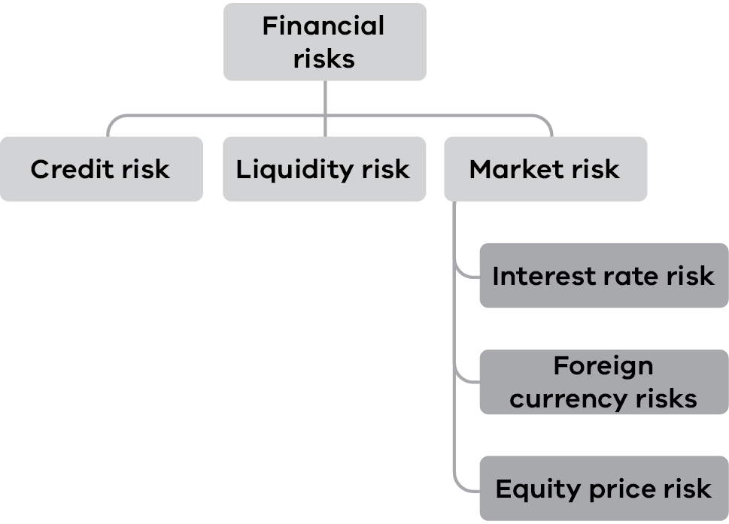
As a whole, the department’s financial risk management program seeks to manage these risks and the associated volatility of its financial performance.
Details of the significant accounting policies and methods adopted, including the criteria for recognition, the basis of measurement, and the basis on which income and expenses are recognised, with respect to each class of financial asset, financial liability and equity instrument above are disclosed throughout the financial statement notes.
The main purpose in holding financial instruments is to prudently manage the department’s financial risks within the government policy parameters.
The department’s main financial risks include credit risk, liquidity risk and market risk. The department manages these financial risks in accordance with its financial risk management policy.
The department uses different methods to measure and manage the different risks to which it is exposed. Primary responsibility for the identification and management of financial risks rests with the accountable officer of the department.

(a) Financial instruments: Credit risk
Credit risk refers to the possibility of the department’s counter party defaulting on their contractual obligations resulting in financial loss to the department. Credit risk is measured at fair value and is monitored on a regular basis.
Credit risk associated with contractual financial assets with the main debtor as the Victorian government is considered minimal. For all other contractual financial assets other than those with government, credit assessments are required where $5,000 or more of goods and services are provided. If a customer has a credit rating of less than a Triple-B rating, collateral security in the form of a bank guarantee or security deposit is obtained to reduce the department’s credit risk exposure. The collateral security does not apply to the Solar Victoria loans as these loans are less than $5,000. Refer to Note 6.2 for credit risk relating to derivative financial instruments.
Credit quality of financial assets
 | 2022 Financial institution (AA credit rating)  $’000 | 2022 Government agencies (AA credit rating)  $’000 | 2022 Government agencies (BBB credit rating)  $’000 | 2022  Other (min BBB credit rating)  $’000 | 2022  Other unrated  $’000 | 2022  Total  $’000
Contractual financial assets
Financial assets with loss allowance measured at 12-month expected credit loss:
Cash and deposits (not assessed for impairment due to materiality) | 1,281,536 | – | – | – | – | 1,281,536
Concessional loans | – | – | – | – | 110,584 | 110,584
Financial assets with loss allowance measured at lifetime expected credit loss:
Trade receivables applying the simplified approach for impairment | – | 238 | – | – | 39,232 | 39,470
Total contractual financial assets^{(i)} | 1,281,536 | 238 | – | – | 149,816 | 1,431,590
- The total amounts disclosed here exclude statutory amounts (e.g. amounts owing from Victorian Government and GST input tax credit recoverable) and derivatives.
 | 2021 Financial institution (AA credit rating)  $’000 | 2021 Government agencies (AA credit rating)  $’000 | 2021 Government agencies (BBB credit rating)  $’000 | 2021  Other (min BBB credit rating)  $’000 | 2021  Other unrated  $’000 | 2021  Total  $’000
Contractual financial assets
Financial assets with loss allowance measured at 12-month expected credit loss:
Cash and deposits (not assessed for impairment due to materiality) | 1,242,681 | – | – | – | – | 1,242,681
Concessional loans | – | – | – | – | 100,044 | 100,044
Financial assets with loss allowance measured at lifetime expected credit loss:
Trade receivables applying the simplified approach for impairment | – | 3,045 | – | – | 41,653 | 44,698
Total contractual financial assets^{(i)} | 1,242,681 | 3,045 | – | – | 141,697 | 1,387,423
- The total amounts disclosed here exclude statutory amounts (e.g. amounts owing from Victorian government and GST input tax credit recoverable) and derivatives.
Impairment of financial assets under AASB 9
The department records the allowance for expected credit loss for the relevant financial instruments applying AASB 9’s Expected Credit Loss approach. Subject to AASB 9 impairment assessment include the department’s contractual receivables and statutory receivables.
Equity instruments are not subject to impairment under AASB 9. Other financial assets designated at fair value through net result are not subject to impairment assessment under AASB 9. While cash and cash equivalents are also subject to the impairment requirements of AASB 9, the identified impairment loss was immaterial.
Contractual receivables at amortised cost
The maximum exposure to credit risk at balance date for receivables is the gross carrying amount of those assets. No collateral is held as security and there are no other credit enhancements relating to the department’s receivables.
The department applies both the AASB 9 simplified approach and the general approach to measure expected credit losses.
Simplified approach
The simplified approach is applied for all contractual receivables that result from transactions within the scope of AASB 15 Revenue from Contracts (i.e. trade receivables) using a lifetime expected loss allowance based on the assumptions about risk of default and expected loss rates.
The department has grouped contractual receivables on shared credit risk characteristics and days past due and select the expected credit loss rate based on the department’s past history, existing market conditions, as well as forward-looking estimates at the end of the financial year.
On this basis, the department determines the closing loss allowance at end of the financial year as follows:
Contractual receivables
 | Current | Less than 1 month | 1–3 months | 3–6 months | 6 months–  1 year | 1–5  years | Total
30-Jun-22
Expected loss rate – Public Bodies | 0% | 0% | 0% | 0% | 0% | 0%
Expected loss rate – Individual/ Commercial customers | 0% | 0% | 0.3% | 0.8% | 2.9% | 100.0%
Gross carrying amount of contractual receivables ($’000) | 27,911 | 6,687 | 3,046 | 467 | 514 | 845 | 39,470
Loss allowance ($’000) | – | – | 1 | 1 | 2 | 53 | 57

 | Current | Less than 1 month | 1–3 months | 3–6 months | 6 months–  1 year | 1–5  years | Total
30-Jun-21
Expected loss rate – Public Bodies | 0% | 0% | 0% | 0% | 0% | 0%
Expected loss rate – Individual / Commercial customers | 0% | 0% | 0% | 1.2% | 15.0% | 100.0%
Gross carrying amount of contractual receivables ($’000) | 30,943 | 4,946 | 2,077 | 3,753 | 1,995 | 984 | 44,698
Loss allowance ($’000) | - | - | - | 21 | 11 | 86 | 118

General approach – Solar concessional loans
The general approach is applied to contractual receivables that contain a significant financing component such as concessional loans advanced to customers. The general approach defines the expected credit loss (ECL) to be function of the risk dimensions, being the probability of default (PD), loss given default (LGD) and exposure at default (EAD). In addition, the department considers the time value of money by applying an appropriate discount factor to the expected credit loss model.
In assessing the ECL for the current financial year, the department considered the impact that COVID-19 might have on the ability of customers to make future repayments on their outstanding concessional loan balances. This was done through utilisation of an estimated unemployment rate in the ECL calculation. The estimated unemployment rate for the state of Victoria was published by the Australian Bureau of Statistics in June 2022 and includes adjustments for factors relating to the impact of COVID-19.
The department considers the probability of default upon initial recognition of a contractual asset containing a significant financing component and whether there has been a significant increase in credit risk on an ongoing basis throughout each reporting period. To assess whether there is a significant increase in credit risk, the department compares the risk of a default occurring on the asset as at the reporting date with the risk of default as at the date of initial recognition. It considers available reasonable and supportive forwarding-looking information. Regardless of the analysis above, a significant increase in credit risk is presumed if a customer under the concessional loan scheme is more than 90 days past due in making a contractual payment
Contractual assets containing a significant financing component
 | Outstanding balance  $’000 | Expected Credit Loss  $’000 | Coverage ratio  %
30-Jun-22
Stage 1 – Performing loans | 115,707 | 505 | 0.44
Stage 2 – Underperforming loans | 2,057 | 705 | 34.27
Stage 3 – Non-performing loans | 1,584 | 1,378 | 86.98
Loss allowance | 119,348 | 2,588 | 2.17

 | Outstanding balance  $’000 | Expected Credit Loss  $’000 | Coverage ratio  %
30-Jun-21
Stage 1 – Performing loans | 104,170 | 793 | 0.76
Stage 2 – Underperforming loans | 934 | 406 | 43.51
Stage 3 – Non-performing loans | 731 | 766 | 104.79
Loss allowance | 105,835 | 1,965 | 1.86

Reconciliation of the movement in the loss allowance for contractual receivables is shown as follows:
 | 2022  $’000 | 2021  $’000
Balance at 1 July | 2,083 | 1,305
Reversal of unused provision recognised in the net result | – | –
Reversal of provision of receivables written off during the year as uncollectible | – | –
Increase in provision recognised in the net result | 562 | 778
Balance at 30 June | 2,645 | 2,083

Credit loss allowance is classified as other economic flows in the net result. Contractual receivables are written off when there is no reasonable expectation of recovery and impairment losses are classified as a transaction expense. Subsequent recoveries of amounts previously written off are credited against the same line item.
Statutory receivables at amortised cost
The department’s non-contractual receivables arising from statutory requirements are not financial instruments. However, they are nevertheless recognised and measured in accordance with AASB 9 requirements as if those receivables are financial instruments.
The statutory receivables are considered to have low credit risk, taking into account the counterparty’s credit rating, risk of default and capacity to meet contractual cash flow obligations in the near term. As the result, the loss allowance recognised for these financial assets during the period was limited to 12 months expected losses. The department has recognised no loss allowance.

(b) Financial instruments: Liquidity risk
Liquidity risk arises from being unable to meet financial obligations as they fall due. The department operates under the government fair payments policy of settling financial obligations within 30 days and in the event of a dispute, making payments within 30 days from the date of resolution.
The department is exposed to liquidity risk mainly through the financial liabilities as disclosed in the face of the balance sheet. The department manages its liquidity risk by:
- close monitoring of its short-term and long-term borrowings and financial exposure by senior management, including monthly reviews on current and future borrowing levels and financial exposure requirements;
- maintaining an adequate level of uncommitted funds that can be drawn at short notice to meet its short-term obligations;
- holding investments and other contractual financial assets that are readily tradeable in the financial markets;
- careful maturity planning of its financial obligations based on forecasts of future cash flows; and
a high credit rating for the state of Victoria (Moody’s Investor Services and Standard & Poor’s double-A, which assists in accessing debt market at a lower interest rate).
The department’s exposure to liquidity risk is deemed insignificant based on prior periods’ data and current assessment of risk.
The carrying amount detailed for contractual payables in Note 6.3.1, and the carrying amount of derivative financial instruments recorded in Note 6.2(b) represents the department’s maximum exposure to liquidity risk.

(c) Financial instruments: Market risk
The department’s exposures to market risk are primarily through interest rate and equity price risk with insignificant exposure to foreign currency risks. Objectives, policies and processes used to manage each of these risks is disclosed below.
Sensitivity disclosure analysis and assumptions
Taking into account past performance, future expectations, economic forecasts, and management’s knowledge and experience of the financial markets, the department believes the following movements are ‘reasonably possible’ over the next 12 months (the cash rate is sourced from the Reserve Bank of Australia):
a movement of 200 basis points up and 100 basis points down (2021: 100 basis points up and down) in market interest rates (AUD);
The tables that follow show the impact on the department’s net result and equity for each category of financial instrument held by the department at the end of the reporting period, if the above movements were to occur.
Interest rate risk
Fair value interest rate risk is the risk that the fair value of a financial instrument will fluctuate because of changes in market interest rates.
Cash flow interest rate risk is the risk that the future cash flows of a financial instrument will fluctuate because of changes in market interest rates. The department has minimal exposure to cash flow interest rate risks through cash and deposits in the Centralised Banking System (CBS). The interest rate paid on surplus account balances are the cash rate plus 15 basis points and funds are all at call.
The department’s borrowings are office accommodation, motor vehicle leases and other asset leases as disclosed in Note 7.3. The department’s motor vehicles leases are managed by VicFleet and Fleet Plus and interest rates are fixed at the inception of the lease. Office accommodation and other asset leases liabilities are determined using the interest rate implicit in the lease if that rate is readily determinable.
The department leases office accommodation, motor vehicles, and various other assets for fire emergency purposes.
Office accommodation are mostly leased from the Shared Service Provider (SSP), part of the Department of Treasury and Finance. As a result of the Central Accommodation Management initiative implemented in the current financial year, the department has entered into two year lease agreements with SSP for all its office accommodation.
Motor vehicles are leased through the VicFleet and Fleet Plus lease facilities. The lease term is the period over which the vehicle is to be leased. Generally, vehicles must be retained for three years or 60,000 kilometres for VicFleet vehicles and 15 years for FleetPlus vehicles, whichever occurs first. On disposal of the vehicle any profit or loss on sale is borne by the department.
Other leased assets include airport hangars, and emergency management system hosting and storage. These assets are leased to assist the department in delivering its fire and emergency management outputs. The assets are leased for a period between 1 and 3 years.
The carrying amounts of financial assets and financial liabilities that are exposed to interest rates and the department’s sensitivity to interest rate risk are set out in the table that follows.
Interest rate exposure of financial instruments
 | Weighted average effective interest rate | Interest rate exposure Carrying amount  $‘000 | Interest rate exposure Fixed interest rate  $‘000 | Interest rate exposure Variable interest rate  $‘000 | Interest rate exposure Non-interest bearing  $‘000
2022
Financial assets
Cash and deposits
Cash and deposits on call | 0.33% | 1,281,536 | – | 545,854 | 735,682
Receivables^{(i)}
Trade and other receivables |  | 39,470 | – | – | 39,470
Concessional loans |  | 110,584 | – | – | 110,584
Derivative financial Instruments |  | 429,933 | – | – | 429,933
Total financial assets |  | 1,861,523 | – | 545,854 | 1,315,669
Financial liabilities
Payables^{(ii)}
Trade creditors |  | 8,828 | – | – | 8,828
Accrued grants and other transfers |  | 106,071 | – | – | 106,071
Capital accruals |  | 4,446 | – | – | 4,446
Other payables and accrued expenses |  | 109,681 | – | – | 109,681
Other financial liabilities |  | 204,383 | – | – | 204,383
Borrowings | 2.79% | 49,664 | 49,664 | – | –
Derivative financial Instruments |  | – | – | – | –
Other liabilities |  | 8,129 | – | – | 8,129
Total financial liabilities |  | 491,202 | 49,664 | – | 441,538
Note:
- The amount of receivables disclosed excludes accrued income and statutory receivables (i.e. amounts owing from Victorian government, landfill levies receivable and GST input tax credit receivable) totalling $957.438 million – Refer to Note 6.1 Receivables.
- The amount of payables disclosed excludes statutory payables (i.e. advances from the Public Account and taxes payable) totalling $31.289 million – Refer to Note 6.3 Payables.
Interest rate exposure of financial instruments (continued)
 | Weighted average effective interest rate | Interest rate exposure Carrying amount  $‘000 | Interest rate exposure Fixed interest rate  $‘000 | Interest rate exposure Variable interest rate  $‘000 | Interest rate exposure Non-interest bearing  $‘000
2021
Financial assets
Cash and deposits
Cash, deposits on call | 0.33% | 1,242,681 | – | 525,575 | 717,106
Receivables ^{(i)}
Trade and other receivables |  | 44,698 | – | – | 44,698
Concessional loans |  | 100,044 | – | – | 100,044
Derivative financial instruments |  | 80,669 | – | – | 80,669
Total financial assets |  | 1,387,423 | – | 525,575 | 861,848
Financial liabilities
Payables^{(ii)}
Trade creditors |  | 29,910 | – | – | 29,910
Accrued grants and other transfers |  | 64,095 | – | – | 64,095
Capital accruals |  | 2,168 | – | – | 2,168
Other payables and accrued expenses |  | 116,262 | – | – | 116,262
Other financial liabilities |  | 201,146 | – | – | 201,146
Borrowings | 2.94% | 50,812 | 50,812 | – | –
Derivative financial instruments |  | 1,931 | – | – | 1,931
Other liabilities |  | 5,692 | – |  | 5,692
Total financial liabilities |  | 472,016 | 50,812 | – | 421,204
Note:
- The amount of receivables disclosed excludes accrued income and statutory receivables (i.e. amounts owing from Victorian Government, landfill levies receivable and GST input tax credit receivable) totalling $769.123 million – Refer to Note 6.1 Receivables.
- The amount of payables disclosed excludes statutory payables (i.e., amounts owing to Victorian Government for advances from the Public Account and taxes payable) totalling $48.239 million – Refer to Note 6.3 Payables.
Interest rate risk sensitivity
 | Carrying amount  $’000 | 2022 Interest rate risk  -1.0%  (-100 basis points)  Net result  $‘000 | 2022 Interest rate risk  +2.0%  (200 basis points) Net result  $‘000
Contractual financial assets:
Cash and deposits^{(i)} | 1,281,536 | (5,459) | 10,917
Total impact |  | (5,459) | 10,917
Contractual financial liabilities:
Borrowings^{(ii)} | 49,664 | – | –
Total impact |  | – | –

 | Carrying amount  $’000 | 2021 Interest rate risk -1.0%  (-100 basis points) Net result  $‘000 | 2021 Interest rate risk +1.0%  (100 basis points)  Net result  $‘000
Contractual financial assets:
Cash and deposits^{(i)} | 1,242,681 | (5,256) | 5,256
Total impact |  | (5,256) | 5,256
Contractual financial liabilities:
Borrowings^{(ii)} | 50,812 | – | –
Total impact |  | – | –
Note:
- All cash and cash equivalents are held in Australian dollars. $545.854 million (2021: $525.575 million) cash and cash equivalents were held on deposit at variable interest rates. The remainder of the balance was held in non-interest bearing accounts. This item is not subject to any other identified risk sensitivities.
- Borrowings relate to lease liabilities associated with office accommodation, other assets and motor vehicles. Office accommodation and other assets have incremental borrowings rates applied. Motor vehicle leases have interest fixed at the inception of the lease. This item is not subject to identified risk sensitivities.
Foreign currency risk
The department had no exposure to foreign currency risk as at either 30 June 2022 or 30 June 2021.
Equity price risk
The department’s exposure to equity price risk is outlined in Note 6.2 Derivative financial instruments.

8.2 Contingent assets and contingent liabilities
Contingent assets and contingent liabilities are not recognised in the balance sheet but are disclosed in the notes to the financial statement and, if quantifiable, are measured at nominal value.
Contingent assets and liabilities are presented inclusive of GST receivable or payable respectively.

Contingent assets
Contingent assets are possible assets that arise from past events, whose existence will be confirmed only by the occurrence or non-occurrence of one or more uncertain future events not wholly within the control of the entity.
These are classified as either quantifiable, where the potential economic benefit is known, or non-quantifiable.

Contingent liabilities
Contingent liabilities are:
- possible obligations that arise from past events, whose existence will be confirmed only by the occurrence or non-occurrence of one or more uncertain future events not wholly within the control of the entity
- present obligations that arise from past events but are not recognised because:
- it is not probable that an outflow of resources embodying economic benefits will be required to settle the obligations
- the amount of the obligations cannot be measured with sufficient reliability.
Contingent liabilities are also classified as either quantifiable or non-quantifiable.
 | 2022  $’000 | 2021  $’000
Quantifiable contingent assets
Other | – | –
 | – | –
Quantifiable contingent liabilities
Damages claims | 670 | 670
Public liability insurance claims^{(i)} | 1,231 | 1,016
Other^{(ii)} | 2,875 | 2,550
 | 4,776 | 4,236
Note:
- The public liability insurance claims relate to various personal expense matters resulting from serious injury and natural disasters.
- The other contingent liabilities relate to various planning application and compensation claims.

Unquantifiable contingent liabilities
The department has the following unquantifiable contingent liabilities.

Native Titles
There have been four native title claims made in relation to Victorian land and resources (2021: three native title claims). No material losses are anticipated in respect of any of these contingencies.

Planning scheme compensation
Under section 98 of the Planning and Environment Act 1987, the owner or occupier of any land may claim compensation from the planning authority for financial loss suffered as the natural, direct and reasonable consequence of the land being reserved, or declared as reserved for a public purpose under a planning scheme. The future liability depends on a number of factors and cannot be reliably quantified.

Yallourn Power Station safety net
The government has reached an agreement with EnergyAustralia (EA) to ensure an orderly transition as EA implements the closure of the Yallourn Power Station in June 2028.
The agreement includes, should it be needed, a safety net to avoid an unplanned exit from Yallourn. As part of this safety net, under certain scenarios, the state agrees to provide partial support to EA in the event of exceptional costs incurred in the operation of the Yallourn Power Station.
This support will help to ensure Yallourn’s workers and Victoria’s energy system have sufficient time to plan for the plant’s closure. The possible liability depends on a number of future events and cannot be reliably and readily quantified.

8.3 Fair value determination
This section sets out information on how the department determined fair value for financial reporting purposes. Fair value is the price that would be received to sell an asset or paid to transfer a liability in an orderly transaction between market participants at the measurement date.
The following assets and liabilities are carried at fair value:
- Contractual financial assets and liabilities at fair value through net result (financial derivatives)
- Property, plant and equipment
Non-financial physical assets classified as held for sale (refer to Note 5.2)
In addition, the fair values of other assets and liabilities which are carried at amortised cost, also need to be determined for disclosure purposes.
The department determines the policies and procedures for determining fair values for both financial and non-financial assets and liabilities as required.

Fair value hierarchy
In determining fair values, a number of inputs are used. To increase consistency and comparability in the financial statements, these inputs are categorised into three levels, also known as the fair value hierarchy. The levels are as follows:
- Level 1 – Quoted (unadjusted) market prices in active markets for identical assets or liabilities
- Level 2 – Valuation techniques for which the lowest level input that is significant to the fair value measurement is directly or indirectly observable
Level 3 – Valuation techniques for which the lowest level input that is significant to the fair value measurement is unobservable.
The department determines whether transfers have occurred between levels in the hierarchy by reassessing categorisation (based on the lowest level input that is significant to the fair value measurement as a whole) at the end of each financial year.

How fair value disclosures are structured
For those assets and liabilities for which fair values are determined, the following disclosures are provided:
- carrying amount and the fair value (which would be the same for those assets measured at fair value)
- which level of the fair value hierarchy was used to determine the fair value:
- in respect of those assets and liabilities subject to fair value determination using Level 3 inputs:
- a reconciliation of the movements in fair values from the beginning of the year to the end
- details of significant unobservable inputs used in the fair value determination.
This is divided between disclosures in connection with fair value determination for financial assets and liabilities (refer to Note 8.3.1 and Note 6.2) and non-financial physical assets (refer to Note 5.1.3 and Note 5.2.1).

8.3.1 Fair value determination of financial assets and liabilities
The fair value of the financial assets and liabilities is included at the amount at which the instrument could be exchanged in a current transaction between willing parties, other than in a forced or liquidation sale.
The fair values and net fair values of financial instrument assets and liabilities are determined as follows:
- Level 1 – the fair value of financial instrument with standard terms and conditions and traded in active liquid markets are determined with reference to quoted market prices
- Level 2 – the fair value is determined using inputs other than quoted prices that are observable for the financial asset or liability, either directly or indirectly
Level 3 – the fair value is determined in accordance with generally accepted pricing models based on discounted cash flow analysis using unobservable market inputs.
The department currently holds a range of financial instruments that are recorded in the financial statements where the carrying amounts approximate to fair value, due to their short-term nature or with the expectation that they will be paid in full by the end of the 2022-23 reporting period. These financial instruments include:
Financial assets | Financial liabilities
Cash and deposits  Receivables  Trade receivables | Payables  Trade creditors  Accrued grants and other transfers  Capital accruals  Other payables and accrued expenses  Borrowings  Lease liabilities  Other liabilities

Note 9. Other disclosures

Introduction
This section includes additional material disclosures required by accounting standards or otherwise, for the understanding of this financial report.

Structure
9.1 Ex-gratia expenses
9.2 Other economic flows included in net result
9.3 Equity
9.3.1 Physical asset revaluation surplus
9.3. Capital contributions transferred to portfolio entities
9.4 Subsequent events
9.5 Responsible persons
9.6 Remuneration of executive officers
9.7 Remuneration of auditors
9.8 Related parties
9.9 Other accounting policies
9.10 Australian Accounting Standards issued that are not yet effective
9.11 Style conventions
9.12 Glossary of technical terms

9.1 Ex gratia expenses
The department made no ex gratia payments during 2021-22 or 2020-21.

9.2 Other economic flows included in net result
Other economic flows are changes in the volume or value of an asset or liability that do not result from transactions. Other gains/(losses) from other economic flows include the gains or losses from:
- disposals of financial assets and derecognition of financial liabilities
- realised and unrealised gains and losses from revaluations of financial instruments at fair value
- the revaluation of the present value of the long service leave liability due to changes in the bond interest rates
re-measurement of other provisions.
 | 2022  $’000 | 2021  $’000
Net gain/(loss) on non-financial assets
Net gain/(loss) on disposal of property, plant and equipment and large scale generation certificates held for sale | 3,925 | (3,762)
Net recognition of non-financial assets | 90,745 | 879,748
Write-down of property, plant and equipment and intangible assets | (3,615) | (3,362)
Total net gain/(loss) on non-financial assets | 91,055 | 872,624
Net gain/(loss) on financial instruments
Impairment of receivables | (676) | (1,295)
Net gain on disposal of financial assets through profit and loss account | – | 2,008
Net gain/(loss) arising from the revaluation of financial assets at fair value | 381,742 | (89,521)
Total net gain/(loss) on financial instruments | 381,066 | (88,808)
Other gains/(losses) from other economic flows
Loss from revaluation of investment in associates | – | –
Net gain arising from revaluation of employee benefits | 10,575 | 12,411
Other provision discount rate adjustments | (769) | 351
Total other gains from other economic flows | 9,806 | 12,762
Total other economic flows included in net result | 481,927 | 796,578

The net gain/(loss) on non-financial assets and liabilities includes realised and unrealised gains and losses as follows:
Net gain/(loss) on disposal of property, plant and equipment
Any gain or loss on the disposal of property, plant and equipment is recognised at the date of disposal and is the difference between the proceeds and the carrying value of the asset at the time.
Recognition and derecognition of non-financial assets
Land is recognised under the categories set out at Note 5.1 Property, plant and equipment when the department identifies specific parcels of land, park, forest or reserve that it controls, and their cost can be reliably determined. The department considers relevant information from land management databases and systems, such as the use and purpose for which a particular parcel has been reserved for, to determine the parcels of Crown land over which it has control and responsibility. Where land has been received at no cost the fair value is determined by the Valuer-General Victoria.
Other government entities are able to change the status of Crown land through grants and reservations made under legislation that is not administered by either of the Ministers who hold portfolio responsibility (for example, Crown grants may be issued under the Project Development and Construction Management Act 1994). The department’s policy is to recognise the effect of such changes when it is made aware of the change in status.
Land is derecognised when it is not eligible to be treated as a return of equity to other government entities or when the information is available in the Land Information Management System regarding changes to area size. Gains or losses on the recognition or derecognition of land are recognised in the net result (other economic flows).
Write-down of property, plant and equipment and intangible assets
The department will recognise a write-down of property, plant and equipment and intangible assets when there is evidence that there is a change in the market or an equipment breakdown. This is identified through impairment and life reviews.
Net gain/(loss) arising from the revaluation of financial assets at fair value
Any gains or losses arising from changes in the fair value of derivatives after initial recognition are recognised in the comprehensive operating statement as an ‘other economic flow’ included in the net result.

9.3 Equity

9.3.1 Physical asset revaluation surplus
 | 2022  $’000 | 2021  $’000
Physical asset revaluation surplus
Balance at 1 July | 5,564,684 | 4,862,639
Increment/(decrement) on revaluation during the year resulting from:
Freehold land | 20,133 | (30,658)
Buildings and structures | – | 26,500
Roads | – | (257,095)
Historic and cultural assets | 244 | 1,146
Crown land – Land used for operational purposes | 4,857 | 6,850
Crown land – State forests | 414,353 | 920,782
Crown land – Land, unused roads | 593,376 | 42,266
Crown land – National parks | 1,047 | 1,684
Crown land – Conservation reserves | 15,387 | (7,704)
Crown land – Metropolitan parks | 1,582 | (1,726)
Total increment/(decrement) on revaluation during the year to be included in Operating Statement under other economic flows: | 1,050,979 | 702,045
Balance at 30 June | 6,615,663 | 5,564,684
Net change in physical asset revaluation surplus | 1,050,979 | 702,045

Nature and purpose of physical asset revaluation surplus
The physical asset revaluation surplus is used to record increments and decrements on the revaluation of non-current physical assets.

9.3.2 Capital contributions transferred to portfolio entities
 | 2022  $’000 | 2021  $’000
Capital contributions transferred to portfolio entities
Contributions to Parks Victoria | 35,315 | 5,055
Contributions to water authorities | 48,740 | 61,851
Contributions to Zoological Parks and Gardens Board of Victoria | 20,595 | 7,676
Contribution to Alpine Resort Management Boards | 3,000 | –
Total capital contributions transferred to portfolio entities | 107,650 | 74,582

Consistent with the requirements of AASB 1004 Contributions, contributions by owners (that is, contributed capital and its repayment) are treated as equity transactions and, therefore, do not form part of the income and expenses of the department.
Additions to net assets that have been designated as contributions by owners are recognised as contributed capital. Other transfers that are in the nature of contributions to or distributions by owners have also been designated as contributions by owners.
Transfers of net assets arising from administrative restructuring are treated as distributions to or contributions by owners. Transfers of net liabilities arising from administrative restructuring are treated as distributions to owners.

9.4 Subsequent events

Establishment of Recycling Victoria
On 14 December 2021, the Circular Economy (Waste Reduction and Recycling) Act 2021 received Royal Assent. The Act saw the establishment of Recycling Victoria on 1 July 2022, a dedicated business unit within DELWP that provides strategic leadership and oversight of the waste and recycling sector. On commencement, the seven Waste and Resource Recovery Groups, as well as the infrastructure planning function performed by Sustainability Victoria transferred to DELWP.
The assets and liabilities of the WRRGs and the Sustainability Victoria function will transfer to DELWP via contributed capital as per FRD 119 on 1 July 2022. The estimated amount of total net assets to be transferred is $7 million.
There are no other subsequent events to disclose.

9.5 Responsible persons
In accordance with the Ministerial Directions issued by the Assistant Treasurer under the Financial Management Act 1994, the following disclosures are made regarding responsible persons for the reporting period.

Names
The persons who held the positions of Ministers and Accountable Officers in the department are as follows:
Minister for Water | The Hon. Lisa Neville MP | 1 July 2021 to 27 June 2022
Minister for Water | The Hon. Harriet Shing MP | 27 June 2022 to 30 June 2022
Minister for Energy, Environment and Climate Change | The Hon. Lily D’Ambrosio MP | 1 July 2021 to 27 June 2022
Minister for Energy | The Hon. Lily D’Ambrosio MP | 27 June 2022 to 30 June 2022
Minister for Environment and Climate Acton | The Hon. Lily D’Ambrosio MP | 27 June 2022 to 30 June 2022
Minister for Solar Homes | The Hon. Lily D’Ambrosio MP | 1 July 2021 to 30 June 2022
Minister for Planning | The Hon. Richard Wynne MP | 1 July 2021 to 27 June 2022
Minister for Planning | The Hon. Lizzie Blandthorn MP | 27 June 2022 to 30 June 2022
Secretary | Mr John Bradley PSM | 1 July 2021 to 30 June 2022

Remuneration received or receivable by the Accountable Officer in connection with the management of the department during the reporting period was in the range: $580,000–$590,000 ($570,000–$580,000 in 2020-21).

Acting arrangements
The Hon. Richard Wynne MP acted as Minister for Water for the periods 1 to 6 July 2021, 15 July 2021 to 22 August 2021, 21 to 25 January 2022 and 29 May to 5 June 2022. He also acted as Minister for Energy, Environment and Climate Change and Minister for Solar Homes for the period 21 January to 2 February 2022.
The Hon. Lily D’Ambrosio MP acted as Minister for Water for the period 7 to 14 July 2021 and 10 to 20 January 2022. She also acted as Minister for Planning for the period 10 to 20 January 2022.
The Hon. Lisa Neville MP acted as Minister for Planning for the period 1 to 9 January 2022.
The Hon. Melissa Horne MP acted as Minister for Water for the period 7 to 14 July 2021
Graeme Emonson acted as Secretary for the period 1 to 11 July 2021 and Helen Vaughan acted as the Secretary for the period 18 December 2021 to 9 January 2022.

9.6 Remuneration of executive officers (including executives defined as Key Management Personnel)
The number of executive officers, other than ministers and the accountable officer, and their total remuneration during the reporting period are shown in the table below. Total annualised employee equivalents provide a measure of full time equivalent executive officers over the reporting period.
Remuneration comprises employee benefits (as defined in AASB 119 Employee Benefits) in all forms of consideration paid, payable or provided by the entity, or on behalf of the entity, in exchange for services rendered, and is disclosed in the following categories.
Short-term employee benefits include amounts such as wages, salaries, annual leave or sick leave that are usually paid or payable on a regular basis, as well as non-monetary benefits such as allowances and free or subsidised goods or services.
Post-employment benefits include superannuation contributions and other retirement benefits paid or payable on a discrete basis when employment has ceased.
Other long-term benefits include long service leave and deferred compensation.
Termination benefits include termination of employment payments, such as severance packages.
 | 2022  $’000 | 2021  $’000
Remuneration of executive officers
Short-term employee benefits | 36,387 | 32,971
Post-employment benefits | 3,483 | 3,205
Other long-term benefits | 1,077 | 853
Termination benefits | 145 | 339
Total remuneration of executive officers^{(i)(iii)(iv)} | 41,092 | 37,368
Total number of executives^{(iv)} | 197 | 173
Total annualised employee equivalent (AEE)^{(ii)(iv)} | 180.0 | 152.9
Note
- The total number of executive officers includes persons who meet the definition of Key Management Personnel (KMP) of the department under AASB 124 Related Party Disclosures and are also reported within the related parties note disclosure (Note 9.8).
- Annualised employee equivalent is based on the time fraction worked over the reporting period.
- Remuneration for staff who have acted in executive positions over two months have been included in the table above.
- Totals include the cost incurred on executives that delivered services, as executive officers, under secondment or similar arrangements to the department, but that are employed by another public sector body.

9.7 Remuneration of auditors
 | 2022  $’000 | 2021  $’000
Victorian Auditor-General’s Office
Audit of the financial statements | 550 | 604
Total remuneration of auditors | 550 | 604

The remuneration of auditors is recognised in other operating expenses.

9.8 Related parties
The department is a wholly owned and controlled entity of the state of Victoria. Related parties of the department include:
- all key management personnel and their close family members and personal business interests (controlled entities, joint ventures and entities they have significant influence over)
- all cabinet ministers and their close family members
all departments and public sector entities that are controlled and consolidated into the whole of state consolidated financial statements.
All related party transactions have been entered into on an arm’s length basis.

Significant transactions with government related entities
The following transactions are considered to be related parties with significant transactions with the department.
The department receives parliamentary and special appropriation to draw funds out of the Consolidated Funds to be applied towards departmental outputs (see Note 2.2 Appropriations and 2.2.1 Summary of compliance with annual parliamentary appropriations) and income from government related entities such as grant income (see Note 2.3.4 Grants), landfill levy (see Note 2.3.2 Municipal and Industrial Waste Levy) and parks charge (see Note 2.3.3 Metropolitan Parks Improvement Rate). In addition, the department oversees administered items on behalf of the state with reference to Payments made on behalf of the state (see Note 2.2 Appropriations and 2.2.1 Summary of compliance with annual parliamentary appropriations) and detailed in (Note 4.2 Administered (non-controlled) items).
The department transacts with other portfolio and government agencies through transactions such as grants (Note 3.1.2 Grants and other transfers), supplies and services (Note 3.1.4 Supplies and services) and capital appropriations (Note 9.3.2 Capital contribution transferred to portfolio entities) in line with budgeted allocations.
The department has advances from government, such as those related to GST payments (required to account for timing differences). These advances are unsecured loans which bear no interest (see Note 6.3 Payables). In addition, the department leases motor vehicles for operating purposes from VicFleet (Note 7.2 Borrowings)

Other related parties
Key management personnel of the department include the Portfolio Ministers, the Secretary John Bradley; the Deputy Secretaries and some members of the Executive Team, which includes:
- Deputy Secretary Corporate Services, Dr Graeme Emonson PSM
- Deputy Secretary Energy, Ms Anthea Harris (1 July 2021 to 18 March 2022)
- Deputy Secretary Energy, Ms Anh Mai (21 March to 30 June 2022)
- Deputy Secretary Environment and Climate Change, Ms Carolyn Jackson (on leave 23 August 2021 to 29 April 2022)
- Acting Deputy Secretary Environment and Climate Change, Ms Karen Lau (23 August 2021 to 29 April 2022)
- Deputy Secretary Forest, Fire and Regions, Ms Christine Ferguson PSM
- Deputy Secretary Land Services and First People, Mr Terry Garwood PSM
- Deputy Secretary Planning, Mr Julian Lyngcoln
- Deputy Secretary Water and Catchments, Ms Helen Vaughan PSM
- Chief Executive Officer Solar Homes, Mr Stan Krpan PSM
- Chief Fire Officer, Mr Chris Hardman
Director Victorian Desalination Project, Mr Andrew Ogilvie
Remuneration of key management personnel
The compensation detailed below excludes the salaries and benefits the Portfolio Ministers receive. The Ministers’ remuneration and allowances is set by the Parliamentary Salaries and Superannuation Act 1968 and is reported within the State’s Annual Financial Report.
 | 2022  $’000 | 2021  $’000
Compensation of key management personnel
Short-term employee benefits | 4,303 | 3,939
Post-employment benefits | 288 | 302
Other long-term benefits | 113 | 95
Termination benefits | – | –
Total compensation of key management personnel | 4,704 | 4,336
Note: The above remuneration amounts have also been disclosed in Note 9.6 Remuneration of executive officers.
Remuneration for staff who have acted in the executive position for over two months have been included in the table above and Note 9.6.

Transactions with key management personnel and other related parties
Given the breadth and depth of state government activities, related parties transact with the Victorian public sector in a manner consistent with other members of the public e.g. stamp duty and other government fees and charges.
Further employment of processes within the Victorian public sector occur on terms and conditions consistent with the Public Administration Act 2004 and Codes of Conduct and Standards issued by the Victorian Public Sector Commission.
Procurement processes occur on terms and conditions consistent with the Victorian Government Procurement Board requirements.
Outside of normal citizen type transactions with the department, there were no related party transactions that involved key management personnel and their close family members. No provision has been required, nor any expense recognised, for impairment of receivables from related parties.
The Secretary is a board member of Infrastructure Victoria and there were no transactions entered into by the department during the reporting period.
The Secretary is also the president and the Deputy Secretary Corporate Services is a board member of the Institute of Public Administration Australian (Victorian Division Inc) to which the department paid services fees and charges on normal commercial terms during the reporting period.

9.9 Other accounting policies

Accounting for goods and services tax (GST)
Income, expenses and non-financial assets and liabilities are recognised net of the amount of associated GST, except where the GST incurred is not recoverable from the taxation authority. In this case, the GST payable is recognised as part of the cost of acquisition of the asset or as part of the expense. Receivables and payables are stated inclusive of the amount of GST receivable or payable. The net amount of GST recoverable from, or payable to, the Australian Taxation Office is included with other receivables or payables in the balance sheet.
Cash flows are presented on a gross basis. The GST components of cash flows arising from investing or financing activities which are recoverable from, or payable to the taxation authority, are presented as operating cash flows.
Commitments for expenditure and contingent assets and liabilities are also stated inclusive of GST.

9.10 Australian Accounting Standards issued that are not yet effective
Certain new and revised accounting standards have been issued but are not effective for the 2021-22 reporting period. These accounting standards have not been applied to these financial statements. DELWP is reviewing its existing policies and assessing the potential implications of these accounting standards which include:
Standard/ Interpretation | Summary | Applicable for annual reporting periods beginning on | Impact on financial statements
AASB 2020-1 Amendments to Australian Accounting Standards – Classification of Liabilities as Current or Non-Current. | The Standard amends AASB 101 to clarify requirements for the presentation of liabilities in the statement of financial position as current or non-current. A liability is classified as non-current if an entity has the right at the end of the reporting period to defer settlement of the liability for at least 12 months after the reporting period. The meaning of settlement of a liability is also clarified.  AASB 2020-6 Amendments to Australian Accounting Standards – Classification of Liabilities as Current or Non-current – Deferral of Effective Date was issued in August 2020 and defers the effective date to annual reporting periods beginning on or after 1 January 2023 instead of 1 January 2022, with earlier application permitted. | 1 January 2023 | The standard is not expected to have a significant impact.

9.11 Style conventions
Figures in the tables and in the text have been rounded. Discrepancies in tables between totals and sums of components reflect rounding. Percentage variations in all tables are based on the underlying unrounded amounts.
The notation used in the tables is as follows:
(xxx.x) negative numbers
20xx year period
20xx–xx year period
The financial statements and notes are presented based on the illustration for a government department in the 2021-22 Model Report for Victorian Government Departments. The presentation of other disclosures is generally consistent with the other disclosures made in earlier publications of the department’s annual report.

9.12 Glossary of technical terms
Grants for on- passing
All grants paid to one institutional sector (e.g. a state general government entity) to be passed on to another institutional sector (e.g. local government or a private non-profit institution).
Intangible produced assets
Refer to produced assets in this glossary.
Joint ventures
Joint ventures are contractual arrangements between the department and one or more other parties to undertake an economic activity that is subject to joint control and have right to the net assets of the arrangement. Joint control only exists when the strategic financial and operating decisions relating to the activity require the unanimous consent of the parties sharing control (the venturers).
Net result
Net result is a measure of financial performance of the operations for the period. It is the net result of items of revenue, gains and expenses (including losses) recognised for the period, excluding those that are classified as ‘other economic flows – other comprehensive income’.
Net result from transactions/net operating balance
Net result from transactions or net operating balance is a key fiscal aggregate and is income from transactions minus expenses from transactions. It is a summary measure of the ongoing sustainability of operations. It excludes gains and losses resulting from changes in price levels and other changes in the volume of assets. It is the component of the change in net worth that is due to transactions and can be attributed directly to government policies.
Net worth
Net worth is assets less liabilities, which is an economic measure of wealth.
Non-financial assets
Non-financial assets are all assets that are not ‘financial assets. It includes inventories, land, buildings, road networks, land under roads, plant and equipment, cultural and heritage assets, intangible and biological assets.
Non-produced assets
Non-produced assets are assets needed for production that have not themselves been produced. They include land, subsoil assets, and certain intangible assets. Non-produced intangibles are intangible assets needed for production that have not themselves been produced. They include constructs of society such as patents.
Other economic flows included in net result
Other economic flows included in net result are changes in the volume or value of an asset or liability that do not result from transactions. It includes:
- gains and losses from disposals, revaluations and impairments of non-financial physical and intangible assets
fair value changes of financial instruments and agricultural assets.
Other economic flows – other comprehensive income
Other economic flows – other comprehensive income comprises items (including reclassification adjustments) that are not recognised in net result as required or permitted by other Australian Accounting Standards.
The components of other economic flows - other comprehensive income include:
- changes in physical asset revaluation surplus
- gains and losses on remeasuring available-for-sale financial assets.
Produced assets
Produced assets include buildings, plant and equipment, inventories, cultivated assets and certain intangible assets. Intangible produced assets may include computer software, motion picture films and research and development costs (which does not include the start-up costs associated with capital projects).
Sales of goods and services
Refers to income from the direct provision of goods and services and includes fees and charges for services rendered, sales of goods and services, fees from regulatory services and work done as an agent for private enterprises. It also includes rental income under operating leases and on produced assets such as buildings and entertainment, but excludes rent income from the use of non-produced assets such as land. User charges includes sale of goods and services income.
Taxation income
Taxation income represents income received from the state’s taxpayers and includes:
- levies (including the environmental levy) on statutory corporations in other sectors of government
- the Metropolitan Parks Improvement Rate
other taxes, including landfill levies, licence and concession fees.
Transactions
Transactions are those economic flows that are considered to arise as a result of policy decisions, usually an interaction between two entities by mutual agreement. They also include flows into an entity such as depreciation where the owner is simultaneously acting as the owner of the depreciating asset and as the consumer of the service provided by the asset. Taxation is regarded as mutually agreed interactions between the government and taxpayers. Transactions can be in kind (e.g. assets provided/given free of charge or for nominal consideration) or where the final consideration is cash. In simple terms, transactions arise from the policy decisions of the government.

Appendices

Appendix 1: Disclosure Index
The annual report is prepared in accordance with all relevant Victorian legislations and pronouncements. This index has been prepared to facilitate identification of the department’s compliance with statutory disclosure requirements. [FRD 10]
Click on a requirement or legislation title (Ctrl+click in Microsoft Word) to refer to the relevant requirements for the corresponding disclosure requirements, or alternatively, refer to the corresponding page references.
Standing Directions and Financial Reporting Directions
Report of operations
Charter and purpose
Legislation | Requirement | Page reference
FRD 22 | Manner of establishment and the relevant Ministers | 16
FRD 22 | Purpose, functions, powers and duties | 21
FRD 8 | Departmental objectives, indicators and outputs | 25
FRD 22 | Key initiatives and projects | 27
FRD 22 | Nature and range of services provided | 20

Management and structure
Legislation | Requirement | Page reference
FRD 22 | Organisational structure | 22

Financial and other information
Legislation | Requirement | Page reference
FRD 8 | Performance against output performance measures | 30
FRD 8 | Budget portfolio outcomes | 374
FRD 10 | Disclosure index | 353
FRD 12 | Disclosure of major contracts | 182
FRD 15 | Executive disclosures | 364
FRD 22 | Employment and conduct principles | 122
FRD 22 | Occupational health and safety policy | 123
FRD 22 | Summary of the financial results for the year | 167
FRD 22 | Significant changes in financial position during the year | 138
FRD 22 | Major changes or factors affecting performance | 138
FRD 22 | Subsequent events | 167
FRD 22 | Application and operation of Freedom of Information Act 1982 | 184
FRD 22 | Compliance with building and maintenance provisions of Building Act 1993 | 189
FRD 22 | Statement on National Competition Policy | 194
FRD 22 | Application and operation of the Public Interest Disclosure Act 2012 | 188
FRD 22 | Application and operation of the Carers Recognition Act 2012 | 189
FRD 22 | Details of consultancies over $10,000 | 182
FRD 22 | Details of consultancies under $10,000 | 182
FRD 22 | Disclosure of government advertising expenditure | 182
FRD 22 | Statement of availability of other information | 219
FRD 24 | Reporting of office based environmental impacts | 120
FRD 25 | Local Jobs First | 179
FRD 29 | Workforce Data disclosures | 357
SD 5.2 | Specific requirements under Standing Direction 5.2 | Inside front cover

Compliance attestation and declaration
Legislation | Requirement | Page reference
SD 5.4.1 | Attestation for compliance with Ministerial Standing Direction | 169
SD 5.2.3 | Declaration in report of operations | Inside front cover

Financial statements
Declaration
Legislation | Requirement | Page reference
SD 5.2.2 | Declaration in financial statements | 185

Other requirements under Standing Directions 5.2
Legislation | Requirement | Page reference
SD 5.2.1(a) | Compliance with Australian accounting standards and other authoritative pronouncements | 232
SD 5.2.1(a) | Compliance with Standing Directions | 169
SD 5.2.1(b) | Compliance with Model Financial Report | 350

Other disclosures as required by FRDs in notes to the financial statements ^{(a)}
Legislation | Requirement | Page reference
FRD 9 | Departmental Disclosure of Administered Assets and Liabilities by Activity | 261
FRD 11 | Disclosure of Ex gratia Expenses | 342
FRD 13 | Disclosure of Parliamentary Appropriations | 235
FRD 21 | Disclosures of Responsible Persons, SES and other Personnel (Contractors with Significant Management Responsibilities) in the Financial Report | 345
FRD 103 | Non-Financial Physical Assets | 281
FRD 110 | Cash Flow Statements | 312
FRD 112 | Defined Benefit Superannuation Obligations | 241
FRD 114 | Financial Instruments – general government entities and public non-financial corporations | 325
Note:
(a) References to FRDs have been removed from the Disclosure Index if the specific FRDs do not contain requirements that are in the nature of disclosure.
Legislation
Building Act 1993 | 189
Carers Recognition Act 2012 | 189
Caulfield Racecourse Reserve Act 2017 | 191
Disability Act 2006 | 189
Electricity Industry Act 2000 | 425
Financial Management Act 1994 | 221
Flora and Fauna Guarantee Act 1988 | 193
Freedom of Information Act 1982 | 184
Heritage Act 2017 | 191
Local Jobs Act 2003 | 179
Marine and Coastal Act 2018 | 192
Melbourne Strategic Assessment (Environment Mitigation Levy) Act 2020 | 193
Planning and Environment Act 1987 | 194
Public Interest Disclosure Act 2012 | 188
Water Act 1989 | 209

Appendix 2: Comparative workforce data
The following table provides the head count and full-time staff equivalent (FTE) numbers of all active public service employees of the department, employed in the last full pay period in June 2022, and in the last full pay period in June 2021 of the previous reporting period.
Profile of the DELWP workforce: June 2022
On 30 June 2022, DELWP employed 5,186 full time equivalent (FTE) staff across Victoria.
Table 1: Details of DELWP employment levels in June 2022 and 2021
Demographic data
 | June 2022 All employees Number (head-count) | June 2022 All employees FTE | June 2022 Ongoing Full-time (head-count) | June 2022 Ongoing Part-time (head-count) | June 2022 Ongoing FTE | June 2022 Fixed term and casual Number (head-count) | June 2022 Fixed term and casual FTE | June 2021 All employees Number (head-count) | June 2021 All employees FTE | June 2021 Ongoing Full-time (head-count) | June 2021 Ongoing Part-time (head-count) | June 2021 Ongoing FTE | June 2021 Fixed term and casual Number (head-count) | June 2021 Fixed term and casual FTE
Gender
Women | 2,709 | 2,505 | 1,380 | 543 | 1,767 | 786 | 738 | 2,489 | 2,303 | 1,279 | 493 | 1,627 | 717 | 675
Men | 2,712 | 2,663 | 1,862 | 110 | 1,946 | 740 | 718 | 2,594 | 2,553 | 1,783 | 92 | 1,855 | 719 | 699
Self-Described | 18 | 17 | 13 | 2 | 15 | 3 | 2 | 13 | 13 | 9 | 1 | 10 | 3 | 3
Total Employees | 5,439 | 5,186 | 3,255 | 655 | 3,727 | 1,529 | 1,458 | 5,096 | 4,869 | 3,071 | 586 | 3,492 | 1,439 | 1,377
Age
15-24 | 188 | 184 | 62 | 4 | 65 | 122 | 119 | 190 | 185 | 49 | 2 | 50 | 139 | 135
25-34 | 1,341 | 1,312 | 684 | 63 | 731 | 594 | 581 | 1,284 | 1,257 | 662 | 64 | 706 | 558 | 551
35-44 | 1,634 | 1,522 | 879 | 302 | 1,093 | 453 | 429 | 1,520 | 1,420 | 834 | 265 | 1,024 | 421 | 395
45-54 | 1,273 | 1,216 | 866 | 177 | 1,000 | 230 | 216 | 1,158 | 1,107 | 805 | 159 | 922 | 194 | 185
55-64 | 836 | 799 | 646 | 81 | 702 | 109 | 97 | 772 | 745 | 601 | 72 | 654 | 99 | 92
65+ | 167 | 152 | 118 | 28 | 137 | 21 | 15 | 172 | 154 | 120 | 24 | 136 | 28 | 19
Total Employees | 5,439 | 5,186 | 3,255 | 655 | 3,727 | 1,529 | 1,458 | 5,096 | 4,869 | 3,071 | 586 | 3,492 | 1,439 | 1,377

Classification data
 | June 2022 All employees Number (head-count) | June 2022 All employees FTE | June 2022 Ongoing Full-time (head-count) | June 2022 Ongoing Part-time (head-count) | June 2022 Ongoing FTE | June 2022 Fixed term and casual Number (head-count) | June 2022 Fixed term and casual FTE | June 2021 All employees Number (head-count) | June 2021 All employees FTE | June 2021 Ongoing Full-time (head-count) | June 2021 Ongoing Part-time (head-count) | June 2021 Ongoing FTE | June 2021 Fixed term and casual Number (head-count) | June 2021 Fixed term and casual FTE
VPS grades
VPS 1 | 2 | 2 | – | – | – | 2 | 2 | 27 | 26 | – | 1 | 1 | 26 | 25
VPS 2 | 178 | 158 | 84 | 36 | 106 | 58 | 52 | 171 | 150 | 74 | 38 | 97 | 59 | 53
VPS 3 | 715 | 679 | 416 | 97 | 485 | 202 | 193 | 763 | 730 | 449 | 84 | 509 | 230 | 221
VPS 4 | 1,401 | 1,322 | 798 | 191 | 930 | 412 | 392 | 1,290 | 1,218 | 754 | 174 | 873 | 362 | 345
VPS 5 | 1,472 | 1,401 | 867 | 208 | 1,023 | 397 | 378 | 1,254 | 1,195 | 760 | 173 | 889 | 321 | 305
VPS 6 | 762 | 739 | 527 | 83 | 590 | 152 | 148 | 698 | 676 | 503 | 78 | 562 | 117 | 114
Science Adaptives | 76 | 73 | 56 | 11 | 64 | 9 | 8 | 75 | 71 | 57 | 11 | 65 | 7 | 7
Legal Adaptives | 16 | 15 | 9 | 5 | 13 | 2 | 2 | 14 | 12 | 8 | 5 | 12 | 1 | 1
VPS 1-6 grades | 4,622 | 4,388 | 2,757 | 631 | 3,212 | 1234 | 1,176 | 4,292 | 4,080 | 2,605 | 564 | 3,009 | 1,123 | 1,071
Senior employees
Senior Technical Specialist (STS) | 27 | 26 | 18 | – | 18 | 9 | 8 | 28 | 27 | 16 | 1 | 17 | 11 | 11
Principal Scientist (PS) | 3 | 3 | 2 | – | 2 | 1 | 1 | 4 | 4 | 2 | – | 2 | 2 | 2
Executives | 178 | 173 | 157 | 21 | 173 | – | – | 155 | 152 | 138 | 17 | 152 | – | –
Senior employees | 208 | 202 | 177 | 21 | 193 | 10 | 9 | 187 | 184 | 156 | 18 | 171 | 13 | 13
Field Staff | 588 | 575 | 301 | 3 | 303 | 284 | 273 | 596 | 585 | 292 | 4 | 294 | 300 | 290
Other | 21 | 21 | 20 | – | 20 | 1 | 1 | 21 | 21 | 18 | – | 18 | 3 | 3
Total employees | 5,439 | 5,186 | 3,255 | 655 | 3,727 | 1,529 | 1,458 | 5,096 | 4,869 | 3,071 | 586 | 3,492 | 1439 | 1,377
Notes:
- Ongoing employees includes people engaged on an open-ended contract of employment and executives engaged on a standard executive contract who were active in the last full pay period of June each year.
- FTE means ‘full time staff equivalent’ and is rounded to the nearest whole number.
- Employees reported with a classification of ‘other’ include the following categories: Trainee and Wild Dog controllers.
- Employees reported with a classification of ‘Executives’ includes the Accountable Officer.
- All figures reflect employment levels during the last full pay period in June each year.
- Excluded are those on leave without pay or absent on secondment, external contractors/consultants, and temporary staff employed by employment agencies, and people who are not employees but appointees to a statutory office, as defined in the Public Administration Act 2004. Employees attached to the Commissioner for Environmental Sustainability are employees of the DELWP Secretary and are included in the above figures.

Table 2: Annualised total salary, by $20,000 bands, for executives and other senior non-executive staff
The following table discloses the annualised total salary for senior employees of the department, categorised by classification. The salary amount is reported as the full-time annualised salary.
Income band (salary) | Executives | Senior Technical Specialist | Principal  Scientist | Senior  Medical  Advisor | Senior  Regulatory  Analyst | Other
< $160,000 | – | – | – | – | – | –
$160,000 – $179,999 | – | 4 | – | – | – | –
$180,000 – $199,999 | 79^{(a)} | 9 | 2 | – | – | –
$200,000 – $219,999 | 43^{(b)} | 8 | – | – | – | –
$220,000 – $239,999 | 15 | 6 | – | – | – | –
$240,000 – $259,999 | 9 | – | – | – | – | –
$260,000 – $279,999 | 6 | – | – | – | – | –
$280,000 – $299,999 | 12 | – | – | – | – | –
$300,000 – $319,999 | 1 | – | – | – | – | –
$320,000 – $339,999 | 4 | – | – | – | – | –
$340,000 – $359,999 | 4 | – | – | – | – | –
$360,000 – $379,999 | – | – | – | – | – | –
$380,000 – $399,999 | 1 | – | – | – | – | –
$400,000 – $419,999 | 1 | – | – | – | – | –
$420,000 – $439,999 | 1 | – | – | – | – | –
$440,000 – $459,999 | – | – | – | – | – | –
$460,000 – $479,999 | 1 | – | – | – | – | –
$480,000 – $499,999 | – | – | – | – | – | –
Total^{(c)} | 177 | 27 | 2 | – | – | –
Footnotes:
The salaries reported above are for the full financial year, at a 1-FTE rate, and excludes superannuation.
- There are five employees employed on a part-time basis at 0.6 FTE rate, four at 0.8 FTE rate, four at 0.9 FTE rate and one at 0.98 FTE rate.
- There are three employees employed on a part-time basis at 0.6 FTE rate, one at 0.8 FTE rate, two at 0.9 FTE rate and one at 0.94 FTE rate.
- This table excludes the Accountable Officer.

Table 3: Profile of Sustainability Victoria workforce
Sustainability Victoria is a statutory authority that facilitates and promotes environmental suitability in the use of resources. Employees attached to Sustainability Victoria are employees of the DELWP Secretary. As at June 2022, Sustainability Victoria employed 192 FTE staff across Victoria.
Demographic data
 | All employees Number (head-count) | All employees FTE | Ongoing Full-time (head-count) | Ongoing Part-time (head-count) | Ongoing FTE | Fixed term and casual Number (head-count) | Fixed term and casual FTE | All employees Number (head-count) | All employees FTE | Ongoing Full-time (head-count) | Ongoing Part-time (head-count) | Ongoing FTE | Fixed term and casual Number (head-count) | Fixed term and casual FTE
Gender
Women | 147 | 136 | 39 | 12 | 48 | 96 | 88 | 107 | 100 | 33 | 14 | 42 | 60 | 58
Men | 57 | 56 | 17 | 1 | 18 | 39 | 38 | 47 | 46 | 17 | 1 | 18 | 29 | 28
Self-described | 1 | 1 | 0 | 0 | 0 | 1 | 1 | 0 | 0 | 0 | 0 | 0 | 0 | 0
Total employees | 205 | 192 | 56 | 13 | 65 | 136 | 127 | 154 | 147 | 50 | 15 | 60 | 89 | 86
Age
15-24 | 0 | 0 | 0 | 0 | 0 | 0 | 0 | 0 | 0 | 0 | 0 | 0 | 0 | 0
25-34 | 52 | 50 | 9 | 0 | 9 | 43 | 41 | 35 | 35 | 5 | 0 | 5 | 30 | 30
35-44 | 75 | 69 | 20 | 5 | 24 | 50 | 45 | 57 | 53 | 15 | 7 | 20 | 35 | 34
45-54 | 50 | 46 | 12 | 6 | 16 | 32 | 30 | 38 | 35 | 14 | 7 | 19 | 17 | 16
55-64 | 24 | 24 | 12 | 1 | 13 | 11 | 11 | 20 | 20 | 13 | 1 | 14 | 6 | 6
65+ | 4 | 4 | 3 | 1 | 4 | 0 | 0 | 4 | 4 | 3 | 0 | 3 | 1 | 1
Total employees | 205 | 192 | 56 | 13 | 65 | 136 | 127 | 154 | 147 | 50 | 15 | 60 | 89 | 86

Classification data
 | All employees Number (head-count) | All employees FTE | Ongoing Full-time (head-count) | Ongoing Part-time (head-count) | Ongoing FTE | Fixed term and casual Number (head-count) | Fixed term and casual FTE | All employees Number (head-count) | All employees FTE | Ongoing Full-time (head-count) | Ongoing Part-time (head-count) | Ongoing FTE | Fixed term and casual Number (head-count) | Fixed term and casual FTE
VPS Grades
VPS 1 | 0 | 0 | 0 | 0 | 0 | 0 | 0 | 0 | 0 | 0 | 0 | 0 | 0 | 0
VPS 2 | 0 | 0 | 0 | 0 | 0 | 0 | 0 | 0 | 0 | 0 | 0 | 0 | 0 | 0
VPS 3 | 2 | 2 | 2 | 0 | 2 | 0 | 0 | 3 | 3 | 2 | 0 | 2 | 1 | 1
VPS 4 | 69 | 63 | 13 | 5 | 16 | 51 | 47 | 44 | 41 | 12 | 5 | 15 | 27 | 26
VPS 5 | 102 | 96 | 29 | 7 | 34 | 66 | 62 | 77 | 73 | 24 | 9 | 30 | 44 | 43
VPS 6 | 21 | 21 | 10 | 1 | 11 | 10 | 10 | 21 | 21 | 12 | 1 | 13 | 8 | 8
Senior Employees
Senior Technical Specialist | 3 | 3 | 1 | 0 | 1 | 2 | 2 | 1 | 1 | 0 | 0 | 0 | 1 | 1
Principal Scientist | 0 | 0 | 0 | 0 | 0 | 0 | 0 | 0 | 0 | 0 | 0 | 0 | 0 | 0
Senior Medical Advisor | 0 | 0 | 0 | 0 | 0 | 0 | 0 | 0 | 0 | 0 | 0 | 0 | 0 | 0
Senior Regulatory Analyst | 0 | 0 | 0 | 0 | 0 | 0 | 0 | 0 | 0 | 0 | 0 | 0 | 0 | 0
Executives | 8 | 8 | 1 | 0 | 1 | 7 | 7 | 8 | 8 | 0 | 0 | 0 | 8 | 8
Total employees | 205 | 192 | 56 | 13 | 65 | 136 | 127 | 154 | 147 | 50 | 15 | 60 | 89 | 86
Notes:
- All figures reflect employment levels during the last full pay period in June of each year.
- FTE means ‘full time staff equivalent’ and is rounded to the nearest whole number.
- Excluded are those on leave without pay or absent on secondment, external contractors/consultants, and temporary staff employed by employment agencies.
- All employees have been correctly classified in workforce data collection aligned to the VPS classification structure.
- Employees attached to Sustainability Victoria are employees of the DELWP Secretary. Employee numbers are also reported in their annual report

Executive data
For a department, a member of the Senior Executive Service (SES) is defined as a person employed as an executive under Part 3 of the Public Administration Act 2004 (PAA). For a public body, an executive is defined as a person employed as an executive under Part 3 of the PAA or a person to whom the Victorian Government’s Public Entity Executive Remuneration Policy applies. All figures reflect employment levels at the last full pay period in June of the current and corresponding previous reporting year.
The definition of SES does not include a statutory office holder or an Accountable Officer.
The following tables disclose the SES profile of the department (Tables 1 and 2) and its portfolio agencies (Tables 3, 4 and 5) for 30 June 2022:
- Table 1 discloses the total numbers of SES for the department, broken down by gender
Table 2 provides a reconciliation of executive numbers presented between the report of operations and Note 9.9 Remuneration of executives in the financial statements.

Profile of DELWP Senior Executive Service staff: June 2022 and comparative variance 2021
Table 1: Total number of SESs for the department, broken down by gender
Class | All  No. | All  Var.^{(a)} | Men  No. | Men  Var. | Women No. | Women Var. | Self-described  No. | Self-described  Var.
SES-3 | 8 | 1 | 5 | 1 | 3 | 0 | 0 | 0
SES-2 | 45 | 6 | 22 | 5 | 23 | 1 | 0 | 0
SES-1 | 124 | 16 | 57 | 8 | 67 | 8 | 0 | 0
Total^{(b)} | 177 | 23 | 84 | 14 | 93 | 9 | 0 | 0
Footnotes:
- The June 2022 figures disclose the variations, denoted by ‘var’, between the current and previous reporting periods.
- The total number of FTEs does not include the Accountable Officer (Secretary).
The number of executives in the report of operations is based on the number of executive positions that are occupied at the end of the financial year. Note 9.8 in the financial statements lists the actual number of SES and the total remuneration paid to SES over the course of the reporting period. The financial statements note does not include the Accountable Officer, nor does it distinguish between executive levels or disclose separations. Separations are executives who have left the department during the relevant reporting period. To assist readers, these two disclosures are reconciled below.
Table 2: Reconciliation of DELWP executive numbers
 | 2022 | 2021
Executives | 202 | 170
Accountable Officer (Secretary) | 1 | 1
sub total | 203 | 171
Less
Separations | (24) | (15)
Leave without pay | (1) | (1)
sub total | (25) | (16)
Total executive numbers at 30 June | 178^{(a)} | 155^{(a)}
Footnotes:
- The total number includes the Accountable Officer (Secretary).

Profile of Sustainability Victoria Senior Executive Service staff: June 2022
Table 3. Total number of SESs for Sustainability Victoria, broken down by gender
Class | All  No. | All  Var.^{(a)} | Men  No. | Men  Var. | Women No. | Women Var. | Self-described  No. | Self-described  Var.
SES-3 | 0 | 0 | 0 | 0 | 0 | 0 | 0 | 0
SES-2 | 1 | 1 | 0 | 0 | 1 | 1 | 0 | 0
SES-1 | 7 | (1) | 2 | 0 | 5 | (1) | 0 | 0
Total | 8 | 0 | 2 | 0 | 6 | 0 | 0 | 0

Table 4. Reconciliation of Sustainability Victoria executive numbers
 | 2022 | 2021
Executives | 9 | 8
Accountable Officer (CEO) | 0 | 0
sub total | 9 | 8
Less
Separations | (1) | 0
Leave without pay | 0 | 0
sub total | 0 | 0
Total executive numbers at 30 June | 8 | 8

Number of SES for the department’s portfolio agencies
Organisation Name | All No | All Var | Women No | Women Var | Men No | Men Var | Self described No | Self described Var
Architects Registration Board of Victoria | 1 | 0 | 1 | 0 | 0 | 0 | 0 | 0
Barwon Asset Solutions Pty Ltd | 1 | 0 | 0 | 0 | 1 | 0 | 0 | 0
Barwon Coast Committee of Management | 1 | 0 | 0 | 0 | 1 | 0 | 0 | 0
Barwon Region Water Corporation | 14 | 4 | 9 | 4 | 5 | 0 | 0 | 0
Barwon South West Waste and Resource Recovery Group | 1 | 0 | 0 | 0 | 1 | 0 | 0 | 0
Bellarine Bayside Foreshore Committee of Management (Inc) | 1 | 0 | 0 | 0 | 1 | 0 | 0 | 0
Central Gippsland Region Water Corporation | 7 | 1 | 2 | 0 | 5 | 1 | 0 | 0
Central Highlands Region Water Corporation | 7 | 2 | 2 | 1 | 5 | 1 | 0 | 0
Cladding Safety Victoria | 7 | 0 | 2 | 0 | 5 | 0 | 0 | 0
Coliban Region Water Corporation | 6 | -1 | 3 | 0 | 3 | -1 | 0 | 0
Corangamite Catchment Management Authority | 1 | 0 | 0 | 0 | 1 | 0 | 0 | 0
East Gippsland Catchment Management Authority | 1 | 0 | 0 | 0 | 1 | 0 | 0 | 0
East Gippsland Region Water Corporation | 4 | 1 | 1 | 1 | 3 | 0 | 0 | 0
Energy Safe Victoria | 5 | -2 | 3 | 0 | 2 | -2 | 0 | 0
Environment Protection Authority | 14 | -6 | 7 | -1 | 7 | -5 | 1 | 1
Falls Creek Alpine Resort Management Board | 1 | 0 | 0 | 0 | 1 | 0 | 0 | 0
Gippsland and Southern Rural Water Corporation | 8 | 4 | 4 | 2 | 4 | 2 | 0 | 0
Gippsland Waste and Resource Recovery Group | 1 | 0 | 0 | 0 | 1 | 0 | 0 | 0
Glenelg Hopkins Catchment Management Authority | 1 | 0 | 0 | 0 | 1 | 0 | 0 | 0
Goulburn Broken Catchment Management Authority | 1 | 0 | 1 | 0 | 0 | 0 | 0 | 0
Goulburn Murray Rural Water Corporation | 9 | 0 | 4 | 0 | 5 | 0 | 0 | 0
Goulburn Valley Region Water Corporation | 7 | 0 | 2 | 0 | 5 | 0 | 0 | 0
Goulburn Valley Waste and Resource Recovery Group | 1 | 0 | 0 | 0 | 1 | 0 | 0 | 0
Grampians Central West Waste and Resource Recovery Group | 1 | 0 | 1 | 0 | 0 | 0 | 0 | 0
Grampians Wimmera Mallee Water Corporation | 4 | 0 | 1 | 0 | 3 | 0 | 0 | 0
Great Ocean Road Coast and Parks Authority | 5 | 4 | 3 | 3 | 2 | 1 | 0 | 0
Greater Western Water | 12 | 0 | 6 | 1 | 5 | -2 | 1 | 1
Lower Murray Urban and Rural Water Corporation | 6 | 0 | 2 | 0 | 4 | 0 | 0 | 0
Mallee Catchment Management Authority | 1 | 0 | 1 | 0 | 0 | 0 | 0 | 0
Melbourne Water Corporation | 11 | -2 | 4 | 0 | 7 | -2 | 0 | 0
Metropolitan Waste and Resource Recovery Group | 1 | 0 | 1 | 0 | 0 | 0 | 0 | 0
Mount Buller and Mount Stirling Alpine Resort management Board | 1 | 0 | 0 | 0 | 1 | 0 | 0 | 0
Mount Hotham Resort Management Board | 1 | 0 | 1 | 0 | 0 | 0 | 0 | 0
North Central Catchment Management Authority | 1 | 0 | 0 | 0 | 1 | 0 | 0 | 0
North East Catchment Management Authority | 1 | 0 | 1 | 0 | 0 | 0 | 0 | 0
North East Region Water Corporation | 6 | 2 | 3 | 2 | 3 | 0 | 0 | 0
North East Waste and Resource Recovery Group | 1 | 0 | 1 | 0 | 0 | 0 | 0 | 0
Parks Victoria | 26 | 1 | 13 | 1 | 13 | 0 | 0 | 0
Phillip Island Nature Park Board of Management | 1 | 0 | 1 | 0 | 0 | 0 | 0 | 0
Royal Botanic Gardens Board | 6 | 0 | 2 | 0 | 4 | 0 | 0 | 0
South East Water Corporation | 8 | -1 | 4 | 0 | 4 | -1 | 0 | 0
South Gippsland Region Water Corporation | 6 | 1 | 1 | 0 | 5 | 1 | 0 | 0
Southern Alpine Resort Management Board | 1 | 0 | 1 | 0 | 0 | 0 | 0 | 0
Sustainability Victoria | 7 | -1 | 5 | -1 | 2 | 0 | 0 | 0
Trust for Nature (Victoria) | 1 | 0 | 1 | 0 | 0 | 0 | 0 | 0
Victorian Building Authority | 15 | -3 | 6 | -4 | 9 | 1 | 0 | 0
Victorian Planning Authority | 5 | -1 | 2 | -1 | 3 | 0 | 0 | 0
Wannon Region Water Corporation | 6 | 0 | 1 | 0 | 5 | 0 | 0 | 0
West Gippsland Catchment Management Authority | 1 | 0 | 0 | 0 | 1 | 0 | 0 | 0
Westernport Region Water Corporation | 3 | -1 | 1 | 0 | 2 | -1 | 0 | 0
Wimmera Catchment Management Authority | 1 | 0 | 0 | 0 | 1 | 0 | 0 | 0
Winton Wetlands Committee of Management | 1 | 0 | 1 | 0 | 0 | 0 | 0 | 0
Working Heritage Incorporated | 1 | 0 | 0 | 0 | 1 | 0 | 0 | 0
Yarra Valley Water Corporation | 8 | 0 | 4 | 0 | 4 | 0 | 0 | 0
Zoological Parks and Gardens Board | 9 | 0 | 4 | -1 | 5 | 1 | 0 | 0
Notes:
- For the purpose of this table, SES are defined as employees who have significant management responsibility and receive a total remuneration package of $199,014 or more.
- All figures reflect SES employment levels as at the last pay period in June 2022. Excluded are those on leave without pay or absent on secondment, external contractors / consultants and temporary staff employed by employment agencies.
- Data includes the CEO for Sustainability Victoria and the Environment Protection Authority
- Greater Western Water was formed on 1 July 2021 by bringing together City West Water and Western Region Water Corporation. The variance is reported against the total SES for City West Water and Western Region Water Corporation in June 2021.
- Point Leo Foreshore and Public Parks Reserves Committee of Management Inc, Loddon Mallee Waste and Resource Recovery Group and Capel Sound Foreshore Committee of Management Inc have no executives reported for 2021 nor 2022.

Appendix 3: Occupational Health and Safety Performance Measures
OHS performance indicators
Measure | Key Performance indicator | 2021-22 | 2020-21 | 2019-20
Incidents | Incidents^{(a)} | 2318 | 812^{(b)} | 1055
Incidents | Incidents excluding COVID-19 Incidents^{(c)} | 686 | 153 | 1055
Incidents | Incident rate per 100 FTE | 13.2^{(f)} | 13.54 ^{(d) (f)} | 23.29
Incidents | Number of incidents requiring first aid (and/or further medical treatment) | 131 | 149 | 257
Incidents | Number of incidents requiring further medical treatment | 90^{(e)} | 130 | 178
Incidents | Percentage of investigations completed against the total number of incidents reported | 4.8%^{(f)} | 5% | 11%
Hazards | No. of hazards reported | 143 | 121 | 235
Hazards | Rate per 100 FTE | 2.75 | 2.49 | 5.18
WorkCover Claims | Number of standard claims^{(g)} | 60 | 83^{(h)} | 70^{(h)}
WorkCover Claims | Rate per 100 FTE | 1.15 | 1.52 | 1.5
WorkCover Claims | Number of lost time claims | 49 | 62 | 50
WorkCover Claims | Rate per 100 FTE | 0.95 | 1.58 | 1.10
WorkCover Claims | Number of claims at 13 weeks | 45 | 54 | 43
WorkCover Claims | Rate per 100 FTE | 0.91 | 1.37 | 0.95
WorkCover Claims | Percentage of claims at 13 weeks | 81% | 87% | 86%
WorkCover Claims | Number of claims exceeding 13 weeks | 9 | 8 | 7
WorkCover Claims | Rate per 100 FTE | 0.12 | 0.20 | N/A
WorkCover Claims | Number of claims at 26 weeks | 6 | 1 | 0
WorkCover Claims | Percentage of claims at 26 weeks against total number of standard claims | 10% | 1.2%^{(h)} | 0%
Fatalities | Fatality claims | 0 | 0 | 3
Claim costs | Average cost per standard claim⁽⁶⁾ | $39,087 | $28,722^{(i)} | $37, 788^{(i)}
Absenteeism | Number of days absent due to sickness | 37,131 | 25,321 | 26,684
Absenteeism | Rate per 100 FTE | 770 | 577 | 673
Return to Work (RTW) | Percentage of RTW arrangements initiated for claims by premium period | 77% | 70% | 58%
Legislative compliance | Number of WorkSafe Victoria Notices issued | 1 | 1 | 0
Legislative compliance | Rate of notices issued per inspector visit | 0 | 0 | 0
Legislative compliance | Number of prosecutions | 0 | 0 | 0
Management commitment | Evidence of safety and wellbeing policy statement, objectives, regular reporting to senior management and plans. | Completed | Completed | Completed
Management commitment | Evidence of safety and wellbeing criteria in purchasing guidelines (including goods, services and personnel) | Completed | Completed | Completed
Consultation and participation | Evidence of agreed structure of designated workgroups (DWG), health and safety representatives (HSR) and issue resolution processes (IRP) | Completed | Completed | Completed
Consultation and participation | Compliance with agreed structure on DWGs, HSRs and IRPs | Completed | Completed | Completed
Risk management | Percentage of internal audits/ inspections conducted as planned | 100% | 100% | 100%
Risk management | Number of Improvement Notices issued across the department by WorkSafe Inspector | 1 | 1 | 0

Number of issues identified and actioned arising from:
Measure | Key Performance indicator | 2021-22 | 2020-21 | 2019-20
Risk management | Internal audits^{(j)} | 193 | 217 | 329
Risk management | HSR provisional improvement notices (PINs) | 0 | 0 | 0
Risk management | WorkSafe notices | 1 | 0 | 0
Corrective Actions | No. of corrective actions | 136 | 79 | 307
Corrective Actions | Percentage of corrective actions completed | 28.6% | 62.7% | 73.7%
Occupational Health and Safety Management System (OHSMS) | Number of procedures developed and approved; and/or | 1 new policy developed and approved | 2 new policies developed and approved | 2 new policies developed and approved
Occupational Health and Safety Management System (OHSMS) | Number of procedures reviewed and refined | 12 policies reviewed and refined (10  approved;  2 waiting approval)  9  procedures reviewed and refined (7  approved; 2 waiting approval) | 9 safety policies reviewed and refined (6 approval pending)  10 safety procedures reviewed and refined (6 awaiting approval) | 18 policies/ procedures reviewed and refined
Percentage of SES, managers and staff that have received OHS training | Induction | 24% | 18% | 44%
Percentage of SES, managers and staff that have received OHS training | SES training | 45% | 47% | 62%
Percentage of SES, managers and staff that have received OHS training | Management training | 42% | 50% | 60%
Percentage of SES, managers and staff that have received OHS training | Contractors, temps and visitors^{(k)} | Provided | Provided | Provided
Percentage of HSRs trained | Acceptance of role | 34% | 19% | 21%
Percentage of HSRs trained | Retraining (refresher) | 20% | 46% | 39%
Percentage of HSRs trained | Reporting of incident and injuries^{(l)} | N/A | N/A | N/A
Percentage of staff that have received Mental Health and Wellbeing Training | DELWP-wide | 73% | 68% | 67%
Percentage of staff that have received Mental Health and Wellbeing Training | Executives (SES) (SES3/SES2) | 88% | 91% | 91%
Percentage of staff that have received Mental Health and Wellbeing Training | People Leaders (SES1/VPS 6) | 83% | 83% | 80%
Percentage of staff that have received Mental Health and Wellbeing Training | Managers, Supervisors and employees  (up to VPS 5) | 71%^{(m)} | 65%^{(m)} | 64%^{(n)}
People Matter Survey results (or equivalent) | Percentage of response rates | 72% | 57% | 66%^{(o)}
Mental health and wellbeing | Mental injury 13-week claims as a percentage of total claims | 22% | 13% | 50%
Mental health and wellbeing | Mental injury 26-week claims as a percentage of total claims | 20% | 53.85% | 50%
Mental health and wellbeing | Averaged fully developed costs – mental injury claims^{(p)} | $101,737 | $266,418 | $173,664
Mental health and wellbeing | Averaged no. of days/shifts lost per workers’ compensation claim for mental injury | 60.50 | 95.6 | 174.1
Mental health and wellbeing | Staff appointed and trained as peer support officers | 80 | 84 | 103
Footnotes:
- Data sourced from DELWP’s incident and hazard reporting system, POSSUM, and includes all incidents, including COVID-19 related incidents.
- Figure has been revised from what was reported in 2020-21. The number of incidents reported within a financial year can change due to delays in reporting of incidents.
- New metric for 2021-22. Represents the total number of incidents excluding COVID-19 positive cases reported in line with departmental reporting requirements and is a subset of the total number of incidents reported.
- Figure has been revised. The number of incidents reported within a financial year can change due to delays in reporting of incidents.
- Excludes COVID-19 related incidents where there was self-reporting that further medical treatment was required.
- Excludes COVID-19 related incidents when calculating the percentage of incidents reported.
- Data is sourced from the Victorian WorkCover Authority. Rates are based on FTE counts as at 30 June. This excludes external contractors/consultants and temporary staff employed by employment agencies.
- Figures have been revised. The number of standard claims reported can change due the fact that an injured worker may have returned to work early. In addition to this, a minor claim reported in one year can also be reclassified to a standard claim due to medical costs or compensation for lost time.
- Figures have been revised. Statistics relating to claims including days lost or average costs of claims are calculated based on the financial year they occur and include statistical claims estimate as well as the actual cost of the claim. Claims from previous reporting periods that remain open will continue to affect statistics reported for the financial year in which they occurred.
- This metric reports on the total number of Safety and Wellbeing Advisor system reviews undertaken for the year.
- The department does not have a mechanism to record the completion rate of ‘training’ undertaken by contractors, temporary staff and visitors but the department does provide induction to contractors, temporary staff and visitors.
- The department does not deliver specific training on how to report incidents and injuries. Information about the ‘incident and hazard’ reporting system, POSSUM is included within induction.
- Rates include fixed term employees, ongoing employees and Project Fire Fighters.
- Rates include fixed term and ongoing employees only. Project Fire Fighters have been excluded from this metric.
- Figure has been revised. The 2020 data point refers to the People Matter Wellbeing Survey conducted in October 2020. The People Matter Survey did not occur in May 2020 due to the impact of COVID-19.
- This metric reports the average of payments including estimates of future costs for all claims made in the 12-month period to 30 June each year, where the employer has paid the time loss excess (10 days of earnings).

Appendix 4: Budget portfolio outcomes
The budget portfolio outcomes provide a comparison between the actual financial statements of DELWP, and the forecast financial information published in Budget Paper No.5 2021-22 Statement of Finances (BP5).
The budget portfolio outcomes comprise the comprehensive operating statement, balance sheet, statement of cash flows, statement of changes in equity, and administered items statement for the full financial year 2021-22.
Financial transactions and balances are classified into either controlled or administered categories as agreed with the Treasurer in the context of the published statements in BP5. The budget portfolio outcome statements are not subject to audit by the Victorian Auditor-General’s Office (VAGO).

Financial performance – operating statement
In 2021-22, the portfolio recorded an operating surplus of $132 million compared with a 2021-22 published budgeted deficit of $3 million. The variance between the budgeted deficit and actual surplus is mainly related to an increase in revenue in the Municipal and Industrial Waste Levy from increased rates and income from financial instruments related department contracts that were designed to bring forward investment in renewable energy generation, to support the achievement of Victoria’s renewable energy targets. This has been partially offset by an increase in grants expense for financial instruments related to the department’s renewable energy generation contracts, grants associated with the department’s flood and storm recovery efforts and grants to deliver the Commonwealth funded Sustainable Rural Water Use and Infrastructure Development program.

Financial position – balance sheet
Total assets are $1,656 million higher than the published budget. This is mostly attributed to the change in value of property, plant and equipment resulting from the increase in land values due to the annual fair value assessment, first-time recognition of Crown land and the revaluation of derivative financial instruments based on electricity pricing forecasts. Total liabilities are $168 million higher than the published budget. This is mainly due to provisions for compulsory land acquisitions under the Suburban Parks program.

Cash flows
The overall cash position at the end of the 2021-22 financial year is $1,070 million, which is $231 million lower than the published budget for 2021-22.

Administered items statement
The department administers expenses on behalf of the state relating to Victoria’s share of the Murray Darling Basin Authority’s operating costs.
The department’s administered income primarily comprises contributions to the Victorian Desalination Plant and the Goulburn-Murray Water Connections Project, the Environmental Contribution Levy and Consolidated Fund revenue collected by Land Use Victoria.
The net result administered by the department on behalf of the state is $61 million higher than published budget primarily due to higher than anticipated Land Registry Services revenue, partially offset by higher contractual payments to the private operator associated with the additional revenue received and a change in funding profile for the Victorian Desalination Plant.
Detailed financial results for the 2021-22 portfolio budget and actual results are included in the following pages.
Table 1. Operating statement for the financial year ended 30 June 2022
 | 2021-22 Actual  ($ million) | 2021-22 Published Budget  ($ million) | Variance  ($ million) | Variance  (%) | Variance  Notes
Net result from continuing operations
Income from transactions
Output appropriations | 2,192 | 2,081 | 111 | 5%
Special appropriation | 182 | 182 | 0 | 0%
Interest | 9 | 22 | (13) | (59%) | 1
Sales of goods and services | 87 | 81 | 6 | 7%
Grants | 44 | 6 | 38 | 633% | 2
Other income | 720 | 515 | 205 | 40% | 3
Total income from transactions | 3,234 | 2,887 | 347 | 12%
Expenses from transactions
Employee benefits | 713 | 608 | 105 | 17% | 4
Depreciation | 88 | 65 | 23 | 35% | 5
Interest expense | 11 | 0 | 11 | 100% | 6
Grants and other transfers | 1,532 | 1,366 | 166 | 12% | 7
Capital asset charge | 0 | 0 | 0 | 0%
Other operating expenses | 758 | 851 | (93) | (11%) | 8
Total expenses from transactions | 3,102 | 2,890 | 212 | 7%
Net result from transactions (net operating balance) | 132 | (3) | 135 | 4,500%
Other economic flows included in net result
Net gain/(loss) on non-financial assets | 91 | (7) | 98 | 1,400% | 9
Net gain/(loss) on financial instruments and statutory receivables/payables | 381 | 0 | 381 | 100% | 10
Other gains/(losses) from other economic flows | 10 | 0 | 10 | 100% | 11
Total other economic flows included in net result | 482 | (7) | 489 | 6,986%
Net result | 614 | (10) | 624 | 6,240%
Other economic flows – other comprehensive income
Changes in non-financial assets revaluation reserve | 1,051 | 0 | 1,051 | 100% | 12
Financial assets available for sale reserve | 0 | 0 | 0 | 0%
Other | 0 | 0 | 0 | 0%
Total other economic flows – other comprehensive income | 1,051 | 0 | 1,051 | 100%
Comprehensive result | 1,665 | (10) | 1,675 | 16,750%
Variance Notes:
- The variance is primarily due to lower than anticipated interest income received by the Growth Areas Infrastructure Contribution (GAIC) and Parks and Reserves Trust Account (PRTA) and lower than expected concessional loan take-ups for the Solar Homes programs.
- The variance is primarily due to an increase in grant funding from Bushfire Recovery Victoria for recovery programs to be delivered by the department.
- The variance is primarily due to an increase in revenue in the Municipal and Industrial Waste Levy from increased levy rates and income from financial instruments related to department contracts designed to bring forward investment in renewable energy generation, to support the achievement of Victoria’s renewable energy targets.
- The variance is due to an increase in employee expenses primarily associated with the management of natural emergencies including flood and storm, and advanced bushfire management, as well as an increase in the superannuation guarantee levy and Enterprise Bargaining Agreement salary increases.
- The variance is primarily due to an increase in depreciation and amortisation expenses driven by higher asset values following the scheduled five-year asset revaluation that occurred in 2021.
- The variance is primarily due to an increase in interest expense related to Solar Homes concessional loans.
- The variance is primarily due to an increase in grants expenses for financial instruments related to the department’s renewable energy generation contracts, grants associated with the department’s flood and storm recovery efforts and grants to deliver the Commonwealth funded Sustainable Rural Water Use and Infrastructure Development program.
- The variance is primarily due to a change in expenditure profile for Recycling Victoria – Circular Economy, Cheaper Cleaner Energy to Drive Economic Recovery program and the Suburban Parks program.
- The variance is primarily due to first-time recognition of Crown land.
- The variance is primarily due to the mandatory annual fair value assessment of derivative financial instruments resulting from the Victorian Renewable Energy Auction Scheme.
- The variance is due to the revaluation of long service leave driven by an increase in the discount rate.
- The variance is primarily due to the change in value of land resulting from a managerial revaluation recognised in June 2022 based on the annual fair value assessment according to Financial Reporting Directions 103 Non-financial physical assets.
Table 2. Balance sheet as at 30 June 2022
 | 2021-22 Actual  ($ million) | 2021-22 Published Budget  ($ million) | Variance  ($ million) | Variance  (%) | Variance  Notes
Assets
Financial assets
Cash and deposits | 1,071 | 1,300 | (229) | (18%) | 1
Receivables | 1,323 | 955 | 368 | 39% | 2
Other financial assets | 430 | 79 | 351 | 444% | 3
Total financial assets | 2,824 | 2,334 | 490 | 21%
Non-financial Assets
Inventories | 22 | 29 | (7) | (24%)
Non-financial assets classified as held for sale including disposal group assets | 10 | 11 | (1) | (9%)
Property, plant and equipment | 9,252 | 8,109 | 1,143 | 14% | 4
Intangible assets | 46 | 39 | 7 | 18%
Other | 61 | 37 | 24 | 65% | 5
Total non-financial assets | 9,391 | 8,225 | 1,166 | 14%
Total assets | 12,215 | 10,559 | 1,656 | 16%
Liabilities
Payables | 224 | 256 | (32) | (13%) | 6
Borrowings | 296 | 245 | 51 | 21% | 6
Provisions | 373 | 224 | 149 | 67% | 7
Total liabilities | 893 | 725 | 168 | 23%
Net assets | 11,322 | 9,833 | 1,489 | 15%
Equity
Accumulated surplus/(deficit) | 4,514 | 3,889 | 625 | 16% | 8
Reserves | 6,616 | 5,565 | 1,051 | 19% | 9
Contributed capital | 192 | 379 | (187) | (49%) | 10
Total equity | 11,322 | 9,833 | 1,489 | 15%
Variance Notes:
- The variance is primarily due to lower than anticipated Trust fund balances relating to the Growth Areas Infrastructure Contribution, due to an increase in grants paid to the Department of Transport.
- The variance is primarily due to an increase in receivables for the Municipal and Industrial Waste Levy associated with the increased levy, higher than expected receivables from the Victorian Government State Administration Unit and accrued income from financial instruments related to the department’s renewable energy generation contracts.
- The variance is primarily due to revaluation of the derivative financial instruments based on electricity pricing forecasts.
- The variance is primarily due to the change in value of land assets as a result of the managerial revaluation recognised in June 2022 due to the annual fair valuation assessment and first-time recognition of Crown land.
- The variance is primarily due to higher than anticipated prepayments for management of the Solar Homes loans and rebates.
- The variance is primarily due to a change in the classification of the payments associated with the Bulgana Support agreement.
- The variance is primarily related to provisions for compulsory land acquisitions under the Suburban Parks program.
- Refer Operating statement variance commentary.
- The variance is primarily due to the managerial valuation adopted for land, resulting from a 17 per cent movement in the value. This is in line with the requirements of Financial Reporting Direction 103 Non-financial physical assets.
- This is primarily due to lower than anticipated demand for Solar Home loans, loss on disposal of large-scale energy certificates and equity contributions to portfolio entities for the Goulburn Murray Water Efficiency project, National Water Infrastructure programs, expanding Werribee Open Range Zoo and Safe, Better Public Parks program, partially offset by funding provided for the Suburban Parks program.
Table 3. Statement of cash flows for the financial year ended 30 June 2022
Cash Flow Statement – Controlled | 2021-22 Actual  ($ million) | 2021-22 Published Budget  ($ million) | Variance  ($ million) | Variance  (%) | Variance  Notes
Cash flows from operating activities
Receipts
Receipts from Government | 2,063 | 2,265 | (202) | (9%) | 1
Receipts from other entities | 649 | 662 | (13) | (2%)
Goods and Services Tax recovered from the ATO | 0 | 0 | 0 | 0%
Interest received | 2 | 6 | (4) | (67%)
Other receipts | 122 | 25 | 97 | 388% | 2
Total receipts | 2,836 | 2,958 | (122) | (4%)
Payments
Payments of grants and other transfers | (1,604) | (1,445) | (159) | (11%)
Payments to suppliers and employees | (1,357) | (1,463) | 106 | 7%
Goods and Services Tax paid to the ATO | 0 | 0 | 0 | 0%
Capital asset charge | 0 | 0 | 0 | 0%
Interest and other costs of finance paid | (12) | 0 | (12) | 100% | 3
Total payments | (2,973) | (2,908) | (65) | (2%)
Net cash flows from/ (used in) operating activities | (137) | 50 | (187) | (374%)
Cash flows from investing activities
Net investment | 0 | 0 | 0 | 0%
Payments for non-financial assets | (321) | (201) | (120) | (60%) | 4
Proceeds from sale of non-financial assets | 23 | 19 | 4 | 21%
Net loans to other parties | (11) | (37) | 26 | 70% | 5
Net cash flows from/ (used in) investing activities | (309) | (219) | (90) | 41%
Cash flows from financing activities
Owner contributions by State Government | 137 | 235 | (98) | (42%) | 6
Repayment of finance lease | (1) | 0 | (1) | (100%)
Net borrowings | 133 | (12) | 145 | 1208% | 7
Net cash flows from/ (used in) financing activities | 269 | 223 | 46 | 21%
Net increase/(decrease) in cash and cash equivalents | (177) | 54 | (231) | (428%)
Cash and cash equivalents at the beginning of the financial year | 1,247 | 1,247 | 0 | 0%
Cash and cash equivalents at the end of the financial year | 1,070 | 1,301 | (231) | (18%)
Variance Notes:
- The variance is primarily due to higher than anticipated receivables from the Victorian Government State Administration Unit.
- The variance is primarily due to the timing of the initial recognition of the Bulgana Support agreement.
- The variance is primarily due to higher than anticipated interest foregone expense for Solar Homes concessional loans.
- The variance is primarily due to funding received for the Suburban Parks program compulsory land acquisitions.
- The variance is primarily due to lower than anticipated demand for Solar Home loans.
- Refer commentary ‘Payments for non-financial assets’.
- The variance is primarily due to the mandatory annual fair value assessment of derivative financial instruments for the Victorian Renewable Energy Auction Scheme.
Table 4. Statement of changes in equity for the financial year ended 30 June 2022
Statement of Changes in Equity – Controlled | 2021-22  Actual  ($ million) | 2021-22 Published  Budget  ($ million) | Variance  ($ million) | Variance  (%)
Opening accumulated surplus/(deficit) – 1 July | 3,900 | 3,900 | 0 | 0%
Net result | 614 | (11) | 625 | 5,682%
Accumulated funds | 0 | 0 | 0 | 0%
Adjustment due to change in accounting policy | 0 | 0 | 0 | 0%
Closing accumulated surplus/(deficit) – 30 June | 4,514 | 3,889 | 625 | 16%
Opening contribution by owners – 1 July | 144 | 144 | 0 | 0%
Net transaction with owners in their capacity as owners | 48 | 235 | (187) | (80%)
Closing contribution by owners – 30 June | 192 | 379 | (187) | (49%)
Opening physical asset revaluation reserve – 1 July | 5,565 | 5,565 | 0 | 0%
Movement in physical asset reserve | 1,051 | 0 | 1,051 | 100%
Closing physical asset revaluation reserve – 30 June | 6,616 | 5,565 | 1,051 | 19%
Total equity | 11,322 | 9,833 | 1,489 | 15%

Table 5. Administered items statement for the financial year ended 30 June 2022
Administered items statement | 2021-22 Actual  ($ million) | 2021-22 Published Budget  ($ million) | Variance  ($ million) | Variance  (%) | Variance  Notes
Administered income
Appropriations – payments made on behalf of the State | 678 | 684 | (6) | (1%)
Fair value of assets and services received free of charge or for nominal consideration | 2 | 0 | 2 | 100%
Sales of goods and services | 787 | 627 | 160 | 26% | 1
Grants | 1 | 0 | 1 | 100%
Interest | 401 | 407 | (6) | (1%)
Other income | 344 | 342 | 2 | 1%
Total administered income | 2,213 | 2,060 | 153 | 7%
Administered expenses
Expenses on behalf of the State | 250 | 198 | 52 | 26% | 2
Grants and other transfers | 83 | 59 | 24 | 41% | 3
Payments into consolidated fund | 1,401 | 1,301 | 100 | 8%
Interest and depreciation expense | 381 | 418 | (37) | (9%) | 4
Total administered expenses | 2,115 | 1,976 | 139 | 7%
Income less expenses | 98 | 84 | 14 | 17%
Other economic flows included in net result
Net gain/(loss) on non-financial assets | 19 | (28) | 47 | 168% | 5
Net gain/(loss) on financial instruments and statutory receivables/payables | 0 | 0 | 0 | 0%
Total other economic flows included in net result | 19 | (28) | 47 | 168%
Net result | 117 | 56 | 61 | 109%
Other economic flows – other comprehensive income
Asset revaluation reserve | 140 | 0 | 140 | 100% | 6
Adjustment to accumulated surplus/(deficit) due to a change in accounting policy | 646 | 0 | 646 | 100% | 7
Total other economic flows – other comprehensive income | 786 | 0 | 786 | 100%
Comprehensive result | 903 | 56 | 847 | 1,513%

Administered items statement | 2021-22 Actual  ($ million) | 2021-22 Published Budget  ($ million) | Variance  ($ million) | Variance  (%) | Variance  Notes
Administered assets
Cash and cash deposits | 559 | 51 | 508 | 996% | 8
Receivables | 3,241 | 3,649 | (408) | (11%) | 9
Property, plant and equipment | 824 | 711 | 113 | 16% | 10
Intangible assets | 769 | 726 | 43 | 6%
Non- financial assets classified as held for sale including disposal group assets | 36 | 29 | 7 | 24%
Total administered assets | 5,429 | 5,166 | 263 | 5%
Administered liabilities
Payables | 2,657 | 2,655 | 2 | 0%
Borrowings | 3,226 | 3,226 | 0 | 0%
Provisions | 17 | 45 | (28) | (62%) | 11
Total administered liabilities | 5,900 | 5,926 | (26) | 0%
Net assets | (471) | (760) | 289 | (38%)
Variance Notes:
- The variance is primarily due to higher than anticipated Land Registry Services revenue.
- The variance is primarily due to a change in funding profile for the Victorian Desalination Plant and land transfers to councils and Committees of Management in line with the requirements of Financial Reporting Directions 117 Contributions of Existing Non-Financial Assets to Third Parties.
- The variance is primarily due to contractual payments to the private operator associated with the additional revenue received for land registration services and additional contributions required to meet the state’s commitment to the Murray-Darling Basin joint programs.
- The variance is primarily due to a change in funding profile for the Victorian Desalination Plant.
- The variance is primarily due to lower than anticipated disposal of renewable energy certificates for the Victorian Desalination Plant due to the 2021-22 water order being lower than budgeted.
- The variance is primarily due to the revaluation of Murray Darling Basin Authority infrastructure assets as well as the revaluation of intangible assets associated with the service concession arrangement for Land Use Victoria.
- The variance is primarily due to an increase in DELWP’s investment in portfolio agencies as a result of the merger of Western Water Corporation into City West Water Corporation to form Greater Western Water on 1 July 2021.
- The variance is due to the land registry commercialisation trust account being treated as cash and deposits instead of receivables.
- Refer commentary ‘cash and deposits’
- Refer commentary ‘asset revaluation reserve’.
- The variance relates to lower than anticipated provision for the surrender of large scale certificates related to the Victorian Desalination Plant

Appendix 5: Capital projects
The department and its related portfolio entities manage a range of capital projects to deliver services for government.
Information on new and existing capital projects for departments and the broader Victorian public sector is contained in the most recent Budget Paper No. 4: State Capital Program which is available on the Department of Treasury and Finance’s website.
During the 2021-22, the department completed the following capital projects with a Total Estimated Investment (TEI) of $10 million or greater. The details related to these projects are reported below:
Table 1: Capital projects reaching practical completion during the financial year ended 30 June 2022
Project Name | Original completion date | Latest approved completion date | Practical  completion date | Reason for variance in completion dates | Original approved TEI budget  ($ million) | Latest approved TEI  budget  ($ million) | Actual  TEI cost  ($ million) | Variation between actual cost and latest approved TEI budget | Reason for variance from latest approved TEI Budget
Climate ready Victorian infrastructure – critical coastal protection assets (statewide) | Jun-20 | Jun-22 | Jun-22 | The completion date was revised due to COVID-19 impacts on the program. | 15.0 | 14.7 | 14.2 | (0.5) | Variance between original TEI and latest approved TEI is a result of certain expenditure being reclassified as operating instead of capital in line with accounting standards.

Table 2: Capital projects reaching financial completion during the financial year ended 30 June 2022
Project Name | Practical completion date | Financial completion date | Original approved TEI budget  ($ million) | Latest approved TEI  budget  ($ million) | Actual  TEI cost  ($ million) | Variation between actual cost and latest approved TEI | Reason for variance from latest approved TEI Budget
Climate ready Victorian infrastructure – critical coastal protection assets (statewide) | Jun-22 | Dec-21 | 15.0 | 14.7 | 14.2 | (0.5) | Variance between original TEI and latest approved TEI is a result of certain expenditure being reclassified as operating instead of capital in line with accounting standards.

Appendix 6: Disclosure of grants and transfer payments
This section provides information on grants and contributions awarded by the department in 2021-22. Financial assistance provided by way of grants and contributions in 2021-22 was as follows:
Table 1 – Disclosure of grants and transfer payments by output
Table number | Output | $
3 | Climate Change | 10,550,605
4 | Environment and Biodiversity | 111,428,833
5 | Statutory Activities and Environment Protection | 222,925,901
6 | Waste and Recycling | 27,405,752
7 | Energy | 117,646,679
8 | Solar Homes | 114,505,573
9 | Land Use Victoria | 1,640,602
10 | Management of Public Land and Forests | 227,145,254
11 | Parks Victoria | 153,563,827
12 | Effective Water Management and Supply | 215,523,834
13 | Planning, Building and Heritage | 203,837,562
14 | Fire and Emergency Management | 57,183,642
 | Total | 1,463,358,064
Please note that this appendix has been prepared on a cash basis.
Table 2 – Disclosure of grants and transfer payments to Aboriginal Corporations by output
As outlined in DELWP’s Aboriginal Self-Determination Reform Strategy Pupangarli Marnmarnepu, DELWP is committed to facilitating the transfer of power and resources to Traditional Owners and Aboriginal Victorians to enable self-determination.
A summary of funding provided to Aboriginal Corporations by way of grants and contributions in 2021-22 and 2020-21, as a subset of Table 1 above, is as follows:
Output | Total grants and transfers paid to Aboriginal Corporations ($) 2021-22 | Total grants and transfers paid to Aboriginal Corporations ($) 2020-21
Climate Change | 68,183 | 488,498
Environment and Biodiversity | 5,870,669 | 3,367,660
Statutory Activities and Environment Protection | – | –
Waste and Recycling | – | –
Energy | 662,500 | 90,000
Solar Homes | – | –
Land Use Victoria | – | –
Management of Public Land and Forests | 17,482,092 | 10,353,913
Parks Victoria | – | –
Effective Water Management and Supply | 3,469,932 | 3,919,380
Planning, Building and Heritage | 164,018 | 53,182
Fire and Emergency Management | 6,417,375 | 4,619,950
Total | 34,134,769 | 22,892,583

Table 3 – Climate Change
Grant recipient | $
Environment Protection Authority | 3,290,165
Sustainability Victoria | 2,905,000
Department of Health (Victoria) | 894,000
Deakin University | 554,290
Victorian Council of Social Service | 380,000
University of Melbourne | 300,000
Closed Loop Environmental Solutions Pty Ltd | 210,000
Mornington Peninsula Shire Council | 200,000
Bass Coast Shire Council | 150,000
Great Ocean Road Coast and Parks Authority | 119,619
Borough of Queenscliffe | 105,300
West Gippsland Catchment Management Authority | 100,000
Ironbark Sustainability | 98,482
Gippsland Climate Change Network Inc | 95,455
Latrobe University | 90,000
Gippsland Agricultural Group | 69,091
Trentleck Pty Ltd | 67,000
Maroondah City Council | 60,909
Dja Dja Wurrung Clans Aboriginal Corporation | 60,000
Ararat Landcare Group Inc | 55,500
Greater Shepparton City Council | 49,500
South East Councils Climate Change Alliance (SECCCA) | 40,000
Stipa Native Grasses Association Inc | 37,500
Federation University Australia | 30,129
Barwon South West Climate Alliance | 30,000
Goulburn Broken Catchment Management Authority | 30,000
West Wimmera Health Services | 30,000
Golden Plains Shire Council | 30,000
Energy Innovation Co-Operative Ltd | 28,045
North East Catchment Management Authority | 28,000
Buloke and Northern Grampians Landcare Network | 27,000
Nepean Conservation Group | 27,000
Victorian National Parks Association | 26,992
Bass Coast Landcare Network Inc | 26,364
Jawbone Marine Sanctuary Care Group Inc | 24,195
Alpine Valleys Community Leadership | 22,500
Hepburn Shire Council | 22,500
Brimbank City Council | 22,000
Tarwin Landcare Group Inc | 21,227
Wadawurrung Traditional Owners Aboriginal Corporation | 20,000
Beach Patrol Australia Inc | 19,098
Phillip Island Nature Park Board of Management | 18,900
Friends of Chinamans Creek Inc | 18,037
Department of Jobs Precincts and Regions (Victoria) | 14,750
Strathbogie Shire Council | 13,200
Mccrae Homestead Coastal Group | 12,596
Southern Otway Landcare Network Inc | 12,362
Acres and Acres Co-Op Ltd | 11,500
Gunaikurnai Land and Waters Aboriginal Corporation | 11,455
Merricks Beach Foreshore Committee of Management | 11,142
Boonwurrung Land and Sea Council | 10,909
Australian Energy Foundation | 10,816
Werribee River Association Inc | 10,620
Gecko Clan Landcare Network Inc | 10,000
Wodonga TAFE | 10,000
Murray Dairy Limited | 10,000
Wimmera Development Association | 10,000
Eagle Point Landcare Coastcare Group | 9,600
Seaside Scavenge Ltd | 9,360
Sustainable Upper Ovens | 9,020
Bellarine Bayside Foreshore Committee of Management | 8,800
Climate for Change | 8,000
Totally Renewable Beechworth Inc | 7,850
Lismore Land Protection Group | 7,800
Wodonga Urban Landcare Network | 7,500
Wooragee Primary School | 7,500
Regen Studios Pty Ltd | 7,500
Banksia Gardens Community Services | 7,500
Tambo Bluff Landcare Coastcare | 6,940
Swamps Rivers and Ranges Inc | 6,818
Y Water Discovery Centre | 6,675
Wangaratta Landcare and Sustainability Inc | 6,638
GV Community Energy Pty Ltd | 6,150
Bunanyung Landscape Alliance | 5,000
Hindmarsh Shire Council | 5,000
Other < $5,000 | 81,712
Return of funds | (257,906)
Total | 10,550,605

Table 4 – Environment and Biodiversity
Grant recipient | $
Sustainability Victoria | 23,005,905
Parks Victoria | 19,565,968
Trust for Nature Victoria | 18,111,613
Recipients under the Bushbroker Program | 12,641,376
Department of Jobs Precincts and Regions (Victoria) | 2,760,516
Royal Botanic Gardens Victoria | 1,737,251
Melbourne Water | 1,492,042
Mallee Catchment Management Authority | 1,436,793
Goulburn Broken Catchment Management Authority | 1,314,195
West Gippsland Catchment Management Authority | 1,204,306
Corangamite Catchment Management Authority | 1,052,481
Glenelg-Hopkins Catchment Management Authority | 1,040,940
North Central Catchment Management Authority | 1,023,732
Recipients under the Wildlife Rehabilitator Grants Program | 951,150
Victorian Fisheries Authority | 942,485
Gunaikurnai Land and Waters Aboriginal Corporation | 936,895
Wimmera Catchment Management Authority | 858,939
North East Catchment Management Authority | 829,746
First People of the Millewa-Mallee Aboriginal Corporation | 823,000
Moogji Aboriginal Council | 740,000
East Gippsland Catchment Management Authority | 699,123
Gunditj Mirring Traditional Owners Aboriginal Corporation | 625,000
Environment Protection Authority | 621,173
Taungurung Land and Waters Council | 620,000
Port Phillip and Westernport Catchment Management Authority | 575,505
Jaithmathang Traditional Ancestral Bloodline Original Owners | 564,500
Landcare Australia Ltd | 550,000
Landcare Victoria Inc | 483,983
Duduroa Dhargal Aboriginal Corporation | 476,800
University of Melbourne | 464,017
Dja Dja Wurrung Enterprises Pty Ltd | 458,500
Wyndham City Council | 393,289
Deakin University | 384,467
Odonata Foundation | 334,818
Yarra Ranges Shire Council | 315,883
Department of Justice and Community Safety (Victoria) | 309,630
Wildlife Victoria | 298,000
Nature Glenelg Trust | 278,500
South Gippsland Landcare Network | 254,808
Port Phillip Ecocentre Inc | 251,576
Whittlesea City Council | 232,413
Australian Marine Mammal Conservation Foundation | 229,787
Envite Environment | 224,825
Bass Coast Landcare Network Inc | 219,597
Nindi Ngujarn Ngarigo Monero Aboriginal Corporation | 218,430
Yarra Riverkeeper Association Inc | 207,204
Upper Goulburn Landcare Network | 202,785
Threatened Species Conservancy | 199,291
Zoological Parks and Gardens Board | 197,026
Maffra and Districts Landcare Network | 180,256
Ovens Landcare Network Inc | 174,825
Goulburn Murray Landcare Network Inc | 174,825
Wadawurrung Traditional Owners Aboriginal Corporation | 170,000
Surfcoast Wildlife Rescue | 164,254
Gateway Beet Inc | 161,010
Nillumbik Shire Council | 157,413
Victorian National Parks Association | 156,421
Wurundjeri Woi Wurrung Cultural Heritage Aboriginal Corporation | 150,500
Hindmarsh Landcare Network | 146,713
Birdlife Australia | 144,102
Sustainable Living In The Mallee | 141,573
Moorabool Landcare Network | 139,860
South West Environment Alliance | 135,913
Nullawil Landcare Group | 135,908
Cesar Consultants Pty Ltd | 133,160
Conservation Volunteers Australia | 132,526
Mid Loddon Sub-Catchment Management Group | 126,704
Nalderun Education Aboriginal Corporation | 119,647
Wodonga Urban Landcare Network | 117,797
Mornington Peninsula Shire Council | 117,413
Wando River Landcare Group Inc | 115,698
Upper Deep Creek Landcare Network | 115,641
Cardinia Environment Coalition Inc | 115,477
Upper Campaspe Landcare Network Inc | 111,413
Werribee River Association Inc | 111,300
Basalt to Bay Landcare Network | 110,951
Upper Barwon Landcare Network Inc | 109,913
Project Platypus Inc | 108,862
Connecting Country (Mt Alexander Region) Inc | 107,113
Bunurong Land Council Aboriginal Corporation | 102,800
Warrnambool Coastcare Landcare Network | 101,638
Euroa Arboretum | 100,085
Mange Management Inc | 100,000
Kiewa Catchment Landcare Group Inc | 97,363
Wetland Revival Pty Ltd | 90,000
Barapa Land and Water | 90,000
Buloke and Northern Grampians Landcare Network | 87,913
Mitta to Murray Landcare Inc | 87,413
Bellarine Landcare Group Inc | 87,413
Southwest Goulburn Landcare Inc | 87,413
Heytesbury District Landcare Network | 87,413
Lismore Land Protection Group | 87,413
Far East Victoria Landcare Inc | 87,413
Upper Mt Emu Creek Landcare Network | 87,413
Panyyabyr Landcare Group | 87,413
Surf coast and Inland Plains Network | 87,413
Millewa Carwarp Landcare Group Inc | 87,413
Central Otway Landcare Network | 87,413
Up2us Landcare Alliance | 87,413
Horsham Rural City Council | 87,413
Loddon Plains Landcare Network | 87,413
Upper Murray Landcare Network | 87,413
Upper Loddon and Avoca Landcare Network | 87,413
Mid Ovens Landcare Consortium | 87,413
Gecko Clan Landcare Network Inc | 87,413
Southern Otway Landcare Network Inc | 87,413
Hughes Creek Catchment Collaborative | 87,413
Yarrowee Leigh Catchment Group Inc | 87,413
Western Port Catchment Landcare Network | 87,413
Yarrilinks Inc | 87,413
Blampied-kooroocheang Landcare Group | 87,413
Naturewest | 87,413
Merri Creek Management Committee Inc | 86,798
Geelong Landcare Network | 83,783
Upper Hopkins Land Management Group | 82,798
H11 – H12 Community Action Group | 82,798
Conservation Ecology Centre | 81,010
Barengi Gadjin Land Council | 80,597
Dja Dja Wurrung Clans Aboriginal Corporation | 75,000
Hamilton to Coleraine Railway Line Landcare Group | 73,598
Swifts Creek Ensay Landcare Group | 73,598
Murrayville Landcare Group | 64,399
Snowy River Interstate Landcare Committee | 64,399
RMIT University | 62,572
Kowree Farm Tree Group Inc | 62,528
Frankston City Council | 58,000
Northern Yarra Landcare Network | 57,250
Eastern Maar Aboriginal Corporation | 52,500
Warrnambool City Council | 52,000
Western District Health Service | 51,500
Carboor Bobinawarrah Landcare Group Inc. | 50,000
Albury Conservation Co Ltd | 50,000
Latrobe Catchment Landcare Network | 50,000
BIO-R OZ | 50,000
Bass Valley Landcare Group Inc | 49,980
Ashbourne Landcare Group | 49,485
Friends of the Wildlife Reserves Inc | 49,375
Australasian Native Orchid Society – Victorian Group Inc | 49,181
French Island Landcare | 48,800
Friends of Sassafras Creek Inc | 47,993
Friends of Emerald Lake Park Inc | 47,100
Mornington Environment Association | 46,550
Euroa Arboretum | 46,114
Middle Yarra Landcare Network | 46,006
Bush Heritage Australia | 45,845
Monash University | 45,000
Tati Tati Kaiejin Ltd | 43,600
Earthcare St Kilda Inc | 41,790
Brimbank City Council | 40,000
Stonnington City Council | 39,532
Mount Korong Eco-Watch | 38,750
Strathfieldsaye and Districts Community Enterprise Ltd | 35,700
Balcombe Estuary Reserves Group Mt Martha Inc | 33,817
Department of Agriculture Water and Environment (Commonwealth) | 32,529
Upper Ovens Valley Landcare Group Inc | 32,000
Moorabool Catchment Landcare Group | 31,160
City of Greater Dandenong | 30,000
Ozfish Unlimited | 30,000
City of Casey | 30,000
Hobsons Bay City Council | 30,000
University of New South Wales | 30,000
City of Kingston | 30,000
Cardinia Shire Council | 30,000
Outdoors Victoria Limited | 29,900
Bellarine Bayside Foreshore Committee of Management | 29,500
Dargo Landcare Group | 28,755
Friends of Merri Creek Inc | 28,174
Greening Australia Ltd | 27,000
Friends of the Helmeted Honeyeater Inc | 26,757
Gippsland Intrepid Landcare | 26,600
Mt Hotham Alpine Resort Management Board | 26,500
Phillip Island Landcare Group | 25,521
Barwon Region Water Authority | 25,000
Winda-mara Aboriginal Corporation | 25,000
Ballarat Environment Network Inc | 24,916
Phillip Island Nature Park Board of Management | 24,783
Swan Bay Environment Association | 24,385
Beach Patrol Australia Inc | 24,100
Cairnlea Conservation Reserves Committee of Management | 23,700
Friends of the Forgotten Woodlands Inc | 22,199
Victorian Environment Friends Network Inc | 22,000
Friends of Flinders Coastline Inc | 21,833
Muckleford Catchment Landcare Group Inc | 21,196
Napoleons Enfield Landcare Group Inc | 20,653
Indigo Creek Landcare Group Inc | 15,400
Dromana Foreshore Committee Of Management Inc | 15,000
North Harcourt Sedgwick Landcare Group Inc | 14,860
Southern Ranges Environment Alliance | 14,143
East Gippsland Landcare Network Inc | 14,143
Friends of the Upper Nicholson Catchment Inc | 14,020
Bunanyung Landscape Alliance | 11,730
Moonlit Sanctuary Wildlife Conservation Park | 11,531
Frankston Beach Association Inc | 10,550
Volunteering Victoria | 10,000
McCrae Homestead Coastal Group | 9,245
Friends of the Prom Inc | 8,306
Remember the Wild | 6,500
Eynesbury Environment Group Inc | 5,160
Other < $5,000 | 25,624
Return of funds | (2,283,861)
Total | 111,428,833

Table 5 – Statutory Activities and Environment Protection
Grant recipient | $
Environment Protection Authority | 120,528,701
Sustainability Victoria | 58,267,916
Parks Victoria | 20,194,691
Metropolitan Waste and Resource Recovery Group | 9,867,670
Department of Jobs Precincts and Regions (Victoria) | 5,000,000
Commissioner for Environmental Sustainability | 1,872,884
Grampians Central West Waste and Resource Recovery Group | 1,212,094
Loddon Mallee Waste and Resource Recovery Group | 1,149,185
Department of Transport (Victoria) | 1,127,000
Barwon South West Waste and Resource Recovery Group | 933,128
Gippsland Waste and Resource Recovery Group | 892,322
Goulburn Valley Waste and Resource Recovery Group | 761,665
North East Waste and Resource Recovery Group | 744,512
Trust for Nature Victoria | 314,333
University of Melbourne | 59,800
Total | $222,925,901

Table 6. Waste and Recycling
Grant recipient | $
Environment Protection Authority | 14,180,250
Nacro National Association of Charitable Recycling Organisations Inc | 1,285,000
Ade Consulting Group (Vic) Pty Ltd | 653,785
Enviropacific Services Limited | 500,000
City of Greater Dandenong | 485,405
Bass Coast Shire Council | 451,794
Hume City Council | 419,360
City of Greater Geelong | 343,313
City of Maribyrnong | 327,689
Cardinia Shire Council | 310,470
Darebin City Council | 306,789
Mount Alexander Shire Council | 303,702
Mornington Peninsula Shire Council | 299,674
City of Casey | 263,517
City of Melbourne | 231,862
Monash City Council | 214,696
City of Boroondara | 212,089
Wyndham City Council | 207,401
Moreland City Council | 206,873
Whittlesea City Council | 202,707
Yarra Ranges Council | 202,262
Whitehorse City Council | 201,331
Brimbank City Council | 199,651
Colac Otway Shire Council | 193,900
City of Kingston | 193,452
City of Port Phillip | 184,853
Glen Eira City Council | 180,413
Knox City Council | 178,212
Frankston City Council | 173,812
Stonnington City Council | 172,955
City of Greater Bendigo | 165,575
Melton City Council | 161,478
Banyule City Council | 155,851
Moonee Valley City Council | 154,940
City of Ballarat | 148,053
Victorian Workcover Authority | 147,504
Rtd Environmental Pty Ltd | 143,636
Yarra City Council | 141,936
Manningham City Council | 139,780
Maroondah City Council | 138,904
Latrobe City Council | 131,908
Bayside City Council | 128,853
Hobsons Bay City Council | 116,024
East Gippsland Shire Council | 114,483
Benalla Rural City Council | 101,122
Mildura Rural City Council | 97,348
Greater Shepparton City Council | 95,613
Wellington Shire Council | 93,701
The Water and Carbon Group Pty Ltd | 87,924
Baw Baw Shire Council | 78,666
Macedon Ranges Shire Council | 77,905
Nillumbik Shire Council | 69,985
Campaspe Shire Council | 69,783
Mitchell Shire Council | 67,920
Surf Coast Shire | 67,581
Moira Shire Council | 65,766
South Gippsland Shire Council | 64,103
Moorabool Shire Council | 61,170
City of Wodonga | 56,546
Wangaratta Rural City Council | 54,051
Warrnambool City Council | 51,898
Murrindindi Shire Council | 45,074
Swan Hill Rural City Council | 43,670
Moyne Shire Council | 41,931
Corangamite Shire Council | 41,750
Glenelg Shire Council | 40,873
Hepburn Shire Council | 39,847
Golden Plains Shire Council | 38,993
Indigo Shire Council | 31,960
Buloke Shire Council | 31,342
Strathbogie Shire Council | 31,277
Southern Grampians Shire Council | 30,971
Gannawarra Shire Council | 30,127
Towong Shire Council | 29,758
Pyrenees Shire Council | 29,555
Mansfield Shire Council | 29,410
Horsham Rural City Council | 28,906
Mt Hotham Alpine Resort Management Board | 28,125
Southern Alpine Resort Management Board | 28,125
Mt Buller and Mt Stirling Alpine Resort Management Board | 28,125
Falls Creek Resort Management | 28,125
Ararat Rural City Council | 27,747
Loddon Shire Council | 27,252
Alpine Shire Council | 26,363
Northern Grampians Shire Council | 25,800
Hindmarsh Shire Council | 21,646
Central Goldfields Shire Council | 21,288
West Wimmera Shire Council | 21,261
Borough of Queenscliffe | 19,227
Total | 27,405,752

Table 7 – Energy
Grant recipient | $
$250 Power Saving Bonus Program – Payments to eligible Victorian households | 43,406,150
Recipients of the Prolonged Power Outage Payment | 12,797,860
Recipients of the Zero Emissions Vehicle Subsidy Program | 9,033,000
Sustainability Victoria | 7,166,060
Ausnet Electricity Services Pty Ltd | 3,836,284
Ausnet Services (Distribution) Pty Ltd | 3,100,000
Origin Energy Limited | 2,500,000
Department of Jobs Precincts And Regions (Victoria) | 1,804,090
Australian Energy Market Commission | 1,557,170
Allied Pinnacle Pty Ltd | 1,348,966
Powercor Australia | 1,182,500
St John of God Healthcare | 1,154,126
GPT Property Management Pty Ltd | 1,059,543
Monash University | 1,022,823
Melbourne Airport | 941,991
Energy Safe Victoria | 882,450
Telstra Corporation Limited | 836,105
KY D PAK Pty Ltd | 812,759
Yarra Energy Foundation Ltd | 800,000
Primewest Pty Ltd | 753,890
Energys Australia Pty Ltd | 750,000
Viva Energy Australia Ltd | 665,116
Department of Families Fairness and Housing (Victoria) | 650,791
Air Liquide Australia Ltd | 649,900
Toyota Motor Corporation Australia | 621,800
The Embedded Networks Company Pty Ltd | 587,154
Coles Supermarkets | 554,717
Coles Express | 538,000
National Energy Resources Australia (NERA) | 525,000
IND Technology Pty Ltd | 482,000
Bai Communications Pty Limited | 455,906
Centre for New Energy Technologies | 450,000
Australian Red Cross | 370,440
Volgren Australia Pty Ltd | 360,000
Department of Treasury and Finance (Victoria) | 350,000
Aldi Stores (a limited partnership) | 343,000
Australian Gas Networks Limited | 340,271
Evie Networks | 297,297
Royal Automobile Club Of Victoria (RACV) Ltd | 294,216
Brighton Savoy Motel | 282,843
Sorbent Paper Company Pty Ltd | 271,158
MTM Pty Ltd | 271,103
Victorian Building Authority | 268,200
Liquorland (Australia) Pty Ltd | 260,000
Asahi Beverages Pty Ltd | 258,520
Latrobe University | 255,566
1 Chapel Street Pty Ltd | 247,893
Orsida Fresh | 244,750
Lancey Family Trust | 240,230
Fort Street Real Estate Capital Pty Ltd | 233,940
Cub Pty Ltd | 220,089
Energy Efficiency Council Inc | 208,635
St Vincents Hospital Melbourne | 202,160
Victoria University | 200,000
Essential Services Commission | 200,000
Yarra Valley Water | 192,287
Bellarine Bayside Foreshore Committee of Management | 190,818
Nikep Dairy | 189,853
Bega Cheese | 188,959
Fulton Hogan Industries Pty Ltd | 185,093
Bricktop Traralgon Unit Trust | 182,877
Stawell Gold Mines Pty Ltd | 175,000
Labelmakers Group | 162,000
Natimuk Community Energy Inc | 158,910
Park Hyatt Melbourne | 154,700
Department of Industry Science Energy and Resources (Commonwealth) | 152,225
Midfield Meat International Pty Ltd | 152,188
Inghams Enterprises Pty Ltd | 150,814
City of Melbourne | 150,000
Deakin University | 150,000
Energy Innovation Co-Operative Ltd | 147,500
Valley Pack Pty Ltd | 144,736
APD Projects Pty Ltd | 144,200
AGL Energy | 140,600
H.J Mcrae and J.M Mcrae and L.P Mcrae | 135,923
Tetris Energy Pty Ltd | 135,000
Bendigo Sustainability Group | 130,000
Amcor Flexibles (Australia) Pty Ltd | 122,650
Northeast Health Wangaratta | 121,980
Totally Renewable Yackandandah Inc | 118,520
Upper Murray Electrical | 114,262
Agmate Rural Services | 109,875
Geelong Sustainability Group Inc | 105,000
Wadawurrung Traditional Owners Aboriginal Corporation | 100,000
Walwa Bush Nursing Centre Incorporated | 100,000
Darebin City Council | 100,000
Wurundjeri Woi Wurrung Cultural Heritage Aboriginal Corporation | 100,000
Dja Dja Wurrung Clans Aboriginal Corporation | 100,000
Melbourne Water | 99,930
Surf Coast Energy Group | 97,154
Weston Dairies | 91,029
Department of Justice and Community Safety (Victoria) | 90,000
Clean Energy Nillumbik | 87,802
Mandalay Resources Costerfield Operations Pty Ltd | 87,500
Burra Foods Pty Ltd | 85,203
Manningham City Council | 82,531
First People of the Millewa-Mallee Aboriginal Corporation | 82,500
Hepburn Shire Council | 82,299
Turosi Pty Ltd | 81,242
Newstead 2021 | 80,000
Rowville Secondary College | 77,460
Boeing Aerostructures Australia Pty Limited | 77,323
Applied Electric Vehicles Pty Ltd | 75,512
Electromotiv Pty Ltd | 75,000
Gunaikurnai Land and Waters Aboriginal Corporation | 70,000
Central Victorian Greenhouse Alliance | 70,000
Taungurung Land and Waters Council | 70,000
Bowens | 69,955
Euroa Environment Group Inc | 69,576
Viva Energy Refining | 67,208
Gisborne Foodworks | 64,640
Race for 2030 limited | 64,286
Hepburn Wind | 63,828
Gunditj Mirring Traditional Owners Aboriginal Corporation | 60,000
TMB Farms Trust | 60,000
Pyrenees Shire Council | 58,662
Apollo Bay Chamber of Commerce | 58,135
Monash Health | 51,668
Austeng | 50,000
Not a Trace | 48,040
Collins Electrical | 46,067
Macedon Ranges Sustainability Group Inc | 45,400
Bass Coast Shire Council | 43,500
Goulburn Valley Water Authority | 42,500
Woolworths Group Ltd | 41,358
Barengi Gadjin Land Council | 40,000
Yorta Yorta Nation Aboriginal Corporation | 40,000
Fonterra Australia Stanhope | 39,848
Wellington Shire Council | 36,500
Bulla Dairy Foods | 36,500
Boundary Power Pty Ltd | 35,230
Clean Energy Council | 34,940
Furphy's Foundry Sales Pty Ltd | 33,936
DTC Marciano Magic | 32,900
Gippsland Climate Change Network Inc | 32,710
Tahbilk Wines | 30,400
Vicinity Centres PM Pty Ltd | 29,221
HAMR Energy Pty Ltd | 28,587
Jelbart Dairy Pty Ltd | 27,500
Northern Health | 27,242
Chargefox Pty Ltd | 23,925
Northern Geelong Rental Housing Co-Operative Ltd | 23,500
Western District Health Service | 22,800
East Gippsland Shire Council | 22,500
Manpak Pty Ltd | 22,490
RMIT University | 22,195
Breathe Fresh Australia Pty Ltd | 21,400
Mount Waverley Secondary College | 19,080
Shepparton Partners Collective | 19,000
Blackmores Limited | 18,551
South Gippsland Shire Council | 18,000
City of Greater Geelong | 18,000
Mitchell Shire Council | 17,710
Nexgen Power Solutions | 17,520
MTAA Superannuation Fund (Ferntree Business Park) Property | 17,500
Quality Packaging Services Pty Ltd | 17,336
Breaze – Ballarat Renewable Energy and Zero Emissions | 17,300
Basalt Wines | 17,200
Scatoplus | 16,258
Multi Cultural Islamic Study Group | 15,800
Biopower Systems Pty Ltd | 15,577
Startupbootcamp | 15,000
Wyndham City Council | 14,250
Mansfield Apartments | 13,916
Yarra Glenergy | 12,250
Maffra Golf Club Inc | 11,974
Tatwash | 11,900
Cutri Fruit Pty Ltd | 10,863
Yarra City Council | 10,500
Surf Coast Shire | 10,500
Borough of Queenscliffe | 10,500
The Environment Shop | 10,058
Greenham Gippsland Pty Ltd | 9,920
Wandin Electrics Pty Ltd | 9,530
City of Boroondara | 9,000
Rosebud RSL Sub Branch Inc | 8,750
Monash City Council | 8,750
City of Kingston | 8,700
MTAA Superannuation (40 Market Street) Property Pty Ltd | 8,250
MBK Electrical Pty Ltd | 7,985
Moira Shire Council | 7,425
Heyfield Tennis Club | 7,296
Heyfield and Districts Historical Society Inc | 7,065
Banyule City Council | 7,000
Ventia Australia Pty Ltd | 6,859
Delcom Services | 6,764
Coongulla Reserves Committee of Management Inc | 6,718
Qantas Airways Limited | 6,600
Snowy River Electrical Services | 6,202
Stonnington City Council | 6,000
Warrnambool City Council | 6,000
William La Trobe Pty Ltd | 5,985
PPG Industries Australia Pty Ltd | 5,960
Heyfield Golf Club Inc | 5,909
574 St Kilda Road Pty Ltd | 5,740
Landers Electrical | 5,714
11 Queens Road Pty Ltd | 5,635
176 Wellington Parade Pty Ltd | 5,635
Bureau of Meteorology | 5,424
The Trustee for Pro-Invest hie mel sb Trust | 5,400
Twinkle Investments Pty Ltd | 5,215
Nillumbik Shire Council | 5,000
Other < $5,000 | 14,973
Return of funds | (35,332)
Total | 117,646,679

Table 8 – Solar Homes
Grant recipient | $
Recipients of Solar Victoria Rebate Programs | 110,756,643
Service Victoria | 2,260,529
AGA Apprenticeships Plus | 696,741
AI Group Apprentice and Trainee Centre | 200,000
Housing Choices Australia | 148,363
Holmesglen Institute | 77,998
Department of Families, Fairness and Housing (Victoria) | 61,200
Uniting Housing (Victoria) Limited | 53,096
Solar Training Centre | 53,095
Department of Premier and Cabinet (Victoria) | 31,152
The Institute of Electrotechnology | 29,828
Chisholm Institute | 23,352
Earth Common Equity Rental Housing Co-Operative Ltd | 21,700
Beyond Housing | 20,350
Bendigo Kangan Institute | 18,132
Centre for U | 15,969
TAFE Gippsland | 15,336
Box Hill Institute | 6,918
Other < $5,000 | 21,892
Return of funds | (6,721)
Total | 114,505,573

Table 9 – Land Use Victoria
Grant recipient | $
Ararat Rural City Council | 1,000,000
Development Victoria | 339,556
Department of Transport (Victoria) | 209,332
Gender Equity Victoria (Gen Vic) | 90,580
Other < $5,000 | 1,134
Total | 1,640,602

Table 10 – Management of Public Land and Forests
Grant recipient | $
Zoological Parks and Gardens Board | 46,709,392
Parks Victoria | 43,998,943
Royal Botanic Gardens Victoria | 23,901,648
Great Ocean Road Coast and Parks Authority | 14,216,225
Southern Alpine Resort Management Board | 10,501,181
Department of Jobs Precincts and Regions (Victoria) | 7,172,400
Luna Park Melbourne | 5,959,000
Department of Transport (Victoria) | 5,458,822
Mt Hotham Alpine Resort Management Board | 4,733,795
Wyndham City Council | 4,180,790
Dja Dja Wurrung Clans Aboriginal Corporation | 3,439,847
University of Melbourne | 3,263,622
Gunaikurnai Land and Waters Aboriginal Corporation | 3,063,560
Mt buller and Mt Stirling Alpine Resort Management Board | 3,026,350
Melbourne Water | 2,937,093
Yorta Yorta Nation Aboriginal Corporation | 2,740,370
Hobsons Bay City Council | 1,941,530
Yarra Ranges Council | 1,921,250
City of Port Phillip | 1,829,157
Phillip Island Nature Park Board of Management | 1,653,249
Frankston City Council | 1,603,811
Taungurung Land and Waters Council | 1,378,545
East Gippsland Shire Council | 1,225,380
Bushfire and Natural Hazards CRC Limited | 1,217,195
Barengi Gadjin Land Council | 1,190,919
Wurundjeri Woi Wurrung Cultural Heritage Aboriginal Corporation | 1,165,000
Wangaratta Rural City Council | 1,140,000
Brimbank City Council | 1,129,250
Glen Eira City Council | 1,125,000
Moreland City Council | 1,050,000
Shrine of Remembrance | 1,038,000
Wadawurrung Traditional Owners Aboriginal Corporation | 957,500
Eastern Maar Aboriginal Corporation | 950,000
Falls Creek Resort Management | 914,877
Nillumbik Shire Council | 900,000
Gunditj Mirring Traditional Owners Aboriginal Corporation | 887,000
City of Kingston | 725,834
Gunaikurnai Traditional Owner Land Management Board | 700,000
Gippsland Plains Rail Trail Committee of Management | 680,271
Monash City Council | 675,000
Hume City Council | 637,250
Whittlesea City Council | 605,000
Darebin City Council | 578,500
Collingwood Children's Farm Inc | 535,000
City of Casey | 504,110
Banyule City Council | 475,000
Caulfield Racecourse Reserve Trust | 400,000
First People of The Millewa-Mallee Aboriginal Corporation | 400,000
Bunurong Land Council Aboriginal Corporation | 344,000
Warrnambool City Council | 323,683
City of Maribyrnong | 318,750
Campaspe Shire Council | 315,000
Bellarine Bayside Foreshore Committee of Management | 309,442
Deakin University | 301,874
Mornington Peninsula Shire Council | 299,173
Maroondah City Council | 293,750
Yorta Yorta Traditional Owner Land Management Board | 252,624
Melton City Council | 250,000
National Trust of Australia (Victoria) | 242,000
Murrindindi Shire Council | 241,849
Knox City Council | 230,250
Walhalla Board of Management Inc | 226,144
Blackwood Crown Reserves Com | 226,000
City of Greater Dandenong | 217,500
Nelson Reserves Committee of Management | 217,253
Gentle Annie Camping Reserve | 200,000
Merri Creek Management Committee Inc | 200,000
Mornington Peninsula Shire | 200,000
Harrietville Camping and Recreation Reserve Committee of Management Inc | 200,000
Bayside City Council | 196,210
Barwon Coast Committee of Management | 194,006
Moonee Valley City Council | 193,750
Colac Otway Shire Council | 180,000
First Nations Legal and Research Services Ltd | 161,944
Australian Deer Association Inc | 158,500
Point Leo Foreshore Committee of Management | 154,123
City of Boroondara | 143,750
Snowy Wilderness Discovery Centre Committee of Management Inc | 143,235
Horsham Rural City Council | 142,720
Corinella Foreshore Reserve Inc | 140,478
Hepburn Shire Council | 130,078
Alpine Shire Council | 127,890
Corangamite Catchment Management Authority | 120,000
Balnarring Foreshore Parks and Reserves | 119,418
Grand Ridge Rail Trail Committee of Management Inc | 110,116
Melbourne Ballpark | 108,000
Manningham City Council | 105,000
East Gippsland Rail Trail Committee of Management Inc. | 98,848
Victorian Plantations Corporation | 90,000
Lake Charlegrark Recreation Reserve Committee | 83,831
Indigo Shire Council | 80,000
Moorabool Shire Council | 70,000
Stonnington City Council | 68,750
Greater Shepparton City Council | 68,118
Glenelg Shire Council | 57,600
Camperdown Timboon Rail Trail Committee of Management | 57,500
Loddon Shire Council | 54,241
Baw Baw Shire Council | 53,350
Birdlife Australia | 50,037
City of Greater Geelong | 50,000
Murchison River Road Caravan Park Inc | 50,000
Oxley Recreation Reserve | 48,000
Marlay Point Public Purposes Reserve | 46,000
Sandy Point Foreshore Committee of Management | 42,536
Bass Coast Shire Council | 40,163
Natimuk Lake Foreshore Committee | 40,000
Cardinia Shire Council | 39,500
Sebastopol Community Centre | 30,936
Landcare Victoria Inc | 27,044
Marine Care Ricketts Point Inc | 26,955
Reef Life Survey | 26,622
Ventnor Coast Care Association Incorporated | 25,638
Merricks Beach Foreshore Committee of Management | 25,060
Invasive Species Council | 25,000
Borough of Queenscliffe | 22,672
Bellarine Catchment Network Inc | 22,168
Thorpdale Recreation Reserve | 21,217
Mirboo Recreation Reserve Incorporated | 20,500
City of Ballarat | 20,000
Grassy Spur Camping Reserve Inc | 19,080
Shoreham Foreshore Reserve Committee of Management | 17,500
Westgate Biodiversity Bili Nursery and Landcare | 17,433
Ocean Grove Primary School | 17,389
Apollo Bay Mechanics Hall | 17,015
Warrowie Recreation Reserve | 16,000
Tanjil Bren Water Co-Operative | 15,779
Friends of the Bluff | 15,210
Crib Point Stony Point Foreshore Committee of Management Inc | 15,000
Gunbower Soldiers Memorial Hall Committee | 14,411
Biik Environmental | 13,115
Moogji Aboriginal Council | 12,727
Tag for Life | 12,119
Dunolly Recreation Reserves Committee | 11,578
Tyers Mechanics Hall Committee of Management Inc | 10,985
Capel Sound Foreshore Committee of Management Inc | 10,148
Koonwarra Recreation Reserve Committee of Management | 9,845
French Island Landcare Group | 9,186
Dromana Foreshore Committee of Management Inc | 8,360
Merbein Golf Club | 8,000
Yallourn North Hall and Recreation Reserve | 7,200
Hawkesdale Memorial Hall | 7,000
Whitecliffs – Camerons Bight Foreshore Reserves Com | 5,246
Chinkapook Reserve Committee of Management | 5,000
Other < $5,000 | 28,428
Return of funds | (135,962)
Total | 227,145,254

Table 11 – Parks Victoria
Grant recipient | $
Parks Victoria | 153,563,827
Total | 153,563,827

Table 12 – Effective Water Management and Supply
Grant recipient | $
Goulburn-Murray Rural Water Corporation | 29,807,000
Lower Murray Water | 25,725,000
North Central Catchment Management Authority | 16,443,578
Goulburn Broken Catchment Management Authority | 15,111,893
West Gippsland Catchment Management Authority | 12,238,977
Mallee Catchment Management Authority | 11,391,124
Melbourne Water | 10,735,215
North East Catchment Management Authority | 10,424,601
Corangamite Catchment Management Authority | 8,740,746
East Gippsland Catchment Management Authority | 8,261,200
Victorian Environmental Water Holder | 7,706,000
Glenelg-Hopkins Catchment Management Authority | 6,223,267
Wimmera Catchment Management Authority | 4,705,984
Department of Jobs Precincts and Regions (Victoria) | 4,548,500
Coliban Water | 3,784,438
Department of Justice and Community Safety (Victoria) | 3,540,000
Wangaratta Rural City Council | 3,500,000
Southern Rural Water | 3,009,510
Yarra Valley Water | 2,777,002
Mount Alexander Shire Council | 2,217,000
Greater Western Water | 2,103,931
Bendigo and Adelaide Bank Limited | 1,966,954
Bureau of Meteorology | 1,741,888
City of Casey | 1,600,000
City of Melbourne | 1,500,000
Central Goldfields Shire Council | 1,450,000
Central Highlands Region Water Authority | 1,167,420
Environment Protection Authority | 945,000
Yarra City Council | 630,479
Barengi Gadjin Land Council | 529,500
Bendigo Heritage Attractions | 486,417
Yorta Yorta Nation Aboriginal Corporation | 479,093
Taungurung Land and Waters Council | 467,955
Campaspe Shire Council | 449,500
Barwon Region Water Authority | 423,000
First People of the Millewa-Mallee Aboriginal Corporation | 408,000
Wannon Water | 405,800
Tati Tati Kaiejin Ltd | 403,000
South East Water Corporation | 386,818
Yarra Ranges Council | 375,833
Bunurong Land Council Aboriginal Corporation | 372,000
City of Greater Bendigo | 349,966
Port Phillip and Westernport Catchment Management Authority | 337,000
VicWater | 336,000
Victorian Planning Authority | 332,957
Eastern Maar Aboriginal Corporation | 301,592
Federation of Victorian Traditional Owner Corporations | 300,000
Ewater Ltd | 297,272
Mansfield Shire Council | 280,000
Gunaikurnai Land and Waters Aboriginal Corporation | 270,944
North East Water | 270,000
Latrobe City Council | 250,000
Frankston City Council | 250,000
Murray Lower Darling Rivers Indigenous Nations | 234,000
Dja Dja Wurrung Enterprises Pty Ltd | 218,752
Dja Dja Wurrung Clans Aboriginal Corporation | 217,000
Wyndham City Council | 212,000
City of Ballarat | 206,850
Westernport Water | 200,000
Commonwealth Scientific and Industrial Research Organisation (CSIRO) | 200,000
Wadawurrung Traditional Owners Aboriginal Corporation | 175,000
Yarra Riverkeeper Association Inc | 157,922
Hobsons Bay City Council | 155,000
Odonata Foundation | 150,000
Parks Victoria | 150,000
East Gippsland Shire Council | 150,000
Golden Plains Shire Council | 130,000
Goulburn Valley Water Authority | 130,000
Grampians Wimmera Mallee Water | 103,000
Moreland City Council | 100,000
City of Wodonga | 89,400
University of Melbourne | 87,653
Bass Coast Shire Council | 87,324
Melton City Council | 85,000
Northern Grampians Shire Council | 81,094
Jobsbank Limited | 66,000
Warrnambool City Council | 65,000
Greater Western Water | 65,000
First Nations Staffing Pty Ltd | 62,912
Jaithmathang Traditional Ancestral Bloodline Original Owners | 62,000
Barapa Land and Water | 62,000
Nindi Ngujarn Ngarigo Monero Aboriginal Corporation | 61,848
South Gippsland Shire Council | 55,000
Wiran Aboriginal Corporation | 52,000
Municipal Association of Victoria | 50,000
City of Greater Geelong | 50,000
Darebin City Council | 50,000
Baw Baw Shire Council | 45,000
Monash University | 44,000
Benalla Rural City Council | 42,220
East Gippsland Water | 41,000
Southern Grampians Shire Council | 38,000
Infrastructure Sustainability Council of Australia | 33,460
Recipients under the Our Catchments, Our Communities leadership development grants | 32,225
Trust for Nature Victoria | 30,000
Gippsland Water | 20,000
Gunditj Mirring Traditional Owners Aboriginal Corporation | 11,000
South Gippsland Water Authority | 10,000
West Wimmera Shire Council | 8,270
Return of funds | (1,612,450)
Total | 215,523,834

Table 13 – Planning, Building and Heritage
Grant recipient | $
Cladding Safety Victoria | 67,714,392
Department of Transport (Victoria) | 42,123,887
Victorian Planning Authority | 26,484,605
Department of Education and Training | 16,874,776
Department of Health (Victoria) | 13,267,230
Victorian Building Authority | 11,725,979
Victorian Government Solicitor | 7,246,602
Environment Protection Authority | 4,040,000
Public Transport Victoria | 2,975,000
Department of Families, Fairness and Housing (Victoria) | 2,110,755
Department of Justice and Community Safety (Victoria) | 1,319,617
Department of Jobs Precincts and Regions (Victoria) | 1,101,622
Fire Rescue Victoria | 1,050,000
The Trades Hall and Literary Institute | 760,000
Court Services Victoria | 574,034
State Revenue Office | 570,120
Yarra Ranges Shire Council | 320,000
Office of the Victorian Government Architect | 297,696
Melbourne Anglican Trust Corporation | 289,400
Municipal Association of Victoria | 250,000
National Trust of Australia (Vic) | 231,000
East Gippsland Shire Council | 223,000
Central Goldfields Shire Council | 200,000
Horsham Rural City Council | 180,000
The Ballarat Mechanics Institute | 170,500
Working Heritage | 163,000
Puffing Billy Railway | 162,000
National Chinese Museum of Australia Ltd | 119,700
Mornington Peninsula Shire Council | 115,500
Yarriambiack Shire Council | 100,000
Wandong History Group Inc | 100,000
The Melbourne Athenaeum Inc | 100,000
Mount Alexander Shire Council | 99,000
City of Greater Bendigo | 92,000
Hindmarsh Shire Council | 92,000
Country Fire Authority | 84,254
Boroondara General Cemetery | 80,000
Lake Tyers Aboriginal Trust | 80,000
Mitchell Shire Council | 80,000
Abbotsford Convent Foundation | 78,400
Department of Treasury and Finance (Victoria) | 75,000
Whittlesea City Council | 70,000
Moonee Valley City Council | 70,000
Banyule City Council | 70,000
Maroondah City Council | 70,000
Bellarine Catchment Network Inc | 55,000
Ballarat Hebrew Congregation Inc | 53,500
Queen Victoria Womens Centre | 50,000
Murrindindi Shire Council | 48,627
Indigo Shire Council | 48,000
Castlemaine Art Museum | 42,500
Castlemaine Cemetery Trust | 38,500
Romsey and Lancefield Districts Historical Society Inc | 37,000
Taungurung Land and Waters Council | 30,482
Dja dja Wurrung Clans Aboriginal Corporation | 30,000
Hobsons Bay City Council | 30,000
Beechworth Public Cemetery | 28,000
Alexandra Community Hub | 24,500
Boonwurrung Land and Sea Council (Aboriginal Corporation) | 22,727
Benalla Water Tower Preservation Group Inc | 22,000
Windsor House Bed and Breakfast | 20,825
Norfolk Island Museum | 20,000
La Mama Inc | 20,000
Brimbank City Council | 20,000
Towong Shire Council | 15,000
Australasian Institute for Maritime Archaeology | 13,500
Borough of Queenscliffe | 13,000
RMIT University | 12,000
Northern Grampians Shire Council | 8,000
Gippsland International Inc | 6,000
Other < $5,000 | 6,580
Return of funds | (879,248)
Total | 203,837,562

Table 14 – Fire and Emergency Management
Grant recipient | $
Parks Victoria | 36,648,057
Country Fire Authority | 6,927,100
Department of Justice and Community Safety (Victoria) | 2,616,189
Bushfire and Natural Hazards CRC Limited | 1,128,983
Wadawurrung Traditional Owners Aboriginal Corporation | 999,000
Barengi Gadjin Land Council | 985,000
Wurundjeri Woi Wurrung Cultural Heritage Aboriginal Corporation | 925,000
Dja Dja Wurrung Clans Aboriginal Corporation | 665,000
University of Melbourne | 655,975
Taungurung Land and Waters Council | 550,000
Yorta Yorta Nation Aboriginal Corporation | 550,000
Gunaikurnai Land and Waters Aboriginal Corporation | 518,000
Environment Protection Authority | 451,553
Gunditj Mirring Traditional Owners Aboriginal Corporation | 366,000
Eastern Maar Aboriginal Corporation | 359,375
First People of the Millewa-Mallee Aboriginal Corporation | 350,000
Vicforests | 261,819
Tati Tati Kaiejin Ltd | 225,000
Mitchell Shire Council | 225,000
Bureau of Meteorology | 195,021
Nillumbik Shire Council | 150,000
Towong Shire Council | 150,000
Federation of Victorian Traditional Owner Corporations | 150,000
Bunurong Land Council Aboriginal Corporation | 150,000
City of Greater Bendigo | 150,000
Golden Plains Shire Council | 132,000
Wangaratta Rural City Council | 130,000
Wellington Shire Council | 125,000
Department of Transport (Victoria) | 100,000
Lions Clubs International District 201 V3 | 100,000
Southern Grampians Shire Council | 80,000
Northern Grampians Shire Council | 77,200
Recipients under the Fencing Repair and Replacement Program | 38,620
Bullumwaal Mechanics Hall Reserve Committee of Management | 30,000
Cardinia Shire Council | 13,750
Deakin University | 5,000
Total | 57,813,642

Appendix 7: Environmental contributions
Legislation was passed in 2004 requiring water corporations to make an environmental contribution to fund initiatives that promote the sustainable management of water or address adverse water-related environmental impacts, equivalent to five per cent of urban authorities’ revenues and two per cent of rural water authorities’ revenues. Section 195 of the Water Industry Act 1994 requires DELWP to report on the details of expenditure funded by environmental contributions in its annual report.

Environmental Contribution Tranche 5
In 2020, the Victorian Government committed to a fifth tranche of the environmental contribution (EC5). The fifth tranche, which commenced on 1 July 2020, is expected to raise $693.9 million over four years to fund delivery of the government’s long-term water plan, Water for Victoria.
The table below displays all project expenditure funded by the fifth tranche of the environmental contribution in 2021-22. Total EC5 expenditure as at 30 June 2022 was $309.7 million, leaving $383.5 million left to invest during the remaining two years of the tranche. The annual expenditure of these projects will continue to be reported until their completion.
Program Title (EC5) | 2021-22 Expenditure $’000
Output
Water wise rural communities | 16,883
Building flood resilience in Victoria | 6,662
Building a sustainable water sector | 5,183
Bendigo Groundwater Management | 3,000
Strong foundations for Victoria's water: compliance, markets, water entitlements and oversight of the water grid | 6,913
Sustaining a Resilient and Secure Water Register for Victoria | 4,280
The evidence base for Victorian water: availability and knowledge | 14,727
Enhancing urban water security, iconic urban waterways and recreational water | 22,121
Making Victorians water wise: Investing in communities for a secure water future | 3,667
Improving the health of Victoria’s waterways and catchments in the face of escalating impacts of climate change | 55,014
Improving recognition and management of water by Traditional Owners and Aboriginal Victorians | 4,836
Integrated Water Projects Package of works | 6,270
Macalister Irrigation District (MID) Modernisation Project – Phase 2 | 250
Compliance and interceptions: protect reliability of water entitlements and maximise water resources for regional business and communities | 739
Resilient Water Markets, Regional Communities and Infrastructure | 3,586
Delivering a Sustainable Solution for Bendigo’s Central Deborah Historic Mine Workings and Bendigo Creek | 3,165
Supporting regional communities and economic recovery through healthy waterways | 8,500
Total Output Funding | 165,796
Asset
The Evidence Base for Victorian Water: Availability and Knowledge | 400
Total Asset Funding | 400
Total Environmental Contribution (EC5) | 166,196

Appendix 8: Ministerial Statements of Expectations
Ministerial Statements of Expectations (SoEs) aim to improve regulatory governance and performance. The statements articulate the Government’s priorities and objectives for regulators. Regulators report annually on actions to fulfil these expectations.
The development of each statement is a collaborative effort. Consultation takes place with each regulator to ensure the statements are fit for purpose and take into account the regulator’s circumstances, including objectives, legislative basis, size of organisation, and current practices and processes.
In relation to SoEs, the department has two broad areas of regulatory responsibility – Land and Environment; and Planning. Regulatory powers and functions are allocated to the Minister for Energy, Minister for Environment and Climate Action, Minister for Planning and Secretary of the department, and in many cases these powers are delegated.

Land and Environment
In August 2018, the Minister for Energy and Minister for Environment and Climate Action issued a SoE for the regulation of land and environment business activities. The improvements outlined in the SoE address the mandatory elements of good regulatory practice and are grouped into the broad delivery approaches:
- review of existing systems or approaches: Wildlife licensing, Native Vegetation and Timber Harvesting
- updated guidance material or information: Beekeeping, Native Vegetation and Flora and Fauna Guarantee
review and update licencing and compliance arrangements: Timber Harvesting, Beekeeping, Pipelines and Tour operators.
The Land and Environment SoE applied for the period 2018-19 and 2019-20. A new SoE is under development and expected to be issued in 2022-23. Until the new SoE is finalised, the August 2018 SoE will continue to apply and be reported on.
Timeliness
Area | Improvement Measure – Timeliness | Target | Progress
Native Vegetation Clearing Controls | Reduce the time taken to respond to queries about the native vegetation removal regulations. | No more than five working days | In 2021-22, 99 per cent of queries about the native vegetation removal regulations were responded to within five working days.
Native Vegetation Clearing Controls | Reduce the time taken to provide native vegetation removal reports, native vegetation offset reports and allocated credit extracts. | No more than five working days | In 2021-22, 99 per cent of vegetation removal reports, native vegetation offset reports and allocated credit extracts were issued within five working days.
Wildlife | Reduce the time taken for the Online Wildlife Licensing System (OWLS) licence application process. | 15 working days and same-day for online customers | The Online Wildlife Licensing System was not implemented. Reform of licences and permits remains a key priority and in 2021-22 the Conservation Regulator delivered a range of improvements including:  introduction of online (digital) application forms for Authority to Control Wildlife, Import and Export permits, and private wildlife licences, allowing more than 90 per cent of wildlife licence applications to be submitted online  introduction of online (digital) annual returns for wildlife licence holders, replacing a purely paper and post based annual reporting system  transformation of the process for Research Permits under the Wildlife Act 1975 and the Flora and Fauna Guarantee Act 1988 through introducing new guidance for applicants, reforming the regulatory assessment and decision-making process, and re-writing permit conditions so that they are easier to understand and comply with. This reform has substantially reduced the time for decisions, with applications previously taking an average of 67 days in March 2021, reduced to an average of 8 days in June 2022.  DELWP will continue to reform wildlife licensing. This includes pursuing a new project to replace the legacy Wildlife Licensing System with a contemporary IT system. The new IT system will be designed to further improve the efficiency and transparency of licence and permit transactions, and enable effective monitoring and reporting of licensing and permitting by the Conservation Regulator.
Beekeeping | Improve access to and the quality of information on public land beekeeping and bee site location to assist beekeepers with applications and management of bee sites. | Improved licence information online provided by 30 June 2019 | Information on public land beekeeping and licensing is available via www.forestsandreserves.vic.gov.au/land-management/managing-crown-land/crown-land-leases-licences-and-permits/apiculture-on-public-land. This complements existing information for beekeepers available on the Agriculture Victoria and Parks Victoria websites.
Timber harvesting | Reduce the time taken to respond to public reports of threatened species in timber harvesting coupes. | No more than two days to respond | The average number of days to respond to public reports in 2021-22 was 0.83 days.
Timber harvesting | Resolve triage and preliminary (initial) investigation into alleged breaches of the Code of Practice for Timber Production 2014. | No more than 10 days to resolve | Since this measure was introduced DELWP established the Conservation Regulator to oversee timber harvesting regulation.  The Conservation Regulator has established a broad suite of performances measures through its Statement of Regulatory Intent for Timber Harvesting.  Two are relevant to this improvement measure:  Performance measure: Completion of complex investigations.  Target: Complex investigations complete within a 12-month period.  Result: The average time to complete complex investigations in 2021-22 was 7.5 months.  Performance measure: Provide receipt of reports of alleged non-compliance.  Target: Less than two business days.  Result: The average time to provide receipt of reports in 2021-22 was 1.61 days.  These measures provide a more contemporary and relevant set of criteria to assess performance, particularly in regard to adherence to correspondence with stakeholders and investigation timeliness.  Progress against these measures is reported annually in the Conservation Regulator’s Year in Review publication.  The Conservation Regulator is committed to prompt engagement with report sources and ensuring the timely resolution of investigations into alleged breaches, as guided by its Compliance and Enforcement Policy.  This measure will be revised in the new Statement of Expectations that is currently under development

Risk-based strategies
Area | Improvement Measure – Risk Based Strategies | Target | Progress
Wildlife | Mitigate critical-system and critical-person risks associated with the obsolete Wildlife Licensing System through the introduction of the OWLS system. | The OWLS system introduced by 30 June 2019 | The OWLS project was discontinued in 2020. Works to improve the stability and functionality of the current Wildlife Licensing System have been undertaken to improve system stability and support the introduction of online application options. Identified critical risks have been mitigated through the appointment of an IT specialist.
Pipelines | Implement a strategy that targets long standing legacy issues with non-compliance that are proportionate to risk. | All high-pressure pipelines are appropriately licensed by 30 June 2019 | While the extent of legacy issues were more severe than expected when the 2018 SoE requirements were set, approved safety and environment management plans were put in place for all pipeline licences by 30 September 2021.  Action to address the implications of the Pipelines Act 2005 for licences granted under the now repealed Pipelines Act 1967 has been delayed beyond the scheduled 30 June 2021 date due to a significant rise in applications for new pipeline licences. The remaining residual issues will be progressively addressed and projected to be closed out by 30 June 2023.
Beekeeping | Ensure that bee sites are located appropriately and recorded accurately and site location data amended where necessary. | System-wide review of bee site locations to be completed by 30 June 2019 | Timelines for the survey of mapped bee site locations have been delayed by the 2019-20 bushfire season, the COVID-19 pandemic, a transition to a new land data system and a significant broad-based workload increase. The audit of bee sites was conducted between October 2021 and February 2022. The outcome of the audit is being reviewed and an action plan developed to address mapping and other issues identified. Resolution of bee site issues is anticipated to be completed by December 2022. In the meantime, issues with bee sites can be resolved when reported to regional offices.

Compliance related assistance and advice
Area | Improvement Measure – Compliance related assistance and advice | Target | Progress
Native vegetation | Review current information materials and identify opportunities to improve information products to support the sourcing and securing of native vegetation offsets. | Publish an updated suite of documents on the DELWP website by 31 December 2018. | An updated suite of documents was published and is available on the DELWP website: https://www.environment.vic.gov.au/native-vegetation/native-vegetation
Wildlife | Update the Authority to Control Wildlife (ATCW) assessment and decision-making guidelines for DELWP staff. | Updated ATCW assessment and decision making guidelines developed by 31 December 2018. | Final assessment and decision-making guidelines were completed in December 2020. An ATCW digitalisation project for online applications was delivered in early 2022, along with updated external guidance for applicants. These documents are being utilised as standard practice across the Conservation Regulator.
Flora and Fauna Guarantee (FFG) | Develop guidance materials for public authorities to better comply with their duty to have regard to the flora and fauna conservation and management objectives of the FFG Act. | Completed guidelines to be available to public authorities by 30 June 2019. | The passage of the Flora and Fauna Guarantee Amendment Act 2019 was delayed and did not commence until 1 June 2020.  The guidelines to assist public authorities in complying with the duties are due for completion by December 2022.

Incentive based regulation
Area | Improvement Measure – Incentive based regulation | Target | Progress
Tour operators | Work collaboratively with Parks Victoria to offer longer licences for businesses with a history of full compliance. | Prepare and release a policy update document including new licence terms by 31 July 2018. Publicly report on the take-up of longer licences by 30 June 2019. | Since the policy update was introduced in May 2018, there has been a significant uptake of longer licences on land managed by Parks Victoria and DELWP. Multiyear licences (total of 229) in 2021-22 outnumbered one year licences for the first time:  143 operators with a three year licence  66 operators with a five year licence  20 operators with a 10 year licence  220 operators with a one year licence.

Accountability and transparency
Area | Improvement Measure – Accountability and Transparency | Target | Progress
Native vegetation | The native vegetation regulations monitoring and reporting framework and an annual report on native vegetation removal and protection to be made public. | Report to be published on the DELWP website by 31 October 2018 (then annually). | Since the inaugural annual report on the operation of the native vegetation removals regulations was published in December 2018, a further three annual reports have been published (2018-19, 2019-20 and 2020-21). The three-yearly report on the operation of the native vegetation removal regulations was published in July 2021. These and the monitoring and evaluation plan are available on DELWP’s website https://www.environment.vic.gov.au/native-vegetation/native-vegetation.
Wildlife | Improve governance with greater accountability and transparency of decision-making across the licensing process. | Introduce the Online Wildlife Licensing System (OWLS) by 30 June 2019. | The OWLS project was discontinued in 2020.  Following public consultation in 2017, guidelines for applicants on when and how to submit an Authority to Control Wildlife (ATCW) application were published by the Conservation Regulator in late 2020. These were updated in February 2022 to support new online application processes.  Internal guidance has also been developed to ensure a consistent and effective approach to assessing ATCW applications.  An online ATCW application option was made available to landholders in February 2022 offering a streamlined approach for applications that helps reduce processing times.  The Conservation Regulator releases annual data in relation to the number of all licenses and permits issued for improved accountability and transparency on its website.

Planning
In March 2021, the Minister for Planning wrote to Heritage Victoria, providing a SoE to reduce red tape affecting businesses, not-for-profit organisations, government service providers and households by promoting greater efficiency and effectiveness in the administration and enforcement of regulation. The SoE targets continued in 2021-22, while a new SoE Framework was being developed by the Victorian Government.
2021-22 progress
Statement of Expectations Target | 2021-22 progress
Implement communication strategies to ensure information regarding Heritage Victoria’s statutory responsibilities under the Heritage Act 2017 are clearly articulated to its stakeholders. | Since its launch in February 2021, the Heritage Website has continued to be a source of accessible information about Victoria’s significant heritage places and objects. The website recorded an average of over 10,000 user sessions per month and a monthly average of over 22,000 page views. Top stories included A history of LGBTIQ-Victoria: 2,689 page views; Ned Kelly’s childhood home: 2,090 page views; and Shipwreck discovery: 2,009 page views.  To support the delivery of quality information to stakeholders, Heritage Victoria has developed internal guidelines for web authoring and preparing internal and external communications content.
Enhance existing systems which improve access and streamline processing of statutory approvals under the Heritage Act 2017. | Heritage Victoria continued to update its primary database (HERMES Orion) in 2021-22 and the older version of the database was deactivated in June 2022. Work also began on the online forms dashboard (AppHub) which included updates and improvements to HERMES Orion to ensure successful integration of the two platforms. Key enhancements include:  updates and migration of local government data and processes to HERMES Orion based on workshops and feedback from users  migration of all underwater cultural heritage data to HERMES Orion and an uplift of associated statutory processes  migration of all external users to HERMES Orion  new features to allow interaction with AppHub including Message Function and the ability to send correspondence and attachments between the two  continued refinement of event steps, reporting and search functionality.
Develop tools which improve internal practices, systems and visibility of data to ensure Heritage Victoria fulfils its regulatory obligations under the Heritage Act 2017, while achieving the best possible outcome for stakeholders. | Heritage Victoria experienced an unprecedented number of reports of potential breaches of the Heritage Act 2017 in 2021-22, requiring it to improve its data collection practices for alleged offences, templating letters and forms for improved consistency and the use of dashboard functionality for case management purposes.  A Permit Conditions Manual has been produced and implemented from May 2022. This is currently an internal guidance document to provide assistance to heritage officers when writing permits and aims to save time, provide a consistent approach to permits issued under the Heritage Act 2017 and ensure conditions are sound and achieve the objectives intended.
Utilise existing digital tools to improve transparency of internal operations, identify areas of improvement and redefine current operations to fulfil regulatory responsibilities under the Heritage Act 2017. | Work has commenced on the Heritage Victoria pages of the DELWP website to improve permit applicants’ user experience. This work was largely completed by 30 June 2022.  New functionality has been developed in HERMES Orion for heritage permit reporting, as well as the ability to record the time taken to determine and issue permit exemption applications. The introduction of dashboard functionality within HERMES Orion has significantly improved visibility and management of officer workload and performance.
Develop guidelines to streamline the permit exemption process and reduce the administrative burden on owners, government asset managers, municipal councils and applicants when applying for Statutory approvals in accordance with the Heritage Act 2017. | The Incentivising Low Harm Proposals Project commenced in 2022 and is due to complete in February 2023. The policy stream of the project seeks to reduce the regulatory burden of the statutory approval process for registered places and objects by introducing 13 categories of works or activities which may be undertaken without the need to obtain approvals under the Heritage Act 2017. External consultation on all standing exemption categories has commenced, and initial drafting of eleven of the thirteen standing exemption categories has been completed and is subject to review.
Develop guidelines to streamline the permit exemption process and reduce the administrative burden on owners, government asset managers, municipal councils and applicants when applying for Statutory approvals in accordance with the Heritage Act 2017. | The other arm of the Incentivising Low Harm Proposals Project has delivered guidelines to better identify and assess low harm permit proposals and to expedite the assessment of proposals for solar installations and heritage protection plans. Drafting for a guideline for subdivision commenced in January and is scheduled for completion by September 2022. New officer reports and templates have also been created to streamline the assessment of low harm proposals. A Permit Procedures Manual has commenced and is expected to result in substantial efficiencies for permit officers as it will provide a definitive guide to all tasks, protocols and principles for permit assessment work.

Appendix 9: Municipal and Industrial Waste Levy (MIWL) Trust Account
Victoria applies a levy on each tonne of municipal and industrial waste disposed to Victorian landfills. Section 448 of the Environment Protection Act 2017 governs the collection and distribution of the MIWL trust and determines how municipal and industrial waste levy revenue is to be managed and spent.
Under the Act, the Environment Protection Authority (EPA) is responsible for collecting municipal and industrial waste levies and transferring them to the MIWL Trust Account on a quarterly basis. The MIWL Trust Account is held and managed by DELWP.
The Act specifies which government agencies may receive payments from the MIWL Trust Account and requires that payments be made in accordance with a determination made by the Minister for Environment and Climate Action.
In 2021-22, $327 million cash was received from the EPA and $201 million was paid to portfolio agencies. The remaining cash balance of $126 million was transferred to the Sustainability Fund Account in accordance with section 449 (2) of the Act.
Note: new legislative provisions covering the Municipal and Industrial Waste Levy came into effect on 1 July 2021 under the amended Environment Protection Act 2017. These provisions update the name of the levy to the Municipal and Industrial Waste Levy.
Table 1 below shows operating funding provided to portfolio agencies in 2021-22.
Table 1 – Municipal and Industrial Waste Levy cash flows
 | ($ million) | ($ million)
Opening cash balance |  | 0.00
Plus: Municipal and Industrial Waste Levy funds transfer from EPA |  | 326.93
Total Receipts |  | 326.93
Less
Environment Protection Authority | 105.83
Sustainability Victoria | 19.16
Waste and Resource Recovery Groups | 13.35
Parks Victoria | 59.69
Commissioner for Environmental Sustainability | 1.95
Victorian Environmental Assessment Council | 0.90
Trust for Nature | 0.55
Total Agency Payments | 201.43 | 201.43
Sub-total |  | 125.50
Less
Balance transferred to the Sustainability Fund Account |  | 125.50
Closing cash balance |  | 0.00

In 2021-22, $425 million was recognised as MIWL revenue by the department in the period in which it was earned (refer to Note 2.3.2 of the Financial Statements). As EPA transfers cash from waste levies to the department six months after accrual recognition, in accordance with the Act, the timing difference creates a variance between the accrual and cash figures during any given financial year. Table 2 below provides a reconciliation of this difference.
Table 2 – Reconciliation of Municipal and Industrial Waste Levy accrual revenue to cash receipts
 | ($ million)
Municipal and Industrial Landfill Levy (accrual basis) | 424.92
Add: Opening balance of receivable from EPA at 1 July 2021 | 138.25
Less: Closing balance of receivable from EPA at 30 June 2022 | (236.24)
Municipal and Industrial Landfill Levy (cash receipts) | 326.93

Appendix 10: Sustainability Fund Account and Sustainability Fund Grants
The Sustainability Fund operates under section 449 of the Environment Protection Act 2017 and receives money collected from the Municipal and Industrial Waste Levy (MIWL). After funds are distributed by the Minister for Environment and Climate Action to key environmental agencies including the Environment Protection Authority (EPA), Sustainability Victoria (SV) and the seven Waste and Resource Recovery Groups^{i}, remaining revenue is transferred and held in the Sustainability Fund.
The purpose of the fund is to:
- foster environmentally sustainable uses of resources and best practices in waste management to advance the social and economic development of Victoria
foster community action or innovation in relation to the reduction of greenhouse gas substance emissions or adaptation or adjustment to climate change in Victoria.
Funding allocations are made by the Premier and the Minister for Environment and Climate Action in accordance with the published Sustainability Fund Priority Statement and government policy.
An independent Sustainability Fund Committee is in place to support the strategic and accountable management of the Sustainability Fund so that it best uses the MIWL revenue collected in accordance with the legislated objectives above.
The table below provides details of the cashflow totals into and out of the Sustainability Fund Trust Account, including a detailed breakdown of payments to programs (Table 1)
Table 1 – Sustainability Fund Trust Account Cashflows
 | ($ million)
Opening cash balance | 132.25
Receipts
Transfer from Municipal and Industrial Waste Levy Trust Account | 125.50
Unexpended program funds returned to the Sustainability Fund^{ii} | 1.01
Investment Revenue | 0.26
Total receipts | 126.77
Payments to programs
Recycling Victoria: Education and Behaviour Change | 14.20
Recycling Victoria: Waste Crime Prevention | 9.66
Recycling Victoria: Kerbside Reform | 9.19
Recycling Victoria: Circular Economy Business Support | 7.97
Recycling Victoria: Market Acceleration Program SV | 5.01
Recycling Victoria: Expanding Victoria’s Waste Data Systems | 4.67
Recycling Victoria: Planning for Waste and Recycling Infrastructure | 3.04
Recycling Victoria: Supporting Victorian Councils and Communities | 2.66
Recycling Victoria: Victorian Container Deposit Scheme | 2.26
Recycling Victoria: High Risk Sites | 2.22
Recycling Victoria: EPA High Risk Sites | 2.06
Recycling Victoria: Waste and Resource Recovery Groups Recycling Victoria 2020-22 | 2.01
Recycling Victoria: Household Detox Program 2020-22 | 2.00
Recycling Victoria: Single-Use Plastics Business Engagement | 1.69
Recycling Victoria: Supporting Charities | 1.38
Recycling Victoria: New Regulation to Improve Recycling | 1.21
Recycling Victoria: Recycled First Major Transport Infrastructure Authority | 1.13
Recycling Victoria: Recycling Victoria Project Management Office | 1.10
Recycling Victoria: Environment Protection Policy and Reform Delivery | 0.66
Recycling Victoria: Reducing Regulatory Barriers EPA | 0.65
Recycling Victoria: Single-use plastic ban and government phase out | 0.61
Recycling Victoria: Asbestos Disposal Management Plan | 0.60
Recycling Victoria: Recycling Markets Acceleration Package | 0.56
Recycling Victoria: Hazardous Waste and Waste to Energy Policy | 0.35
Recycling Victoria: Circular Economy Business Innovation Centre | 0.35
Recycling Victoria: Recycled First Sustainability Victoria | 0.35
Recycling Victoria: Statewide Education and Behaviour Change | 0.10
Recycling Victoria Program Subtotal | 77.67
Suburban Parks Program | 24.11
Recycling Industry Response Interim Measures: Industry and Infrastructure Development Package | 18.76
Recycling Industry Response Interim Measures: Education for Waste Minimisation | 1.05
Recycling Industry Response Interim Measures: Sustainable Government Procurement | 0.74
Recycling Industry Response Interim Measures: Oversight of the Implementation of the Recycling Industry Reform Package | 0.20
Recycling Industry Response Interim Measures Subtotal | 20.76
Protecting Victoria's Environment – Biodiversity 2037: Protecting Biodiversity 2021-25 | 20.00
Protecting Victoria's Environment – Biodiversity 2037: Biodiversity Enabling Actions | 0.46
Protecting Victoria's Environment – Biodiversity 2037: Subtotal | 20.46
Maintaining Essential Energy Functions: Energy Safety and Security | 7.63
Maintaining Essential Energy Functions: Supporting Victorians Through the Energy Transition | 2.74
Maintaining Essential Energy Functions: Ensuring the Rights of Energy Consumers | 2.30
Maintaining Essential Energy Functions: ESR Driving Growth in Renewables, Reducing Emissions and Improving Reliability | 2.15
Maintaining Essential Energy Functions: ESD Driving Growth in Renewables | 2.07
Maintaining Essential Energy Functions Subtotal | 16.89
Cheaper, Cleaner Energy to Drive Economic Recovery | 5.79
Timber Plantation Establishment | 5.00
Climate Change Community Action: ResourceSmart Schools | 2.90
Climate Change Community Action: Community Climate Change and Energy Action | 2.00
Climate Change Community Action Subtotal | 4.90
Securing Our Energy Future: Solar Trams | 4.69
2018-19 Illegal Dumping Strikeforce | 2.33
Protecting Port Philip Bay and its Beaches | 2.15
Clean-Up of Contaminated Public Land | 2.10
Core Environmental and Traditional Owner Programs | 1.55
Volunteers Protecting the Coast | 1.08
Securing Our Modern Energy Future: Renewable Energy Action Plan | 1.08
Recycling Industry Strategic Plan: Collaborative procurement | 0.21
Recycling Industry Strategic Plan: Market development | 0.15
Recycling Industry Strategic Plan Subtotal | 0.36
Investing in Waste and Resource Recovery for a Growing Victoria | 0.10
Taking Decisive Action on Climate Change | 0.09
Non-Regulatory Support for e-Waste Landfill Ban | 0.05
Communicating Up-to-Date Climate Science and Impacts | 0.03
Sustainability Fund Operations | 1.00
Total payments | 192.18
Closing Cash Balance | 66.85
Note:
Further detail of the 2021-22 Sustainability Fund Grants are available in the 2021-22 Sustainability Fund Activities Report.
- The seven Waste and Resource Recovery Groups were abolished on 30 June 2022 under the Circular Economy (Waste Reduction and Recycling) Act 2021. Recycling Victoria commenced operating as the state’s new waste and recycling regulator on 1 July 2022.
- Any program expenditure which is unexpended by the date of program completion is required to be returned to the Sustainability Fund by program recipients. In 2021-22 a total of $1,010,729.36 was repaid to the Sustainability Fund.

Appendix 11: Feed-in tariff data

Annual feed-in tariff reporting data provided by Victorian distribution businesses
The Electricity Industry Act 2000 requires Victorian electricity distribution businesses to provide an annual report on the premium feed-in tariff (PFiT) scheme as a condition of their licence to distribute electricity.
Distribution businesses must report on:
- the number of qualifying solar energy generation facilities connected, on the reporting day, to a distribution system operated by that licensee
- the aggregate installed or name-plate generation capacity of qualifying solar energy generation facilities connected, on the reporting day, to a distribution system operated by that licensee; and
the total amount of qualifying solar energy generation electricity conveyed, in the 12 months prior to the reporting day, along a distribution system operated by that licensee.
Notes:
a) Reporting for the PFiT scheme is on an annual basis. The reporting day is 31 December of each year.
b) Aggregate energy exports have been converted to kilowatt hours (kWh) where reported in megawatt hours (MWh) and all installed capacity and aggregate energy export data has been rounded up to the nearest whole number.
c) Distribution businesses were previously required to report on the transitional feed-in tariff (TFiT) scheme. This is not required any longer because the scheme expired on 31 December 2016.
 | AusNet Services | Jemena | Powercor | CitiPower | United Energy
Number PFiT Customers | 29,113 | 8,137 | 28,311 | 3,370 | 17,603
Installed capacity (kW) | 60,064 | 14,931 | 59,304 | 5,970 | 30,714
Aggregate energy exports (kWh) | 39,992,149 | 9,315,784 | 40,348,000 | 3,312,000 | 19,827,000

Quarterly feed-in tariff reporting data provided by relevant Victorian retailers
The Electricity Industry Act 2000 requires Victorian electricity retailers with more than 5,000 customers (relevant retailers) to provide a quarterly report on the general feed-in tariff scheme as a condition of their license to sell electricity.
Relevant retailers must report on:
- the number of small renewable energy generation facilities from which electricity was generated and sold to the licensee in the three months prior to the reporting day; and
the total amount of electricity generated by means of small renewable energy generation facilities and purchased by the licensee in the three months prior to the reporting day.
Note:
a) The general feed-in tariff scheme has been available for new customers since 1 January 2013.
b) Aggregate energy exports have been converted to kilowatt hours (kWh) where reported in megawatt hours (MWh) and all installed capacity and aggregate energy export data has been rounded up to the nearest whole number.
c) Previously, the general feed-in tariff scheme included the standard feed-in tariff (SFiT) scheme. The SFiT scheme expired on 31 December 2016.
Number of systems where exports generated and sold to retailer
Quarter ending | Sep-21 | Dec-21 | Mar-22 | Jun-22
1st Energy | 4,208 | 3,981 | 4,248 | 5,141
AGL | 86,227 | 86,200 | 87,416 | 88,824
Alinta Energy | 25,608 | 27,466 | 28,478 | 29,824
Blue NRG | 695 | 721 | 715 | 723
Elysian Energy | 1,948 | 2,657 | 2,685 | 2,782
EnergyAustralia | 73,481 | 77,933 | 77,820 | 79,774
GloBird Energy | 11,039 | 10,976 | 11,208 | 11,722
Lumo Energy | 21,440 | 25,542 | 26,733 | 27,713
M2 Energy | 11,433 | 5,389 | 7,289 | 8,337
Momentum Energy | 17,098 | 19,019 | 17,651 | 19,489
Origin Energy | 75,177 | 78,345 | 79,333 | 80,114
Mojopower (Q Energy) | 405 | 428 | 435 | 901
Powerdirect | 6,294 | 6,008 | 5,726 | 5,565
Powershop | 19,071 | 18,036 | 16,426 | 15,577
Red Energy | 40,392 | 40,661 | 40,975 | 41,819
Simply Energy | 38,848 | 37,011 | 36,014 | 37,535
Sumo Power | 5,996 | 7,204 | 8,005 | 9,021
Tango Energy | 22,238 | 22,991 | 23,001 | 23,552
TOTAL | 461,598 | 470,568 | 474,158 | 488,413

Total amount generated and purchased from these systems (kWh)
Quarter ending | Sep-21 | Dec-21 | Mar-22 | Jun-22
1st Energy | 2,516,423 | 5,265,070 | 6,458,856 | 4,016,097
AGL | 51,736,093 | 109,159,271 | 130,019,785 | 72,793,342
Alinta Energy | 12,485,436 | 29,081,391 | 39,484,800 | 24,973,372
Blue NRG | 1,023,437 | 2,468,183 | 2,272,261 | 894,109
Elysian Energy | 3,693,370 | 3,087,698 | 3,963,197 | 1,821,582
EnergyAustralia | 38,002,673 | 97,629,912 | 98,863,485 | 42,112,583
GloBird Energy | 5,578,063 | 11,627,912 | 14,212,770 | 6,403,370
Lumo Energy | 12,520,643 | 28,433,544 | 34,094,888 | 18,063,869
M2 Energy | 4,143,946 | 6,375,843 | 15,476,999 | 10,827,691
Momentum Energy | 7,309,844 | 25,035,171 | 18,628,927 | 10,195,619
Origin Energy | 38,513,013 | 79,570,301 | 102,933,745 | 64,351,791
Mojopower (Q Energy) | 314,479 | 643,368 | 652,474 | 547,978
Powerdirect | 3,333,094 | 6,894,519 | 8,433,278 | 5,188,202
Powershop | 7,985,347 | 18,188,038 | 18,997,732 | 8,463,845
Red Energy | 20,050,487 | 42,618,486 | 54,261,855 | 34,178,319
Simply Energy | 20,714,086 | 42,080,345 | 41,300,868 | 19,597,033
Sumo Power | 2,424,768 | 9,903,356 | 8,793,039 | 3,852,385
Tango Energy | 12,682,401 | 28,891,168 | 34,253,474 | 19,417,622
TOTAL | 241,334,235 | 546,953,576 | 633,102,435 | 347,698,812

Appendix 12: Acronyms and Abbreviations
AAS | Australian Accounting Standards | LJFP | Local Jobs First Policy
AASB | Australian Accounting Standards Board | MIWL | Municipal and Industrial Waste Levy
AEMO | Australian Energy Market Operator | N/A | Not Applicable
ARI | Arthur Rylah Institute for Environmental Research | NAIDOC | National Aboriginal and Islanders Observance Committee Week
ATNAB | Addition to Net Assets Base | OHS | Occupational Health and Safety
CFA | Country Fire Authority | PFF | Project Firefighter
CMA | Catchment Management Authority | POBOS | Payments made on behalf of the state
DELWP | Department of Environment, Land, Water and Planning | PTV | Public Transport Victoria
DET | Department of Education and Training | PV | Parks Victoria
DH | Department of Health | REZ | Renewable Energy Zone
DJCS | Department of Justice and Community Safety | RPV | Rail Projects Victoria
DJPR | Department of Jobs, Precincts and Regions | SDG | Sustainable Development Goal
DoT | Department of Transport | SES | Senior Executive Service
DPC | Department of Premier and Cabinet | SES | State Emergency Service
DTF | Department of Treasury and Finance | SGV | Surveyor-General Victoria
EPA | Environment Protection Authority | SoE | Ministerial Statement of Expectations
EWR | Environmental Water Reserve | SRO | State Revenue Office
FFMVic | Forest Fire Management Victoria | SSP | Shared Service Provider
FOI | Freedom of Information | SV | Sustainability Victoria
FRD | Financial Reporting Direction | TOC | Traditional Owner Corporation
FRV | Fire Rescue Victoria | VAGO | Victorian Auditor General’s Office
FTE | Full-Time Equivalent | VBA | Victorian Building Authority
GAIC | Growth Areas Infrastructure Contribution | VCAT | Victorian Civil and Administrative Tribunal
GST | Goods and Services Tax | VEU | Victorian Energy Upgrades
HSR | Health and Safety Representative | VEWH | Victorian Environmental Water Holder
IBAC | The Independent Broad Based Anti-Corruption Commission | VGV | Valuer-General Victoria
ICT | Information and Communications Technology | VPA | Victorian Planning Authority
IGEM | Inspector-General for Emergency Management | VPS | Victorian Public Service
IPAA | Institute of Public Administration Australia | VRET | Victorian Renewable Energy Target
LGBTIQ+ | Lesbian, Gay, Bisexual, Transgender, Intersex, Queer+ | VWA | Victorian Water Accounts
LGC | Large-scale generation certificates | WoVG | Whole of Victorian Government

Units of Measure
CO₂-e | Carbon dioxide equivalent
L | Litre
GL | Gigalitre
MJ | Megajoules
ML | Megalitre
Ha | Hectare
NLA | Net Lettable Area
Ws1 | Total waste
Ws2 | Waste efficiency

All compared with 2005 levels.

