Voluntary Committees of Management Newsletter

Edition 12 – September 2017

Grampians National Park (Wiki Commons)

Hume: https://www.facebook.com/DELWPHume Port Phillip: https://www.facebook.com/DELWPPortPhillip Gippsland: https://www.facebook.com/DELWPGippsland Grampians: https://www.facebook.com/DELWPGrampians Loddon Mallee: https://www.facebook.com/DELWPLoddonMallee
Barwon South West: https://www.facebook.com/DELWPBarwonSouthWest

Bellarine Bayside Foreshore ACM, Barwon South West Region
Each year Bellarine Bayside hosts an Annual Community Meeting (ACM) to share past year’s achievements, identify future directions, release the Annual Report, and provide the community a forum to informally speak with Committee members, the CEO and Senior Management.
In October 2016, the Annual Community Meeting was held in the Indented Head Community Hall, which is managed by Bellarine Bayside. This hall recently received an upgrade with input from a local community reference group and a splash of funding received from the City of Greater Geelong. The hall upgrade included air-conditioning, an audio-visual and projector system, formal off-road car parking, an all-access bathroom and updating the external façade.
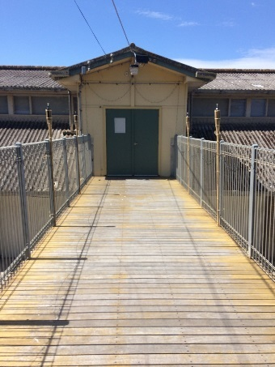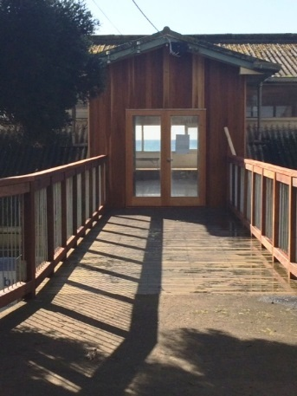
The old façade (left) & the new façade (right)
With approximately 80 community members in attendance on Thursday 27 October 2016 the ACM began, as always, with a traditional Welcome to Country by a representative of the Wadawurrung (https://wathcorp.com.au/), people, the traditional owners of the land. Uncle Bryon Powell, a well-known elder of the Wadawurrung people, has performed the Welcome to Country for several years.
Every year a guest speaker is invited to present on a locally significant issue. In 2016, local community members were surveyed prior to the meeting to determine which topics are most important locally.

The hot topic was coastal management and processes, which resulted in Bellarine Bayside engaging David Provis as their guest speaker.
David is an oceanographer who is very familiar with the Northern Bellarine coastline and Port Phillip Bay. He is the Senior Principal for Cardno, who delivered the Our Coast Inundation Summary report. David presented some great information on coastal processes of the Northern Bellarine coastline, particularly erosion that can affect our foreshore quite dramatically.

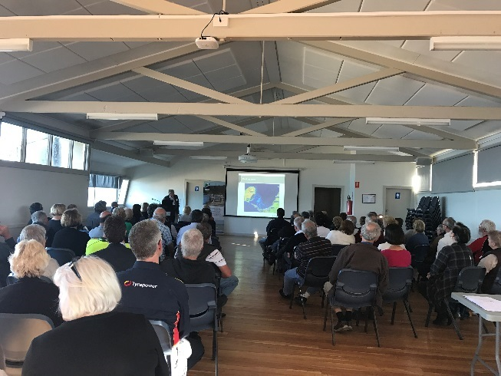
Bellarine Bayside Annual Community Meeting

The evening always concludes with a BBQ provided by the local Lions Club where the community mingles with the Committee, CEO, management and staff for an informal chat.

Applying for a grant?
To apply for grants or to get consent to do works, committees should contact their local DELWP Officers.
We typically need the location of the works, details of the works proposed, whether you need a planning permit, and what grant you are applying for.
To get contact information for your local officer, visit our website: https://www2.delwp.vic.gov.au/ or email voluntary.committees@delwp.vic.gov.au

Putting in the “hard yards” at Chiltern Racecourse and Recreation Reserve, Hume Region
Race meetings may have ceased a long time ago at the Chiltern Racecourse and Recreation Reserve, but the equine-friendly facility is going strong.
The reserve is best known for hosting its rodeo each March long weekend, but it’s the people behind the scenes every day that DELWP wanted to highlight.
A thank you morning tea and presentation was held on the 23rd June for the reserve’s nine volunteer CoM members.
Now predominantly an equine facility, the Chiltern Racecourse and Recreation Reserve has many user groups, and caters for functions and other local activities.
The race club itself has a long and colourful history, having been formed back in 1860 with the first race meeting held at the current site back in February 1874.
The racecourse continued to host racing events up until the last official farewell meeting held by the club on 13 June 1983.
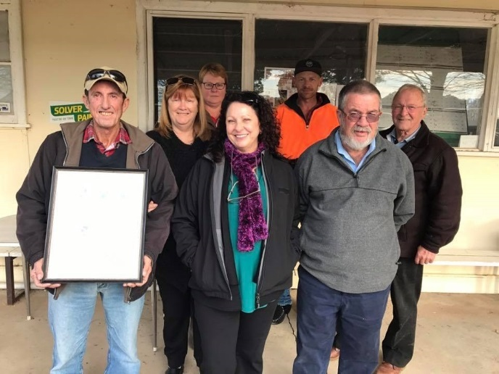
DELWP Officer, Lois Pauline with committee members

DELWP’s Regional Manager Land, Planning and Approvals, James Stewart, said: “We wanted to thank the Committee of Management for their continued efforts in the negotiation of licences and their ongoing work with many of the reserve’s local user groups.”

“Committees of Management perform a valuable service to the community by managing Crown land reserves for the benefit of the public,” Mr Stewart said.
Chiltern Racecourse and Recreation Reserve committee secretary, Sharon Duke, said: “It means everything to the committee to be recognised and receive a Certificate of Recognition; for the fact that we put in the hard yards to keep the reserve looking great.”

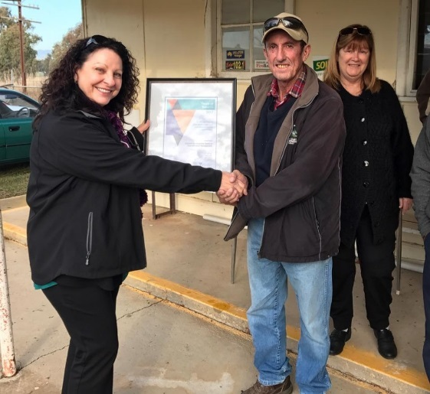
DELWP Officer, Lois Pauline presents the certificate to Kelvin and Sharon Duke

“There is lots of work to be done such as fencing and a new hall, and we are committed to get these things done,” Ms Duke said.
“We are always looking at ways to improve the facilities.”

Being a Child Safe Organisation
The Commission for Children and Young People has released Child Safety Standards that are compulsory for organisations that: provide any services or facilities specifically for children under the entity’s supervision; or engage a child as a contractor, employee or volunteer.
Although your committee members might not have direct contact with children at grassroots level, an organisational culture of child safety involves everybody including management, staff, volunteers.
Further information can be found on their website: https://ccyp.vic.gov.au/child-safety/

Rheola Hall Centenary, Loddon Mallee Region
The Rheola Public Hall Committee hosted a social afternoon tea on the 26th of February 2017, celebrating 100 years and to recognise the service of committee members.
The Crown land was reserved as a site for a public hall on 9 November 1915 and the first committee of management was appointed in 1917.
A group was established to oversee and contribute to the construction of the hall. During the 100 years, it has been operating, generations of local families have given their time to serve on the committee.
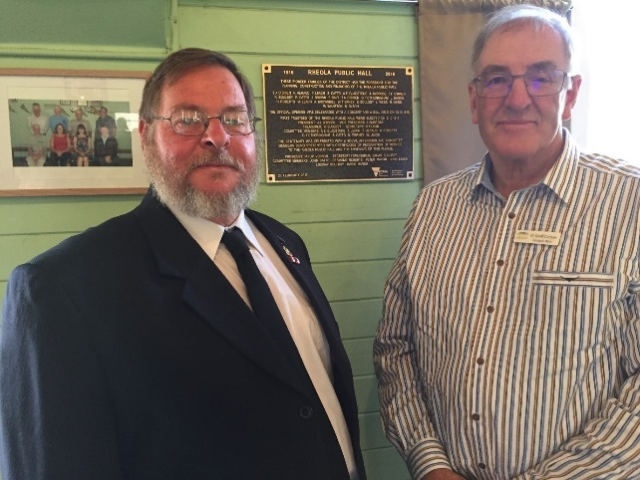
Philip Vernon (left) and Councillor Geoff Curnow (right) in front of commemorative plaque

DELWP in conjunction with the committee organised a commemorative plaque that was unveiled at the centenary celebration. Marg Allan Regional Director DELWP Loddon Mallee presented all members with a certificate recognising the number of years of dedicated service, with two of the committee members each serving on the committee for 48 years!

40 Fantastic Years with the Ferny Creek Recreation Reserve CoM, Port Phillip Region
In May 2017, DELWP celebrated the good work of Bob Horner who has been on the Ferny Creek Recreation Reserve Committee for over 40 years. Bob was appointed to the Committee on the May 2, 1977. Just under half his time was spent as the committee president with another four years in the secretary role.
Bob is an active member of the committee and was heavily involved in coordinating maintenance of the hall and log cabin as well as the removal of dangerous trees.
He is an avid mower taking care of all the mowing on the reserve, has worn out two mowers and is onto his 3rd. Such is his dedication he has been spotted on the day of Christmas Carols mowing in the rain and dressed somewhat similar to Paddington Bear!

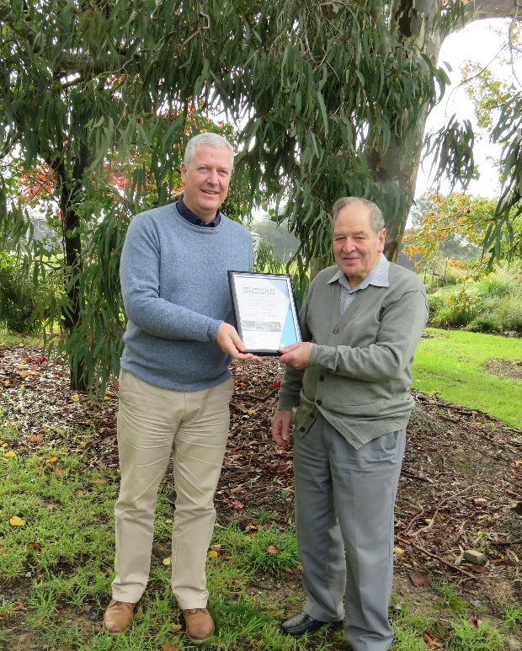
DELWP Regional Manager, Rod Anderson with Bob Horner

During celebrations, the committee unveiled a plaque naming the “Bob Horner Hall”. The engraved plaque even used a Blackwood backing cut from a tree grown in the Reserve.
Congratulations to Bob on his amazing 40 years of service.

Crown Land Information Improvement Project (CLIIP)
Over the next 3 years DELWP will be replacing the IT systems used for the administration of Crown Land. The new platform will be designed to support a range of Crown land administration processes.
Part of this is an intention to provide direct access for committees to relevant information such as the location and extent of reserves under their management. There is also an intention to allow committees to upload information into the system. Committees will only be able to access information for reserves under their management. Access to the system will be tightly controlled and require users to sign in.
Over the coming months, discussions will be held with a range of committees to understand how this new system can be designed to support them.
For more details contact the project manager: michael.black@delwp.vic.gov.au

Dunkeld Public Lands Committee, Barwon South West Region
A popular place in the Grampians, is the small town of Dunkeld.
Many will be familiar with the iconic Royal Mail Hotel, but few will know that many of the town’s spots are managed by the Dunkeld Public Lands Committee of Management. The committee of nine volunteers manage the Memorial gardens and playground, the Salt Creek walk, the Fitzpatrick Sawmill, the beautiful Arboretum (leased to the Dunkeld Arboretum Development group), and the caravan park.
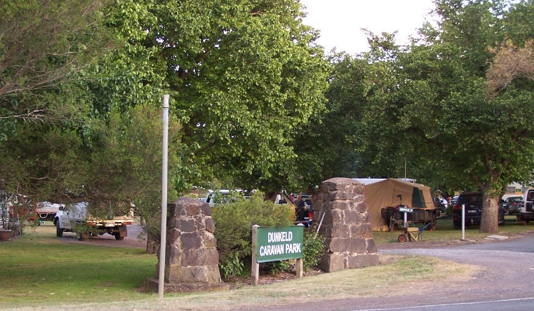
Dunkeld Caravan Park entrance

Ten years ago, after being closed for some eight years, the committee reopened the caravan park. The committee, who were a bit younger then, put in sullage, water and power to about twenty sites, with the aid of a few tradies and a grant under the departments Stewardships in Action program (SIA).
A fulltime caretaker is now employed and there are four cabins, a caretaker’s office and living rooms. The committee are currently working with a Hamilton group of school children through the Hamilton District Skills Centre to build the second stage of the office/residence, sleeping quarters and bathroom.
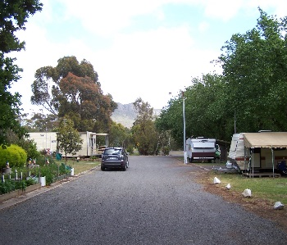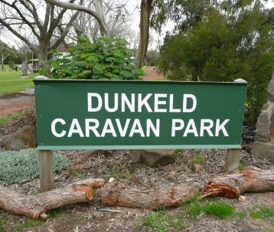
Dunkeld Caravan Park

Caretaker Gary, works very hard to provide clean amenities and travel advice to the three thousand or more patrons who use the park yearly.
What is next? The committee have undertaken a twelve-month improvement plan, with upgrades to signage, waste facilities, site leveling and terracing. Garden improvements are also on their list.
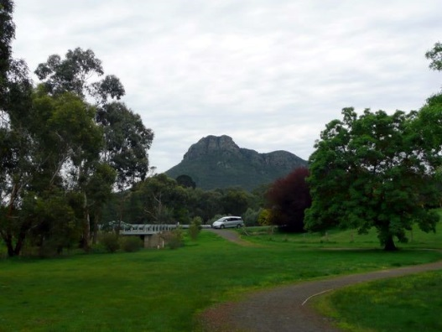
Salt Creek walking track
with Mt Sturgeon in the background

If you are planning to visit the Grampians, come to Dunkeld to enjoy the lawns and playground, the Salt Creek walk, view the static display at the Old Sawmill or stay a few nights with Gary at the Dunkeld Caravan Park.

Weerite Hall Stumps – Article from the Camperdown Chronicle, Barwon South West Region
There will be plenty of foot-stomping fun at the Weerite Hall for years to come after restumping works are completed this week.
Nearing its 60th year, the hall received a new roof five years ago and is now having its original stumps replaced with concrete stumps.
Hall Committee president Peter Hay said the works will ensure the hall remains the central hub of the Weerite community for decades to come.
He said the $25,000 project was made possible thanks to a $10,000 grant from the Department of Environment, Land, Water and Planning.

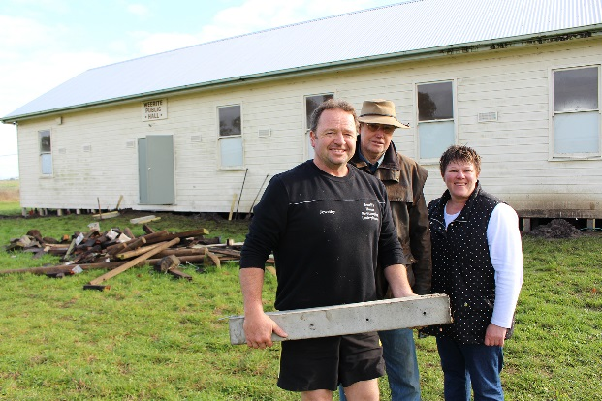
Photo credit – Camperdown Chronicle

“That was a huge injection for a community the size of Weerite and really kicked off the whole project,” he said.

“We were then able to secure a $2000 Corangamite Shire grant and a $500 Bendigo Bank grant. We added that to savings we already had, thanks to a few fundraisers we staged, including a very successful cabaret. We’ve had great support and am very appreciative of it.”

Jewell’s House Re-Stumping and Underpinning is carrying out the work.
Share your stories in Edition 13!
DELWP is seeking contributions for Edition 13, and any feedback on the frequency and content of the newsletter. Please send any comments, suggestions or articles and photos to voluntary.committees@delwp.vic.gov.au

Mr Hay said the hall committee was now raising funds to cover the cost of final works which include new spouting and minor plumbing upgrades.
The hall continues to be used for annual events such as the Biggest Morning Tea, a cabaret, community muster and regular meetings of the Weerite CFA and Landcare groups.
DELWP Voluntary Committees together on Facebook
DELWP Port Phillip and Grampians Regions have started two closed Facebook groups.
These groups provide a private space for volunteer committees. Members can ask questions of DELWP staff and other committee members as well as share photos, posts, stories and event information.
DELWP welcomes the use of this group as a place for our committees to ask questions, engage in discussion and share information.
If you are a member of a committee in either Port Phillip or the Grampians and you would like to join a group please contact voluntary.committees@delwp.vic.gov.au

Willow Park - Koondrook, London Mallee Region
Willow Park Recreation Reserve Committee in Koondrook were successful in securing a grant just over $38k from Murray River Council, New South Wales (!), for the construction of a new large open shelter with picnic and BBQ facilities.
The source of the funding seems unusual, however the CoM secretary explained that as Barham (NSW) doesn't have a swimming pool, the grant was extended to the Koondrook swimming pool as the twin town on the Victorian side of the Murray River.
Construction is set to commence in the next few months.
Grant name | Purpose | Amount | Key dates | Website
Victorian Heritage Restoration Funds | Restoration works to places of identified historical significance under a heritage overlay in the City of Melbourne, City of Yarra, and City of Ballarat. | Assessed on case by case basis | Various dates – see their website | http://www.vhrf.org.au/
Melbourne Water Corridors of green funding | To improve river health through the corridors of green program. | Up to $20,000 | Ongoing | https://melbournewater.smartygrants.com.au/corridorsofgreen
Public Safety on Public Land – Major Projects | To improve public safety on public land through projects such as reconstruction or reinforcement of structures, demolition of structures, decontamination, control access, or tree risk projects. | $20,000 and more | Contact your local DELWP representative | Applications must be made through your local DELWP representative.
Recreational Fishing – Small Grants Program | To support actions or programs which aim to boost participation in recreational fishing and related activities. | Up to $5,000 | Ongoing | http://agriculture.vic.gov.au/fisheries/recreational-fishing/recreational-fishing-grants-program/small-grants-program
Inspiring Environmental Solutions community funding program – EPA | To enhance the environment in a public place, or undertake environmental activities for the benefit of the community. | Varies | Ongoing | http://www.epa.vic.gov.au/our-work/programs/inspiring-environmental-solutions
PPWCMA Community Grants | To assist with projects and activities that protect environmental assets, address priority issues and improve the health of the environment. | Up to $30,000 | 25 September 2017 | http://www.ppwcma.vic.gov.au/grants/community-grants/
Restoring Community War Memorials and Avenues of Honour Grants Program | Supports communities in Victoria to ensure local war memorials, honour rolls and avenues of honour are restored to their origin al condition or improved to reflect the service history of the local community. | Up to $20,000 | Round 2 opens 27 November 2017 | http://www.dpc.vic.gov.au/index.php/veterans/veterans-grants/commemorative-grants-restoring-war-memorials-and-avenues-of-honour
Anzac Centenary Community Grant Program | For projects that commemorate the service and sacrifice or inform and educate Victorians about the experiences of World War One (WWI) veterans and their communities. | Up to $20,000 | Round 2 opens 27 November 2017 | http://www.dpc.vic.gov.au/index.php/veterans/veterans-grants/victorian-veterans-council-anzac-centenary-community-grants-program
North East CMA Integrated Incentives and Grants Program | Community Grants, Enhancing Waterways Grants and Enhancing Woodlands and Wetlands Grants | Varies | 11 October 2017 | http://www.necma.vic.gov.au/Solutions/Grants-Incentives

