Traditional Owner and Aboriginal Community Engagement Framework  
Edition 2

# Acknowledgement

We acknowledge and respect Victorian Traditional Owners as the original custodians of Victoria’s land and waters, their unique ability to care for Country and deep spiritual connection to it. We honour Elders past and present whose knowledge and wisdom has ensured the continuation of culture and traditional practices. We are committed to genuinely partner, and meaningfully engage, with Victoria’s Traditional Owners and Aboriginal Communities to support the protection of Country, the maintenance of spiritual and cultural practices and their broader aspirations in the 21st century and beyond.

**NOTE:** Aboriginal and Torres Strait Islander readers are warned that this document may contain images of Aboriginal people who have passed.

Table of Contents

Mirring – ‘Country’ 3

Explanation of terms 6

Secretary foreword 10

Introduction 12

Traditional Owner rights and responsibilities 14

Our commitment to self‑determination and engagement 26

Engaging with Traditional Owners and Aboriginal Communities 30

The pathway to engagement 34

Who to talk to: partnership and engagement support 56

Publication information 60

# Mirring – ‘Country’

**Artist Tom Day, a Gunditjmara, Yorta Yorta and Wemba Wemba man, designed DEECA's Aboriginal identity. The Mirring artwork was created in collaboration with Aboriginal staff to better understand our work and our values.**

The Mirring artwork is a visual reminder of our ongoing commitment to working in full partnership with Traditional Owners and Aboriginal Victorians. It also represents our commitment to creating a culturally safe and respectful environment for Aboriginal staff and visitors.

Image 1: The Mirring artwork, DEECA's Aboriginal identity

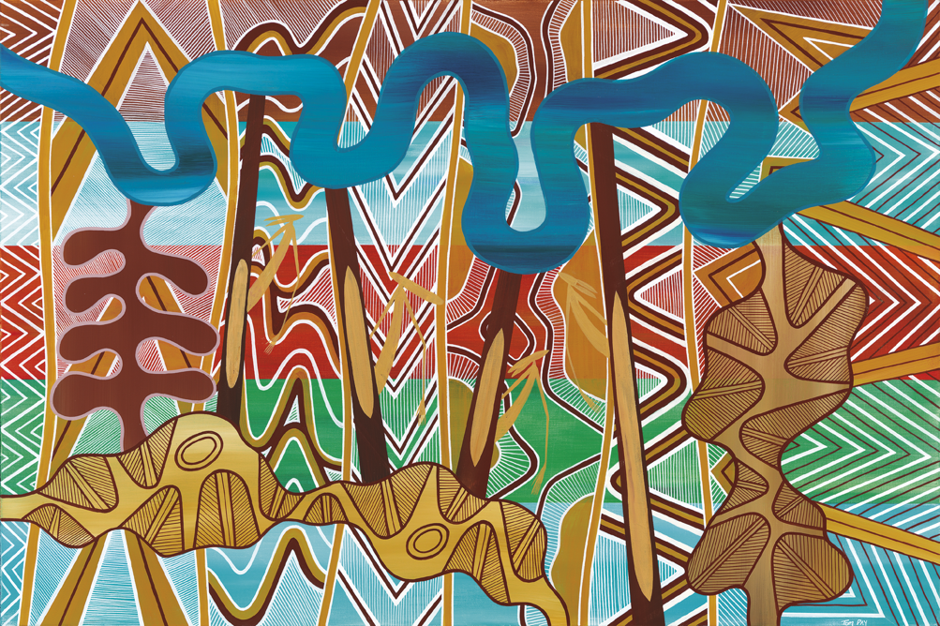

The Mirring artwork has three layers:

## Layer one (background)

* Mountain/Stone Country
* Wetland
* Desert
* Forest/Grass

Sea Country

## Layer two

* Line work (straight, triangles, flowing) that drapes over the work represent the whole of the state’s Aboriginal culture in reflection of various artifacts.
* Four scar trees represent the directions north, south, east and west, and the figures represent the older Aboriginal generation.

Each line across the artwork represents the current generation over 1,500 generations.

## Layer three

* River (not representative of any river in Victoria)
* Artist’s stamp – Lava flow
* Boy to Man
* Girl to Woman. Ceremony ‘Bora grounds’ and their journey in life. Lines represent the lineage.

Figure 1: An explanation of the three layers of the Mirring artwork, DEECA's Aboriginal identity

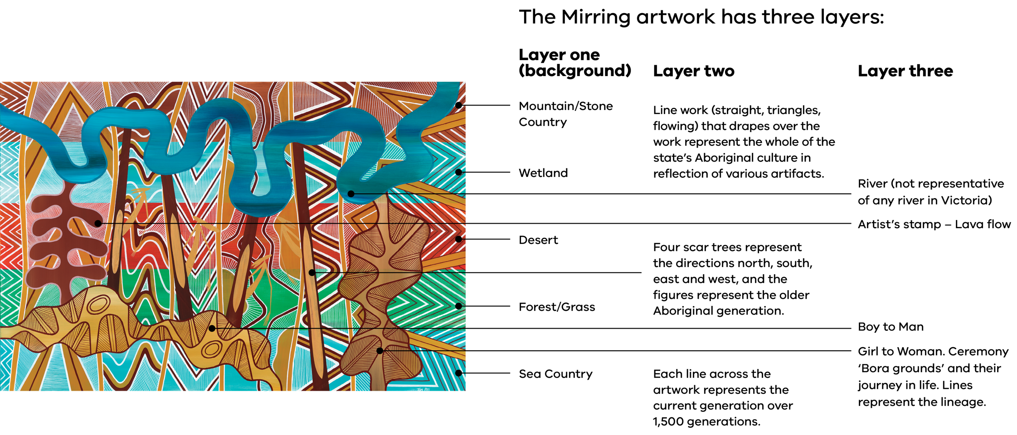

# Explanation of terms

**Aboriginal** refers to both Aboriginal and Torres Strait Islander peoples. They may have connections within and outside of Victoria. The use of the term Indigenous is sometimes used in the names of programs, initiatives, publication titles and, unless otherwise noted, is inclusive of both Aboriginal and Torres Strait Islander peoples[1].

**Aboriginal Community** refers to and acknowledges all Aboriginal and/or Torres Strait Islander people living in Victoria. Community can be used to describe the entire Victorian Aboriginal and/or Torres Strait Islander Community or smaller specific Communities.

**Collective rights** are those human rights generally recognised to be exercisable by collectives (or groups of individuals) and not reducible to the individual.

**Cultural awareness** is about respect and ownership. It is awareness about how cultural experiences (values, knowledge, skills and attitudes) are formed and affect others.

**Cultural capability** refers to the skills, knowledge and behaviours that are required to plan, support, improve and deliver services in a culturally respectful and appropriate manner. It is also how we recognise, support, value and embrace Aboriginal decision-making to embed self‑determination.

**Cultural safety** refers to an environment that is safe for people - where there is no assault, challenge or denial of their identity, of who they are and what they need. It is about shared respect, shared meaning, shared knowledge, and experience, of learning, living and working together with dignity and truly listening[2]. For Aboriginal staff working at DEECA, and the department’s partnerships with Traditional Owners, cultural safety means creating environments, relationships, and systems, free from racism and discrimination so that people feel safe, valued and able to participate. In other words, cultural safety makes space for culture to live and for spiritual and belief systems to exist[3]. Cultural safety is everyone’s responsibility.

**Indigenous data** is any information or knowledge, in any format or medium, which is collected or recorded from and/or is about Traditional Owners both collectively and individually. This may include information, interviews, surveys, statistics, reports, sound recordings, films, photographs, health records, mapping of Country, samples of plants and animals, languages, knowledge, art and stories.

**Indigenous Data Sovereignty** is the right of Aboriginal people to govern the collection, ownership and use of data about their communities, people, land and resources.

**Individual rights** are the fundamental rights guaranteed by a government so that every individual citizen can live a free and equitable life.

**Remuneration** is the financial compensation provided in exchange for services performed.

**First Peoples or First Nations people** refers to peoples or nations of people connected to an area prior to colonisation. These terms have some general acceptance but may not be the term preferred by individuals or specific groups of Aboriginal and/or Torres Strait Islander peoples.

**Formal recognition** refers to the legal process under which Traditional Owner groups are recognised as the right group to speak to about land and waters within a specific area. Traditional Owners can be formally recognised under various acts which is typically accompanied by the appointment of a corporate entity to perform the functions under the relevant act:

* *Native Title Act 1993 (Cth)*
* *Aboriginal Heritage Act 2006 (Vic)*
* *Traditional Owner Settlement Act 2010 (Vic).*

**Free, prior and informed consent** is a specific right granted to Indigenous Peoples recognised in the *United Nations Declaration on the Rights of Indigenous Peoples* (UNDRIP), which aligns with their universal right to self-determination. Free, prior and informed consent allows Indigenous Peoples to provide or withhold/withdraw consent, at any point, regarding projects impacting their land.

**Self-determination** is all about choice. The UNDRIP describes self-determination as the ability for Indigenous people to freely determine their political status and pursue their economic, social and cultural equity, based on their own values and way of life. That means Traditional Owners have the right to make choices that best reflect them on their journey to self-determination and self-governance.

A **Traditional Owner** is an Aboriginal and/or Torres Strait Islander person who has traditional connections to an identified geographical area of Country.

A **Traditional Owner Corporation** is an incorporated group that represents the interests of Traditional Owners in a particular area. They may hold rights under the *Native Title Act 1993* (Cth)*, Aboriginal Heritage Act 2006* (Vic)or *Traditional Owner Settlement Act 2010* (Vic)on behalf of the Traditional Owners they represent, or they may have no formal agreements in place.

**Treaty** is a negotiated political agreement between a group and government that recognises the group as a distinct political community. It provides a path to negotiate the transfer of power and resources for First Peoples to control matters which impact their lives.

# Secretary foreword

**At DEECA, we're committed to self-determination - it's everyone's business. Our commitment is backed by coordinated, meaningful and culturally safe engagement, partnerships and expectations.**

Much has changed since we first published the Traditional Owner and Aboriginal Community Engagement Framework (the Framework) in 2019. We have released [Pupangarli Marnmarnepu ‘Owning Our Future’ – Aboriginal Self-Determination Reform Strategy 2020-2025](https://www.deeca.vic.gov.au/__data/assets/pdf_file/0031/493456/Pupangarli-Marnmarnepu-Aboriginal-Self-Determination-Reform-Strategy-2020-2025.pdf), established the Statewide and Regional Caring for Country Partnership Forums, established the Yoorrook Justice Commission Taskforce and continue to prepare for Treaty. We have updated the Framework to reflect significant policy changes and support greater partnerships with Traditional Owners.

Our revised Framework will act as a tool to support staff to partner with Traditional Owners appropriately and meaningfully. Our engagement with Traditional Owners should align with the levels of participation defined by the IAP2 Public Participation Spectrum – inform, consult, involve, collaborate, or empower. Levels of participation should be informed by a Traditional Owner group’s formal recognition status and have proper consideration to the [Charter of Human Rights and Responsibilities Act 2006 (Vic)](https://www.legislation.vic.gov.au/in-force/acts/charter-human-rights-and-responsibilities-act-2006/014). This will help ensure that we're actively working towards meeting the expectations of Traditional Owners and Aboriginal Communities, as well as meeting our obligations and commitments.

This edition includes important legislative and policy context, a set of 10 principles for engagement and a 5-step engagement pathway. It also includes best practice considerations to ensure our engagement activities are better coordinated and informed, guided by the best available resources and information and carried out in a culturally safe way.

Engagement with every Traditional Owner group and Aboriginal Community should be tailored to their preferences and priorities. It's important to understand that this Framework is a starting point - it's a resource to help you understand the policy context, not a complete guide. While every engagement will be different, the principles, steps and considerations should be consistently applied.

It's everyone’s responsibility to embed self‑determination by understanding how to meaningfully engage and genuinely partner with Traditional Owners and Aboriginal Communities.

**John Bradley**

DEECA Secretary

# Introduction

**The Framework was developed to coordinate and strengthen DEECA's engagement and partnerships with Traditional Owners. This version has been updated to align with current policies and commitments and responds to feedback and advice from Traditional Owner partners and DEECA staff.**

The scope of the Framework is to:

* outline the rights and responsibilities of Traditional Owners in their individual and collective capacity
* clarify how formal recognition changes the role of Traditional Owner groups in engagement and decision-making
* provide context about our obligations as a public authority and our commitments to Traditional Owners as partners

provide guidance about best practice engagement principles, processes and considerations.

The purpose of the Framework is to ensure all staff and our delivery partners are engaging with Traditional Owners and Aboriginal Communities in a culturally safe way and meeting our legislative obligations and commitments. It’s also important to understand and uphold Traditional Owners’ rights and responsibilities. By doing this, we can build genuine and meaningful partnerships.

The Framework is essential if you're considering engaging Traditional Owners or Aboriginal Communities, either directly or indirectly.

# Traditional Owner rights and responsibilities

**The Victorian Government has extensive commitments to Traditional Owners under legislation and policy.**

Our obligations and responsibilities include:

* respecting Aboriginal cultural rights under the *Charter of Human Rights and Responsibilities Act 2006* (Vic)
* upholding Traditional Owner rights under the *Traditional Owner Settlement Act 2010* (Vic) and *Native Title Act 1993* (Cth)

respecting cultural heritage rights under the *Aboriginal Heritage Act 2006*(Vic).

The Victorian Government’s broader commitments include acting in ‘good faith’ as a Treaty partner under *Advancing the Treaty Process with Aboriginal Victorians Act 2018* (Vic).

DEECA is required to act in accordance with all commitments made by the Victorian Government relating to Traditional Owner rights within both legislative and policy frameworks. These obligations and responsibilities inform our engagement approaches with Traditional Owners and Aboriginal Communities.

## Victorian context

### *Charter of Human Rights and Responsibilities Act 2006* (Vic*)*

Section 19(2) of the *Charter of Human Rights and Responsibilities* *Act 2006* (Vic) (the Charter) recognises the distinct cultural rights of Aboriginal people in Victoria. These are the rights to:

* enjoy their identity and culture
* maintain and use their language
* maintain their kinship ties

maintain their distinctive spiritual, material and economic relationship with land, waters and other resources they are connected to under traditional laws and customs.

According to Section 38(1) of the Charter, it is unlawful for DEECA, as a public authority, to:

act in a way that is incompatible with a human right, such as the distinct cultural rights held by Aboriginal persons as outlined in Section 19(2), or

fail to properly consider human rights when making decisions, which includes Section 19(2) cultural rights.

While the scope of the obligation to give proper consideration to human rights varies depending on the context, the obligation can extend to engaging with all Traditional Owner groups that assert rights, including groups without formal recognition, on matters that impact their cultural rights.

### *Traditional Owner Settlement Act 2010* (Vic)

This Act provides an alternative framework to native title for the recognition of Traditional Owner rights, financial and land management outcomes and settlement of native title claims in Victoria. This includes a number of different agreements.

### Recognition and Settlement Agreements

A Recognition and Settlement Agreement (RSA) is negotiated by Traditional Owners with the Victorian Government. Before a Traditional Owner group enters into an RSA they appoint a corporate entity to represent them. This is called a Traditional Owner Group Entity (TOGE).

There are different rights and terms of an RSA, which could affect how you engage with the relevant TOGE, including:

* rights for activities on Crown land under a Land Use Activity Agreement
* natural resource participation rights under a Natural Resource Agreement

joint management rights under a Traditional Owner Land Management Agreement.

The RSA provides the Traditional Owner group with formal recognition to speak for their Country.

### *Aboriginal Heritage Act 2006* (Vic)

Through this Act, Registered Aboriginal Parties (RAPs) are appointed by the Victorian Aboriginal Heritage Council. They are the primary custodians and keepers of Indigenous Ecological Knowledge, and are responsible for protecting and managing Aboriginal cultural heritage, along with:

* approval or refusal of Cultural Heritage Management Plans and Cultural Heritage Permit applications
* nomination of places for the Victorian Aboriginal Heritage Register
* Welcome to Country and Aboriginal cultural awareness training
* engagement with the broader community about a range of activities undertaken on Country
* Country mapping through assessments of cultural values
* ranger crews undertaking caring for Country activities
* community capacity building

economic development.

#### Find out more

Visit [www.aboriginalheritagecouncil.vic.gov.au/victoria-registered-aboriginal-parties](https://www.aboriginalheritagecouncil.vic.gov.au/victoria-registered-aboriginal-parties)

### Treaty

Victoria’s Treaty process is shifting the way government has historically engaged with Traditional Owners and Aboriginal Victorians. Treaty provides a path to negotiate the transfer of power and resources to First Peoples.

#### What is Treaty in Victoria?

In negotiating Treaty with First Peoples, the Victorian Government is acknowledging that before the formation of the State of Victoria, First Peoples were here – practising their own law, lore and cultural authority. Treaty-making in Victoria will include the negotiation of both a Statewide Treaty and local Traditional Owner Treaties. The Treaty Negotiation Framework sets out rules that guide negotiations. Each Treaty is unique and negotiated based on the interest and needs of the parties involved. Treaty will be guided by the Treaty Authority, an independent umpire, who will oversee negotiations between parties.

#### What is a Statewide Treaty?

Statewide Treaty negotiations commenced with a cultural ceremony in November 2024. Statewide Treaty will support First Peoples in Victoria, as a collective, to continue exercising self-determination. This includes structural reform to establish an ongoing First Peoples’ representative body, and introducing measures to support accountability and reconciliation. Statewide Treaty is being negotiated between the Victorian Government and the First Peoples’ Assembly of Victoria.

#### What are Traditional Owner Treaties?

Traditional Owner Treaty negotiations will be negotiated between the State and First Peoples' Treaty Delegations. The delegations are made up of all Traditional Owners who want to negotiate Treaty over a particular local area. Traditional Owner Treaties will support the exercise of self-determination and may include discussions on:

* traditional relationships with Country
* protecting land, waters and sky
* protecting culture and language

economic sustainability and empowerment.

#### Our responsibilities

We are required to follow the guiding principles of the Advancing the Treaty Process with Aboriginal Victorians Act 2018. This includes acting in good faith throughout the Treaty process.

### Yoorrook Justice Commission

The Yoorrook Justice Commission (the Commission) was established in May 2021 as the first formal truth-telling process into historical and ongoing injustices experienced by First Peoples in Victoria since colonisation. Aboriginal Victorians have been clear and consistent in the call for truth-telling as an essential part of the Treaty process.

Over 4 years the Commission conducted inquiries into land, sky and waters (land injustice), health, housing and education (social injustice), criminal justice and child protection and economic prosperity to:

* establish an official record of the impact of colonisation on Traditional Owners and First Peoples in Victoria
* develop a shared understanding among all Victorians of the impact of colonisation, as well as the diversity, strength, and resilience of First Peoples’ cultures

make recommendations for healing, system reform and practical changes to laws, policy, and education, as well as matters to be included in future Treaties.

In June 2025, the Commission finalised its truth-telling work with the delivery of an official public record and final reform report. These final reports build understanding of our shared history, make findings and recommendations for meaningful change and provide the foundation for Treaty.

#### Victorian Aboriginal Affairs Framework

This is the overarching framework for working with Aboriginal Victorians, Aboriginal organisations and the wider community to drive action and improve outcomes. Read the framework at [www.firstpeoplesrelations.vic.gov.au/victorian-aboriginal-affairs-framework.](http://www.firstpeoplesrelations.vic.gov.au/victorian-aboriginal-affairs-framework)

#### Self-Determination Reform Framework

This framework guides public service action to enable self-determination in line with the Victorian Aboriginal Affairs Framework. It also provides an architecture for government departments to report annually on this action under the Framework, outlining progress towards transforming government systems and structures to enable self-determination. Read the Self-Determination Reform Framework at [www.firstpeoplesrelations.vic.gov.au/self-determination-reform-framework](http://www.firstpeoplesrelations.vic.gov.au/victorian-aboriginal-affairs-framework).

Our response to this framework is [*Pupangarli Marnmarnepu*](https://www.deeca.vic.gov.au/__data/assets/pdf_file/0031/493456/Pupangarli-Marnmarnepu-Aboriginal-Self-Determination-Reform-Strategy-2020-2025.pdf)available on the DEECA website. It's a 5-year roadmap that enables self-determination by fostering an environment that honours the rights and dignity of Traditional Owners and Aboriginal Communities. It's founded on cultural authority and sets the strategic direction and actions to advance Aboriginal self-determination.

## Federal context

### *Native Title Act 1993* (Cth)

Native title is a right held by Aboriginal and Torres Strait Islander people under traditional laws and customs, which pre-dates colonisation and is recognised by Australian law.

### What is the process?

There are two stages to securing native title:

* a native title claimant files an application in the Federal Court of Australia.
* the native title claimant enters into mediation with, or litigation against the relevant state. This process can take years.

At the end of this process, the Federal Court makes a native title determination – deciding whether or not native title rights exist.

### Native title holders

If a native title claim is successful, the Traditional Owners will then be referred to as native title holders. A corporate entity will be appointed to manage the native title rights and interests as trustee or agent. This entity is known as a Prescribed Body Corporate or Registered Native Title Body Corporate. The native title rights and interests held by a Traditional Owner group may affect how you engage with the relevant corporate entity. Native title holders speak for their Country via their appointed corporate entity. The native title holders are also entitled to procedural rights for activities proposed on Crown land under the *Native Title Act 1993* (Cth) future act regime.

## International context

**Under international covenants, DEECA is responsible for upholding the rights of Indigenous people and self-determination.**

### International Covenant on Civil and Political Rights (ICCPR)

Part 1, Article 1 of the ICCPR notes that all people have the right of self-determination. By virtue of that right they freely determine their political status and freely pursue their economic, social, and cultural development. Part 3, Article 27 of the ICCPR notes that minorities shall not be denied the right, in community with the other members of their group, to enjoy their own culture, to profess and practise their own religion, or to use their own language.

Australia is a signatory to ICCPR and has ratified the covenant, however not all of the rights have been fully incorporated into Australian law. Victoria has broadly incorporated Article 27 into Section 19(1) of the Victorian *Charter of Human Rights and Responsibilities 2006* (the Charter). At DEECA, we need to give proper consideration to the cultural rights outlined in the Charter.

### United Nations Declaration on the Rights of Indigenous Peoples (UNDRIP)

In 2009, Australia became a signatory to the UNDRIP, the most comprehensive international instrument on the rights of Indigenous peoples. It establishes a universal framework of minimum standards for the survival, dignity, and wellbeing of Indigenous peoples of the world. All signatories commit to its terms ‘as a standard of achievement to be pursued in a spirit of partnership and mutual respect’. Article 3 of UNDRIP recognises Indigenous peoples’ right to self-determination. Australia is yet to ratify the UNDRIP and incorporate into Australian law.

## Formal recognition status

The below formal recognition is accurate as of July 2025 and may be subject to change.

Table 1: Formal recognition status

| Traditional Owner Corporation | DEECA Lead Region | Registered Aboriginal Party *Aboriginal Heritage Act 2006* (Vic) | Recognition and Settlement Agreement *Traditional Owner Settlement Act 2010* (Vic) | *Native Title  Act 1993* (Cth) |
| --- | --- | --- | --- | --- |
| Barengi Gadjin Land Council Aboriginal Corporation | Grampians | Yes | Yes | Yes |
| Bunurong Land Council Aboriginal Corporation | Port Phillip | Yes | – | – |
| Dja Dja Wurrung Clans Aboriginal Corporation (DJAARA) | Loddon Mallee | Yes | Yes | – |
| Eastern Maar Aboriginal Corporation | Barwon South West | Yes | In negotiations | Yes |
| First Peoples of the Millewa-Mallee Aboriginal Corporation | Loddon Mallee | Yes | – | Yes |
| Gunaikurnai Land and Waters Aboriginal Corporation | Gippsland | Yes | Yes | Yes |
| Gunditj Mirring Traditional Owners Aboriginal Corporation | Barwon South West | Yes | – | Yes |
| Taungurung Land and Waters Council | Hume | Yes | Yes | – |
| Wadawurrung Traditional Owner Aboriginal Corporation | Grampians | Yes | – | Registered application |
| Wamba Wemba Aboriginal Corporation | Loddon Mallee | Yes | – | Active application – not registered |
| Wurundjeri Woi Wurrung Cultural Heritage Aboriginal Corporation | Port Phillip | Yes | – | – |
| Yorta Yorta Nation Aboriginal Corporation | Hume | Yes | – | – |

## Map of Victoria’s Registered Aboriginal Parties

The below map is accurate as of October 2024. For an up-to-date map of formally recognised Traditional Owner boundaries, please visit the [Victorian Aboriginal Heritage Council online map](https://achris.vic.gov.au/#/onlinemap).

Alt text to be provided

# Our commitment to self‑determination and engagement

**At DEECA, we're committed to building and maintaining meaningful partnerships with Traditional Owners and Aboriginal Communities. This commitment is embedded in all our work, and reflected in our key strategic documents.**

## Community Charter

This Charter is our public promise to ‘be available’, ‘to speak and listen’ and to ‘take action’. The Charter is an overarching guide for all the work we do. It asks us to put the community at the centre of everything we do and provide them with the authority to make decisions.

## Strategic Framework

Our framework demonstrates our commitment to self-determination and engagement across all areas of DEECA. It's supported by our annual business plans. We also have 5 organisational pillars which are fundamental to the way we work.

## Our 5 organisational pillars

Figure 2: Our 5 organisational pillars

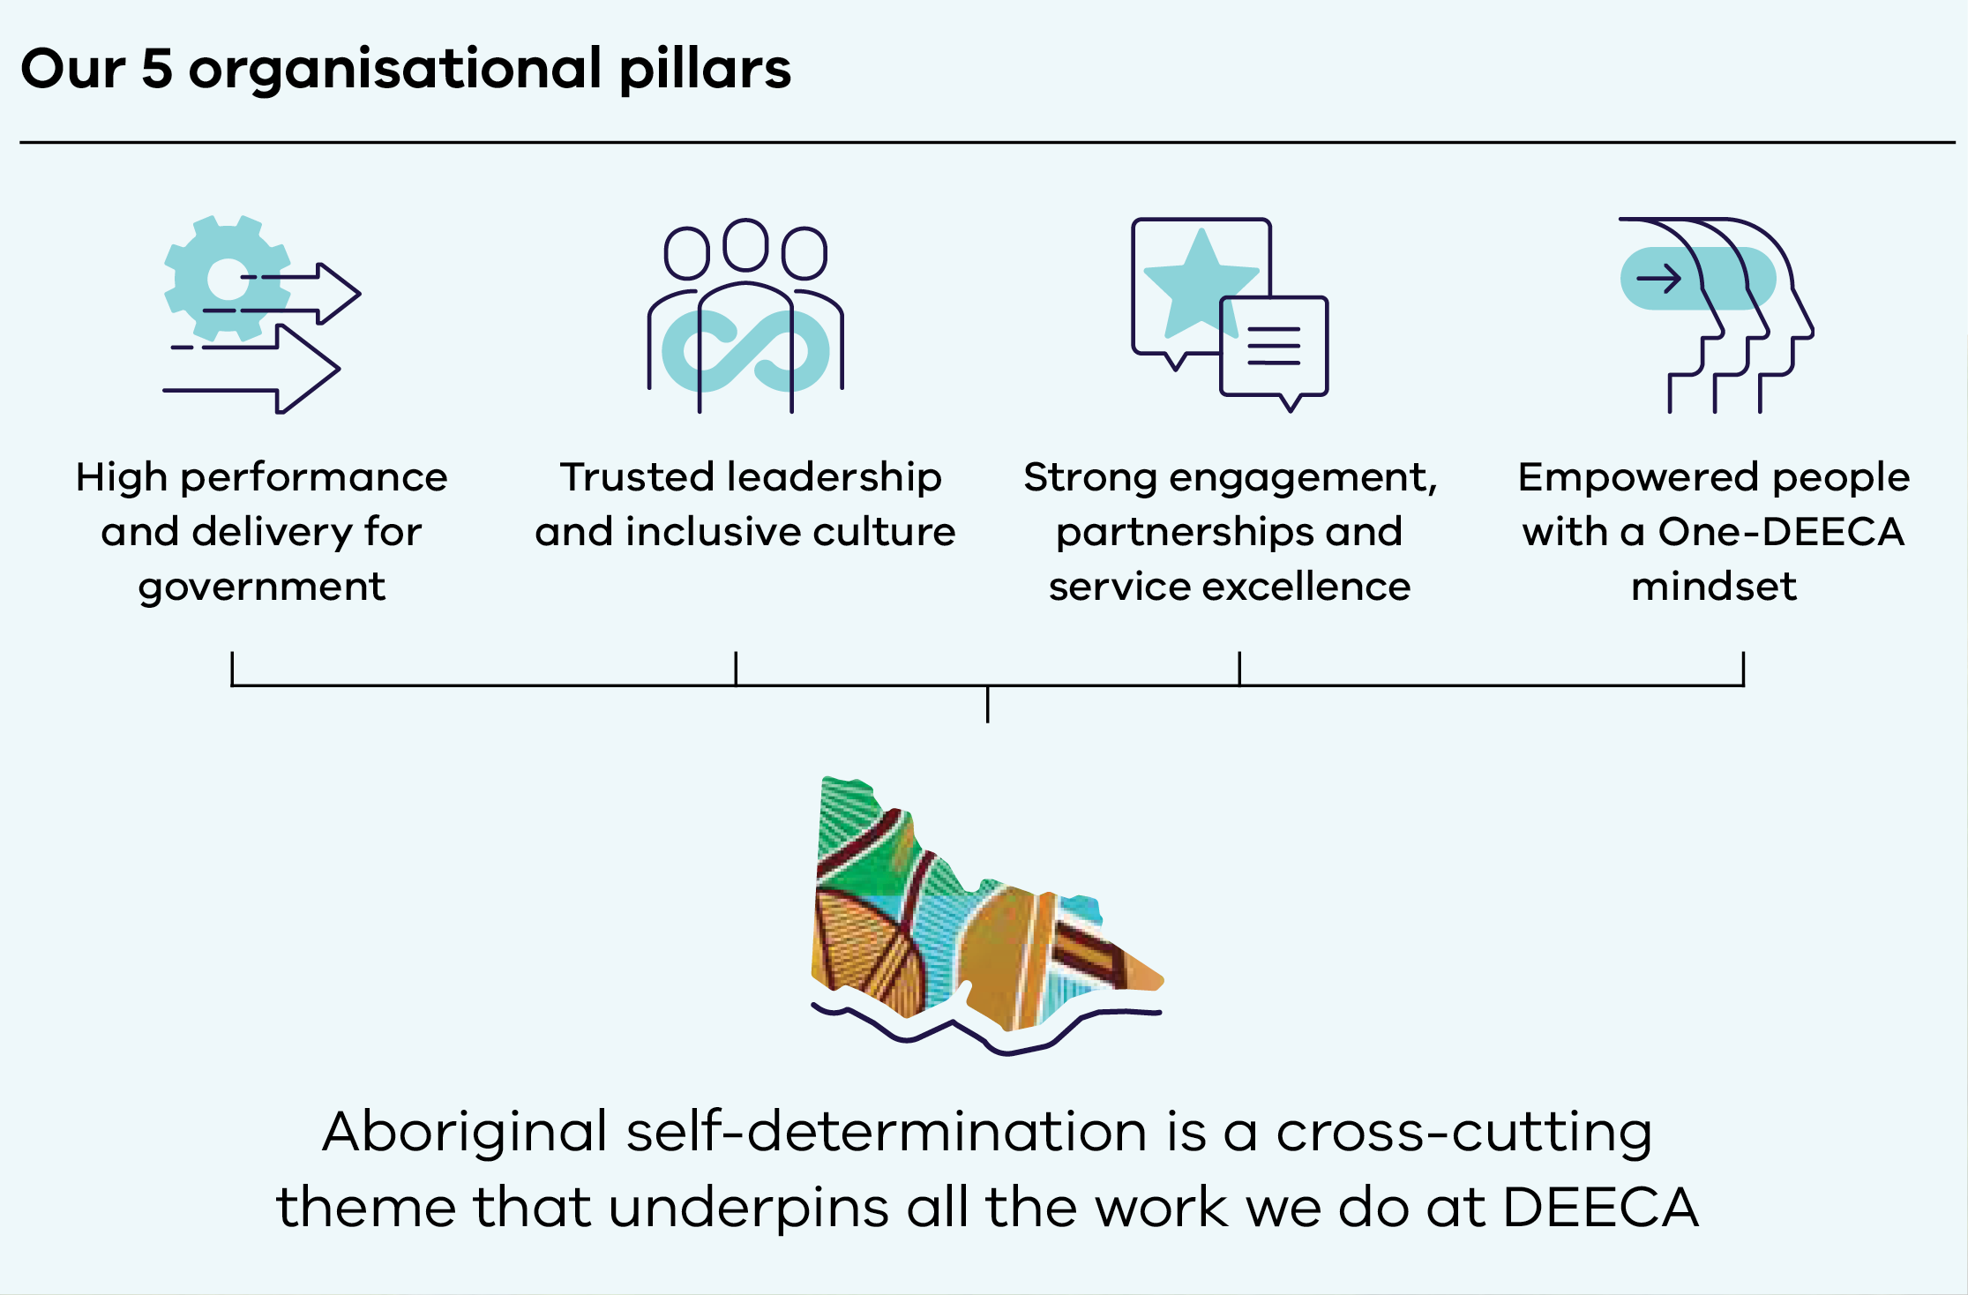

## *Pupangarli Marnmarnepu ‘Owning Our Future’ – Aboriginal Self-Determination Reform Strategy 2020-2025*

[Pupangarli Marnmarnepu](https://www.deeca.vic.gov.au/__data/assets/pdf_file/0031/493456/Pupangarli-Marnmarnepu-Aboriginal-Self-Determination-Reform-Strategy-2020-2025.pdf) is our 5-year roadmap that sets the strategic direction, outcomes and priorities to respond to Aboriginal self-determination. *Pupangarli Marnmarnepu* incorporates the needs of Traditional Owners and Aboriginal Communities, and its outcomes, measures, indicators and yearly priorities are measured in partnership with Traditional Owners and Aboriginal Victorians. Visit [deeca.vic.gov.au](http://deeca.vic.gov.au/) to read the full strategy.

## Statewide Caring for Country Partnership Forum

This forum is a Traditional Owner-led mechanism to hold DEECA accountable for the implementation of *Pupangarli Marnmarnepu*, and demonstrates our commitment to systematic reform. The membership is made up of representatives from all 12 Registered Aboriginal Parties (RAPs). Through the Forum, RAPs engage with government and agency staff at the most senior levels, including DEECA's Secretary and Deputy Secretaries, First Peoples State Relations' Deputy Secretary and Parks Victoria's CEO and Director, Managing Country Together. This enables the RAPs to set and progress their priorities, and ensure that power and resources are transferred back to Traditional Owners.

## Regional Caring for Country Partnership Forums

At these forums, Traditional Owner groups engage with DEECA's Regional Directors and Deputy Chief Fire Officers to:

* progress matters of priority to them
* guide regional implementation of *Pupangarli Marnmarnepu*

ultimately transfer power and resources back to Traditional Owners.

The Regional Forums are Country-based rather than by DEECA region. Meetings can involve all regions relevant to the Traditional Owners.

## Regional Traditional Owner Engagement Plans

Each DEECA region has a Traditional Owner Engagement Plan which includes information about the region and existing engagement approaches. Where there are multiple regions across Traditional Owners' Country, there is a lead region.

# Engaging with Traditional Owners and Aboriginal Communities

## What is engagement?

**For DEECA, the term engagement describes the planned (and unplanned) ways we interact and relate to communities, stakeholders and partners to understand their needs and expectations.**

Community and stakeholder engagement is a key part of our business. We engage for a wide range of reasons, including:

* sharing knowledge and information
* decision-making
* building and maintaining relationships

increasing community capacity for planning, action and learning.

Equally, engagement should be about building and sustaining relationships and working in partnership towards a shared goal.

## Principles of engagement

At DEECA, all staff and delivery partners need to follow our 10 principles when engaging and partnering with Traditional Owners and Aboriginal Communities.

### Principle 1: Self-determination

We must understand self-determination as a core principle and embed it in our business as usual. The enablers of self-determination are to:

* prioritise culture
* address trauma and support healing
* address racism and promote cultural safety

transfer power and resources to communities.

Traditional Owners must have the opportunity to meaningfully participate in and control processes that affect their Country and Community, in ways decided by them.

### Principle 2: Aboriginal cultural safety and competency

We must all work towards becoming more culturally competent. This means being aware of and valuing the cultural knowledge and skills of Aboriginal people, and creating culturally safe environments.

### Principle 3: Acknowledge past injustices and structural inequity

DEECA acknowledges that past decisions and processes in land and natural resource management have not considered the interests or benefits of Traditional Owners and Aboriginal Communities. We need to ensure these are not repeated. That's why all DEECA projects need to create respectful processes with Traditional Owners and Aboriginal Communities that recognise this history. By making sure our engagement is carried out through the lens of self-determination, we can work towards our ultimate goal of transferring power and resources to Traditional Owners and Aboriginal Communities.

### Principle 4: Free, prior and informed consent

DEECA cannot act unilaterally. Traditional Owners and Aboriginal Communities must give free, prior and informed consent to any decisions or changes that impact them.

### Principle 5: Respect for decision-making processes

Traditional Owners and Aboriginal Communities have their own governance structures and ways of making decisions. Their representatives often need to discuss matters with a committee or their community before being able to confirm their involvement. This must be respected, and timelines must incorporate governance structures and ways of making decisions.

### Principle 6: Adequately resource Traditional Owners and Aboriginal Communities to participate in DEECA business

It's important to factor in adequate budget for Traditional Owners and Aboriginal Communities to participate in your projects, programs and initiatives. This includes cultural expertise and knowledge, sitting fees, travel and accommodation expenses.

### Principle 7: Engage early and talk with Traditional Owners

Reach out to the relevant Traditional Owners and Aboriginal Communities at the very start of your project. The sooner you start, the sooner you will find out how (or whether) your project connects with their priorities and aspirations. Incorporate what you learn into your project design.

### Principle 8: Traditional Owners set their own priorities

Traditional Owners and Aboriginal Communities self-determine their own priorities and capacity for participation. It's important we support this in a culturally safe way.

### Principle 9: Traditional Owners as partners and rights holders

Traditional Owners and the Victorian Government are equal partners in the management of land and natural resources. Traditional Owners have inherent rights to care for Country. That's why any decision-making must balance Traditional Owners' formalised rights and responsibilities.

### Principle 10: Place-based or Whole of Country approach

Engagement with Traditional Owners and Aboriginal Communities should be place-based. This means focusing on local needs, knowledge and solutions, and the unique attributes of a place. Where you can, go out on Country and meet with Traditional Owners and Aboriginal Communities.

# The pathway to engagement

Figure 3: The pathway to engagement

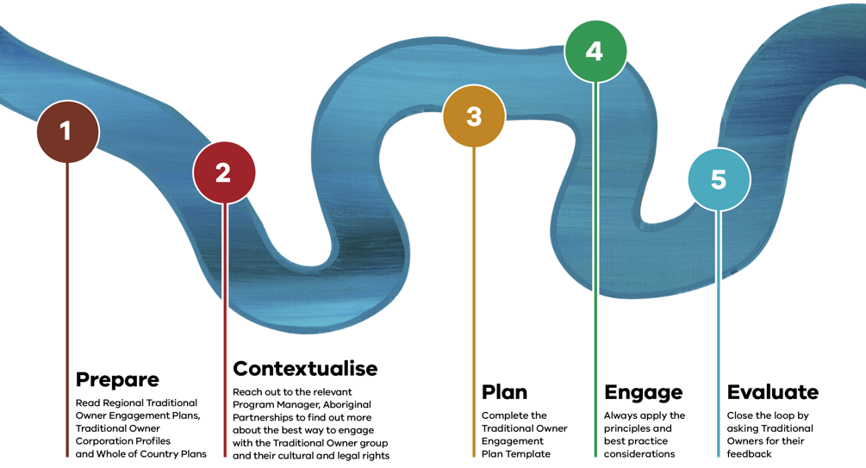

1. **Prepare**

Read Regional Traditional Owner Engagement Plans, Traditional Owner Corporation Profiles and Whole of Country Plans.

1. **Contextualise**

Reach out to the relevant Program Manager, Aboriginal Partnerships to find out more about the best way to engage with the Traditional Owner group and their cultural and legal rights.

1. **Plan**

Complete the Traditional Owner Engagement Plan Template.

1. **Engage**

Always apply the principles and best practice considerations.

1. **Evaluate**

Close the loop by asking Traditional Owners for their feedback.

## Prepare

**As you begin your project, make sure you clearly define the purpose of your engagement and what you'd like to achieve.**

### Read

* Take a look at the Regional Traditional Owner Engagement Plans before you contact the relevant Program Manager, Aboriginal Partnerships.
* Read the Traditional Owner Whole of Country Plans and any authored strategies to understand their priorities, and the Traditional Owner Corporation profile to understand legal rights and expectations.

Read through the Traditional Owner Engagement Plan Template. This will guide you through the process in more detail.

### Consider

* Read [*Pupangarli Marnmarnepu*](https://www.deeca.vic.gov.au/__data/assets/pdf_file/0031/493456/Pupangarli-Marnmarnepu-Aboriginal-Self-Determination-Reform-Strategy-2020-2025.pdf).
* Understand how you can ensure cultural safety throughout the life cycle of the engagement and project.
* Read [DEECAs Aboriginal Cultural Capability Framework](https://www.deeca.vic.gov.au/aboriginalselfdetermination/cultural-safety).

Register for Aboriginal Cultural Safety Training through PeopleCentral.

### Recommended points for review

* Why do you want to engage with Traditional Owners and Aboriginal Communities? And why would they want to engage or partner with your project?
* Can you financially support Traditional Owners to participate?
* How will you consider feedback?
* What relationships with Traditional Owners already exist across your branch or division?

Does your project align with Traditional Owner Whole of Country Plans and their priorities?

## Contextualise

**Before you start any engagement or partnership with Traditional Owners or Aboriginal Communities, it’s important to do your research. Make sure you understand their aspirations and assertions for Country.**

### Connect

Reach out to the Program Manager, Aboriginal Partnerships and provide them with your project plan so they can guide you on which Traditional Owner group you should work with. They can also help you understand each groups’ recognition status and how groups want to be engaged.

### Learn

* Find out the legal status and different rights of Traditional Owners under various legislation.
* If your project or activity is within an area where there is formal recognition, you should engage with the formally recognised group appointed for that area. If the project covers more than one formally recognised Traditional Owner group, you should engage with each group as they self-determine.
* Understand the recognition status of Traditional Owner groups and how this informs levels of participation.
* Understand the priorities, assertions, and expectations of the Traditional Owner group. Talk to your colleagues – find out if your work area has engaged with the Traditional Owner groups before.

### Understand the legal status of Traditional Owner groups

It is important to understand the legal status and different rights of Traditional Owners under various legislation. This will help us ensure we meet our obligations. There are 3 ways the Victorian Government formally recognises Traditional Owners of a particular Country:

1. The Victorian Aboriginal Heritage Council appoints a Traditional Owner Corporation as a RAP under the *Aboriginal Heritage Act 2006* (Vic).
2. Through a Recognition and Settlement Agreement under the *Traditional Owner Settlement Act 2010* (Vic).
3. Through a consent determination by the Federal Court under the *Native Title Act 1993* (Cth) and accompanying Indigenous Land Use Agreements.

### Formally and non-formally recognised: what's the difference?

#### Formally recognised groups

These groups have gained rights and obligations through the *Native Title Act* (Cth), *Traditional Owner Settlement Act* (Vic)and *Aboriginal Heritage Act* (Vic). It is important to recognise this when partnering with these groups. Traditional Owner groups self-determine their level of participation and might choose not to be involved.

#### Non-formally recognised Traditional Owner groups

These groups assert rights and interests for Country without formal recognition. If your project, initiative or program is in one of these areas, any Traditional Owner groups with an interest must be included and engaged with. It’s important to understand that some RAPs may also have an interest in non-RAP areas.

### Engaging with non-formally recognised Traditional Owner groups

It's important to note that DEECA has no role in formal recognition processes and does not make any judgement about the assertions of different groups. If there is no Traditional Owner group formally appointed for the area, engage broadly and inclusively with Traditional Owners who assert rights and interests in the area. This may include Traditional Owner families and groups with and without formal recognition.

**Note:** there could also be instances where you may need to engage with non-formally recognised groups within an area subject to formal recognition (e.g. asserted rights, such as registered native title claims or court processes).

### Understanding cultural rights

* Understand the Traditional Owner group’s priorities, assertions and expectations, and think about how your project could align with these.
* Consider any relevant previous work that your team has done – what information was shared by Traditional Owners? What did your team learn?
* Will your project use and manage Indigenous data? Indigenous Data Sovereignty is the right of Aboriginal people to govern the collection, ownership, and use of data about their communities, people, land and resources.

### *Charter of Human Rights and Responsibilities Act 2006* (Vic)

Under Section 38 of the Charter, all public authorities, including DEECA employees, need to act compatibly with human rights and give proper consideration to human rights when making decisions. The Charter also identifies the distinct cultural rights of Aboriginal people in Section 19(2). This means you need to consider how your project, activity or decision might impact the cultural rights of all Aboriginal people, regardless of their recognition status, before any decisions or actions are made.

#### Find out more

See page 13 and read the *Charter of Human Rights and Responsibilities Act 2006* (Vic) .

### How do I consider impacts on cultural rights?

**Step 1. Understand who is affected and which rights are relevant**

Identify which human rights are relevant to your action, inaction or decision. Besides Aboriginal cultural rights, are any other Charter rights relevant?

**Step 2. Consider whether rights are being limited by your action, inaction or decision**

Will your action or decision limit or interfere with a person’s or group’s Aboriginal cultural rights or any other relevant rights you’ve identified?

**Step 3. Is the limitation lawful, justified and proportionate?**

If you’re taking an action (or inaction), ensure you are authorised to do this by identifying the law or regulation that allows you to limit a person’s or group’s rights. You then need to determine whether your limitation of a person’s or group’s rights is justified and proportionate in all the circumstances. As part of this inquiry, consider whether there is another way to achieve your purpose that won’t limit the group’s cultural rights (and any other relevant rights).

### Recommended points for review

* What formal recognition status do the Traditional Owner groups have?
* How does the IAP2 Public Participation Spectrum apply to your engagement?
* How does the Charter of Human Rights apply to your engagement?
* Have you read the Traditional Owner Whole of Country Plan or any other Traditional Owner-authored strategies?
* Have you read the Traditional Owner Corporation Profile?
* Have you considered Indigenous Data Sovereignty principles?

## Plan

**After reaching out to the Program Manager, Aboriginal Partnerships and Traditional Owner groups, start planning your engagement. This includes timeframes, budget, expectations, engagement preferences and how you will enable Traditional Owner participation.**

### Timeframes

Be flexible with your timeframes as these may change throughout the engagement process. Refer to the best practice considerations and the Hanging Rock precinct Master Plan case study, on page 53.

### Complete the Traditional Owner Engagement Plan Template

Fill out the Traditional Owner Engagement Plan Template and seek approval from your manager and/or director.

#### Principle 4: Free, prior and informed consent

The Victorian Government should not impose its position onto Traditional Owners, without first considering Traditional Owner rights. It's important to follow the principles of free, prior and informed consent: ​

* **Free** means no force, bullying or pressure. ​
* **Prior** means consult Traditional Owners before activity begins. ​
* **Informed** means Traditional Owners understand the information you have given them. If there is new or changed information, and Traditional Owners don’t understand this information, they have not been informed.
* **Consent** means Traditional Owners must be consulted and participate in an honest and open process of negotiation that ensures: ​
* all parties are equal, neither having more power or strength ​
* group decision-making processes are allowed to operate ​
* their right to choose how they live is respected.

#### Navigating remuneration

Regardless of recognition status, you should always engage with Traditional Owners early and ensure they are adequately resourced to participate in DEECA business. There is currently no whole of Victorian Government guidance about how, when and what you should remunerate Traditional Owners for participation as every engagement is different. It is important to work with the Traditional Owner group to determine a suitable fee and process for the type of engagement. Speak with colleagues to understand previous remuneration processes and costings.

### Budget

* When planning your engagement budget, consider the following:
* ensure your project budget includes an allocation of funds for Traditional Owner engagement (some Traditional Owner groups have a schedule of rates on their website)
* equity across groups when working with multiple groups and/or at a statewide level
* costs will differ depending on how the group is participating (e.g. empower vs. inform)
* the Traditional Owner group may need to engage with their community (and their decision-making processes)
* preparation time, travel, accommodation, or equipment needed to enable them to participate

fees for Welcome to Country and other cultural protocols for on Country meetings.

### Recommended points for review

* Does your project budget include an allocation for Traditional Owner participation?
* Do the Traditional Owners need to be paid in advance (either in full or part) to enable them to prepare for and attend the engagement?
* Do they have a preferred payment method?
* Has DEECA paid them previously for engagement?
* How will you pay? Discuss with your team's finance representative.

## Engage

**Put your plan into action and ensure all activities are culturally safe. Our aim is to deliver genuine, inclusive and respectful engagement.**

### Prioritise cultural safety

Plan ahead so your engagement activities are at times and locations that suit Traditional Owners, on Country where possible.

Make sure the format and materials are culturally safe.

Prepare an Acknowledgement of Traditional Owners and Country.

### Deliver

Discuss with Traditional Owners how they will influence decision-making. They will self-determine their level of participation.

Make sure you provide Traditional Owners with enough time to take part in engagement processes and incorporate their governance and decision-making processes.

Ensure DEECA staff attending face-to-face meetings and events understand:

* the scope of their role
* the service they can provide
* the intention of the engagement

the priorities, aspirations and assertions of the Traditional Owners.

It's also important not to make assumptions, and always ask what people need. Be flexible and adapt the process as necessary.

Share how any previous feedback from the Traditional Owner group has been incorporated into your project.

During the engagement activity, identify opportunities where Traditional Owners can provide suggestions, feedback and views.

### Recommended points for review

* Were the objectives met for the delivery of the engagement?
* Did the engagement meet the needs and expectations of the Traditional Owners?
* Is more engagement required to meet the objectives?
* Were the principles and best practice considerations in this Framework applied?
* Be flexible - you may need to adapt your project based on Traditional Owner contributions, expectations and assertions.

## Evaluation

**Closing the loop is a vital part of the engagement pathway - consider how you will evaluate the engagement activity and report on final decisions to the Traditional Owner group.**

### Feedback

Ask for and provide feedback: a two-way discussion can help you reflect and learn from engagement. Be honest and accept accountability - it's important to listen to what Traditional Owners are saying.

Respond and action any feedback in a timely manner. This can strengthen your relationship with the Traditional Owner group or Aboriginal Community, and build trust.

### Recommended points for review

* What engagement activities did you undertake?
* What needed to be addressed?
* What were the priorities and preferences of participants?
* What was the final decision, and how did participants influence that decision?

How will you communicate the process, findings, and outcomes with participants?   
(e.g. email, report, video, presentations).

### Indicators of success

* Alignment with:
* *Pupangarli Marnmarnepu* outcomes
* Aboriginal Cultural Capability Framework outcomes
* Level of self-determined participation from Traditional Owners and Aboriginal Communities.

## Best practice considerations

**Here are some important things to consider when engaging with Traditional Owners and Aboriginal Communities.**

### Preparing for engagement

#### Communication preferences

Traditional Owner groups determine how they would like to communicate – written, verbal or both – and this may change throughout the project. Seek guidance from the relevant Program Manager, Aboriginal Partnerships on communication preferences.

#### Changing priorities

Traditional Owner groups may wish to participate, but have limited resources. Similarly, they might start participating in your project, but as the project progresses or evolves, their capacity might also change. Be flexible in your approach and maintain open lines of communication.

#### Be in it for the long haul

Engagement is a long-term relationship based on trust, respect and honesty. Having the right process is paramount to a successful relationship. Be transparent from the outset of your project so you can incorporate Traditional Owner and Aboriginal Community assertions into your project at the planning and scoping stage. Listen and learn. And, where possible, link environmental outcomes to Traditional Owner aspirations and assertions for Country.

#### Aboriginal procurement

The Victorian Government has committed to a 1% procurement target for engaging with Aboriginal businesses. Identify potential opportunities as early as possible for working with

#### Meet on Country

Participate in community meetings or other existing forums rather than asking people to join pre-determined processes and travel to head office or Melbourne. If it’s a place-based project, coordinate with the Traditional Owner groups to meet on site.

### During engagement

#### Respect cultural protocols

It is important to acknowledge the Traditional Owners of the Country you are meeting on or discussing. Ask Elders if they would like to be addressed as ’Aunty’ or ’Uncle’ and always allow Traditional Owners and Elders to speak first.

#### Sustainable resourcing

Traditional Owner groups are often engaged in an inconsistent and ad hoc way. Consider how your program could sustainably resource Traditional Owners beyond the lifespan of your project, such as long-term funding agreements, learning and development opportunities, office or equipment hire.

#### Actively listen

Traditional Owners are expert knowledge holders and know what’s best for themselves, their families and their communities. This deep and diverse understanding of knowledge, science and Country has been built up over thousands of years and can only add benefit to your project. Actively listening to Traditional Owners is one of the most important parts of engagement. Paraphrasing is a powerful way of deepening your understanding of what someone is saying - and making sure you've interpreted their message correctly.

#### Don’t make assumptions

Ask how the Traditional Owner group prefers to make decisions and be engaged. This may change throughout the project.

#### Don’t use jargon or acronyms

Try to avoid using western scientific or technical terms.

### Other considerations

#### Indigenous Data Sovereignty

Ensure Traditional Owners approve any information or images they provide.

#### Transparency

Clearly communicate your timelines and processes.

#### Share learnings and knowledge

Traditional Owners and Aboriginal Communities may want to be involved in your program area where historically they haven’t been considered. Discuss creating two-way knowledge sharing opportunities.

#### Close the loop

In alignment with DEECA’s Community Charter, “closing the loop” is a vital step in project delivery, regardless of the purpose or scale of the engagement. Not only is it important to keep communities informed about the outcomes of projects, but also throughout the different engagement phases of a project. If and when plans change, it’s important to communicate when this happens and why. This demonstrates to Traditional Owners and Aboriginal Communities:

* the consultation process was genuine (builds trust)
* their voices were heard and reflected
* their opinions were acknowledged and will inform or influence the next stage of the project's decision-making process.

#### Find out more

Email [self.determination@deeca.vic.gov.au](mailto:self.determination@deeca.vic.gov.au)

### IAP2 Public Participation Spectrum

The Spectrum helps you choose the public’s level of participation in any engagement process. The Spectrum is used internationally, and it is found in many public participation and engagement plans.

Table 2: IAP2 Public Participation Spectrum

|  | INFORM | CONSULT | INVOLVE | COLLABORATE | EMPOWER |
| --- | --- | --- | --- | --- | --- |
| **Public participation goal** | To provide the public with balanced and objective information to assist them in understanding the problem, alternatives, opportunities and/or solutions. | To obtain public feedback on analysis, alternatives and/or decisions. | To work directly with the public throughout the process to ensure that public concerns and aspirations are consistently understood and considered. | To partner with the public in each aspect of the decision including the development of alternatives and the identification of the preferred solution. | To place final decision making in the hands of the public. |
| **Promise to the public** | We will keep you informed. | We will keep you informed, listen to and acknowledge concerns and aspirations, and provide feedback on how public input influenced the decision. | We will work with you to ensure that your concerns and aspirations are directly reflected in the alternatives developed and provide feedback on how public input influenced the decision. | We will look to you for advice and innovation in formulating solutions and incorporate your advice and recommendations into the decisions to the maximum extent possible. | We will implement what you decide. |

## Case study: Hanging Rock precinct Master Plan

**Hanging Rock is an iconic and highly significant feature of the Victorian and Australian landscape and has many different meanings and values for the people and groups who live in and visit the area.**

To protect the cultural and environmental values of Hanging Rock, and safeguard it as a popular tourist destination, DEECA worked with Traditional Owners, community members and Macedon Ranges Shire Council on the [Hanging Rock Strategic Plan](https://www.forestsandreserves.vic.gov.au/initiatives/hanging-rock-project).

The Plan was developed through extensive engagement with three RAPs, Dja Dja Wurrung Clans Aboriginal Corporation, Taungurung Land and Waters Council and Wurundjeri Woi Wurrung Cultural Heritage Aboriginal Corporation who have a shared cultural interest in the site.

### Key challenges

* Shared boundaries of different Traditional Owner groups

Providing all RAPs with the same opportunities to contribute their views, ideas, aspirations, and expectations while being respectful of each group’s right to choose when, where and how they shared cultural stories and knowledge.

### Key learnings

#### Engage early

Reach out to Traditional Owners at the very beginning of your project, not when it's already in progress. If your project timelines don't work for Traditional Owners, go back to the project governance to reassess timelines. It's important to be flexible and not put pressure on Traditional Owners.

#### Understand how the Traditional Owner group wants to be engaged

For this project, Traditional Owner groups wanted to participate and asked for direct consultation with the Minister. This was achieved through a Ministerial Advisory Group with a representative (plus two observers) from each group.

#### Ensure cultural safety and competency

Every consultant under the project was briefed about self-determination and had to be culturally competent. The Project Manager also worked with Macedon Ranges Shire Council staff to help build their understanding about partnering with multiple Traditional Owners as they had previously only consulted with Wurundjeri Woi Wurrung Cultural Heritage Aboriginal Corporation.

#### Respect and protect each group’s intellectual property

The sovereignty of data was especially important to all three RAPs. They stipulated that they did not want any information or stories they shared to be provided to the other two RAPs. This was respected by structuring the Cultural Heritage Management Plan so that each group’s information was provided as an appendix and only shared with the respective Traditional Owner group.

#### Don’t make assumptions

You shouldn’t assume each Traditional Owner group shares the same views or ways of working as the other groups. It's also important to recognise that not everyone in the same group will share the same view.

#### Listen and learn

Ask if you’re unsure and be prepared that some of the earlier conversations might be difficult. In this project, deep, active listening helped to establish trust and to respectfully navigate any difficult matters. It took six to nine months to build relationships and trust.

# Who to talk to: partnership and engagement support

## Who can help in the regions?

**For help with connecting to regional teams, Traditional Owners, other stakeholders and supporting a One-DEECA, coordinated approach to project planning and delivery.**

### Regional Directors

The Regional Directors oversee the delivery of key programs, projects and services, and provide advice on directions, principles, strategies and actions for Traditional Owner and Aboriginal Community partnerships and engagement.

### Community and Partnerships Program

#### Regional Managers

The Regional Managers lead Community and Partnerships Program teams in providing place-based Traditional Owner and Aboriginal Communities partnership support and engagement advice.

#### Program Managers, Aboriginal Partnerships

The Program Managers, Aboriginal Partnerships ensure cultural safety is embedded and visible across all our sites and levels in the region. They partner with Traditional Owners and Aboriginal Communities to consistently deliver on what DEECA says it will do, as well as support a culturally safe workplace for Aboriginal staff and visitors.

#### Aboriginal Partnership Coordinators

The Aboriginal Partnership Coordinators work closely with the Program Managers, Aboriginal Partnerships to support the coordination and delivery of *Pupangarli Marnmarnepu* and embed cultural safety across the regions to partner with Traditional Owners and Aboriginal Communities.

## First Peoples Self-Determination Division

**The division provides leadership, culturally sound advice, and strategic direction to guide and empower staff to genuinely partner and meaningfully engage with Traditional Owners and Aboriginal Communities.**

The division's primary responsibilities are to:

* drive the self-determination reform agenda across DEECA
* guide and empower staff to genuinely partner and meaningfully engage with Traditional Owners and Aboriginal Communities
* promote and build understanding and systems to respond to and engage with the work of the Yoorrook Justice Commission
* promote and support Treaty preparations and readiness
* build cultural capability and a culturally safe environment and develop DEECA’s Aboriginal workforce
* work with Traditional Owners and Aboriginal Victorians to develop self-determination strategies to achieve on‑Country goals and assertions

lead DEECA’s involvement in the negotiation and implementation of Land Justice agreements with Traditional Owners.

### Aboriginal Engagement and Delivery Branch

The branch meets regularly with Traditional Owners to build meaningful relationships to advocate for their aspirations and assertions for Country. We ensure DEECA is accountable to its legislative obligations to Traditional Owners and upholds its commitments to self-determination.

Through providing best-practice advice, the branch empowers DEECA staff and helps to build their capability to engage with Traditional Owners.

By championing systemic and structural change, the branch supports the transference of decision-making powers and resources back to Traditional Owners as outlined in [Pupangarli Marnmarnepu](https://www.deeca.vic.gov.au/__data/assets/pdf_file/0031/493456/Pupangarli-Marnmarnepu-Aboriginal-Self-Determination-Reform-Strategy-2020-2025.pdf).

### Truth, Treaty and Reform Branch

#### Traditional Owner Agreements Unit

The unit supports the resolution of native title and related matters by supporting agreement-making between Traditional Owners and the Victorian Government under the *Traditional Owner Settlement Act 2010* (Vic) and *Native Title Act 1993* (Cth).

#### Program Managers, Traditional Owner Agreements

These roles support the regional leadership teams and partner with Traditional Owners and internal staff to co-deliver the outcomes of Recognition Settlement Agreements, including Joint Management, Natural Resource Agreement rights and Land Use Activity Agreement obligations.

#### Traditional Owner Agreements Officers

These roles support the Program Managers, Traditional Owner Agreements and partner with Traditional Owners and internal staff to co-deliver the outcomes of Recognition Settlement Agreements, including Joint Management, Natural Resource Agreement rights and Land Use Activity Agreement obligations.

### Traditional Owner Corporations

#### Departmental Liaison Officers

Each formally recognised Traditional Owner Corporation and other Traditional Owner organisations, have a Departmental Liaison Officer (DLO) position funded by DEECA. The DLOs help to ensure effective and efficient engagement with the department and their corporation. There might be other funded roles in Traditional Owner organisations or other agencies that may be relevant to your portfolio or project.

#### Find out more

Email [self.determination@deeca.vic.gov.au](mailto:self.determination@deeca.vic.gov.au)

# Publication information

## Copyright

© The State of Victoria Department of Energy, Environment and Climate Action, June 2025.

## Creative Commons

This work is licensed under a Creative Commons Attribution 4.0 International licence, visit the [Creative Commons website](http://creativecommons.org/licenses/by/4.0/) (<http://creativecommons.org/licenses/by/4.0/>).

You are free to re-use the work under that licence, on the condition that you credit the State of Victoria as author. The licence does not apply to any images, photographs or branding, including the Victorian Coat of Arms, and the Victorian Government and Department logos.

ISBN 978-1-76176-369-4 (pdf/online/MS word)

## Disclaimer

This publication may be of assistance to you but the State of Victoria and its employees do not guarantee that the publication is without flaw of any kind or is wholly appropriate for your particular purposes and therefore disclaims all liability for any error, loss or other consequence which may arise from you relying on any information in this publication.

## Accessibility

To receive this document in an alternative format, phone the Customer Service Centre on 136 186, email [customer.service@delwp.vic.gov.au](mailto:customer.service@delwp.vic.gov.au), or contact National Relay Service on 133 677. Available at DEECA website ([www.deeca.vic.gov.au](http://www.deeca.vic.gov.au/)).

**End of document.**

1. Snook, Scott, Nitin Nohria, and Rakesh Khurana (2012), The Handbook for Teaching Leadership: Knowing, Doing, and Being.
2. <https://humanrights.gov.au/our-work/projects/chapter-4-cultural-safety-and-security-tools-address-lateral-violence-social>
3. <https://humanrights.gov.au/our-work/projects/chapter-4-cultural-safety-and-security-tools-address-lateral-violence-social>