**Victorian Regional Forest Agreements**

**Major Event Review of the 2019-20 bushfires**

Summary report:   
Information and data to inform public consultation

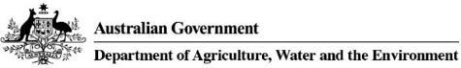Logo for the Victoria State Government
 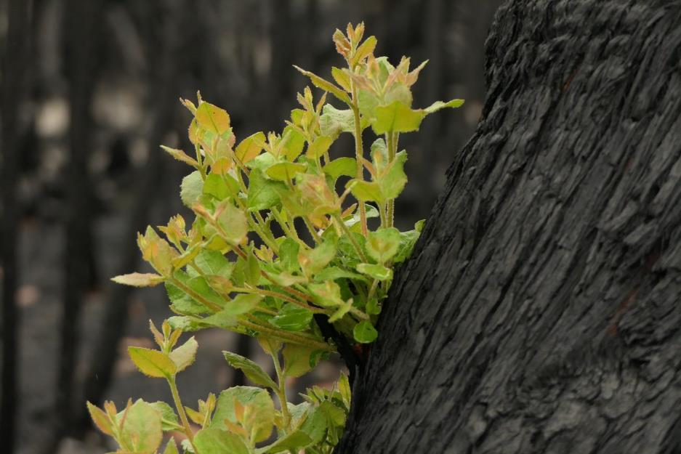

|  |
| --- |
| Acknowledgment  We acknowledge and respect Victorian Traditional Owners as the original custodians of Victoria’s land and waters, their unique ability to care for Country and deep spiritual connection to it. We honour Elders past and present whose knowledge and wisdom has ensured the continuation of culture and traditional practices.  We are committed to genuinely partner, and meaningfully engage, with Victoria’s Traditional Owners and Aboriginal communities to support the protection of Country, the maintenance of spiritual and cultural practices and their broader aspirations in the 21st century and beyond. |
| © The State of Victoria Department of Environment, Land, Water and Planning 2021  Closed Caption LogoThis work is licensed under a Creative Commons Attribution 4.0 International licence. You are free to re-use the work under that licence, on the condition that you credit the State of Victoria as author. The licence does not apply to any images, logo’s, photographs or branding, including the Commonwealth Coat of Arms, Victorian Coat of Arms, the Victorian Government logo and the Department of Environment, Land, Water and Planning (DELWP) logo. To view a copy of this licence, visit <http://creativecommons.org/licenses/by/4.0/>  ISBN 978-1-76105-352-8(pdf/online/MS Word)  Cover Photo Credit: Mike Irvine, Parks Victoria  Disclaimer  This report has been jointly prepared by the State of Victoria and the Commonwealth of Australia to inform the Victorian Regional Forest Agreements Major Event Review of the 2019-20 bushfires.  This publication may be of assistance to you but the State of Victoria and its employees do not guarantee that the publication is without flaw of any kind or is wholly appropriate for your particular purposes and therefore disclaims all liability for any error, loss or other consequence which may arise from you relying on any information in this publication.  Accessibility  If you would like to receive this publication in an alternative format, please telephone the DELWP Customer Service Centre on 136186, email [customer.service@delwp.vic.gov.au](mailto:customer.service@delwp.vic.gov.au), or via the National Relay Service on 133 677 [www.relayservice.com.au](http://www.relayservice.com.au). |

Contents

List of figures and tables iii

Executive summary iv

1. Introduction 1

1.1 What are the Victorian Regional Forest Agreements? 2

1.2 What is a Major Event Review? 2

1.3 What is the scope of the Major Event Review of the 2019–20 bushfires? 3

1.4 What is the purpose of this report? 3

2. Extent and severity of the 2019–20 bushfires within RFA regions 5

2.1 Extent of the bushfires 5

2.2 Severity of the bushfires 7

3. Impacts on the comprehensive, adequate and representative (CAR) reserve system 12

4. Impacts on forest industries 14

4.1 Timber and forest products industry 14

4.1.1 Available wood volumes in native forests 14

4.1.2 Plantation timber resources 15

4.2 Apiaries 16

4.3 Tourism 16

5. Impacts on matters of national environmental significance (MNES) 18

5.1 World Heritage and National Heritage listed areas 18

5.2 Ramsar wetlands 18

5.3 Listed species and ecological communities 19

6. Social and other economic impacts 23

6.1 Recreation 23

6.2 Social impacts 23

7. Cultural and heritage values 24

7.1 Culture and heritage 24

7.1.1 Aboriginal heritage places 24

7.1.2 Non-Aboriginal heritage sites 25

7.2 Traditional Owner values and uses 26

8. Impacts on ecosystem services 27

8.1 Water 27

8.2 Soil erosion control (soil retention) 27

8.3 Carbon sequestration 27

9. Further reading 29

Sources used in the Summary Report 29

Additional reading 30

List of figures and tables

Figures

Figure 1: Forest regrowth, post 2019–20 bushfires vi

Figure 2: Black Wallaby grazing on new shoots of Xanthorrea (grass tree) 1

Figure 3: Fires between Bairnsdale and Buchan, East Gippsland 5

Figure 4: 2019–20 bushfire extent and forest within the bushfire extent in Victorian RFA regions 6

Figure 5: Total area of 2019–20 bushfire extent in RFA regions 6

Figure 6: Distribution of burn severity across Victoria from 2019–20 bushfires 8

Figure 7: Area proportions of high severity fire, low to moderate severity fire and non-canopy classifications (as per Table 1) across the forested extent within the 2019–20 bushfire extent for the affected Victorian RFA regions 10

Figure 8: Ash forests across North East, Gippsland and East Gippsland RFA regions within bushfire extent in the 2019–20 bushfires 11

Figure 9: Plantation forest within the 2019–20 bushfire extent 16

Figure 10: DELWP staff undertaking forest work post 2019–20 bushfires, Bairnsdale area, East Gippsland 23

Figure 11: Fire damage to two non-Aboriginal heritage sites in the RFA areas 25

Figure 12: Fire damage to a heritage site (non-Aboriginal) in the RFA areas 26

Figure 13: Regrowth in forest burnt in 2019–20 bushfires 28

Tables

Table 1: Fire severity classification of bushfires 7

Table 2: Impacts on the CAR reserve system and related components by type of protection 12

Table 3: Area and percentage of tenure in 2019–20 bushfire extent 13

Table 4: Area and percentage* of tenure in 2019–20 bushfire extent burnt at high severity 13

Table 5: Fire impact on wood volumes (D+ Operable Inventory) by RFA 15

Table 6: Number of high priority species and ecological communities requiring management intervention following the 2019–20 bushfires at a national scale, the number that occur in Victorian RFA regions, and the number that are listed under the EPBC Act 19

Table 7: Impacts on EPBC Act listed communities 21

Table 8: Impacts on FFG Act listed communities 22

Executive summary

As part of Victoria’s modernised Regional Forest Agreements (RFAs), the Australian and Victorian governments are undertaking a Major Event Review of the impacts of the 2019–20 bushfires on Victoria’s RFA regions.

The Review will consider the 2019–20 bushfires impacts to all of Victoria’s five RFA regions – Central Highlands, East Gippsland, Gippsland, North East, and West Victoria.

The purpose of the Summary Report is to provide information and data about the impacts of the 2019-20 bushfires. The Summary Report will inform an independent Panel who will undertake the Major Event Review.

As required under Victoria’s RFAs, the Major Event Review of the impacts of the 2019–20 bushfires will consider:

* the operation of the five RFAs
* ecologically sustainable forest management
* the Comprehensive, Adequate and Representative (CAR) reserve system
* the effective management and protection of Matters of National Environmental Significance (MNES)
* harvest level
* the long-term stability of Victorian forests and forest industries.

This Summary Report presents known data about key impacts of the 2019–20 bushfires on Victoria’s RFAs, in relation to:

* forested areas burnt
* the CAR reserve system
* forest industries
* MNES, including listed species and ecological communities
* social and economic impacts of the bushfires
* cultural values, including Traditional Owner values
* ecosystem services.

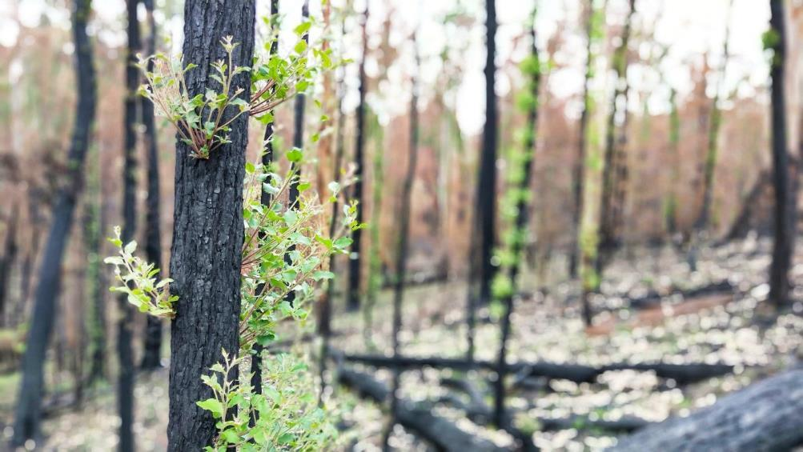

Figure 1: Forest regrowth, post 2019–20 bushfires

Photo credit: Lili Prins

1. Introduction

The 2019–20 fires in south-eastern Australia burnt over 10.3 million hectares across multiple states and a territory. In Victoria, approximately 1.5 million hectares was burnt, including around 1.3 million hectares, or 18 per cent, of the total public native forest estate.[1]

The fires affected individuals, communities, businesses, infrastructure, plants, animals and forest ecosystems. The impacts have been acute in Victoria’s regions.

As a result, the Victorian and Australian governments have agreed to undertake a Major Event Review to assess the impacts of the 2019–20 bushfires on the operation of Victoria’s five RFAs. The Review will identify what, if any, remedial actions need to be taken to address the impacts of the 2019–20 bushfires in relation to the RFAs. The Review will not open the RFAs for renegotiation.

This report summarises the information we have to date about the impacts of the 2019–20 bushfires on Victoria’s RFAs.

The Victorian and Australian governments have undertaken a range of response and recovery initiatives following these bushfires. You can find detailed information about this work in the resources listed at the end of this document.

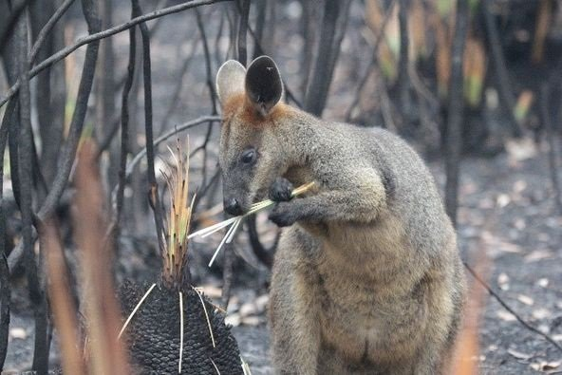

Figure 2: Black Wallaby grazing on new shoots of Xanthorrea (grass tree)

Photo credit: Tony Mitchell, DELWP

## 1.1 What are the Victorian Regional Forest Agreements?

Regional Forest Agreements (RFAs) are long-term agreements between the Australian and Victorian governments that establish the framework for the sustainable management and conservation of forests in an RFA region.[2]

Victoria has five RFAs, covering the following regions: Central Highlands, East Gippsland, Gippsland, North East and West Victoria. They were originally signed between 1997 and 2000, each for a period of 20 years. In March 2020, all five RFAs were modernised and extended until 30 June 2030.

Victoria’s RFAs provide a robust framework for sustainable, active and adaptive management of Victoria’s forests for all uses and benefits — cultural, social, recreational, environmental and economic. Through the RFAs, the Australian Government accredits Victoria’s forest management system. As a result, forestry operations undertaken in accordance with a relevant RFA do not require additional approvals under Part 3 of the Commonwealth Environment Protection and Biodiversity Conservation Act 1999(EPBC Act).

Victoria’s RFAs recognise the importance of stakeholder and community understanding of ecologically sustainable forest management and participation in decision-making processes related to our forests. They also commit to ensuring the involvement of Traditional Owners in decision-making and identifying opportunities for Traditional Owners to partner in land, water, fire and environmental management.

## 1.2 What is a Major Event Review?

The Major Event Review is one of the many new features of the modernised Victorian RFAs. The Victorian and Australian governments can undertake a joint review to assess the impacts of Major Events, such as significant natural disturbances, that may have a significant impact on RFA matters.[3]

Major Event Reviews are unique to Victoria’s RFAs, and the Victorian Regional Forest Agreements Major Event Review of the 2019–20 Bushfires will be the first review to be undertaken.

As defined in the Victorian RFAs, a ‘Major Event’ is a substantial change in circumstances that has the potential to significantly impact upon:

* the objectives and operation of the RFAs
* the comprehensiveness, adequacy or representativeness of the Comprehensive, Adequate and Representative (CAR) Reserve System
* Ecologically Sustainable Forest Management (ESFM)
* one or more Matters of National Environmental Significance (MNES), or
* the stability of Forest Industries.[4]

By assessing the impacts of the Major Event and identifying if there are any remedial actions required, the Major Event Review will enable the continued effective operation of the RFAs after Major Events. This supports active, adaptive and accountable forest management, which is a cornerstone of the modernised RFAs. A Major Event Review is undertaken jointly by the Victorian and Australian governments, as Parties to the Victorian RFAs. A Panel established by the governments will conduct the Review. The Panel membership will comprise:

* the Victorian Commissioner for Environmental Sustainability
* an independent reviewer selected by the Australian Government, and agreed by Victoria
* a Victorian Traditional Owner.

The Panel will make recommendations to the Victorian and Australian governments on what, if any, remedial action needs to be undertaken to address the impacts of the 2019–20 fires.

## 1.3 What is the scope of the Major Event Review of the 2019–20 bushfires?

The bushfire extent occurred largely across the East Gippsland, Gippsland and North East RFA regions, but the implications for forest management in RFA regions may extend to forest values across all RFA regions. As such, the Major Event Review will assess impacts across all Victorian RFA regions.

The Scoping Agreement established by the Victorian and Australian governments for the Major Event Review of the 2019–20 bushfires outlines arrangements for undertaking the Review.[5]

As per the requirements of the Victorian RFAs, the Major Event Review will assess the impacts on the 2019-20 bushfires on:

* operation of the RFAs
* ESFM
* the CAR reserve system
* the effective management and protection of MNES
* Harvest level
* the long-term stability of forests and forest industries.

## 1.4 What is the purpose of this report?

This Summary Report provides an overview of known information about the impacts of the 2019–20 bushfires. Its objective is to summarise key information about the impact of bushfires on RFA matters to inform public consultation.

The information summarised in this report reflects the information that the Victorian and Australian governments have agreed to provide for the Review under the Scoping Agreement.[6]

Information in this Summary Report focuses on impacts in the East Gippsland, Gippsland and North East RFA regions, with relevant information on the Central Highlands and West Victoria RFA regions included where available.

This Report uses a summary format to present key information that is available at the time of publication. Knowledge of the impacts over the short, medium and long term following these bushfires continues to develop.

# 

2. Extent and severity of the 2019–20 bushfires within RFA regions

## 2.1 Extent of the bushfires

Between November 2019 and March 2020, fires impacted Victoria, predominantly in the east and north-east, which includes three RFA regions: East Gippsland, Gippsland and North East. Less-extensive fires also affected the two remaining RFA regions — West and Central Highlands — as well as areas outside an RFA region in the north-west of the state (Figure 4).

The 1.5 million hectares[7] of fire-affected area across Victoria predominantly occurred within RFA regions; of this, over 1.35 million hectares was on public land.[8] Of this, 1.3 million hectares was forested (Figure 5).[9] Within Victoria’s RFA regions, the fires impacted over 870,000 hectares of State forest, and over 460,000 hectares of national parks and conservation reserves was within the bushfire extent. Around 67,000 hectares of forest on private land was also within the fire extent.[10]

East Gippsland was the most severely affected RFA region, with 67 per cent of land and 70 per cent of forest within the bushfire extent. In Gippsland, 12 per cent of land and 19 per cent of forest was within the bushfire extent, while in the North East, 15 per cent of land and 22 per cent of forest was within the bushfire extent. In the Central Highlands and West RFA regions, 53 hectares and 12,506 hectares of forest area, respectively, was within the bushfire extent.[11]

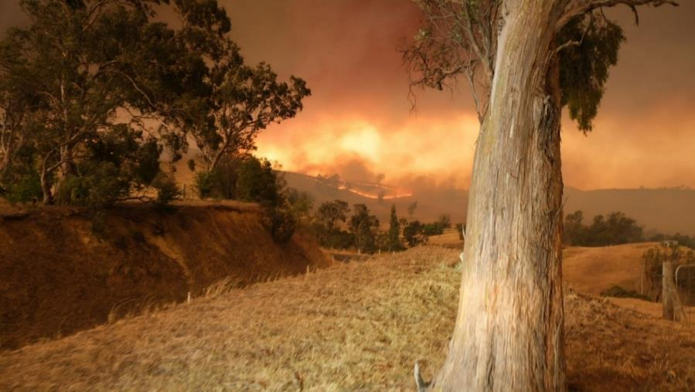

**Figure 3: Fires between Bairnsdale and Buchan, East Gippsland**

Photo credit: Lachlan Spark, Sparklabs

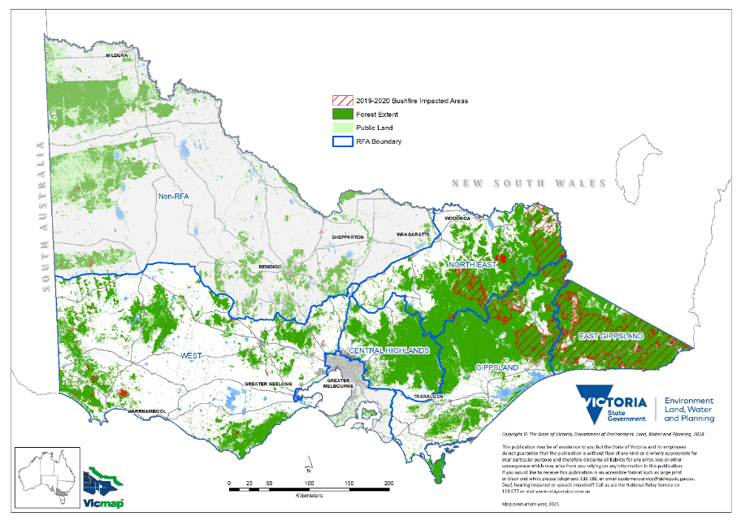

Figure 4: 2019–20 bushfire extent and forest within the bushfire extent in Victorian RFA regions

Source: Regional Forestry Agreement boundaries (RFA25), FIRE HISTORY, FIRE SEVERITY map of the major fires in Gippsland and north east Victoria in 2019/20, Forest cover 2018

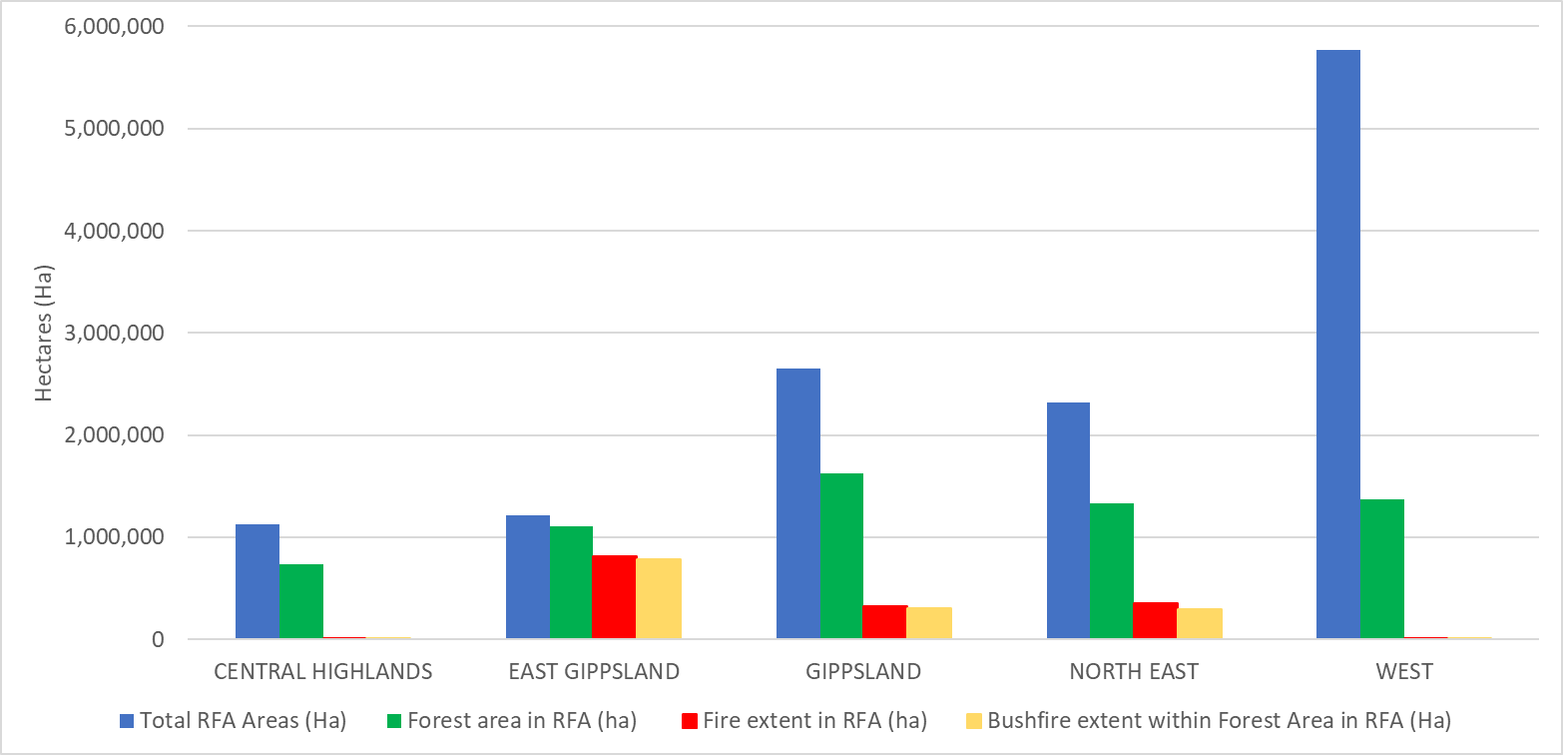

Figure 5: Total area of 2019–20 bushfire extent in RFA regions

Source: Regional Forestry Agreement boundaries (RFA25), FIRE HISTORY, FIRE SEVERITY map of the major fires in Gippsland and north east Victoria in 2019/20, Forest cover 2018

## 2.2 Severity of the bushfires

‘Fire severity’ describes the level of impact on forest vegetation, usually being measured from satellite imagery, with scorched or consumed foliage in the forest canopy indicating high severity fire. Table 1 outlines the fire severity classification that DELWP uses.

Table 1: Fire severity classification of bushfires[12]

|  |  |  |
| --- | --- | --- |
| Fire severity classification | Category | Description |
| High severity fire | Class 6 | Canopy burnt (>20% canopy foliage consumed) |
| High severity fire | Class 5 | High canopy scorch (>80% of canopy foliage scorched) |
| Low to moderate severity fire | Class 4 | Medium canopy scorch (canopy a mosaic of both unburnt and scorched foliage, 20–80%) |
| Low to moderate severity fire | Class 3 | Low canopy scorch (canopy foliage is largely unaffected, <20% scorched, but understorey has been burnt) |
| Non-canopy classifications | Class 2 | Unburnt (canopy and understorey foliage are largely unburnt, >90%) |
| Non-canopy classifications | Class 1 | Non-woody vegetation (unclassified) |
| Non-canopy classifications | Class 0 | No data (e.g. due to obscuration by cloud, cloud-shadow and/or smoke and haze) |

DELWP has mapped fire severity for the 2019–20 bushfires across east and north-east Victoria (Figure 6).[13] Across the three RFA regions where the fires predominantly occurred, East Gippsland had the greatest area of forest burnt by high severity fire (47 per cent). High severity fire burnt 51 per cent of forest area in the North East and 50 per cent of forest area in Gippsland (Figure 7).

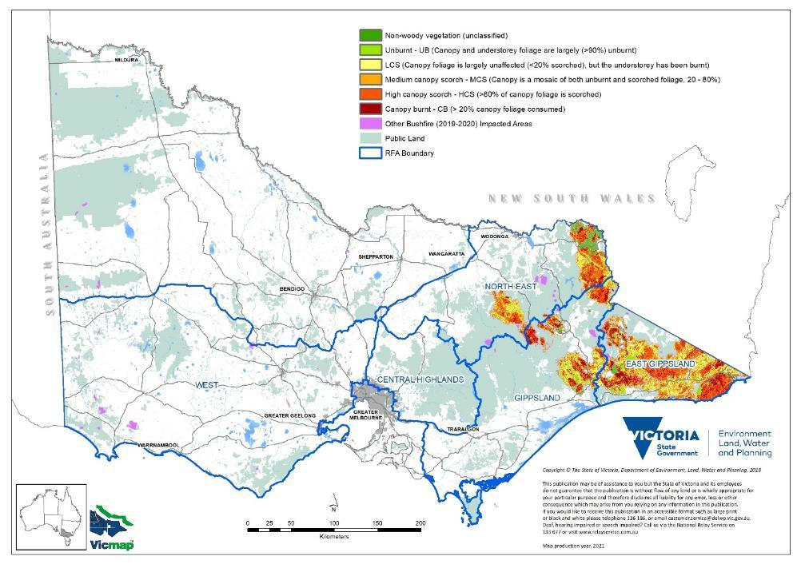

Figure 6: Distribution of burn severity across Victoria from 2019–20 bushfires

Source: Regional Forest Agreement boundaries (RFA25), FIRE HISTORY, FIRE SEVERITY map of the major fires in Gippsland and north east Victoria in 2019/20

|  |
| --- |
| Pie chart showing area proportions of high severity fire, low to moderate severity fire and non-canopy classifications (as per Table 1) across the forested extent within the 2019–20 bushfire extent for East Gippsland RFA. |
|  |
| Pie chart showing area proportions of high severity fire, low to moderate severity fire and non-canopy classifications (as per Table 1) across the forested extent within the 2019–20 bushfire extent for North East RFA. |
| Pie chart showing area proportions of high severity fire, low to moderate severity fire and non-canopy classifications (as per Table 1) across the forested extent within the 2019–20 bushfire extent for Gippsland RFA. |

Figure 7: Area proportions of high severity fire, low to moderate severity fire and non-canopy classifications (as per Table 1) across the forested extent within the 2019–20 bushfire extent for the affected Victorian RFA regions[14]

Source: Regional Forestry Agreement boundaries (RFA25), FIRE HISTORY, FIRE SEVERITY map of the major fires in Gippsland and north east Victoria in 2019/20, Forest cover 2018

Most of the area burnt in the 2019–20 bushfires was fire-tolerant mixed-species eucalypt forest. These species typically survive most fires and regenerate by resprouting after the fire event.

However, Ash species were also affected by the bushfires. Ash species are typically killed by high severity fire and regenerate through seeds that are released from the canopy. If Ash trees are killed before they reach seed-bearing age (around 20 years), Ash forests may not regenerate without intervention. Large areas of Ash forests have been impacted by recurring fires since 2003, meaning there was an extensive area of immature Ash forest in the landscape in the lead-up to the 2019–20 fire event.[15] The total area of Ash forest impacted by the bushfires in 2019–20 is 4,286 hectares of Mountain Ash forest and 52,516 hectares of Alpine Ash forest.[16] It is estimated that 11,500 hectares of immature Ash forest was impacted by high severity fire in 2019–20; this was then reseeded in 2020 (Figure 8; the area considered for reseeding is coloured red).[17]

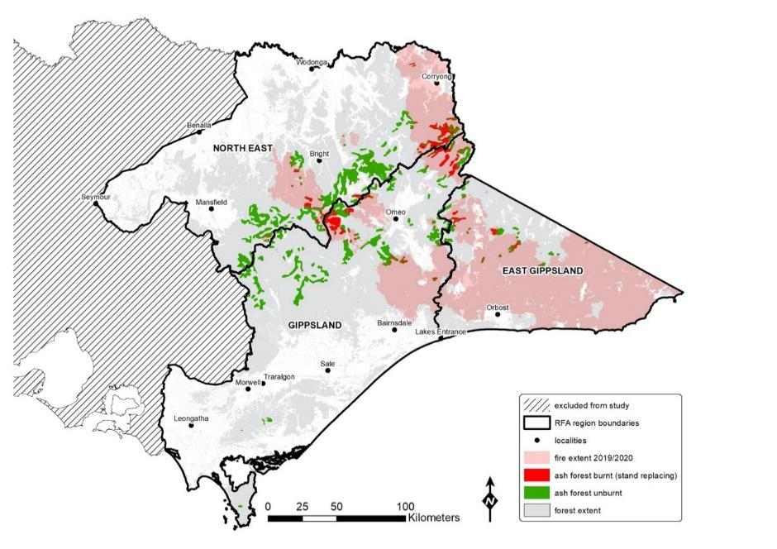

Figure 8: Ash forests across North East, Gippsland and East Gippsland RFA regions within bushfire extent in the 2019–20 bushfires

Source: FIRE SEVERITY map of the major fires in Gippsland and north east Victoria in 2019/20, SVEG100

3. Impacts on the comprehensive, adequate and representative (CAR) reserve system

The comprehensive, adequate and representative (CAR) reserve system includes reserves and other areas of public and private land protected by prescription or agreed management arrangements where conservation values are protected. It is a system of protected areas established for the purpose of protecting examples of different ecosystems and comply with national and international conventions.

Large areas of the CAR reserve system in Victoria were affected by the 2019–20 bushfires (Table 2). In Victoria, there are just over 4.3 million hectares of native forest in the CAR reserve system, 2.9 million hectares of which are in the RFA regions.[18] The 2019–20 fire extent included nearly 760,000 hectares of native forest in the CAR reserve system.[19]

Table 2:[20] Impacts on the CAR reserve system and related components by type of protection[21]

|  |  |  |  |  |
| --- | --- | --- | --- | --- |
| Area | Included in CAR reserve or a related protected area | Total area across the state (ha) | Area in fire extent (ha) | Area in fire extent burnt by high severity fire (ha) |
| National parks and nature conservation reserves | CAR reserve | 3,900,480 | 482,094 | 285,462 |
| Permanent protection on private land | CAR reserve | 49,025 | 404 | 130 |
| Special protection zone (SPZ) areas | CAR reserve | 765,900 | 203,758 | 127,966 |
| Prescriptions (modelled exclusions and rainforest, per *Management Standards and Procedures for timber harvesting operations in Victoria’s State forests*) | CAR reserve | 629,120 | 193,375 | 12,359 |
| Immediate Protection Areas (additional new protected areas, as identified in the Greater Glider Action Statement No. 267)[22] | Related protected area, not part of CAR reserve | 95,107 | 44,169 | 31,255 |

A breakdown of the impact of the 2019–20 bushfires on the CAR reserve is provided in Table 3. The area of the CAR reserve that was burnt by high severity fire is outlined in Table 4.

Table 3: Area and percentage of tenure in 2019–20 bushfire extent[23]

|  |  |  |  |  |  |  |  |  |  |  |  |  |  |  |  |  |  |  |
| --- | --- | --- | --- | --- | --- | --- | --- | --- | --- | --- | --- | --- | --- | --- | --- | --- | --- | --- |
| RFA region | Dedicated | Dedicated | Special Protection Zone (SPZ) | Special Protection Zone (SPZ) | Covenant | Covenant | Prescription | Prescription | Other public land | Other public land | General Management Zone (GMZ) | General Management Zone (GMZ) | Special Management Zone (SMZ) | Special Management Zone (SMZ) | Private | Private | Grand total | Grand total |
| RFA region | ha | % | ha | % | ha | % | ha | % | ha | % | ha | % | ha | % | ha | % | ha | % |
| Central Highlands | 0 | 0 | 4 | 0 | 0 | 0 | 0 | 0 | 61 | 0 | 0 | 0 | 0 | 0 | 5 | 0 | 71 | 0 |
| East Gippsland | 297,094 | 64 | 84,467 | 78 | 0 | 0 | 84,178 | 83 | 4,488 | 33 | 254,097 | 81 | 37,469 | 72 | 53,618 | 33 | 815,410 | 67 |
| Gippsland | 73,788 | 13 | 53,569 | 23 | 275 | 1 | 53,350 | 25 | 2,238 | 2 | 95,455 | 29 | 1,567 | 20 | 42,175 | 4 | 322,417 | 12 |
| North East | 105,779 | 24 | 43,244 | 25 | 0 | 0 | 67,575 | 28 | 8,031 | 6 | 52,802 | 20 | 969 |  | 73,514 | 7 | 351,913 | 15 |
| West | 7,006 | 1 | 2,115 | 2 | 106 | 2 | 19 | 0 | 535 | 0 | 1,604 | 1 | 79 | 0 | 5,273 | 0 | 16,736 | 0 |
| Non-RFA | 3,047 | 0 | 0 | 0 | 0 | 0 | 0 | 0 | 46 | 0 | 712 | 0 | 0 | 0 | 2,458 | 0 | 6,263 | 0 |
| Grand total | 486,714 |  | 183,400 |  | 381 |  | 205,121 |  | 15,399 |  | 404,670 |  | 40,083 |  | 177,042 |  | 1,512,810 |  |

Table 4: Area and percentage* of tenure in 2019–20 bushfire extent burnt at high severity[24] [25]

|  |  |  |  |  |  |  |  |  |  |  |  |  |  |  |  |  |  |  |
| --- | --- | --- | --- | --- | --- | --- | --- | --- | --- | --- | --- | --- | --- | --- | --- | --- | --- | --- |
| RFA region | Dedicated | Dedicated | SPZ | SPZ | Covenant | Covenant | Prescription | Prescription | Other public land | Other public land | GMZ | GMZ | SMZ | SMZ | Private | Private | Grand total | Grand total |
|  | ha | % | ha | % | ha | % | ha | % | ha | % | ha | % | ha | % | ha | % | ha | % |
| East Gippsland | 141,861 | 30 | 39,372 | 36 |  | 0 | 39,744 | 39 | 1,371 | 10 | 123,712 | 39 | 16,145 | 31 | 12,722 | 8 | 374,927 | 31 |
| Gippsland | 40,980 | 7 | 27,554 | 12 | 49 | 0 | 25,554 | 12 | 1,164 | 1 | 47,080 | 14 | 551 | 7 | 11,706 | 1 | 154,639 | 6 |
| North East | 49,132 | 11 | 21,051 | 12 |  | 0 | 35,573 | 15 | 4,478 | 3 | 28,447 | 11 | 494 | 4 | 14,815 | 1 | 153,990 | 7 |
| Grand total | 231,973 |  | 87,976 |  | 49 |  | 100,872 |  | 7,012 |  | 199,240 |  | 17,190 |  | 39,242 |  | 683,555 |  |

\***Note: Percentages have been rounded to the nearest integer.**

4. Impacts on forest industries

Forest industries depend on forests to generate jobs and economic benefits. Forest industries include the timber and forestry products industries*, nature-based tourism and apiculture.

*For the purposes of the Victorian RFAs, timber and forest products industries include industries involved in growing, management, harvesting, haulage to mill, milling and processing, importing/exporting, haulage of finished goods to market, and wholesale and retail sales of wood and paper products in Australia associated with plantations, native forestry and farm forestry.

The following sections provide available information on impacts of the 2019–20 fires on forest industries.

## 4.1 Timber and forest products industry

The Victorian timber industry sources timber from native forests and plantations within RFA regions. It employs approximately 15,000 workers in forest growing and management, harvest, haulage, and primary and secondary processing.[26] It also generates income for communities in regional Victoria.

Due to the 2019-20 bushfires, many forest industry businesses experienced a reduced capacity to operate because of power loss and road closures.[27]

### 4.1.1 Available wood volumes in native forests

During the 2019–20 fires approximately 1.3 million hectares, or 18 per cent, of the total public native forest estate was burnt.[28] Of this area, 650,000 hectares was native forest that could be made available for timber supply. Of this, approximately 40,000 hectares was Ash forest, including roughly 7,800 hectares of immature Ash forest affected by high severity fire. 610,000 hectares was mixed-species eucalypt forest.[29]

The impact of the fires on the timber resource from native forests differs between Ash and mixed species eucalypts.

Ash species are typically killed by high-intensity fire and regenerate through seeds that are released from the canopy. However, if Ash trees are killed before they reach seed-bearing age (around 20 years), Ash forests may not regenerate without intervention. Once Ash species have been burnt, there is a limited window in which to conduct salvage operations to harvest the burnt stands, before the timber deteriorates. Salvage operations in burnt Ash forest following the 2019–20 bushfires are substituting harvesting of timber in unburnt areas, with no harvesting of unburnt areas within the fire footprint taking place in 2020.[30] This has occurred within the limits on harvesting and is consistent with the calculated annual harvest levels.[31]

Mixed species eucalypts are more fire tolerant and can survive fire intensities that would kill Ash species. Fire-affected mixed species, while experiencing some mortality and a reduction in harvestable volume due to fire damage, will largely still be available for harvest in the future. Consequently, although the fires affected a far greater area of mixed species eucalypts, the expected volume of loss in timber resource for mixed species eucalypts is much lower than for Ash (Table 5).

Table 5: Fire impact on wood volumes (D+ Operable Inventory) by RFA[32] [33]

|  |  |  |
| --- | --- | --- |
| RFA region | Ash (m3) | Mixed species (m3) |
| Central Highlands | Nil impact | Nil impact |
| East Gippsland | −7,095 | −306,569 |
| Gippsland | −155,871 | −16,307 |
| North East | −208,279 | −12,435 |
| Western Victoria | Nil impact | Nil impact |
| Total | −371,245 | −335,310 |

### 4.1.2 Plantation timber resources

A mix of softwood and hardwood plantations were burnt in the North East and East Gippsland RFA regions (Figure 9).[34] Approximately 6,400 hectares of the total 416,000 hectares of Victorian plantations were affected by the 2019–20 bushfires.[35]

While provision of timber may be sustained or even increase in the short term due to the 2019–20 bushfires as post-fire salvage harvesting occurs, there will likely be longer-term impacts on timber supply as plantations need to be replanted and regrown.

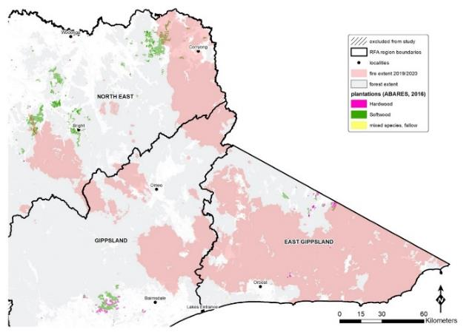

Figure 9: Plantation forest within the 2019–20 bushfire extent

Source: Regional Forestry Agreement boundaries (RFA25), FIRE SEVERITY map of the major fires in Gippsland and north east Victoria in 2019/20, ABARES Plantation data 2016

## 4.2 Apiaries

According to industry reports, floral resources for honey and pollination from forests burnt in the 2019–20 bushfires are expected to decrease in the short to medium term, reducing the capacity of these forests to support the provision of honey and pollination services. This capacity is expected to recover over time as forests regenerate. The speed at which this occurs is related to how severely forests were burnt. Some estimates suggest that the recovery time for floral resources ranges from 3 to 25 years. Eucalypts that have had their crowns burnt can take over 10 years to recover.[36]

The overall impact of the bushfires on honey and pollination will depend on whether apiarists can relocate hives to unburnt forests and access floral resources in other areas.

## 4.3 Tourism

Tourism is a significant economic driver for Victoria, directly contributing $11.3 billion to the economy and over 140,000 full-time and part-time jobs in 2016–17.[37] Tourism associated with forests contributes directly to regional economies through visitation and jobs. There was an estimated loss in tourism revenue of $330–350 million in bushfire-affected regions between December 2019 and March 2020.[38]

5. Impacts on matters of national environmental significance (MNES)

The Environment Protection and Biodiversity Conservation Act 1999 (EPBC Act)defines matters of national environmental significance (MNES) and provides for their protection. There are nine MNES protected under the EPBC Act. For the purposes of Victoria’s RFAs, MNES that are potentially impacted by forestry operations are limited to:

* world heritage properties
* National Heritage places
* wetlands of international importance (listed under the Ramsar Convention)
* listed threatened species and ecological communities.

## 5.1 World Heritage and National Heritage listed areas

World Heritage properties are protected for their natural or cultural values. All properties listed under Article 11 of the Convention Concerning the Protection of the World Cultural and Natural Heritage are protected under the EPBC Act. National Heritage places are sites that are recognised for their national heritage values and are also protected under the EPBC Act.

Within Victoria’s RFA regions, there is one World Heritage listed site (Budj Bim Cultural Landscape in the West RFA region) and thirteen National Heritage places.

Two heritage listed reserves are located within the current fire extent: Budj Bim Cultural Landscape and Australian Alps National Parks and Reserves.[39]

The Budj Bim Cultural Landscape, which was listed as a National Heritage area in 2004 and a designated UNESCO World Heritage site in 2019, was significantly impacted by the 2019–20 bushfires with over 60 per cent of the northern component in the fire extent.[40] The fires threatened multiple Aboriginal cultural heritage places, burning over 7,000 hectares within Budj Bim National Park.[41] Over 80 per cent of the Lake Condah Indigenous Protected Area, part of the World Heritage Budj Bim Cultural Landscape, has been impacted by the 2019–20 bushfires. Significant firefighting effort was undertaken to protect cultural sites within the area. Further detail about fire impacts on cultural heritage and Traditional Owner values is at sections 6.3 and 6.4.

In addition, 26 per cent (224,445 hectares) of the Victorian part of the Australian Alps National Parks and Reserves National Heritage area is within the fire area.

## 5.2 Ramsar wetlands

Ramsar sites are wetlands included in the List of Wetlands of International Importance, kept under the Ramsar Convention, to which Australia is a signatory. They are recognised as being of international importance because the wetland is a representative, rare or unique wetland type, or is of international importance for conserving biological diversity (e.g. waterbirds and indigenous fish).

There are no Ramsar sites within the 2019–20 fire extent; however, indirect impacts on the Gippsland Lakes Ramsar site, resulting from soot, ash, sediment and black water, may become evident over time.

## 5.3 Listed species and ecological communities

The RFAs aim to provide for the protection and management of species and communities listed under the EPBC Act and species and communities listed under Victoria’s Flora and Fauna Guarantee Act 1988 (FFG Act)where they are, or have the potential to be, impacted by forestry operations.

Following the 2019–20 bushfires, the Australian Government Threatened Species Commissioner convened an Expert Panel to assist in prioritising recovery actions for native species, ecological communities, and natural assets including their cultural values for Indigenous Australians.[42] Table 6outlines the number of species and communities identified as a high priority for management intervention at a national scale, the number of species and communities that occur within Victorian RFA regions, and the number that are listed under the EPBC Act.

Table 6: Number of high priority species and ecological communities requiring management intervention following the 2019–20 bushfires at a national scale, the number that occur in Victorian RFA regions, and the number that are listed under the EPBC Act

|  |  |  |  |
| --- | --- | --- | --- |
| Category | National list | Victorian RFA regions | Victorian RFA regions |
| Category | Total priority species/communities | Total priority species/communities | EPBC Act listed |
| **Animals**[43] | 114 | 48 | 21 |
| Birds | 17 | 9 | 3 |
| Mammals | 20 | 13 | 10 |
| Reptiles | 23 | 5 | 2 |
| Frogs | 16 | 4 | 4 |
| Spiny crayfish | 22 | 7 | 0 |
| Freshwater fish | 16 | 10 | 2 |
| **Invertebrates** | 191 | 43 | 2 |
| **Plants** | 427 | 91 | 11 |
| **Ecological communities[44]** | 78 | 12 | 6[45] |

The Victorian Government has undertaken separate assessments, analysing data for thousands of species to understand the impact of the 2019–20 fires on Victoria’s biodiversity, including Listed Species and Communities (listed under the EPBC Act and the FFG Act).[46] This process has highlighted species of immediate concern for Victoria[47] and identified a range of potential actions that would benefit those species (such as the provision of artificial habitats).

The Victorian Government assessments identified 244 species with more than 50 per cent of their modelled habitat within the fire extent, including 215 rare or threatened species.[48] Four species are listed under the EPBC Act. Species of most immediate concern include the Long-footed Potoroo, Ground Parrot, Glossy Black-Cockatoo, Large Brown Tree Frog, Diamond Python and Freshwater Galaxiids species.

Invertebrate groups, including species that are Listed Species, have also been impacted. The major hazards to invertebrate groups include immediate mortality due to fire (caused by a lack of mobility), loss of critical habitat features (e.g. leaf litter, logs, etc.) and dependent flora, increased trampling from introduced herbivores, predators, loss of water quality and the long-term impacts of small population size in remnant patches caused by the fire.

Listed communities (assemblages of plants and animals and organisms that naturally occur together and interact in a unique habitat) have also been impacted. Table 7 shows impacts on communities listed under the EPBC Act[49] and Table 8 shows impacts on communities listed under the FFG Act.[50]

Communities and species of most immediate concern include the Colquhoun Grevillea, Betka Bottlebrush and a number of rainforest types in east Gippsland.

There are two main forms of rainforest in Victoria: cool temperate and warm temperate. Cool Temperate Rainforest, some types of Warm Temperate Rainforest, and Dry Rainforest (Limestone) are listed as threatened under the FFG Act. One type of rainforest in Victoria, Littoral Rainforest, is listed under the EPBC Act. Rainforest in Victoria develops in the long-term absence of severe disturbance such as fire, and there are significant areas of rainforest within the current fire extent. Following the 2019–20 bushfires, 78 per cent of Victoria’s Warm Temperate Rainforest was assessed to be within the fire extent.

Table 7: Impacts on EPBC Act listed communities[51]

|  |  |  |  |
| --- | --- | --- | --- |
| Community | Impact of fire | % of community within fire extent | Australian Government identified priority[52] |
| Alpine Sphagnum Bogs and Associated Fens ecological community | Direct and severe impacts on this community will be likely given the protracted period of low rainfall leading up to the fires. In several places across the projected impact area, this community has been subject to repeat fires. Impacts include destruction associated with peat ignition, altered hydrology and mass movement of soils and siltation. The community is at risk of the future indirect impacts of bushfire such as feral herbivore browsing, trampling and wallowing. | 11% | Very High |
| Littoral Rainforest and Coastal Vine Thickets of Eastern Australia | The community is at risk of the future indirect impacts of bushfire such as soil erosion, exposure, weed encroachment and feral herbivore browsing. | 15% | Very High |
| Natural Temperate Grassland of the South Eastern Highlands | While the community is ‘tolerant of fire’, the impact of hot summer fire combined with drought is unknown. | Adjacent to but not within current fire extent | High |
| Silurian Limestone Pomaderris Shrubland of the South East Corner and Australian Alps Bioregions | This site was completely burnt in 2003 and is in recovery from this event. The impact of repeated burning is potentially a problem for many of the constituent species whose fire response is relatively poorly known. | Adjacent to but not within current fire extent | N/A |
| White Box – Yellow Box – Blakely’s Red Rum Grassy Woodland and Derived Grassland ecological community | This community was severely impacted by the 2003 fires. There is a risk of the ongoing loss of the fire-sensitive White Native Pine, a keystone species in this community. | 5% | Medium |
| Subtropical and Temperate Coastal Saltmarsh | The main area of this community in far East Gippsland, Mallacoota Inlet (Howe Flat), largely avoided impact by the 2020 fire. A very small area was impacted by the fire at Double Creek. An area of this community, represented in Victoria by the ecological vegetation class Estuarine Wetland, was impacted at Wingan Inlet and very small extents at Tamboon and Sydenham Inlets were potentially impacted. It is anticipated that this community will recover well from fire impacts; however, this will be slow. | <1% | High |
| River-flat eucalypt forest on coastal floodplains of southern NSW and eastern Victoria[53] | A large proportion of this ecological community occurs within the area of the 2019–20 fires, but impacts are unknown. It is at risk of future indirect impacts such as soil erosion, weed encroachment and feral herbivore browsing. | 50% | N/A |

Table 8: Impacts on FFG Act listed communities[54]

|  |  |  |
| --- | --- | --- |
| Community | Extent | % of community within fire extent |
| Cool Temperate Mixed Forest Community | Substantial areas of Cool Temperate Mixed Forest estimated to be >10,000 hectares are within the currently mapped fireground largely within the Errinundra National Park and adjacent areas. | ~40% |
| Dry Rainforest (Limestone) | The extent of this rainforest community is extremely restricted and likely to be less than 100 hectares in area. | 44% |
| Limestone Grassy Woodland | Potentially up to 50,000 hectares of this community remain in the Buchan and Murrindal areas. Largely previously cleared for agriculture. | >90% |
| Warm Temperate Rainforest (Coastal East Gippsland) | Less than 7,500 hectares remain. | >80% |
| Warm Temperate Rainforest (East Gippsland Alluvial Terraces) | Less than 3,500 hectares remain. | ~90% |
| Warm Temperate Rainforest (Far East Gippsland) | Less than 2,000 hectares remain. | >70% |
| Warm Temperate Rainforest (Cool Temperate Overlap, Howe Range) Community | Less than 5,500 hectares of this community remain in Victoria. | >90% |
| Cool Temperate Rainforest | Less than 15,000 hectares of this community remain in Victoria. | 8% |

# 

6. Social and other economic impacts

## 6.1 Recreation

Over 1.3 million hectares of State forests, parks and reserves were burnt in the 2019–20 bushfires, affecting 49 State forests and 98 parks and reserves. Areas of national parks and State forests have been closed to protect visitor safety and support forest regeneration. In State forests, there were 24 recreation sites and tracks closed as of June 2020, and 18 remained closed as of October 2020.[55]

Bushfires have also impacted built assets such as signage, picnic and camping facilities, walking tracks, and mountain bike trails. At least $30 million in damage to buildings and infrastructure managed by Parks Victoria has occurred.[56]

Recreation and tourism have decreased as a result of the 2019–20 bushfires and the COVID-19 restrictions in place for much of 2020.

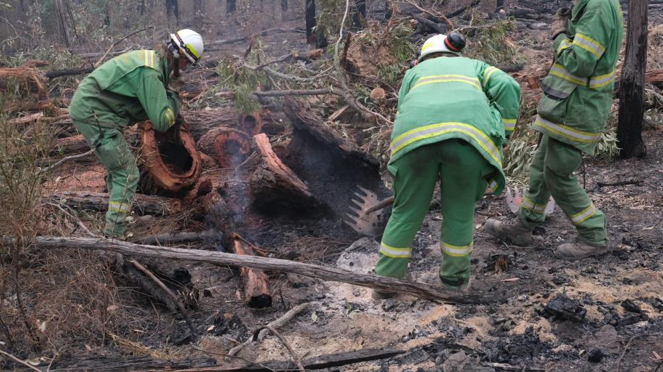

Figure 10: DELWP staff undertaking forest work post 2019–20 bushfires, Bairnsdale area, East Gippsland

Photo credit: Lachlan Spark, Sparklabs

## 6.2 Social impacts

The enjoyment and visitation of Victoria’s forests is expected to decrease as a short-term result of the 2019–20 bushfires, as nearby residents are unable to safely access burnt forests and visual appeal is reduced. This will increase over time as forests regenerate.

7. Cultural and heritage values

## 7.1 Culture and heritage

Forests encompass both landscapes and sites of cultural and historical significance. As a part of cultural landscapes, forests have immense value for Traditional Owners and Aboriginal communities, as well as providing heritage value to all Victorians. In this report, cultural heritage refers to all heritage sites, places and objects.

The threats of fire and related fire-response actions on cultural heritage values can be direct and indirect. Direct threats are those caused by fire and its by-products (smoke, ash and erosion). Indirect threats come from a fire-altered environment (loss of vegetation exacerbating the effects of wind or rainfall in the fire-affected area and resulting in erosion), and human factors (impacts stemming from suppression methods used, emergency stabilisation rehabilitation works, vandalism/looting).

Similar to other forest values, the direct impact on cultural heritage places will be influenced by fire severity. In the case of cultural heritage places, the material properties of the cultural heritage place ‘type’ and the location of the cultural heritage value (relative to the fire-affected area) will also influence the nature of the fire impact.

There are over 1,000 known registered Aboriginal heritage places and over 130 known non-Aboriginal heritage places within the fire-affected areas.[57]

### 7.1.1 Aboriginal heritage places

Aboriginal heritage values[58] are a critical component of Traditional Owner values, this includes both tangible and intangible heritage. This section summarises information about impacts of the 2019–20 fires on Aboriginal heritage, and section 6.4 has further information on Traditional Owner values.[59]

There are three Registered Aboriginal Parties whose Country covers parts of the fire-affected area within RFA boundaries: the Gunaikurnai Land and Waters Aboriginal Corporation (GLaWAC), the Taungurung Land and Waters Council Aboriginal Corporation (TLaWC) and the Gunditj Mirring Traditional Owners Aboriginal Corporation (GMTOAC).[60] These groups have formal roles as land managers in relation to land and Country management, including around fire recovery and assessments in both natural and cultural heritage.

There are also many Traditional Owner groups across the State who do not have formal recognition status under the law (i.e. under the Aboriginal Heritage Act 2006 (Vic), Traditional Owner Settlement Act 2010 (Vic) or Native Title Act 1993 (Cth)). Almost 80 per cent of the fire-affected area is in areas where there has not been formal recognition by the State of Traditional Owner groups.

The Victorian Government recognises that Victorian Traditional Owner knowledge of cultural landscapes is their intellectual property and may only be shared with government following the consent of relevant Traditional Owners.

Desktop assessments of impacts on Aboriginal cultural heritage were undertaken after the 2019–20 bushfires, using spatial databases of registered Aboriginal heritage values (i.e. places recorded on the Victorian Aboriginal Heritage Register). On-ground assessments have not yet been undertaken. Further work is required to understand impacts on Aboriginal heritage places.

### 7.1.2 Non-Aboriginal heritage sites

More than 130 known non-Aboriginal heritage sites exist within the fire extent (for examples see Figure 11 and Figure 12 below). As part of DELWP’s rapid risk assessments undertaken within the East Gippsland, Gippsland and North East RFA regions, 13 site audits have been conducted through the Heritage Victoria Bushfire Recovery Program.

The Bushfire Recovery Program also [identified another 23 heritage places](https://www.heritage.vic.gov.au/about-heritage-in-victoria/heritage-victorias-bushfire-response/bushfire-recovery-heritage-places-under-investigation) that warrant investigation, due to direct damage from the fires, potential damage from rehabilitation works, or the fact that certain types of sites are becoming increasingly rare after the summer fire season..[61]

Of the sites in the East Gippsland and North East RFA regions, 21 sites on the Victorian Heritage Register were directly impacted. Further assessment is required to understand the full extent of the fire impact.

|  |  |
| --- | --- |
| Photo of Gibsons Hut at Mt Pinnibar in the Alpine National Park | Photo of trestle bridges impacted by fire at Cudgewa Creek, High Country Rail Trail |
| a) Gibsons Hut at Mt Pinnibar, Alpine National Park | b) Trestle bridges impacted by fire at Cudgewa Creek, High Country Rail Trail |

Figure 11: Fire damage to two non-Aboriginal heritage sites in the RFA areas

Photo credit: Upper Murray RRAT Report

|  |  |
| --- | --- |
| Photo of Stringers Knob Fire Spotting Tower, prior to the fires | Photo of Damage to Stringers Knob Fire Spotting Tower, January 2020 |
| a) Stringers Knob Fire Spotting Tower, prior to the fires | b) Damage to Stringers Knob Fire Spotting Tower, January 2020 |

Figure 12: Fire damage to a heritage site (non-Aboriginal) in the RFA areas

Photo credit: Chris Anderson of DELWP, Orbost

## 7.2 Traditional Owner values and uses

Victoria’s Traditional Owners have intrinsic cultural and spiritual connection to land, water and other resources through their associations and relationship with Country. Traditional Owners have managed land and water sustainably over thousands of years, and access and connection to Country are important for Aboriginal people’s health and wellbeing. Consistent with the RFAs, the Victorian and Australian governments recognise and seek to enable Traditional Owner self-determination in forest and land management.

The impact of the 2019–20 bushfires on Aboriginal and Traditional Owner values has been significant and the assessment and understanding of this impact by Traditional Owners and the Victorian Government is ongoing.

Victorian Traditional Owners have provided input and proposed recommendations about bushfire impact and sector response to inquiries following the bushfires, including to the Royal Commission into National Natural Disaster Arrangements and the Inquiry into the 2019–20 Victorian Fire Season conducted by the Inspector-General for Emergency Management (IGEM).

Where the Victorian Government has been advised to do so by Traditional Owners, these submissions will be referred to the independent Panel as part of the Major Event Review.

8. Impacts on ecosystem services

Victoria’s forests provide a broad range of uses and ecosystem services that benefit Victoria’s economy and community wellbeing. Impacts on many of these have been outlined in sections above. The impacts of the fires on other important ecosystem services are outlined below. [62]

## 8.1 Water

Water provision may be impacted over the long term following the 2019–20 bushfires.

The North East and Gippsland areas are expected to be the most significantly impacted, due to the area of Ash forest burnt at high severity within these RFA regions, subject to the influence that any future fires have on the forest.[63] The potential reduction in water yield in the fire-affected catchments is expected to be relatively small in comparison to the total water yield of these catchments.

It is possible that the 2019–20 bushfires will lead to some decreased water provision over the long term.

## 8.2 Soil erosion control (soil retention)

Soil retention is expected to decrease as a result of the 2019–20 bushfires. The size of the decrease will depend on the timing and severity of post-fire rainfall, which exacerbates soil erosion. Soil erosion to major waterways is estimated to increase by 130,000–261,000 tonnes over 2020 and 2021 due to the bushfires, if rainfall and other conditions are similar to the historical average.[64].

## 8.3 Carbon sequestration

It is estimated that there will be a net decrease in forest carbon stocks in Victoria of 55 million tonnes in 2019–20, and that some carbon will be reabsorbed through regrowth of the forest over the coming years. This includes emission of 57 million tonnes due to fire and sequestration of 2 million tonnes due to post-fire regrowth in 2019–20. Note that these figures only relate to carbon stock changes relating to carbon dioxide emissions, not methane emissions, and work is underway to assess the total emissions of greenhouse gases from the fires.[65]

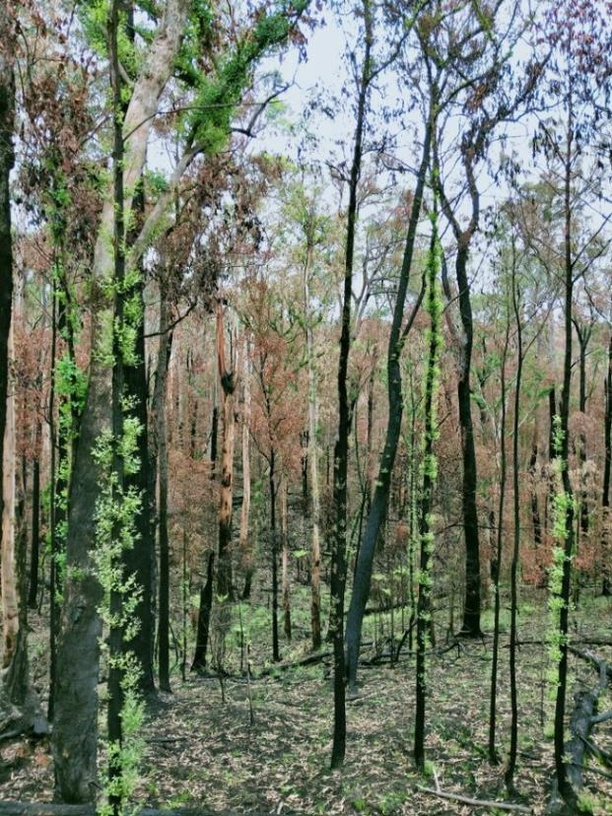**Figure 13: Regrowth in forest burnt in 2019–20 bushfires**

Photo credit: Lili Prins

9. Further reading

## Sources used in the Summary Report

The following list sets out the information available for the Major Event Review as summarised in this Summary Report and to be provided to the Major Event Review Panel:

Australian Government and Victorian Government, [*Scoping Agreement for the Major Event Review to assess the impacts of the 2019-20 bushfires*](https://www.agriculture.gov.au/sites/default/files/documents/major-event-review-scoping-agreement.pdf), September 2020.

Australian Government Bureau of Meteorology and CSIRO, [State of the climate 2020](https://www.csiro.au/en/Showcase/state-of-the-climate), CSIRO website, 2020.

Australian Government Department of Agriculture, Water and the Environment, [Bushfire recovery for wildlife and their habitat](https://www.environment.gov.au/biodiversity/bushfire-recovery), Department of Agriculture, Water and the Environment website, 2020.

Australian Government Department of Agriculture, Water and the Environment, [EPBC Act lists](https://www.environment.gov.au/epbc/about/epbc-act-lists), Department of Agriculture, Water and the Environment website, 2020.

Australian Government Department of Agriculture, Water and the Environment, [Regional Forest Agreements](https://www.agriculture.gov.au/forestry/policies/rfa), Department of Agriculture, Water and the Environment website, 2020.

Australian Government Department of Industry, Science, Energy and Resources, [*Estimating greenhouse gas emissions from bushfires in Australia’s temperate forests: focus on 2019-20.*](https://www.industry.gov.au/data-and-publications/estimating-greenhouse-gas-emissions-from-bushfires-in-australias-temperate-forests-focus-on-2019-20#:~:text=The%20department%20has%20made%20a,carbon%20sink%20in%20the%20coming)

CSIRO, [The 2019-20 bushfires: a CSIRO explainer](https://www.csiro.au/en/Research/Environment/Extreme-Events/Bushfire/preparing-for-climate-change/2019-20-bushfires-explainer), CSIRO website, 2020.

East Gippsland Recovery Committee, [East Gippsland fires 2019–20 economic recovery sub-plan](https://www.eastgippsland.vic.gov.au/Bushfire_information/Recovery_Plans_and_Reports), East Gippsland Shire Council website, n.d.

Victorian Government and [Gunaikurnai Land and Waters Aboriginal Corporation, Gurnaikurnai Settlement Agreement](https://www.forestsandreserves.vic.gov.au/joint-management/agreements-with-traditional-owners), 2010.

Victorian Government and [Gunditj Mirring Traditional Owners Aboriginal Corporation](http://www.gunditjmirring.com/) (GMTOAC), [*Gunditjmara Settlement Agreement*](https://www.forestsandreserves.vic.gov.au/joint-management/agreements-with-traditional-owners),2007.

Inspector-General for Emergency Management, [Inquiry into the 2019–20 Victorian fire season: phase 1 — report into community and sector preparedness for and response to the 2019–20 fire season](https://www.igem.vic.gov.au/fire-season-inquiry/inquiry-reports/inquiry-phase-1), Inspector-General for Emergency Management, Melbourne, 2020.

M Clarke, [Bushfire recovery plan: understanding what needs to be done to ensure the honey bee and pollination industry recovers from the 2019–20 bushfire crisis](https://agrifutures.com.au/product/rebuilding-the-honey-bee-and-pollination-industry/), Australian Honey Bee Industry Council, AgriFutures Australia, July 2020.

Victorian Government and Taungurung Land and Waters Council Aboriginal Corporation and Taungurung Traditional Owner group, [*Taungurung Recognition and Settlement Agreement*](https://www.justice.vic.gov.au/your-rights/native-title/taungurung-recognition-and-settlement-agreemen)*,* 2018.

Tourism Research Australia, [Economic Contribution of Tourism to Victoria 2018–19: estimates published by Tourism Research Australia](https://www.business.vic.gov.au/__data/assets/pdf_file/0008/1855601/Economic-Contribution-of-Tourism-in-Victoria-2018-19.pdf), Tourism and Events Visitor Economy Research Branch, Tourism Research Australia, May 2020.

Victorian Government, [Additional firewood collection area opens in the Upper Murray](https://www.delwp.vic.gov.au/media-centre/media-releases/additional-firewood-collection-area-opens-in-the-upper-murray) [media release], Department of Environment, Land, Water and Planning (DELWP), 13 May 2020.

Victorian Government, Bushfire Recovery Victoria, [Bushfire Recovery Victoria](https://www.vic.gov.au/bushfire-recovery-victoria), 2020.

Victorian Government, Bushfire Recovery Victoria, [Eastern Victorian fires 2019–20 state recovery plan](https://www.vic.gov.au/bushfire-recovery-programs-and-initiatives), Bushfire Recovery Victoria, July 2020.

Victorian Government, [Bushfire-affected Alpine Ash forests given a helping hand](https://www.delwp.vic.gov.au/media-centre/media-releases/bushfire-affected-alpine-ash-forests-given-a-helping-hand) [media release], DELWP, 2 August 2019.

Victorian Government, [Comprehensive, Adequate and Representative (CAR) Reserve for the Regional Forest Agreements (CAR_RESERVE_2020)](https://services.land.vic.gov.au/SpatialDatamart/dataSearchViewMetadata.html?anzlicId=ANZVI0803008634&extractionProviderId=1) [data set], DELWP, 2020.

Victorian Government, DELWP spatial datasets used in GIS analysis (PLM25 + RFA 25 + DELWP FIRE SEVERITY MAPPING).

Victorian Government, [Fire severity map of the major fires in Gippsland and north east Victoria in 2019-20 (version 1.0)](https://discover.data.vic.gov.au/dataset/fire-severity-map-of-the-major-fires-in-gippsland-and-north-east-victoria-in-2019-20-version-1-) [data set], DataVic website, 2020.

Victorian Government, [Flora and Fauna Guarantee Act Threatened List](https://www.environment.vic.gov.au/conserving-threatened-species/threatened-list), DELWP website, 2020.

Victorian Government, [Forest Protection Survey Program](https://www.forestsandreserves.vic.gov.au/forest-management/forest-protection-survey-program), DELWP website, 2020.

Victorian Government, [Forestry](https://djpr.vic.gov.au/forestry), Department of Jobs, Precincts and Regions (DJPR), website, 2020.

Victorian Government, [Greater Glider: Action Statement No. 267](https://www.environment.vic.gov.au/conserving-threatened-species/threatened-species-fact-sheets/greater-glider), DELWP, 2019.

Victorian Government, [Heritage](https://www.heritage.vic.gov.au/) Victoria, DELWP website, 2020.

Victorian Government, [Heritage Victoria’s bushfire response](https://www.heritage.vic.gov.au/about-heritage-in-victoria/heritage-victorias-bushfire-response), DELWP website, 2020.

Victorian Government, [Plantations](https://djpr.vic.gov.au/forestry/plantations), DJPR website, 2020.

Victorian Government, [Public Land Management (PLM25)](https://discover.data.vic.gov.au/dataset/public-land-management-plm25) [data set], DataVic website, 2020.

Victorian Government, [Victoria’s bushfire emergency: biodiversity response and recovery](https://www.wildlife.vic.gov.au/home/biodiversity-bushfire-response-and-recovery), DELWP website, 2020.

Victorian Government, Victoria’s bushfire emergency: biodiversity response and recovery — Preliminary report (version one), DELWP, East Melbourne.

Victorian Government, [Victoria’s bushfire emergency: biodiversity response and recovery](https://www.wildlife.vic.gov.au/home/biodiversity-bushfire-response-and-recovery), version 2, DELWP, Melbourne, August 2020.

Victorian Government, [Victorian forestry plan](https://djpr.vic.gov.au/forestry/forestry-plan), DJPR website, 2020.

Victorian Government, [Victorian Government response to the Inspector-General for Emergency Management ‘Review of 10 years of reform in Victoria’s emergency management sector’, and; ‘Inquiry into the 2019–20 Victorian fire season: phase 1 report’](https://www.emv.vic.gov.au/publications/gov-response-igem-review-10years-reform-and-2019-20-inquiry-phase1), October 2020.

Victorian Government, [Victorian Regional Forest Agreements](https://www.delwp.vic.gov.au/futureforests/what-were-doing/victorian-regional-forest-agreements), DELWP website, 2020.

## Additional reading

Other relevant sources informing the Major Event Review are listed below:

Brockington, J, N Finegan & P Rozen, Independent Review of Timber Harvesting Regulation: Panel Report to the Secretary of the Department of Environment, Land, Water and Planning, 24 October 2018, Independent Review of Timber Harvesting Regulation, East Melbourne, 2018.

Commissioner for Environmental Sustainability, [Victoria’s State of the Forests report 2018](https://www.forestsandreserves.vic.gov.au/forest-management/state-of-the-forests-report), Commissioner for Environmental Sustainability, Victoria, 2018.

[Fire Season Inquiry - phase 1 submissions](https://www.igem.vic.gov.au/fire-season-inquiry/community-participation/fire-season-inquiry-phase-1-submissions), Inquiry into the 2019–20 Victorian Fire Season, IGEM website, 2020.

Parliament of Victoria, [Inquiry into Ecosystem Decline in Victoria](https://www.parliament.vic.gov.au/995-epc-lc/inquiry-into-ecosystem-decline-in-victoria), Parliament of Victoria website, n.d.

Royal Commission into National Natural Disaster Arrangements, [Royal Commission into National Natural Disaster Arrangements report](https://naturaldisaster.royalcommission.gov.au/publications), Royal Commission into National Natural Disaster Arrangements, 2020.

[Submissions](https://naturaldisaster.royalcommission.gov.au/submissions), Royal Commission into National Natural Disaster Arrangements website, 2020.

Victorian Government, [Airlift operation to bring forest back to life after bushfire](https://www.premier.vic.gov.au/airlift-operation-bring-forest-back-life-after-bushfire) [media release], Victorian Government, 2 October 2020.

Victorian Government, [Code of practice for bushfire management on public land](https://www.ffm.vic.gov.au/who-we-are/code-of-practice), Department of Sustainability and Environment, Melbourne, 2012.

Victorian Government, [Code of practice for timber production 2014](https://www.forestsandreserves.vic.gov.au/__data/assets/pdf_file/0016/29311/Code-of-Practice-for-Timber-Production-2014.pdf), Department of Environment and Primary Industries, 2014.

Victorian Government, ‘[Reseeding Giants - reseeding the Ash forests](https://www.youtube.com/watch?v=BEfCE22q8aU&list=UUzkDUC-IEBl-KQeZLCxgBqw)’ [video], DELWP, YouTube, 5 October 2020.

Victorian Government, [Overview of Victoria’s Forest Management System](https://www.delwp.vic.gov.au/__data/assets/pdf_file/0027/458640/Forest-Management-System-Overview-2019-1.pdf), DELWP, 2019.

Victorian Government, [Response to the Independent Review of Timber Harvesting Regulation](https://www.forestsandreserves.vic.gov.au/__data/assets/pdf_file/0022/414166/DELWP-Response-to-the-Independent-Review-of-Timber-Harvesting-Regulation.pdf), DELWP, Melbourne, 2019.

Victorian Government, [Safer together](https://www.safertogether.vic.gov.au/), Safer Together website, 2020.

1. Inspector-General for Emergency Management, [Inquiry into the 2019–20 Victorian fire season: phase 1 — report into community and sector preparedness for and response to the 2019–20 fire season](https://www.igem.vic.gov.au/fire-season-inquiry/inquiry-reports/inquiry-phase-1), IGEM, Melbourne, 2020.
2. Victorian Government, DELWP, [Victorian Regional Forest Agreements](https://www.delwp.vic.gov.au/futureforests/what-were-doing/victorian-regional-forest-agreements), DELWP website, 2020; Australian Government, Department of Agriculture, Water and the Environment, [Regional Forest Agreements](https://www.agriculture.gov.au/forestry/policies/rfa), Department of Agriculture, Water and the Environment website, 2020.
3. The Commonwealth of Australia and The State of Victoria, [*Scoping Agreement for the Major Event Review to assess the impacts of the 2019-20 bushfires*](https://www.agriculture.gov.au/sites/default/files/documents/major-event-review-scoping-agreement.pdf), September 2020.
4. Victorian Government, DELWP, [*Victorian Regional Forest Agreements*](https://www.delwp.vic.gov.au/futureforests/what-were-doing/victorian-regional-forest-agreements), DELWP website, 2020; Australian Government, Department of Agriculture, Water and the Environment, [*Regional Forest Agreements*](https://www.agriculture.gov.au/forestry/policies/rfa), Department of Agriculture, Water and the Environment website, 2020.
5. The Commonwealth of Australia and The State of Victoria, [*Scoping Agreement for the Major Event Review to assess the impacts of the 2019-20 bushfires*](https://www.agriculture.gov.au/sites/default/files/documents/major-event-review-scoping-agreement.pdf), September 2020, section 9
6. The Scoping Agreement established by the Victorian and Australian governments provides that the Victorian and Australian governments will compile the following information for RFA regions, where available during the course of the Review:

   * supporting information at the gross level about forested areas burnt, including fire extent and severity, as well as any other relevant assessments, analysis or data;
   * assessments of fire impacts on the condition of species, particularly listed species and ecological communities, and other MNES;
   * assessment of the impacts on the CAR reserve system;
   * assessments of the impacts of bushfires on areas (native forest and plantation) available for harvest;
   * assessment of the impacts on Forest Industries and the social and economic impacts of the bushfires;
   * information provided by Traditional Owners for the purposes of the Review; and
   * any other relevant assessments of the direct and indirect impacts of the bushfires.

   (The Commonwealth of Australia and The State of Victoria, [Scoping Agreement for the Major Event Review to assess the impacts of the 2019-20 bushfires](https://www.agriculture.gov.au/sites/default/files/documents/major-event-review-scoping-agreement.pdf), September 2020, section 9.)
7. Victorian Government, DELWP, [Fire severity map of the major fires in Gippsland and north east Victoria in 2019/20 (version 1.0)](https://discover.data.vic.gov.au/dataset/fire-severity-map-of-the-major-fires-in-gippsland-and-north-east-victoria-in-2019-20-version-1-) [data set], DataVic website, 2020.
8. Victorian Government, DELWP, [Victoria’s bushfire emergency: biodiversity response and recovery](https://www.wildlife.vic.gov.au/home/biodiversity-bushfire-response-and-recovery), version 2.; Inspector-General for Emergency Management, [Inquiry into the 2019–20 Victorian fire season: phase 1 — report into community and sector preparedness for and response to the 2019–20 fire season](https://www.igem.vic.gov.au/fire-season-inquiry/inquiry-reports/inquiry-phase-1), IGEM, Melbourne, 2020.
9. Victorian Government, DELWP data, unpublished.
10. Victorian Government, DELWP data, unpublished.
11. Victorian Government, DELWP data (RFA Regions - RFA25 [data set], [*Fire severity map of the major fires in Gippsland and north east Victoria in 2019-20 (version 1.0)*](https://discover.data.vic.gov.au/dataset/fire-severity-map-of-the-major-fires-in-gippsland-and-north-east-victoria-in-2019-20-version-1-) [data set], DataVic website, 2020, FIRE HISTORY [dataset], Forestcover 2018 [dataset, unpublished]
12. Victorian Government, DELWP, [Fire severity map of the major fires in Gippsland and north east Victoria in 2019-20 (version 1.0)](https://discover.data.vic.gov.au/dataset/fire-severity-map-of-the-major-fires-in-gippsland-and-north-east-victoria-in-2019-20-version-1-) [data set], DataVic website, 2020.
13. Victorian Government, DELWP, [Fire severity map of the major fires in Gippsland and north east Victoria in 2019/20 (version 1.0)](https://discover.data.vic.gov.au/dataset/fire-severity-map-of-the-major-fires-in-gippsland-and-north-east-victoria-in-2019-20-version-1-), [data set], DataVic website, 2020.
14. Areas classified as Class 0, Class 1 and Class 2 are no data, non-woody and not burnt respectively within the fire extent that overlap with the Victorian Forest Monitoring Program forest extent.
15. Reseeding of Alpine Ash to initiate forest regeneration was undertaken in the immediate months after the 2019–20 bushfires to support biodiversity recovery. DELWP is working with the University of Melbourne to assess the benefits of variable sowing density on Alpine Ash ecosystem fire resilience, a project which is due for completion in 2022; DELWP, Victoria’s bushfire emergency: biodiversity response and recovery — Preliminary report (version one), DELWP, East Melbourne, p. 30.
16. Victorian Government, DELWP, [Victoria’s bushfire emergency: biodiversity response and recovery](https://www.wildlife.vic.gov.au/home/biodiversity-bushfire-response-and-recovery), version 2, p. 51.
17. Victorian Government, [Airlift operation to bring forest back to life after bushfire](https://www.premier.vic.gov.au/airlift-operation-bring-forest-back-life-after-bushfire) [media release], Victorian Government, 2 October 2020.
18. Forest area derived from the National Forest Inventory Forests of Australia (2018) spatial dataset; Victorian Government, DELWP, [*Comprehensive, Adequate and Representative (CAR) Reserve for the Regional Forest Agreements (CAR_RESERVE_2020)*](https://services.land.vic.gov.au/SpatialDatamart/dataSearchViewMetadata.html?anzlicId=ANZVI0803008634&extractionProviderId=1) [data set], 2020.
19. Australian Government, National Indicative Aggregated Fire Extent Dataset (v20200428), Department of Agriculture, Water and the Environment, current to 28 April 2020; Forest area derived from the National Forest Inventory Forests of Australia (2018) spatial dataset; refer to the National Indicative Aggregated Fire Extent Dataset metadata statement for information on the purpose, lineage, known issues and data limitations of the fire extent dataset.
20. ‘Prescriptions’ in this table relate to the modelled exclusion and rainforest prescriptions outlined in the Management Standards and Procedures for timber harvesting operations in Victoria’s state forests. The Immediate Protection Area figures refer only to the new, additional areas identified in the Greater Glider Action Statement No. 267. Immediate Protection Area are not part of the CAR reserve system, but they are considered related components for the purposes of this report only.
21. Victorian Government, DELWP, [Victoria’s bushfire emergency: biodiversity response and recovery](https://www.wildlife.vic.gov.au/home/biodiversity-bushfire-response-and-recovery), version 2.
22. Victorian Government, DELWP, [Greater Glider: Action Statement No. 267](https://www.environment.vic.gov.au/conserving-threatened-species/threatened-species-fact-sheets/greater-glider), DELWP, 2019.
23. Victorian Government, DELWP, [Comprehensive, Adequate and Representative (CAR) Reserve for the Regional Forest Agreements (CAR_RESERVE_2020)](https://services.land.vic.gov.au/SpatialDatamart/dataSearchViewMetadata.html?anzlicId=ANZVI0803008634&extractionProviderId=1) [data set], 2020; Victorian Government, DELWP, [Fire severity map of the major fires in Gippsland and north east Victoria in 2019/20 (version 1.0)](https://discover.data.vic.gov.au/dataset/fire-severity-map-of-the-major-fires-in-gippsland-and-north-east-victoria-in-2019-20-version-1-) [data set].
24. Victorian Government, DELWP, [Comprehensive, Adequate and Representative (CAR) Reserve for the Regional Forest Agreements (CAR_RESERVE_2020)](https://services.land.vic.gov.au/SpatialDatamart/dataSearchViewMetadata.html?anzlicId=ANZVI0803008634&extractionProviderId=1) [data set].
25. Victorian Government, DELWP, [Fire severity map of the major fires in Gippsland and north east Victoria in 2019/20 (version 1.0)](https://discover.data.vic.gov.au/dataset/fire-severity-map-of-the-major-fires-in-gippsland-and-north-east-victoria-in-2019-20-version-1-) [data set], DataVic website, 2020.
26. J Schirmer, M Mylek, A Magnusson, B Yabsley and J Morison, [Socio-economic impacts of the forest industry Victoria (exc. the Green Triangle)](https://www.fwpa.com.au/resources/reports/other/1631-socio-economic-impacts-of-the-forest-industry-victoria-exc-the-green-triangle.html), Forest & Wood Products Australia, 2018.
27. East Gippsland Recovery Committee, [East Gippsland fires 2019–20 economic recovery sub-plan](https://www.eastgippsland.vic.gov.au/Bushfire_information/Recovery_Plans_and_Reports), East Gippsland Shire Council website, n.d.
28. IGEM, [Inquiry into the 2019–20 Victorian fire season: phase 1 — report into community and sector preparedness for and response to the 2019–20 fire season](https://www.igem.vic.gov.au/fire-season-inquiry/inquiry-reports/inquiry-phase-1).
29. Victorian Government, [Forestry](https://djpr.vic.gov.au/forestry), DJPR website, 2020.
30. Victorian Government, [Bushfire affected timber to be salvaged for the future](https://www.premier.vic.gov.au/bushfire-affected-timber-be-salvaged-future) [media release], Victorian Government, 2 December 2020.
31. For further information about environmental standards for planning and conducting commercial timber harvesting operations, see the Code of practice for timber production 2014. 
32. D+ Operable Inventory is the volume of D grade sawlog and better that is available for harvest within VicForests’ Strategic Wood Supply Model at the commencement of the planning period, in this case, 1 July 2019. This modelling factors in constraints including, but not limited to, forest management zoning, modelled Code of Practice exclusions, catchment area limits, age limits and Ash forest green patch exclusions (post-fire).
33. Figures in this table have been rounded down to the nearest whole integer.
34. Victorian Government, DELWP data, unpublished.
35. Victorian Government, DELWP data, unpublished.
36. M Clarke, [Bushfire recovery plan: understanding what needs to be done to ensure the honey bee and pollination industry recovers from the 2019–20 bushfire crisis](https://agrifutures.com.au/product/rebuilding-the-honey-bee-and-pollination-industry/), Australian Honey Bee Industry Council, AgriFutures Australia, July 2020, p. vi.
37.
38.
39. Victorian Government, DELWP, [Victoria’s bushfire emergency: biodiversity response and recovery](https://www.wildlife.vic.gov.au/home/biodiversity-bushfire-response-and-recovery), version 2.
40. Victorian Government, DELWP, [Victoria’s bushfire emergency: biodiversity response and recovery](https://www.wildlife.vic.gov.au/home/biodiversity-bushfire-response-and-recovery), version 2, p. 13. There is currently no fire severity data available for Budj Bim Cultural Landscape.
41. IGEM, [Inquiry into the 2019–20 Victorian fire season: phase 1 — report into community and sector preparedness for and response to the 2019–20 fire season](https://www.igem.vic.gov.au/fire-season-inquiry/inquiry-reports/inquiry-phase-1).
42. Australian Government, [Bushfire recovery for wildlife and their habitat](https://www.environment.gov.au/biodiversity/bushfire-recovery), Department of Agriculture, Water and the Environment website, 2020.
43. The number of priority animals has been adjusted to account for the separate report on priority invertebrates requiring urgent management intervention. Five invertebrate species included in the priority animals report are not included in the priority animal numbers in this table, to avoid duplication with the priority invertebrate numbers listed separately. (Australian Government, [Bushfire recovery for wildlife and their habitat](https://www.environment.gov.au/biodiversity/bushfire-recovery), Department of Agriculture, Water and the Environment website, 2020)
44. The Expert Panel report on ecological communities combines some state listed communities (e.g. four Victorian listed rainforests are combined with a NSW rainforest into a single community), so the numbers will not match the state lists, but they likely contain the same ecological communities.
45. The number of EPBC Act listed ecological communities has been updated to reflect a new listing since the Expert Panel released their [report](http://www.environment.gov.au/system/files/pages/cae21f42-9328-45ee-b558-a79628aaf68f/files/tecs-threats-and-actions.pdf). The [River-flat eucalypt forest on coastal floodplains of southern NSW and eastern Victoria](http://www.environment.gov.au/cgi-bin/sprat/public/publicshowcommunity.pl?id=154) was included as in the Panel’s report ‘under assessment, but has subsequently been listed under the EPBC Act.
46. Victorian Government, DELWP, [*Victoria’s bushfire emergency: biodiversity response and recovery*](https://www.wildlife.vic.gov.au/home/biodiversity-bushfire-response-and-recovery), version 2.
47. Bushfire impacts have changed the biodiversity value at the landscape level and must be considered in terms of state-wide conservation, across the different RFAs. See further information at DELWP, [*Victoria’s bushfire emergency: biodiversity response and recovery*](https://www.wildlife.vic.gov.au/home/biodiversity-bushfire-response-and-recovery), version 2.
48. Victorian Government, DELWP, [Victoria’s bushfire emergency: biodiversity response and recovery](https://www.wildlife.vic.gov.au/home/biodiversity-bushfire-response-and-recovery), version 2.
49. Australian Government Department of Agriculture, Water and the Environment, [EPBC Act lists](https://www.environment.gov.au/epbc/about/epbc-act-lists), Department of Agriculture, Water and the Environment website, 2020.
50. Victorian Government, DELWP, [Flora and Fauna Guarantee Act Threatened List](https://www.environment.vic.gov.au/conserving-threatened-species/threatened-list), DELWP website.
51. Victorian Government, DELWP, [Victoria’s bushfire emergency: biodiversity response and recovery](https://www.wildlife.vic.gov.au/home/biodiversity-bushfire-response-and-recovery), version 2.
52. Content derived from Australian Government Department of Agriculture, Water and the Environment, [Wildlife and threatened species bushfire recovery Expert Panel](https://www.environment.gov.au/biodiversity/bushfire-recovery/expert-panel), Department of Agriculture, Water and the Environment website.
53. Content derived from Australian Government Department of Agriculture, Water and the Environment, [Wildlife and threatened species bushfire recovery Expert Panel](https://www.environment.gov.au/biodiversity/bushfire-recovery/expert-panel), Department of Agriculture, Water and the Environment website. This listing is not included in [Victoria’s bushfire emergency: biodiversity response and recovery](https://www.wildlife.vic.gov.au/home/biodiversity-bushfire-response-and-recovery), version 2, as this community was not listed under the EPBC Act until 15 December 2020.
54. Victorian Government, DELWP, [Victoria’s bushfire emergency: biodiversity response and recovery](https://www.wildlife.vic.gov.au/home/biodiversity-bushfire-response-and-recovery), version 2.
55. Victorian Government, Recweb Current Closure statistics, DELWP data, unpublished
56. Victorian Government, Bushfire Recovery Victoria, [Eastern Victorian fires 2019–20 state recovery plan](https://www.vic.gov.au/bushfire-recovery-programs-and-initiatives), Bushfire Recovery Victoria, July 2020.
57. Victorian Government, Bushfire Recovery Victoria, [Eastern Victorian fires 2019–20 state recovery plan](https://www.vic.gov.au/bushfire-recovery-programs-and-initiatives), Bushfire Recovery Victoria, July 2020; Victorian Government, [Heritage Victoria’s bushfire response](https://www.heritage.vic.gov.au/about-heritage-in-victoria/heritage-victorias-bushfire-response), DELWP website, 2020.
58. Aboriginal heritage values means ‘Aboriginal cultural heritage, and Aboriginal intangible heritage’ as defined under the Aboriginal Heritage Act 2006 (Vic).
59. Traditional Owner values include Aboriginal heritage and Traditional Owner identified living natural and biocultural uses and values. Victorian RFAs commit to the management and protection of Aboriginal heritage including the maintenance of Traditional Owner identified living natural and biocultural uses and values.
60.
61. Victorian Government, [Heritage Victoria’s bushfire response](https://www.heritage.vic.gov.au/about-heritage-in-victoria/heritage-victorias-bushfire-response), DELWP website, 2020.
62. Ecosystem services are the benefits provided by ecosystems, and the contributions that forest and ecosystem values make to human wellbeing. These include natural ecosystem functions that provide life-giving benefits (like clean air and water, climate regulation and carbon storage), as well as environmental values and services of preserving ecosystems and habitats of plants and animals.
63. Victorian Government, DELWP data, unpublished
64. Victorian Government, DELWP data, unpublished.
65. DELWP analysis of emissions data from Australian Government, Department of Industry, Science, Energy and Resources, [*Estimating greenhouse gas emissions from bushfires in Australia’s temperate forests: focus on 2019-20,* Department of Industry, Science, Energy and Resources, 2020*.*](https://www.industry.gov.au/data-and-publications/estimating-greenhouse-gas-emissions-from-bushfires-in-australias-temperate-forests-focus-on-2019-20#:~:text=The%20department%20has%20made%20a,carbon%20sink%20in%20the%20coming)