Voluntary Committees of Management Newsletter
Edition 4

Consulting Committees

Welcome to the fourth edition of the Voluntary Committee of Management newsletter. In our previous edition we asked for your input on how committees consult with their community. Thank you to all those who took the time to respond – more information on the outcome of this survey can be found below.

Also in, are the results of DSE’s survey on Committee of Management members, motivation for volunteering and satisfaction levels. They provide some interesting insights and suggestions for how the important work of committees can be supported.

We also showcase the flood recovery work of Blackwood Crown Reserves CoM.

Tony Edgar
General Manager, Regional Services

Fact Sheet: Voluntary Committees of Management Community Consultation

Have you ever thought about consulting with your community? DSE conducted a survey of its Committees of Management (CoM) to find out how they interact with their communities. Thank you to all those voluntary committee of management members who filled in the survey for us. Using this feedback we have developed a Community Consultation Fact Sheet that will soon be available on the DSE website.

The fact sheet provides information on when a CoM should consult with its community, highlights some benefits of effective consultation and provides tips on communicating effectively. It also includes a case study and a link to an engagement kit.

Committee survey reveals volunteers love to serve the community

Serving the community and caring for a reserve and its assets were the top two reasons why people volunteered on committees of management. These findings were part of a committee of management survey completed in November 2011 in which more than 1,708 committee members took part.

The survey also provided valuable insights into the commitment of committee members. Most members were aged over 50, with the average length of service on a committee just over 13 years, with 10% of members on a committee for more than 30 years. The survey also found there were twice as many males as females on local committees and members devoted about eight hours per month to the committee.

The survey found that most members were reasonably satisfied with their experiences of being on a committee. However, the most common challenge facing committees over the next 5-10 years was reported to be low rates of participation. Another significant challenge was maintaining the reserve, either by volunteers themselves or through other funding sources. See Figure 1 for a full summary of the challenges identified.

DSE thanks those committee members who responded for sharing their views on all aspects of committee volunteering. DSE is now exploring potential responses to the findings. More information about the project will be available in the Committee of Management section of the DSE website.

Figure 1 Suggestions for increased support of local committees of management (source: DSE 2012).

More than a century and a half of service from local volunteers

A Gippsland hall’s committee of management was recognised this year after volunteers put in more than 156 years of service.

The Jeeralang North Hall Committee of Management formed in 1954 (Jeeralang is roughly south of Traralgon). Since then Zelma Mildenhall, Robert Mildenhall, Hans Dortmans, Berni Mele and Judith Mele have collectively racked up over 156 years of service.

Zelma Mildenhall spent 46 years on the committee as secretary and her husband Robert Mildenhall was also a committee member for 37 years. Hans Dortman was appointed in 1967, took a break in 1986 and renominated in 1989. He is still a serving committee member with a total of 41 years service. Berni Mele has been on the committee for 25 years. In 2004 his wife Judith Mele joined in on the committee and has served seven years.

These volunteers and the service they have given were recognised earlier this year by the Department of Sustainability and Environment.

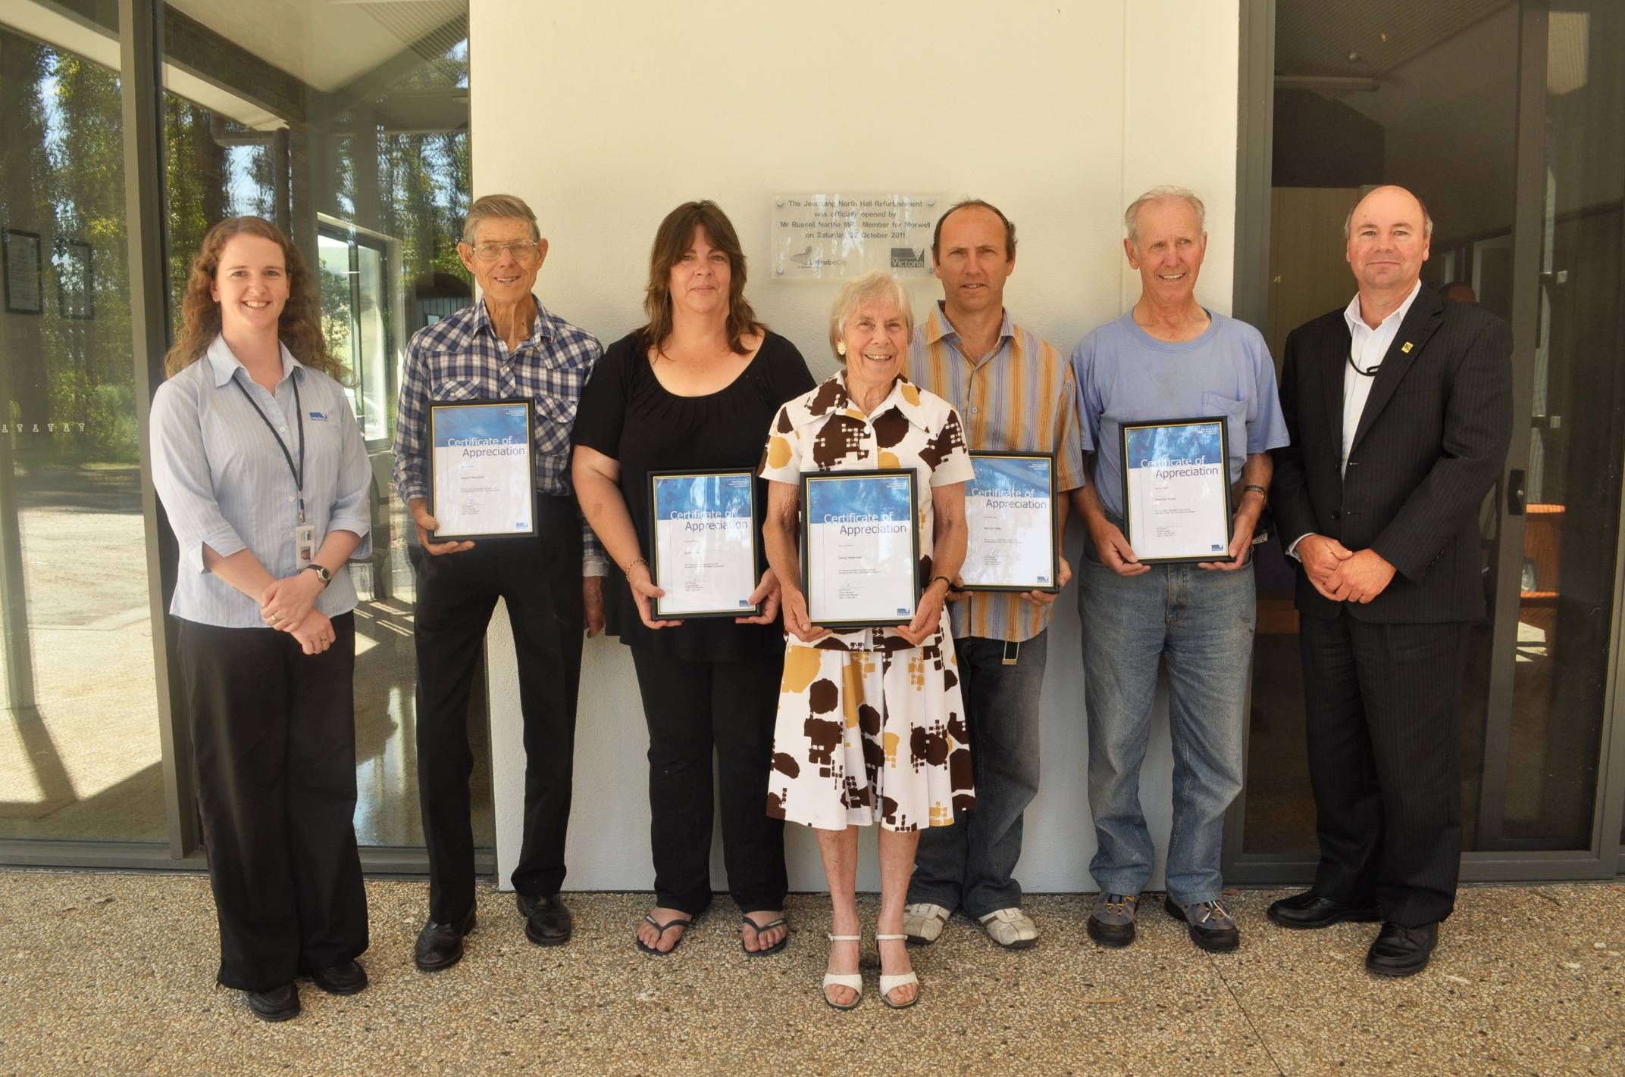

Flood Recovery for Community Infrastructure Fund
Blackwood Crown Reserves Committee of Management.

The beautiful tree lined river and picnic grounds of Blackwood Reserves are open after the completion of flood recovery works by the Blackwood Crown Reserves Committee of Management. The reserves, located north of Bacchus Marsh, were destroyed during the 2011 January and February floods. The recovery works included replacing the picnic facilities, removing trees that had fallen across the Lerderderg River and the erosion of tracks.

The Blackwood Reserves Committee of Management manages numerous reserves within the picturesque township of Blackwood. One of the reserves managed is the Mineral Springs and Tourist Camp Reserve where the Blackwood and Soda mineral springs are located. This is part of the popular mineral springs region of central Victoria. In addition the reserve accommodates the Blackwood Caravan Park.

During the recovery works some issues with access and machinery threatened to derail the project. DSE officers worked with the committee and the contractor to reach a successful outcome in the clean up of the Lerderderg River. The result is a beautiful picnic spot with the backdrop of Lerderderg State Park – a perfect spot to enjoy a weekend.

Photograph 1 – shows a large tree blocking water flow across the creek.

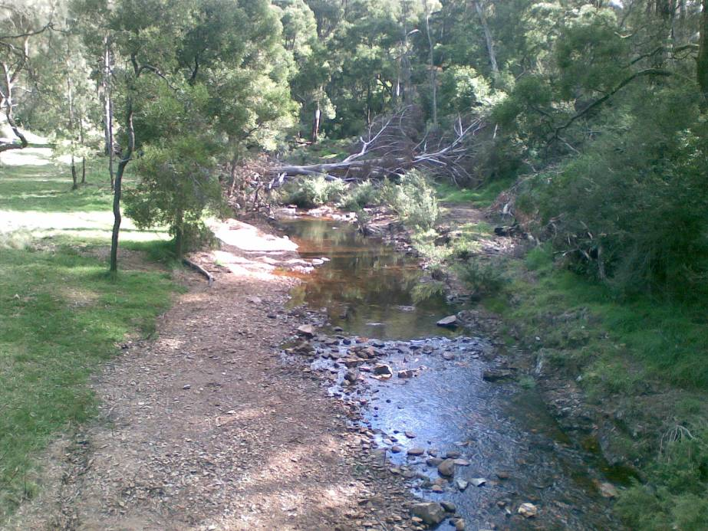

Photo 2 – is the same view (as photo 1) after the removal works have been completed.

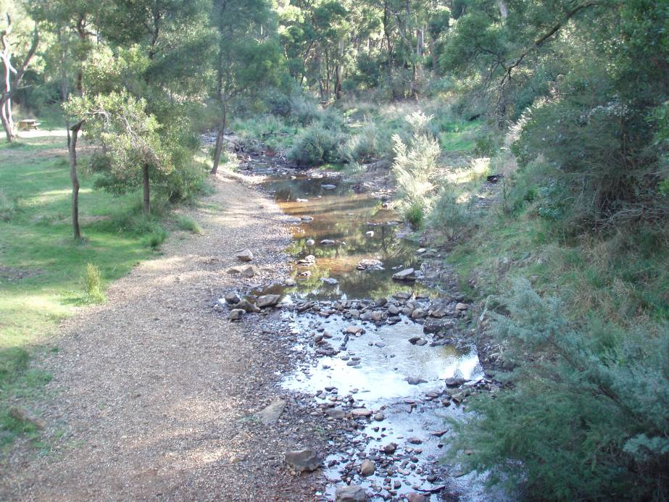

Do you manage a reserve in a fire prone are?

Ever thought about using plants that could protect buildings from bushfires?

Well apparently you can. A new publication called Landscaping for Bushfire – Garden Design and Plant Selection includes information on how fire behaves and how you can design and landscape to help protect buildings from bushfires.

The tool, designed by CFA this year, may help committees of management understand vegetation management a little better and help guide their landscaping decisions. The four design principles for reducing radiant heat, preventing flame contact and minimising ember attack on buildings are:

- Create defendable space;
- Remove flammable objects from around the house;
- Break up fuel continuity;
- Carefully select, locate and maintain trees.

The tool also has a plant selection key so that committees can determine what to plant based on the flammability rating of the plant. CFA warns against relying on lists of fire retardant plant species as many are out-of-date and advocate plants that won’t protect your building or are environmental weeds.

Landscaping is only part of an holistic approach that should also consider building construction and maintenance, preparing a Bushfire Survival Plan, water supply and road access.

For more information visit http://www.cfa.vic.gov.au/firesafety/bushfire/documents/landscaping_for_bushfire.pdf

Does your reserve support guided walking tours, fitness classes, rock climbing, surfing or canoeing?

These types of activities conducted on Crown land and waters require a licence. The 2012/13 tour operator licence template and application form are now available at www.dse.vic.gov.au/licencereform. These documents are to assist committees of management who licence tour operators under Part 3A of the Crown Land (Reserves) Act 1978.

You may notice a change from last year – the form and template don’t refer to GST. This reflects advice provided to Victorian and NSW government agencies. So if your committee licences tour operators please be aware of this change and refer to the link provided above for further information.

Is your committee adequately insured?

The Victorian Government currently provides cover for appointed committees of management. However committees are encouraged to assess if further insurance is required.

So what’s covered….?
Committees of management appointed under the Crown Land (Reserves) Act 1978 are insured under the DSE Public and Products Liability policy. DSE even covers claims that fall below the deductable. Under this arrangement committees are required to notify DSE as soon as they become aware of a claim or an incident likely to result in a claim and provide all relevant information. The claim is then managed by DSE including the cost of legal representation.

DSE also has in place a Group Accident Policy which covers volunteers aged 5 to 100 years including volunteers arranged by a committee of management. There needs to be a sufficient connection between the committee (or DSE) and the volunteer activity and records kept detailing who volunteered, when and the nature of the activity.

Committees of management are now also insured under the Professional Indemnity Policy. Policy wording is available at http://www.vmia.vic.gov.au/

… and what’s not?
DSE does not provide insurance cover for buildings on Crown land managed by committees of management. DSE recommends committees arrange insurance cover for assets (buildings and contents) via the private insurance market.

If you would like further information please contact your local DSE office.

