Voluntary Committees of Management Newsletter
Edition 9 - June 2016

Foreword
Welcome to a special edition of the Voluntary Committees of Management Newsletter. This edition is dedicated to celebrating those committees that received awards for their outstanding contribution to the management of Crown land reserves.
Last year’s inaugural Committee of Management Volunteer Week Awards provided a fantastic opportunity to showcase and recognise some of our committees and their members. Congratulations to the winners and thank you to everyone who took the time to nominate.
On behalf of the Department of Environment, Land, Water and Planning, I would also like to thank all our committee members for your continued commitment to managing Victoria’s precious public land.

We rely on your dedication and passion of the local community to keep our outdoor spaces safe, clean, accessible and looking good.
This newsletter is for voluntary committees of management state wide. We love seeing your initiatives and achievements. This is your newsletter, and I encourage you to share your stories and achievements with committees across the state.
Please send comments, suggestions or articles to voluntary.committees@delwp.vic.gov.au
Chris Padovani
Acting Regional Director, Port Phillip Region

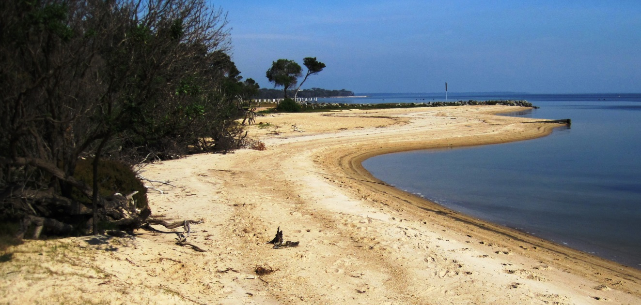
Loch Sport Foreshore CoM manages part of the foreshore in beautiful Gippsland, where groyne replacement works have started.
Hume: https://www.facebook.com/DELWPHume Port Phillip: https://www.facebook.com/DELWPPortPhillip Gippsland: https://www.facebook.com/DELWPGippsland Grampians: https://www.facebook.com/DELWPGrampians Loddon Mallee: https://www.facebook.com/DELWPLoddonMallee
Barwon South West: https://www.facebook.com/DELWPBarwonSouthWest

The Walhalla Board of Management, Gippsland

The Walhalla Board of Management manages several Crown land reserves within the historic township of Walhalla.
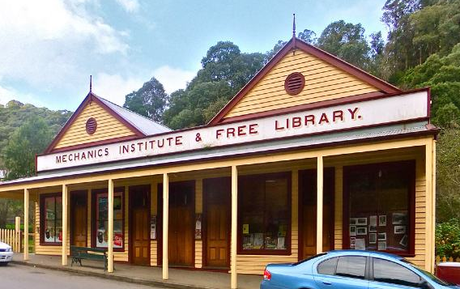 Walhalla Mechanics Institute

These include the following tourist draw-cards; the Walhalla Long Tunnel Extended Mine, the Chinese Gardens, the heritage listed buildings of the Walhalla Post Office, and the Mechanics Institute.
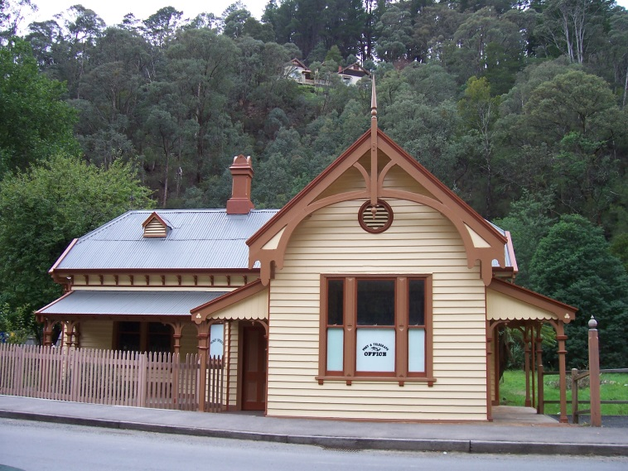
Walhalla Post Office

Congratulations to John Buchecker of the Walhalla Board of Management for receiving an award at the inaugural Committee of Management Volunteer Week Awards. John has been a member of the Board for six years and during this time he has managed the Old Post Office, contributed to applications for grants to maintain and conserve the building, and has created and coordinated a team of volunteers to open the building to the public.

Is your CoM on Facebook?
DELWP’s communication team would love to have a link to your Facebook page. We can assist you to promote the fantastic work you are doing and find potential new CoM members. Please email your Facebook page to voluntary.committees@delwp.vic.gov.au

Heidelberg Historical Society, Port Phillip

Nick Gammon has received an award for his information technology contribution to the Heidelberg Historical Society. He has designed and implemented a large suite of programs covering volunteer rosters, resource access, and development and management of 17 databases. His work has increased membership, increased publicity for the society, encouraged participation by members, and provided accurate statistics that will be relevant to future grant applications.
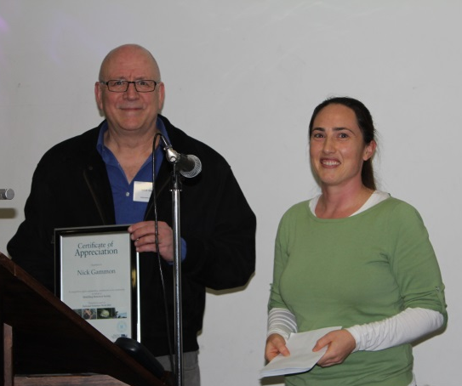
Nick Gammon of Heidelberg Historical Society and Victoria Purdue

Victoria Purdue, Program Manager Regional Planning and Approvals Port Phillip Region presented the award to Nick for his laudable contribution to this voluntary committee of management.

Celebrating our voluntary Committees of
Management in the Loddon Mallee Region
DELWP Loddon Mallee celebrated National Volunteer Week by awarding certificates of appreciation to 38 volunteers.

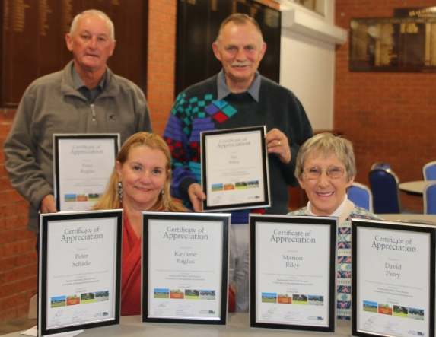
Rushworth Public Park Reserve Committee of Management

The awards recognise the volunteers’ efforts and achievements in managing and caring for much-loved reserves and community facilities.

Echuca Historical Society Incorporated

Popular local spots in the region including the Kyneton Racecourse, Echuca Historical Society Museum, the former Castlemaine Courthouse, Rushworth Public Park Reserve and the Old Fryerstown School are managed by volunteer CoMs, responsible for the ongoing maintenance and enhancement of the land.

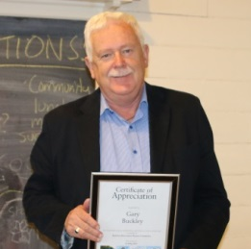
Gary Buckley of Kyneton Moora Racecourse Recreation Racecourse Reserve CoM Reserve

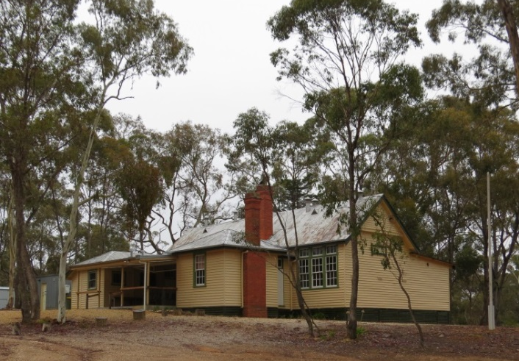
Fryerstown Community Reserve
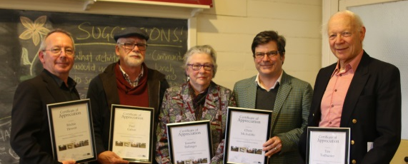
Fryerstown Community Reserve Committee
DELWP Loddon Mallee Regional Manager, Adam Melis said “We absolutely rely on the generosity and passion of the local community to keep our outdoor spaces safe, clean, accessible and looking good.
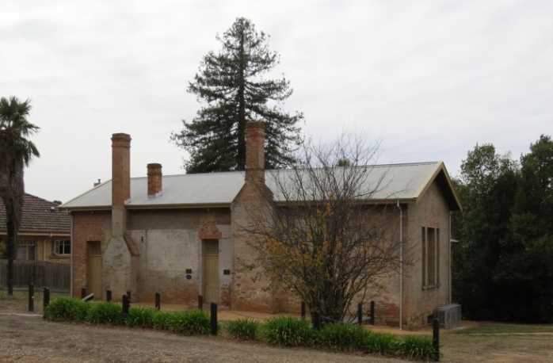
Castlemaine Historical Society 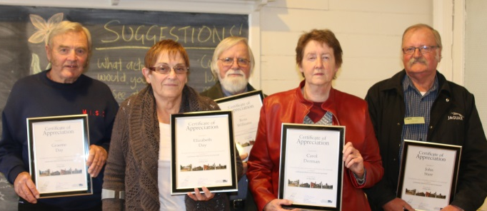Castlemaine Historical Society Incorporated
Committee of Management volunteers are the unsung custodians of our great outdoors, lending their hands to help manage Victoria’s public land estate.”
Fawcett Mechanics Institute – Fawcett Hall on Spring Creek, Hume
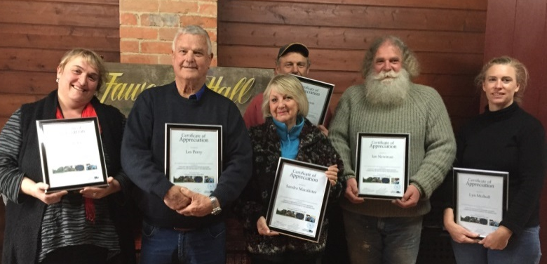
Fawcett Mechanics Institute Reserve Committee of Management
Fawcett Hall was founded in 1882 by local residents wanting to provide a library for the education and enjoyment of the local community.
It fell into terrible disrepair and at one time was almost demolished. The restoration of the Hall has been a significant catalyst in bringing today’s Fawcett community together, providing a place to gather for enjoyment and to distribute information.
A majority of the grants money was raised by efforts from local volunteers such as Jan Young.
In 2014, the committee with the community planned and built a new kitchen, new toilets, and outdoor decking connecting the new extension to the original building. They also built in environmentally sustainable design elements including connection of storm water pipes to tanks; septic plumbing to reuse rain/grey water from the kitchen and toilets; and solar panels to offset electricity costs.
This was completed with a budget of $63,000 via Regional Development Victoria’s funding “Putting Locals First Program” and it brought the entire community together. Community members who were qualified tradespeople worked alongside others to make the renovation happen over 12 months.
With a population of only 90 permanent residents this has been an amazing effort.
The entire CoM was nominated for volunteer awards and received them personally and on behalf of their great community.

Heyfield Wetlands CoM, Gippsland
Members of the Heyfield Wetlands Committee of Management Incorporated nominated six of its nine members for the inaugural Committee of Management Volunteer Week Awards. DELWP extended the awards to recognise the work of all the members of the committee.

Heyfield Wetlands CoM with Carole Macmillan, Regional Manager (second from right).

The certificates acknowledged the various tasks undertaken by each member in managing and caring for the beautiful Wetlands Reserve in Heyfield.
Edward Artso was also recognised for 14 years of service alongside Wendy Rhodes for her 23 years of service. Congratulations and thank you to these hard-working volunteers!
Guidance notes and simple model policies available!
New, easy-to-read guidance notes and simple model policies that CoMs need are now available.
Contact your local DELWP regional office or go to the new ‘Committees of management’ support module on the website: www.delwp.vic.gov.au/committees

CoMs guidelines – updated!
The Committees of management responsibilities and good practice guidelines have been updated.. Please use the new version,available from your local DELWP regional office or the website: www.delwp.vic.gov.au/committees

Kilmany Public Hall and Recreation Reserve CoM, Gippsland
Over 130 years of combined volunteer service by the Kilmany Public Hall and Recreation Reserve Committee has been recognised.
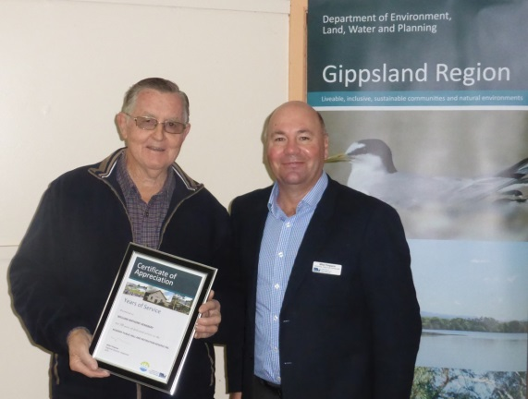
Bill Henebery (left) with Mike Timpano

Pictured above is Gippsland’s Regional Director, Mike Timpano, presenting long-serving volunteer, Bill Henebery, with a Recognition Award recognising 50 years of service to the Kilmany Public Hall and Recreation Reserve Committee.
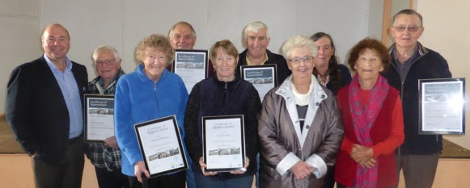
Kilmany Public Hall and Recreation Reserve Committee with Mike Timpano, Gippsland Regional Director (far left)

Mike Timpano also presented the other members of the committee with awards, including significant milestones of 30 plus years.
Theft Alert
A number of hot water units have been stolen from public halls and buildings. Two units were stolen from Crown land reserves very recently. We encourage CoMs to secure their units to discourage thieves.

Does your CoM have email?
CoMs are encouraged to create an email for their committee. Something like kilmany-CoM@email.com The Department can provide this to anyone wishing to get in touch. Once you have an email address please let your DELWP regional contact know or send it to voluntary.committees@delwp.vic.gov.au

Great Southern Rail Trail, Gippsland
Public use of the popular Great Southern Rail Trail in Gippsland has been made safer thanks to the recent lopping and removal of dangerous trees.

In partnership with DELWP, the Great Southern Rail Trail CoM recently organised an extensive audit of potentially hazardous trees along the trail.
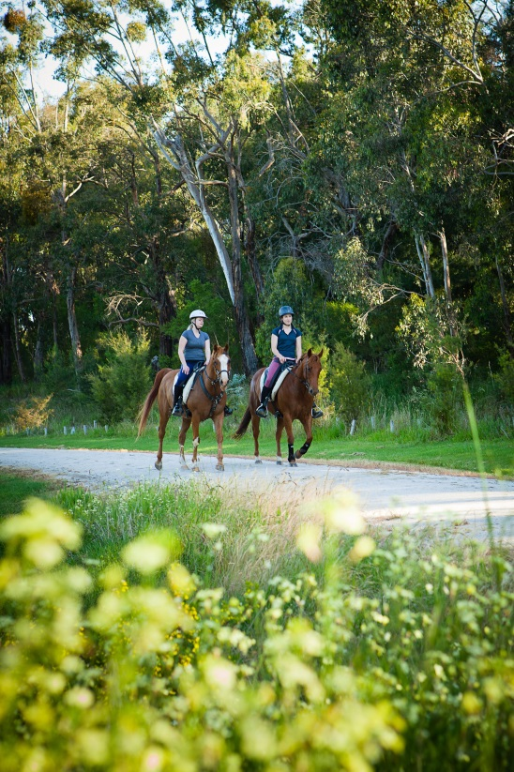
Great Southern Rail Trail

Neville Pulham, committee chairperson said: “We appreciate the support given to our volunteer committee by DELWP.” Congratulations are also in order for Neville who received his award in the recent CoM Volunteer Week awards.

AWARD WINNING VOLUNTEERS:
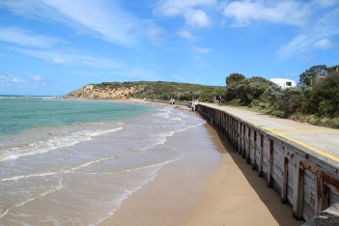 | Barwon South West  Region
Dunkeld Community Centre
Mary-Ann Brown, Heather Macgugan, Doug Fleming, John Prust, Nikki Parker, Christina Manolas, Marcia Macgugan
Hawksdale Racecourse and Reserve
Anne-Maree Huglin, Maxine Keane, Kate Julius, Jenny Ryan
Kirkstall Recreation Reserve
Rochelle Hine, Sharon Wohlers, Leah Brown, Debbie Lenehan, Brian Lenehan, Daryl Brown, Mark Shanley, Tim Mahoney, Gerard Kearney
Wallacedale Public Hall
John Whyte, Barabara Hinchliffe
Woolsthorpe Hall
Kathryn Anne Ewenson, David Richardson, Denis Richardson, Margaret Richardson, Kim Williams, Karen Mahony
Yeodene Hall
William Phillips
Grampians  Region | 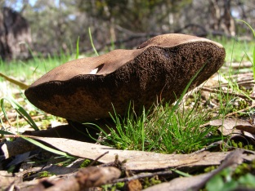
Dooen Public Hall
Kola Kennedy, Maxwell Johns
Dooen Recreation Reserve
Laurence Pearson
Garibaldi Hall
Steve Hodgetts
Gordon Public Park
Mary-Teresa Ritchie, Sophie Benkemoun, Adam Frazer, Therese Winter, Lisa Ferguson
Maude Recreation Reserve
Lexie Stray
Yendon Recreation Reserve
Kay Paton
Loddon Mallee Region | 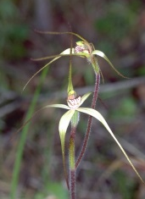
Castlemaine Historical Society Inc.
Carol Dorman, Walter Dunstan, Warwick Anderson, John Starr, Ken Gifkins, Elizabeth Day, Alleyne Hockley, Ian Hockley, Clive Willman, David Major, Peter Benson, Mary O'Toole, Ross Williams, Graeme Day
Echuca Historical Society Inc.
Heather Rendle, Jan Hollingsworth, Margaret Hart, Diedre Coombs, Mesh Thomson, Dorothy Hamond
Fryerstown Community Reserve Committee
Tim Todhunter, Stephanie Holt, Jeanette Ballinger, Jodi Oakman, Lynne Landy, Ritchie Hewett, Paul Gahan, Chris McAuliffe
Kyneton Racecourse Reserve Committee
Gary Buckley
Moora Racecourse Recreation Reserve
Max Matthey, George Ralph
Romsey Mechanics Institute Committee
Kathy Lakey
Rushworth Public Park Reserve CoM Inc.
Peter Raglus, Kaylene Raglus, Peter Schade, David Perry, Ian Riley, Marion Riley
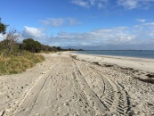 | Port Phillip  Region
Heidelberg Historical Society Inc.
Nick Gammon
Merricks Beach Foreshore Reserve CoM
William (Bill) Cleveland
Pakenham Upper Recreation Reserve COM
Paul Garvey
Christopher Gunton
Point Leo Foreshore CoM
Phillip Trigger
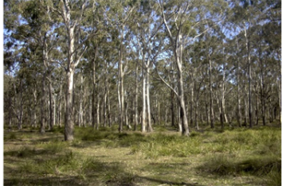 | Gippsland  Region
East Gippsland Rail Trail CoM Inc.
Andrew Sharpe, Brian Gustus, John Nelson, Michael Oxer
Gippsland Plains Rail Trail Inc.
Andrew Ashworth, Anthony Richards, Beth Ripper, Christine Richards, Dianne Honey, Eleisha Keogh, Helen Hoppner, John Cahill, Tania Brooker
Grand Ridge Rail Trail CoM Inc.
Brian Cook, Neil Trease
Great Southern Rail Trail CoM Inc.
Neville Pulham
Heyfield Wetlands CoM Inc.
Daniel (‘Dan’) Davies, Peter Lawrence, Wendy Rhodes, Lynda (‘Lyn’) Judd, Genoneva (‘Gena’) Hughes, Barry Donahoe, Terence (‘Terry’) Stephenson, Edward (‘Ted’) Artso, Michael (‘Mike’) Kube
Hinnomunjie Recreation Reserve
Stuart Stagg
Kilmany Public Hall and Recreation Reserve Inc.
William (‘Bill’) Henebery, Thomas Wallace, John (‘Ron’) Healey, Ian McMahon, Paul March, Ronald Morton, Jean Morton, Gabrielle Wallace, Glenda Anderson
Seaspray Reserves CoM Inc.
Diana Teo, John Morgan, Daniel Rodaughan, Peter Lawrence
Walhalla Board of Management Inc.
John Buchecker
Walhalla Tourist Railway CoM Inc.
David Balfour, Geoffrey Anderson
Want to share your stories in Edition 10?

DELWP is seeking contributions for Edition 10 and would also welcome any feedback on the frequency of the newsletter and its content. Please send any comments, suggestions or articles and photos to voluntary.committees@delwp.vic.gov.au

Hume Region
Corryong Recreation Reserve
Marilyn Hill
El Dorado Museum Association Inc.
Sue Phillips, Trent Cupid, Don Stewart, Dave De Prada, Eric Ramsay, Howard Phillips, Robert Godfrey
Fawcett Mechanics Institute Reserve CoM
Sam Hicks, Ian Newman, Sandra Macalister, Les Perry, Lyn Mulhall, Joy Burchell, Jimmy Young, Jim Swanton, Geoff Sparke, Berhard Sauerbeck
Harrietville Tronoh Reserve Committee
Eleanor Hoy
Mongans Bridge Caravan Park Inc.
Elwyn Ried
Narbethong Public Hall Committee Inc.
Jennifer Wood
Reedy Creek Progress Association Inc.
Karen Zanini, Gail Griggs,
Rowen Park
John Maddock, Scott Carroll
Swanpool Memorial Hall and Recreation Reserve Committee Inc.
Ian Herbet
Walwa Services Memorial Hall Committee
John (“Red”) Stuart

Grant name | Purpose | Amount | Key dates | Website
Melbourne Heritage Restoration Fund and Yarra Heritage Restoration Fund | Restoration works to places of identified historical significance under a heritage overlay in the City of Melbourne. Restoration works to places of identified historical significance under a heritage overlay in the City of Yarra. | Assessed on case by case basis | 26 July 2016  25 October 2016 | http://www.vhrf.org.au/
Restoring Community War Memorials and Avenues of Honour Grants Program | Supports communities in Victoria to ensure local war memorials, honour rolls and avenues of honour are restored to their origin al condition or improved to reflect the service history of the local community. | Up to $20,000 | Ongoing | http://www.dpc.vic.gov.au/index.php/veterans/veterans-grants/commemorative-grants-restoring-war-memorials-and-avenues-of-honour
Restoring Community War Memorials and Avenues of Honour Grants Program | Restore/ improve local war memorials, honour rolls, avenues of honour | Up to $20,000 | Ongoing | http://www.dpc.vic.gov.au/index.php/veterans/veterans-grants/commemorative-grants-restoring-war-memorials-and-avenues-of-honour
Community Sports Infrastructure Fund | To help provide high-quality, accessible community sport and recreation facilities across Victoria | Up to $100,000 | Ongoing | http://www.sport.vic.gov.au/community-sports-infrastructure-fund
Melbourne Water Corridors of green funding | To improve river health through the corridors of green program. | Up to $20,000 | Ongoing | http://www.melbournewater.com.au/getinvolved/applyforfunding/pages/corridors-of-green-funding.aspx
Public Safety on Public Land – Major Projects | To improve public safety on public land through projects such as reconstruction or reinforcement of major structures, demolition of major structures, decontamination, control visitor access, or tree risk projects. | $20,000 and more | Contact your local DELWP representative | Applications must be made through your local DELWP representative.

