Introduction
As of late March 2023, the DEECA’s Image Web Server (IWS) will move to cloud based hosting. Existing users will need to update their connection url.
Only authorised users can access the IWS.
To register as an authorised user of the IWS please refer to the User Registration section.

Connecting to a Web Map Service
- Run QGIS Desktop (from Start>All Programs>QGIS)
- From the Browser Panel, right-click on WMS / WMTS
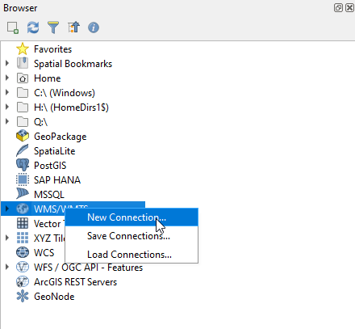
- Select “New Connection…”
- In the window that opens, copy and paste the following text into the respective fields:
Name: DEECA Image Web Server
URL: https://iws.maps.vic.gov.au/erdas-iws/ogc/wms/RDP?SERVICE
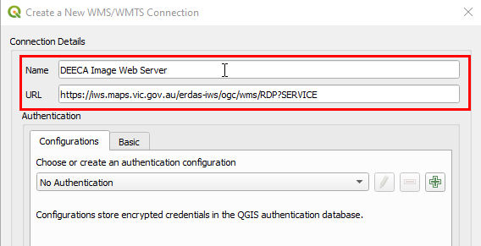
There are 2 options regarding authenticating (confirming your permission to access the IWS) : Basic or Configurations
Basic authentication is not recommended. It saves your credentials (in plain text) as part of your QGIS project file. If anyone opens your QGIS project in a text editor they will be able to see your user name and password.
The more secure method is to create an authentication configuration. This method encrypts your credentials and stores them in a local “authentication configuration database”. If anyone opens your QGIS project in a text editor they “will not” be able to see your user name and password.

Creating an Authentication Configuration
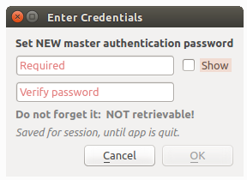
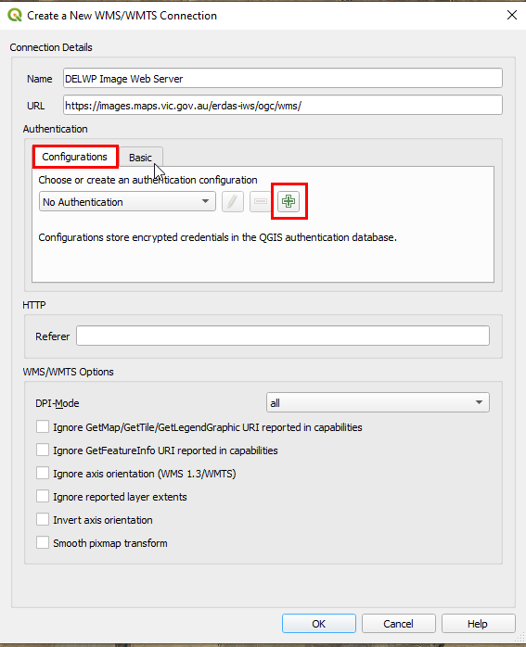
  - To store or access sensitive information within the “authentication configuration database”, a user must define a “master password”. A new master password is requested and verified when initially storing any encrypted data to the database. y
If the user forgets the master password, there is no way to retrieve or override it. There is also no means of retrieving encrypted information without knowing the master password.
If a user inputs their existing password incorrectly three times, the dialog will offer to erase the database.
  - Once the master password is set the user completes the authentication configuration by setting :
Name = DEECA Image Web Server
Username = <your corporate email address>
Password = <your IWS password>
If you are unsure of your IWS password please refer to the User Registration section.
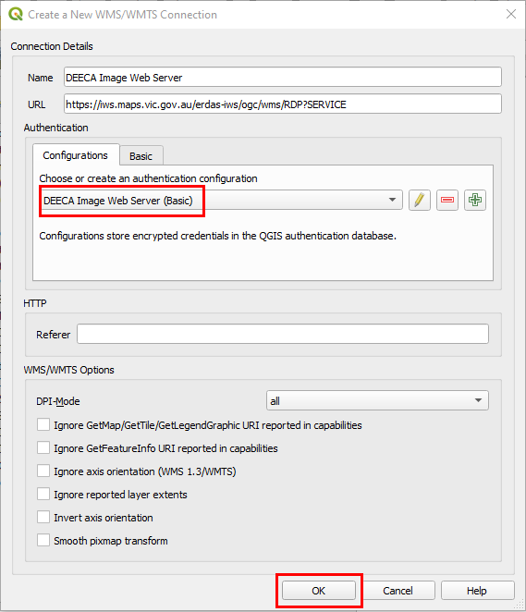
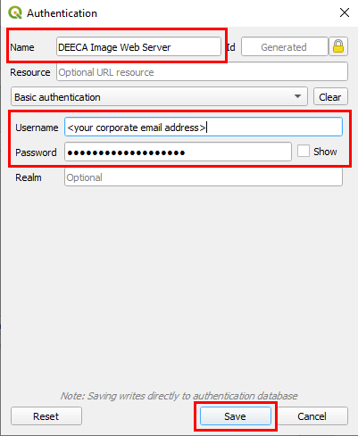
  - When the authentication configuration is complete ensure “DEECA Image Web Server (Basic)” is displayed in the authentication configuration drop down and then select OK

Loading an Image into QGIS
- From the Browser panel, double click the “DEECA Image Web Server” to expand the directory tree (you will repeat this to expand each level.
- Double clicking on the image name will add it to your “Layers” panel in QGIS
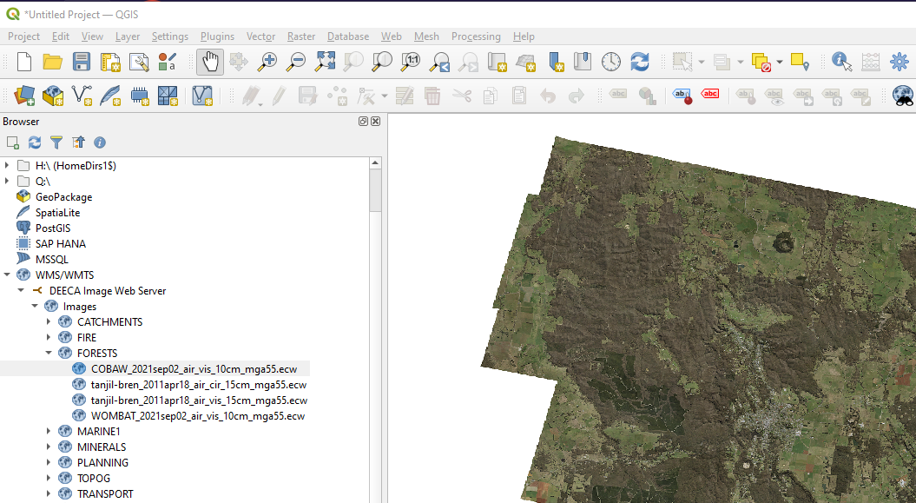
- The image should now appear in your QGIS map window.

Image Footprints layer
The image footprints layer is a spatial index of all georeferenced images stored on the Image Web Server. The layer contains information about the image file which will support basic searching for appropriate images.
Internal users can access the footprints layer via ArcGIS as an ESRI file geodatabase via the VSDL on:
J:\Gis_Public\CSDL\CORPORATE.gdb\IWSFOOTPRINT
External users can order and download the footprints layer via DataShare, which supports MapInfo tab and mid/mif as well as ESRI shp formats.

User Registration
Approved customers need an account in the identity management system (idam), to access the IWS.

DEECA staff
If you have previously created a DataShare account then you will already have an account in the identity management system. You will be able to log into the Image Web Server using your “corporate email address” and your single sign on password.
DEECA staff without an account in the identity management system (eg you don’t have an existing DataShare account (https://datashare.maps.vic.gov.au/)) need to create one via the DataShare login option
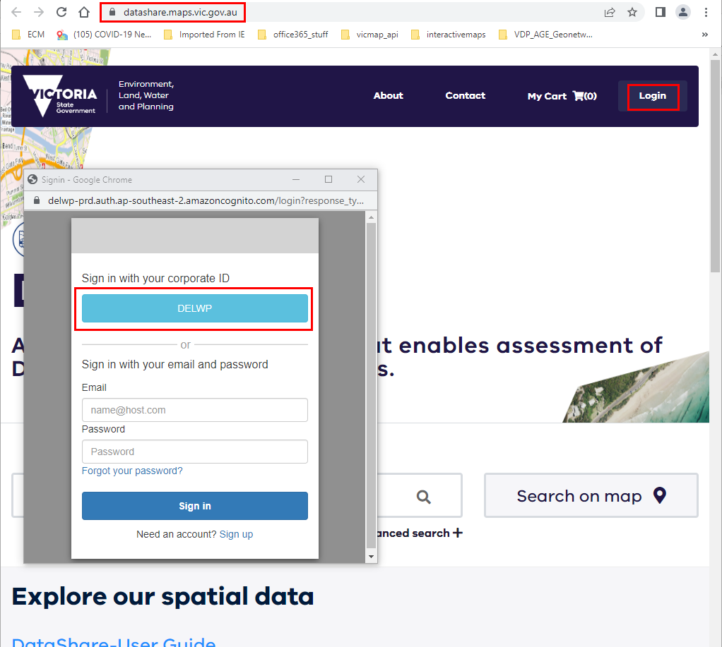
NOTE: once complete you can log out of DataShare
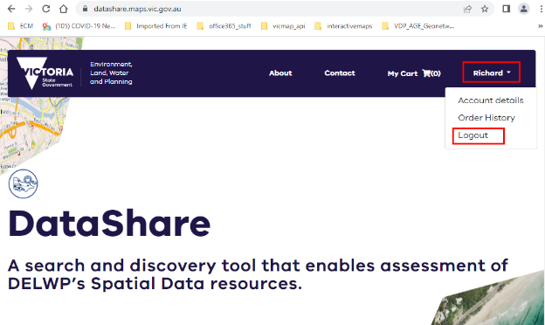
You can now log into the Image Web Server using your “corporate email address” and your single sign on password.

Non DEECA staff
If you have previously created a DataShare account (created using your corporate email address) then you will already have an account in the identity management system. You will be able to log into the Image Web Server using your “corporate email address” and your Datashare password.
Non DEECA staff without an account in the identity management system (eg you don’t have an existing DataShare account (https://datashare.maps.vic.gov.au/)) need to create one via the DataShare login option. Use your corporate email address.
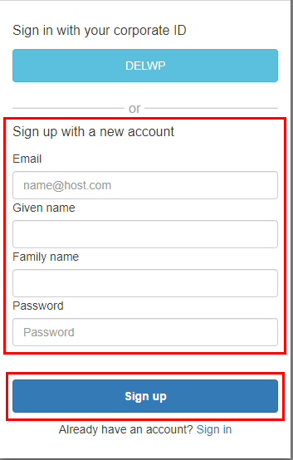
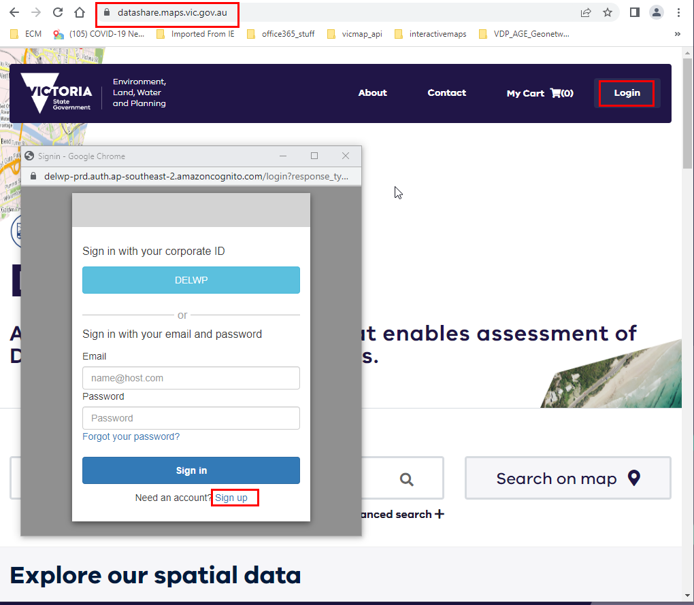
NOTE: once complete you can log out of DataShare
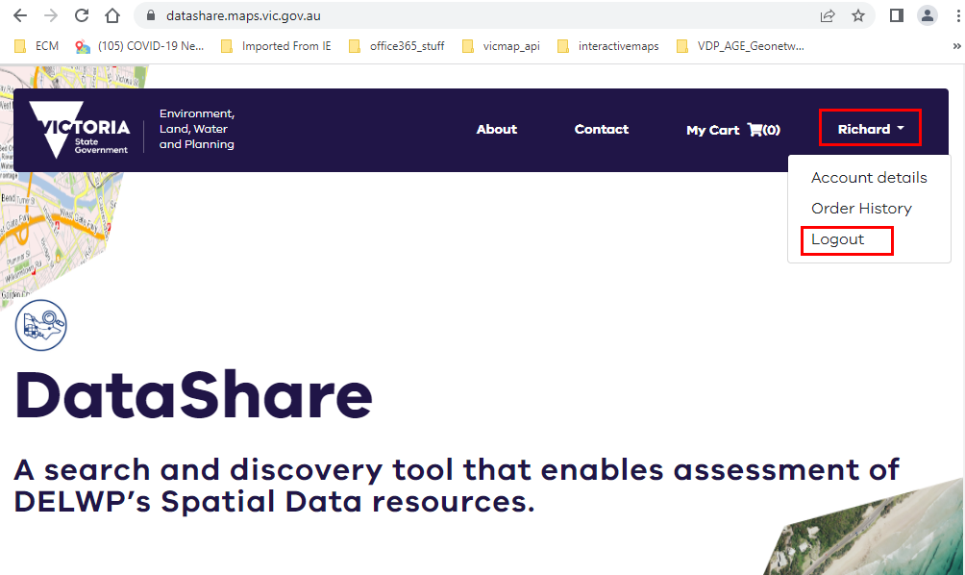
You can now log into the Image Web Server using your “corporate email address” and your DataShare password.

Coming Soon
The ability to view and save a list of Image Web Server imagery, so that you can differentiate between all the imagery on the image web server and those that you have access to is currently being developed and will be available soon.

Image Web Server Contact Details
The Enterprise Spatial Services team (DEECA) manages the IWS. Departmental users can address any feedback or queries to GIS Help Desk via the DEECA Service Portal. External users can provide feedback via the GIS.Helpdesk@deeca.vic.gov.au email address.

