|  |
| --- |
| Image Web server |
| MapInfo v12 |

#### Introduction

As of late March 2023, the DEECA’s Image Web Server (IWS) will move to cloud based hosting. Existing users will need to update their connection url.

Only authorised users can access the IWS.

To register as an authorised user of the IWS please refer to the User Registration section.

#### View available images via WMS

1. Choose the File > Open Web Service > Open WMS… menu option.
2. Select the Servers… button
3. Then the Add… button
4. In the resulting WMS Server Information menu

For Server URL enter –  
https://iws.maps.vic.gov.au/erdas-iws/ogc/wms/RDP?SERVICE

For Description: enter –   
Victorian Government Image Web Server

1. Then click OK
2. Now set this entry as the default by clicking the Set Default button
3. Then click OK
4. Now select the images to be viewed from the WMS Layers: list and then the Add>> button to add them to the right hand menu window
5. Enter a Table filename: by navigating to the C:/TEMP directory, entering the name and clicking the Save button
6. Under the Preferred View: pull down select the appropriate mapper window option
7. Then click OK to add the image to the Mapper window
8. When adding an image for the first time, you will need to enter in your “corporate email address” and password. Refer to the “User Registration” section if you are unsure you are a registered user of the IWS

Please Note: Some images on the Image Web Server are not georeferenced and therefore may not be suitable for viewing in MapInfo. These images will contain a dpi value in the file name rather than a coordinate systems value (eg mga54, mga55, vg94 or dd94).

#### Useful Tips

##### Blank Map Window

1. If the Map Window appears blank then you may need to change the display settings to see the image.
2. Right click in image name in the Layer Control window.
3. 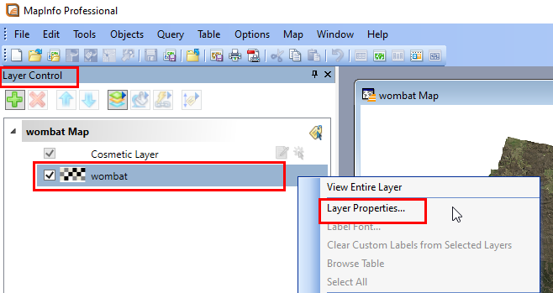Select Layer Properties
4. 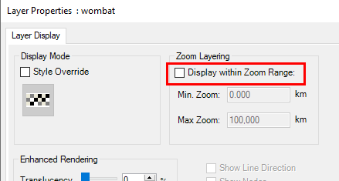Unselect Display within Zoom Range:
5. Click OK and the Image will appear.

##### Loading Images into the same Map Window

1. From the File > Open Web Service > Open WMS… window
2. Under the Preferred View: pull down select the Current Mapper option
3. Now load multiple images

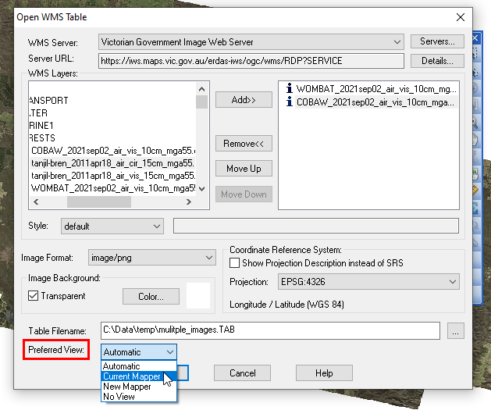

##### Viewing Vigrid94 images

To view images in the Vicgrid94 coordinate system your MapInfo projection file must be updated with the VicGrid94 EPSG number as follows;

1. Navigate to your MapInfo installation directory. The default path is: C:\Program Files\MapInfo\Professional
2. Then open the MAPINFO.PRJ file in Wordpad.
3. Then via the Edit > Find menu options, search for "Vicgrid94"
4. Add the EPSG Number \p102171 as follows; "VicGrid94 (GDA94)\p102171",3, 116, 7, 145, -37, -36, -38, 2500000, 2500000
5. Save the file and exit
6. Now go to MapInfo and add a *vg94 image as a WMS (as described in View available images via WMS section of this document)

Please note the following points when using ECW in MapInfo;

1. Need to set the projection of the map window to match that of the image, new data (point, line or polygon) will be re-projected to match the image projection
2. If you move the image TAB file you MUST also move the ALG file with the TAB file (if it exists)

#### Settings

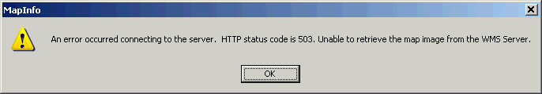If you experience delays/timeout in display of imagery and you receive an error like this one:

Change the Proxy Server Settings from the default (Use System Settings) to Use Direct Connection as follows:

1. Select the MapInfo Options > Preferences menu options
2. In the resulting pop up window click on the Web Services button.
3. In the resulting pop up window select the Use Direct Connection radio button
4. Click the OK button
5. Click the OK button again.

#### Image Footprints layer

The image footprints layer is a spatial index of all georeferenced images stored on the Image Web Server. The layer contains information about the image file which will support basic searching for appropriate images.

Internal users can access the footprints layer via ArcGIS as an ESRI file geodatabase via the VSDL on:

J:\Gis_Public\CSDL\CORPORATE.gdb\IWSFOOTPRINT

External users can order and download the footprints layer via [DataShare](https://datashare.maps.vic.gov.au/), which supports both MapInfo tab and mid/mif as well as ESRI shp formats.

#### User Registration

Approved customers need an account in the identity management system (idam), to access the IWS.

##### DEECA staff

If you have previously created a DataShare account then you will already have an account in the identity management system. You will be able to log into the Image Web Server using your “corporate email address” and your single sign on password.

DEECA staff without an account in the identity management system (eg you don’t have an existing DataShare account (<https://datashare.maps.vic.gov.au/>)) need to create one via the DataShare login option

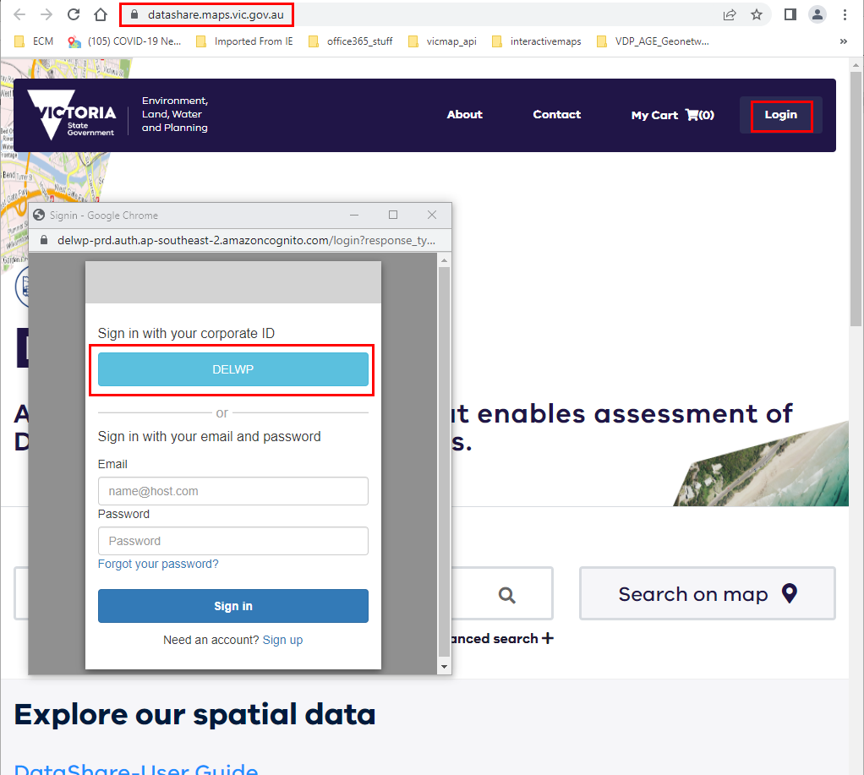

NOTE: once complete you can log out of DataShare

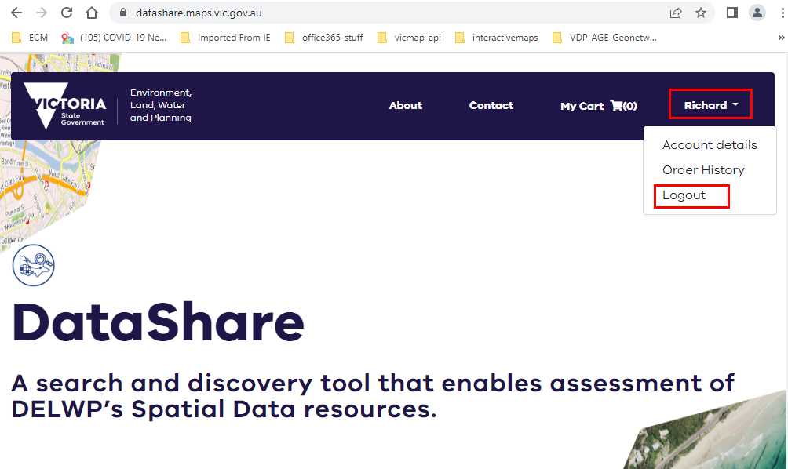

You can now log into the Image Web Server using your “corporate email address” and your single sign on password.

##### Non DEECA staff

If you have previously created a DataShare account (created using your corporate email address) then you will already have an account in the identity management system. You will be able to log into the Image Web Server using your “corporate email address” and your Datashare password.

Non DEECA staff without an account in the identity management system (eg you don’t have an existing DataShare account (<https://datashare.maps.vic.gov.au/>)) need to create one via the DataShare login option. Use your corporate email address.

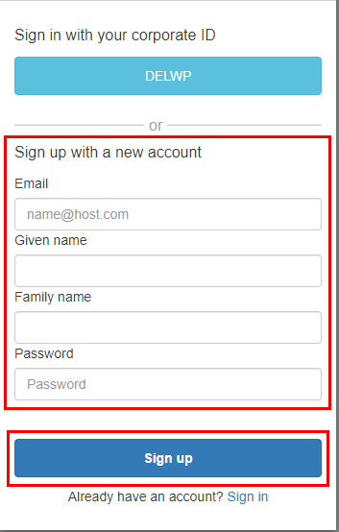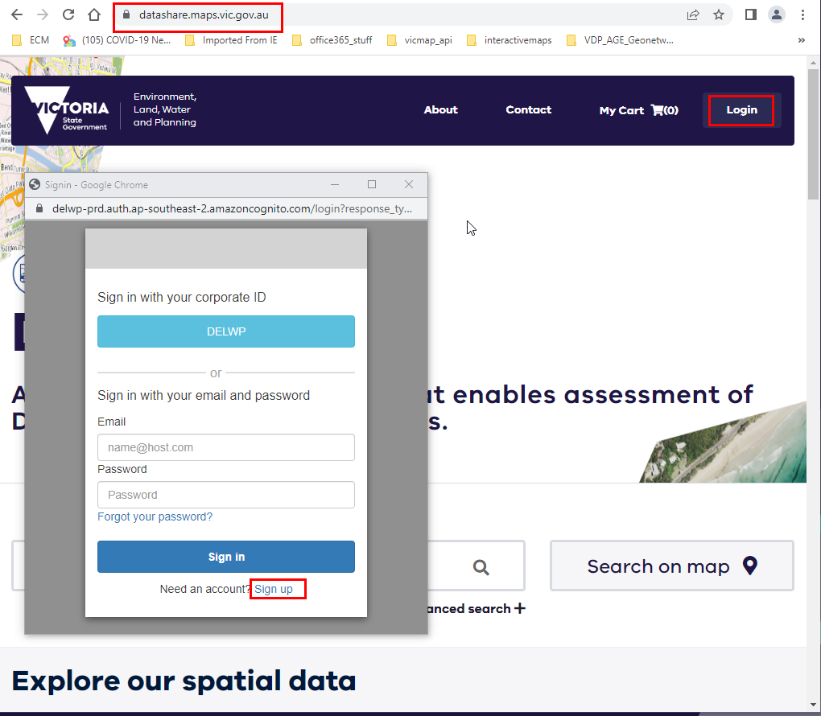

NOTE: once complete you can log out of DataShare



You can now log into the Image Web Server using your “corporate email address” and your DataShare password.

#### Coming Soon

The ability to view and save a list of Image Web Server imagery, so that you can differentiate between all the imagery on the image web server and those that you have access to is currently being developed and will be available soon.

#### Image Web Server Contact Details

The Information Services Division (DEECA) manages the IWS. Please address any feedback or queries to [GIS.Helpdesk@delwp.vic.gov.au](mailto:GIS.Helpdesk@delwp.vic.gov.au)

|  |  |
| --- | --- |
| © The State of Victoria Department of Energy, Environment and Climate Action 2023  Creative Commons BYThis work is licensed under a Creative Commons Attribution 4.0 International licence. You are free to re-use the work under that licence, on the condition that you credit the State of Victoria as author. The licence does not apply to any images, photographs or branding, including the Victorian Coat of Arms, the Victorian Government logo and the Department of Energy, Environment and Climate Change (DEECA) logo. To view a copy of this licence, visit http://creativecommons.org/licenses/by/4.0/  Disclaimer  This publication may be of assistance to you, but the State of Victoria and its employees do not guarantee that the publication is without flaw of any kind or is wholly appropriate for your particular purposes and therefore disclaims all liability for any error, loss or other consequence which may arise from you relying on any information in this publication. | Accessibility  If you would like to receive this publication in an alternative format, please telephone the DEECA Customer Service Centre on 136186, email [customer.service@delwp.vic.gov.au](mailto:customer.service@delwp.vic.gov.au) or via the National Relay Service on 133 677 [www.relayservice.com.au](http://www.relayservice.com.au). This document is also available on the internet at [www.deeca.vic.gov.au](http://www.deeca.vic.gov.au). |

.