Privacy collection statement –

Gift Offers
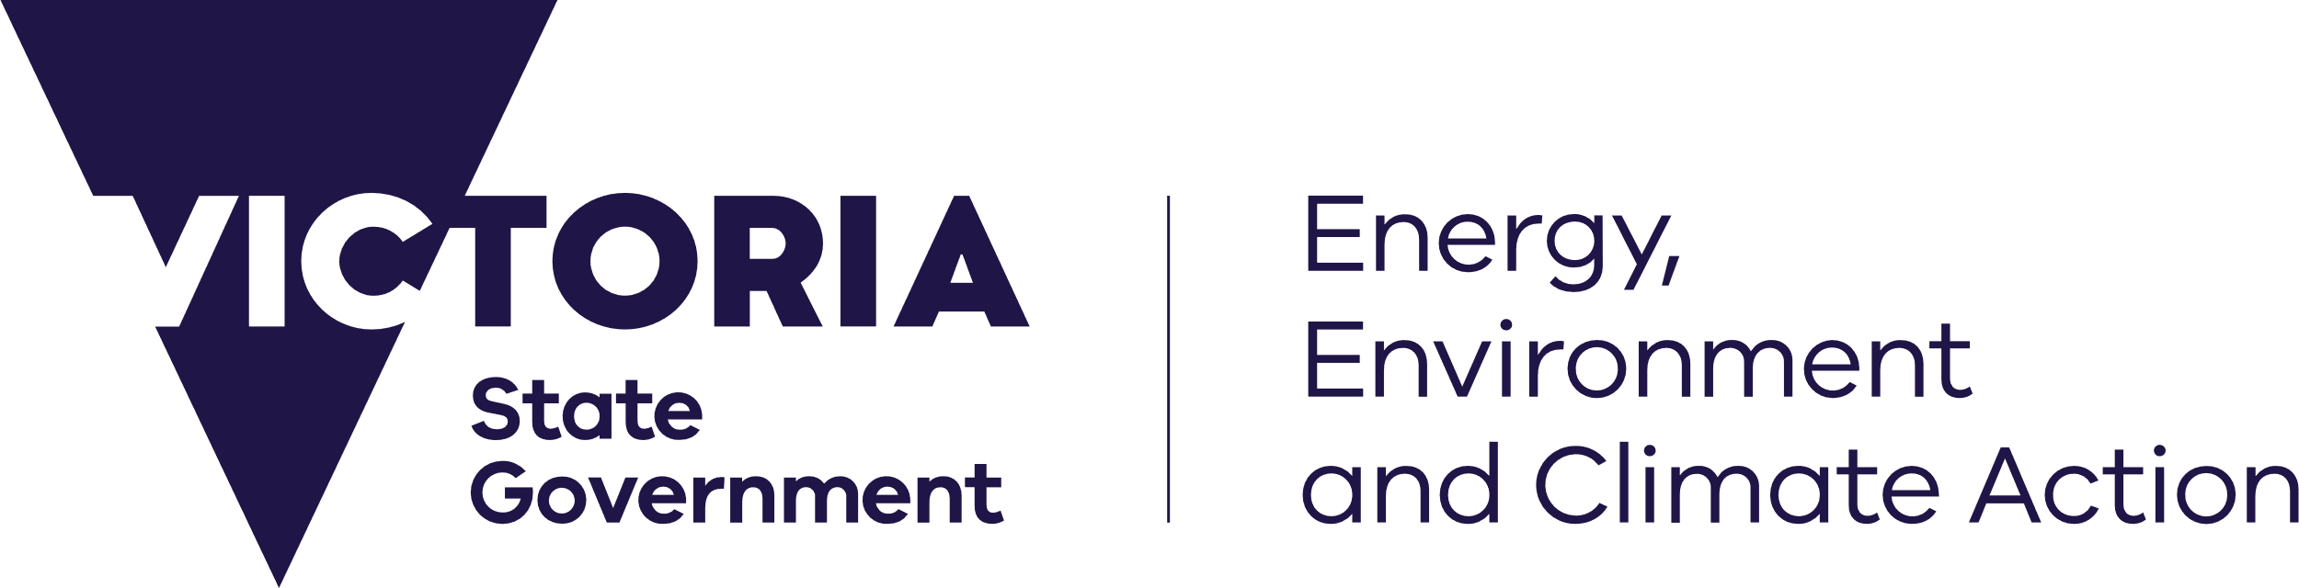
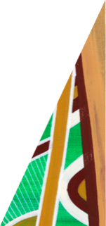
deeca.vic.gov.au

Gifts, benefits and hospitality

This Privacy collection statement – gift offers sets out how the department collects, retains and uses information about gift offers made to its employees (including other workplace participants) by an external source.

Background
This privacy collection statement is published in accordance with the Information Privacy Principles in Schedule 1 of the Privacy and Data Protection Act 2014.
The Department of Energy, Environment and Climate Action (department) is part of the public sector. As such, it complies with a range of laws and other obligations, including:
- the Public Administration Act 2004
- the Minimum accountabilities for the management of gifts, benefits and hospitality issued by the Victorian Public Sector Commission (Minimum accountabilities)
- the Privacy and Data Protection Act 2014.

Purpose of collection, retention and use of information
As part of the department’s compliance with its obligations and good public sector governance practice:
- If you (individual or organisation) offer a gift, benefit or hospitality (gift) to a departmental employee, or to their close friend, relative or associate, as a result of the employee’s role with the department, then information about the offer will be recorded, retained and used by the department.
- The information that will be recorded, retained and used by the department is set out in the department’s policy on Gifts, benefits and hospitality.
- The policy is published on the department’s external website (www.deeca.vic.gov.au).
- As set out in the policy, a copy of the department’s Register of Reportable Gift Offers (register),
is also published on its external website.
- The purpose of collecting, retaining and using information about gift offers made to departmental employees (including publishing the register) is to help ensure our policy is effective and meet our legal obligations, including:
    - comply with the Minimum accountabilities
    - promote transparency, consistency and accountability in public sector decision-making.

Viewing information
If you (individual or organisation) have offered a gift, benefit or hospitality to a departmental employee, or to their close friend, relative or associate, because of the employee’s role with the department you can view the information recorded by the department by contacting the FOI Unit, Department of Energy, Environment and Climate Action, PO Box 500 East Melbourne Victoria 8002 or foi.unit@delwp.vic.gov.au.
Please note that, in accordance with the department’s policy:
- Information about both reportable and token gifts (as defined in the policy) is recorded, retained and used by the department.
- Only information about reportable gifts is recorded in the register. Steps are taken to de-identify personal information in the copy of the register published on the department’s external website.
- Consistent with Victorian Public Sector Commission Guidance, the public register must include the position title and employing company of the person offering a reportable gift, if that gift is accepted.

© The State of Victoria Department of Energy, Environment and Climate Action 2023.
Creative Commons
This work is licensed under a Creative Commons Attribution 4.0 International licence, visit the Creative Commons website (http://creativecommons.org/licenses/by/4.0/).
You are free to re-use the work under that licence, on the condition that you credit the State of Victoria as author. The licence does not apply to any images, photographs or branding, including the Victorian Coat of Arms, and the Victorian Government and Department logos.
Disclaimer
This publication may be of assistance to you but the State of Victoria and its employees do not guarantee that the publication is without flaw of any kind or is wholly appropriate for your particular purposes and therefore disclaims all liability for any error, loss or other consequence which may arise from you relying on any information in this publication.
Accessibility
To receive this document in an alternative format, phone the Customer Service Centre on 136 186, email customer.service@delwp.vic.gov.au, or contact National Relay Service on 133 677. Available at DEECA website (www.deeca.vic.gov.au).

This term includes all workplace participants in the department.

